


Account Executive Management
Handbook
56 Hudson Street Northboro, MA 01532
800-833-4459 Fax: 506-393-0255
www.wireready.com
56 Hudson Street Northboro, MA 01532
800-833-4459 Fax: 508-393-0255
www.wireready.com

Account Executives: Navigating SalesReady 5
Navigating the database to find your accounts 5
Using the Search/ Sort functions 5
Using the List button to print or view specific information for any account(s) 13
List Type 13
Source 13
Destination 13
Delimiter 13
Updating your accounts in the database to reflect your daily activity 14
Schedule button & Change Schedule button 14
1. On a new account or new deal on that account: 14
2. On an existing deal that only needs to be updated: 17
Protect Buttons (Do Not Call Requests, Bad Telephone Numbers and Protected Accounts) 19
Recording Information about the Customer contacts 20
To Access the Customer Profile page 20
Sales Managers: Learning the management features of the SalesReady software 29
Learning the extra security features of the software 29
Account Executive management: Adding reps names & updating monthly goals or quotas 30
Account Executive management: Generating reports to monitor your team and your sales 32
Quota Period Reports: Comparing monthly sales goals to actual sales totals 32
Hot Lead Reports: Quick view of all the leads for the entire department 34
Sales Report: All the sales ever closed by any rep 36
Finding the reports you have generated: 38
Event management: Event editing buttons 41
Event management: Adding a new event 43
Step 1: The Event Detail screen 43
Step 2: The New Event dialog window 43
Additional management tools: Pitch delete 46
Additional management tools: Mass update (database) 47
Additional management tools: Protect Buttons (Do Not Call Requests, Bad Telephone Numbers and Protected Accounts) 49
Configuring Security Settings 51
To configure the Edit Sales Rep or Mass Update menu item for manager use only: 51
To configure the settings for Event Materials: 51
To configure the settings for blocked numbers: 52
To make the blocked accounts disappear: 52
To lockout the blocked accounts: 52
To restrict other settings to sales manager use only: 53
Appendix A: Quick synopsis of each button and menu item in SalesReady 56
Database Window 56
Button Name: F2 Show 56
Button Name: F3 Find ID 56
Button Name: F4 Add 56
Button Name: F6 Report 56
Button Name: Ctrl + U User 56
Button Name: View Record 56
Button Name: Delete Record 57
Button Name: Event Info 57
Button Name: List 57
Sales Entry Window 57
Button Name: Schedule 57
Button Name: Chng Schedule 3 57
Button Name: Print 58
Button Name: Change Pitch 58
Button Name: Delete Pitch 58
Button Name: Event Info (first explained above) 58
Button Name: Evnt Materials 58
Button Name: Contracts 58
Button Name: Contact Info 58
Button Name: Stats 58
Button Name: Email 59
Button Name: Open Notes 59
Button Name: View Old Calls 59
Button Name: Record 59
Button Name: Start Call 59
Button Name: End Call 59
Button Name: New Pitch 59
Button Name: Done 59
Button Name: Cancel 59
Button Name: Help 60
Button Name: Change (town or category) 60
Button Name: Protect 1 (Phone Number) 60
Button Name: Change (callback date) 60
Button Name: Protect 2 (Fax Number) 60
Event Materials Window 61
Button Name: Launch 61
Button Name: Cancel 61
Button Name: New File 61
Button Name: Edit Selected 61
Button Name: Help 61
Button Name: Event Info 1 61
Button Name: View Notes 62
Button Name: Edit Notes 62
Button Name: Launch As Form 62
Button Name: Copy As Template 62
Button Name: Print ALL as Form 62
Button Name: Print ALL Folders as Form 62

Account Executives: Navigating SalesReady
This document is written assuming the user has previously learned how to start the software, and more specifically, start the sales section of the software. Basic computer operation skills are also assumed. If you are not familiar with WireReady32, consult the Community Event Coordinator Handbook.

Navigating the database to find your accounts

Using the Search/ Sort functions
The F2 Show button allows a user to display accounts based on specific criteria. See the diagram below to find the F2 Show button.

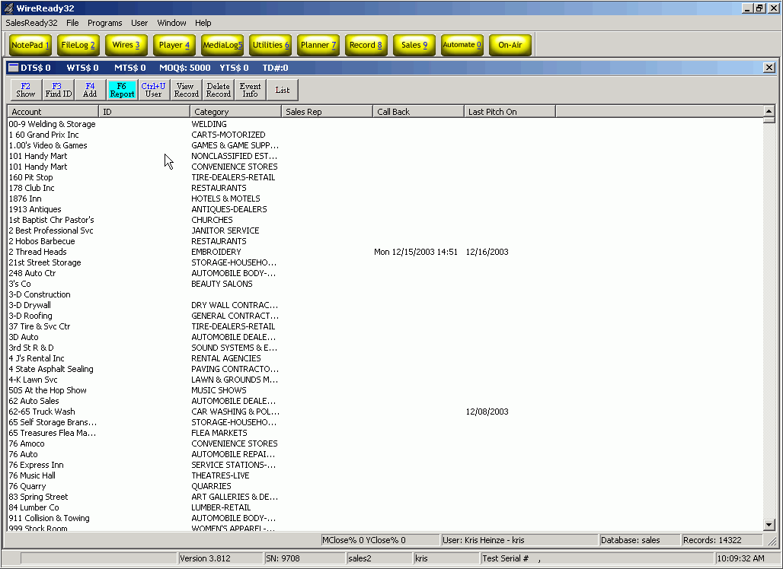

When you click the F2 Show button, SalesReady® will ask you to choose the specifications of your account sort. There are many different ways to sort the database and we will cover those methods most likely used by an account executive.

- To display a specific record or set of records, choose:
SEARCH: Show matching text…sort by…
This is the most popular way to view any account or group of accounts. Any bit of information can be used, be it the name of the account, the name of the contact person, the name of the street where the business is located or the account number that the station has assigned, the category of the business, etc.

- Double-click Show matching text…sort by…
- Type in the information you want to use to find the account (typically, the fewer letters, the better), and click OK or strike the Enter key.
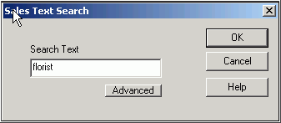
- Double-click your preferred sorting method for the list of accounts that will be displayed.
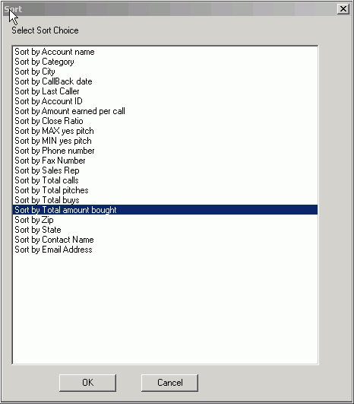

- After sorting, the SalesReady® database will display only those records including the text that was asked for. See the results below:

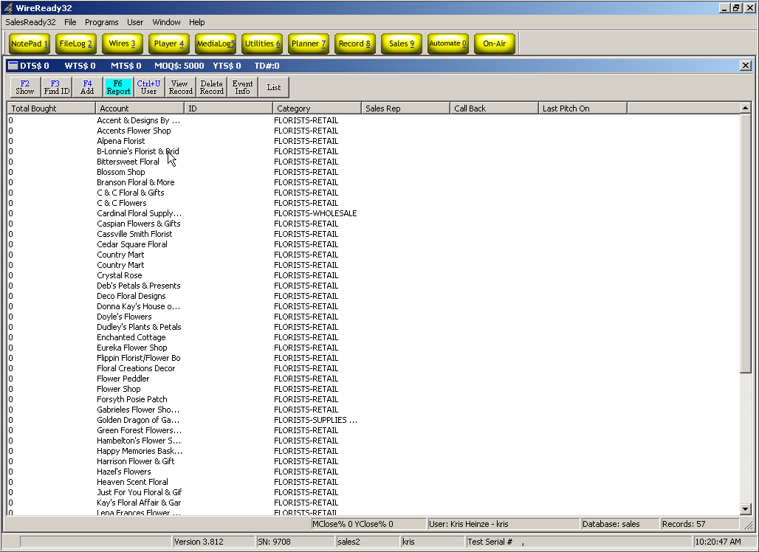

- To view all the callbacks you’ve ever scheduled, choose:
SEARCH: Show callbacks to be made from…to…for last caller
This search is good to clean up any callbacks that you have forgotten about or missed from days past. See the following diagrams to view all your past callbacks.

  - Double-click Show callbacks to be made from…to…for last caller.
  - Choose the button Max Date Range at the bottom of the screen or choose your own preferred date range using the provided buttons or typing in a date. See the diagram below:
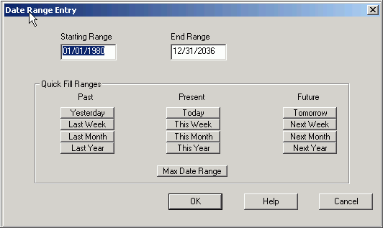

  - Choose your name from the list of users to view your callbacks.
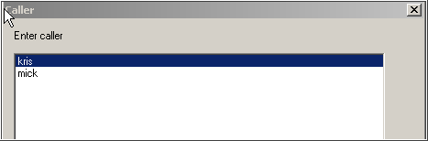
  - The screen will display only your callbacks yet to be made.

- To view your callbacks for today only, choose:
SEARCH: Show today’s callbacks for last caller…sort by…
This is the most popular callback sort.
1. Double-click Show today’s callbacks for last caller…sort by…
- Choose your name from the list of callers.
- SalesReady® will then refresh with the list of callbacks scheduled for today.

- To view YOUR hot leads list, choose:
SEARCH: Show hot leads…pitched by caller…in date range…sort by…
This is a popular way to track the most important negotiations you have in the works. Any account in the list can be double-clicked for a closer look at the details for that deal.

- Double-click Show HOT LEADS… pitched by CALLER…in DATE RANGE…sort by…
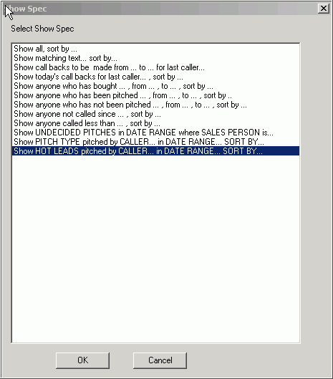
- Choose your name from the list of callers
- Choose your time frame (this month, next month, etc)
- Sort the list however you like (alphabetical, categorical, etc)
- The screen will refresh with all the accounts in which you have logged a lead (sure, hoped for, expected).
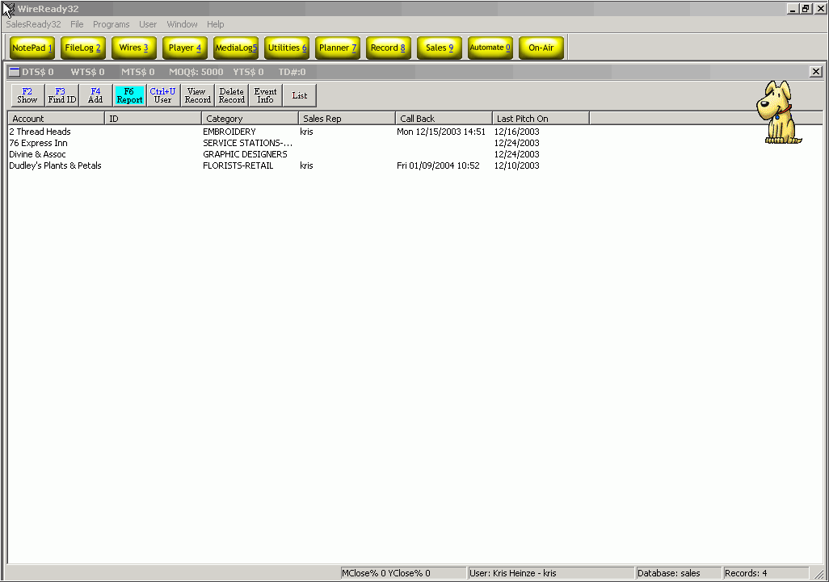

Using the List button to print or view specific information for any account(s)
No more waiting for the billing department to get you a list of addresses and phone numbers for your accounts. The List button allows users to create a list of accounts to be printed, saved to a file or viewed on-screen.

List Type
- Calling List: Generates a list of accounts that includes Account Name, Contact, Contact Title and Phone Number fields, sorted in the order they appear on the screen.
- Mailing Label Data: Generates a list of accounts that includes Account, Contact, Title, Address1, Address2, City, State and Zip Code fields, sorted in the order they appear on the screen.
- Current Browser: Generates a list of accounts that includes the fields currently displayed on the screen, sorted in the order they appear on the screen.

Source
- Selected Records: Uses only the records that are selected (highlighted) in the list of accounts for the output. You have the freedom to select only the records you need.
- Entire Browser: Uses all the records currently displayed on the screen in the browser for the output.

Destination
- File: The list will be created into a file that can be stored in any folder available to the user. When giving the file a name, include the extension.
- Printer: The list will be generated and sent to the printer.

Delimiter
- Space (Text Documents): The list will be generated as a text file. A choice for both File and Printer output.
- Comma (CSV/Excel Format): The list will be generated as a Comma Separated Value file. This option is only available when saving to a destination file. See the diagram below:
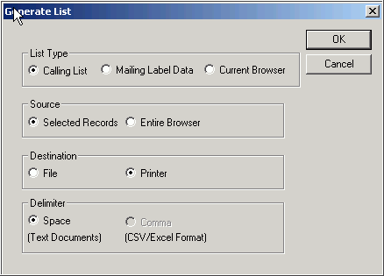

Updating your accounts in the database to reflect your daily activity
In just a few minutes per day, you can update your accounts in SalesReady. That information is then at your fingertips when you need it most.

Schedule button & Change Schedule button
When you are ready to update the activity on the deal on a particular account, you navigate the database to find that account and then double-click to open.

1. On a new account or new deal on that account:
Start by clicking the Schedule button. See the diagram below:

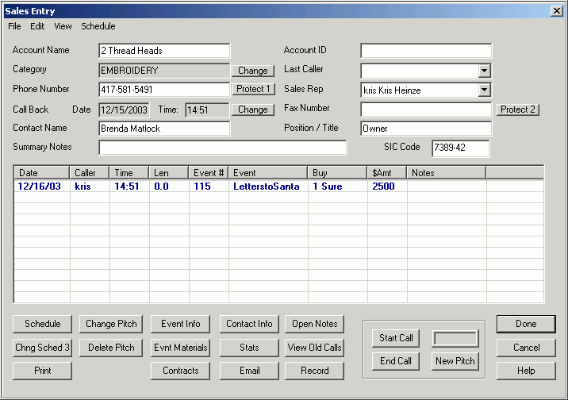

Choose your name from the list and then enter the date that you expect to close the deal. See the diagram below:

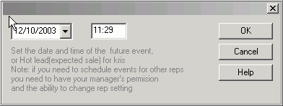
Next, enter details about the deal. The associated event or programming, the amount, your perception of the likelihood of closing the deal (hoped for, expected, sure), and set a callback date if you like. See the diagram below:

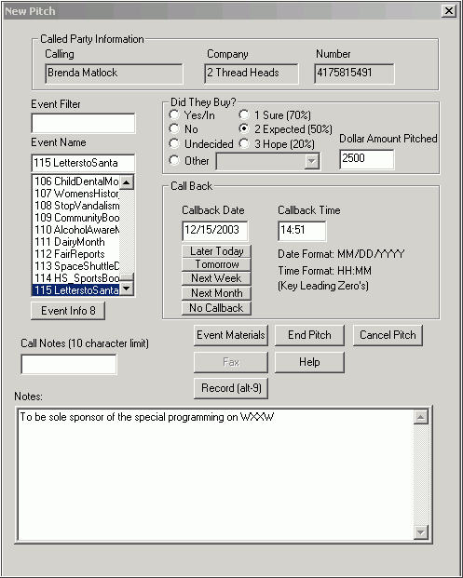

Simply click End Pitch to save your information, and then click Done to exit the customer record.

2. On an existing deal that only needs to be updated:
Start by clicking on the deal that needs to be updated. See the diagram below:

Next, click the Chng Sched 3 button to update the information for this deal.
You’ll be prompted to update the expected date of close. Use the drop down calendar to click on the date, rather than typing it into the box. See the diagram below:
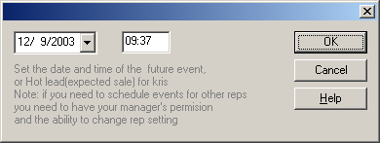
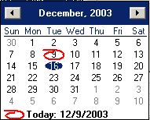

The New Pitch window will open, containing all the information you have previously entered about this deal (the event, amount, likelihood of close, callback date, etc). Update any information that needs to be updated and hit the End Pitch button. Remember to click the Done button to save the information when you exit the customer record.

Protect Buttons
(Do Not Call Requests, Bad Telephone Numbers and Protected Accounts)

Blocking accounts is not an action to be taken lightly. If your group uses SalesReady for both Account Executives and Telesales, there may be a need to “protect” the AE accounts from being called upon by the telesales persons. The protect buttons can offer a control mechanism, but can work against you if don’t speak with your sales manager before you decide to protect an account.

The system can be configured 3 ways to handle blocked accounts.
- Accounts can be viewed by everyone, but the phone numbers will be altered depending on the type of block you put on the account.
- They can disappear entirely from the database—no one will be able to bring up that account in any search, except the sales manager.
- They can be locked out. The account will turn red in the database, and only the sales rep who owns the account will be able to view and edit it.

When you have spoken with your sales manager and are aware of the consequences of blocking an account, you may proceed.

To block an account, you simply click the Protect Button near the phone number or fax number, depending on which you wish to block. A box pops up with 3 reasons for blocking this number. You must click the radio button that corresponds with your reasoning. See the diagram on the following page.
- Do Not Call: Used when the customer has requested not to be called.
- Bad Number: Used when the phone number is known to be bad or disconnected. This is used more in telesales than anything.
- Protect: Used to restrict access to the account so that only the rep who owns it may access and edit.

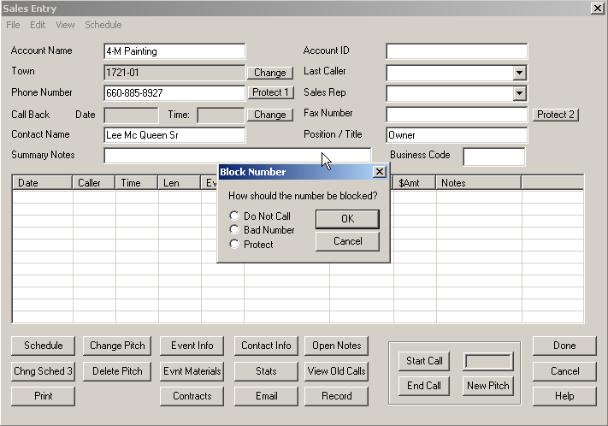

Recording Information about the Customer contacts

To Access the Customer Profile page
Open the account to add information about the business and the main contact persons.
Click on the Cust. Profile button at the bottom of the Sales Entry screen.
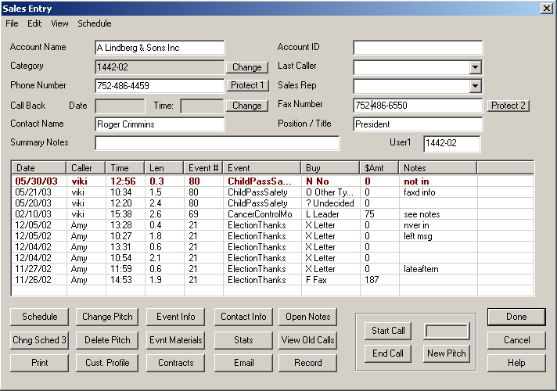

The SalesReady Profile Database Entry Dialog screen will open. This screen allows the user to enter information about the main customer contacts and decision makers for the account, along with information about the demographics, needs, budget and goals of the business.
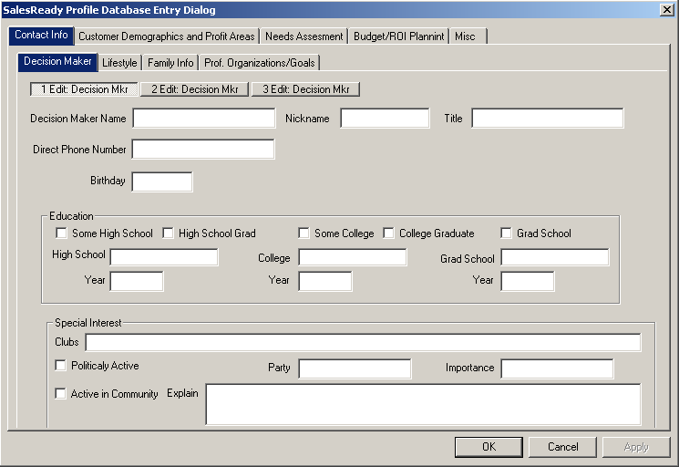

Contact/Personal Information

The Contact Info tab allows information about 3 Decision Makers to be stored for this account. Either the mouse or the Tab key can be used to navigate between fields and tabs. Clicking the OK button or striking the Enter key will close the Profile Database Entry Dialog window. Once information is entered into a field, and the cursor is moved to another field, that information will be saved.

On the Decision Maker tab, enter the name of the first decision maker. Once the field is filled out and the cursor is moved to another field, the 1 Edit Decision Mkr button will display the entered name.
Fill in the other fields for the first decision maker on this tab.

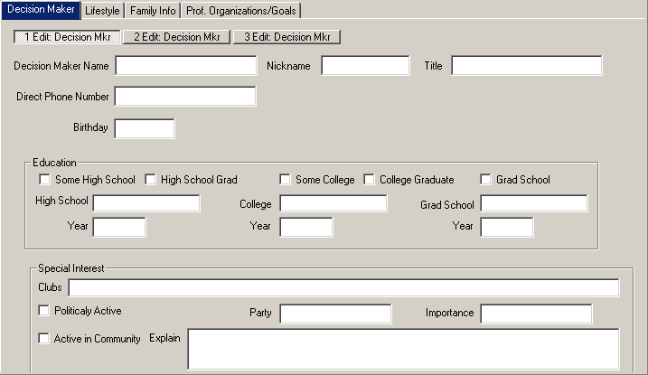
Click on the Lifestyle tab to enter information on the decision maker’s favorite restaurant, achievements and goals.

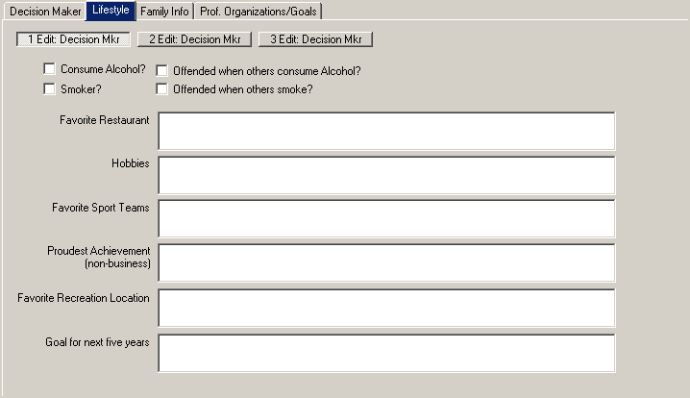

Click on the Family Info tab to enter information about the first decision maker’s spouse and children.
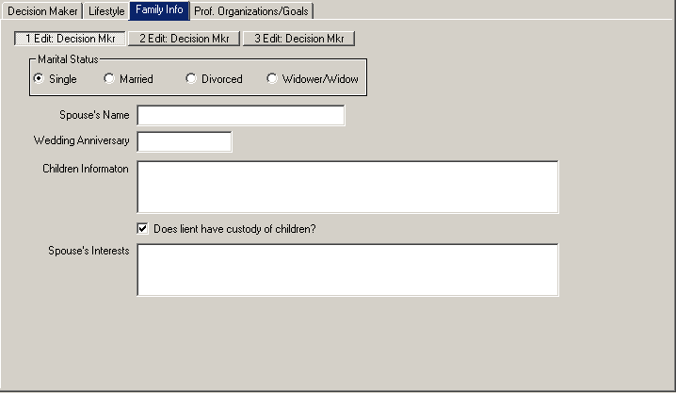

Click on the Prof. Organizations/Goals tab to enter information about the first decision maker’s involvement in professional organizations and business goals.

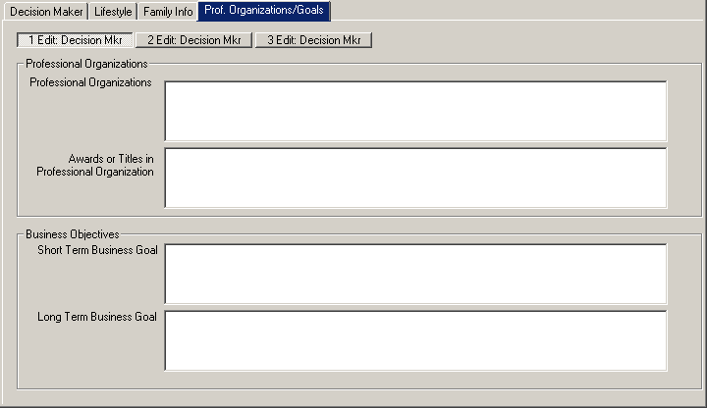

Click on the Decision Maker tab to enter information on the second and third decision maker/contact at that account, if needed.

While in the Contact Info screen, you can click on any of the 3 decision maker buttons to switch to information about that contact.

Customer Demographics
Click on the Customer Demographics and Profit Areas tab to enter information about customer base and profit areas for the business.
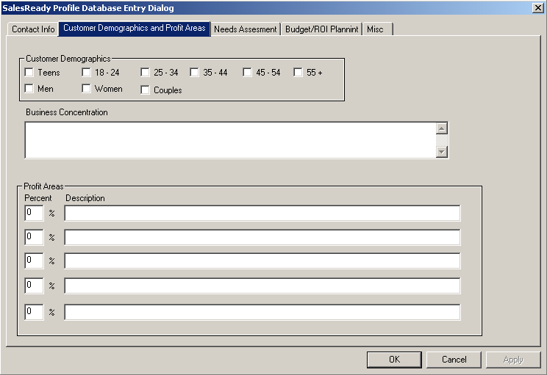

Check off the Customer Demographics that apply to the business in the top section of this page.
Enter the Business Concentration and Profit Areas that this business currently focuses on.

Needs Assessment
Click on the Needs Assessment tab to enter reasons that the customer should be advertising.
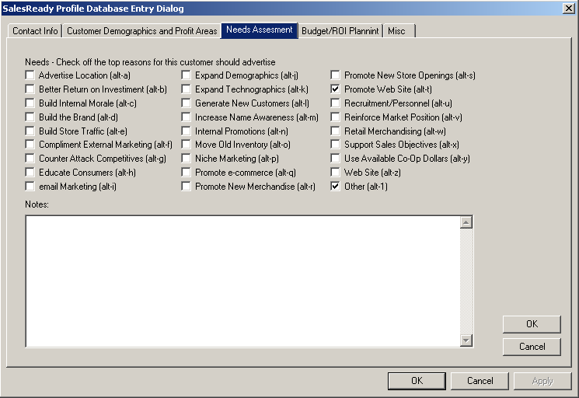

Check off as many reasons to advertise as apply to this customer, and any unique needs in the Notes entry box.
Click on the upper OK button to save the changes to this page.

Advertising Budget
Click on the Budget/ROI Planning button to enter information about the customer’s monthly and annual advertising budget.
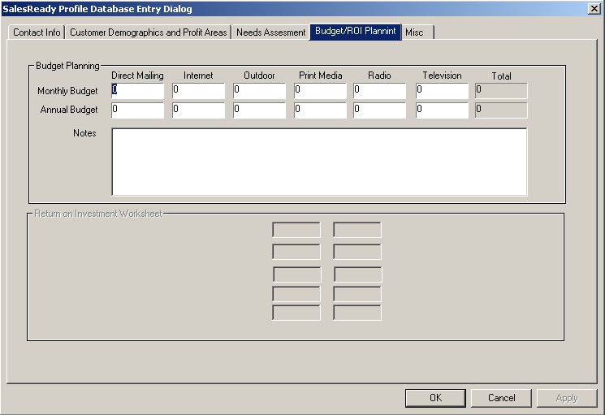

Enter in monthly values for the dollar amounts spent or available for each type of advertising. The totals will be calculated based on the values entered. Enter whole dollar amounts, without the decimal and cents.

Additional Miscellaneous Information
Click on the Misc tab to record information about traffic volume, public image, and other information that may be useful in developing a solid sales strategy for this customer.
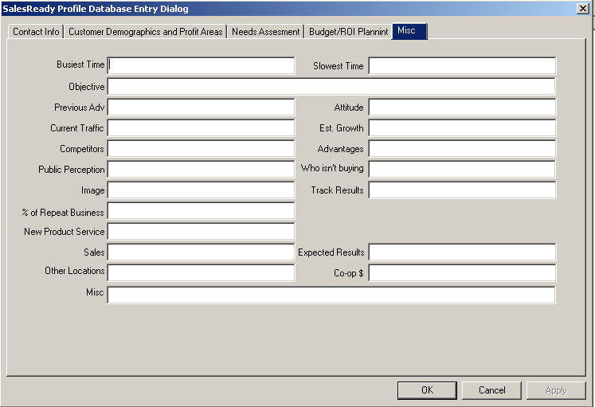

Click the OK button or strike the Enter key to close the SalesReady Profile Database Entry Dialog window and return to the Sales Entry screen.

Sales Managers: Learning the management features of the SalesReady software

Learning the extra security features of the software
Certain management buttons will need to be disabled for most account executives, but the manager needs to have a good grasp on these features of the software (you can always call 1-800-833-4459 and ask for assistance with features of the software and turning them on and off for specific users). Specific features allowed for managers only include:
- Rep management
  - Adding new reps to the system (new hires)
  - Generating reports to keep on top of your team and your sales
- Event management
  - Event editing buttons
  - Adding a new event
- Additional management tools
  - Pitch delete
  - Mass update (database)
  - Protect buttons

AE Mode—SalesReady was designed for many purposes. One of the most common ways it has been used thus far is for telesales. With a dynamic database at your fingertips, you can track as little or as much information as you need. For Account Executives, we have what we call AE Mode. This mode enables some extra buttons, but more importantly, it lets the sales manager control the software in more ways.

Color Coding--One of the most helpful features we’ve added is as simple as color coding. Deals that are accepted turn green; deals that are rejected turn red. In one simple glance, you can see the sales history of any client and instantly know what worked and what didn’t. The same goes for events. You can plan your sales events and one glance at the screen tells your AE’s what events are sellable and what events are on the air.

Account Executive management: Adding reps names & updating monthly goals or quotas
As a sales manager, you put much of your focus into monthly sales goals or quotas for your account executives. You will hold them accountable and you expect them to take the recommended goals seriously. SalesReady® makes it easy to update those goals and, at the same time, motivates your account executives to hit those goals.

The Edit Sales Reps menu item is configurable so that only the management has access to the rep names and quotas. This menu item can be grayed out for account executives and enabled for managers in the user.ini. See Configuring Security Settings section in this manual for instructions.

Begin by clicking the yellow Sales button (alt-9 on your keyboard).
Go to the SalesReady32 menu on the left side of the screen. The drop down menu includes a choice called Edit Sales Reps. See the diagram below to find the SalesReady32 menu as well as the Edit Sales Reps drop down option.

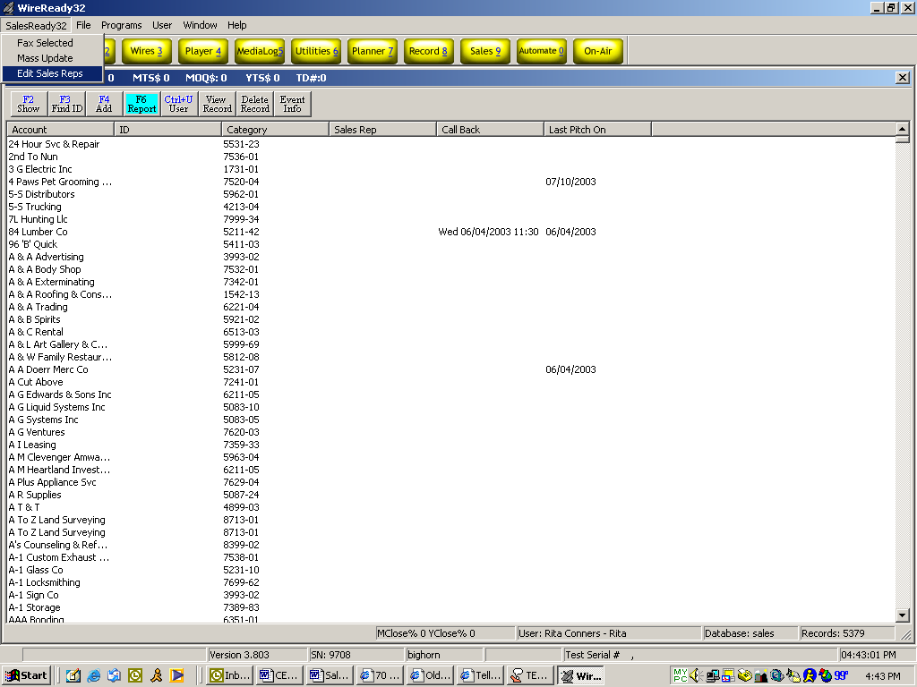

Upon choosing Edit Sales Reps, a separate dialog box opens giving a manager the opportunity to assign month-by-month goals, as well as add new rep names to the system for login purposes. See the diagram on the following page.
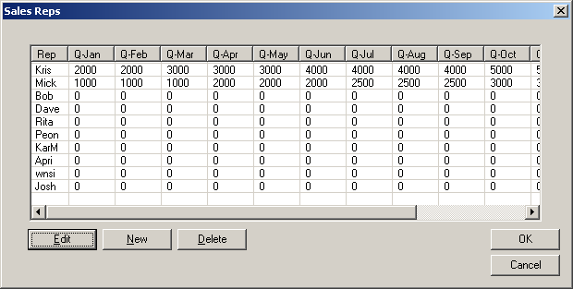
Click on the New button to add a new rep name. You are limited to 4 characters, no spaces in the first box. Tab through the remaining boxes to add information as you see fit.

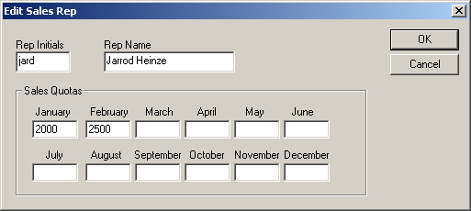
Click OK to exit the Edit Sales Rep box back to the Sales Reps box. Again click OK to exit back the SalesReady® database.

Call WireReady if you have special permissions or restrictions for your new user(s), or if you have multiple databases. Multiple databases require a different type of login setup and the instructions for these same actions are different. 800-833-4459.

Account Executive management: Generating reports to monitor your team and your sales

Quota Period Reports: Comparing monthly sales goals to actual sales totals
To generate a Quota Period Report, click the F6 Report button. Then choose Quota Period Report from the list of reports. See the diagram below:
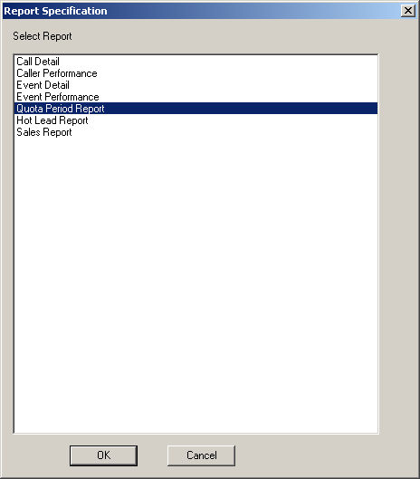

Next you must choose the month and year in which you would like to view results.

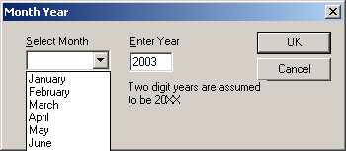

A message appears that informs you that the report has been generated and is in your “Personal” folder. Refer to the section, Finding the reports you have generated in this manual. An example Quota Period Report follows below.

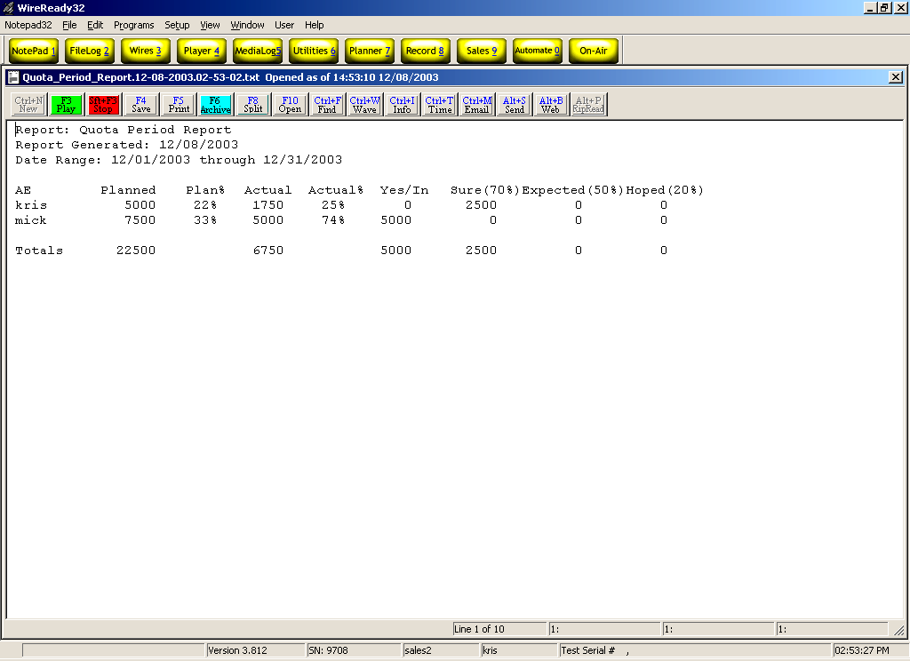

- The “Planned” column reflects the goals that you have set for your AE’s.
- The “Actual” column reflects the possible sales for the month, according the logged deals and their expectations (Sure, Expected & Hoped For).
The “Actual” amount will be the dollar amount entered, multiplied by the percentage of the choice (in the above display, $2500 x 70% = $1750. If there were amounts in the Expected and Hoped columns, they would be multiplied by their percentage and added to the Actual column)
- The “Yes/In” column reflects the sales that have been closed. Reminder: This is not a billing system, so you cannot rely on SalesReady reports for commissions.

Hot Lead Reports: Quick view of all the leads for the entire department
To generate a Hot Lead Report, click the F6 Report button. Then choose Hot Lead Report from the list of reports. See the diagram below:

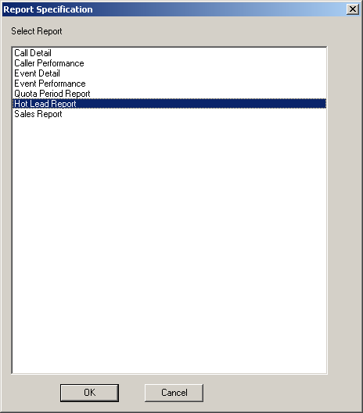

Next you must choose the month and year in which you would like to view results.

Choose your rep, and then choose the activity for which you want to view the leads. (regular advertising, NTR events, etc.)
This report lists all the leads any rep is negotiating in whatever events you chose. The hot leads are sorted first by the likelihood of close (sure’s at the top, then expected’s, lastly, hoped for’s), and then by date. As a manager, you can then focus on the most pertinent deals and find ways to close them by the expected close date.

Also, at the bottom of the list is a summary of how this rep compares to his/her quota for the month, but not a comparison to other reps. See the diagram below for an example Hot Lead report:
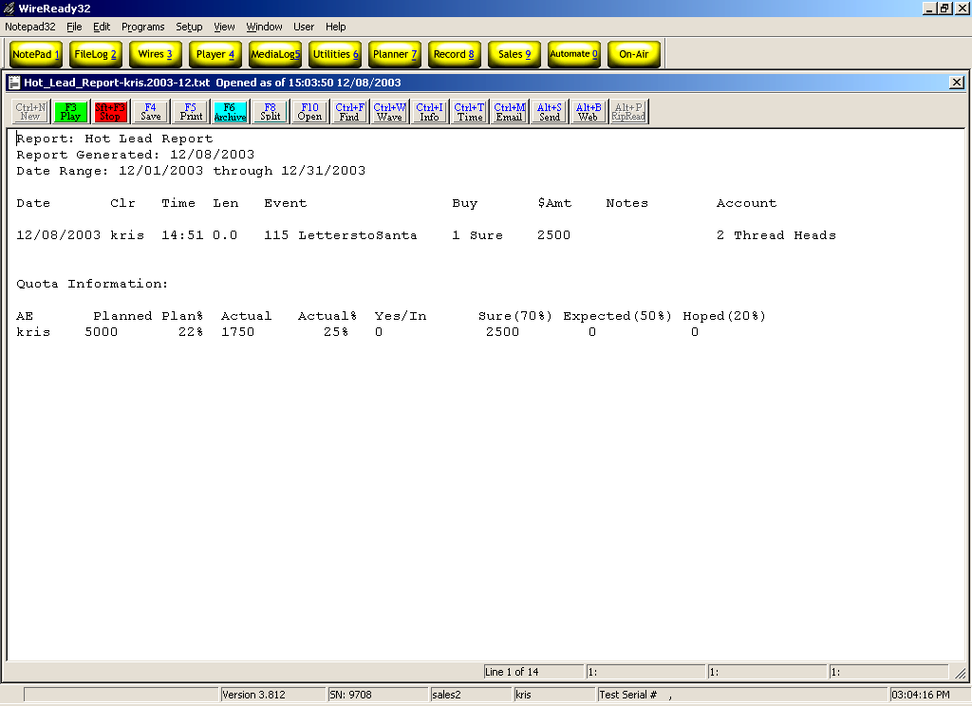

Sales Report: All the sales ever closed by any rep
To generate a Sales Report, click the F6 Report button. Then choose Sales Report from the list of reports. See the diagram below:

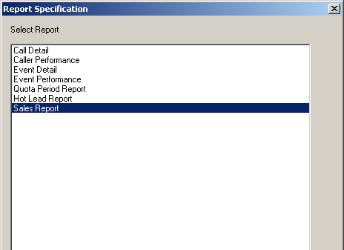

The report simply lists the closed deals and the total sold at the bottom. See below:
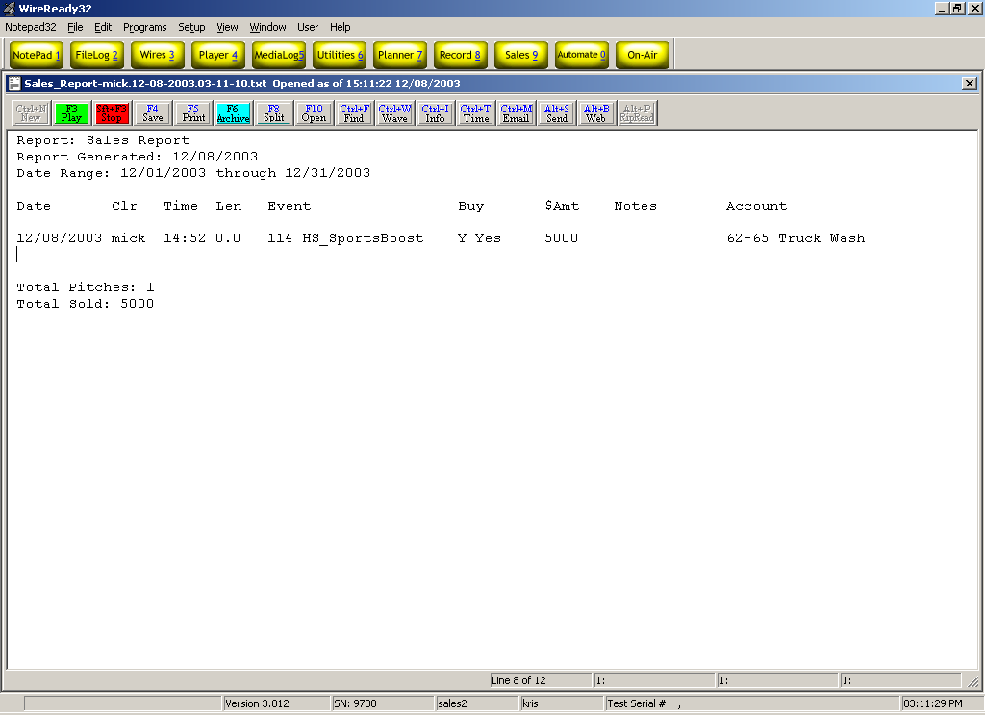

Finding the reports you have generated:
When you generate a report, a message appears that informs you that the report has been generated and is in your “Personal” folder. You must now navigate to the Personal folder in order to view the report.

First click OK on the message that tells you to view your Personal folder.
Next click on the yellow Filelog2 button at the top of your screen. See the diagram below to find the Filelog2 button.

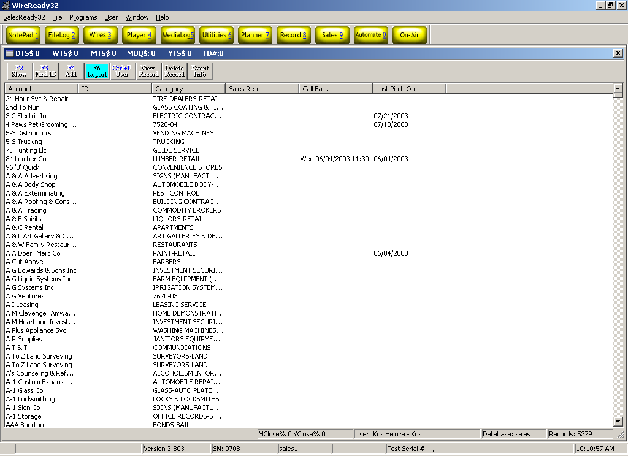

From the Filelog, click the Ctrl + L Select button to choose from a list of folders. See the diagram below to find the Ctrl + L Select button.

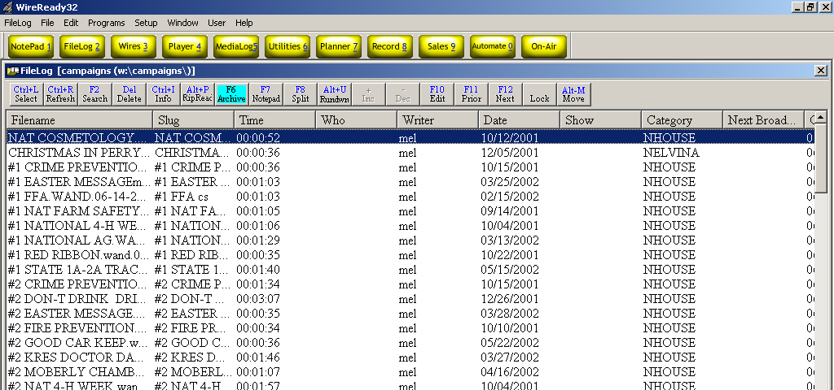

Click on the Personal button. See the diagram below to find the Personal button.

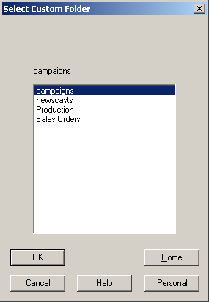

Now your list of reports appears in the Filelog. Double-click the top report to view the latest report that was generated. If the report you recently generated does not appear at the top of the list, click the Ctrl + R Refresh button to redraw the list of reports. Now your report should be listed at the top of the screen. Double-click to open the report, and hit the Esc key to close the report when you are done viewing.

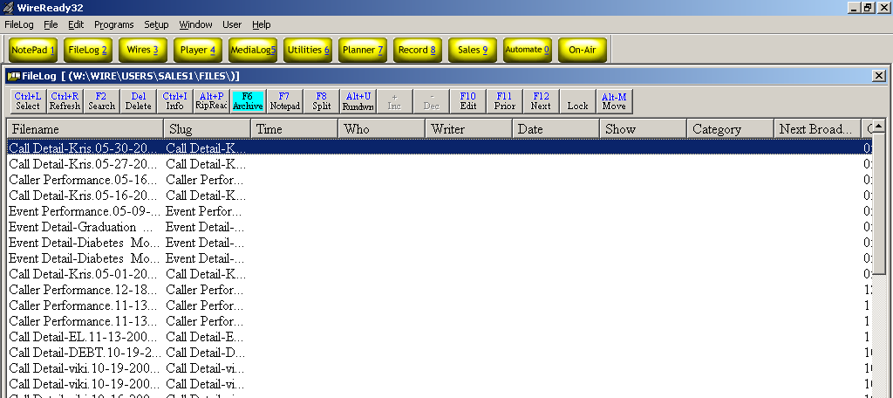

Event management: Event editing buttons
You can edit the information listed in the Event Detail at any time for any event. Click on the Event Info button. See the diagram below:

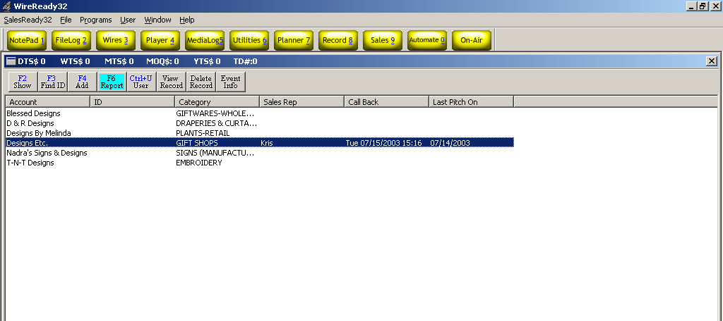

In the Event Detail screen, click once on the number 1 in the number column, and then type the number of the event you wish to modify. You can also scroll the through the list if you do not know the number of the event. Click on the line to select it. While the event line of the event you wish to modify is highlighted blue, click the Edit button. See the diagram below:

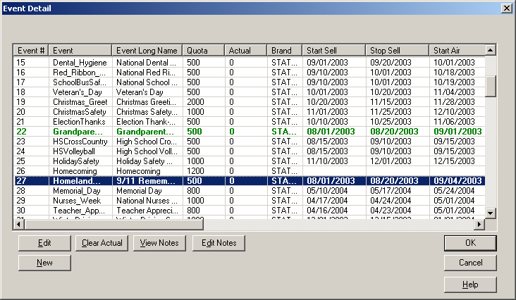

In the following box, tab through the fields until you arrive at the field you wish to modify. Make your changes and click OK. See the diagram on the following page:

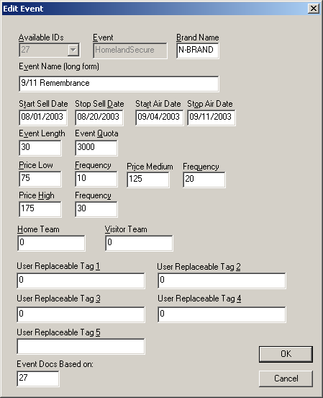

You can also edit the notes associated with that event, clear the actual sales totals listed, or add a new event from the Event Detail information window.

Event management: Adding a new event
Adding a new event to this list of possibilities is similar to editing event properties.

Step 1: The Event Detail screen
Begin by clicking on the Event Info button to bring up the Event Detail screen.

Step 2: The New Event dialog window

Start by selecting a number for your new event. SalesReady® assigns unique numbers to each event.
Tab to enter the short name of the new event. Event names cannot exceed 15 characters, and cannot contain spaces. (You may use the underscore (_) to separate words in the event name text box).

Tab to go to the next text box labeled Brand Name. Here you may enter information about your station or cluster. Again, there are no spaces allowed here.

Tab to the Event Name (long form) text box. Here you may write out the name of the event as you wish it to appear. Use Capital letters and full words…no abbreviations.

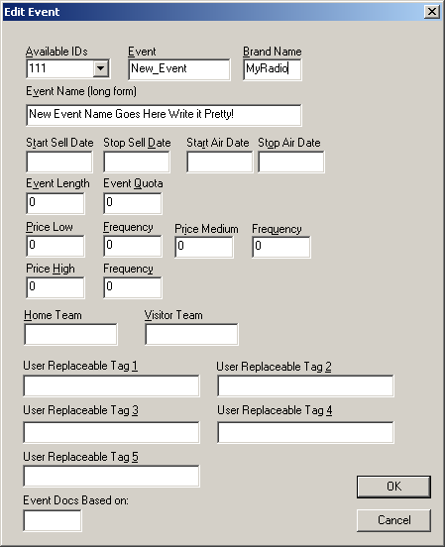

Keep tabbing through this dialog box where you will be given opportunities to enter Start and Stop Sell Dates. The next tab is Start and Stop Air Dates.

The next tab is the length of the event sponsorship. This is the number of seconds the message will be. Enter as whole numbers with no punctuation (15, 30, 60, 90, etc).

The next tab is the Event Quota (this is for the entire department to achieve together).

Now enter the pricing packages: low, medium and high, each with frequency (frequency is the number of mentions the customer gets for the price).

Click the OK button to save this information.

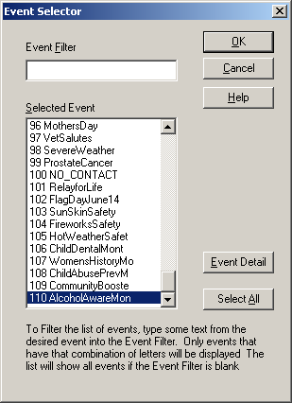
Additional management tools: Pitch delete
Once in awhile, an AE will make a mistake and log a yes when they didn’t mean to. Yes pitches cannot be changed. As the manager, you are responsible for correcting the mistake. In addition, you are the only member of the team that has the button to do this task.

To delete a pitch, you must first open the account that contains the mistake.
Select the incorrect pitch by clicking once on the date listed in the Sales History window.
Click on the Delete Pitch button in the lower left corner of the screen. See the below:

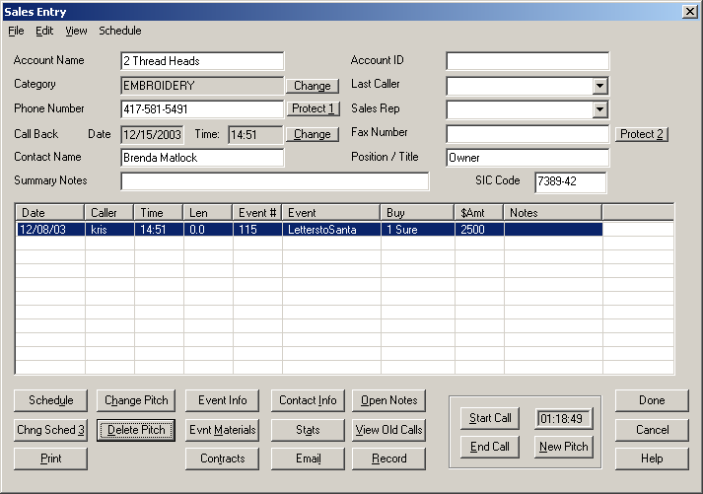

The system will ask you if you are sure you want to delete this pitch, you must verify by clicking Yes, before the pitch will disappear from the Sales History for this account. The amount entered for that pitch will be subtracted from the rep’s statistics listed at the top of the Sales screen.

Additional management tools: Mass update (database)
The Mass Update tool quickly and easily modifies large amounts of information, spread across many accounts, in your database. The Mass Update tool is extremely useful for assigning reps to particular accounts, updating an area code change in particular phone numbers, or even scheduling a mass pitch for all your reps. The Sales Manager should be the only person who has the Mass Update menu item enabled. It should be grayed out for all other users.

To find the Mass Update tool, double-check that you are viewing the sales database.
At the top of your screen, there is a menu named SalesReady32. When you click on this menu, the drop down list includes the Mass Update tool. See the diagram below:
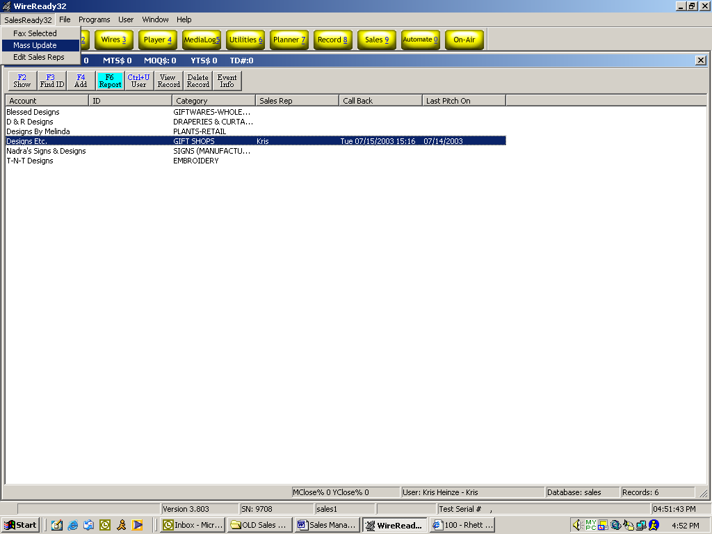

There are 5 ways you can mass update the database. Choose from the list. Follow the directions from that point to finish the task. See the diagram below:

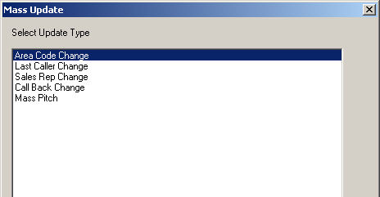

Note: the database will be automatically backed up before the Mass Update is performed.

Additional management tools: Protect Buttons
(Do Not Call Requests, Bad Telephone Numbers and Protected Accounts)
The 2 Protect buttons enable a manager to block the telephone and fax number on any particular account so that AEs cannot call those blocked accounts.

Software can be configured to let the AEs view blocked accounts, but with a warning message that explains the account is blocked and there is no access to it…
OR
Configured to make the blocked accounts “disappear” from the database (the manager can still view blocked accounts).
Call our 800 number for help configuring viewing blocked accounts.

When you wish to block an account, you simply click the Protect button near the phone number or fax number, depending on which you wish to block. A box pops up with 3 reasons for blocking this number, you must click the radio button that corresponds with your reasoning. See the diagram on the following page.
- Do Not Call: If the customer has requested not to be called the sales rep who owns the account can still access and view the account, but all others will be locked out. The account turns red to signify it’s been blocked. This can also be configured to disappear from the database, so it doesn’t get in anyone’s way.
At the end of the year, the blocked numbers can be viewed again, so that information can be updated.
- Bad Number: If the number if a bad or disconnected number, the sales rep who owns the account can still access and view the account, but all others will be locked out. The account turns red to signify it’s been blocked. This can also be configured to disappear from the database, so it doesn’t get in anyone’s way.
At the end of the year, the blocked numbers can be viewed again, so that information can be updated.
- Protect: If the number is protected, the sales rep who owns the account can still access and view the account, but all others will be locked out. The account turns red to signify it’s been blocked.

Note: The telephone number will appear in the Old Call window with the date it was blocked, when the number is marked with Protect, Bad Number or Do Not Call.

Configuring Security Settings

The security settings are set for the “workstation” or “user”, depending on how the AEs and TeleReps log into SalesReady.
In Workstation mode, the user is already set in the shortcut to SalesReady, and a user name and password are not required.
In Secure User mode, SalesReady requires a workstation login and a secure user name and password. (the workstation login is still set in the desktop shortcut)

To configure the Edit Sales Rep or Mass Update menu item for manager use only:
This action must be done for the user.ini file:
- From the desktop, double-click on the My Computer icon.
- Double-click the server drive containing the SalesReady® software. ( w: )
- Double-click the Wire folder.
- If using workstation mode, double-click the User folder. If using secure mode, double-click on the Login folder.
- Double-click the folder for the user you wish to update.
- Open the user.ini file (ex: bob.ini)
- Find the [Sales] section of this file
- Find the line that reads: SalesAllowRepViewDialog=yes or no
  - Yes enables the feature for the manager’s user.ini.
  - No grays out the option for the account executives.
- Find the line that reads: AllowSalesMassUpdate=yes or no
  - Yes enables the feature for the manager’s user.ini.
  - No grays out the option for the account executives.
- Repeat these steps to update each user.ini file

To configure the settings for Event Materials:
In Event Materials, there is a Notes button that can be used to add notes to an event and an Edit Selected button for the ability to edit or make permanent changes to the event documents.

This action must be done for the user.ini file. Follow the above instructions to open and edit the user ini files.

Find the line that reads: SalesAllowItemsDlgEditBtn=no or yes
  - Yes enables the features for the manager’s user.ini.
  - No grays out the option for the account executives.

To configure the settings for blocked numbers:

This action must be done from the user.ini file:
- From the desktop, double-click on the My Computer icon.
- Double-click the server drive containing the SalesReady® software. ( w: )
- Double-click the Wire folder.
- If using workstation mode, double-click the User folder. If using secure mode, double-click on the Login folder.
- Double-click the folder for the user you wish to update.
- Open the user.ini file (ex: bob.ini)
- Find the [Sales] section of this file
- Repeat steps below for each user that needs configuration

To make the blocked accounts disappear:
Find the lines named: ViewDNCAccounts=, ViewBadTelephoneNumbers=, and ViewProtectedAccounts=. They should all be set to “no” or “false” if you do not want the accounts to appear for this user.

Setting these lines to “yes” or “true” causes the accounts to be viewed as usual (except the phone numbers will display as 000-0000, 111-1111, or 222-2222).

Example:
Manager Configuration: User Configuration:
SalesViewBlockedNumbers=true SalesViewBlockedNumbers=false
ViewDNCAccounts=true ViewDNCAccounts=false
ViewBadTelephoneNumbers=true ViewBadTelephoneNumbers= false
ViewProtectedAccounts=true ViewProtectedAccounts=false
LockoutBadNumber=false LockoutBadNumber=true
LockoutProtectedNumber=false LockoutProtectedNumber=true
LockoutDNCNumber=false LockoutDNCNumber=true

To lockout the blocked accounts:
Find the lines named: LockoutDNCNumber=, LockoutBadNumber=, and LockoutProtectedNumber=. They should all be set to “yes” or “true” if you do not want the accounts to be viewed except by the owner. All others will see a red colored listing and will be restricted from viewing any information about that account.

Setting these lines to “no” or “false” causes the accounts to be viewed as usual (except the phone numbers will display as 000-0000, 111-1111, or 222-2222).

See the above Example.

To restrict other settings to sales manager use only:
AE’s or telesales reps should not be able to delete pitches, change the sales rep assigned to the account, or edit events.

These settings can all be edited in the Setup32 configuration utility. If you have a shortcut to this program, just double-click to start the software and skip to the diagram.

- From the desktop, double-click on the My Computer icon.
- Double-click the server drive containing the SalesReady® software. ( w: )
- Double-click the Wire folder.
- Double-click the INSTALL folder.
- Double-click the file: setup32.exe.

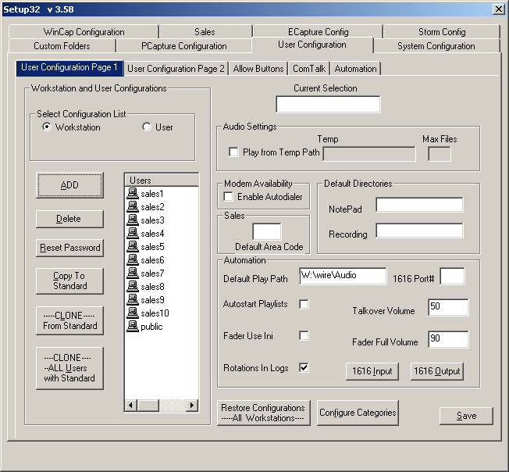

Click on the User Configuration tab to get started.
Choose the Workstation radio button In Select Configuration List if in Workstation mode, or User if using Secure User mode, and then click on the Allow Buttons tab.
See the diagram on the following page for the Allow Buttons configuration page.

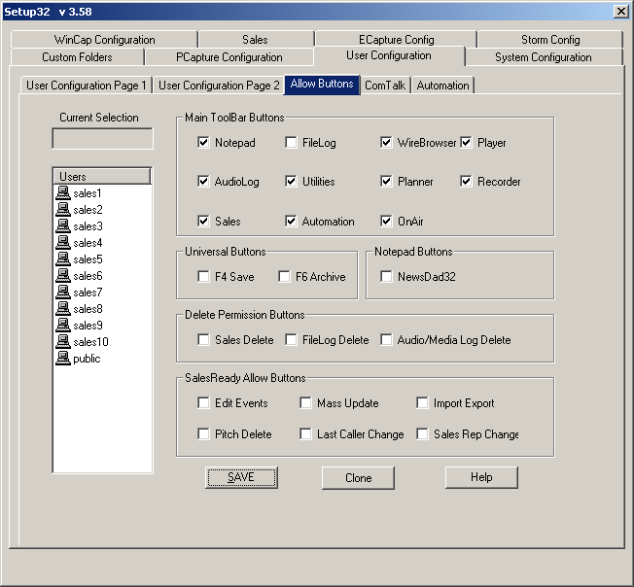

For each user that you select on the left side of the screen, you must:
- Check or un-check the buttons that correspond to software features that you want available or not available. Example: Sales Delete and Pitch Delete would not be checked for AE’s or telesales persons, but would be checked for sales managers.
- Remember to click the Save button when you have completed configurations for one user, before you move on to the next user that you want to configure settings for.

Appendix A: Quick synopsis of each button and menu item in SalesReady

Database Window
To get to the SalesReady Database Window, you must first start the WireReady software from the computer desktop, login, and then click on the yellow Sales-9 button at the top right of the screen.

Button Name: F2 Show
Function: Standard window button
Use: To sort or organize the entire database or narrow the database to a manageable list of accounts. Lists can be sorted by city, category, zip code, total amount bought, callbacks scheduled…just about any sort parameter you would need.

Button Name: F3 Find ID
Function: Standard window button
Use: To quickly find a particular account(s) using an ID number only. Unique ID numbers have to be assigned account-by-account before the search can be utilized.

Button Name: F4 Add
Function: Standard window button
Use: To enter a new account to the database.
Recommended Users: The Sales Manager

Button Name: F6 Report
Function: Standard window button
Use: To monitor sales progress or event progress using software-generated reports. Reports can be generated on one caller, all callers, one event, all events, monthly sales, or leads. Instead of gathering this information by hand, the software tracks it for you and bundles it into a summarized report.

Button Name: Ctrl + U User
Function: Standard window button
Use: To switch 4-letter rep name without exiting the WireReady software entirely.
Pro: A manager can login as a AE to correct a pitch that was logged incorrectly.
Con: This button cannot be used to switch between secure logins (with passwords); only switches between 4-letter rep names.
Recommended Users: The Sales Manager

Button Name: View Record
Function: Standard window button
Use: To open or view any particular account window. This same function is more commonly performed by double-clicking the account name.

Button Name: Delete Record
Function: Configurable (grayed out if disabled) for added security
Use: To delete an entire account from the database.
Pro: To clean out any extraneous records that were added.
Con: We recommend NOT deleting records for several reasons.
- Deleting a record that has been called upon erases sales history and alters reports
- Deleting records interferes with yearly database updates provided by WireReady. It is possible to end up with that account again anyway when the database it updated if you have deleted it in the past.
Recommended Users: The Sales Manager ONLY

Button Name: Event Info
Function: Standard window button
Use: To organize, plan and schedule events in the system in an easy-to-use interface. Managers can also add new events at this location. Not only does this window help keep a manager on top of his/her duties, it can be used as a communication tool between AE’s and their manager because of the color-coding that indicates when an event is selling and when it is airing. Managers can also take notes in the Event Info window about events, for their own use, or take notes to be used in communication with AEs.

Button Name: List
Function: Standard window button
Use: To allow users to create a list of accounts to be printed or saved to a file. For calling lists, mailing labels and on-screen information capture. You may export the information from the database either to file or directly to printer.
Recommended Users: Any AE or Sales Manager

Sales Entry Window
To get to the Sales Entry Window, you must first view an account record by double-clicking the account name or clicking the View Record button.

Button Name: Schedule
Function: Standard window button
Use: To schedule meetings or negotiations (track sales leads). This is typically used by an account executive, rather than a telesales rep. If an account executive spends just a few minutes per day entering their negotiations, a sales manager can quickly review the deals happening and help facilitate a sale.
Recommended Users: Account Executives

Button Name: Chng Schedule 3
Function: Standard window button
Use: To update records of negations or change the pitch on a previously schedule negotiation. This is a way to track the on-going communications/ relationship between the salesperson and the client.
Recommended Users: Account Executives

Button Name: Print
Function: Standard window button
Use: To print one account’s information, event history, notes or old calls. AEs can print out this information to take with them on the street.
Recommended Users: Account Executives

Button Name: Change Pitch
Function: Standard window button
Use: To update a previous Undecided pitch to Yes or No. The goal is to follow up on all those Undecided calls and persuade the client to go one way or the other. No money should be left on the table at the end of the month.

Button Name: Delete Pitch
Function: Configurable (no button at all if disabled) for added security
Use: To delete a pitch (usually a mistake or a client changed decision)
Pro: The manager can remove pitches that were entered incorrectly, or sales pitches that that were not real sales, from the history of that account.
Con: Access to this button will allow the user to delete any pitch. This could be used to delete real pitches or sales and affect the records of activity on an account or by a AE.
Recommended Users: The Sales Manager ONLY

Button Name: Event Info (first explained above)
Function: Standard window button
Use: To organize, plan and schedule events in the system in an easy-to-use interface. Managers can also add new events at this location. Not only does this window help keep a manager on top of his/her duties, it can be used as a communication tool between AE’s and their manager because of the color-coding that indicates when an event is selling and when it is airing. Managers can also take notes in the Event Info window about events, for their own use, or take notes to be used in communication with AEs.

Button Name: Evnt Materials
Function: Standard window button
Use: To access event documents such as ad copy forms, broadcast order-forms, faxable brochures/flyers, invoices or any other document that might be needed when finished or negotiating a sale.

Button Name: Contracts
Function: Standard window button
Use: To launch production forms, contracts or event forms
Recommended Users: Account Executives

Button Name: Contact Info
Function: Standard window button
Use: To view account address and email address information

Button Name: Stats
Function: Standard window button
Use: To access sales history information about that account. Lists (in a summary bulleted list): total number of calls, total number of pitches, total number of buys, close ratio, max $Y pitch, min $Y pitch, total $ bought, $ earned/ call, total busy attempts, total not in attempts, total answering machine attempts.
Recommended Users: The Sales Manager

Button Name: Email
Function: Standard window button
Use: To send customer contact information to a selected email recipient. User simply clicks the email address to where he/she wishes to send email to, and chooses the destination folder.

Button Name: Open Notes
Function: Standard window button
Use: To view account notes written by anyone who has happened to call on this account. Any complicated issues or preferred ad copy can be stored in notes for future reference.

Button Name: View Old Calls
Function: Standard window button
Use: To view sales history past the calls that fit into the sales history window that is already visible. This holds all the past calls that don’t fit into the window. Sales History helps when figuring target categories or businesses for a particular event. If the customer has purchased or not purchased similar types of events in the past, it could affect whether this customer is called when time is crunched.

Button Name: Record
Function: Standard window button
Use: To open a blank *.wav file for recording audio over the phone or through a microphone. Customized commercials or interviews can be conducted through the telephone and recorded from SalesReady. This is the same as using the “Record 8” button from the main WireReady32 button bar.

Button Name: Start Call
Function: Standard window button
Use: To open the auto-dialing window and start the call timer. Autodialing saves wear on the AE and initiates a call timer for tracking the outcomes of calls.

Button Name: End Call
Function: Standard window button
Use: To stop the call timer after the Start Call button has been used.

Button Name: New Pitch
Function: Standard window button
Use: To open call log window. The New Pitch window is the launch pad for everything a AE might log as the result of a call—the event pitched, the buy, the dollar amount, set a callback, take notes, and open event materials.

Button Name: Done
Function: Standard window button
Use: To finish/ save work on a particular account and let the software officially close the account. Even when no changes are made, the Done button needs to be clicked.

Button Name: Cancel
Function: Standard window button
Use: To exit an account without saving any changes. This button should only be used when changes have been made that the user is sure does not need to be saved. When closing an account, it is best to use the Done button.

Button Name: Help
Function: Standard window button
Use: To open the help website. The Help buttons are not supported at this time.

Button Name: Change (town or category)
Function: Standard window button
Use: To change the sort specification associated with a particular account. If a business category or town location changes, the user can update that label with the Change button. This button will be used to assign a category or town when first adding new records.
Recommended Users: The Sales Manager

Button Name: Protect 1 (Phone Number)
Function: Standard window button
Use: To block a phone number from regular use by labeling it with Do Not Call, Bad Number, or Protect.
Pro: Blocking a number prevents AEs from calling on that customer. Software should be configured so that everyone can see the blocked accounts but cannot access them.
Con: As long as they AE can view the account (with no access), he/she will not try to add it back into the database.
Recommended Users: The Sales Manager

Button Name: Change (callback date)
Function: Standard window button
Use: To change the callback date/time set for that account.
Pro: When a callback has been set, and a AE makes an attempt to follow up, only to find the decision maker is still not available, he/she may wish to simply change the callback date for further into the future. After a call back to the account has occurred, this button can be used to clear the call back date and time.

Button Name: Protect 2 (Fax Number)
Function: Standard window button
Use: To block a fax phone number from regular use by labeling it with Do Not Call, Bad Number, or Protect.
Pro: Blocking a number prevents AEs from faxing that customer. Software should be configured so that everyone can see the blocked accounts but cannot access them.
Con: As long as they AE can view the account (with no access), he/she will not try to add it back into the database.
Recommended Users: The Sales Manager

Event Materials Window
To get to the Event Materials Window, you must first view an account record by double-clicking the account name or clicking the View Record button. For ease of use, you can find the Event Materials button in 2 different places. From the Sales Entry window, there is an Event Materials button, and also in the New Pitch window there is an Event Materials button. The most common way to get to Event Materials is through the New Pitch window.

Button Name: Launch
Function: Standard window button
Use: To open an event materials document (brochure, invoice, etc) so that it auto-grabs the contact information and event information for the customer and event you choose. This technology utilizes WireReady tags embedded into template event materials documents. Each time the template is Launched for a particular customer, it is customized automatically to save AE time. The AEs name is automatically entered as a salutation; there are very few edits the AE must perform before sending out the document.

Button Name: Cancel
Function: Standard window button
Use: To close the Event Materials window without opening any documents.

Button Name: New File
Function: Standard window button
Use: To insert a new blank document into an existing event folder. When creating an entirely new document, this button ensures that the document rests in a location where it can be found easily using SalesReady software.
Recommended Users: The Sales Manager

Button Name: Edit Selected
Function: Configurable (grayed out if disabled) for added security
Use: To edit or make permanent changes to the event document template.
Pro: Each time an event is sold each year, the template usually needs to be edited to reflect changed dates or updated ad copy. NOTE: If you are using the starter pack of events provided by WireReady, titles and event packaging does not need to be altered on the document template because it is housed in the Event INFO Screen instead.
Con: The user must be careful not to accidentally delete an entire WireReady tag or part of a WireReady tag, otherwise the requested information will not auto-fill correctly when the document is launched by a AE. Documents cannot be edited if they don’t exist to begin with.
Recommended Users: The Sales Manager

Button Name: Help
Function: Standard window button
Use: To open the help website. The Help buttons are not supported at this time.

Button Name: Event Info 1
Function: Standard window button
Use: To organize, plan and schedule events in the system in an easy-to-use interface. Managers can also add new events at this location. Not only does this window help keep a manager on top of his/her duties, it can be used as a communication tool between AE’s and their manager because of the color-coding that indicates when an event is selling and when it is airing. Managers can also take notes in the Event Info window about events, for their own use, or take notes to be used in communication with AEs.

Button Name: View Notes
Function: Standard window button
Use: To view notes edited by a manager about a particular event. Notes can be used to remember how an event performed from one year to the next. Notes can also be used to inform callers of extra information that would be helpful in making a sale.

Button Name: Edit Notes
Function: Configurable (grayed out if disabled) for added security
Use: To edit/add notes about a particular event.
Pro: Notes can be saved to remember how an event performed from one year to the next. Notes can also be saved to inform callers of extra information that would be helpful in making a sale.
Con: A user could change the information in this field, and assign the good accounts to himself, or remove notes the management added about the event.
Recommended Users: The Sales Manager

Button Name: Launch As Form
Function: Standard window button
Use: To open an event materials document (brochure, invoice, etc) so that it inserts blank lines where it normally would have auto-grabbed the contact information. This “blank” document can then be photocopied to be used as template hard copy.

Button Name: Copy As Template
Function: Standard window button
Use: To copy an event materials document (brochure, invoice, etc) template to another event folder.
Pro: When you add a new event, and you have a master template saved, or just have another event document that would be similar to what you want for your new event, use the Copy Template as a starting point. Copy the similar template to the new folder, and then make just a few edits to the new document instead of starting from scratch.
Con: You cannot copy a document to a new folder if that folder does not already exist. See the handbook to learn how to add a new event folder each time a new event is added to the system.
Recommended Users: The Sales Manager

Button Name: Print ALL as Form
Function: Standard window button
Use: To print all the event materials documents (brochure, invoice, etc) in a particular folder so that it inserts blank lines where it normally would have auto-grabbed the contact information on each document printed from the folder. This would be most often utilized to gain hard copy of all documents to work with for any event. If you need a copy of one or two documents, print each document separately.

Button Name: Print ALL Folders as Form
Function: Configurable (no button at all if disabled) for added security
Use: To print all the event materials documents (brochure, invoice, etc) in all of the event folders so that it inserts blank lines where it normally would have auto-grabbed the contact information on each document printed from the folders.
Pro: The “blank” documents can then be photocopied to be used as template hard copies.
Con: It takes time for the computer and printer to “spool” all the information associated with all the documents (especially because they have color graphics on them). When using this feature, the computer cannot be used for anything else until it is done spooling.
Recommended Users: The Sales Manager ONLY

