

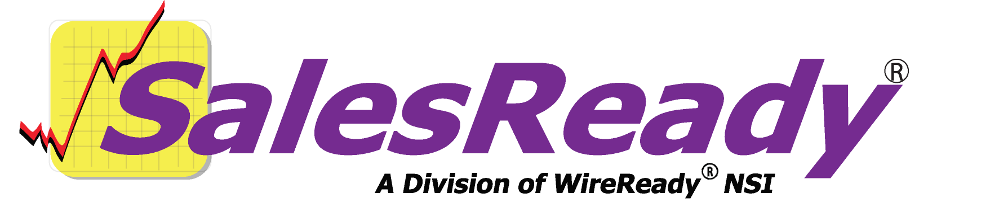
Account Executive
56 Hudson Street Northboro, MA 01532
800-833-4459 Fax: 506-393-0255
www.wireready.com
56 Hudson Street Northboro, MA 01532
800-833-4459 Fax: 508-393-0255
www.wireready.com
User Guide

Account Executives: Navigating SalesReady 4
Navigating the database to find your accounts 4
Using the Search/ Sort functions 4
Using the List button to print or view specific information for any account(s) 9
List Type 9
Source 9
Destination 9
Delimiter 9
Updating your accounts in the database to reflect your daily activity 10
Schedule button & Change Schedule button 10
1. On a new account or new deal on that account: 10
2. On an existing deal that only needs to be updated: 12
Protect Buttons (Do Not Call Requests, Bad Telephone Numbers and Protected Accounts) 14
Recording Information about the Customer contacts 15
To Access the Customer Profile page 15
Appendix A: Quick synopsis of each button and menu item in SalesReady 24
Database Window 24
Button Name: F2 Show 24
Button Name: F3 Find ID 24
Button Name: F4 Add 24
Button Name: F6 Report 24
Button Name: Ctrl + U User 24
Button Name: View Record 24
Button Name: Delete Record 25
Button Name: Event Info 25
Button Name: List 25
Sales Entry Window 25
Button Name: Schedule 25
Button Name: Chng Schedule 3 25
Button Name: Print 26
Button Name: Change Pitch 26
Button Name: Delete Pitch 26
Button Name: Event Info (first explained above) 26
Button Name: Evnt Materials 26
Button Name: Contracts 26
Button Name: Contact Info 26
Button Name: Stats 26
Button Name: Email 27
Button Name: Open Notes 27
Button Name: View Old Calls 27
Button Name: Record 27
Button Name: Start Call 27
Button Name: End Call 27
Button Name: New Pitch 27
Button Name: Done 27
Button Name: Cancel 27
Button Name: Help 28
Button Name: Change (town or category) 28
Button Name: Protect 1 (Phone Number) 28
Button Name: Change (callback date) 28
Button Name: Protect 2 (Fax Number) 28
Event Materials Window 29
Button Name: Launch 29
Button Name: Cancel 29
Button Name: New File 29
Button Name: Edit Selected 29
Button Name: Help 29
Button Name: Event Info 1 29
Button Name: View Notes 30
Button Name: Edit Notes 30
Button Name: Launch As Form 30
Button Name: Copy As Template 30
Button Name: Print ALL as Form 30
Button Name: Print ALL Folders as Form 30

Account Executives: Navigating SalesReady
This document is written assuming the user has previously learned how to start the software, and more specifically, start the sales section of the software. Basic computer operation skills are also assumed. If you are not familiar with WireReady32, consult the Community Event Coordinator Handbook.

Navigating the database to find your accounts

Using the Search/ Sort functions
The F2 Show button allows a user to display accounts based on specific criteria. See the diagram below to find the F2 Show button.

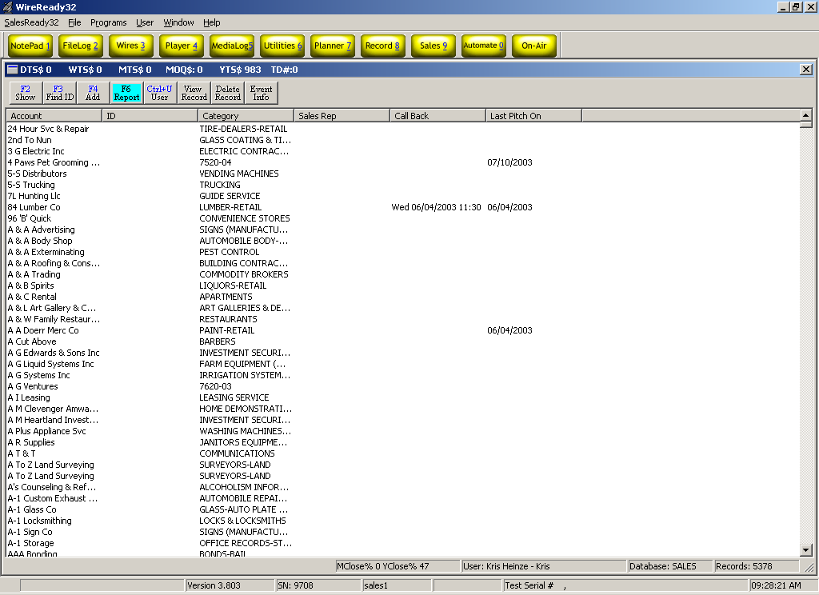

When you click the F2 Show button, SalesReady® will ask you to choose the specifications of your account sort. There are many different ways to sort the database and we will cover those methods most likely used by an account executive.

- To display a specific record or set of records, choose:
SEARCH: Show matching text…sort by…
This is the most popular way to view any account or group of accounts. Any bit of information can be used, be it the name of the account, the name of the contact person, the name of the street where the business is located or the account number that the station has assigned, the category of the business, etc.

- Double-click Show matching text…sort by…
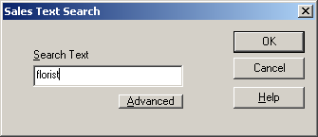
- Type in the information you want to use to find the account (typically, the fewer letters, the better), and click OK or strike the Enter key.

- Double-click your preferred sorting method for the list of accounts that will be displayed.

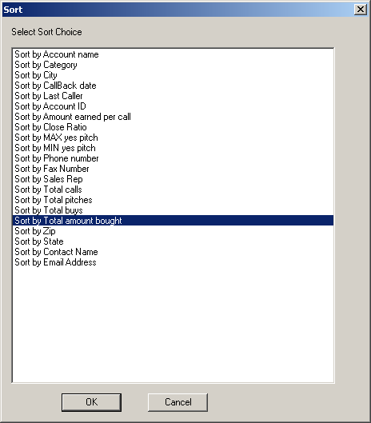

- After sorting, the SalesReady® database will display only those records including the text that was asked for. See the results below:

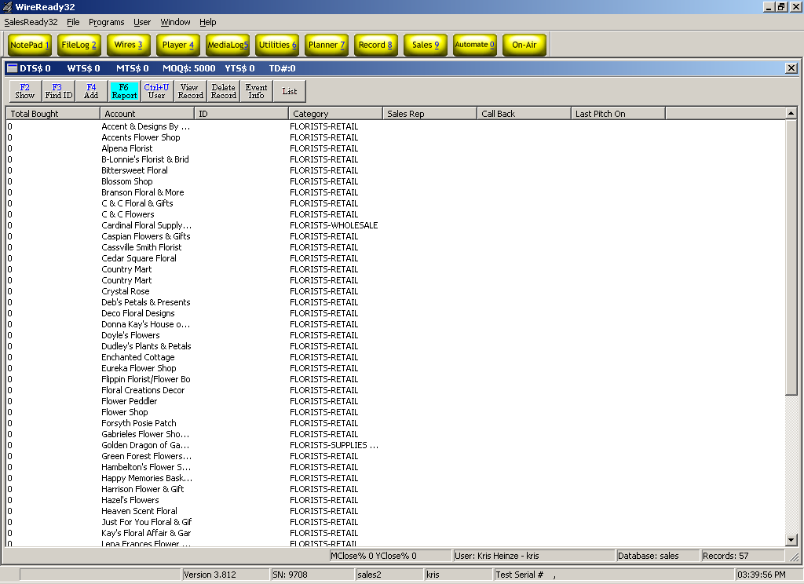

- To view all the callbacks you’ve ever scheduled, choose:
SEARCH: Show callbacks to be made from…to…for last caller
This search is good to clean up any callbacks that you have forgotten about or missed from days past. See the following diagrams to view all your past callbacks.

  - Double-click Show callbacks to be made from…to…for last caller.
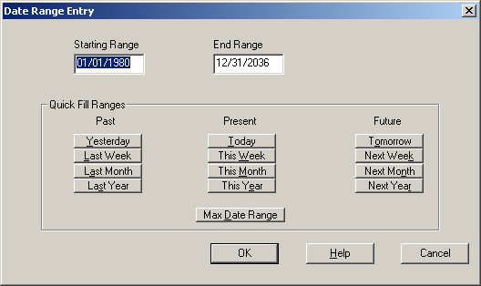
  - Choose the button Max Date Range at the bottom of the screen or choose your own preferred date range using the provided buttons or typing in a date. See the diagram on the following page:
  - Choose your name from the list of users to view your callbacks.
  - The screen will display only your callbacks yet to be made.

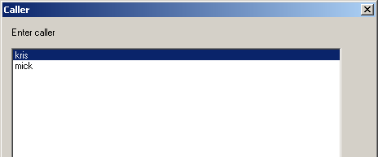

- To view your callbacks for today only, choose:
SEARCH: Show today’s callbacks for last caller…sort by…
This is the most popular callback sort.

  - Double-click Show today’s callbacks for last caller…sort by…
  - Choose your name from the list of callers.
  - SalesReady® will then refresh with the list of callbacks scheduled for today.

- To view your list of accounts and related activity, choose:
SEARCH: Show hot leads…pitched by caller…in date range…sort by…
This is a popular way to keep track of the most important negotiations you have in the works. Any account in the list can be double-clicked for a closer look at the details for that deal.

- Double-click Show HOT LEADS… pitched by CALLER…in DATE RANGE…sort by…
- Choose your name from the list of callers
- Choose your time frame (this month, next month, etc)
- Sort the list however you like (alphabetical, categorical, etc)
- The screen will refresh with all the accounts in which you have logged a lead (sure, hoped for, expected).

Using the List button to print or view specific information for any account(s)
No more waiting for the billing department to get you a list of addresses and phone numbers for your accounts. The List button allows users to create a list of accounts to be printed, saved to a file or viewed on-screen.

List Type
- Calling List: Generates a list of accounts that includes Account Name, Contact, Contact Title and Phone Number fields, sorted in the order they appear on the screen.
- Mailing Label Data: Generates a list of accounts that includes Account, Contact, Title, Address1, Address2, City, State and Zip Code fields, sorted in the order they appear on the screen.
- Current Browser: Generates a list of accounts that includes the fields currently displayed on the screen, sorted in the order they appear on the screen.

Source
- Selected Records: Uses only the records that are selected (highlighted) in the list of accounts for the output. You have the freedom to select only the records you need.
- Entire Browser: Uses all the records currently displayed on the screen in the browser for the output.

Destination
- File: The list will be created into a file that can be stored in any folder available to the user. When giving the file a name, include the extension.
- Printer: The list will be generated and sent to the printer.

Delimiter
- Space (Text Documents): The list will be generated as a text file. A choice for both File and Printer output.
- Comma (CSV/Excel Format): The list will be generated as a Comma Separated Value file. This option is only available when saving to a destination file.

See the diagram below:
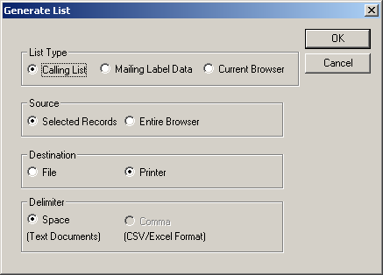

Updating your accounts in the database to reflect your daily activity
In just a few minutes per day, you can update your accounts in SalesReady. That information is then at your fingertips when you need it most.

Schedule button & Change Schedule button
When you are ready to update the activity on the deal on a particular account, you navigate the database to find that account and then double-click to open.

1. On a new account or new deal on that account:
Start by clicking the Schedule button. See the diagram on the below to find the Schedule button:
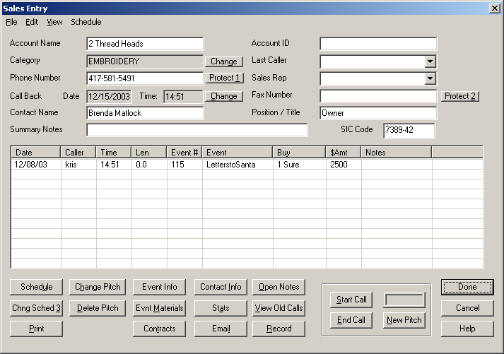

Start by entering the date that you expect to close the deal.

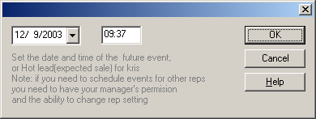

Next, enter details about the deal. The associated event or programming, the amount, your perception of the likelihood of closing the deal (hoped for, expected, sure), and set a callback date if you like. See the diagram on the following page.

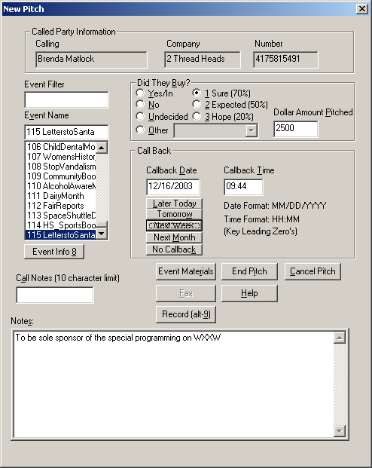

Simply click End Pitch to save your information, and then click Done to exit the customer record.

2. On an existing deal that only needs to be updated:
Start by clicking on the deal that needs to be updated. See the diagram below.

Next, click the Chng Sched 3 button to update the information for this deal.
You’ll be prompted to update the expected date of close. Use the drop down calendar to click on the date, rather than typing it into the box.
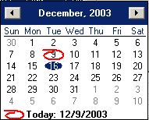

The New Pitch window will open, containing all the information you have previously entered about this deal (the event, amount, likelihood of close, callback date, etc). Update any information that needs to be updated and hit the End Pitch button. Remember to click the Done button to save the information when you exit the customer record.

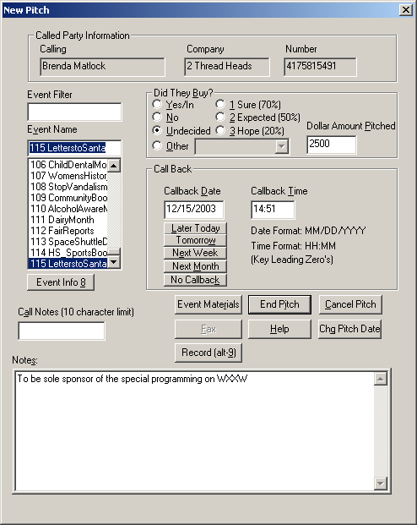

Protect Buttons
(Do Not Call Requests, Bad Telephone Numbers and Protected Accounts)

Blocking accounts is not an action to be taken lightly. If your group uses SalesReady for both Account Executives and Telesales, there may be a need to “protect” the AE accounts from being called upon by the telesales persons. The protect buttons can offer a control mechanism, but can work against you if don’t speak with your sales manager before you decide to protect an account.

The system can be configured 3 ways to handle blocked accounts.
- Accounts can be viewed by everyone, but the phone numbers will be altered depending on the type of block you put on the account.
- They can disappear entirely from the database—no one will be able to bring up that account in any search, except the sales manager.
- They can be locked out. The account will turn red in the database, and only the sales rep who owns the account will be able to view and edit it.

When you have spoken with your sales manager and are aware of the consequences of blocking an account, you may proceed.

To block an account, you simply click the Protect Button near the phone number or fax number, depending on which you wish to block. A box pops up with 3 reasons for blocking this number. You must click the radio button that corresponds with your reasoning. See the diagram on the following page.
- Do Not Call: Used when the customer has requested not to be called.
- Bad Number: Used when the phone number is known to be bad or disconnected. This is used more in telesales than anything.
- Protect: Used to restrict access to the account so that only the rep who owns it may access and edit.

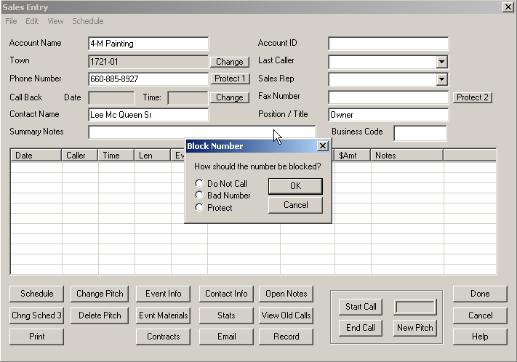

Recording Information about the Customer contacts

To Access the Customer Profile page
Open the account to add information about the business and the main contact persons.
Click on the Cust. Profile button at the bottom of the Sales Entry screen.
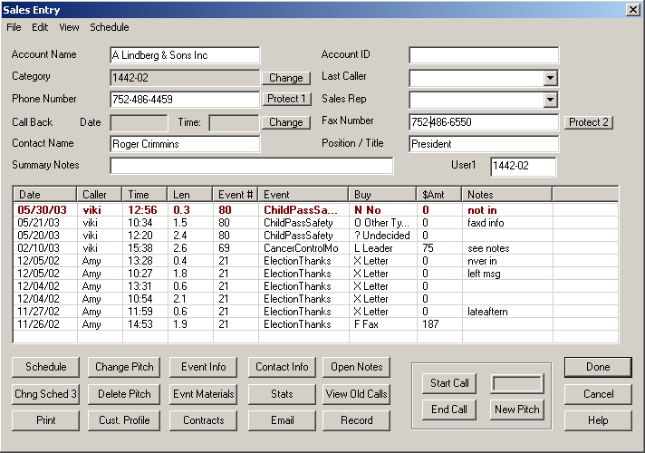

The SalesReady Profile Database Entry Dialog screen will open. This screen allows the user to enter information about the main customer contacts and decision makers for the account, along with information about the demographics, needs, budget and goals of the business.
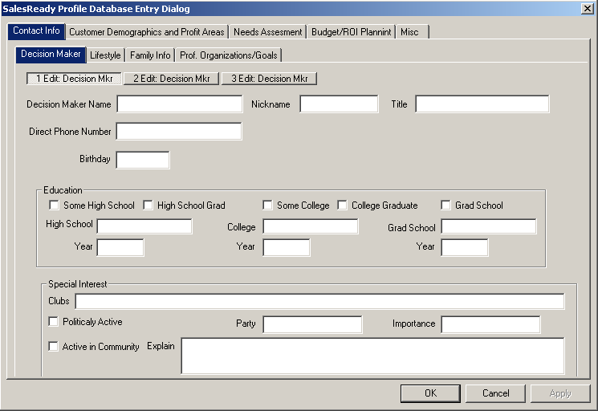

Contact/Personal Information

The Contact Info tab allows information about 3 Decision Makers to be stored for this account. Either the mouse or the Tab key can be used to navigate between fields and tabs. Clicking the OK button or striking the Enter key will close the Profile Database Entry Dialog window. Once information is entered into a field, and the cursor is moved to another field, that information will be saved.

On the Decision Maker tab, enter the name of the first decision maker. Once the field is filled out and the cursor is moved to another field, the 1 Edit Decision Mkr button will display the entered name.
Fill in the other fields for the first decision maker on this tab.

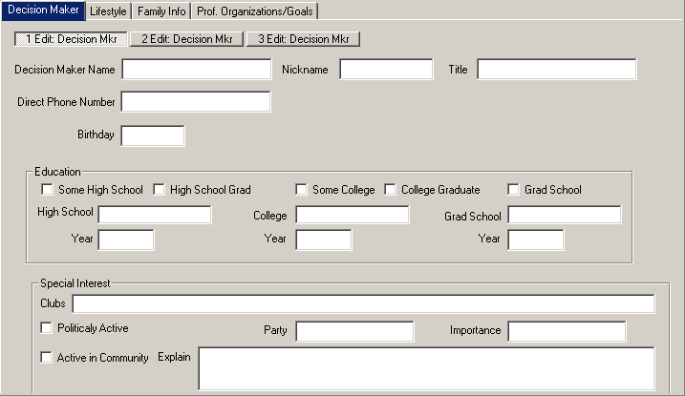
Click on the Lifestyle tab to enter information on the decision maker’s favorite restaurant, achievements and goals.

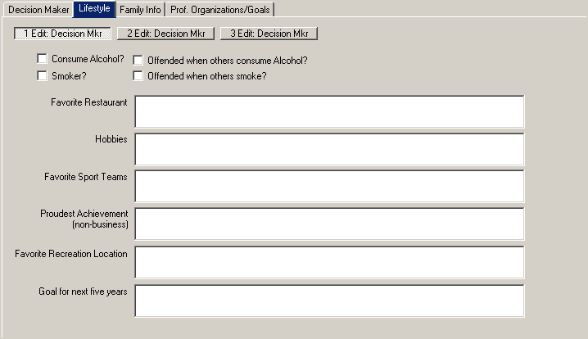

Click on the Family Info tab to enter information about the first decision maker’s spouse and children.
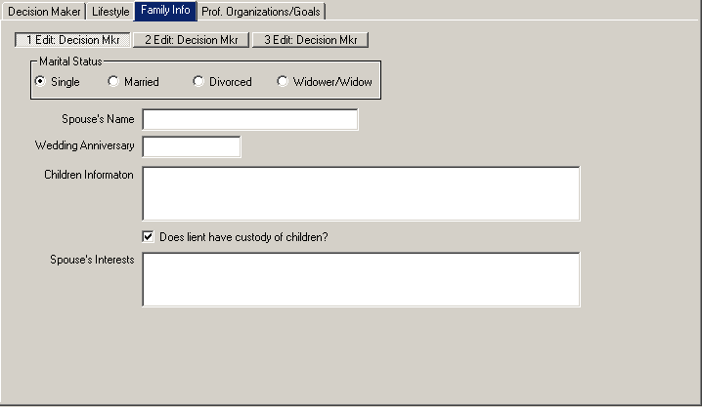

Click on the Prof. Organizations/Goals tab to enter information about the first decision maker’s involvement in professional organizations and business goals.

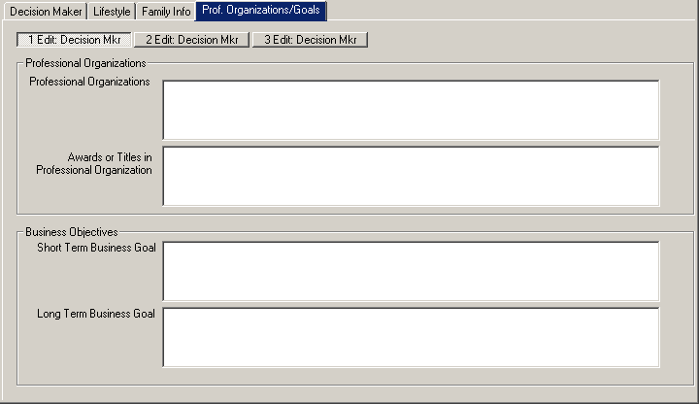

Click on the Decision Maker tab to enter information on the second and third decision maker/contact at that account, if needed.

While in the Contact Info screen, you can click on any of the 3 decision maker buttons to switch to information about that contact.

Customer Demographics
Click on the Customer Demographics and Profit Areas tab to enter information about customer base and profit areas for the business.
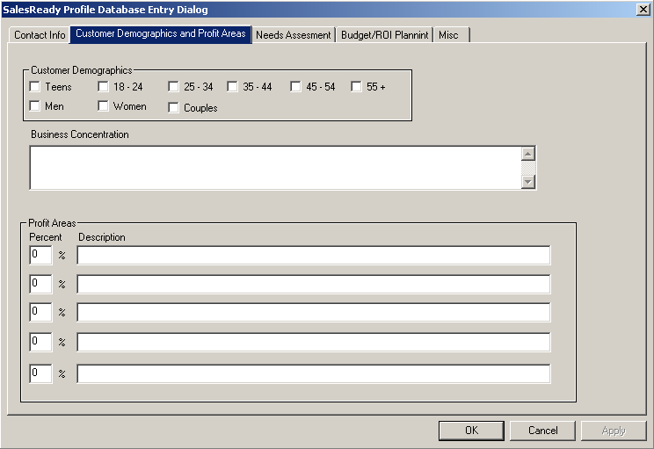

Check off the Customer Demographics that apply to the business in the top section of this page.
Enter the Business Concentration and Profit Areas that this business currently focuses on.

Needs Assessment
Click on the Needs Assessment tab to enter reasons that the customer should be advertising.
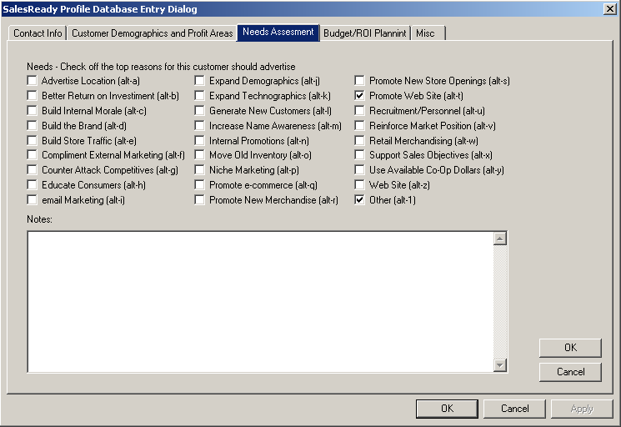

Check off as many reasons to advertise as apply to this customer, and any unique needs in the Notes entry box.
Click on the upper OK button to save the changes to this page.

Advertising Budget
Click on the Budget/ROI Planning button to enter information about the customer’s monthly and annual advertising budget.
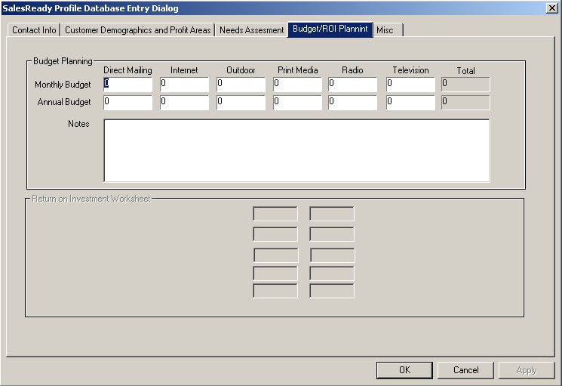

Enter in monthly values for the dollar amounts spent or available for each type of advertising. The totals will be calculated based on the values entered. Enter whole dollar amounts, without the decimal and cents.

Additional Miscellaneous Information
Click on the Misc tab to record information about traffic volume, public image, and other information that may be useful in developing a solid sales strategy for this customer.
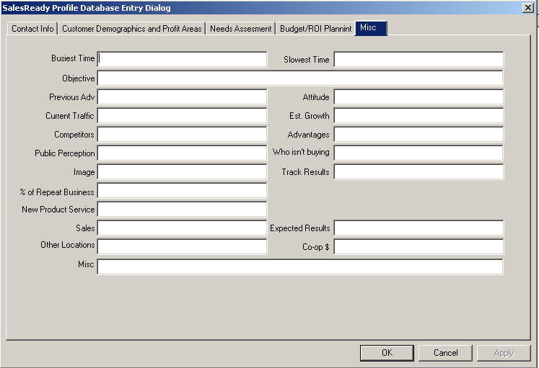

Click the OK button or strike the Enter key to close the SalesReady Profile Database Entry Dialog window and return to the Sales Entry screen.

Appendix A: Quick synopsis of each button and menu item in SalesReady

Database Window
To get to the SalesReady Database Window, you must first start the WireReady software from the computer desktop, login, and then click on the yellow Sales-9 button at the top right of the screen.

Button Name: F2 Show
Function: Standard window button
Use: To sort or organize the entire database or narrow the database to a manageable list of accounts. Lists can be sorted by city, category, zip code, total amount bought, callbacks scheduled…just about any sort parameter you would need.

Button Name: F3 Find ID
Function: Standard window button
Use: To quickly find a particular account(s) using an ID number only. Unique ID numbers have to be assigned account-by-account before the search can be utilized.

Button Name: F4 Add
Function: Standard window button
Use: To enter a new account to the database.
Recommended Users: The AE Director/ Team Leader

Button Name: F6 Report
Function: Standard window button
Use: To monitor sales progress or event progress using software-generated reports. Reports can be generated on one caller, all callers, one event, all events, monthly sales, or leads. Instead of gathering this information by hand, the software tracks it for you and bundles it into a summarized report.

Button Name: Ctrl + U User
Function: Standard window button
Use: To switch 4-letter rep name without exiting the WireReady software entirely.
Pro: A manager can login as a AE to correct a pitch that was logged incorrectly.
Con: This button cannot be used to switch between secure logins (with passwords); only switches between 4-letter rep names.
Recommended Users: The AE Director/ Team Leader

Button Name: View Record
Function: Standard window button
Use: To open or view any particular account window. This same function is more commonly performed by double-clicking the account name.

Button Name: Delete Record
Function: Configurable (grayed out if disabled) for added security
Use: To delete an entire account from the database.
Pro: To clean out any extraneous records that were added.
Con: We recommend NOT deleting records for several reasons.
- Deleting a record that has been called upon erases sales history and alters reports
- Deleting records interferes with yearly database updates provided by WireReady. It is possible to end up with that account again anyway when the database it updated if you have deleted it in the past.
Recommended Users: The AE Director/ Team Leader or Sales Manager ONLY

Button Name: Event Info
Function: Standard window button
Use: To organize, plan and schedule events in the system in an easy-to-use interface. Managers can also add new events at this location. Not only does this window help keep a manager on top of his/her duties, it can be used as a communication tool between AE’s and their manager because of the color-coding that indicates when an event is selling and when it is airing. Managers can also take notes in the Event Info window about events, for their own use, or take notes to be used in communication with AEs.

Button Name: List
Function: Standard window button
Use: To allow users to create a list of accounts to be printed or saved to a file. For calling lists, mailing labels and on-screen information capture. You may export the information from the database either to file or directly to printer.
Recommended Users: Any AE or Sales Manager

Sales Entry Window
To get to the Sales Entry Window, you must first view an account record by double-clicking the account name or clicking the View Record button.

Button Name: Schedule
Function: Standard window button
Use: To schedule meetings or negotiations (track sales leads). This is typically used by an account executive, rather than a telesales rep. If an account executive spends just a few minutes per day entering their negotiations, a sales manager can quickly review the deals happening and help facilitate a sale.
Recommended Users: Account Executives

Button Name: Chng Schedule 3
Function: Standard window button
Use: To update records of negations or change the pitch on a previously schedule negotiation. This is a way to track the on-going communications/ relationship between the salesperson and the client.
Recommended Users: Account Executives

Button Name: Print
Function: Standard window button
Use: To print one account’s information, event history, notes or old calls. AEs can print out this information to take with them on the street.
Recommended Users: Account Executives

Button Name: Change Pitch
Function: Standard window button
Use: To update a previous Undecided pitch to Yes or No. The goal is to follow up on all those Undecided calls and persuade the client to go one way or the other. No money should be left on the table at the end of the month.

Button Name: Delete Pitch
Function: Configurable (no button at all if disabled) for added security
Use: To delete a pitch (usually a mistake or a client changed decision)
Pro: The manager can remove pitches that were entered incorrectly, or sales pitches that that were not real sales, from the history of that account.
Con: Access to this button will allow the user to delete any pitch. This could be used to delete real pitches or sales and affect the records of activity on an account or by a AE.
Recommended Users: The Sales Manager ONLY

Button Name: Event Info (first explained above)
Function: Standard window button
Use: To organize, plan and schedule events in the system in an easy-to-use interface. Managers can also add new events at this location. Not only does this window help keep a manager on top of his/her duties, it can be used as a communication tool between AE’s and their manager because of the color-coding that indicates when an event is selling and when it is airing. Managers can also take notes in the Event Info window about events, for their own use, or take notes to be used in communication with AEs.

Button Name: Evnt Materials
Function: Standard window button
Use: To access event documents such as ad copy forms, broadcast order-forms, faxable brochures/flyers, invoices or any other document that might be needed when finished or negotiating a sale.

Button Name: Contracts
Function: Standard window button
Use: To launch production forms, contracts or event forms
Recommended Users: Account Executives

Button Name: Contact Info
Function: Standard window button
Use: To view account address and email address information

Button Name: Stats
Function: Standard window button
Use: To access sales history information about that account. Lists (in a summary bulleted list): total number of calls, total number of pitches, total number of buys, close ratio, max $Y pitch, min $Y pitch, total $ bought, $ earned/ call, total busy attempts, total not in attempts, total answering machine attempts.
Recommended Users: The Sales Manager

Button Name: Email
Function: Standard window button
Use: To send customer contact information to a selected email recipient. User simply clicks the email address to where he/she wishes to send email to, and chooses the destination folder.

Button Name: Open Notes
Function: Standard window button
Use: To view account notes written by anyone who has happened to call on this account. Any complicated issues or preferred ad copy can be stored in notes for future reference.

Button Name: View Old Calls
Function: Standard window button
Use: To view sales history past the calls that fit into the sales history window that is already visible. This holds all the past calls that don’t fit into the window. Sales History helps when figuring target categories or businesses for a particular event. If the customer has purchased or not purchased similar types of events in the past, it could affect whether this customer is called when time is crunched.

Button Name: Record
Function: Standard window button
Use: To open a blank *.wav file for recording audio over the phone or through a microphone. Customized commercials or interviews can be conducted through the telephone and recorded from SalesReady. This is the same as using the “Record 8” button from the main WireReady32 button bar.

Button Name: Start Call
Function: Standard window button
Use: To open the auto-dialing window and start the call timer. Autodialing saves wear on the AE and initiates a call timer for tracking the outcomes of calls.

Button Name: End Call
Function: Standard window button
Use: To stop the call timer after the Start Call button has been used.

Button Name: New Pitch
Function: Standard window button
Use: To open call log window. The New Pitch window is the launch pad for everything a AE might log as the result of a call—the event pitched, the buy, the dollar amount, set a callback, take notes, and open event materials.

Button Name: Done
Function: Standard window button
Use: To finish/ save work on a particular account and let the software officially close the account. Even when no changes are made, the Done button needs to be clicked.

Button Name: Cancel
Function: Standard window button
Use: To exit an account without saving any changes. This button should only be used when changes have been made that the user is sure does not need to be saved. When closing an account, it is best to use the Done button.

Button Name: Help
Function: Standard window button
Use: To open the help website. The Help buttons are not supported at this time.

Button Name: Change (town or category)
Function: Standard window button
Use: To change the sort specification associated with a particular account. If a business category or town location changes, the user can update that label with the Change button. This button will be used to assign a category or town when first adding new records.
Recommended Users: The Sales Manager

Button Name: Protect 1 (Phone Number)
Function: Standard window button
Use: To block a phone number from regular use by labeling it with Do Not Call, Bad Number, or Protect.
Pro: Blocking a number prevents AEs from calling on that customer. Software should be configured so that everyone can see the blocked accounts but cannot access them.
Con: As long as they AE can view the account (with no access), he/she will not try to add it back into the database.
Recommended Users: The Sales Manager

Button Name: Change (callback date)
Function: Standard window button
Use: To change the callback date/time set for that account.
Pro: When a callback has been set, and a AE makes an attempt to follow up, only to find the decision maker is still not available, he/she may wish to simply change the callback date for further into the future. After a call back to the account has occurred, this button can be used to clear the call back date and time.

Button Name: Protect 2 (Fax Number)
Function: Standard window button
Use: To block a fax phone number from regular use by labeling it with Do Not Call, Bad Number, or Protect.
Pro: Blocking a number prevents AEs from faxing that customer. Software should be configured so that everyone can see the blocked accounts but cannot access them.
Con: As long as they AE can view the account (with no access), he/she will not try to add it back into the database.
Recommended Users: The Sales Manager

Event Materials Window
To get to the Event Materials Window, you must first view an account record by double-clicking the account name or clicking the View Record button. For ease of use, you can find the Event Materials button in 2 different places. From the Sales Entry window, there is an Event Materials button, and also in the New Pitch window there is an Event Materials button. The most common way to get to Event Materials is through the New Pitch window.

Button Name: Launch
Function: Standard window button
Use: To open an event materials document (brochure, invoice, etc) so that it auto-grabs the contact information and event information for the customer and event you choose. This technology utilizes WireReady tags embedded into template event materials documents. Each time the template is Launched for a particular customer, it is customized automatically to save AE time. The AEs name is automatically entered as a salutation; there are very few edits the AE must perform before sending out the document.

Button Name: Cancel
Function: Standard window button
Use: To close the Event Materials window without opening any documents.

Button Name: New File
Function: Standard window button
Use: To insert a new blank document into an existing event folder. When creating an entirely new document, this button ensures that the document rests in a location where it can be found easily using SalesReady software.
Recommended Users: The Sales Manager

Button Name: Edit Selected
Function: Configurable (grayed out if disabled) for added security
Use: To edit or make permanent changes to the event document template.
Pro: Each time an event is sold each year, the template usually needs to be edited to reflect changed dates or updated ad copy. NOTE: If you are using the starter pack of events provided by WireReady, titles and event packaging does not need to be altered on the document template because it is housed in the Event INFO Screen instead.
Con: The user must be careful not to accidentally delete an entire WireReady tag or part of a WireReady tag, otherwise the requested information will not auto-fill correctly when the document is launched by a AE. Documents cannot be edited if they don’t exist to begin with.
Recommended Users: The Sales Manager

Button Name: Help
Function: Standard window button
Use: To open the help website. The Help buttons are not supported at this time.

Button Name: Event Info 1
Function: Standard window button
Use: To organize, plan and schedule events in the system in an easy-to-use interface. Managers can also add new events at this location. Not only does this window help keep a manager on top of his/her duties, it can be used as a communication tool between AE’s and their manager because of the color-coding that indicates when an event is selling and when it is airing. Managers can also take notes in the Event Info window about events, for their own use, or take notes to be used in communication with AEs.

Button Name: View Notes
Function: Standard window button
Use: To view notes edited by a manager about a particular event. Notes can be used to remember how an event performed from one year to the next. Notes can also be used to inform callers of extra information that would be helpful in making a sale.

Button Name: Edit Notes
Function: Configurable (grayed out if disabled) for added security
Use: To edit/add notes about a particular event.
Pro: Notes can be saved to remember how an event performed from one year to the next. Notes can also be saved to inform callers of extra information that would be helpful in making a sale.
Con: A user could change the information in this field, and assign the good accounts to himself, or remove notes the management added about the event.
Recommended Users: The Sales Manager

Button Name: Launch As Form
Function: Standard window button
Use: To open an event materials document (brochure, invoice, etc) so that it inserts blank lines where it normally would have auto-grabbed the contact information. This “blank” document can then be photocopied to be used as template hard copy.

Button Name: Copy As Template
Function: Standard window button
Use: To copy an event materials document (brochure, invoice, etc) template to another event folder.
Pro: When you add a new event, and you have a master template saved, or just have another event document that would be similar to what you want for your new event, use the Copy Template as a starting point. Copy the similar template to the new folder, and then make just a few edits to the new document instead of starting from scratch.
Con: You cannot copy a document to a new folder if that folder does not already exist. See the handbook to learn how to add a new event folder each time a new event is added to the system.
Recommended Users: The Sales Manager

Button Name: Print ALL as Form
Function: Standard window button
Use: To print all the event materials documents (brochure, invoice, etc) in a particular folder so that it inserts blank lines where it normally would have auto-grabbed the contact information on each document printed from the folder. This would be most often utilized to gain hard copy of all documents to work with for any event. If you need a copy of one or two documents, print each document separately.

Button Name: Print ALL Folders as Form
Function: Configurable (no button at all if disabled) for added security
Use: To print all the event materials documents (brochure, invoice, etc) in all of the event folders so that it inserts blank lines where it normally would have auto-grabbed the contact information on each document printed from the folders.
Pro: The “blank” documents can then be photocopied to be used as template hard copies.
Con: It takes time for the computer and printer to “spool” all the information associated with all the documents (especially because they have color graphics on them). When using this feature, the computer cannot be used for anything else until it is done spooling.
Recommended Users: The Sales Manager ONLY

