

AirCheckReady

Users Guide

WireReady NSI 56 Hudson Street Northborough MA 01532
(800) 833-4459 (508) 393-0200 FAX (508) 393-0255
sales@wireready.com support@wireready.com www.wireready.com
1997-2006 © WireReady® NSI
AirCheckReady

TABLE OF CONTENTS

INTRODUCTION 5
OVERVIEW 7
AUTOMATION DECKS & AUTOMATION PROGRAMS - WHAT ARE THEY? 7
WHAT ARE AUTOMATION DECKS? 7
WHAT ARE AUTOMATION PROGRAMS? 7
AUTOMATION DECKS & AUTOMATION PROGRAMS - THEIR RELATIONSHIP 8
SCREEN OVERVIEW: AUTOMATION DECK 9
TOP STATUS LINE 9
SEQUENCE LINES 10
OPTION BUTTONS 11
MAIN DROP-DOWN MENU 12
WORKING WITH AUTOMATION DECKS AND PROGRAMS 17
HOW TO GET TO THE AUTOMATION DECKS 17
HOW TO MOVE BETWEEN AUTOMATION DECKS 18
HOW TO CREATE AN AUTOMATION PROGRAM 19
HOW TO SAVE AN AUTOMATION PROGRAM 19
HOW TO LOAD AN AUTOMATION PROGRAM 19
HOW TO START AN AUTOMATION PROGRAM 20
HOW TO STOP AN AUTOMATION PROGRAM 20
HOW TO CHANGE A SAVED AUTOMATION PROGRAM 21
HOW TO CLEAR AN AUTOMATION DECK 21
COMMANDS 23
WHY TO USE PASTE TO COPY BLOCKS OF COMMANDS 23
HOW TO COPY BLOCKS OF COMMANDS IN THE SAME DECK 24
HOW TO COPY BLOCKS OF COMMANDS INTO ANOTHER DECK 25
HOW TO CROSS THE MIDNIGHT HOUR PROPERLY 26
INTRODUCTION TO COMMANDS 27
INTRODUCTION TO TIME WINDOWS 27
INTRODUCTION TO CHANNELS 28
COMMANDS SECTION 29
INTRODUCTION 29
AUTORECORD 32
HOW TO SET UP: AutoRecord 33
BE HERE AT 34
HOW TO SET UP: Be Here At 35
CHANGE PATH 36
HOW TO SET UP: Change Path 36
CHECK 37
HOW TO SET UP: Check 37
COMTALK 39
HOW TO SET UP: ComTalk 40
CONTROLDECK 41
HOW TO SET UP: ControlDeck 41
CUSTOM 42
HOW TO SET UP: Custom 43
DELAY FOR 44
HOW TO SET UP: Delay For 44
EMAIL 45
HOW TO SET UP: Email 46
GOSUB 48
HOW TO SET UP: GoSub 49
GOTO 50
HOW TO SET UP: Goto 50
HEX TALK 51
IF 52
HOW TO SET UP: If 53
IF DAY 54
HOW TO SET UP: If Day 54
IF MONTH 56
HOW TO SET UP: If Month 56
IF YEAR 58
HOW TO SET UP: If Year 58
LABEL 59
HOW TO SET UP: Label 59
LATCH CHANNEL 60
HOW TO SET UP: Latch Channel 60
LOAD AND START 61
HOW TO SET UP: Load and Start 62
LOG 63
HOW TO SET UP: Log 63
PACKAGER 64
HOW TO SET UP: Packager 65
PULSE AND WAIT 66
HOW TO SET UP: Pulse And Wait 66
PULSE CHANNEL 67
HOW TO SET UP: Pulse Channel 68
RECORD BY NAME/CODE 69
HOW TO SET UP: Record By Name/Code 70
RETURNSUB 72
HOW TO SET UP: ReturnSub 72
RUN 73
HOW TO SET UP: Run 73
SET CLOCK 74
HOW TO SET UP: Set Clock 74
SETENDTIME 75
HOW TO SET UP: SetEndTime 75
SKIP 76
HOW TO SET UP: Skip 76
SPLICE 77
HOW TO SET UP: Splice 78
STOP / SHUT DOWN 79
HOW TO SET UP: Stop / Shut Down 79
SYNC 80
HOW TO SET UP: Sync 81
WAIT FOR CHANNEL 83
HOW TO SET UP: Wait for Channel 84
WAIT FOR CLOSURE 85
HOW TO SET UP: Wait for Closure 86
WAIT FOR HOT KEY 87
HOW TO SET UP: Wait for Hot Key 88
WAIT UNTIL 89
HOW TO SET UP: Wait Until 89
WEB PUBLISH 90
HOW TO SET UP: Web Publish 91
EXAMPLE OF AN AUTOMATION PROGRAM 93
SYSTEM CONFIGURATION AND OTHER OPTIONS 95
The Logs created by the Log command 95
Assigning Sound Cards to the ControlReady for Windows Decks 97
Printing the Playlists 100
Configuration Files 101
[server]:\wire\system\SyncDir32.dat 101
The User *.ini File 102
HOW TO REACH WIREREADY 110

INTRODUCTION

AirCheckReady is an application that uses WireReady NSI's ControlReady automation deck screens, which are part of the WireReady32 (WR32) family of software.
ControlReady consists of the screens listed under the AUTOMATE button from the main screen. By default, there are 8 automation decks. That is 8 separate playlists that can be mapped to different sound cards and be recording different things at the same time.
AirCheckReady provides you ALL the logic commands of the full ControlReady system. You can not only record based on time with the WAIT UNTIL and IF TIME commands, but you can use GPI logic commands with various Broadcast Tools devices (or equivalents) with our COMTALK, PULSE, LATCH, WAIT FOR CHANNEL, and CUSTOM command macros, to make your recording commands start and stop based on GPI signals and time windows.
There are commands that can be used to automatically copy files to other locations (SYNC) as well as commands like RUN that can call 3rd party programs to compress or do other things to your audio. We also have the WEB PUBLISH command that can be used in combination with our DBCapture program to move and compress recorded wav files another folder without interrupting the recording playlists (since transcoding sometimes takes time based on the size of the file).
NOTE: You will notice that some commands may be grayed out (for example, the PLAY commands). This is because AirCheckReady is for recording. To have automatic playback capability you need to license the entire ControlReady application. You may also see other commands which have no value since they pertain to PLAY commands, like the BE HERE AT, Fade to Stop and similar commands. In certain cases, we may
give you an unlocked version of the software that makes these commands available. But keep in mind that if we did not license you the full ControlReady program, we are not obliged to provide any support for playback. Please do not try to automate your music and commercial playback with AirCheckReady. Even if you find a way to play files from the automation decks, please do not, since you were not licensed to do so.
AirCheckReady does let you use the Notepad (our word processor), which can be handy for browsing activity logs (if you use the LOG=on command and have configured paths for us to write activity logs to). You will also have to set the advanced navigation lines in the SYSTEM.INI file to let you browse folders to open up these files with our Notepad, otherwise we only let you browse to pre-set folder paths.
You also have the FileLog in case you want to define a custom folder to be the path that looks at your activity logs, which is another way to quickly open logs. And you have the MediaLog that lets you search for, sort, preview, or edit (by calling your installed default WAV editing software) any wav files in the system.
Any other screens in the program are provided for evaluation use only in case you are ever interested in licensing the full product for playback purposes.
Please note with respect to audio switching, GPI control, and recording, AirCheckReady can do anything that ControlReady can do. With the exception of playback specific features, anything else in terms of requirements, or accessory hardware is the same between the products. For example, the KickOff reboot/monitoring device works with AirCheckReady just as ControlReady does. You can also browse the ControlReady FAQs at www.wireready.com or documentation for any feature information you think pertains to the areas described above.

OVERVIEW

AUTOMATION DECKS & AUTOMATION PROGRAMS - WHAT ARE THEY?

WHAT ARE AUTOMATION DECKS?

There are eight (8) Automation Decks which can be used for creating, maintaining, and running your Automation Programs.

Automation Decks always have an Automation Program loaded. When you clear an Automation Deck, a blank Automation Program (called New Playlist) is instantly loaded into the Automation Deck.

WHAT ARE AUTOMATION PROGRAMS?

Automation Programs are sequences of Automation Commands that are arranged in an Automation Deck and saved with a unique name as an Automation Program.

Basically, an Automation Program is a list of things to do. Just like any other list, the commands (things to do) in an Automation Programs are listed, and therefore executed, in sequential order. Automation Programs are also referred to as Playlists.

Automation Programs are lists of commands which each do something. That "something" might be to record the onair signal, wait for a channel to get a closure (when a mic is opened), etc. See the Commands section in this manual for usage of each command.

AUTOMATION DECKS & AUTOMATION PROGRAMS - THEIR RELATIONSHIP

In terms of the relationship between Automation Decks and Automation Programs, think of the Automation Decks as Cart Machines, and Automation Programs as carts.

Just as cart decks are used for recording audio as well as playing the recording, Automation Decks are used for creating Automation Programs as well as running them.

Just as a cart can be played in ANY cart deck (regardless of which deck was used to record the cart), an Automation Program can be run in ANY Automation Deck, regardless of which Automation Deck was used to create the Automation Program.

Just as a cart machine can have more than 1 cart deck playing at one time, more than one Automation Deck can be running at one time. Actually ALL eight Automation Decks can have Automation Programs running at the same time.

Just as one deck can be playing a cart and another deck in the same machine can be recording a cart, Automation Decks can be active at the same time that you are creating/editing an Automation Program in a different Automation Deck.

Just as you can make a copy of a cart, and edit the copy while the original cart remains unchanged, you can make a copy of an Automation Program (by saving it to a different name), and edit the copy while the original Automation Program remains unchanged.

Just as the audio on the cart will PLAY when the cart is inserted in the cart deck and the PLAY button pressed, an Automation Program will become active when the Automation Program is inserted into an Automation Deck and the START (F3) key is pressed.

Just as one cart deck can activate another cart deck (with tones), one Automation Program can activate another Automation Program (with a command). The only difference here is that the called cart plays in a DIFFERENT deck than the cart which called it, while the called Automation Program runs in the SAME Automation Deck that the calling Automation Program was running in.

SCREEN OVERVIEW: AUTOMATION DECK

This is an Automation Deck with a blank, unsaved Automation Program loaded into it.

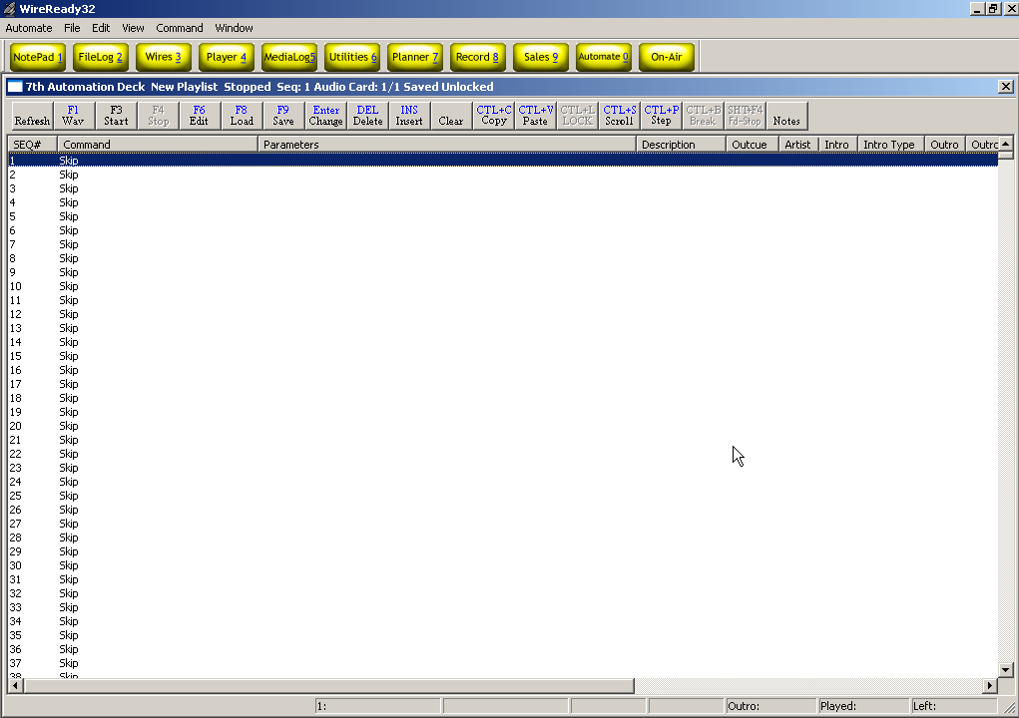

TOP STATUS LINE

The TOP STATUS LINE of the Automation Deck:
- Displays which Automation Deck you are in (1-8).
- Displays the name of the Automation Program that is currently loaded into this Automation Deck.
- Displays whether the Automation Deck is Running or Stopped.
- Displays the Sequence Number of the Automation Program where the Automation Program was last stopped. (When the Automation Program is running, this shows the sequence number of the line currently being executed).
- Displays the Audio Cards being used by this Automation Deck. This is displayed as "Audio Card: 1 / 2" where the 1 is the first audio card and 2 is the second audio card when the deck is configured to use 2 cards for overlapping audio during playback. If not using overlapping during playback, both characters will be the same.
- Displays whether the Automation Program has or has not been saved since modifications were last made to it.
- Displays whether the Automation Program is Locked or Unlocked.

SEQUENCE LINES

There are a total of 2400 sequences (1-2400) per Automation Program.

The SEQUENCE Line Displays:

- The Number of that sequence.
- The Command that is on that sequence.
- The Command's Parameters (Parameters are details which are added to a command to customize it to do the specific task at hand).
- The Description of the audio file (entered from the MediaLog screen)
- The Outcue of the audio file (entered from the MediaLog screen)
- The Artist of the audio file (entered from the MediaLog screen)
- The Intro time of the audio file (entered from the MediaLog screen), in seconds.
- The Intro Type of the audio file (entered from the MediaLog screen). Fade Up, Talk over previous cart, or EOM
- The Outro time of the audio file (entered from the MediaLog screen), in seconds.
- The Outro Type of the audio file (entered from the MediaLog screen). Fade Down, Talk over next cart, or EOM
- The Length of the audio file.
- The End Time of the audio file, or the time that the file will be done playing.
- The Status of the command (waiting, playing, time remaining).

These fields’ widths can be changed if you put the mouse over the divider bar, then click and drag to change the field width or to hide the field.

OPTION BUTTONS
The OPTION BUTTONS at the top of the Automation Deck screen show the keys that can be used to perform operations within the Automation Deck. Each of the possible operations is explained within this manual.

Refresh Refreshes the screen display.
F1 Wav Puts a Play Wave command on the highlighted sequence #.
F3 Start Starts the currently loaded playlist on the highlighted sequence #.
F4 Stop Stops the currently running playlist.
F6 Edit Allows the user to edit the command on the highlighted sequence #.
F8 Load Loads a previously saved playlist into the Automation Deck.
F9 Save Saves the currently loaded playlist.
Enter Change Changes the command on the highlighted sequence #.
DEL Delete Deletes the command and parameters from the highlighted sequence #. Will also remove the line, moving all following commands up one line.
INS Insert Inserts a Skip line above the highlighted sequence #.
Clear Clears the loaded playlist and opens a blank New Playlist.
CTL+C Copy Copies the command in the highlighted sequence #.
CTL+V Paste Pastes single or multiple commands to the current playlist.
CTL+L Lock Toggles between Locked and Unlocked state.
CTL+S Scroll Allows the user to scroll to a specific sequence # in the playlist.
CTL+P Step Allows the user to run a command on one sequence of the playlist, where the playlist will not continue to the next line when the command is completed.
CTL+B Break Continues execution of the current command but will stop the deck after the completion of the current command.
Shift+F4 Fd Stop Fade To Stop. Starts fading down the current file being played, from normal volume to no volume, over the next 5 seconds and then stop the deck.
Notes Opens a window to allow text notes about the deck. Information about when live periods are, which playlist should be running in the deck, which inputs and outputs are connected to each satellite receiver, or any other information that a user would need to know about this deck can be entered here.

MAIN DROP-DOWN MENU

The Main Menu, above the main Button bar, has 8 drop-down menus available for users to change decks, playlists, and screen viewing options, and to configure the audio cards. Use the keyboard shortcut or click on the choice with the mouse to activate the menu choice.

Automate
The Automate drop-down menu allows you to switch decks, start and stop the playlists, insert a Voice Track, and switch to the MediaLog.
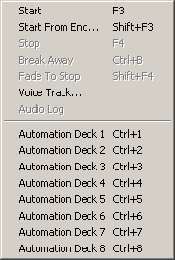
Start F3 Starts the currently loaded playlist on the highlighted sequence number.
Start From End Shift+F3 Allows the user to play the end of an audio file. Used in conjunction with voice tracking, to audition how the song/voice track sound together. Not for use on air.
Stop F4 Stops the currently running playlist.
Break Away CTL+B Continues execution of the current command but will stop the deck after the completion of the current command.
Fade To Stop Shift+F4 Starts fading down the current file being played, from normal volume to no volume, over the next 5 seconds and then stop the deck.
Voice Track Inserts a Voice Track command above the highlighted sequence number. See the section Using Voice Tracking in this manual.
Audio Log Used for audio trace level logging. This will be grayed out, unless WireReady is using it for debugging purposes.
Ctrl+[1-8] Automation Deck 1-8 Allows the user to switch between decks

File
Open/Load Ctrl+O Loads a previously saved playlist into the Automation Deck.
Save F9 Saves the currently loaded playlist.
Save as Saves the currently loaded playlist.
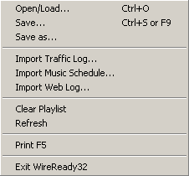
Import Traffic Log Starts the process of importing the Traffic log. See the section How to Import A Traffic/Music Log in this manual for instructions.
Import Music Schedule Starts the process of importing the Music log. See the section How to Import A Traffic/Music Log in this manual for instructions.
Import Web Log Starts the process of importing the Web log. See the section How to Import a Web Log in this manual for instructions.
Clear Playlist Clears the loaded playlist and opens a blank New Playlist.
Refresh Refreshes the screen display
Print F5 Prints the current playlist commands. See the section Printing the Playlists in this manual for instructions.
Exit WireReady32 Exits the program

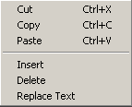
Edit
Cut Ctrl+X Deletes the command and parameters from the highlighted sequence #. Will also remove the line, moving all following commands up one line.
Copy CTL+C Copies the command in the highlighted sequence #.
Paste CTL+V Pastes single or multiple commands to the current playlist.
Insert Inserts a Skip line above the highlighted sequence #. Will also move all following commands down one line.
Delete Deletes the command and parameters from the highlighted sequence #. Will also remove the line, moving all following commands up one line.
Replace Text Opens a window that allows the user to replace text in certain commands in the playlist. See the section Replacing Text in a Playlist in this manual.

View
The menu choices in this drop-down window are either checked or unchecked. The default is unchecked.

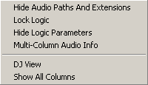
Hide Audio Paths and Extensions Removes the display of path and extension for the wave files in the Play commands, when checked.
Lock Logic Sets the deck to only allow changes to or addition/deletion of Play and Skip commands. All other commands are locked and cannot be edited or removed. Specific to the ControlReady for Windows deck. Can be set with a password.
Hide Logic Parameters Removes the display of parameters for most commands when checked. Does not affect the display of the Play, Record or Scheduled Break/Music Sweep commands.
Multi-Column Audio Info When checked, the parameters of the Play commands are separated into multiple columns (Description, Artist, Length, etc). When unchecked, all parameters are displayed in the Parameters field of the playlist.
DJ View Uses preset widths for the columns and displays only the Seq#, End Time, Command, Description, Artist, Intro, Outro, Length and Status fields. The display is also set to Hide Logic Parameters and Multi-Column Audio Info.
Show All Columns Displays a portion of each column. The user will need to set the width for each column they wish to display.

Command
This drop-down list shows all the commands available in the AirCheckReady Playlists. See the Commands section of this manual for descriptions of the commands and their use.

Setup
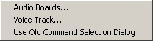
Audio Boards Configures the audio devices that will be used in each deck for playback and recording. See the section Assigning Sound Cards to the AirCheckReady Decks in this manual.
Voice Track Configures the voice tracking parameters. See the section Using Voice Tracking in this manual.
Use Old Command Selection Dialog Allows the users to use the list of commands in the format that was used in versions 3.814 and below of WireReady32, when checked. See the Commands section of this manual for more information on the list of commands.

Programs
The Programs menu lists the 11 screens in WireReady32. Many of these screens are not used in AirCheckReady. Consult the other WireReady manuals for information on using the news and sales screens.
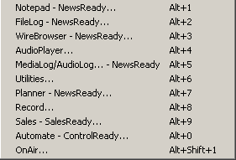
Notepad – NewsReady Alt+1 The Notepad is used to edit text and create new stories and rotations.
FileLog – NewsReady Alt+2 The FileLog is used to access text stories that have been saved from the Notepad, and to edit rotations.
WireBrowser – NewsReady Alt+3 The WireBrowser displays the wire stories that have been captured.
AudioPlayer Alt+4 The Player is used to read newscasts and play the embedded audio.
MediaLog/AudioLog – NewsReady Alt+5 The MediaLog is used to store audio files to be used in newscasts and automation.
Utilities Alt+6 The Utlities screen allows access to StormReady32, QuickRecorder, and the DOS PhoneReady and StormReady programs.
Planner – NewsReady Alt+7 The Planner is a calander program to track appointments and assignments for newsrooms.
Record Alt+8 The Record button is used to manually record new audio files.
Sales – SalesReady Alt+9 The Sales screen is used to record and track contacts with customers/advertisers.
Automate – ControlReady Alt+0 The AirCheckReady decks are used to automate recording of audio, and for web publishing.
OnAir Alt+Shift+1 The OnAir 10-deck screen is used for playback of audio while live.

Window
This drop-down list is used mainly for newsrooms. It allows users to clear stories from wire services that have been set to alert the WireReady32 users, and to check a list of windows that are open within the WireReady32 software. In addition to the menu choices, any open WireReady32 screens or open text files will be listed at the bottom of the menu choices in this drop-down window.
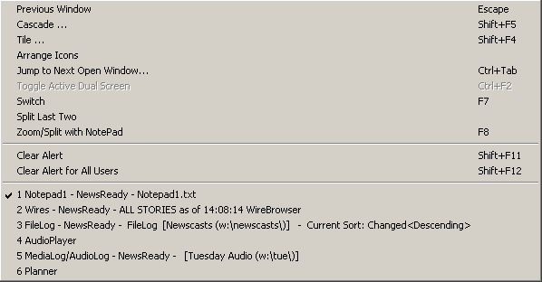
Previous Window Escape Puts the last window that was open before the Notepad as the current display.
Cascade Shift+F5 Allows the screens to be cascaded. Only active when the user is set to Windows Standard mode.
Tile Shift+F4 Allows the screens to be tiled. Only active when the user is set to Windows Standard mode.
Arrange Icons
Jump to Next Open Window Ctrl+Tab Makes the next open screen be displayed.
Toggle Active Dual Screen Ctrl+F2 Toggles between the 2 windows when the user is set to Dual Screen mode.
Switch F7 Toggles between the Notepad and the last open screen.
Split Last Two
Zoom/Split with Notepad F8 Splits the current screen (or last open screen) with the Notepad.
Clear Alert Shift+F11 Clears the red wire alert at the bottom of the screen for the logged-in user.
Clear Alert for All Users Shift +F12 Clears the red wire alert at the bottom of the screen for all users.

WORKING WITH AUTOMATION DECKS AND PROGRAMS

HOW TO GET TO THE AUTOMATION DECKS

From the MAIN button bar in WireReady32, click on the Automate button, or Strike Alt-0 on the keyboard.

The AUTOMATE – CONTROLREADY - DECK SELECTOR screen will open:

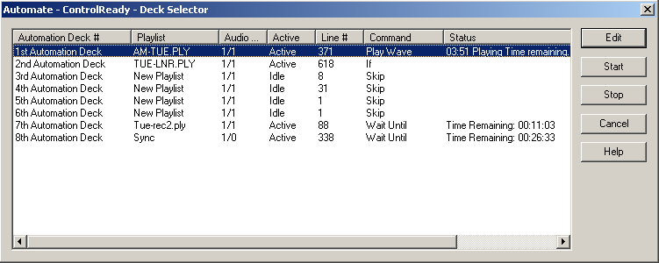
Note: The Automation Deck Selector screen shows the Status of each of the Automation Decks. If a deck shows Idle, there is no playlist running on that deck. If the Status shows Active, that deck is currently running the listed playlist.

Highlight the Automation Deck that you want to go to and press Enter.
-OR-
Highlight the Automation Deck you want to go to and click on the Edit button.
-OR-
Double-click on the Automation Deck

HOW TO MOVE BETWEEN AUTOMATION DECKS
3 Methods

1). Using the main WireReady32 buttons
From the main button bar in WireReady32, Strike Alt-0 or click on the Automate button.

The AUTOMATE – CONTROLREADY - DECK SELECTOR screen will open:

Highlight the Automation Deck that you want to go to and press Enter.
-OR-
Highlight the Automation Deck you want to go to and click on the Edit button.
-OR-
Double-click on the Automation Deck

2). Using the drop-down menu choices in the AirCheckReady screen
From the main menu in WireReady32, click on Automate or strike Alt-A on the keyboard.
The drop-down menu will appear:
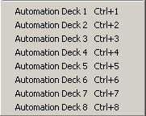
Click on the deck to move to.

3). Using the keyboard shortcuts
On the keyboard, strike the Ctrl key and the number of the deck at the same time.

HOW TO CREATE AN AUTOMATION PROGRAM
(All of the available commands are described in the Commands section.)

To create an Automation Program:
1) Go to an Automation Deck that is not currently active and click the Clear button to clear the deck.
2) Create the Automation Program by:
a) Pressing Enter on a line and adding the necessary command.
b) Pressing F6 over an existing command and Edit the parameters of the command.
c) Pressing the Insert key to add a SKIP command.
d) Pressing the Delete key to delete a command.
e) Clicking on the Copy and Paste buttons to COPY BLOCKS of commands.
3) When you are done putting all of the commands in, press F9 to Save the Automation Program.
Type in the NAME that you want to assign to this Automation Program. If the name is the same name as another Automation Program and you go through with the Save, the original Automation Program will be overwritten by the one you just created.
4) After the Automation Program is Saved, you can click on the Clear button to Clear the Automation Deck.

HOW TO SAVE AN AUTOMATION PROGRAM

1) Press F9 to Save the Automation Program.
2) In the File Name entry box, type the name that you want to assign to this Automation Program, and press Enter or click Save.
-OR-
If the NAME is already there, just press Enter or click Save.
3) If a file with the same name exists, you will be prompted to replace the file. If you are sure you want to overwrite the program (if you were editing that program and are saving the changes) choose Yes to replace the file. If you are not sure if you should replace the file, choose No and give the file a different name.

HOW TO LOAD AN AUTOMATION PROGRAM

1) Press F8 while in the Automation Deck which you want to Load an Automation Program into.
-OR-
Click on the F8 Load button.
2) Type the NAME of the Automation Program that you want to Load, and press Enter or click the Open button.
-OR-
Highlight the Automation Program that you want to Load and press Enter or click on the Open button.

HOW TO START AN AUTOMATION PROGRAM

Strike the F3 key while in the Automation Deck which has the Automation Program that you want to Start loaded into it.
-OR-
Click on the F3 Start button.

If the Automation Decks already have the Automation Programs you want to run loaded, you can start all decks from the Automate Deck Selector window.
-Click on the Automate button from the main button bar, or strike Alt-0 to open the Automate Deck Selector window.
-Highlight the Automation Deck that you would like to start.
-Click on the Start button or strike Alt-S.
-Continue highlighting and starting the Automation Programs.
-Click the Cancel button when done.

Note: A warning message was added to WireReady32 to alert users attempting to exit the program that the Automation is currently running on the machine. This will let users know that they are about to exit the program and stop the audio playback or recording that is scheduled in the playlists. The message reads:
WARNING - AUTOMATION IS RUNNING
If the system is playing or recording, you can take your station off the air or kill a program (if one is being recorded).
Make sure your automation programs are idle/waiting and you won’t interrupt any programming.
Are you really sure you want to exit WireReady32?
(Choose No to double check your automation programs before exiting.)

HOW TO STOP AN AUTOMATION PROGRAM

Press F4 while in the Automation Deck which has the Automation Program that you want to Stop loaded into it.

If you want to stop all decks from running, this can be done from the Automate Deck Selector window.
-Click on the Automate button from the main button bar, or strike Alt-0 to open the Automate Deck Selector window.
-Highlight the Automation Deck that you would like to stop.
-Click on the Stop button or strike Alt-T.
-Continue highlighting and stopping the Automation Programs.
-Click the Cancel button when done.

HOW TO CHANGE A SAVED AUTOMATION PROGRAM
To change (edit) an Automation Program:

1) Go to an Automation Deck that is not currently active and click on Clear to clear the Deck.
2) Press F8 to Load an Automation Program.
Type the NAME of the Automation Program that you want to Load, and press Enter or click the Open button.
-OR-
Highlight the Automation Program that you want to Load and press Enter or click on the Open button.
3) Change the Automation Program by:
a) Pressing Enter over an existing command and overwriting it with a different command.
b) Pressing F6 over an existing command and changing the parameters of the command.
c) Pressing the Insert key to add a SKIP command.
d) Pressing the Delete key to delete a command.
e) Clicking on the Copy and Paste buttons to COPY BLOCKS of commands.
4) When you are done putting all of the commands in, press F9 to Save the Automation Program.
Type in the NAME that you want to assign to this Automation Program. If the name is the same name as another Automation Program and you go through with the Save, the original Automation Program will be overwritten by the one you just created.
5) After the Automation Program is Saved, you can click on the Clear button to Clear the Automation Deck.

HOW TO CLEAR AN AUTOMATION DECK

Click the Clear button to Clear the Automation Deck you are currently using.

The Automation Program that is in the Automation Deck will be cleared and all of the sequences will have the SKIP command on them.

Note: If the Automation Program which you are clearing has not been Saved since changes were last made to it, the changes will be lost if you Clear the Automation Deck.

Clearing an Automation Deck does not delete the Automation Program from the hard drive (Unless it was never saved).

To Delete an Automation program you must go out to DOS or to Windows Explorer and delete the file. The filename will be the name of the Automation Program plus the ".PLY" extension. For example, if the name of the Automation Program that you want to delete is TUESDAY, then the file you need to delete will be called TUESDAY.PLY.

The drive and directory where the files are stored is configurable. However, the Automation Program files will probably be in the W:\WIRE\USERS\PUBLIC\FILES directory.

COMMANDS

WHY TO USE PASTE TO COPY BLOCKS OF COMMANDS

Copying blocks of commands is a VERY useful tool that will most likely save you a lot of time creating and changing Automation Programs.

When setting up recording commands, the commands for one hour may be the same for many, or all, of the other hours. The only differences may be the time that the TIME WINDOWS are set to.
So this is what you would do:

1) Put in the commands for one full hour.
2) Use the PASTE command with the option to INCREMENT HOUR checked, and copy the hour that you created.

HOW TO COPY BLOCKS OF COMMANDS IN THE SAME DECK

1) Highlight the sequence number that you want the block of commands to be copied to. THE HIGHLIGHT BAR CANNOT BE WITHIN THE BLOCK OF COMMANDS THAT YOU WANT TO COPY.

2) Click on the Paste button or strike Ctrl-V on the keyboard.

This window will open:
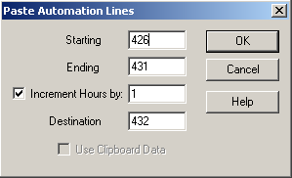

Uncheck Use Clipboard Data if it is checked.

3) Enter the sequence number of the first line of the block you want to copy in the Starting box
4) Enter the sequence number of the last line of the block you want to copy in the Ending box.
5) Check the Increment Hours by: box and enter in the number of hours to increment the time commands by.
6) Enter the sequence number of the line where the block is to be copied to in the Destination box.
7) Click the OK button.
When you use the Paste command with the INCREMENT HOUR option checked, ALL of the TIME WINDOWS are advanced by the number of hours entered in the box, and the THEN GOTO's for the TIME WINDOWS are changed to the correct sequence numbers.

HOW TO COPY BLOCKS OF COMMANDS INTO ANOTHER DECK
There may be times when you want to copy a block of commands from one playlist to another playlist in a different deck.

1) Highlight the first sequence number that you want to copy. While holding the Shift key down, click on the last command in the block that you want to copy.
2) Click on the Copy button or strike Ctrl+C on the keyboard. The block of commands will be sent to the clipboard.

3) Open the deck to paste the block of commands into and highlight the sequence number to paste the block to.

4) Click on the Paste button or strike Ctrl-V on the keyboard.

This window will open:
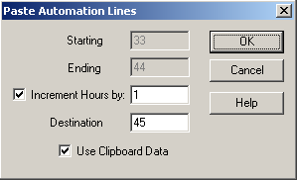

5) Check Use Clipboard Data. The Starting and Ending entry boxes will be grayed out.
6) Check the Increment Hours by: box and enter in the number of hours to increment the time commands by, if you will be incrementing the times in the commands that were copied.
7) Enter the sequence number of the line where the block is to be copied to in the Destination box. If you highlighted that sequence number above, this will be displayed.
8) Click the OK button or strike Enter to paste the block of commands.

When you use the Paste command with the INCREMENT HOUR option checked, ALL of the TIME WINDOWS are advanced by the number of hours entered in the box. Because of all of the variables involved in copying and pasting between decks, the sequence numbers in the THEN GOTO's for the TIME WINDOWS will probably not be accurate. Be sure to check the commands after they are pasted.

HOW TO CROSS THE MIDNIGHT HOUR PROPERLY

As of this writing you need to cross midnight differently than all of the other hours.

If the last command executed before midnight is to record your last hour, the Automation Program will stay on the Record By Name/Code command until the file is done recording and then move on to the next command. So there is a chance that the Automation Program will get to a command with a time window or a Wait Until command before midnight strikes. And what will happen when the Automation Program comes to that command?

Well, In terms of the time window, AirCheckReady will check the IF AFTER time which will be 00:xx:xx (because midnight is the 00 hour), and compare it to the current computer time. This command is gotten to before midnight, so when the times are compared, it will certainly be after 00 hour because it's the 23 hour (11 o'clock pm). And because the time is after the IF AFTER time, the THEN GOTO will be performed, and that is NOT what you want.

In terms of the WAIT UNTIL (00:xx:xx) command, the same thing will happen. When the command is reached, AirCheckReady will compare the time to WAIT UNTIL to the current computer time. This command is gotten to before midnight so when the times are compared, it will certainly be AFTER 00 hour because it's the 23 hour (11 o'clock pm). And because the time is after the WAIT UNTIL time, the Automation Program will proceed - and that is NOT what you want.

HOW TO FIX THE PROBLEM:

Use the IF command. When the IF command is used to look for a time before 1 am, it will wait until after the midnight hour is crossed before moving to the next command. An example of how the command can be used to cross midnight is below:

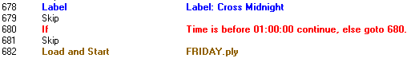

The Automation Program will look at the IF line, and compare the time to the computer's current time. If the time is before midnight, then it will be after 1 am, and the Automation Program will go to line 680. This is the same line that the IF command is on, so the Automation Program will continue to compare the time in the IF command with the computer's time. When the computer's time crosses midnight, the time will be before 1 am, and the Automation Program will continue to the next sequence. In the above example, the next line that the Automation will take action on is the Load and Start line, which will load and start the Friday playlist.

INTRODUCTION TO COMMANDS

INTRODUCTION TO TIME WINDOWS

A TIME WINDOWS is a block of time that you specify for a certain event (closure, hot key pressed, etc.) to take place. TIME WINDOWS consist of NOT BEFORE, IF AFTER, and THEN GOTO parameters.

- If the event occurs before the NOT BEFORE time, it will be ignored
- If the IF AFTER time is reached BEFORE the event occurs, the program will jump to the sequence number specified in THEN GOTO.
- If the event does, in fact, occur within the time window, the Automation Program will simply go to the next sequence number.

For example, let's say I am using the WAIT FOR CHANNEL B1-A to go HI command, which will cause the Automation Program to remain on the sequence which that command is on until the channel goes HI. And let's say that the channel will go HI when the microphone is opened (a closure is sent). Now, what happens if someone turns the mic on too early.

IF I AM NOT USING A TIME WINDOW:

If the mic is opened early, the Automation Program will start the recording prematurely.

If they forget to send the tone, the Automation Program will just sit on that sequence until someone corrects the situation.

IF I AM USING A TIME WINDOW:

If the mic is turned on too early, before the NOT BEFORE time, the Automation Program will ignore it because it was probably a mistake or you do not want to start recording.

If the mic is not turned on, when the IF AFTER time is reached, the Automation Program will jump to the sequence specified in THEN GOTO, and that segment will be skipped. The Automation would move on to wait to start the next segment.

IN SUMMARY, think of a time window as a plan that you might make with a friend. "I (the tone) will be not be there until :00, so if someone rings your doorbell do not open the door because it is not me (NOT BEFORE). If I am not there by 4:00, I am not going to make it and even if I do it is too late by then (IF AFTER), so go ahead and make your other plans (THEN GOTO)".

INTRODUCTION TO CHANNELS

There are two (2) types of channels, INPUTS and OUTPUTS.
INPUTS are channels that AirCheckReady monitors to be told what to do.
OUTPUTS are channels that AirCheckReady uses to tell a device to do something.

THINK OF INPUTS AS THE COMPUTER'S EARS.
THINK OF OUTPUTS AS THE COMPUTER'S MOUTH.

Each channel has a name (B1-A, P1-B, etc.) so that AirCheckReady knows which channel to listen to, or talk to.

If you did not install the hardware for this system, ask the person who did to give you a COMPLETE list of what each of the channels are used for, as well as how they are to be used (latched, pulse, etc.).

IMPORTANT NOTE: WHEN PULSING, LATCHING, OR WAITING FOR A CHANNEL, HI IS EQUIVALENT TO CLOSED (CLOSURE) AND LO IS EQUIVALENT TO OPEN.

COMMANDS SECTION

INTRODUCTION
This COMMANDS section introduces you to each of the commands that are available to you for creating Automation Programs. Depending on what you have purchased AirCheckReady for (recording with closures(recording based on time, etc.), some of these commands may not be available to you within the software.
Play commands are not available in AirCheckReady.

EACH command is presented to you with:
1) An EXAMPLE of the how the command looks when it is in an Automation Program.
2) The PURPOSE of the command.
3) An EXAMPLE OF USE of the command. These are only examples - there are a number of different possible uses for each command.
4) The PARAMETERS associated with each command. Parameters are details that are added to a command to customize it to do the specific task at hand.
5) IMPORTANT NOTES that you should know before using the command.
6) OTHER COMMANDS TO SEE which are similar in purpose, or associated with the command being presented.
7) STEP-BY-STEP INSTRUCTIONS FOR ADDING the command to an Automation Program.

The commands can be displayed in one of 2 ways when adding or editing a sequence line. The Old command selection dialog is shown below:

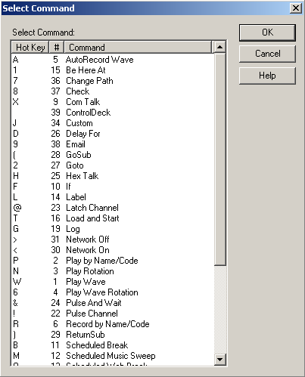

The New command selection dialog (default) is shown below:

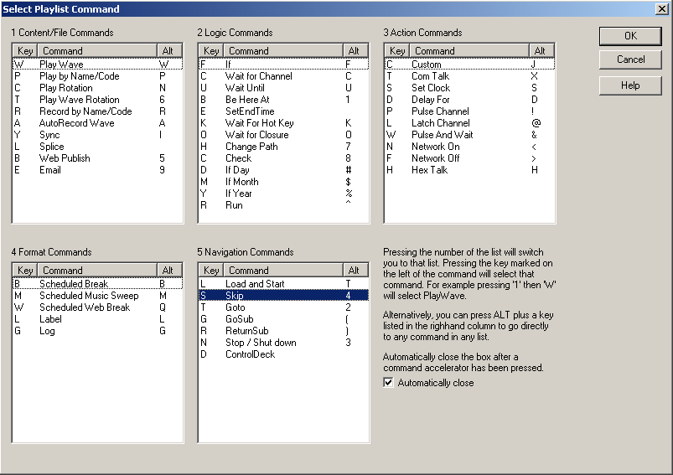

The user can set which view they would like. To set the view to be the Select Command (old) view:

1) From the Main Menu, choose Setup.
This drop-down box will open:
2) Choose Use Old Command Selection Dialog. The drop-down box will close. When the Use Old Command Selection Dialog statement is checked, the Select Command window will open when a playlist is edited.

Note: All time parameters are entered in the commands in Military Format (24 hour) using 6 digits as either HHMMSS or HH:MM:SS, where HH is hours, MM is minutes, and SS is seconds.
COMMANDS

AUTORECORD
ALL ABOUT: AUTORECORD

PURPOSE: The AutoRecord command is used to automatically record an audio source and then create a *.WAV file in the MediaLog which contains your recorded audio.

EXAMPLE OF USE: If there were a program that a satellite network sends down at a certain time, and you want to play it at a different time, you would use the AutoRecord command. The AutoRecord records the audio and creates a file that can then be played at a later time.

PARAMETERS: 1) You select the file name for the WAV file that will be created. The file name that you specify can be a new file name or can be the same as a file that already exists. The existing file will be overwritten with the file created by the AutoRecord.
2) You put in the destination folder, recording length, and audio card to record on.

IMPORTANT NOTES:

ALSO SEE: RECORD BY NAME/CODE

HOW TO SET UP: AutoRecord
1) Highlight the sequence that you want the AutoRecord command to go on.
2) Press Enter to open up the LIST OF COMMANDS.
3) Press Alt-A, or highlight A-AutoRecord Wave and press Enter.

This window will open:
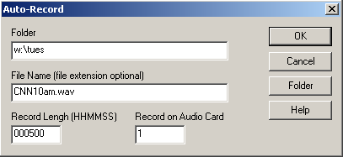
Note: All time parameters are entered in Military Format (24 hour) using 6 digits as HHMMSS, where HH is hours, MM is minutes, and SS is seconds.

4) Enter the folder path in the Folder box to assign the directory where the audio will be stored. Click on the Folder button to see a list of available MediaLog folders.
5) Enter the name of the file in the File Name box. Entering the file extension is not necessary. ControlReady for Windows will record the audio as a WAV file and assign WAV as the extension.
6) Enter the length of the recording in the Record Length box as a 6-digit number (HHMMSS).
7) Enter the audio card to use in the Record on Audio Card box.
8) Click the OK button to save the parameters and add the command.

BE HERE AT
ALL ABOUT: BE HERE AT

PURPOSE: The Be Here At command is used to have the Automation Program move to a specific sequence at a specific time.

EXAMPLE OF USE: This command can be used to make the Automation program skip ahead while playing audio to keep the playlist on time.

PARAMETERS: You select the time of day for the Automation Program to be on that sequence line.

IMPORTANT NOTE: If the sequence line is reached before the time specified in the command, the automation will remain on this line until the time is reached.

ALSO SEE: Wait Until

HOW TO SET UP: Be Here At
1) Highlight the sequence that you want the Be Here At command to go on.
2) Press Enter to open up the LIST OF COMMANDS.
3) Press Alt-1, or highlight 1-Be Here At and press Enter.

This selector box will open:
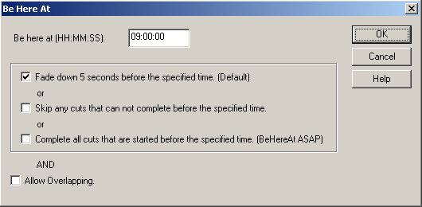
Note: All time parameters are entered in Military Format (24 hour) using 6 digits as HH:MM:SS, where HH is hours, MM is minutes, and SS is seconds.

4) Enter the time you want the Automation Program to be on that sequence line in the Be here at (HH:MM:SS) box.
5) Check the statements that reflect how you want the command to be at the sequence line at the designated time:
Fade down 5 seconds before the specified time (Default). When checked, this will cause the currently playing audio to fade out for the 5 seconds before the specified time.
Skip any cuts that can not complete before the specified time. When checked, this will skip any audio files that cannot be completed before the specified time. If there are no audio files that will fit within the time left before the Be Here At specified time, then the program will arrive at the command early.
Complete all cuts that are started before the specified time (BeHereAt ASAP). When checked, this will continue playing the current audio until that file is completed, then move to the Be Here At sequence line, skipping any other lines between the playing audio and Be Here At line. The playlist will arrive at the command late, but as soon as possible.
Allow Overlapping. (This feature has not been enabled yet) When checked, this will allow the currently playing audio to be overlapped with the first audio file after the Be Here At line.
6) Click the OK button to save the parameters and add the command.

CHANGE PATH
ALL ABOUT: CHANGE PATH

PURPOSE: The Change Path command is used to allow the commands Splice and Record By Name/Code to use a path other than the default play path.

EXAMPLE OF USE: If some segments will be published to the station’s website and others will not, those recordings will need to be saved to a different folder than the Default Play Path.

PARAMETERS: This command must be the located immediately before the non-pathed command, and is only valid for a single command

HOW TO SET UP: Change Path
1) Highlight the sequence that you want the Change Path command to go on.
2) Press Enter to open up the LIST OF COMMANDS.
3) Press Alt-7, or highlight 7-Change Path and press Enter.
This selector box will open:
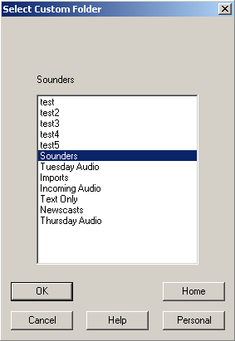

4) Highlight the Custom Folder path you would like to change to, then click OK.

CHECK
ALL ABOUT: CHECK

PURPOSE: The Check command is used to check the existence or state of a file.

EXAMPLE OF USE: This command would be used to alert users if a file has not been recorded or if the file is not the correct size. The command then sends the playlist to a specified line, where other commands can be activated to alert other users/management, or to perform some other action.

PARAMETERS: You choose the dates, times, file size and if a specified file exists. You choose what sequence line to go to if it passes or fails.

SEE ALSO: EMAIL

HOW TO SET UP: Check
1) Highlight the sequence that you want the Check command to go on.
2) Press Enter to open up the LIST OF COMMANDS.
3) Press Alt-8, or highlight 8-Check and press Enter.
This selector box will open:
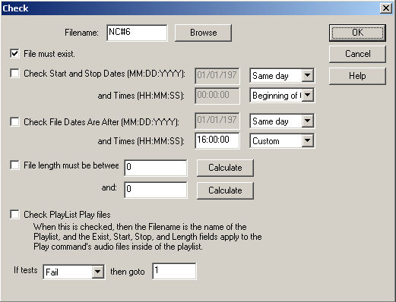

4) Enter the name of the wave file in the Filename field, or click the Browse button to browse to the file.
5) Click the File must exist checkbox if you want to have the Check command be used to see if the file exists.
6) Click the Check Start and Stop Dates box if you are going to have the command check for a specified start and stop date/time. The date and time fields will be made active if this box is checked.
7) Click the Check File Dates Are After box if you are going to have the command check that the file was created after a specified date. The date and time fields will be made active if this box is checked.
8)Check the File length must be between box if you are going to use the command to check the size of the file. Click to Calculate to have the program estimate the file size based on the format of the audio file.
9) Check the Check PlayList Play files to have all of the Play commands in the entire playlist checked for any of the above parameters. If this is used, the Filename field must include the name of the playlist to be checked.
10) Use the drop-down choices in the If box to choose if the above information either Passes or Fails.
11) Enter the sequence number to go to in the Then box.
12) Click the OK button to save the parameters and add the command.

COMTALK
ALL ABOUT: COMTALK

PURPOSE: The ComTalk command is used to send characters out a serial port (com port) to communicate with various devices using serial commands. This command is used mostly for communicating with audio switchers, but can also be used to communicate with the Broadcast Tools Watchdog, SCC4, SCC8, modems, and other devices.

EXAMPLE OF USE:

PARAMETERS: You type in the string of characters to send out the serial port.
You select the serial port that the device is connected to.
You select baud rate, parity, data bits, stop bits, and the inter-character delay that the device uses.

IMPORTANT NOTES: ComTalk is a ONE-WAY command. That means that we send characters out of the serial port, but will ignore ALL incoming characters returned from the device. Therefore devices that require data flow in both directions probably will not work well with this command. See the instruction manual for your specific hardware for details on the string to be used in the ComTalk command.

HOW TO SET UP: ComTalk
1) Highlight the sequence that you want the ComTalk command to go on.
2) Press Enter to open up the LIST OF COMMANDS.
3) Press Alt-X, or highlight X-Com Talk and press Enter.

This window will open:
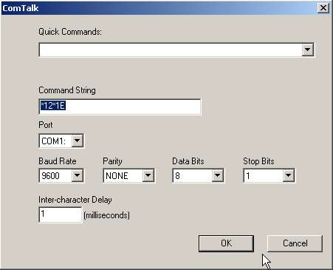

4) Enter the string of characters* that will be sent out of the specified serial port in the Command String box. * - If the string of commands that you need to send includes a CR (Carriage Return - ASCII 13), you need to use "{0x0d}" to reproduce the carriage return.
5) Enter the serial (COM) port that the device you will be communicating with is connected to in the Port box.
6) Use the drop-down menu to select the Baud Rate that the device you are communicating with uses.
7) Use the drop-down menu to select the Parity that the device you are communicating with uses.
8) Use the drop-down menu to select the Data Bits that the device you are communicating with uses.
9) Use the drop-down menu to select the Stop Bits that the device you are communicating with uses.
10) Enter the inter-character delay that the device you are communicating with uses in the Inter-character Delay box. Unless your device requires a pause between characters, leave the intercharacter delay set to 1.
11) Click the OK button to save the parameters and add the command.

CONTROLDECK
ALL ABOUT: CONTROLDECK

PURPOSE: The ControlDeck command is used to control another ControlReady for Windows deck.

EXAMPLE OF USE: This command could be used to control a deck to stop or start other recording sessions.

PARAMETERS: You set the ControlReady for Windows deck to control, if the other deck will be stopped or started, and the sequence line to start the other deck on.

HOW TO SET UP: ControlDeck
1) Highlight the sequence that you want the ControlDeck command to go on.
2) Press Enter to open up the LIST OF COMMANDS.
3) Highlight ControlDeck and press Enter.

This window will open:

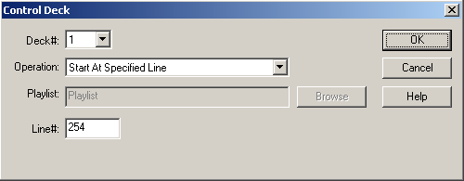

4) Use the drop-down list in the Deck# box to choose which ControlReady for Windows deck to control.
5) Use the drop-down list In the Operation box to choose what action will be taken on the other deck.
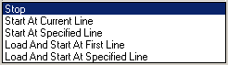
6) If one of the Load and Start statements is selected, the Playlist field will become active. If one of the statements to start at a Specified Line is selected, the Line# field will be active.
7) Enter the playlist name or sequence line # to start on.
8) Click the OK button to save the parameters and add the command.

CUSTOM
ALL ABOUT: CUSTOM

PURPOSE: The Custom command is used to save the parameters for frequently used commands in the Automation Program. By setting up a custom command, you can create a command that is easier to understand for the general user.

EXAMPLE OF USE: When switching between different studio’s signal, it is easier to use a custom command to retain the correct Com Talk commands being sent to the switcher.

PARAMETERS: You set all of the parameters for the specific commands you want to create.

IMPORTANT NOTE: The Custom command is not a command that creates a specific result in the Automation Program. The Custom command has to be set up to use one of the existing commands, and will save the parameters for that command as one of the available custom commands.

HOW TO SET UP: Custom
1) Highlight the sequence that you want the Custom command to go on.
2) Press Enter to open up the LIST OF COMMANDS.
3) Press Alt-J, or highlight J-Custom and press Enter.

This selector box will open:
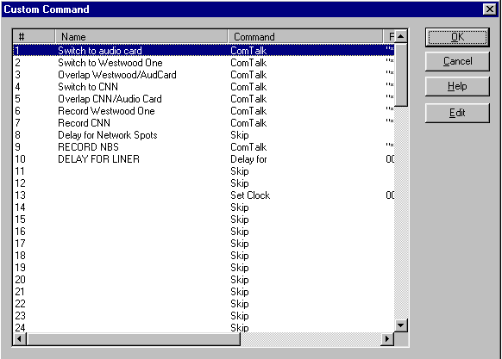

4) If there are already custom commands created, choose one of the commands and click the OK button to save the parameters and add the command.

To create a new Custom command:
1) Highlight an unused line to add the new custom command on.
2) Click the Edit button.
3) Enter a name for the custom command. This is the name that will appear in the Automation Program. Click the OK button
4) Highlight a command from the list and click the OK button.
5) Enter the parameters for the command you are creating. If you are unsure how to enter the parameters, refer to that command’s information in the Commands section of this manual.
6) When you are done creating the custom command, it will be added to the list of custom commands.
7) Continue adding new commands as needed. When done adding new commands, click the OK button.

DELAY FOR
ALL ABOUT: DELAY FOR

PURPOSE: The Delay For command is used to hold the program at a specific sequence number for a specified period of time.

EXAMPLE OF USE: When you use the Auto-record command, you might want to make sure that no other commands attempt to use the same audio card. The Delay For command can be used for this. Set up a Delay For command that is as long as, or a little longer than, the autorecording.

PARAMETERS: You set the time period to delay for.

ALSO SEE: WAIT UNTIL

HOW TO SET UP: Delay For
1) Highlight the sequence that you want the Delay For command to go on.
2) Press Enter to open up the LIST OF COMMANDS.
3) Press Alt-D, or highlight D-Delay For and press Enter.

This window will open:
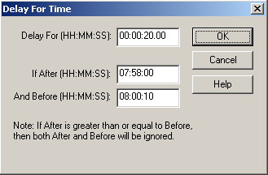
Note: Enter time parameters in Military Format (24 hour) using 6 digits as HH:MM:SS, where HH is hours, MM is minutes, and SS is seconds.

4) Enter the number of hours, minutes and seconds that you want the Automation Program to delay for in the Delay For box.
5) Enter the parameters to restrict this to a specific time of day in the If After and And Before entry boxes. There may be times that you would like to have the program delay if one event is shorter than desired, but not delay if it ends on time.
6) Click the OK button to save the parameters and add the command.

EMAIL
ALL ABOUT: EMAIL

PURPOSE: The Email command is used to send out email notifications to preset email addresses.

EXAMPLE OF USE: The email command could be used to send an error message because something went wrong, or status notifications because something didn't go wrong. Used in conjunction with the Check command.

PARAMETERS: The email addresses need to be set up in advance. You choose the account to send an email to, the text file that will be sent, and what folder/location the message will be written to.

ALSO SEE: CHECK

HOW TO SET UP: Email
1) Highlight the sequence that you want the Email command to go on.
2) Press Enter to open up the LIST OF COMMANDS.
3) Press Alt-9, or highlight 9-Email and press Enter.

This selector box will open:
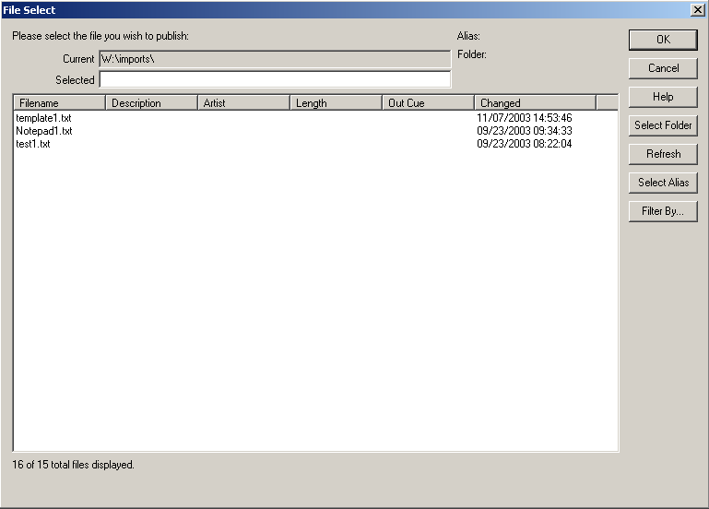

4) Click on the Select Alias button.

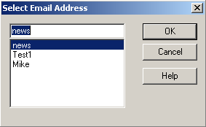

5) Choose the email alias to send the file to, then click OK.
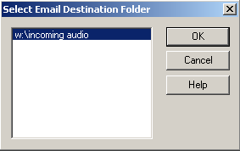

6) Choose the destination folder, then click OK.

7) Choose a text file from the list, and double-click on it to select it or click OK.
-OR-
8) Click on the Select Folder button to choose a file from a different folder.
9) Choose the folder to switch to.
10) Choose a text file from the list, and double-click on it to select it or click OK.

GOSUB
ALL ABOUT: GOSUB

PURPOSE: The GoSub command is used to cause the program to jump to a sequence number. The sequence number that it jumps to is a series of commands that are called more than once over the duration of the program. The purpose of the command is to save time when creating/modifying the program, and to have fewer lines in the program. The GoSub command is always used in conjunction with the ReturnSub command.

EXAMPLE OF USE: If you have a series of commands that are executed at the top of every hour, it is easier to put that set of commands into the program only once and then go to them whenever you want to execute them. Let's say the set of commands that are executed at the top of every hour contains 6 commands. That would be 144 commands if the series of commands were put in each hour (over a 24 hour period). Rather than putting those six commands at the top of every hour throughout the program, you would just list them once at the end of the program, and use the GoSub command to execute the whole set. Then, because ReturnSub is included in the set of commands, when it hits the ReturnSub command, the program jumps back to the sequence immediately following the GoSub command which caused the program to jump in the first place.

PARAMETERS: You choose the sequence number to go to.

IMPORTANT NOTES: GoSub is an advanced command, and should be used with caution.
The series of commands that the GoSub command jumps to MUST be at the end of the automation program. That is, after the Load and Start command, and/or after ALL time/channel-based logic which is not part of the GoSub sets of commands.

ALSO SEE: RETURN SUB; GOTO; LOAD AND START

HOW TO SET UP: GoSub
1) Highlight the sequence that you want the GoSub command to go on.
2) Press Enter to open up the LIST OF COMMANDS.
3) Press Alt-(, or highlight (-GoSub and press Enter.

This window will open:
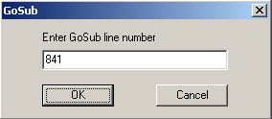

4) Enter the sequence number in the Enter GoSub line number box that you want the Automation Program to jump to when this command is executed.
5) Click the OK button to save the parameters and add the command.

GOTO
ALL ABOUT: GOTO

PURPOSE: The Goto command is used to make the program jump from the sequence the Goto command is issued on, to the sequence number specified.

EXAMPLE OF USE: If you want the program to repeat a certain set of commands, the last line of the set would be a Goto that specifies the first sequence number of the set of commands to repeat.

PARAMETERS: You select which sequence number you want the program to go to when it executes this command.

IMPORTANT NOTES: Goto is different than GoSub because Goto will cause the program to jump to a specific sequence number, without any memory of the sequence number that caused it to jump. While GoSub will cause the program to jump to a specific sequence number, and then return to the sequence below the GoSub.

ALSO SEE: GOSUB

HOW TO SET UP: Goto

1) Highlight the sequence that you want the Goto command to go on.
2) Press Enter to open up the LIST OF COMMANDS.
3) Press Alt-2, or highlight 2-GOTO and press Enter.

This window will open:

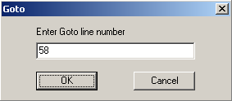

4) Type in the sequence number in the Enter Goto line number that you want the Automation Program to jump to when this command is executed.
5) Click the OK button to save the parameters and add the command.

HEX TALK
ALL ABOUT: HEX TALK

PURPOSE: Hex Talk is, for the most part, the ComTalk command. It was created for a specific use of ComTalk in the DOS version of automation. The Hex Talk command will work in ControlReady for Windows when running playlists created in the DOS ControlReady program, but ComTalk should be used if creating a new playlist.

ALSO SEE: ComTalk

IF
ALL ABOUT: IF

PURPOSE: The If command is used to check for either the current time, or whether or not a closure has been received.

EXAMPLE OF USE (If Time):

PARAMETERS: You choose what time to check for, and which line to go to if it is after that time (or before that time).

EXAMPLE OF USE (If Channel):

PARAMETERS: You choose what channel to check for, which state (HI or LO) to check for, and which line to go to if it is NOT the state you are checking for.

HOW TO SET UP: If
1) Highlight the sequence that you want the If command to go on.
2) Press Enter to open up the LIST OF COMMANDS.
3) Press Alt-F, or highlight F-If and press Enter.

This selector box will open:
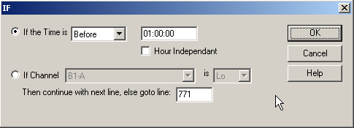
Note: All time parameters are entered in Military Format (24 hour) using 6 digits as HH:MM:SS, where HH is hours, MM is minutes, and SS is seconds.

4) a) If you are using time, use the drop-down menu to choose Before or After in the If the Time is box.
Enter the time of day the If command should use.
b) If you are using a channel, use the drop-down menu to choose the channel in the If Channel box.
Use the drop-down menu to choose if the channel should be Hi or Lo.
Enter the sequence number the Automation Program should go to in the Then continue with next line, else goto line: box.
5) Click on the OK button to save the parameters and add the command.

IF DAY
ALL ABOUT: IF DAY

PURPOSE: The If Day command is used when events occur on certain days of the week …………….

EXAMPLE OF USE:

PARAMETERS: You check the statements that reflect the days of the week that the playlist is to continue to the next line, and enter the sequence line number for the playlist to go to if the current day is not one of the selected days.

IMPORTANT NOTES: The If Day command is not displayed when using the Old Command Selection Dialog screen.

ALSO SEE: IF MONTH; IF YEAR

HOW TO SET UP: If Day
1) Highlight the sequence that you want the If Day command to go on.
2) Press Enter to open up the LIST OF COMMANDS.
3) Press Alt-#, or highlight If Day and press Enter.

This window will open:

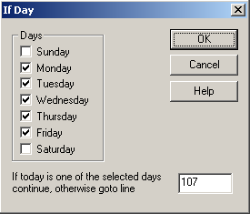

4) Click on the statements for the days of the week that the playlist is to continue to the next line.
5) Enter the line to go to if the day is not one of the selected days in the If today is one of the selected days continue, otherwise goto line entry box.
6) Press Enter or click on the OK button.

IF MONTH
ALL ABOUT: IF MONTH

PURPOSE: The If Month command is for ……..

EXAMPLE OF USE:

PARAMETERS: You check the statements that reflect the months of the year that the playlist should continue to the next line, and enter the sequence line number for the playlist to go to if the current day is not in one of the selected months.

IMPORTANT NOTES: The If Month command is not displayed when using the Old Command Selection Dialog screen.

ALSO SEE: IF DAY; IF YEAR

HOW TO SET UP: If Month
1) Highlight the sequence that you want the If Month command to go on.
2) Press Enter to open up the LIST OF COMMANDS.
3) Press Alt-$, or highlight If Month and press Enter.

This window will open:

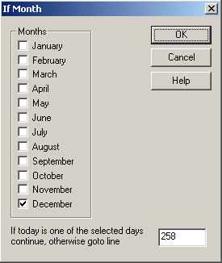

4) Check the statements for the months of the year in which the playlist should continue to the next line.
5) Enter the line to go to if the day is not within one of the selected months in the If today is one of the selected days continue, otherwise goto line entry box.
6) Press Enter or click on the OK button.

IF YEAR
ALL ABOUT: IF YEAR

PURPOSE: The If Year command is for ……………

EXAMPLE OF USE:

PARAMETERS: You check the statement that reflects the year that the playlist should continue to the next line, and enter the sequence line number for the playlist to go to if the current day is not within one of the selected years.
When you choose the year (this year, Next Year, etc), the sequence line will display the numeric equivalent (2004, 2005, etc)

IMPORTANT NOTES: The If Year command is not displayed when using the Old Command Selection Dialog screen.

ALSO SEE: IF DAY; IF MONTH

HOW TO SET UP: If Year
1) Highlight the sequence that you want the If Year command to go on.
2) Press Enter to open up the LIST OF COMMANDS.
3) Press Alt-%, or highlight If Year and press Enter.

This window will open:

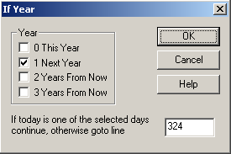

4) Choose the years in which the playlist should continue to the next line.
5) Enter the line to go to if the current day is not within one of the selected years in the If today is one of the selected days continue, otherwise goto line entry box.
6) Press Enter or click on the OK button.

LABEL
ALL ABOUT: LABEL

PURPOSE: The Label command is for you to put labels and comments into the Automation Program. ControlReady for Windows ignores all Label commands.

EXAMPLE OF USE: At the top of every program you should have Label commands that say the name of the Automation Program, as well as the purpose of the Automation Program, and what the different input and output channels are used for. Also at the top of every hour and before each break, as well as any other place you think it is a good idea to explain what the Automation Program is doing.

PARAMETERS: You type in the text to display on the sequence that the Label command is on.

ALSO SEE: SKIP

HOW TO SET UP: Label
1) Highlight the sequence that you want the Label command to go on.
2) Press Enter to open up the LIST OF COMMANDS.
3) Press Alt-L, or highlight L- Label and press Enter.

This window will open:

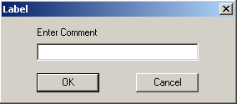

4) Type in the text that you want to be displayed, and press Enter or click on the OK button.

LATCH CHANNEL
ALL ABOUT: LATCH CHANNEL

PURPOSE: The Latch Channel command is used when you want an AT1616 output channel to go to a certain state (HI or LO) and remain in that state until another Automation Program or another device changes the state.

EXAMPLE OF USE: If you have a device that passes audio when it has a closure, you would latch a channel HI. When you do NOT want to allow audio to be passed through the device, you would latch the channel LO.

PARAMETERS: 1) You select the state (HI or LO) that you want to latch the channel.
2) You select which output channel you want latched.

IMPORTANT NOTES: Do NOT use the Latch Channel command unless the device that is connected to the channel that you are latching needs a constant closure/voltage. For Example, do NOT use the Latch Channel command when switching channels with the Broadcast Tools 6x1(a) Stereo Switcher, as that will make it so that you cannot change channels without first unlatching the channel which was latched.

ALSO SEE: PULSE CHANNEL; TURN NETWORK ON; TURN NETWORK OFF.

HOW TO SET UP: Latch Channel
1) Highlight the sequence that you want the Latch Channel command to go on.
2) Press Enter to open up the LIST OF COMMANDS.
3) Press Alt-@, or highlight @-Latch Channel and press Enter.

This window will open:
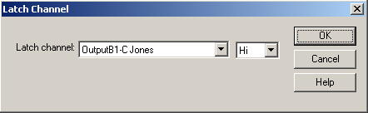

4) Use the drop-down menu in the Latch Channel box to select the output channel that you want to latch.
5) Use the drop-down menu to select whether you want to latch the channel HI or LO.
6) Click the OK button to save the parameters and add the command.

LOAD AND START
ALL ABOUT: LOAD AND START

PURPOSE: The Load and Start command is used to stop the Automation Program that is running and load and start a different program, on sequence 1, in the same automation deck.

EXAMPLE OF USE: If at the end of Monday's program you want to load the program for Tuesday, you would put a Load and Start command at the end of the Monday program so that when it reaches that point the Tuesday program is loaded into the same Automation Deck and immediately started on sequence 1.

PARAMETERS: You specify which Automation Program that you want to be loaded and started.

IMPORTANT NOTES: 1) Make sure that the Automation Program that you want to Load and Start exists.
2) This command will only have an effect on the Automation Deck in which it was executed. It will NOT have any effect on the other Automation Decks that are running.

ALSO SEE: STOP / SHUT DOWN

HOW TO SET UP: Load and Start
1) Highlight the sequence that you want the Load and Start command to go on.
2) Press Enter to open up the LIST OF COMMANDS.
3) Press Alt-T, or highlight T-Load and Start and press Enter.

This window will open:
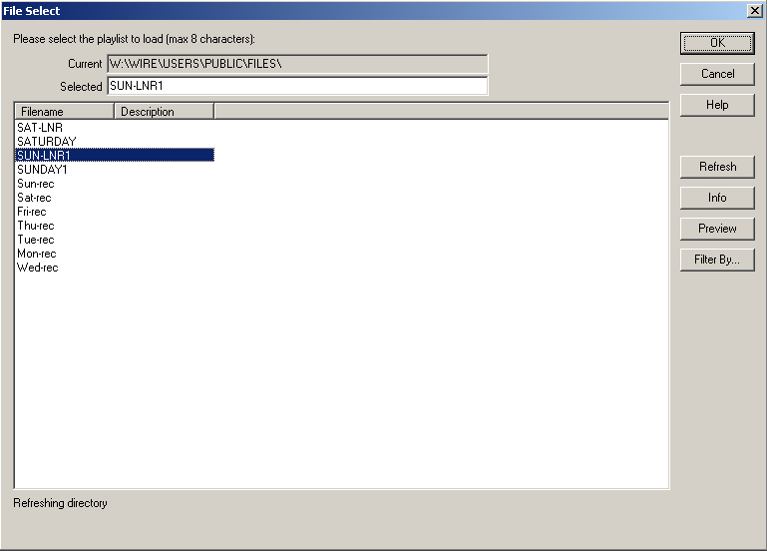

4) Highlight the Filename of the Automation program that you want to load and start when this command is executed and click the OK button.
-OR-
Double click on the Automation program that you want to load and start when this command is executed.

LOG
ALL ABOUT: LOG

PURPOSE: The Log command will cause a file to be created that will record the date and time that each line of the Automation Program was executed.

EXAMPLE OF USE: This is an information and trouble-shooting tool. It gives you the ability to go back at a later time and determine what audio files recorded, when the automation switched to and from studios, or any other commands that have been set up.

PARAMETERS: You choose to turn the logging on or off.

IMPORTANT NOTE: Logging is off by default, so if you do not put a Log On command in a playlist, none of its commands are logged.

IMPORTANT NOTE: If you are using a playlist that cycles or scans for a status, such as shown in the examples for the If and Goto commands, do NOT turn on logging for that playlist. The log file for such a playlist would become too large.

HOW TO SET UP: Log
1) Highlight the sequence that you want the Log command to go on.
2) Press Enter to open up the LIST OF COMMANDS.
3) Press Alt-G, highlight G-Log and press Enter, or double-click on G-Log.

This selector box will open:
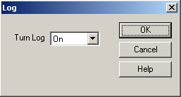
4) Use the drop-down menu to choose Off or On in the Turn Log box.
5) Click the OK button to add the command.

PACKAGER
ALL ABOUT: PACKAGER

PURPOSE: The Packager command is used to take audio files and put them together into a text file. The resulting text file is then sent to other locations using via email or web publishing.

EXAMPLE OF USE: When you want the Automation Program to put files together at a set time to have put to a web site.

PARAMETERS: You select the path and files to put together into a user-defined file.

IMPORTANT NOTE: Scheduling this command also adds the Change Path command before it to switch to the defined path of the source files.
Use Old Command Selection Dialog must be unchecked in the Setup menu choice for the command to show on the list of commands.

ALSO SEE: EMAIL, WEB PUBLISH

HOW TO SET UP: Packager
1) Highlight the sequence that you want the Packager command to go on.
2) Press Enter to open up the LIST OF COMMANDS.
3) Press 1 and then V, highlight Packager and press Enter, or double-click on Packager.

This selector box will open:
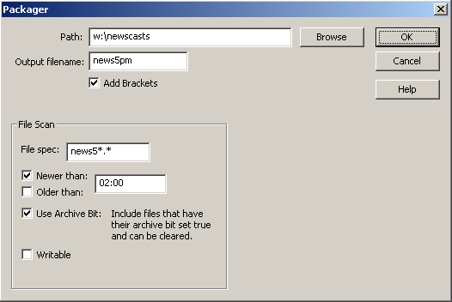

4) Enter the Path of the files that will be packaged. Click the Browse button to navigate to the desired folder, if you are unsure what the exact path is.
5) Enter the name of the file to be created in the Output filename field.
6) Check Add Brackets to have brackets put around the file names in the output file.
7) Enter the File Spec of the files that are to be packaged. Wildcards are allowed if multiple files will be packaged into the output file.
8) Check Newer Than if
Check Older Than if
9) Check Use Archive Bit to have the command look at the attributes of the files. If this is checked, the command will check to see that the Archive attribute exists for the file, and if so, will include the file and clear the Archive attribute. This keeps files from being processed in multiple files.
10) Check Writable to have the command confirm that the file is complete and able to be processed. This prevents files that are still being transferred from another source from being processed while incomplete.
11) Strike Enter or click the OK button to add the command.

PULSE AND WAIT
ALL ABOUT: PULSE AND WAIT

PURPOSE: This is a combination of the Pulse command and the Wait for Channel command.

EXAMPLE OF USE: If you have a device, such as a reel-to-reel machine, that accepts a closure to start, and issues a closure when it is finished, the Pulse and Wait command would trigger that device, then wait for the device to finish.

PARAMETERS: You indicate which output of the AT1616L to send the closure from, and which input on the AT1616L to look for the device to send a closure on.

ALSO SEE: PULSE CHANNEL; WAIT FOR CHANNEL

HOW TO SET UP: Pulse And Wait
1) Highlight the sequence that you want the Pulse And Wait command to go on.
2) Press Enter to open up the LIST OF COMMANDS.
3) Press Alt-&, highlight &-Pulse And Wait and press Enter, or double-click on &-Pulse And Wait.

This selector box will open:
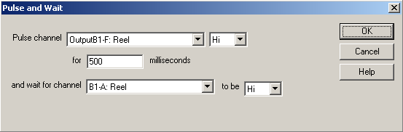
4) Use the drop-down menu to choose the channel to pulse in the Pulse channel box.
5) Use the drop-down menu to choose to pulse the channel Hi or Lo.
6) Enter the number of milliseconds to pulse the channel for in the milliseconds box.
7) Use the drop-down menu to choose the channel to wait for in the and wait for channel box.
8) Use the drop-down menu to choose to wait for the channel to go Hi or Lo in the to be box.
9) Click on the OK button to save the parameters and add the command.

PULSE CHANNEL
ALL ABOUT: PULSE CHANNEL

PURPOSE: The Pulse Channel command is used when you want an output channel to go to a certain state for a specified number of milliseconds (1/1000 second) and then go to the opposite state than the state the Pulse Channel command caused.

EXAMPLE OF USE: If you want to switch channels on the Broadcast Tools 6x1(a) switcher, you would pulse the corresponding output channel on the AT1616 HI for 500 msecs. The channel on the AT1616 will make a closure for 500 msecs that will cause the 6x1(a) to switch channels. After 500 msecs, the AT1616 output channel will return to the open (non-closure) position - but the switcher will remain on the channel that it was switched to.

PARAMETERS: 1) You select which output channel you want to pulse.
2) You select whether you want the channel to be pulsed HI or LO.
3) You set the duration that you want the channel to be pulsed for.

IMPORTANT NOTES: Do NOT use the Pulse Channel command unless the device that you are controlling only needs a brief closure/voltage. The Pulse Channel command will be issued, then the program will continue to the next command. The program does not wait for the length of the pulse to continue, but pulses the channel and immedialtely continues.

ALSO SEE: LATCH CHANNEL

HOW TO SET UP: Pulse Channel
1) Highlight the sequence that you want the Pulse Channel command to go on.
2) Press Enter to open up the LIST OF COMMANDS.
3) Press Alt-!, or highlight !-Pulse Channel and press Enter.

This window will open:
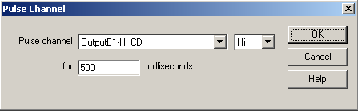

4) Use the drop-down menu to select the output channel that you want to pulse in the Pulse channel box.
5) Use the drop-down menu to select whether you want to pulse the channel Hi or Lo.
6) Enter the number of milliseconds that you want the channel pulsed for in the milliseconds box.
7) Click the OK button to save the parameters and add the command.

RECORD BY NAME/CODE
ALL ABOUT: RECORD BY NAME/CODE

PURPOSE: The Record By Name/Code command is used to automatically record an audio source and then create a *.WAV file in the MediaLog which contains your recorded audio.

EXAMPLE OF USE: If the broadcast signal is to be recorded to be posted to a web site or for monitoring the broadcast quality at a later time, you would use the Record By Name/Code command. The Record By Name/Code records the audio and creates a file that can then be played at a later time.

PARAMETERS: 1) You select the file name for the WAV file that will be created. The file name that you specify can be a new file name or can be the same as a file that already exists. The existing file will be overwritten with the file created by the Record By Name/Code.
2) You put in the recording length or the end time. You can also set up the parameters, if desired.

IMPORTANT NOTES: The record by name command will use the first audio card that is mapped to that automation deck. To use the parameter to end at a set time, you must enable the New Playlist File Format in the user’s ini file.

ALSO SEE: AUTORECORD

HOW TO SET UP: Record By Name/Code
1) Highlight the sequence that you want the Record By Name/Code command to go on.
2) Press Enter to open up the LIST OF COMMANDS.
3) Press Alt-R, or highlight R-Record by Name/Code and press Enter.

This window will open:
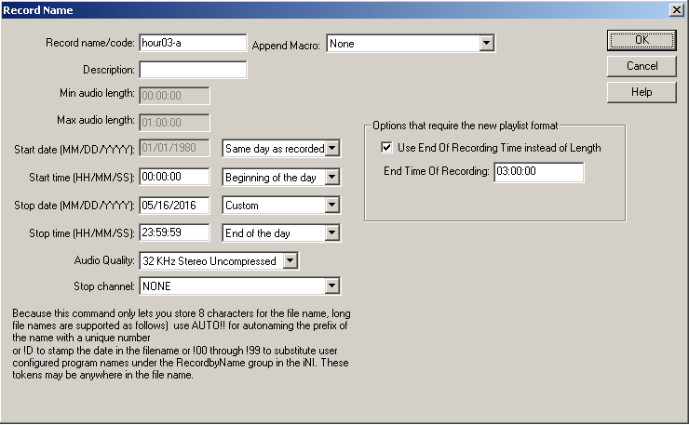
Note: All time parameters are entered in Military Format (24 hour) using 6 digits as HH:MM:SS, where HH is hours, MM is minutes, and SS is seconds.

4) Enter the name of the file in the Record name/code box. Entering the file extension is not necessary. ControlReady for Windows will record the audio as a WAV file and assign WAV as the extension.
5) Enter the description of the file in the Description box.
6) Enter the minimum length of the recording in the Min audio length box as a 6-digit number (HH:MM:SS).
7) Enter the maximum length of the recording in the Max audio length box as a 6-digit number (HH:MM:SS). This will determine the length of file if a stop channel is not activated.
8) If you will be using the option to record until a set time, check the Use End of Recording Time instead of Length statement. Then enter the time that the recording should end into the End Time of Recording box. When this option is used, the fields that hold the minimum and maximum times are grayed out.
9) Enter the Start date and Start time for the file.
10) Enter the Stop date and Stop time for the file.
11) Use the drop-down menu to choose the Audio Quality for the recording.
12) Use the drop-down menu to choose the Stop Channel.
13) Click the OK button to save the parameters and add the command.

RETURNSUB
ALL ABOUT: RETURNSUB

PURPOSE: The ReturnSub command is always used in conjunction with the GoSub command. ReturnSub causes the program to return to the sequence immediately following the GoSub command that caused the program to jump.

EXAMPLE OF USE: If you have issued a GoSub command, you put the ReturnSub command at the END of the series of commands that you want to be executed when the GoSub command is called.

PARAMETERS: There are no parameters associated with this command.

IMPORTANT NOTES: The ReturnSub command MUST be used in conjunction with a GoSub command.

ALSO SEE: GOSUB

HOW TO SET UP: ReturnSub
1) Highlight the sequence that you want the ReturnSub command to go on.
2) Press Enter to open up the LIST OF COMMANDS.
3) Press Alt-), or highlight )-ReturnSub and press Enter.

RUN
ALL ABOUT: RUN

PURPOSE: Run is used when you want a separate program to run outside of AirCheckReady at a certain point in the automation program.

EXAMPLE OF USE: The Run command can be used when you have recorded a program that you will be sending to other markets or affiliates, and it needs to be converted to a different format. A Run command can be scheduled for after the recording is completed, which would start the conversion program to run outside of the automation.

PARAMETERS: You enter the command string, including the path, file name and parameters to start the program.

IMPORTANT NOTE: You must include the path in the command string. This command was added to the program in version 4.006. The Run command is not displayed when using the Old Command Selection Dialog screen.

HOW TO SET UP: Run
1) Highlight the sequence that you want the Run command to go on.
2) Press Enter to open up the LIST OF COMMANDS.
3) Press Alt+^, or highlight Run and press Enter.

This selector box will open:
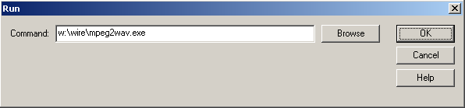

4) Enter the path and command string into the Command entry box.
5) Click the OK button to save the parameters and add the command.

SET CLOCK
ALL ABOUT: SET CLOCK

PURPOSE: The Set Clock command will set the computer's clock to the time of day that is specified. It is very important to keep the computer's clock accurate.

EXAMPLE OF USE: If you know that your satellite network sends down a tone at exactly 59 minutes and 55 seconds after the hour (xx:59:55), you would put in a Wait for Channel or Wait for Closure command to catch the tone, and then the very next command would be Set Clock.

PARAMETERS: You select the hour, minute, and second that you want the computer's clock set to.

IMPORTANT NOTES: You should only use Set Clock when you are sure an event (closure, etc.) will happen at an exact time.

ALSO SEE:

HOW TO SET UP: Set Clock
1) Highlight the sequence that you want the Set Clock command to go on.
2) Press Enter to open up the LIST OF COMMANDS.
3) Press Alt-S, or highlight S-Set Clock and press Enter.

This window will open:
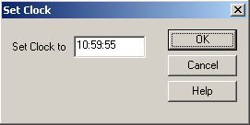
Note: All time parameters are entered in Military Format (24 hour) using 6 digits as HH:MM:SS, where HH is hours, MM is minutes, and SS is seconds.

4) Enter the time in the Set Clock to box.
5) Click the OK button to save the parameters and add the command.

SETENDTIME

ALL ABOUT: SETENDTIME

PURPOSE: The SetEndTime command is used to reset the EndTime of the commands in a playlist. All following commands will calculate their EndTimes based on this command executing at the specified time. Sometimes only the deck programmer can know when the command will really execute. This is for those times.

EXAMPLE OF USE: When playing music from hard-drive, and doing live news, you can use the SetEndTime command to mark when the live news is done. This will allow the end time of the songs to reflect the actual times that each file will end playing.

PARAMETERS: You set the time that the event will be ending.

IMPORTANT NOTES: This command will affect the end time of all the commands following the SetEndTime command.

HOW TO SET UP: SetEndTime
1) Highlight the sequence that you want the SetEndTime command to go on.
2) Press Enter to open up the LIST OF COMMANDS.
3) Highlight SetEndTime and press Enter.

This window will open:
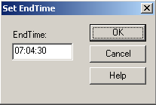
Note: All time parameters are entered in Military Format (24 hour) using 6 digits as HH:MM:SS, where HH is hours, MM is minutes, and SS is seconds.

4) Enter the time in the EndTime box.
5) Click the OK button to save the parameters and add the command.

SKIP
ALL ABOUT: SKIP

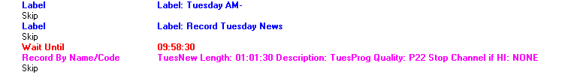

PURPOSE: The Skip command is just an optional space between commands to make the program easier to read/follow. AirCheckReady ignores all Skip commands.

EXAMPLE OF USE: Between scheduled breaks you would probably want a couple of skips to separate the breaks, as well as between different hours.

PARAMETERS: There are no parameters associated with this command

IMPORTANT NOTES: ControlReady for Windows ignores all Skip commands. All GOTO and GOSUB commands will be adjusted correctly as you insert Skips.

ALSO SEE: LABEL

HOW TO SET UP: Skip
1) Highlight the sequence that you want the Skip command to go on.
2) Press the Insert key on the keyboard.

-OR-

1) Highlight the sequence that you want the Skip command to go on.
2) Press Enter to open up the LIST OF COMMANDS.
3) Press Alt-4, or highlight Skip and press Enter.

SPLICE
ALL ABOUT: SPLICE

PURPOSE: The Splice command is used to merge 2 audio files into 1.

EXAMPLE OF USE:

PARAMETERS: You choose the names of the 2 files to add together, and the amount of time that will be added between the files.

IMPORTANT NOTES: This command modifies the first file by adding the audio from the second file.

ALSO SEE: CHANGE PATH

HOW TO SET UP: Splice
1) Highlight the sequence that you want the Splice command to go on.
2) Press Enter to open up the LIST OF COMMANDS.
3) Highlight Splice and press Enter.

This window will open:
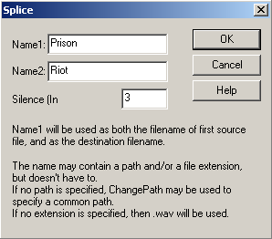

4) Enter the name of the first audio file in the Name1 field.
5) Enter the name of a second audio file in the Name2 field.
6) Enter the amount of silence to insert between the files, in milliseconds (100 would be 1/10 second, 1000 would be 1 second), in the Silence field.
7) Click the OK button to save the parameters and add the command.

STOP / SHUT DOWN
ALL ABOUT: STOP / SHUT DOWN

PURPOSE: The Stop / Shut Down command is used to stop the Automation Program when the command is executed.

EXAMPLE OF USE: If you want the Automation Program to shut down at 7:50 pm, you would put a Wait Until 19:50:00 command followed by Stop / Shut Down.

PARAMETERS: There are no parameters associated with this command.

IMPORTANT NOTES: This command will only stop the Automation Program that contains the Stop / Shut Down command. All other Automation Programs that are running will continue to run.

ALSO SEE: WAIT UNTIL; LOAD AND START

HOW TO SET UP: Stop / Shut Down
1) Highlight the sequence that you want the Stop / Shut Down command to go on.
2) Press Enter to open up the LIST OF COMMANDS.
3) Press Alt-3, or highlight 3-Stop / Shut down and press Enter.

SYNC
ALL ABOUT: SYNC

PURPOSE: The Sync command is used to have the Automation Program synchronize the audio files in a source and destination folder. Any file that exists (or is newer) in the source folder and does not exist in the destination folder will be copied to the destination folder.

EXAMPLE OF USE: This command will enable production to be done on one computer, while the new/edited audio files will be automatically copied to the Control computer for use on air.

PARAMETERS: The parameters are set upon scheduling the command in the Automation Program. The user is given the option to use existing parameters or add a new set of parameters that include the alias and source and destination folders.

IMPORTANT NOTE: Changes made to the existing parameters will affect all future uses of that alias's operation. If the Sync command has an alias of Production, and changes are made to that alias's source or destination folder, the new parameters will be reflected when that Sync command is struck in the Automation Program.

HOW TO SET UP: Sync
1) Highlight the sequence that you want the Sync command to go on.
2) Press Enter to open up the LIST OF COMMANDS.
3) Press Alt-I, highlight I- Sync and press Enter, or double-click on I- Sync.

This selector box will open:
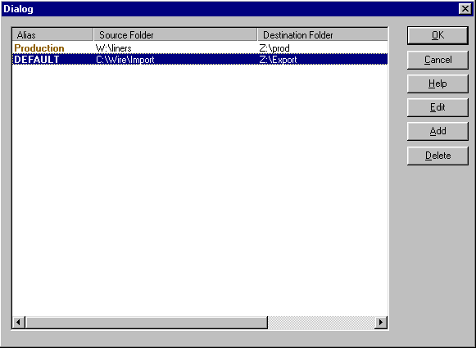

4) If there are already Sync alias parameters created, choose one and click the OK button to add the command.

To create a new Sync alias:
a) Click the Add button or strike Alt-A.
b) Enter an Alias. This is the name that will appear in the Automation Program.
c) Enter the path of the Source directory.
d) Enter the path of the Destination directory.
e) Enter the Filename or file spec that is to be copied. Asterisks and questions marks are allowed.
f) Enter a Speed. This is a number from 1-100, indicating how fast the operation should take place. This is an optional parameter, and if it is not present, then it will default to 50.
g) When you are done creating the new command, click OK or strike Alt-O to save the parameters.

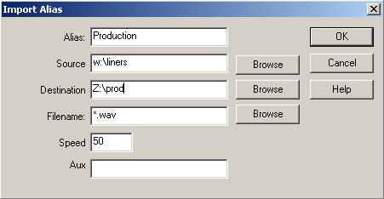

To edit an existing Sync alias:
a) Highlight the alias line to edit.
b) Click the Edit button or strike Alt-E.
c) Change the existing parameters, then click OK or strike Alt-O to save the changes.

5) Click the OK button to add the command.

WAIT FOR CHANNEL
ALL ABOUT: WAIT FOR CHANNEL

PURPOSE: The Wait for Channel command is used to hold the Automation Program on a specific sequence number until the specified input channel makes a closure (or the voltage goes HI or LO), or the time window (if used) expires.

EXAMPLE OF USE: If you were waiting for a tone to signal that the mic was turned on or off that will in turn create a closure on one of your input channels (or cause the voltage to go HI), you would issue this command. Then the Automation Program stays at this sequence until the input channel makes a closure (or the voltage goes HI or LO), or the time window (if used) expires, and then moves on to the next sequence.

PARAMETERS: 1) You select which input channel is to be monitored.
2) You select whether we are looking for the selected channel to go HI or LO.
3) You select whether or not the command will obey a time window.
4) If you choose to obey a time window, you set the time parameters, and the sequence to go to if the time window expires.

IMPORTANT NOTES: This command is used with the AT1616L Controller and the newe BroadcastTools switchers (with PIPs). See the AT1616 document for a diagram of which terminal numbers correspond with which channels.

ALSO SEE: WAIT FOR CLOSURE; WAIT FOR HOT KEY; WAIT UNTIL.

HOW TO SET UP: Wait for Channel
1) Highlight the sequence that you want the Wait for Channel command to go on.
2) Press Enter to open up the LIST OF COMMANDS.
3) Press Alt-C, or highlight C-Wait for Channel and press Enter.

This window will open:
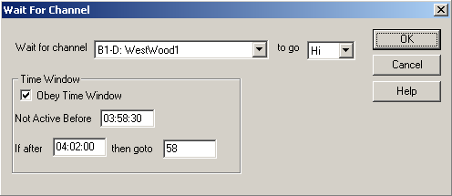
Note: All time parameters are entered in Military Format (24 hour) using 6 digits as HH:MM:SS, where HH is hours, MM is minutes, and SS is seconds.

4) Use the drop-down menu in the Wait for channel box to select the input channel to monitor.
5) Use the drop-down menu in the to go box to select whether the input channel which you specify will be monitored to go Hi (closure) or Lo (open).
6) If you have checked Obey Time Window:
- Enter the earliest time which you want this command to be executed in the Not Active Before box.
- Enter the latest time that you want this command to be executed in the If after box.
- Enter the sequence number that you want the Automation Program to jump to if the command does not occur by the If after time in the then goto box.
7) Click the OK button to save the parameters and add the command.

WAIT FOR CLOSURE
ALL ABOUT: WAIT FOR CLOSURE

PURPOSE: The Wait for Closure command is used to hold the Automation Program on a specific sequence number until the specified input channel detects a closure, or the time window (if used) expires.

EXAMPLE OF USE: If you were waiting for a tone from your satellite network that will in turn create a closure on your tone decoder that will cause the input channel to go HI, you would issue this command. The Automation Program stays at this sequence until the input channel gets the specified voltage, or the time window (if used) expires, and then moves on to the next sequence.

PARAMETERS: 1) You select which input channel is to be monitored.
2) You select whether or not the command will obey a time window.
3) If you choose to obey a time window, you set the time parameters, and the sequence to go to if the time window expires.

IMPORTANT NOTES: This command is present only for backward compatibility with Wireready’s DOS software. If setting up new commands, use the Wait for Channel command instead of Wait for Closure.

ALSO SEE: WAIT FOR CHANNEL; WAIT FOR HOT KEY; WAIT UNTIL.

HOW TO SET UP: Wait for Closure
1) Highlight the sequence that you want the Wait for Closure command to go on.
2) Press Enter to open up the LIST OF COMMANDS.
3) Press Alt-O, or highlight O-Wait for Closure and press Enter.

This window will open:
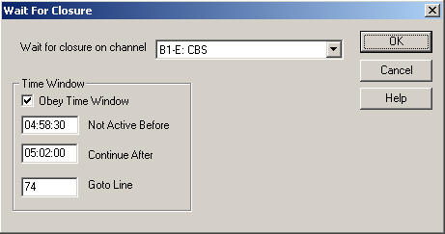
Note: All time parameters are entered in Military Format (24 hour) using 6 digits as HH:MM:SS, where HH is hours, MM is minutes, and SS is seconds.

4) Use the drop-down menu in the Wait for closure on channel box to select the input to monitor.
5) If you have checked Obey Time Window:
- Enter the earliest time which you want this command to be executed in the Not Active Before box.
- Enter the latest time that you want this command to be executed in the Continue After box.
- Enter the sequence number that you want the Automation Program to jump to (if the command does not occur by the Continue After time) in the Goto Line box.
6) Click the OK button to save the parameters and add the command.

WAIT FOR HOT KEY
ALL ABOUT: WAIT FOR HOT KEY

PURPOSE: The Wait for hot key command is used to hold the Automation Program at a specific sequence number until ALT-F3 is pressed, or the time window expires.

EXAMPLE OF USE: If you go live for an unspecified period of time, you would issue the Wait for hot key command so that when you are ready to continue with the Automation Program all you have to do is press ALT-F3.

PARAMETERS: 1) You choose whether or not the command should obey a time window.
2) If you choose to obey a time window, you set the Not Active Before & Continue After times, and the Goto Line if the time window expires.

IMPORTANT NOTES: When ALT-F3 (the hot key) is pressed ALL Automation Programs that are on a Wait for hot key command will advance (except those with time windows that exclude them).

ALSO SEE: WAIT FOR CHANNEL; WAIT FOR CLOSURE; WAIT UNTIL; DELAY FOR.

HOW TO SET UP: Wait for Hot Key
1) Highlight the sequence that you want the Wait for Hot Key command to go on.
2) Press Enter to open up the LIST OF COMMANDS.
3) Press Alt-K, or highlight K-Wait For Hot Key and press Enter.

This window will open:
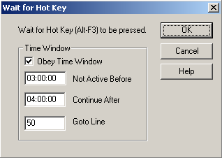
Note: All time parameters are entered in Military Format (24 hour) using 6 digits as HH:MM:SS, where HH is hours, MM is minutes, and SS is seconds.

4) If you have checked Obey Time Window:
- Enter the earliest time which you want this command to be executed in the Not Active Before box.
- Enter the latest time that you want this command to be executed in the Continue After box.
- Enter the sequence number that you want the Automation Program to jump to (if the command does not occur by the Continue After time) in the Goto Line box.
5) Click the OK button to save the parameters and add the command.

WAIT UNTIL
ALL ABOUT: WAIT UNTIL

PURPOSE: The Wait Until command is used to hold the Automation Program on a specific sequence number until a specified time of day.

EXAMPLE OF USE: If you want to begin recording at 5:00 am, you would put a Wait Until 05:00:00 command. The commands following the Wait Until would be to begin recording.

PARAMETERS: You set the hour, minute, and second to wait until.

IMPORTANT NOTES: When the Automation Program comes across this command, it will stay on the sequence until the time of day is at, or after, the time specified. Therefore, if you issue a Wait Until 10:00 command at 5:00 am, the Automation Program will not move for 5 hours. And if you issue a WAIT UNTIL 10:00 command at 5:00 pm, the program will move to the next sequence as soon as it comes to the Wait Until command.

ALSO SEE: DELAY FOR; WAIT FOR HOT KEY; WAIT FOR CHANNEL; WAIT FOR CLOSURE.

HOW TO SET UP: Wait Until
1) Highlight the sequence that you want the Wait Until command to go on.
2) Press Enter to open up the LIST OF COMMANDS.
3) Press Alt-U, or highlight U-Wait Until and press Enter.

This window will open:
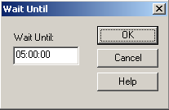
Note: All time parameters are entered in Military Format (24 hour) using 6 digits as HH:MM:SS, where HH is hours, MM is minutes, and SS is seconds.

4) Enter the HOUR, MINUTE, and SECOND that you want the program to Wait Until.
5) Click the OK button to save the parameters and add the command.

WEB PUBLISH
ALL ABOUT: WEB PUBLISH

PURPOSE: The Web Publish command will allow you to publish text and audio to your station's web site. Used in conjunction with DBCapture to publish text and audio to the web.

EXAMPLE OF USE: Publishing a broadcast segment to your Web site. Once the recording is done, the publishing can occur automatically.

PARAMETERS: You choose which file to push to the web, and the alias to use.

IMPORTANT NOTE: See the separate document on setting up DBCapture for publishing to a Web site.

HOW TO SET UP: Web Publish
1) Highlight the sequence that you want the Web Publish command to go on.
2) Press Enter to open up the LIST OF COMMANDS.
3) Press Alt-5, highlight 5-Web Publish and press Enter, or double-click on 5-Web Publish.

This selector box will open:
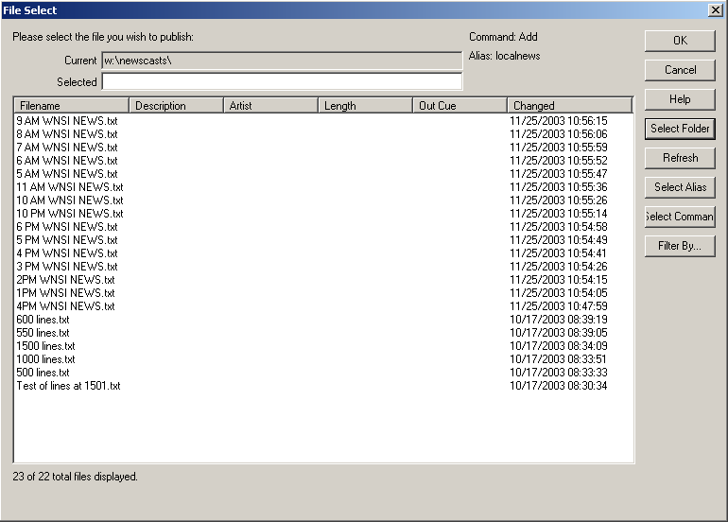

4) Click the Select Alias button.
This selector box will open:
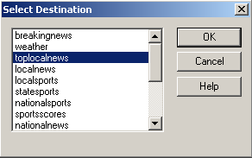

5) Highlight the destination from the list. Double-click on the destination or click the OK button to choose the Alias.

6) Click on the Select Command button to choose if the file is going to be added, removed, or deleted from the website. Use the drop-down list to highlight a Command, then click OK.
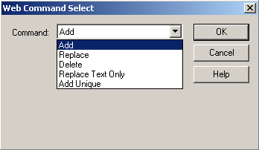

7) If the desired file is not in the File Select window, click on the Select Folder button to choose the folder that contains the file to publish to the web.
8) Highlight a folder name from the list of available folders. Double-click on the folder name or click the OK button to choose the folder.
9) Highlight the file to publish. Double-click on the file name or click the OK button to choose the file.

EXAMPLE OF AN AUTOMATION PROGRAM

This is an example of the beginning of an Automation Program for a station recording based on time.

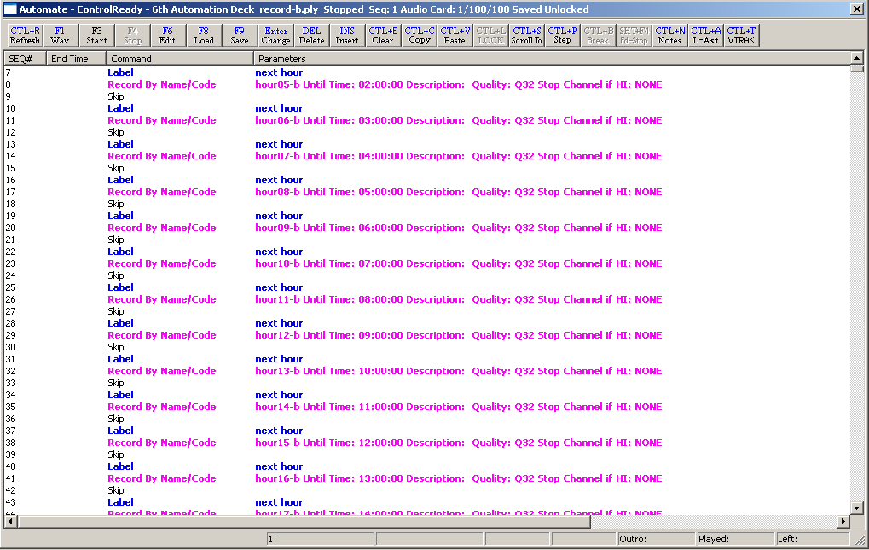

This is an example of the beginning of an Automation Program for a station recording based on length.

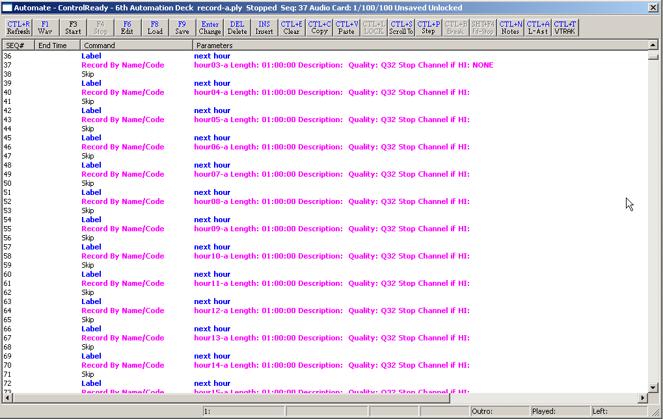

SYSTEM CONFIGURATION AND OTHER OPTIONS

The Logs created by the Log command

The log file is written in the Log folder of the user’s directory. The filename consists of the deck number, the month, the day, the year, and the playlist’s name, all separated with underscores, followed by the extension “.log”.

For example, if the root directory is “W:\Wire”, the user’s name is “Testuser”, the automation deck is 1, the date is 2-3-2002, and the playlist’s name is “Monday”, then the name of the log file is “W:\Wire\Users\Testuser\Logs\1_2_3_2002_Monday_ply.log”.

The log file will be appended to, but neither deleted nor overwritten. It is the responsibility of the system administrator to delete unwanted logs.

The format of the log file is [sequence line number]-[time that the line was executed]-[total length of time the playlist has been running] [the command and its parameters].

Example of the log created by the Log command:
Note: if the command and its parameters will extend past the margins of the page parameters, the line is word-wrapped to the following line.
36-10:59:44- 0:09:45:48 Logging being turned on.
37-10:59:44- 0:09:45:48 Labelnext hour
38-10:59:44- 0:09:45:48 Record By Name/Codehour15-b Length: 00:00:00 Description: Quality: Q32 Stop Channel if HI: NONE
36-11:56:44- 0:10:42:48 User is Deleting lines 36 - 36.
38-11:59:49- 0:10:45:53 Finished recording W:\PROGRAMS\hour15-b.wav
39-11:59:49- 0:10:45:53 Skip
40-11:59:49- 0:10:45:53 Labelnext hour
41-11:59:49- 0:10:45:53 Record By Name/Codehour16-b Length: 00:00:00 Description: Quality: Q32 Stop Channel if HI: NONE
41-12:00:12- 0:00:00:00 User presses F3 Start - Starting the playlist.
41-12:00:12- 0:00:00:00 Record By Name/Codehour16-b Until Time: 13:00:00 Description: Quality: Q32 Stop Channel if HI: NONE
41-12:59:49- 0:00:59:37 Finished recording W:\PROGRAMS\hour16-b.wav
42-12:59:50- 0:00:59:38 Skip
43-12:59:50- 0:00:59:38 Labelnext hour
44-12:59:50- 0:00:59:38 Record By Name/Codehour17-b Until Time: 14:00:00 Description: Quality: Q32 Stop Channel if HI: NONE
44-13:59:48- 0:01:59:36 Finished recording W:\PROGRAMS\hour17-b.wav
45-13:59:49- 0:01:59:37 Skip
46-13:59:49- 0:01:59:37 Labelnext hour
47-13:59:49- 0:01:59:37 Record By Name/Codehour18-b Until Time: 15:00:00 Description: Quality: Q32 Stop Channel if HI: NONE
47-14:59:49- 0:02:59:37 Finished recording W:\PROGRAMS\hour18-b.wav
48-14:59:49- 0:02:59:37 Skip
49-14:59:49- 0:02:59:37 Labelnext hour
50-14:59:49- 0:02:59:37 Record By Name/Codehour19-b Until Time: 16:00:00 Description: Quality: Q32 Stop Channel if HI: NONE
50-15:59:49- 0:03:59:37 Finished recording W:\PROGRAMS\hour19-b.wav
51-15:59:49- 0:03:59:37 Skip
52-15:59:49- 0:03:59:37 Labelnext hour
53-15:59:49- 0:03:59:37 Record By Name/Codehour20-b Until Time: 17:00:00 Description: Quality: Q32 Stop Channel if HI: NONE
53-16:59:49- 0:04:59:37 Finished recording W:\PROGRAMS\hour20-b.wav
54-16:59:49- 0:04:59:37 Skip
55-16:59:49- 0:04:59:37 Labelnext hour
56-16:59:49- 0:04:59:37 Record By Name/Codehour21-b Until Time: 18:00:00 Description: Quality: Q32 Stop Channel if HI: NONE
56-17:59:49- 0:05:59:37 Finished recording W:\PROGRAMS\hour21-b.wav
57-17:59:49- 0:05:59:37 Skip
58-17:59:49- 0:05:59:37 Labelnext hour
59-17:59:49- 0:05:59:37 Record By Name/Codehour22-b Until Time: 19:00:00 Description: Quality: Q32 Stop Channel if HI: NONE
59-18:59:49- 0:06:59:37 Finished recording W:\PROGRAMS\hour22-b.wav
60-18:59:49- 0:06:59:37 Skip
61-18:59:49- 0:06:59:37 Labelnext hour
62-18:59:49- 0:06:59:37 Record By Name/Codehour23-b Until Time: 20:00:00 Description: Quality: Q32 Stop Channel if HI: NONE
62-19:59:49- 0:07:59:37 Finished recording W:\PROGRAMS\hour23-b.wav
63-19:59:49- 0:07:59:37 Skip
64-19:59:49- 0:07:59:37 Labelnext hour
65-19:59:49- 0:07:59:37 Record By Name/Codehour00-b Until Time: 21:00:00 Description: Quality: Q32 Stop Channel if HI: NONE
65-20:59:49- 0:08:59:37 Finished recording W:\PROGRAMS\hour00-b.wav
66-20:59:49- 0:08:59:37 Skip
67-20:59:49- 0:08:59:37 Labelnext hour
68-20:59:50- 0:08:59:38 Record By Name/Codehour01-b Until Time: 22:00:00 Description: Quality: Q32 Stop Channel if HI: NONE
68-21:59:48- 0:09:59:36 Finished recording W:\PROGRAMS\hour01-b.wav
69-21:59:49- 0:09:59:37 Skip
70-21:59:49- 0:09:59:37 Labelnext hour
71-21:59:49- 0:09:59:37 Record By Name/Codehour02-b Until Time: 23:00:00 Description: Quality: Q32 Stop Channel if HI: NONE
71-22:59:49- 0:10:59:37 Finished recording W:\PROGRAMS\hour02-b.wav
72-22:59:49- 0:10:59:37 Skip
73-22:59:49- 0:10:59:37 Labelnext hour
74-22:59:49- 0:10:59:37 Record By Name/Codehour03-b Until Time: 23:59:59 Description: Quality: Q32 Stop Channel if HI: NONE
74-23:59:48- 0:11:59:36 Finished recording W:\PROGRAMS\hour03-b.wav
75-23:59:48- 0:11:59:36 Skip
76-23:59:48- 0:11:59:36 LogOff
76-23:59:48- 0:11:59:36 Logging being turned off.

Assigning Sound Cards to the ControlReady for Windows Decks
The sound cards can be assigned to the ControlReady for Windows decks in either the Automate or Player screen.

To assign the basic configuration options of the decks:

1) From the Automate menu bar, click Setup.
2) Click Audio Boards. This will open the "Configure Audio Devices" dialog box.
3) The Configure Audio Devices window has 3 tabs: Automation Wave Decks, Player Audio Boards and Options. Make changes to each tab, if necessary, before clicking OK to save settings.

Note: Changes to the Automation Wave Decks tab will not take effect until WireReady32 is exited and restarted.

Automation Wave Decks Tab
There are entry fields for each of the 8 ControlReady for Windows Decks in the Automate (Alt-0) screen. Choose the recording audio device to use for a deck by clicking on the drop-down arrow for the Record box and highlighting the desired audio device.

Player Audio Board Tab
This is used to configure the Player screen’s audio devices and is not used in AirCheckReady.

Options Tab
This is used with the Player screen and is not used in AirCheckReady.

4) Click on the Wave Decks tab.

This window will open:

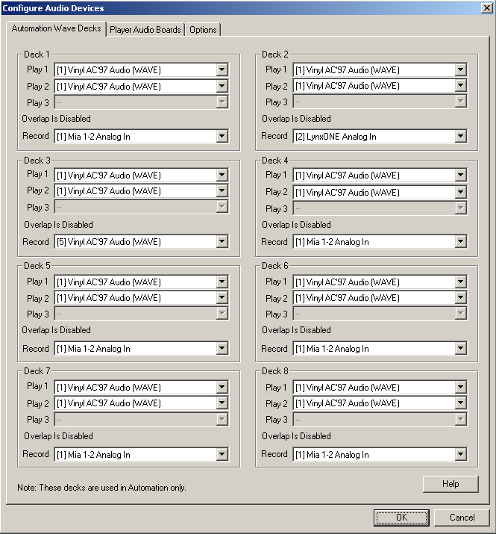

If you have more than one sound card in the computer, you can assign several decks to use device 1, and assign several other decks to use device 2. If you are only recording from one source, you can use the second audio card to preview or edit audio.

5) Assign audio boards to the decks. This applies if there is more than one audio card installed in your computer. If only one audio card is installed, all eight decks should all be assigned to Audio Board 1. Assign the audio devices that will be used for Recording in each deck (if using more than one audio device) using the drop-down lists.
6) When finished assigning devices, click OK.
7) Restart WireReady32 to allow the setting to be written back to the configuration files. The changes will not take effect until the program is restarted.

Printing the Playlists

WireReady32 can print the commands in a playlist from the ControlReady for Windows screen. The print-out will include the Sequence #, the Command and the Parameters fields for each line of the playlist.
Note: If the ControlReady for Windows Decks are set to Hide Audio Paths and Extensions and Hide Logic Parameters, these will not be printed. If you wish to print this information, uncheck these settings under the View menu before printing.

1. Open the playlist you wish to print in one of the decks (playlists will print from any of the 8 decks)
2. From the main menu, click on File or strike Alt+F on the keyboard.
3. Click on Print F5 or strike the F5 key.
The Select Print Range dialog box will open.
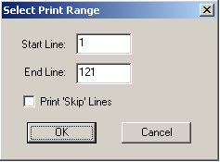
4. Enter the sequence number of the line that you wish to start printing on in the Start Line box.
5. Enter the sequence number of the line that you wish to stop printing on in the End Line box.
6. If you wish to only print the sequence lines that have commands on them, leave the Print “Skip” lines statement unchecked. Checking this statement will include the Skip lines in the printout and will make the print-out use more pages.
7. Click the OK button or strike the Enter key.
Note: The playlists will not print in color.

Configuration Files

[server]:\wire\system\SyncDir32.dat
This file holds the configuration of the Sync lines. When the Automation Program hit s a Sync command, this file will be read for custom folder information. All audio that is in the source directory will be copied into the destination directory.
Except when: The audio in the destination path is newer than the source path and the destination audio cannot be accessed (locked by another process, read only etc.).
Paths are acceptable both with and without trailing backslash characters.

Format of syncdir32.dat file:

<destination alias>;<destination path>;<source alias> (not used any more);<source path>;<file type>;<speed to copy> (value between 1 and 400)

Example:

Production;Z:\prod;;c:\liners;*.wav;10
DEFAULT;Z:\Export;;C:\Wire\Import;*.wav;10

The User *.ini File

[server]:\wire\users\[username]\[username].ini
This file holds configuration information for the user. The below section holds the settings affecting the AirCheckReady screen. This is a list of possible ini keys, what they represent, their possible values, and their default values. The settings may not appear in the same order in the user’s ini files.

[Automation]:
AutoLoadFileSelect - Whether or not the FileSelect list displays files when first started. The FileSelect window lists the files when adding Play and Load and Start commands. True = load the FileSelect list. False = Don't load the list
AudioLogFilename – The filename of the log to use for a detailed log of all audio status. Possible values are any fully qualified filename. Defaults to “Off” which means no logging.
Autostart - Whether or not the automation decks should automatically start. Possible values are: “Yes” and “No”. The default is: “No”.
Automates - This is the count of automation decks that are to be opened. This is an obsolete value and can safely be ignored since all available automation decks are always opened.
B1-A through B1-P - These are the aliases of the input channels for the first AT1616L. Possible values are any character string having 20 or fewer characters. The default values are: “Input1” through “Input16”.
B2-A through B2-P - These are the aliases of the input channels for the second At1616L. Possible values are any character string having 20 or fewer characters. The default values are: “Input1” through “Input16”.
Column_Width_Artist - This is the column width of the Artist column in the automation screen. This ini setting is automatically written by the program whenever the column size changes. Possible values are any number. The default is: 40.
Column_Width_Command - This is the column width of the Command column in the automation screen. This ini setting is automatically written by the program whenever the column size changes. Possible values are any number. The default is: 140.
Column_Width_Description - This is the column width of the Description column in the automation screen. This ini setting is automatically written by the program whenever the column size changes. Possible values are any number. The default is: 90.
Column_Width_EndTime - This is the column width of the EndTime column in the automation screen. This ini setting is automatically written by the program whenever the column size changes. Possible values are any number. The default is: 70.
Column_Width_Intro - This is the column width of the Intro column in the automation screen. This ini setting is automatically written by the program whenever the column size changes. Possible values are any number. The default is: 35.
Column_Width_Intro_Type - This is the column width of the Intro Type column in the automation screen. This ini setting is automatically written by the program whenever the column size changes. Possible values are any number. The default is: 50.
Column_Width_Length - This is the column width of the Length column in the automation screen. This ini setting is automatically written by the program whenever the column size changes. Possible values are any number. The default is: 60.
Column_Width_Outcue - This is the column width of the Outcue column in the automation screen. This ini setting is automatically written by the program whenever the column size changes. Possible values are any number. The default is: 40.
Column_Width_Outro - This is the column width of the Outro column in the automation screen. This ini setting is automatically written by the program whenever the column size changes. Possible values are any number. The default is: 35.
Column_Width_Outro_Type - This is the column width of the Outro Type column in the automation screen. This ini setting is automatically written by the program whenever the column size changes. Possible values are any number. The default is: 50.
Column_Width_Parameters - This is the column width of the Parameters column in the automation screen. This ini setting is automatically written by the program whenever the column size changes. Possible values are any number. The default is: 120.
Column_Width_Seq - This is the column width of the Sequence number column in the automation screen. This ini setting is automatically written by the program whenever the column size changes. Possible values are any number. The default is: 50.
Column_Width_Status - This is the column width of the Status column in the automation screen. This ini setting is automatically written by the program whenever the column size changes. Possible values are any number. The default is: 400.
Column_Width_Start_Date - This is the column width of the Start Date column in the automation screen. This ini setting is automatically written by the program whenever the column size changes. Possible values are any number. The default is: 85.
Column_Width_Stop_Date - This is the column width of the Stop Date column in the automation screen. This ini setting is automatically written by the program whenever the column size changes. Possible values are any number. The default is: 85.
ComTalkPostDelayInMseconds - This is the amount of delay injected after a ComTalk command before any other ComTalk commands is issued. It is measured in milliseconds. Possible values are any number. The default is: 200.
“Deck 1 Name” through “Deck 8 Name” - This is the name of the automation deck. It is displayed in the Title bar of the deck, and in the Automation deck selection dialog box. Possible values are any valid string. The default is: “1st Automation Deck” etc.
DefaultPlayPath - This is the default path that automation will record to when using the Record By Name/Code command. Possible values are any valid local or redirected path.
HideLogicParameters – This controls the display of parameters for logic type commands. Possible values are: “Yes” and “No”. The default is: “No”.
infocache_display_age_limit - This is the maximum time that a check of the audio file is considered to be valid for display purposes before it has to be rechecked. It is measured in minutes. Possible values are any number. The default is: 5.
Logic Lockdown - This determines whether the information for logic commands will be able to be changed or not. Possible values are: “Yes” and “No”. The default is: “No”.
Logic Lockdown Password - This is the password used to unlock the Logic, if a password is being used. If no password is used, this line will not have a value assigned.
OutputB1-A through OutputB1-P - These are the aliases of the output channels for the first At1616L. Possible values are any character string having 20 or fewer characters. The default values are: “Output1” through “Output16”.
OutputB2-A through OutputB2-P - These are the aliases of the output channels for the second At1616L. Possible values are any character string having 20 or fewer characters. The default values are: “Output1” through “Output16”.
PlayStateUpdateInterval - This is the time between writes of the PlayState files. The PlayState file keeps track of the information needed to restart the automation deck after a power failure. This is the time in milliseconds and any number is valid. The default is: 5000 (or 5 seconds).
QuickComTalk1 through QuickComTalk100 - These are the quick ComTalk commands. The default for each of these is: "BLANK”.
Use New Playlist File Format - Controls if the playlists will be saved in the “new” format. Used to control the display of the Record By Name/Code parameter to record to a set time. Default is “No”
Use Old Command Dialog Selection - This controls whether the old or new selection window will open when choosing to add a command. Possible values are “Yes” to use the old selection window, and “No” to use the new window. The default is “No”.
[CommonAudioLog]:
PreviewAudioDevice - The audio device to be used when previewing audio. This is the same device that is used to preview audio from anywhere in WR.

[AudioPlayer]:
Audio Boards - a list of 8 numbers separated by commas that specify which audio board each automation deck will use for the main (primary) audio board. The default is: “0,0,0,0,0,0,0,0”.
Overlapping Audio Boards - a list of 8 numbers separated by commas that specify which audio board each automation deck will use for the overlapping audio board. The default is: “0,0,0,0,0,0,0,0”.
Recording Audio Boards - a list of 8 numbers separated by commas that specify which audio board each automation deck will use for the Recording audio board. The default is: “0,0,0,0,0,0,0,0”.

[Log]:
1-8 - This determines whether or not logging is enabled for an automation deck. This is a detailed debugging type of log. It should only be turned on if directed to be done by WireReady personnel. Possible values are: “Yes” and “No”. The default is: “No”.

[Select Command]:
Column_Width_Hot_Key - This is the column width of the Hot Key column in the Command Selection screen. This ini setting is automatically written by the program whenever the column size changes. Possible values are any number. The default is: 50.
Column_Width_Number - This is the column width of the Number column in the Command Selection screen. This ini setting is automatically written by the program whenever the column size changes. Possible values are any number. The default is: 20.
Column_Width_Command - This is the column width of the Command column in the Command Selection screen. This ini setting is automatically written by the program whenever the column size changes. Possible values are any number. The default is: 195.
SortAscending - This determines whether the columns are sorted in ascending order or descending order. Possible values are: “Yes” and “No”. The default is: “Yes”.
SortColumn - This determines whether the columns are sorted in ascending order or descending order. Possible values are any number. The default is: 0.

[Web Publish Automation Deck 1] - [Web Publish Automation Deck 8]:
Import Source Path - This is the path used for the source files in the Web Publish command. Possible values are fully qualified paths. The default is: the default play path.
Import In Path - This is the Destination path where the files will be written. (It is called IN because it is the input path for DBCapture). Possible values are fully qualified paths. The default is: DBCapture\In under the root.
Import Alias - The alias to use when publishing files. Possible values are: any valid alias. Default is: "WebDefault".
Import Web Log Name - This is the log file that was used the last time that a Web Import was done. It is used to default the name the next time. It is written automatically by the program, and should not normally be modified. Default is: "C:\\*.log".

[FileSelect]
ColumnWidthArtist - This is the column width of the Artist column in the FileSelect screen. This ini setting is automatically written by the program whenever the column size changes. Possible values are any number. The default is: 100.
ColumnWidthAttributes - This is the column width of the Attributes column in the FileSelect screen. This ini setting is automatically written by the program whenever the column size changes. Possible values are any number. The default is: 100.
ColumnWidthCategory - This is the column width of the Category column in the FileSelect screen. This ini setting is automatically written by the program whenever the column size changes. Possible values are any number. The default is: 100.
ColumnWidthChanged - This is the column width of the Changed column in the FileSelect screen. This ini setting is automatically written by the program whenever the column size changes. Possible values are any number. The default is: 100.
ColumnWidthDescription - This is the column width of the Description column in the FileSelect screen. This ini setting is automatically written by the program whenever the column size changes. Possible values are any number. The default is: 100.
ColumnWidthFilename - This is the column width of the Filename column in the FileSelect screen. This ini setting is automatically written by the program whenever the column size changes. Possible values are any number. The default is: 100.
ColumnWidthFileSize - This is the column width of the FileSize column in the FileSelect screen. This ini setting is automatically written by the program whenever the column size changes. Possible values are any number. The default is: 100.
ColumnWidthIntrolength - This is the column width of the Introlength column in the FileSelect screen. This ini setting is automatically written by the program whenever the column size changes. Possible values are any number. The default is: 100.
ColumnWidthLastPlayed - This is the column width of the LastPlayed column in the FileSelect screen. This ini setting is automatically written by the program whenever the column size changes. Possible values are any number. The default is: 100.
ColumnWidthLength - This is the column width of the Length column in the FileSelect screen. This ini setting is automatically written by the program whenever the column size changes. Possible values are any number. The default is: 100.
ColumnWidthOutcue - This is the column width of the Outcue column in the FileSelect screen. This ini setting is automatically written by the program whenever the column size changes. Possible values are any number. The default is: 100.
ColumnWidthOutroLength - This is the column width of the OutroLength column in the FileSelect screen. This ini setting is automatically written by the program whenever the column size changes. Possible values are any number. The default is: 100.
ColumnWidthSampleRate - This is the column width of the SampleRate column in the FileSelect screen. This ini setting is automatically written by the program whenever the column size changes. Possible values are any number. The default is: 100.
ColumnWidthSavedBy - This is the column width of the SavedBy column in the FileSelect screen. This ini setting is automatically written by the program whenever the column size changes. Possible values are any number. The default is: 100.
ColumnWidthStartDate - This is the column width of the StartDate column in the FileSelect screen. This ini setting is automatically written by the program whenever the column size changes. Possible values are any number. The default is: 100.
ColumnWidthStatus - This is the column width of the Status column in the FileSelect screen. This ini setting is automatically written by the program whenever the column size changes. Possible values are any number. The default is: 100.
ColumnWidthStopDate - This is the column width of the StopDate column in the FileSelect screen. This ini setting is automatically written by the program whenever the column size changes. Possible values are any number. The default is: 100.
ColumnWidthTimesPlayed - This is the column width of the TimesPlayed column in the FileSelect screen. This ini setting is automatically written by the program whenever the column size changes. Possible values are any number. The default is: 100.
ColumnWidthArtist - This is the column width of the Artist column in the FileSelect screen. This ini setting is automatically written by the program whenever the column size changes. Possible values are any number. The default is: 100.
Directory - This is the path that is displayed when the dialog is first displayed. This ini setting is automatically written by the program. Possible values are fully qualified paths. The default is: "w:\text&Audio\".
Filename - This is the filename that is displayed when the dialog is first displayed. This ini setting is automatically written by the program. Possible values are any non-qualified filename. The default is: "*.wav".
SortAscending - This determines whether the columns are sorted in ascending order or descending order. Possible values are: “Yes” and “No”. The default is: “No”.
SortColumn - This determines whether the columns are sorted in ascending order or descending order. Possible values are any number. The default is: 0.

[Automation Throttling DO NOT MODIFY]
DisplayUpdateIntervalMS - This is the frequency that the display is updated. Do not modify this unless directed to do so by WireReady personnel. Default is: 250.
MaxBurstLines - This is the maximum number of commands that can be executed in any single clock cycle. Do not modify this unless directed to do so by WireReady personnel. Default is: 500.
MaxContLines - This is the maximum number of commands that can be executed per clock cycle continuously. Do not modify this unless directed to do so by WireReady personnel. Default is: 500.
MaxMSPerTimeSlice - This is the maximum number of milliseconds that can be used executing commands every clock cycle. Do not modify this unless directed to do so by WireReady personnel. Default is: 4.
PlayStateUpdateIntervalMS - This is how often the PlayState file will be updated. Do not modify this unless directed to do so by WireReady personnel. Default is: 5000.

HOW TO REACH WIREREADY

WireReady NSI
56 Hudson Street, Northboro, MA 01532
(800) 833-4459 USA & CANADA (508) 393-0200
FAX: (508) 393-0255
E-MAIL: Sales@WireReady.com
WEB: www.WireReady.com

