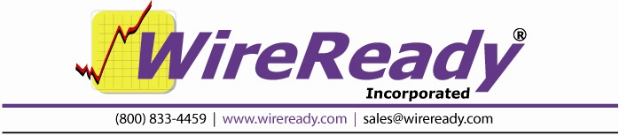

Setting up Alerts in WireReady32

To have users alerted to certain wire stories as they come in, you have to program the capture station to detect and feed alert files to the WireReady32 system.
The capture station (the one that runs the DOS MANAGER program) is where you program what sets off the alarm.
Go to the wire browser in the DOS Manager. (From the World Menu, strike W.)
Hit F2 Search twice to get to the Custom Search screen.
Highlight UNTITLED SEARCH on the right side of the screen.
Tab over (or strike F3) to the left side of the screen.
Create a search of what you want to be an alarm. Choose the Categories, Priorities, Headline and Text matches for the search.
Save (F4) the search. The name you give it is added to the bottom of the list on the right.
Highlight the search name and hit F7 E-mail. (This is not true email, but was named this before email was popular)
For the DOS Destination put the path to WIRE\ALERT\. If you map to the W drive, then the destination would be W:\WIRE\ALERT\ALERT.
For Overlapping OK?, leave it set to No, stop searching.
If you want the alerts to only be active during certain times or days of the week, choose these limitations.
The Header File should be ALERT.HDR.
No Trailer File is needed.
The Write Options is Auto-Extension. (auto-extension has us create unique extensions like .aaa .aab etc. so that we don't accidentally keep overwriting the same file).
Save (F4) the changes. You will see the search on the right have an E next to it.
You can have as many searches as you want active and feeding this directory.

You should have a folder called WIRE\ALERT. If not, create it.

There should already be a text file in your WIRE\FORMAT directory called ALERT.HDR. It should look like this: !!! @_HEADLINE_@ !!!

Basically, this has the capture station put a one-line header on the file with the stories headline. (This is actually all that WireReady32 currently reads when it posts the headline on the bottom of the screen, although in the future we're adding a hot key that lets a user instantly pop open the story in a read only window so they don't have to go to their wire browser to locate it).

Once setup, the capture station will write alert files into \WIRE\ALERT.
The first line of these files is the actual alert text you see courtesy of the header file alert.hdr.

The \WIRE\SYSTEM\SYSTEM.INI file contains the configurations for all users. You can either edit the file manually or use the Setup32 utility (on the System page).

[ALERTS]
Alerts=Yes Turns Alert system on or off YES or NO
Duration=30 Number of seconds before system looks for next file
Repeat=YES Alarm will sound until shut of by user
Sound=NO Audible sound via speaker (yes or no)

The visible alert is the first pane on the main status bar. Alert text will be displayed in red. Clear Alert (Shift+F11) and Clear Alert for all users (Shift+F12) have been added to the Window pull down menu in the WireReady32 program so users can clear the message. 30 second checks seem to be good for most users, but you can safely lower that to 10. It is not advised to go lower than 10, as ever x seconds specified makes every workstation on the network do a file read on the server to check for incoming alert files.

The sound feature uses the speaker to bleep. However, in Win95/98 it is very tricky, since Windows treats the sound system (audio cards) and speakers interchangeably. On some systems, it is impossible for us to hit just the speaker, and we can interfere with the sound card when it's playing/recording.

Most users are disabling all the sounds in windows, which essentially seems to shut us off. The screen text for most users is the best notification of incoming alerts.

