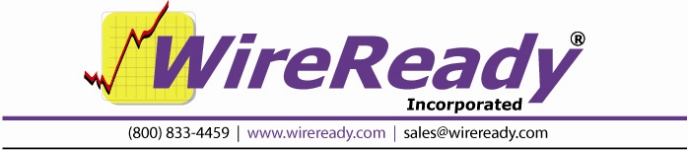

Triple Deck Air Play with WireReady32
(Version 3.176 and later)
Using the WireReady32 Audio “Player”

Overview:

The Audio “Player” screen available in WireReady32 provides digital cart-style decks and a convenient visual platform for broadcasters to read prepared text and fire specific audio cuts. The Player can take full advantage of a multiple audio card system. You can assign the different on-screen decks to independent audio cards and different pots on your console. This makes double or even triple overlap playing a breeze. Or, you can configure all of the decks to play out just two cards or even one card if you only need to play one thing at a time. One reason you might configure all 3 decks to use only one or two cards/channels is if you have dedicated a 3rd card for background recording in the Automate window.

The Player, lets you assemble a “playlist” by either individually grabbing *.WAV files from folders you’ve setup in WireReady32, or you can select one or more entire folders and create a sortable library list. Or you can import TXT files and/or build your own playlist schedules with the WireReady32 Notepad and load entire days or shows and play “from a log.” Audio can be located in multiple files on both the local drive or on multiple servers on your LAN.

You can build a playlist using one or a combination of the above load methods. Once the playlist is assembled you can even drag and drop change the order at anytime on the screen, even while audio is playing or you can move the pointer in the list to add or subtract audio from the list. The decks have a simple load button that pulls the “next up” cut from the playlist and once loaded they are immediately available for airplay. You can move the pointer anywhere in the list if you want to jump around.

The player supports a true cart like remote start/stop capability using a Broadcast Tools AT1616L relay controller available from WireReady or any major broadcast dealer. This connects to a COM port and supports 3 sets of remote start/stops from your console, and we even provide tally logic too. For each audio card one relay latches during playback, and another relay fires an EOM. 6 relays support 3 cards. The actual GPI has 16 inputs and 16 relays, and it’s assumed the 10 extra inputs/outputs can be used with the Automate screen.

This document explains how to use all the features of the WireReady Player for the production, preparation and on-air delivery of your broadcast content.

Open the Audio Player
To open the Audio Player from WireReady, press ALT-4 or click the Player button. The Player is pictured below:
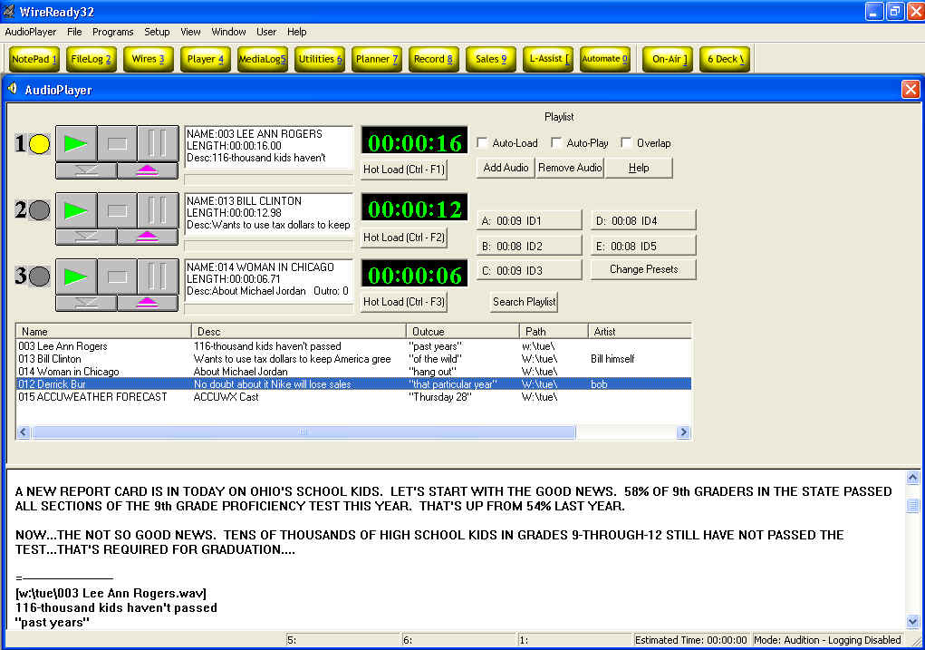

Number of Decks (1-3)
The number of decks corresponds to the number of soundcards installed on your computer, up to a max of three. It is possible to have all 3 decks show regardless of number of audio cards in versions 3.176 and later. In the picture, three cart decks are shown.

The three major elements of the Player are, from top to bottom:
- Cart Decks (with playlist controls on the right),
- Playlist, and
- Text Panel.

TEXT PANEL
The Text Panel is a simple text editor. Use it to freeform type notes you want to read on the air, or use it to load a pre-written broadcast file/script (or log). Typing can be done even while audio is playing. A “broadcast file/script” is created in the Notepad (ALT-1) using text and embedded audio. (Click File, then click on load broadcast file/script.) : After loading a broadcast file, the text of the story is displayed here. Any embedded audio found in a loaded script is automatically added to your playlist window.

Resizing the Text Panel
Click on the horizontal gray bar separating the Text Panel and the Playlist. Hold the mouse button down, and drag the bar up or down to resize amount of Text Panel in view.

PLAYLIST
The playlist manages the order of “ready to go” audio cuts you intend to use for a particular broadcast. We will refer to each cut as a “track” Also, while in auto modes, the playlist defines the order in which tracks are automatically played back to back. Note, in automated mode, the system will not automatically overlap at the current time- overlap is only possible during manual “live-assist” operation. Before a deck can load or play a cut, it first must be added to the playlist: thus, adding to the playlist is our starting point for this section. With an empty playlist, they will be added to the top. Once you have cuts in the playlist, any new selections are added where you’ve left the pointer in the current list.

Add an Individual Audio File to Playlist
Click on the Add Audio button, opening a selection window.
At the right of that window, click on a Custom Folder to show the folder’s contents.
Double-Click on an audio file to add it to the Playlist.

Add an Entire Directory of Audio Files to Playlist
Press ALT-D (or click on the File menu, then the Load from Directory option).
Click on a Folder and click OK. The Player automatically loads all the WAV files in that folder to the playlist. If the folder contains no valid WAV files, nothing will be loaded.

Change the Order of Tracks in a Playlist
Click on the track and hold down the mouse button. Drag the track up or down to the location in the list where you would like it to be and release.

Remove a Track from Playlist
Click on a track in the Playlist to highlight it.
Click the Remove Audio button.

Remove ALL Tracks from Playlist
Press ALT-C to Clear List (or click on the File menu, then the Clear List option).

Save Playlist to FileLog
Press ALT-S to save a copy of the Playlist.
Type a name for the Playlist when prompted. Press ENTER.
Double-Click on the Custom Folder that will hold the playlist.

Load a Saved Playlist or Script
Press ALT-B (or click on File menu, then the Load Playlist/Script from FileLog option.)
At the right of that window, click on a Custom Folder to show the folder’s contents.
Double-Click on a playlist, script or broadcast file (w/ embedded audio) to add it to the Playlist. The text of the file is displayed in the Text Panel, while the audio cuts are added in sequence to the playlist. The Player below is loaded with a broadcast file created in the standard Notepad.

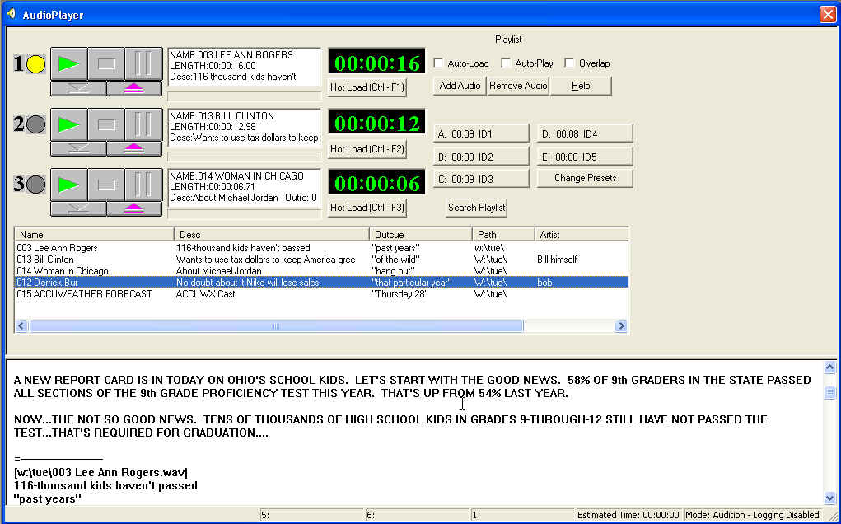
** If Auto-Load is on, the first tracks in the playlist are loaded immediately.
** If Auto-Play is also on, play begins immediately.

Auto Modes
Auto-Load: Automatically loads the next track in the playlist to the first empty deck or auto loads anytime a cut has been played or stopped. It will also auto-eject a track when it is done playing. Auto-Load is on when its box is checked. Click on the box to toggle Auto-Load on and off. If auditioning a cut, be sure auto-load is not checked or it will eject the cut upon finishing playback or if you hit stop on it.
Auto-Play: Automatically plays sequentially through all loaded decks. Auto-Play is on when its box is checked. Click on the box to toggle Auto-Play on and off.

**Use Auto-Load and Auto-Play together to enable continuous play on the playlist, one track at a time, in sequence.
Logging On-Air Broadcast of Tracks
Click on the Setup Menu, then the Configurations option. If there is not a check next to On-Air Mode, click on it: Player then logs the tracks that are played, producing a broadcast log and allowing updates to “Last Played” and the “:# of Times Played” fields.

Resizing the Width of Playlist Columns
Click on the vertical black divider line between two gray column heads (where the cursor changes to double arrows). Hold down the button and drag left or right to resize.

CART DECKS
A deck plays audio, specifically the audio tracks loaded from your playlist. Without tracks in the playlist, there is nothing to load into a deck (see the PLAYLIST section for help building a playlist).

Loading Playlist Tracks into the Decks (3 Methods)
Immediately after loading, the deck displays track info and is ready to play. There are three separate ways to load up the decks:
- The Load button of a particular deck is only lit when the deck is empty. Click on a track in the playlist to highlight it. Then click on the Load button to load the highlighted track to that deck. (The load button is the blue arrow button under each deck)
- Click on Auto-Load to fill empty (or “done”) deck(s) with the next track(s) in the Playlist.
- Double click on any track in the Playlist.
When prompted, double click on the deck you wish to load.

Control via the Keyboard
Start play on Deck #1 by pressing 1 or F1.
Start play on Deck #2 by pressing 2 or F2.
Start play on Deck #3 by pressing 3 or F3.
Re-striking the number (1 2 or 3) of an already playing deck will reset it to the beginning of its cut, where play begins again. If independent audio cards are assigned to each deck, they may all play simultaneously. Otherwise decks playing on the same soundcard may interrupt one another. To stop, click the stop or pause button, or hit SHIFT-F1, SHIFT-F2, or SHIFT-F3.

Control via the AT1616L relay controller/GPI

Separate start and stop controls may be wired to a console or remote button box and tally logic via relays may be supplied to the console. Optional device retails for around $500 and documentation is provided on wiring.

Control via magic keypad box

An optional mini-keyboard (about the size of a numeric keypad with double wide keys) can be purchased for $279. This provides remote start/stops for users who don’t have an AT1616L or console equipped with remote buttons. It plugs in-line with regular keyboard. Over a dozen other keys may be programmed to serve as macros – each key can be preprogram to issue up to 60 keys on the keyboard with one button push.

Reset Broadcast to Top
After playing tracks or editing the playlist, you can reset the broadcast to the top by pressing ALT-R. This empties all the decks. Similar to when loading a broadcast file, if Auto-Load is on, the first tracks in the playlist are loaded immediately. If Auto-Play is also on, play begins immediately.

Control via the Mouse
When colored, click on the buttons next to each deck to control its various functions. The control buttons are work like their “real-life” counterparts on a cart deck or CD player:

 | Play | Green triangle
█ | Stop | Red rectangle
|| | Pause | Light-blue bars
◆ | Load | Blue underscored “down” triangle
 | Eject | Purple underscored “up” triangle

Deck Display
- Yellow Dot: Indicates the “next up” deck. You cannot click to assign the dot.
- Info Panel: The Name, sampling Rate, and Length of the cut are displayed in each Deck’s Info Panel. The Panel has four colors:
- White: ready to play,
- Green: playing,
- Light Blue: paused,
- Red: done playing.
- Progress Bar: the bar is black when a track starts, then green moves from left to right, in proportion to amount of the track played.
- Clock: Counts up from 00:00:00 or down from the total length of the track. [Configure the clock as count-up or count-down (i.e., time elapsed or time remaining) in the Setup Menu, under the Configurations “Options” tab.]

Configuring Multiple Soundcards, Multiple Decks
From the Menu, click on Setup, then on the Configurations option. Assign each deck to a soundcard by changing the Audio Board number. It is best to use independent cards for each deck to allow overlapping playback. This also allows you to send a separate signal from each deck, via its own sound card, to a distinct pot on your console. View details about the soundcards detected (and their assigned numbers) by clicking on the Audio Boards tab.

Player Buttons
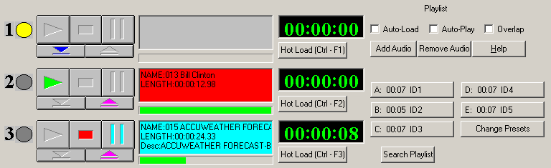

Yellow Dot Shows the Next Up deck, or the deck that will play next when using Auto Play.
Green Arrow Click this to Play the audio in the deck.
Red Square Click this to Stop the audio currently playing in the deck.
Light Blue Bars Click this to Pause the audio currently playing in the deck.
Blue Down-Arrow Click this to Load the deck with the highlighted audio file in the playlist window.
Pink Up-Arrow Click this to Eject the audio file from the deck.
Timer Displays the amount of time of the audio, either counting up or counting down.
Hot Load Button Click this to launch the File Select window to choose an audio file to load into the deck.

Auto-Load When checked, the first 3 audio files in the Playlist window will be loaded into the decks. When a file is done playing, it will be ejected and the next audio file will be loaded into the deck.
Auto-Play When checked, the audio files will play, beginning with the Next Up deck. When used in combination with Auto-Load, all the audio files in the playlist window will play.
Overlap When checked, the fade times will be used to allow the audio files to overlap. See the MediaLog section for setting up the fading parameters.
Add Audio Launches the File Select window to load an audio file into the playlist window. The audio will be added below the highlighted file in the playlist window.
Remove Audio Removes the highlighted audio file from the playlist window.
Help Launches a help file about the Player screen.
Presets A-E Displays the first five Preset buttons from the On-Air screen. These buttons can be loaded with audio that is used frequently, such as liners or Ids. Click on the button to play the audio. Click a second time to stop the audio.
Change Presets Allows the Preset Group to be changed.
Search Playlist Search the fields of the audio files in the playlist screen for the entered text.

Player Drop-Down Menu

The Main Menu, above the main Button bar, has 8 drop-down menus available for users to read newscasts onair, or play a series of audio files. Use the keyboard shortcut or click on the choice with the mouse to activate the menu choice.

AudioPlayer
Play Deck 1 (F1) Plays the audio loaded in Deck 1.
Play Deck 2 (F2) Plays the audio loaded in Deck 2.
Play Deck 3 (F3) Plays the audio loaded in Deck 3.
Stop Deck 1 (SHFT-F1) Stops the audio currently playing in Deck 1.
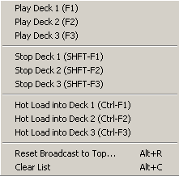
Stop Deck 2 (SHFT-F2) Stops the audio currently playing in Deck 2.
Stop Deck 3 (SHFT-F3) Stops the audio currently playing in Deck 3.

Hot Load into Deck 1 (Ctrl-F1) Launches the File Select window to load an audio file into Deck 1.
Hot Load into Deck 2 (Ctrl-F2) Launches the File Select window to load an audio file into Deck 2.
Hot Load into Deck 3 (Ctrl-F3) Launches the File Select window to load an audio file into Deck 3.
Reset Broadcast to Top Alt+R Ejects all audio from the decks and moves the cursor to the first file in the list of audio files.
Clear List Alt+C Clears all audio from the playlist window.

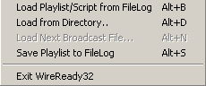
File
Load Playlist/Script from FileLog Alt+B Loads a text file into the bottom half of the screen, and loads the embedded audio files within that test file into the playlist window.
Load from Directory Alt+D Loads all the audio files from a directory into the playlist window.
Load Next Broadcast File Alt+N
Save Playlist to FileLog Alt+S Saves the audio in the playlist window as embedded files in a text file.
Exit WireReady32 Exits the user from the program.

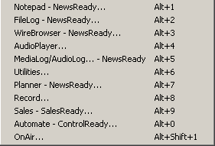
Programs
The Programs menu lists the 11 screens in WireReady32. Consult the other WireReady manuals for information on using the automation and sales screens.

Notepad – NewsReady Alt+1 The Notepad is used to edit text and create new stories and rotations.
FileLog – NewsReady Alt+2 The FileLog is used to access text stories that have been saved from the Notepad, and to edit rotations.
WireBrowser – NewsReady Alt+3 The WireBrowser displays the wire stories that have been captured.
AudioPlayer Alt+4 The Player is used to read newscasts and play the embedded audio.
MediaLog/AudioLog – NewsReady Alt+5 The MediaLog is used to store audio files to be used in newscasts and automation.
Utilities Alt+6 The Utilities screen allows access to StormReady32, QuickRecorder, and the DOS PhoneReady and StormReady programs.
Planner – NewsReady Alt+7 The Planner is a calendar program to track appointments and assignments for newsrooms.
Record Alt+8 The Record button is used to manually record new audio files.
Sales – SalesReady Alt+9 The Sales screen is used to record and track contacts with customers/advertisers.
Automate – ControlReady Alt+0 The Automate decks are used to automate recording and playback of audio, and for web publishing.
OnAir Alt+Shift+1 The OnAir 10-deck screen is used for playback of audio while live.

Setup
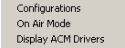
Configurations Allows the user to set the audio boards used for the 3 Player decks, the Notepad and the 8 Automate decks, and set the timer orientation.
On Air Mode When checked, a confirmation/activity log containing a record of every WAV file played from the Player is created in the following directory: [network drive]:\WIRE\USERS\[log-in name]\CONFIRM. This serves as a confirmation log for the audio that was played.
Display ACM Drivers Displays the available ACM drivers. The user cannot edit the information in this window.

View
Status Bar When checked, the status bar, which displays the audio device and counters, is visible at the bottom of the Player screen.
Window
In addition to the menu choices, any open WireReady32 screens or open text files will be listed at the bottom of the menu choices in this drop-down window.
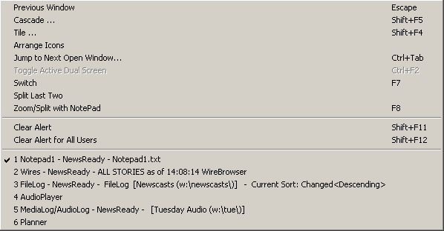
Previous Window Escape Puts the last window that was open before the Notepad as the current display.
Cascade Shift+F5 Allows the screens to be cascaded. Only active when the user is set to Windows Standard mode.
Tile Shift+F4 Allows the screens to be tiled. Only active when the user is set to Windows Standard mode.
Arrange Icons
Jump to Next Open Window Ctrl+Tab Makes the next open screen be displayed.
Toggle Active Dual Screen Ctrl+F2 Toggles between the 2 windows when the user is set to Dual Screen mode.
Switch F7 Toggles between the Notepad and the last open screen.
Split Last Two
Zoom/Split with Notepad F8 Splits the current screen (or last open screen) with the Notepad.
Clear Alert Shift+F11 Clears the red wire alert at the bottom of the screen for the logged-in user.
Clear Alert for All Users Shift +F12 Clears the red wire alert at the bottom of the screen for all users.

User
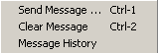
These menu choices are only available when using secure logins.
Send Message Ctrl+1 Sends a message to other users, which will appear in the header of the main window.
Clear Message Ctrl+2 Clears the message from the current user’s screen.
Message History Displays the date and text of the previously sent messages.

Help
Player Help This menu choice is not active at this time.
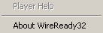
About WireReady32 Displays the version number of the software and contact information for WireReady NSI.

