

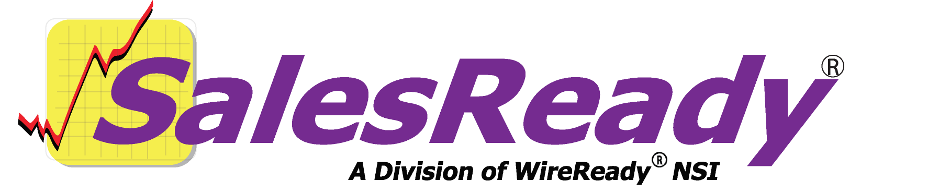
Director of Community
Event Sales
Handbook
56 Hudson Street Northboro, MA 01532
800-833-4459 Fax: 506-393-0255
www.wireready.com
56 Hudson Street Northboro, MA 01532
800-833-4459 Fax: 508-393-0255
www.wireready.com

Responsibility 4
We would like to suggest 4
Contact list 4
Keep 6 to 10 events selling at all times 4
Record of events sold each year 5
Concept: Why SalesReady® makes event sales profitable 5
Event sales as a numbers game 5
Concept: Understanding templates 7
The Role of Templates in SalesReady® 7
Security management features 9
Learning the extra features of the software 9
Community Event Coordinator management: Adding new reps to the system (new hires) 10
To add rep logins for a workstation setup: 10
To add rep logins for secure login setup: 11
Community Event Coordinator management: Generating reports to monitor your team and your sales 16
Call Detail reports: Monitoring everyday activities 16
Caller Performance Reports: Comparing performance among the CEC team 18
Event Detail Reports: Tracking the calls attempted on a specific event 21
Event Performance Reports: Comparing totals for all events in a given time period 23
Quota Period Reports: Comparing sales goals to actual sales totals 24
Finding the reports you have generated: 25
Event management: Navigating the event information sources in the software 28
Event Materials 28
Event Detail Screen 30
Event management: Event editing buttons 31
Event management: Adding a new event 33
Step 1: The Event Detail screen 33
Step 2: Adding a new folder to hold your associated event materials 35
Event Management: Event document editing buttons 36
Editing existing documents 36
Adding new documents to a new event folder from the master templates 37
Additional management tools: Pitch delete 38
Additional management tools: Last caller change 39
Additional management tools: Sales Rep change 39
Additional management tools: Mass update (database) 40
Additional management tools: The List Button (exporting database records) 41
List Type 41
Source 41
Destination 42
Delimiter 42
Additional Management Tools: Creating Mailing Labels 43
To use an existing template for your mail merge: 43
To create your own document template from scratch: 44
Additional Management Tools: Printing an event document for selected records: 45
Appendix A: Quick synopsis of each button and menu item in SalesReady 49
Database Window 49
Button Name: F2 Show 49
Button Name: F3 Find ID 49
Button Name: F4 Add 49
Button Name: F6 Report 49
Button Name: Ctrl + U User 49
Button Name: View Record 49
Button Name: Delete Record 49
Button Name: Event Info 50
Button Name: List 50
Sales Entry Window 50
Button Name: Schedule 50
Button Name: Chng Schedule 3 50
Button Name: Print 50
Button Name: Change Pitch 50
Button Name: Delete Pitch 51
Button Name: Event Info (first explained above) 51
Button Name: Evnt Materials 51
Button Name: Contracts 51
Button Name: Contact Info 51
Button Name: Stats 51
Button Name: Email 51
Button Name: Open Notes 52
Button Name: View Old Calls 52
Button Name: Record 52
Button Name: Start Call 52
Button Name: End Call 52
Button Name: New Pitch 52
Button Name: Done 52
Button Name: Cancel 52
Button Name: Help 52
Button Name: Change (town or category) 53
Button Name: Protect 1 (Phone Number) 53
Button Name: Change (callback date) 53
Button Name: Protect 2 (Fax Number) 53
Event Materials Window 53
Button Name: Launch 53
Button Name: Cancel 54
Button Name: New File 54
Button Name: Edit Selected 54
Button Name: Help 54
Button Name: Event Info 1 54
Button Name: View Notes 54
Button Name: Edit Notes 54
Button Name: Launch As Form 55
Button Name: Copy As Template 55
Button Name: Print ALL as Form 55
Button Name: Print ALL Folders as Form 55

Responsibility
As a Director of Community Event Sales you are responsible for creating relationships with the directors and people in your area that can help you stay on top of the events happening locally. You also need to develop a good relationship with people in the other departments of the station, having good relationships with the news department, traffic and billing, production, and especially the outside AE’s will help your Community Event Coordinator (CEC) team do a better job of serving the local business owners. Events that you are selling might be newsworthy, and you should let the news department know about it. As a department designed to generate revenue, you are also generating more work for traffic and billing and production. The three departments should do everything possible to make transitions smoother. The AE’s might be servicing the same accounts you are calling upon and anything the AE knows about those businesses should be information that the CEC’s have access to and vice versa. The CEC department needs to have good relationships with everyone at the station!

As a Director of Community Event Sales you are also responsible for motivating your team of CEC’s. They should be competitive, money motivated people, but that doesn’t mean that they won’t need an occasional motivator, especially when they encounter a lot of no’s from the business owners they are calling. It might take seven to ten no’s from one business owner before he/she says yes, but the more he/she talks to a CEC on the phone, the closer he/she comes to saying yes for the first time! There are lots of ways to motivate your team. Everything from laying a $50.00 bill on the table and offering it to the first person to sell X new accounts to handing out an inspirational flyer. In order to get the most from your team, you’ll have to get to know your team members and find out how each person is motivated.

The final thing that the Director of Community Event Sales needs to do is keep calling! You need to be the top seller on the team, and you have to practice to keep up on your skills. Not only should you be calling on your contracts to keep you updated on events, you should be generating the goals and materials for your new events, motivating your team, and helping to sell the events on the agenda. Your team will follow their leader and gain courage and confidence just by doing as you do.

We would like to suggest

Contact list
SalesReady® suggests making a list of contacts to call about area events, and updating that list frequently. The Event Contact List Page included in your information is an example and a beginning for your update.

Keep 6 to 10 events selling at all times
SalesReady® suggests keeping the Event Calendar complete with six to ten events at all times. Find events any way possible, funnel ideas from anyone and everyone. Make decisions on packaging, pricing, and when the messages are going to air. Schedule everything for the events so that the CEC team can see electronically what is on the menu, so they can keep calling, moving to the next event.

Record of events sold each year
SalesReady® also suggests keeping a record of what events were sold each year, as well as what your target goal was, and how much money was actually collected on that event. This record will give you good insight on year-by-year record of how your CEC department is doing. You have access to an electronic record of sales in the Event Info screen, and a hard copy, fill-in-the-blank form is in your packet of materials.

Concept: Why SalesReady® makes event sales profitable
SalesReady® is a business model for your station, cluster, or group. It is not a software/hardware combination, but rather a proven, thought-through, reproducible, systematic, reliable, flexible revenue generator. Outlined below are reasons why event sales work and how they have been proven to work.

Event sales as a numbers game
Definition
An event sale, simply put, is the promotion of local, regional, national, or international happenings or occurrences. Whatever happens, occurs, takes place or is recognized in your coverage area, can be packaged and sold.

The evolution of event sales
Event promotions often referred to as PSAs (Public Service Announcements), in the past, and to a certain extent even today, often were aired for free. Many media outlets realized that if someone or an organization believes the event is important enough to be publicized then someone else probably feels it is important enough to pay for sponsorship.

Characteristics of an event sales package
Events span from the dedication of a bridge, to a pancake feed, to a local festival, to high school sports, to safety and awareness weeks and months of every flavor, to national holidays, to…well, you name it. The main element is that a given demographic amongst potential business customers in your coverage or market area identify with the event. Especially if an event package can be pitched with an element of emotional content, some businesses in your coverage area will buy it.

Event sales as a profit center
The point in selling events is that the seller has maximum flexibility in the pricing, structure of the ad copy, schedule placement, and frequency. In some small market stations, the dollars per airtime minute yield rate on event packages run 3 to 6 times higher than their average ROS rates. Ironically, event sales provides the means to regain control over your account executives, who often have no feel for yield management and sell large packages with freebies at rates substantially under your average or desired ROS rates.

Low dollar event sales improve your ROS
Event sales do not dilute the pricing structure quoted to your regular advertisers. In situations where a regular advertiser complains that someone buying an event package gets a better rate than them, quite the opposite is true. Sure, event package buyer may be paying an effective $10 a minute, while the regular advertiser is paying $12. But the regular advertiser is then informed that event package buyer was only one of three to five different sponsors with tags in the package which was aired, which means the event sponsor paid effectively 3 to 5 times as much.

Broaden the customer base
Everyone knows the old saying, “don’t put your eggs all in one basket”. Event sales have the advantage over traditional advertising packages in that the price of admission is rather low to the buyer, which results in sales to many businesses who normally would not spend money at the radio station.

Increase sales from regular advertisers
Event sales allow stations to extract more dollars from their regular advertisers. Even though the regular advertiser may have budgeted a specific amount for their advertising, they too can make emotional decisions or wish to be seen as providing a community service, and pay to sponsor events. Targeting specific events to specific regular advertisers often results in a slam-dunk sale. Everyone knows that the ones most likely to buy from you are the ones already buying from you.

Possibility of add-on sales
Many stations combine event sales with customized advertising for the buyer. The buyer may be a sponsor tagged on the event but simultaneously get a series of ads specific to them. In most cases this is offered as an incentive to sponsor the package. In some cases this eventually leads the buyers into becoming regular advertisers.

A typical objection: Event sponsorships dilute the quality of our programming
While many stations air the events with a straight voice and no beds, the structure of the event promotion can be made to sound like a news item instead of advertising and as such is a public service. On the other hand, if the event packages can yield a per minute rate 3x or more higher than your average ROS, don’t you think it would be worthwhile to look to see the impact of doubling or tripling the production costs and creating on-air events in line with your current programming? Chances are, the effective yield rate will still be higher than the ROS.

Another typical objection: Event sales underestimate post-sales costs
Profiting from a large number of small dollars sales is not difficult if you use a system which removes steps in customer billing, makes use of pre-established ad copy, and allows you to tag multiple sponsors in an ad. Event Sales provides a way to gain back the certain amount of lost revenue and opportunity that occurs because AE’s are simply unable to service everyone. The AE’s and CEC’s (Community Event Coordinators) should be working together to provide maximum opportunity to more businesses. By tagging multiple sponsors to event packages, the ROS rate can triple, meaning new revenue where revenue was previously lost.

Concept: Understanding templates

The Role of Templates in SalesReady®
A template is a form designed prior to use, which contains everything you wish the customer to see. It includes the station/cluster letterhead and logos as well as specific information about a specific event. When a template is launched in SalesReady®, it is no longer a general, boilerplate form for that event, but rather a personalized document specific to a single customer because SalesReady® uses merge fields to import the customer information. The reason that we have created templates to create personalized documents is to save sales people the time-consuming step of hand-writing customer contact information on multiple forms every time they make a sale. In event sales, the main limiting factor is the number of optimal phone minutes in a day; make the most of those minutes.

SalesReady® “Master” templates need to be stored in a location that makes sense to everyone. The most accessible place to locate your templates is in the “general” folder of the “Shortcut to Docs.” The person responsible for revising/ editing the templates can find them and copy & paste them to a new location when used for a new event.

One single order-form or brochure for each event includes all the possible pricing packages as well as all the current ad copy variations. Then when a CEC launches the template, he/she simply deletes the pricing packages that are not relevant to a particular call, and deletes any ad copy that the customer did not agree to, and re-saves the new document into a completed folder.

Components of the SalesReady® provided events:
You can start selling from day one with over 100 SalesReady®-provided events.
The starter pack of events includes:
The template broadcast order-form
(can be used as a liaison between CECs & Production)
The template (pre-customized) order form/ invoice
The template customer information sheet/ faxable brochure
The template ad copy sheet
1. SalesReady® Broadcast order-form
The SalesReady® Broadcast template is meant to fill the need of a communication link between the telesales department and the traffic and billing/production. It gives those departments a way to schedule how and when the event messages will run.
2. SalesReady® order-form/ invoice
The order-form is pre-customized by SalesReady® to match your station or cluster’s brand or image. It has a polished, professional image.
While the customer is under no obligation to use the SalesReady® order-form, its use saves money and makes money. Savings and increased earnings are achieved because the order form simultaneously performs three functions: Invoice, Production Order, and Traffic/Scheduling.
Invoice Function--When an order is taken, and after the CEC has confirmed the customer address information, the customer is asked if they would prefer to be invoiced by fax, email or mail. When the form is launched, it is automatically personalized with the updated customer contact information. Now, depending upon the philosophy of the station, the CEC simply deletes the information that is inaccurate. For example, if the customer buys the $100 package, the CEC deletes the $50 and $150 lines and the other options are gone, the customer has an easily understood document.

Production Order Function--Preloaded onto the order-form template is boilerplate version(s) of that event's ad-copy. If the CEC chooses, he/she could cut and paste the tag the customer wants directly from the customer notes section in the database into the appropriate space in the ad copy of their choosing.

SalesReady® Traffic/Scheduling Function--Since events usually have predetermined days or weeks in which they run, and that they may be scheduled BTA or have already been given pre-defined rotations, this information is entered onto the invoice/sales order template. Thereby, when the sales person deletes the inappropriate sales package lines, the correct scheduling information remains. In some cases, this may save yet another form to be filled out.
Sending the customer the invoice after the sale makes you money because the quicker you invoice, the quicker you get paid, and lessens the likelihood of slow payment or non-collections due to "buyer's remorse". The smartest thing is to get the money upfront, prior to production. By sales directly invoicing the customer right after the sale, you potentially save the cost of producing unpaid ads. Because we recommend selling events 4 to 6 weeks prior to the event airing, accounts receivable has plenty of time to let sales know which accounts are still open as far as two weeks before production begins. The sales person can flag the accounts and remind them to pay with a call. If the money is still not there at production begin, the non-paid orders can be pulled at managements discretion.
Note: SalesReady® does not interface with existing Traffic and Billing systems.

3. SalesReady® brochure/ customer information sheet
The faxable brochure is a customizable template onto which SalesReady® embeds the station or cluster’s logo, contact information, etc. to maintain brand image. The station may also wish to pre-define the package size(s) that can be loaded onto the template ahead of time. The brochure has merge fields, which enables the CEC to send a personalized fax or letter describing the event at the customer’s request. This faxable brochure serves two purposes:
More information -- Some customers may be interested in the event, but either don't have time to listen to the pitch, or they require more information. The brochure enables the CEC to send the customer the information almost instantly from the computer via fax or email, allowing them to provide efficient customer service in a fraction of the time usually required.
For mass faxing or emailing -- Fax 80 to 150 brochures per CEC per day, and do follow-up calls to the businesses the next day while the fax is still on the decision maker's desk. The close ratio with this technique is typically above 10%. This technique is still not as good as cold calling with a good pitch, but its advantage is that even people with reluctance to cold calling can make sales, because viewed psychologically; they are "following up."
If you choose, the brochure also serves as an order confirmation form. Assuming you add the cost of sponsorship to the template, then all the customer has to do is sign it and send it back. For stations that never accept an order without a customer's signature, this brochure template may be renamed "order confirmation template". Then, after the verbal phone sale, the order confirmation template may be launched and sent to the customer with the request that they sign it and fax it back.

4. SalesReady® ad copy sheet
Each SalesReady® provided event has between 2 and 5 versions of ad copy. The ad copy is designed to support multiple sponsors, the number of which is the decision of the station or cluster. We are adding ad copy versions on a continual basis. Customers on our support plan receive regular updates.

Security management features

Learning the extra features of the software
Certain management buttons will be disabled for most members of the call team, but the manager needs to have a good grasp on these features of the software (you can always call 1-800-833-4459 and ask for Event Service Department for assistance with features of the software). Specific features allowed for managers only include:
- Rep management
  - Adding new reps to the system (new hires)
  - Generating reports to keep on top of your team and your sales
  - Motivation/ incentives to keep the team calling and selling
- Event management
  - Navigating the event information sources in the software
  - Event editing buttons
  - Adding a new event
  - Event document editing buttons
- Additional management tools
  - Pitch delete
  - Last caller change
  - Sales rep assignments change
  - Mass update (database)
  - Import export (accounts for database)

Community Event Coordinator management: Adding new reps to the system (new hires)
SalesReady® provides easy automatic monitoring of your reps to maintain an encourage accountability. Due to turnover issues, you WILL have to add and delete user names from the software, not only so your new employees can log in & old employees cannot sabotage, but also for statistical purposes.
You need to determine whether you have (1) secure logins or (2) workstation logins.

To add rep logins for a workstation setup:
Begin by clicking the yellow Sales button (alt-9 on your keyboard).
Go to the SalesReady32 menu on the left side of the screen. The drop down menu includes a choice called Edit Sales Reps. See the diagram below to find the SalesReady32 menu as well as the Edit Sales Reps drop down option.
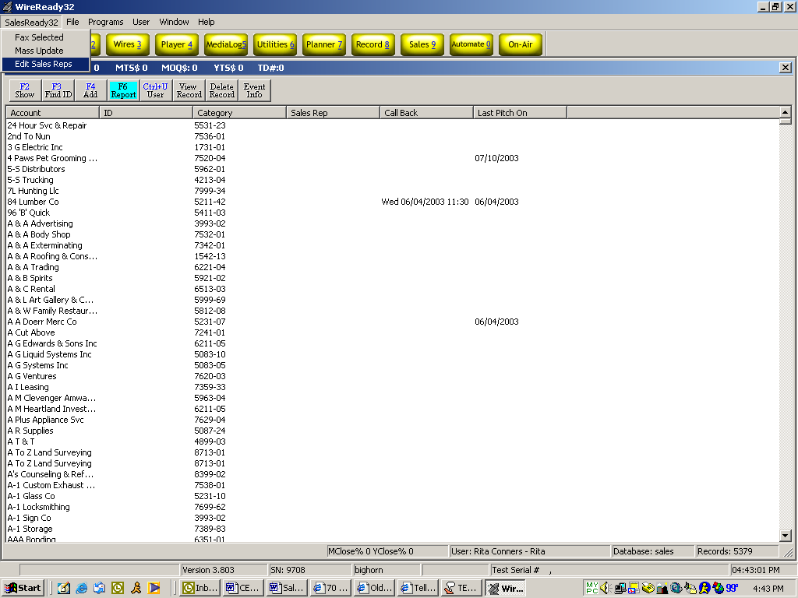

Upon choosing Edit Sales Reps, a separate dialog box opens giving a manager the opportunity to assign month-by-month goals, as well as save the user complete names to be used as salutations on the order-forms and brochures. See the diagram on the following page.
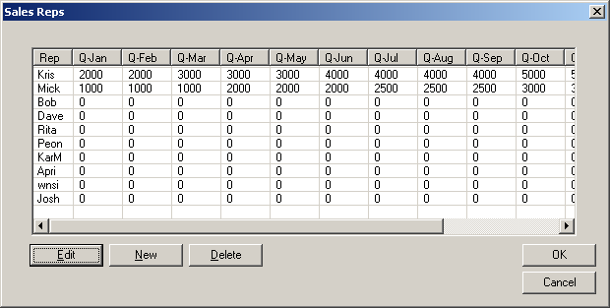
Click on the New button to add a new rep name. You are limited to 4 characters, no spaces in the first box. Tab through the remaining boxes to add information as you see fit.

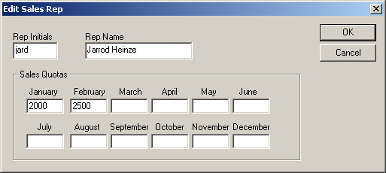
Click OK to exit the Edit Sales Rep box back to the Sales Reps box. Again click OK to exit back the SalesReady® database.

To add rep logins for secure login setup:
To enter, use, modify, or remove representatives in SalesReady®, you must execute the Setup32 utility separately from the SalesReady® program. To run the Setup32 utility:
1. Click on the Start button in the bottom left corner of the computer screen.
2. Click on Run.
3. Find the following path in the drop down list: w:\wire\INSTALL\setup32.exe
4. If that path is not present, then type it in yourself.
5. If your desktop is not already cluttered with shortcuts, you may consider adding this file as a shortcut.
OR
1. From the desktop, double-click on the My Computer icon.
2. Double-click the server drive containing the SalesReady® software. ( w: )
3. Double-click the Wire folder.
4. Double-click the Install folder.
5. Double-click the Setup32.exe file.
To add a new user(s) login, select the User Configuration tab at the top of the screen. See the diagram below to find the User Configuration tab.

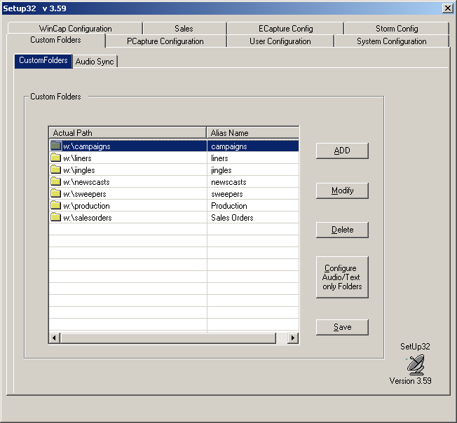
From the User Configuration Page 1 worksheet, double-check to make sure the “User” radio button is highlighted. See next page.

Click the Add button to add a new user(s) to your system. You are allowed only 8 characters total, no spaces to add your new user name. See below for the dialog box that you will see when you click the Add button.
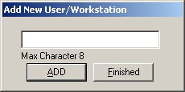
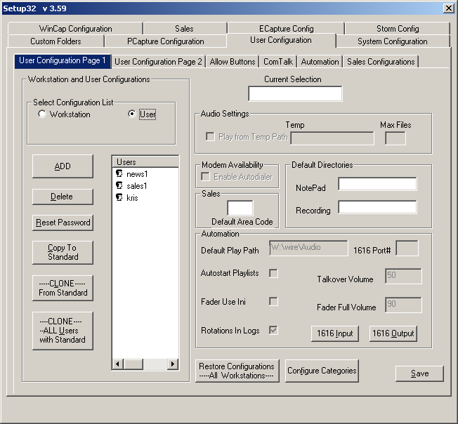
Click the Add button on the small dialog box and then click Finished when you have added all the new users you want to add.
NOTE: Think ahead when planning user names because the user name must match the rep name that you will also assign to this new user (Example: user name = “kris-met”, rep name = “kris”).

Call WireReady if you have special permissions or restrictions for your new user(s). 800-833-4459. Now you must go back and add a rep name that matches your user name. Follow the steps outlined below:

To add a representative, begin by clicking the yellow Sales button (alt-9 on your keyboard).
Go to the SalesReady32 menu on the left side of the screen. The drop down menu includes a choice called Edit Sales Reps. See the diagram below to find the SalesReady32 menu as well as the Edit Sales Reps drop down option.
Upon choosing Edit Sales Reps, a separate dialog box opens giving a manager the opportunity to assign month-by-month goals, as well as save the user complete names to be used as salutations on the order-forms and brochures. See the diagram on the following page.

Click on the New button to add a new rep name. You are limited to 4 characters, no spaces in the first box. Tab through the remaining boxes to add information as you see fit.

Click OK to exit the Edit Sales Rep box back to the Sales Reps box. Again click OK to exit back the SalesReady® database.
NOTE: You can go back and edit properties for each rep at any time.

Community Event Coordinator management: Generating reports to monitor your team and your sales
Anyone can pull reports; in fact, management might even receive a daily report emailed each day. Email reports are not enough; they are just a quick glance with only the bottom dollar in mind. As the director of the Community Event Sales team, you need to know your partners well, and understand what is happening each day with each person in your new department. Pulling reports at the end of each day and week will help you stay on top of your team.

Call Detail reports: Monitoring everyday activities
A Call Detail report outlines each call made by each individual CEC with information about what time the call was ended, how long the call lasted, who was called and why they were called. This report also totals minutes spent on the phone during the day, as well as average call lengths, number of qualified calls and unqualified calls.

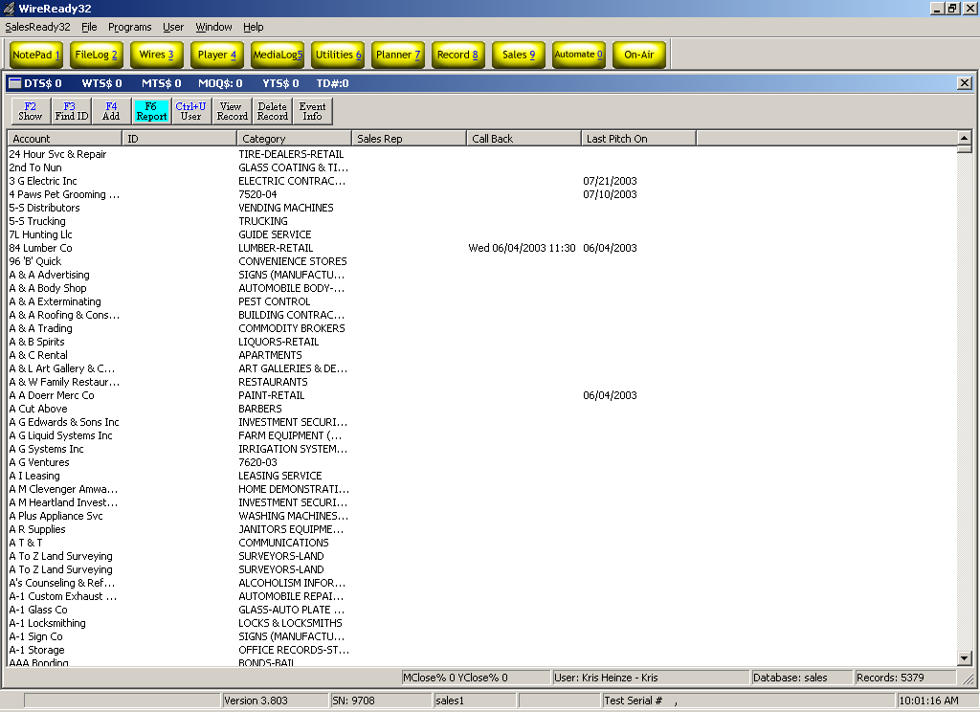
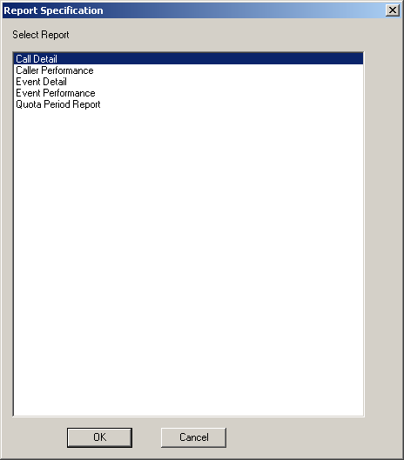
To generate a Call Detail report, click the F6 Report button. From the following list of reports that appears, click the top report, Call Detail. See the diagram below:

From here, SalesReady® will ask you to choose a date range. If you want a report that reflects today’s sales, you leave the start date with today’s date that is defaulted in the window, and then you also leave the end date with today’s date that is defaulted in the window. See the diagram below:

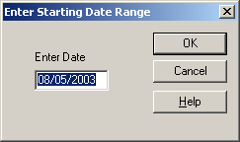

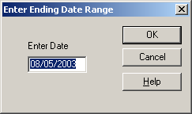

Next you must choose the name of the rep for which you want to review.
See the diagram below:

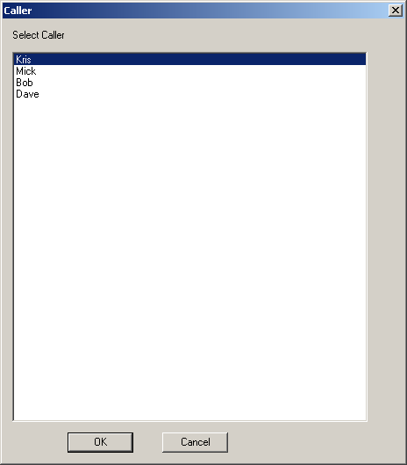

When you click on the appropriate name, a message appears that informs you that the report has been generated and is in your “Personal” folder. You must now navigate to the Personal folder in order to view the report. See the section, “Finding the reports you have generated,” on page 24.
Below is a sample Call Detail Report. Note the totals section at the bottom.

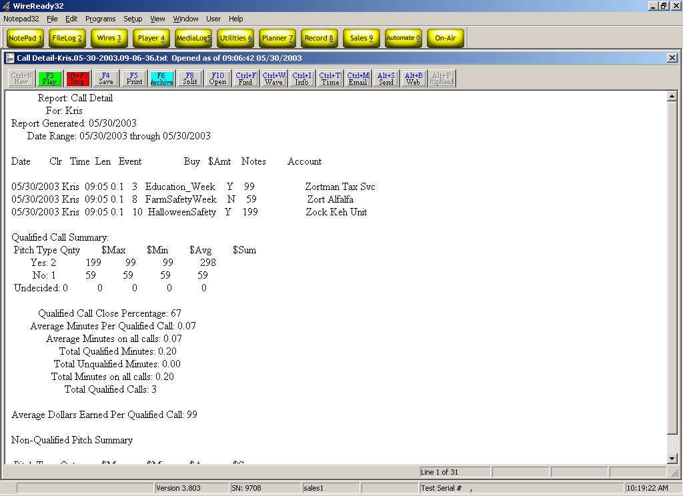

Caller Performance Reports: Comparing performance among the CEC team
Caller Performance Reports help you compare call and sales totals to see what methods are most effective among your individual CEC persuasion styles. One CEC might not make as many dials in a day, but maybe he can sell more people by taking the time to persuade them. While that method is effective for some, the most proven method is making more dials to reach more people, and therefore potentially making more sales.

To generate a Caller Performance report, click the F6 Report button. Then choose Caller Performance from the list of reports. See the diagram on the following page.

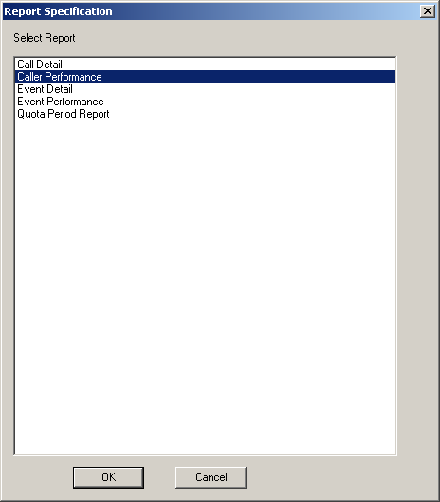

Then you must enter a starting and ending date range to define the time period of which you wish to review.

A message appears that informs you that the report has been generated and is in your “Personal” folder. You must now navigate to the Personal folder in order to view the report. To find the Personal folder, refer to the section, “Finding the reports you have generated” on page 24.

An example Caller Performance Report follows:

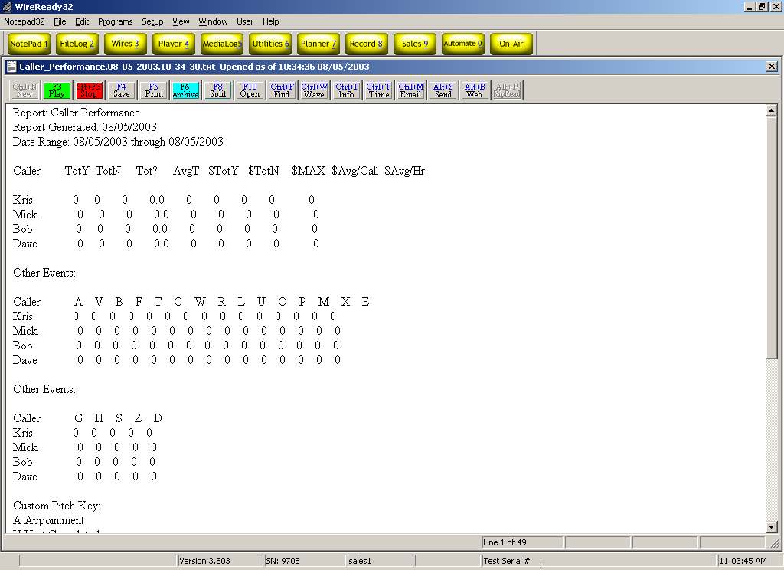

Event Detail Reports: Tracking the calls attempted on a specific event
Event Detail Reports are useful for double-checking the amounts of sales made on a particular event, or learning that CEC called on a particular customer about a certain event.

To generate an Event Detail Report, click the F6 Report button. Then choose Event Detail from the list of reports. See the diagram below.

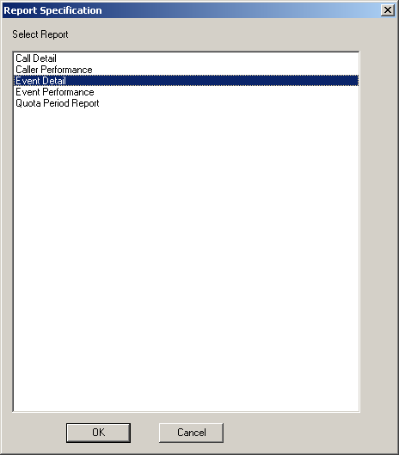

Then you must choose a time period by selecting starting date and ending date ranges.

Finally, you must choose the number and name of the event you want to view. You may choose more than one event, or all of the events by choosing the Select All button. We advise against using the Event Detail reports to view more than a few events at a time. See the diagram below:

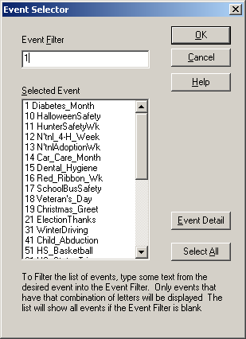

A message appears that informs you that the report has been generated and is in your “Personal” folder. Refer to the section, “Finding the reports you have generated” on page 24. An example Event Detail report follows:

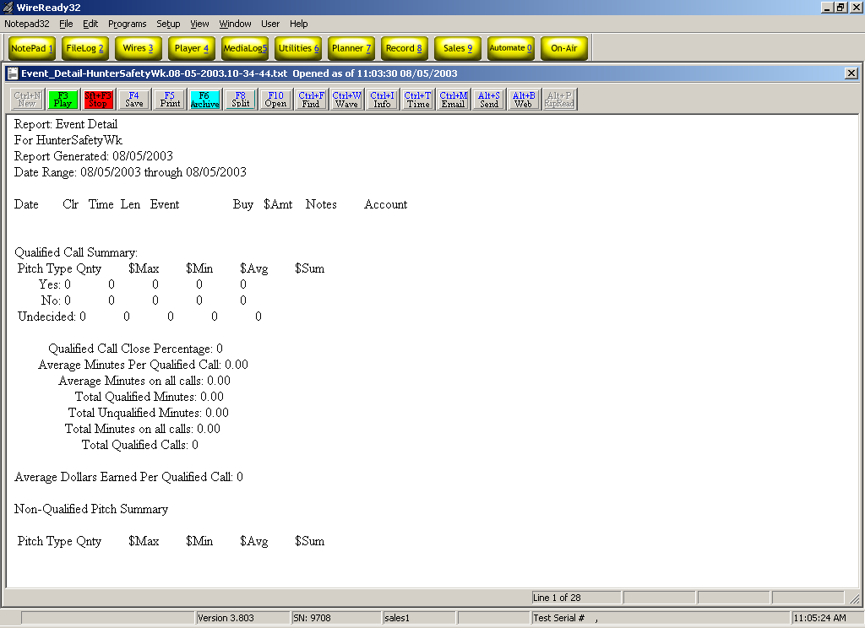

Event Performance Reports: Comparing totals for all events in a given time period
This report is simply just a list of totals for each event sold in a given time period.
To generate an Event Performance Report, click the F6 Report button. Then choose Event Performance from the list of reports. See the diagram below:

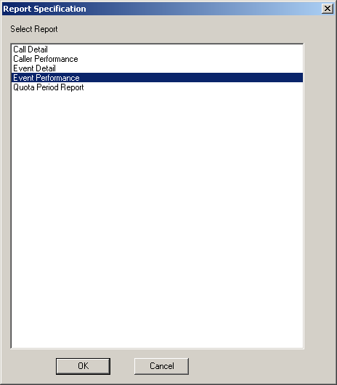

Enter the desired time range. See the diagrams below:

A message appears that informs you that the report has been generated and is in your “Personal” folder. Refer to the section, “Finding the reports you have generated” on page 24. An example Event Performance Report follows on the next page.

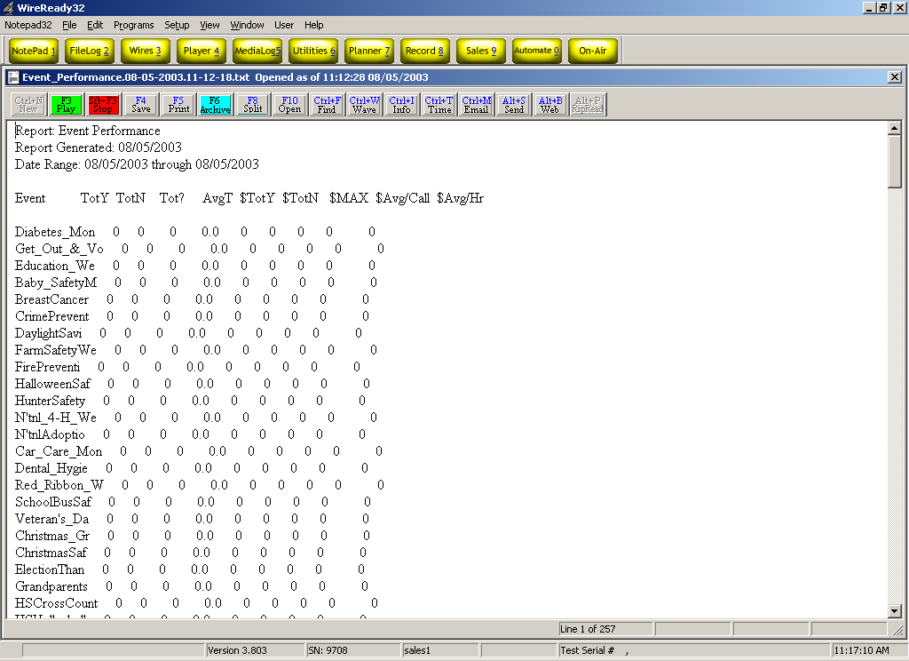

Quota Period Reports: Comparing sales goals to actual sales totals
To generate a Quota Period Report, click the F6 Report button. Then choose Quota Period Report from the list of reports. See the diagram below:

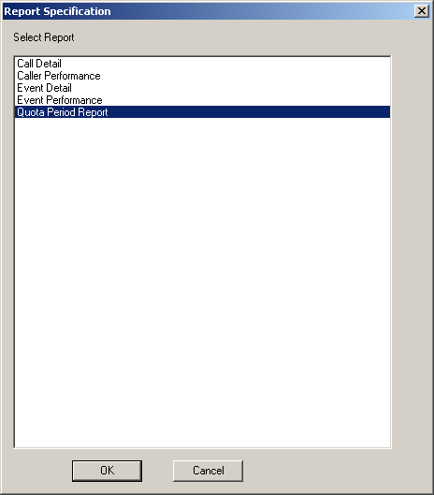

Next you must choose the month and year in which you would like to view results.

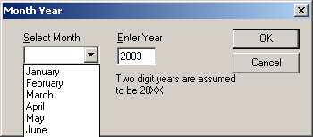

A message appears that informs you that the report has been generated and is in your “Personal” folder. Refer to the section, “Finding the reports you have generated” on page 24. An example Quota Period Report follows below.

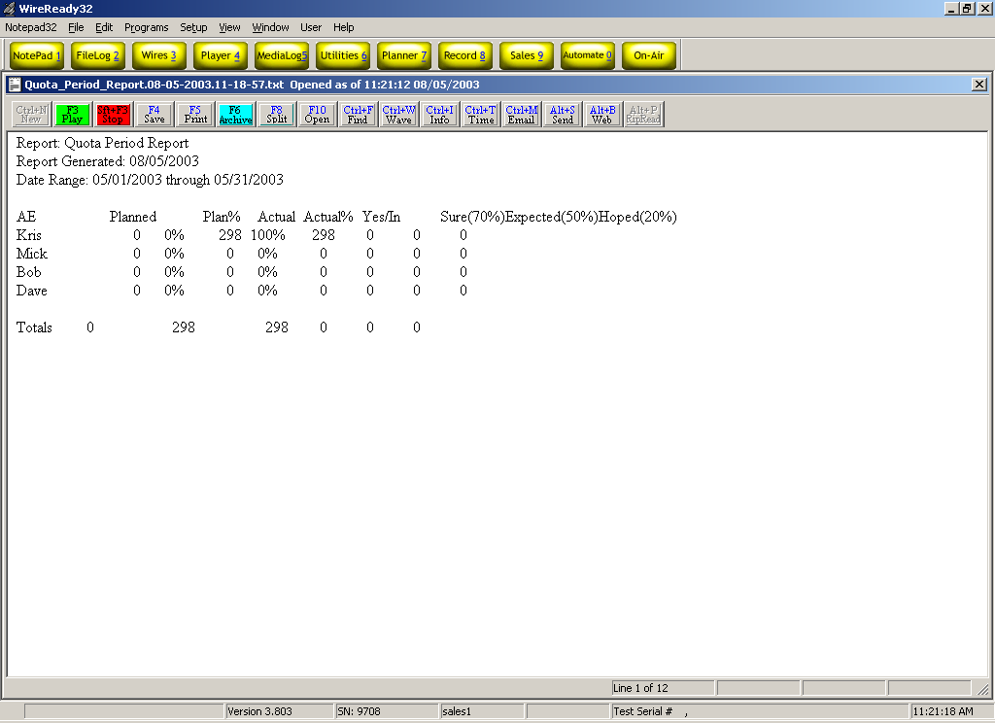

Finding the reports you have generated:
When you click on the appropriate name, a message appears that informs you that the report has been generated and is in your “Personal” folder. You must now navigate to the Personal folder in order to view the report.

First click OK on the message that tells you to view your Personal folder.
Next click on the yellow Filelog2 button at the top of your screen. See the diagram below to find the Filelog2 button.

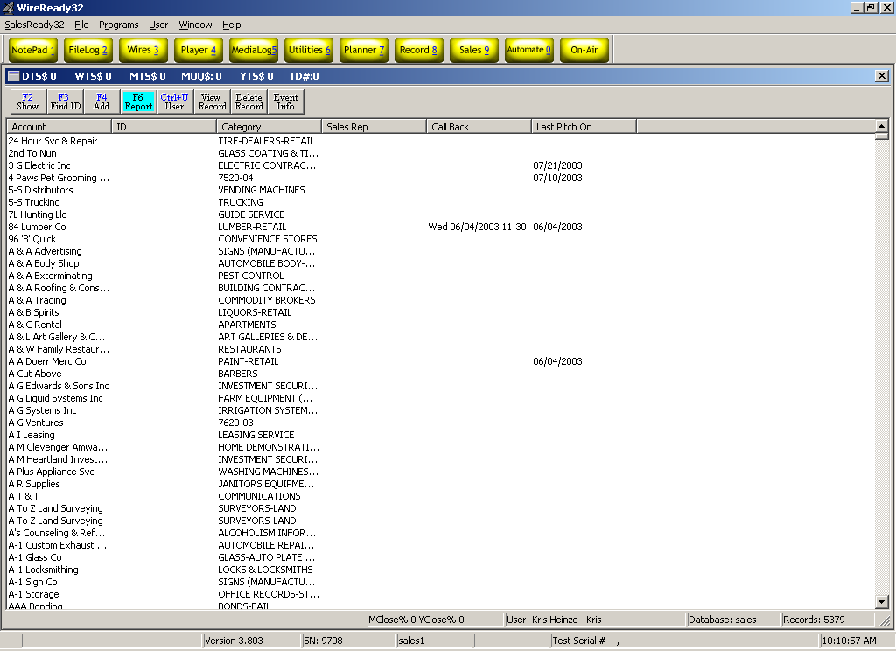

From the Filelog, click the Ctrl + L Select button to choose from a list of folders. See the diagram below to find the Ctrl + L Select button.
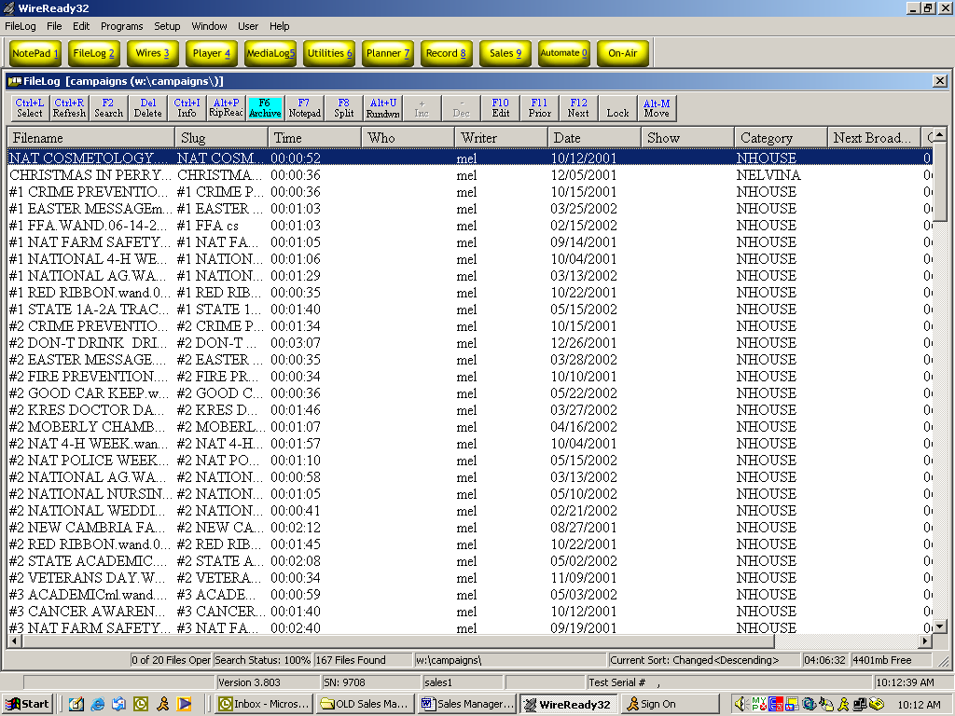

Click on the Personal button. See the diagram below to find the Personal button.

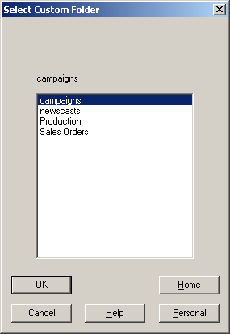

Now your list of reports appears in the Filelog. Double-click the top report to view the latest report that was generated. If the report you recently generated does not appear at the top of the list, click the Ctrl + R Refresh button to redraw the list of reports. Now your report should be listed at the top of the screen.

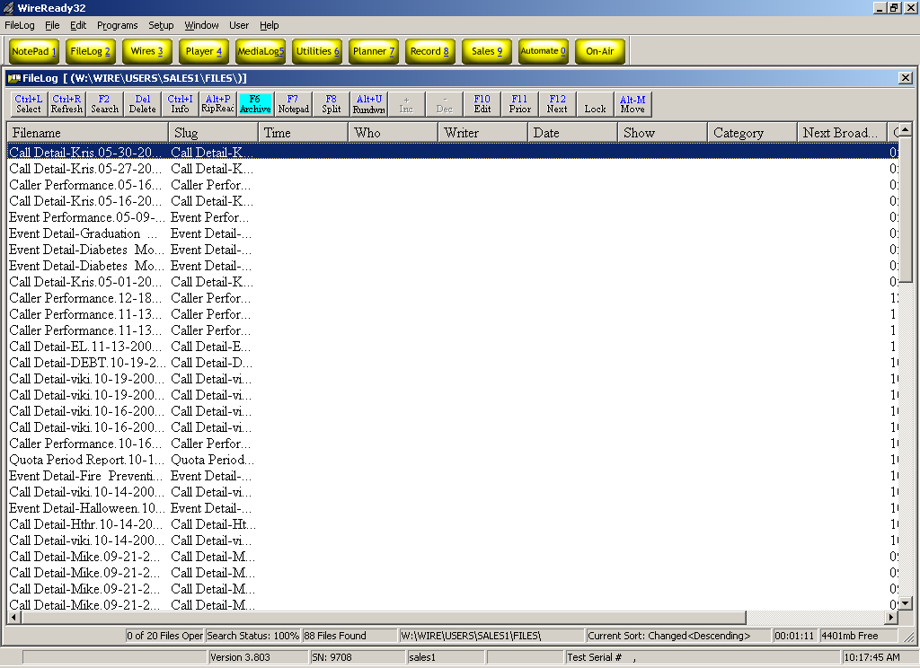

Event management: Navigating the event information sources in the software
There are 3 places where you can find information on existing events. The Event Detail or Event Info screen is the best place to start your search for pertinent information on a particular event package. The next place to find information is to go to the event documents. Event documents can be found electronically in the software, and hard copies of those same documents have been provided in your Event Materials binders.

Event Materials
You can always check out your Event Materials binders to review a hard copy of any document provided by the SalesReady® Event Service team, but you can view those same documents electronically easily in the software.

To find the Event Materials, double-click on any customer account. Click on the Event Materials button in the lower left corner of the screen. See the diagram below:

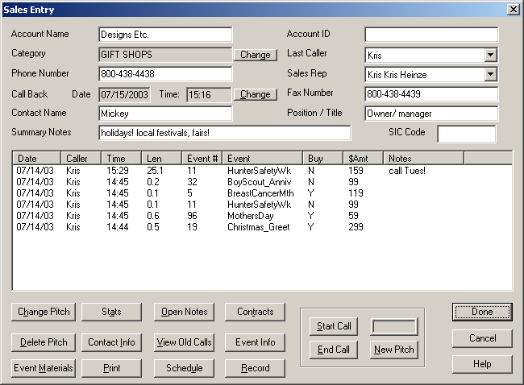

From here, you must choose an event, and then an associated document to view. Click once on the event, and then double-click on the document you want to view. See the diagram on the following page.

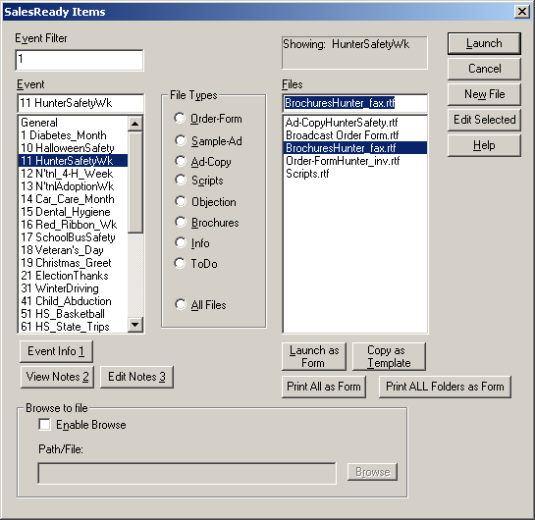

When the document is launched, it will merge the WireReady tags automatically. When you ask the software to open and document that has WireReady tags, a dialog box pops up asking if you want to save the document with WireReady tags. Unless you have opened a valid customer invoice, always click the No button.

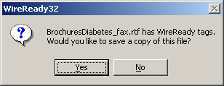

Event Detail Screen
The Event Detail window holds information about the event in relation to how it will be executed at the radio station. What price the package is offered for, how many spots you get for that price, when the event will be sold, when the event will be aired, the name of the event, a reference number for the event, and a sales goal are all types of information that can be found in the Event Detail screen.

To find the Event Detail screen, click on the Event Info button. See the diagram below and the Event Info screen on the next page:

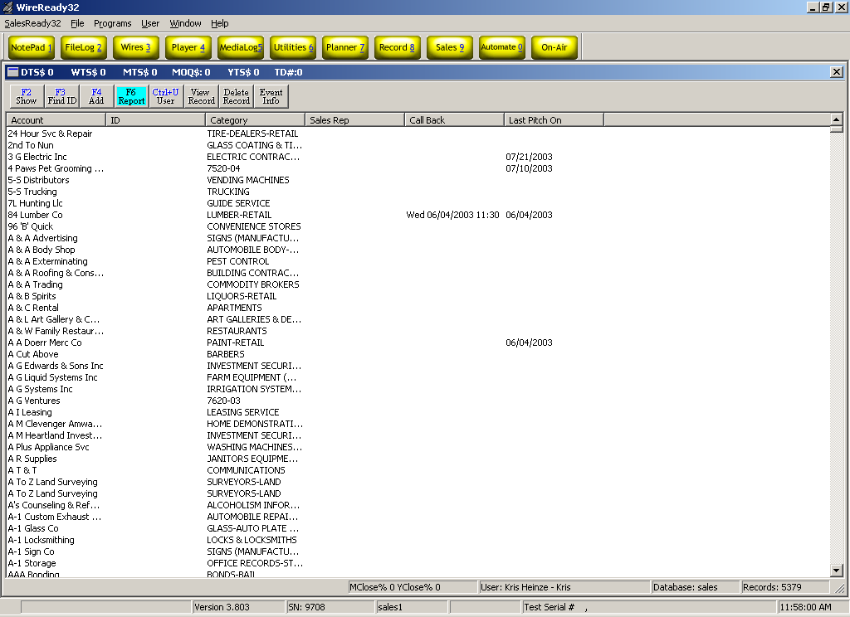

The screen that follows lists each event in numerical order, by default. You may rearrange or sort the information by clicking once on any column header to reorganize the information according to the type of information found in that column. Clicking again on the same column header will reverse the order of the information. For example, if you click on the Start Sell Date column header, the event lines will be rearranged with January events listed at the top, according to the year. By clicking the same header again, the event lines will be rearranged again to put December events at the top, according to the year. See the diagram on the following page:

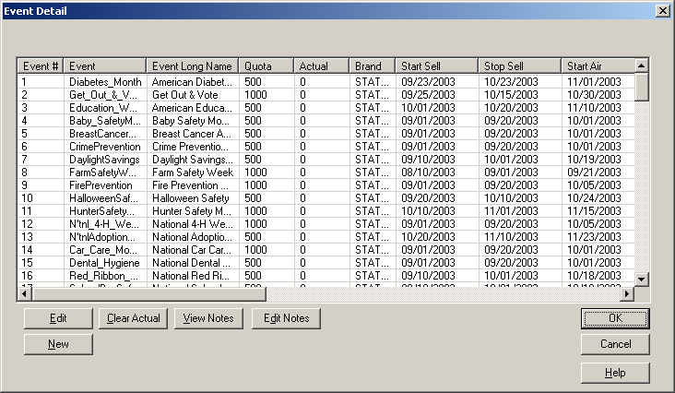

This window is also a good place to monitor sales progress in comparison to the goal you have set for a particular event. The Actual column keeps a running total of all sales for an event.

Event management: Event editing buttons
You can edit the information listed in the Event Detail at any time for any event. These changes will be reflected on the event documents also because of the WireReady tags. The WireReady tags are merge fields that insert customer information into event documents. A list of the WireReady tags can be found in the Appendix at the end of the handbook. To edit the information that appears where WireReady tags are, click on the Event Info button.

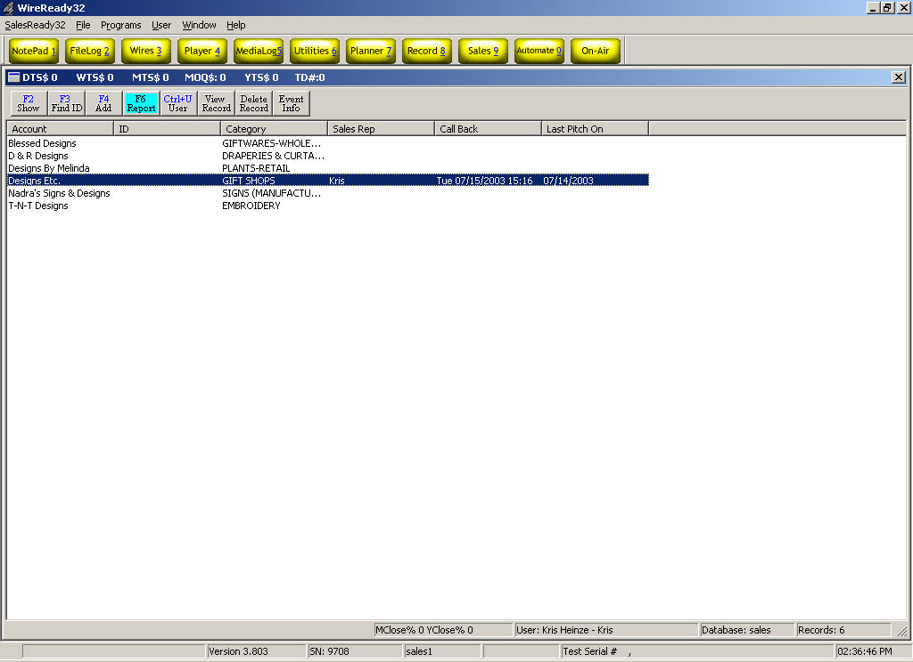

In the Event Detail screen, click once on the number 1 in the number column, and then quickly type the number of the event you wish to modify. While the event line of the event you wish to modify is highlighted with a blue line, click the Edit button. See the diagram below:
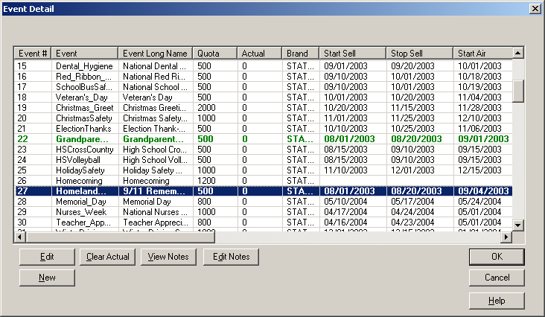

In the following box, tab through the fields until you arrive at the field you wish to modify. Make your changes and click OK. See the diagram below:

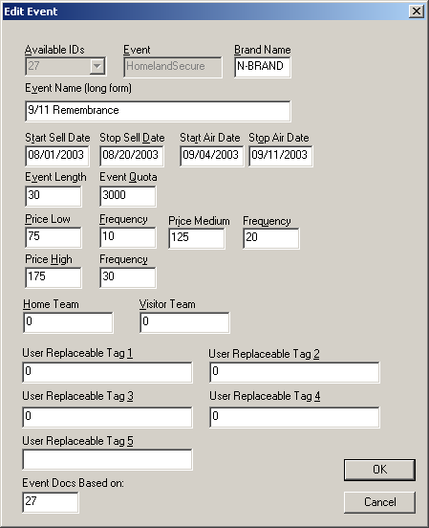

Event management: Adding a new event
Adding a new event to this list of possibilities is similar to editing event properties.

Step 1: The Event Detail screen
Begin by clicking on the Event Info button to bring up the Event Detail screen.

In the Event Detail screen, click the New button.

Start by selecting a number for your new event. SalesReady® assigns unique numbers to each event. There are two categories of numbers to choose from: National and Local events. National events were pre-loaded on your original SalesReady® software and can include any event that could be used at any radio station around the country. Local events are those events that only happen in your area. You can choose to have SalesReady® assign the next available National or Local number for your event, or you can choose your own number from the list.
Tab to enter the short name of the new event. Event names cannot exceed 15 characters, and cannot contain spaces. (You may use the underscore (_) to separate words in the event name text box).

Tab to go to the next text box labeled Brand Name. Here you may enter information about your station or cluster. Again, there are no spaces allowed here.

Tab to the Event Name (long form) text box. Here you may write out the name of the event as you wish it to appear as the title on a Brochure or Order-form.
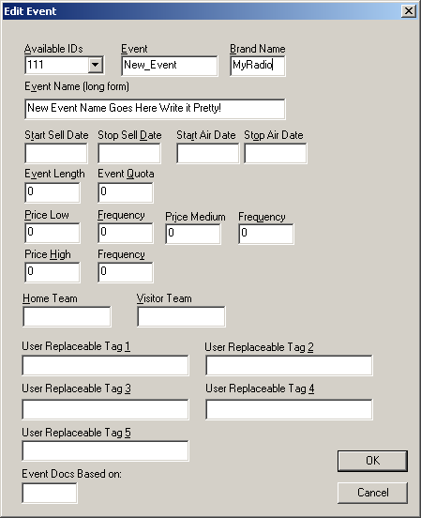

Keep tabbing through this dialog box where you will be given opportunities to enter Start and Stop Sell Dates. We suggest selling most events 4 to 6 weeks prior to the event. The reason is two-fold. First, beat your media competitors to the punch and deny them the money for that event. Remember, most people won't sponsor the same event with more than one vendor because the buy was emotional. Secondly, by selling way in advance of the event, your likelihood of being paid before you have invested production time is much, much higher, and the time spent on collections is reduced. When choosing your sell time period, make sure you leave enough time for Production to create the finished spots.

The next tab is Start and Stop Air Dates. Start airing about a week ahead of the event’s actual date. Stop airing the last actual day of the event.

The next tab is the Length of the event sponsorship, including the sponsorship tags (most likely be 30 – typical 20 second message with 10 seconds of room for two sponsors).

The next tab is the Event Quota (this is for the entire department to achieve together).

Now enter the pricing packages: low, medium and high, each with frequency (frequency is the number of mentions the customer gets for the price).

Click the OK button to save this information.

Step 2: Adding a new folder to hold your associated event materials
In addition to creating the new event, you will have to create a new folder to house new event documents such as brochures, invoices and ad copy. For this task, you need a shortcut on your desktop.

Double-click on the My Computer icon on your desktop
Double-click on the WR-Salesserver W: drive.
Double-click on the Wire folder
Double-click on the Users folder
Double-click on the Public folder
Double-click on the Sales folder
Right-click on the Docs folder and choose Send To > Desktop (create shortcut).

Close the open window and double-click on your new shortcut on your desktop.
Right-click anywhere in the white space of this window and choose New > Folder.

When the new folder appears at the bottom of your window highlighted in blue, rename the folder to match the number of the new event that you added. For example, if you created event #111, then you must create a new folder also named 111. The software will not work correctly if you add anything to the name of the folder besides the number.

Event Management: Event document editing buttons
While as a manager you are welcomed to make edits yourself, you can always fall back on the Event Service Team when you need assistance creating new event materials or editing existing documents.

Editing existing documents
There may come a time when you would like to edit the ad copy, wording, or graphics on brochures, invoices or ad copy sheets. When a member of your team launches a document by double-clicking it or clicking the Launch button, the WireReady tags merge information into the documents automatically. When the WireReady tags are merged, the document is no longer savable when changes are made. It may not give you an error message, but it is guaranteed that your changes will not be saved. Because of this feature, you must open your documents a different way when you want to make permanent edits.

To open an event document so that you can make permanent changes:
Double-click any customer account
Click on the Event Materials button in the lower left corner
Choose the number and event by clicking once
Click once on the particular document you wish to edit
Click the Edit Selected button on the right side of the screen to open the document for editing. See the diagram below:

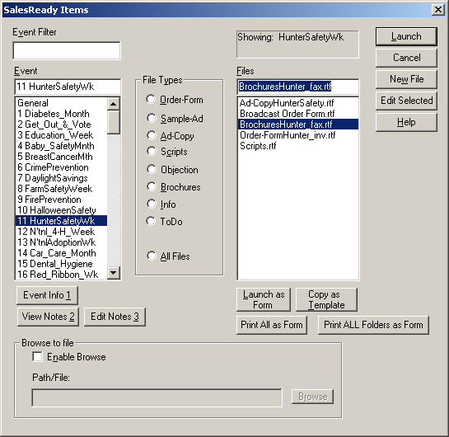

Adding new documents to a new event folder from the master templates
When you create a new event and event folder, you will also want to add template documents at that time. Adding or associating documents with a new event is a simple task.

Double-click any customer account
Click on the Event Materials button in the lower left corner
The General folder contents will be in view, by default. This is good because you want to copy the master templates from the General folder to your new folder.
Click once on the BrochuresMaster.rtf file
Click on the Copy as Template button. See the diagram below:

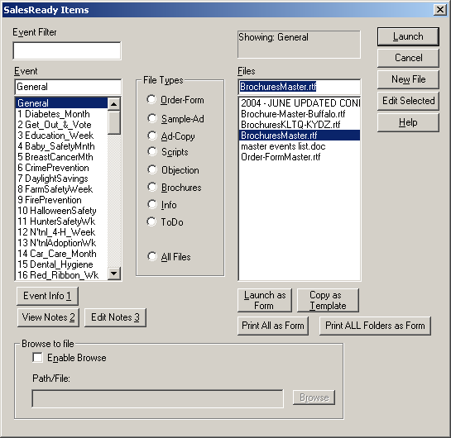

Choose the number of your new event & Click OK. See the diagram below:

Repeat this process with the Order-formMaster.rtf file.
When you are finished copying the master templates to your new event folder, double-check your work by entering the number of your new event into the event filter on the left side of the screen. When you click on that number, your 2 new documents should appear in the window on the right side of the screen. At this point, all that’s left is to edit the ad copy if you so wish.

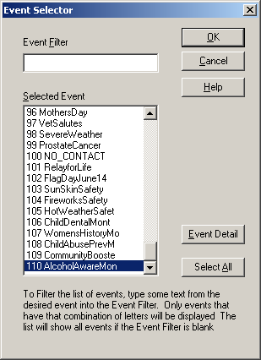
Additional management tools: Pitch delete
Once in awhile, a member of the CEC team will make a mistake and log the wrong amount sale, or log a yes when it should have been a no. Sometimes a customer will change decisions an increase or decrease the amount of their buy. As the manager, you are responsible for correcting the mistake. In addition, you are the only member of the team that has the button to do this task.

To delete a pitch, you must first open the account that contains the mistake.
Click once on the date of the incorrect pitch listed in the Sales History window to highlight the incorrect pitch.
Click on the Delete Pitch button in the lower left corner of the screen. See the diagram on the following page:

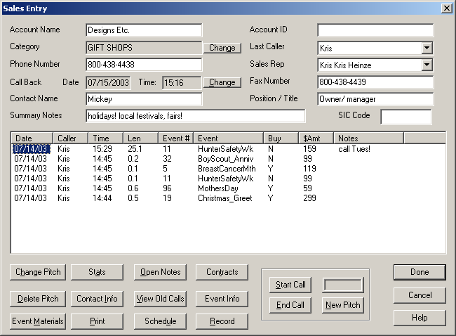

Additional management tools: Last caller change
The Last Caller field indicates the last person to make a change to a single customer record. For the CEC team, the Last Caller field is grayed out so it cannot be edited, but it does show the name of the last caller to them even though it is grayed out.

As a manager, you have the authority to edit the Last Caller field, but you should refrain from changing this frequently. The only time you might want to change the last caller field is when you have deleted a pitch for another CEC, and you want that CEC’s name to remain listed as the last caller rather than your own, since you did not actually call on the customer. For updating large numbers of accounts last caller, see Mass Update.

Additional management tools: Sales Rep change
The Sales Rep field indicates the person assigned to maintain a particular customer record. In most cases, the Sales Rep field is grayed out for the typical CEC, but the field still shows the assigned rep. CEC’s should be cautious and remember to glance at this field each time they open a new account to make sure not to step on someone else’s toes by calling on an assigned account.

As a manager, you have the authority to change the Sales Rep field and assign accounts if you so wish. How you divide accounts among the team is up to you; one method is to assign accounts. Some call teams never assign accounts; accounts are kept open for anyone to call depending on the event that is being worked at the time.

You are also the liaison between the AE’s and the CEC team. When your sales manager lets you know that a particular car dealership account is assigned to a particular AE, you need to mark that account in SalesReady® so your team knows not to call that dealership. Use the drop down list to assign a rep name or AE name to a particular account. For updating large numbers of accounts sales reps, see Mass Update.

Additional management tools: Mass update (database)
The Mass Update tool is extremely useful for assigning reps to particular accounts, or even for updating an area code change in particular phone numbers. Those are just 2 of the 5 instances where you can use the Mass Update tool to quickly and easily modify information in your database.

To find the Mass Update tool, double-check that you are viewing the sales database.
At the top of your screen, there is a menu named SalesReady32. When you click on this menu, the drop down list includes the Mass Update tool. See the diagram below:

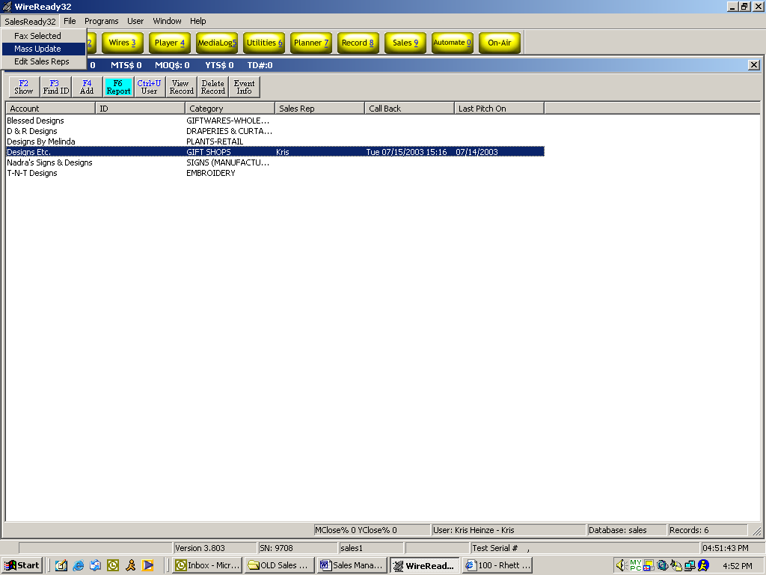

There are 5 ways you can mass update the database. Choose from the list. Follow the directions from that point to finish the task. See the diagram below:

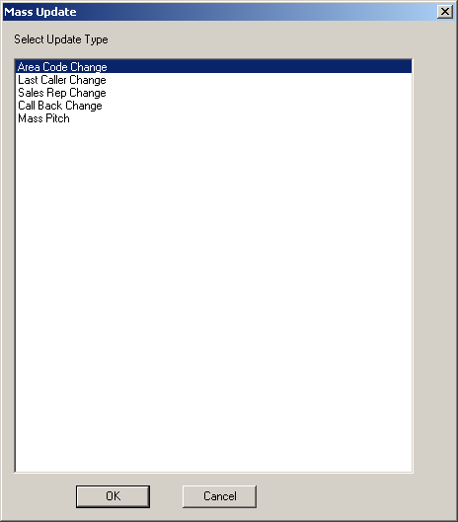

Additional management tools: The List Button (exporting database records)
The List button allows users to create a list of accounts to be printed or saved to a file.

List Type
- Calling List: Generates a list of accounts that includes Account Name, Contact, Contact Title and Phone Number fields, sorted in the order they appear on the screen.
- Mailing Label Data: Generates a list of accounts that includes Account, Contact, Title, Address1, Address2, City, State and Zip Code fields, sorted in the order they appear on the screen.
- Current Browser: Generates a list of accounts that includes the fields currently displayed on the screen, sorted in the order they appear on the screen.

Source
- Selected Records: Uses only the records that are selected (highlighted) in the list of accounts for the output.
- Entire Browser: Uses all the records currently displayed on the screen in the browser for the output.

Destination
- File: The list will be created into a file that can be stored in any folder available to the user. When giving the file a name, include the extension.
- Printer: The list will be generated to the printer.

Delimiter
- Space (Text Documents): The list will be generated as a text file. A choice for both File and Printer output.
- Comma (CSV/Excel Format): The list will be generated as a Comma Separated Value file. Only available when saving to a destination file.

See the diagram below:

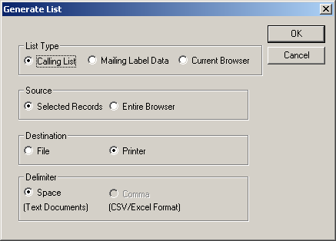

Additional Management Tools: Creating Mailing Labels

Using the Mail Merge feature to create mailing labels or envelopes printed from records in your SalesReady® database
We have created templates for use with some of the basic Avery labels or with standard #10 envelopes. You may use these templates to speed the time it takes to set up a mail merge using records from your SalesReady database, or you may create your own new template for a label not included on the list.

To use an existing template for your mail merge:

- Select the business records in the database that you wish to use.
- Click the List button
  - Check the “Open MS Word Merge File” checkbox
  - The “Mailing Label Data” radio button will become checked by default. Leave it selected.
  - Choose your Selected Records or the Entire Browser
  - Leave the default choice on “save to a file.”
  - Leave the default choice on the format of the file.
- Click OK.
- Navigate to your Mail Merge Templates folder and open the Template document you wish to use (ex: Envelopes10.doc or Avery8660.doc) and click the Merge button.
  - You may have to click the View Merged Data button on the Word toolbar to view your merged data, rather than only the formatted merge fields.
  - You can also choose to click the Merge button on the Word toolbar and choose to merge your data into a “new document.”
- Print.
NOTE: If your merged information does not display immediately, call 800-833-4459 for assistance.

To create your own document template from scratch:

- Set up your blank template document
  - Click on your Shortcut to Docs icon on your desktop and navigate to your Mail Merge Templates folder.
  - Right-click in the white space and choose New Microsoft Word Document. Name the new document in a way that reflects the name of the labels you wish to print upon (ex: Avery8660.doc).
  - Double-click the new document to open it.
- Select data from the WireReady database
  - Go back into WireReady and select the business records in the database that you wish to use.
  - Click the List button
    - Click on the “Mailing Label Data” radio button
    - Choose your Selected Records or the Entire Browser
    - Leave the default choice on “save to a file.”
    - Leave the default choice on the format of the file.
  - Save the data file using the same name as the template you wish you use and make sure to save the data file to your Mail Merge Templates folder (example: Avery8660.txt)
- Format your document template
  - Go back to your Word document named after the labels you wish to use and go to the Tools menu and choose Mail Merge from the list.
  - The Mail Merge Helper window will open and allow you to configure your new Template document.
    - In Step 1 of the Mail Merge Helper window, choose your type of Merge (i.e. envelopes, mailing labels, etc), and also choose to use the “Active Window.”
    - In Step 2 of the Mail Merge Helper window, choose to open your data source, and navigate to the .txt file you saved earlier that matches the same name as this Mail Merge document (ex: Avery 8660.doc and Avery8660.txt). You may have to use the dropdown file type menu to display all the files in the folder, so that the .txt files are visible.
      - If you are merging into labels, Word will ask you to setup your document by choosing the Avery labels from the list of available labels.
      - Word will also ask you to set up the merge fields you wish to use for this merge. You can format the merge fields with returns, punctuation and spacing.
    - In Step 3 of the Mail Merge Helper window, click the Merge button.
  - When the Mail Merge Helper window closes and the Word document opens with the formatted fields, click on the Merge button on the toolbar and choose to merge the information into a “new document.”
- Print.
- Before you close the template document (i.e. Avery8660.doc), click the Save button on the toolbar to save your mail merge configurations for use at a later time.

Additional Management Tools: Printing an event document for selected records:
(to stuff the envelopes for your mail merge labels/ mailing or for mass faxing)

1. Select the business records in the database that you wish to use.
2. Choose “Printed event doc for selected records” from the SalesReady 32 menu at the top left of the screen
3. Choose the document you wish to print and click Launch.
4. The documents will spool and begin printing immediately.
NOTE: If you have chosen to print a large number of documents, the computer will take a significant amount of time spool the large print job, so be prepared to let the computer sit for awhile while printing.

Additional Management Tools: The SalesReady® Shot Clock™

Smart Dialer is a positive reinforcement tool
The only thing that stops the clock is when the user starts a call and stays on it.

It's a very effective, game-like, positive reinforcement tool.

The default shot clock time is 60 seconds, not so much because reps need a full minute in between calls, but because 60 seconds means that each penalty is exactly 1 minute and the penalties represent the minimum amount of time that was wasted.

If the rep doesn't call someone else before the clock reaches 0, the P: penalty field on the top of the screen registers a penalty. We track daily, weekly, monthly and yearly penalties. Each penalty means they took more than 60 seconds in between regular calls.

When they score a sale (Y), the clock counts down from 5 minutes, both as a reward and for time to do paperwork

Reps get three 10-minute breaks and a 30-minute lunch. The on-screen codes show how many breaks have been taken and if lunch break was taken. Once breaks and lunch are taken, the Smart Dialer won't let the reps reset the codes.

NOTE: The shot clock system can be shut off in the INI if it interferes with your system or you decide it's not what you want.

Improved efficiency with SalesReady Smart Dialer
Because reps can cheat by not ending a call in the software at the same time they physically hang up the phone, we introduced another check. Right now, when the user hits New Pitch, the length of the call is only the time elapsed from start of call to the time the End Pitch button is depressed. We added in the time that occurred FROM the time you pitched, to the time you hit DONE and move on to another record.
So if you see lots of 10 and 15-minute non-qualified phone calls, it means the rep left the SalesReady account open well after they stopped speaking with the client.

To speed entry/logging non-qualified calls, we have changed the way the software reacts upon hitting the DONE button. If the DONE button is hit and no pitch has been made, we will automatically bring up the pitch screen displaying the last event pitched. If this call is the same as the last call, all the user has to do is hit DONE one more time and move on to the next call.
In this fashion, we will now start capturing the time (even when they haven't reached a decision maker), so this shows up on the call detail report. Again, if a rep thinks they can cheat by making a 45-minute bogus call, sooner or later these “breaks” will become noticeable on the call detail report.

Smart Dialer on-screen codes:
P = Penalties. Total number of penalties.
B = Breaks Taken. Total number of breaks taken.
L = Lunch Taken. Y = Lunch has been taken, N = Lunch not taken.
SC = Shot Clock. Countdown timer in MM:SS format displays the total time for the current operation (shot clock, lunch, break). If in shot clock mode, the timer will display the time before a penalty on the current pitch wait cycle. When taking a break, it will display a countdown for the current break (duplicated in the ‘break’ dialog explained later).

Shot Clock & Penalties
When smart dialer is active, the shot clock information is displayed next to the stats in the window frame title. When the shot clock expires, a Penalty is accumulated. Whenever a penalty is acquired, it will be saved to the daily stat file.
When the SalesReady screen is first opened, the shot clock will start counting down from 5 minutes. This provides a 5-minute sign-in time to give users a little time to get ready to start the day. After the first 5 minutes, the shot clock then follows its default.

When the user enters a record, the shot clock information will be duplicated on the record entry dialog's window title. This timer may appear to be slightly behind the main timer, but they are actually the same. It isn't possible to sync them, but the Sales Entry Dialog reads the values from the main timer.

When the user initiates a call, the timer will stop until the user either hits the End Call button, or exits the record.

If the user enters a ‘Y’ type pitch, they will receive a bonus amount to their shot clock based on the BonusYPitchSeconds setting in the ini file.
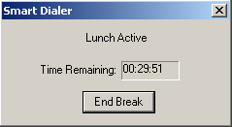
Breaks
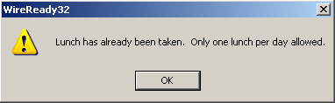
To start a lunch break, either hit CTRL+L or select SmartDialer and Start Lunch from the menu. This will launch the Lunch Active timer. Also, the lunch indicator will be changed in the daily stat file to indicate that the user has taken lunch. If the lunch timer reaches zero, a penalty will be incurred and the daily stat file will be updated.

If the user has already taken lunch today, a message box will pop to tell them they can’t have another lunch.

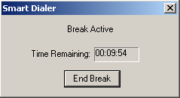
To start a regular break, either hit CTRL+B or select SmartDialer and Start Break from the menu. This will launch the Break Active timer. If the user attempts to exceed the max number of breaks, they will receive an error message. The break timer Dialog works the same as for lunch.

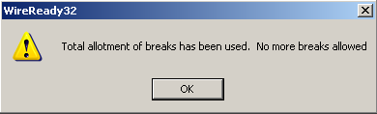

When a break or lunch timer is overrun, the clock is stopped to keep unnecessary penalties from accumulating. The shot clock will resume counting down when the user hits the ‘End Break’ button on the break or lunch timer dialog.
Additional management tools: Protect Buttons (Do Not Call Requests, Bad Telephone Numbers and Protected Accounts)
The 2 Protect buttons enable a manager to block the telephone and fax number on any particular account so that CECs cannot call those blocked accounts. Software can be configured to let the CECs view blocked accounts, but with a warning message that explains the account is blocked and there is no access to it, or configured to make the blocked accounts “disappear” from the database (the manager can still view blocked accounts). Call our 800 number for help configuring viewing blocked accounts.

When you wish to block an account, you simply click the Protect Button near the phone number or fax number, depending on which you wish to block. A box pops up with 3 reasons for blocking this number, you must click the radio button that corresponds with your reasoning. See the diagram on the following page.
- Protect: If the number is protected, the sales rep who owns the account can still access and view the account, but all others will be locked out. The account turns red to signify it’s been blocked.
- Bad Number: If the number if a bad or disconnected number, the sales rep who owns the account can still access and view the account, but all others will be locked out. The account turns red to signify it’s been blocked.
- Do Not Call: If the customer has requested not to be called the sales rep who owns the account can still access and view the account, but all others will be locked out. The account turns red to signify it’s been blocked.

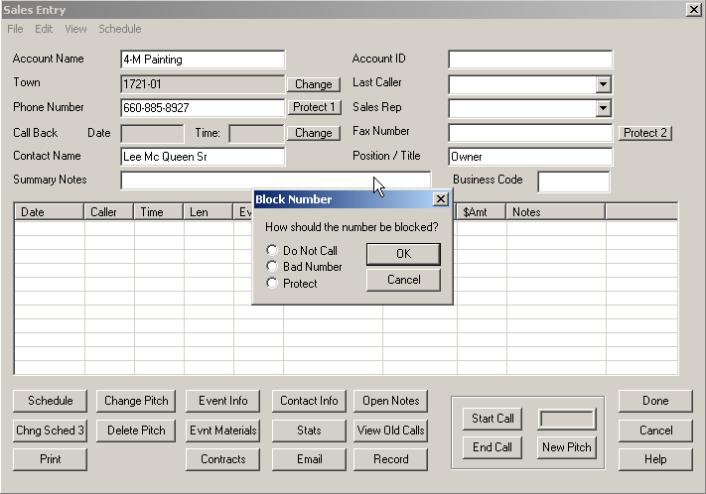

Appendix A: Quick synopsis of each button in SalesReady

Database Window
To get to the SalesReady Database Window, you must first start the WireReady software from the computer desktop, login, and then click on the yellow “Sales-9” button at the top right of the screen.

Button Name: F2 Show
Function: Standard window button
Use: To sort or organize the entire database or narrow the database to a manageable list of accounts. Lists can be sorted by city, category, zip code, total amount bought, callbacks scheduled…just about any sort parameter you would need.

Button Name: F3 Find ID
Function: Standard window button
Use: To quickly find a particular account(s) using an ID number only. Unique ID numbers have to be assigned account-by-account before the search can be utilized.

Button Name: F4 Add
Function: Standard window button
Use: To enter a new account to the database.
Recommended Users: The CEC Director/ Team Leader

Button Name: F6 Report
Function: Standard window button
Use: To monitor sales progress or event progress using software-generated reports. Reports can be generated on one caller, all callers, one event, all events, monthly sales, or leads. Instead of gathering this information by hand, the software tracks it for you and bundles it into a summarized report.

Button Name: Ctrl + U User
Function: Standard window button
Use: To switch 4-letter rep name without exiting the WireReady software entirely.
Pro: A manager can login as a CEC to correct a pitch that was logged incorrectly.
Con: This button cannot be used to switch between secure logins (with passwords); only switches between 4-letter rep names.
Recommended Users: The CEC Director/ Team Leader

Button Name: View Record
Function: Standard window button
Use: To open or view any particular account window. This same function is more commonly performed by double-clicking the account name.

Button Name: Delete Record
Function: Configurable (grayed out if disabled) for added security
Use: To delete and entire account from the database.
Pro: To clean out any extraneous records that were added.
Con: We recommend NOT deleting records for several reasons.
- Deleting a record that has been called upon erases sales history and alters reports
- Deleting records interferes with yearly database updates provided by WireReady. It is possible to end up with that account again anyway when the database it updated if you have deleted it in the past.
Recommended Users: The CEC Director/ Team Leader or Sales Manager ONLY

Button Name: Event Info
Function: Standard window button
Use: To organize, plan and schedule events in the system in an easy-to-use interface. Managers can also add new events at this location. Not only does this window help keep a manager on top of his/her duties, it can be used as a communication tool between CEC’s and their manager because of the color-coding that indicates when an event is selling and when it is airing. Managers can also take notes in the Event Info window about events, for their own use, or take notes to be used in communication with CECs.

Button Name: List
Function: Standard window button
Use: To allow users to create a list of accounts to be printed or saved to a file. For calling lists, mailing labels and on-screen information capture. You may export the information from the database either to file or directly to printer.
Recommended Users: The CEC Director/ Team Leader or Sales Manager

Sales Entry Window
To get to the Sales Entry Window, you must first view an account record by double-clicking the account name or clicking the “View Record” button.

Button Name: Schedule
Function: Standard window button
Use: To schedule meetings or negotiations (track sales leads). This is typically used by an account executive, rather than a Community Event Coordinator. If an account executive spends just a few minutes per day entering their negotiations, a sales manager can quickly review the deals happening and help facilitate a sale.
Recommended Users: Account Executives

Button Name: Chng Schedule 3
Function: Standard window button
Use: To update records of negations or change the pitch on a previously schedule negotiation. This is a way to track the on-going communications/ relationship between the salesperson and the client.
Recommended Users: Account Executives

Button Name: Print
Function: Standard window button
Use: To print one account’s information, event history, notes or old calls. AEs can print out this information to take with them on the street.
Recommended Users: Account Executives

Button Name: Change Pitch
Function: Standard window button
Use: To update a previous Undecided pitch to yes or no. The goal is to follow up on all those Undecided calls and persuade the client to go one way or the other. No money should be left on the table at the end of the month.

Button Name: Delete Pitch
Function: Configurable (no button at all if disabled) for added security
Use: To delete a pitch (usually a mistake or a client changed decision)
Pro: The manager can remove pitches that were entered incorrectly, or sales pitches that that were not real sales, from the history of that account.
Con: Access to this button will allow the user to delete any pitch. This could be used to delete real pitches or sales and affect the records of activity on an account or by a CEC.
Recommended Users: The CEC Director/ Team Leader or Sales Manager ONLY

Button Name: Event Info (first explained above)
Function: Standard window button
Use: To organize, plan and schedule events in the system in an easy-to-use interface. Managers can also add new events at this location. Not only does this window help keep a manager on top of his/her duties, it can be used as a communication tool between CEC’s and their manager because of the color-coding that indicates when an event is selling and when it is airing. Managers can also take notes in the Event Info window about events, for their own use, or take notes to be used in communication with CECs.

Button Name: Evnt Materials
Function: Standard window button
Use: To access event documents such as ad copy forms, broadcast order-forms, faxable brochures/flyers, invoices or any other document that might be needed when finished or negotiating a sale.

Button Name: Contracts
Function: Standard window button
Use: To launch production forms, contracts or event forms
Recommended Users: Account Executives

Button Name: Contact Info
Function: Standard window button
Use: To view account address and email address information

Button Name: Stats
Function: Standard window button
Use: To access sales history information about that account. Lists (in a summary bulleted list): total number of calls, total number of pitches, total number of buys, close ratio, max $Y pitch, min $Y pitch, total $ bought, $ earned/ call, total busy attempts, total not in attempts, total answering machine attempts.
Recommended Users: The CEC Director/ Team Leader or Sales Manager

Button Name: Email
Function: Standard window button
Use: To send customer contact information to a selected email recipient. User simply clicks the email address to where he/she wishes to send email to, and chooses the destination folder.

Button Name: Open Notes
Function: Standard window button
Use: To view account notes written by anyone who has happened to call on this account. Any complicated issues or preferred ad copy can be stored in notes for future reference.

Button Name: View Old Calls
Function: Standard window button
Use: To view sales history past the calls that fit into the sales history window that is already visible. This holds all the past calls that don’t fit into the window. Sales History helps when figuring target categories or businesses for a particular event. If the customer has purchased or not purchased similar types of events in the past, it could affect whether this customer is called when time is crunched.

Button Name: Record
Function: Standard window button
Use: To open a blank *.wav file for recording audio over the phone or through a microphone. Customized commercials or interviews can be conducted through the telephone and recorded from SalesReady. This is the same as using the “Record 8” button from the main WireReady32 button bar.

Button Name: Start Call
Function: Standard window button
Use: To open the auto-dialing window and start the call timer. Autodialing saves wear on the CEC and initiates a call timer for tracking the outcomes of calls.

Button Name: End Call
Function: Standard window button
Use: To stop the call timer after the Start Call button has been used.

Button Name: New Pitch
Function: Standard window button
Use: To open call log window. The New Pitch window is the launch pad for everything a CEC might log as the result of a call—the event pitched, the buy, the dollar amount, set a callback, take notes, and open event materials.

Button Name: Done
Function: Standard window button
Use: To finish/ save work on a particular account and let the software officially close the account. Even when no changes are made, the Done button needs to be clicked.

Button Name: Cancel
Function: Standard window button
Use: To exit an account without saving any changes. This button should only be used when changes have been made that the user is sure does not need to be saved. When closing an account, it is best to use the Done button.

Button Name: Help
Function: Standard window button
Use: To open the help website. The Help buttons are not supported at this time.

Button Name: Change (town or category)
Function: Standard window button
Use: To change the sort specification associated with a particular account. If a business category or town location changes, the user can update that label with the Change button. This button will be used to assign a category or town when first adding new records.
Recommended Users: The CEC Director/ Team Leader or Sales Manager

Button Name: Protect 1 (Phone Number)
Function: Standard window button
Use: To block a phone number from regular use by labeling it with Do Not Call, Bad Number, or Protect.
Pro: Blocking a number prevents CECs from calling on that customer. Software should be configured so that everyone can see the blocked accounts but cannot access them.
Con: As long as they CEC can view the account (with no access), he/she will not try to add it back into the database.
Recommended Users: The CEC Director/ Team Leader or Sales Manager

Button Name: Change (callback date)
Function: Standard window button
Use: To change the callback date/time set for that account.
Pro: When a callback has been set, and a CEC makes an attempt to follow up, only to find the decision maker is still not available, he/she may wish to simply change the callback date for further into the future. After a call back to the account has occurred, this button can be used to clear the call back date and time.

Button Name: Protect 2 (Fax Number)
Function: Standard window button
Use: To block a fax phone number from regular use by labeling it with Do Not Call, Bad Number, or Protect.
Pro: Blocking a number prevents CECs from faxing that customer. Software should be configured so that everyone can see the blocked accounts but cannot access them.
Con: As long as they CEC can view the account (with no access), he/she will not try to add it back into the database.
Recommended Users: The CEC Director/ Team Leader or Sales Manager

Event Materials Window
To get to the Event Materials Window, you must first view an account record by double-clicking the account name or clicking the “View Record” button. For ease of use, you can find the Event Materials button in 2 different places. From the Sales Entry window, there is an Event Materials button, and also in the New Pitch window there is an Event Materials button. The most common way to get to Event Materials is through the New Pitch window.

Button Name: Launch
Function: Standard window button
Use: To open an event materials document (brochure, invoice, etc) so that it auto-grabs the contact information and event information for the customer and event you choose. This technology utilizes WireReady tags embedded into template event materials documents. Each time the template is Launched for a particular customer, it is customized automatically to save CEC time. The CECs name is automatically entered as a salutation; there are very few edits the CEC must perform before sending out the document.

Button Name: Cancel
Function: Standard window button
Use: To close the Event Materials window without opening any documents.

Button Name: New File
Function: Standard window button
Use: To insert a new blank document into an existing event folder. When creating an entirely new document, this button ensures that the document rests in a location where it can be found easily using SalesReady software.
Recommended Users: The CEC Director/ Team Leader or Sales Manager

Button Name: Edit Selected
Function: Configurable (grayed out if disabled) for added security
Use: To edit or make permanent changes to the event document template.
Pro: Each time an event is sold each year, the template usually needs to be edited to reflect changed dates or updated ad copy. NOTE: If you are using the starter pack of events provided by WireReady, titles and event packaging does not need to be altered on the document template because it is housed in the Event INFO Screen instead.
Con: The user must be careful not to accidentally delete an entire WireReady tag or part of a WireReady tag, otherwise the requested information will not auto-fill correctly when the document is launched by a CEC. Documents cannot be edited if they don’t exist to begin with.
Recommended Users: The CEC Director/ Team Leader or Sales Manager

Button Name: Help
Function: Standard window button
Use: To open the help website. The Help buttons are not supported at this time.

Button Name: Event Info 1
Function: Standard window button
Use: To organize, plan and schedule events in the system in an easy-to-use interface. Managers can also add new events at this location. Not only does this window help keep a manager on top of his/her duties, it can be used as a communication tool between CEC’s and their manager because of the color-coding that indicates when an event is selling and when it is airing. Managers can also take notes in the Event Info window about events, for their own use, or take notes to be used in communication with CECs.

Button Name: View Notes
Function: Standard window button
Use: To view notes edited by a manager about a particular event. Notes can be used to remember how an event performed from one year to the next. Notes can also be used to inform callers of extra information that would be helpful in making a sale.

Button Name: Edit Notes
Function: Configurable (grayed out if disabled) for added security
Use: To edit/add notes about a particular event.
Pro: Notes can be saved to remember how an event performed from one year to the next. Notes can also be saved to inform callers of extra information that would be helpful in making a sale.
Con: A user could change the information in this field, and assign the good accounts to himself, or remove notes the management added about the event.
Recommended Users: The CEC Director/ Team Leader or Sales Manager

Button Name: Launch As Form
Function: Standard window button
Use: To open an event materials document (brochure, invoice, etc) so that it inserts blank lines where it normally would have auto-grabbed the contact information. This “blank” document can then be photocopied to be used as template hard copy.

Button Name: Copy As Template
Function: Standard window button
Use: To copy an event materials document (brochure, invoice, etc) template to another event folder.
Pro: When you add a new event, and you have a master template saved, or just have another event document that would be similar to what you want for your new event, use the Copy Template as a starting point. Copy the similar template to the new folder, and then make just a few edits to the new document instead of starting from scratch.
Con: You cannot copy a document to a new folder if that folder does not already exist. See the handbook to learn how to add a new event folder each time a new event is added to the system.
Recommended Users: The CEC Director/ Team Leader or Sales Manager

Button Name: Print ALL as Form
Function: Standard window button
Use: To print all the event materials documents (brochure, invoice, etc) in a particular folder so that it inserts blank lines where it normally would have auto-grabbed the contact information on each document printed from the folder. This would be most often utilized to gain hard copy of all documents to work with for any event. If you need a copy of one or two documents, print each document separately.

Button Name: Print ALL Folders as Form
Function: Configurable (no button at all if disabled) for added security
Use: To print all the event materials documents (brochure, invoice, etc) in all of the event folders so that it inserts blank lines where it normally would have auto-grabbed the contact information on each document printed from the folders.
Pro: The “blank” documents can then be photocopied to be used as template hard copies.
Con: It takes time for the computer and printer to “spool” all the information associated with all the documents (especially because they have color graphics on them). When using this feature, the computer cannot be used for anything else until it is done spooling.
Recommended Users: The CEC Director/ Team Leader or Sales Manager ONLY

