


Community Event Coordinator Handbook

56 Hudson Street Northboro, MA 01532
800-833-4459 Fax: 508-393-0255
www.wireready.com
Using SalesReady® to Make Sales 3
Overview 3
Community Event Coordination vs. Telemarketing 3
How to get started each day 4
Start of each day 4
How to use SalesReady® to best define your audience 5
Figuring out who to call & in what order 5
Using the Search/ Sort functions 6
How to log calls 15
Dialing a customer with SalesReady® 16
Logging calls into SalesReady® 18
The SalesReady® Shot Clock™ 27
Smart Dialer is a positive reinforcement tool 27
Improved efficiency with SalesReady Smart Dialer 27
Smart Dialer on-screen codes: 28
Shot Clock & Penalties 28
Advanced uses of the SalesReady software 30
When to schedule a callback 30
How to change a Maybe pitch to a Yes or No 30
Best way to use Summary Notes 34
How to deal with businesses that request not to be called 35
Procedure to open Event Materials 37
Faxing Event Materials to Customers 40
Procedure to fax an invoice directly to one customer 40
Procedure to fax multiple documents to one customer 42
To Email using Microsoft Word and SalesReady 43
Procedure when you make a sale 44
Appendix A: Working on your pitching skills 45
Explanation of the 4-part pitch 45
Example sales pitch 45
Logics about the pitch: 47
Master these Three Advanced Closing Techniques 47
How to handle the objections 48
How to handle the “no” answers—don’t take it personally 49
The importance of enthusiasm in your voice 50
Appendix B: Working with audio clips and the phone 51
Procedure to play audio over the phone to potential clients 51
Procedure to record audio from clients 53

Using SalesReady® to Make Sales

Overview

Community Event Coordination vs. Telemarketing
You are a Community Event Coordinator, NOT a telemarketer. As a Community Event Coordinator, you are interested in LEARNING what customers like and don’t like and ONLY calling them with opportunities you believe they would be interested in participating in.

The best way to learn about your customers is to build relationships. You can build a relationship with your customer by asking them questions and letting the customer talk. The worst thing you can do is start talking and not stop to take a breath because you are scared the customer will hang up before you tell them about the opportunity. Just start a conversation with him or her, and then get to the point after you’ve got them talking and being involved in the conversation.
By learning about the activities in which they participate and learning about what their kids like, you can better call them with events that they care about. If, by building a relationship with the Bank President you learn that his daughter is the star of the softball team, you can be sure to call him about the softball championship game promotion. When you call him on the softball championship, he is more likely to participate because he gains in two ways. He can support his daughter and her team and gain recognition for his business name at the same time.

At the same time that you can use your knowledge to your advantage, you must not ignore businesses that you are not so familiar with, when you are calling on an event. Each and every business should have the same opportunity to get involved in sponsoring an event.

Telemarketing is annoying people, by trying to sell people you know little or nothing about. Community Event Coordination is LEARNING what people like and don't like and ONLY calling them with opportunities that you have an inkling they will be interested in.

How to get started each day

Start of each day
Log into SalesReady® with the appropriate user name and click the yellow Sales Button (Alt-9 on your keyboard). SalesReady® will then ask you to identify yourself by choosing your name from the list.
The first thing you want to do is to use SalesReady® to generate a list of today’s callbacks (See SEARCH: Show Today’s Callbacks for... , Sort by... in the following section entitled: How to use SalesReady® to best define your audience, page 9).
When you are ready to begin selling for the day, consult your events calendar by clicking the Event Info button, or talk to your Sales Manager to make sure that you know what you are selling. Consult with your Sales Manager if you do not fully understand:
The concept of the event
Why this event is important
Run dates
Sell dates--Start and End dates you should be selling this event (selling at wrong time--too early or too late--will make selling more difficult.)
Understand who on your team is calling where so that you are not all calling the same people over and over again for the same events.

How to use SalesReady® to best define your audience

Figuring out who to call & in what order
The F2 (Show) button allows a user to display accounts based on specific criteria. See the diagram below to find the F2 Show button.

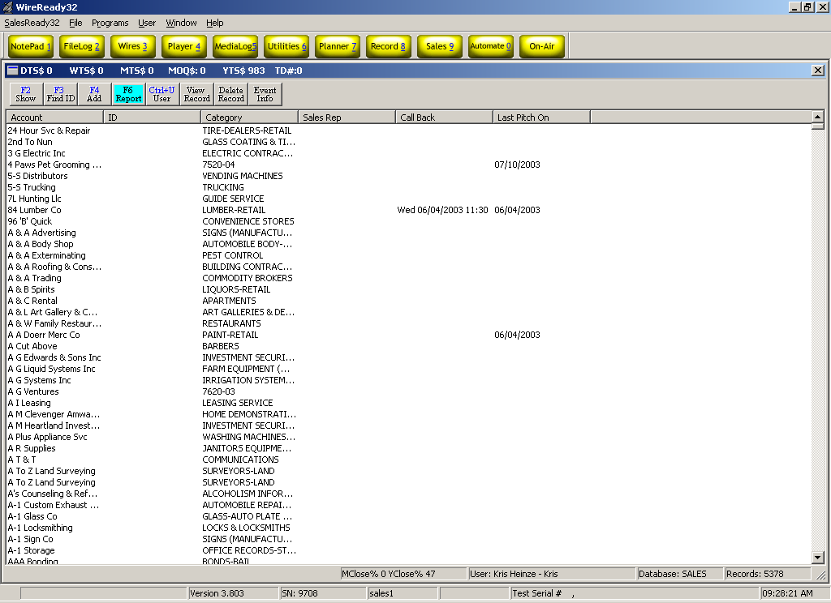
When you click the F2 Show button, SalesReady® will ask you to choose the specifications of your account sort. The following diagram shows the dialog box that will appear after clicking the F2 Show button.
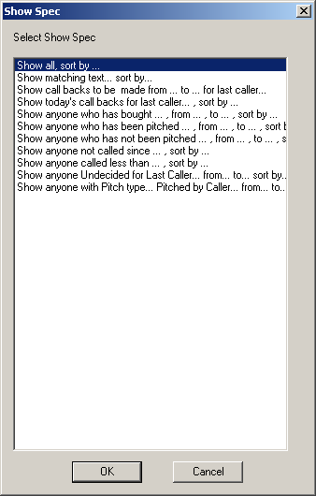

Using the Search/ Sort functions

To display all the records at the same time, choose:
SEARCH: Show all, sort by…
This particular search is good because it is how you get back to the beginning. If you do other searches, you can always show all the accounts again by searching with the Show All, Sort By… option. When you double-click the Show All, Sort By… option, SalesReady® will ask you again to sort your list of records. It really doesn’t matter which way you sort them at this point, whatever makes sense for you is best.

To display records that all have something in common, choose:
SEARCH: Show matching text…sort by…
This search is the best choice when you want to view only those records that are in the town that has been assigned to you as your call area. For example, today the Sales Manager decided that the team is selling the local Blood Drive, and that you are supposed to start in the town of [Ashland]. By double-clicking Show matching text, sort by… , you can view only the records for the town of [Ashland]. See the diagrams below to sort your records by town.

Double-click Show matching text…sort by…
Type in the name of the town from where the records are that you want to view, and click OK. Or type in the name of a category of businesses you would like see (i.e. florists).
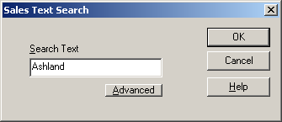
Double-click Sort by City from the next dialog box to double-check your work.

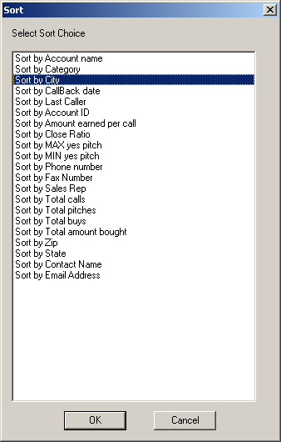
After sorting by city, the SalesReady® database will display only those records with text including [Ashland]. See the results below:

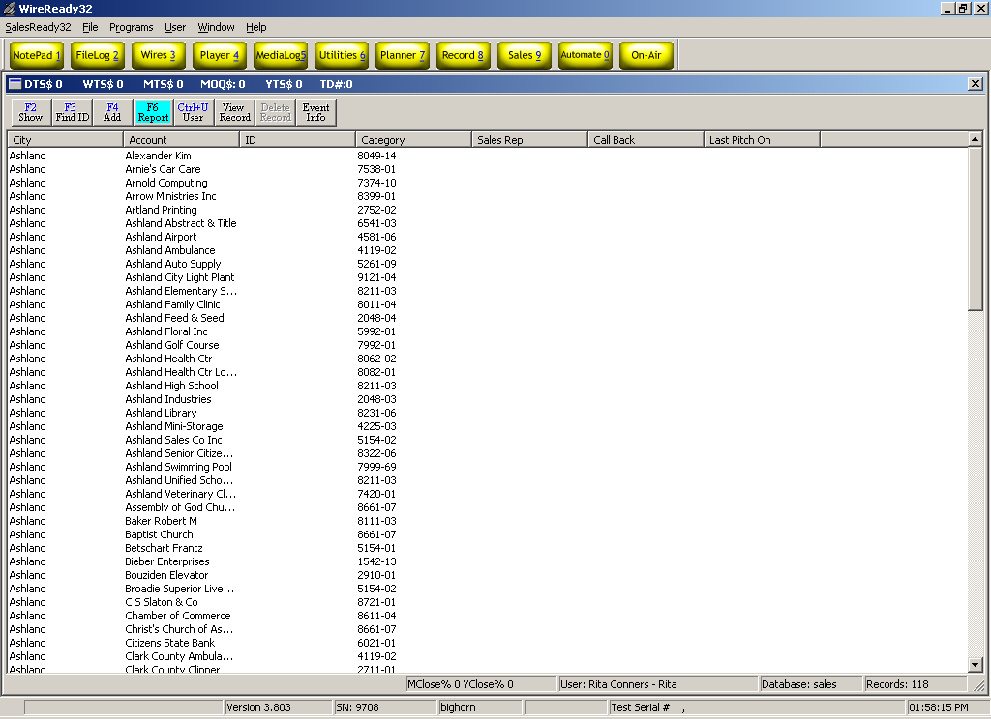

To view all the callbacks you’ve ever scheduled, choose:
SEARCH: Show callbacks to be made from…to…for last caller
This search is good to clean up any callbacks that you have forgotten about or missed from days past. See the following diagrams to view all your past callbacks.

Double-click Show callbacks to be made from…to…for last caller.
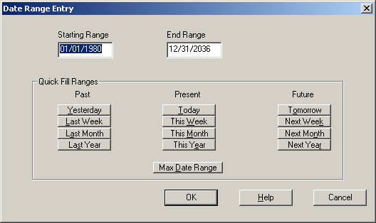
Choose the button Max Date Range at the bottom of the screen.
Choose your name from the list of users to view your callbacks.
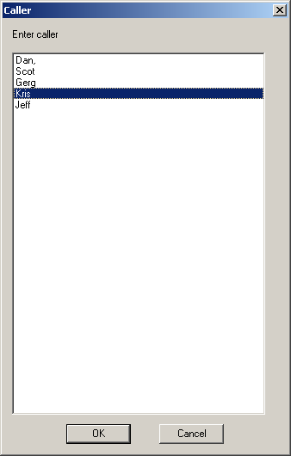

To view your callbacks for today, choose:
SEARCH: SHOW TODAY’S CALLBACKS FOR LAST CALLER…SORT BY…
This is the best way to start your day. Why not begin by calling those whom you believe are likely to buy? Start the day by boosting your confidence with a YES call!

Double-click Show today’s callbacks for last caller…sort by…
Choose your name from the list of callers.
SalesReady® will then refresh with the list of callbacks scheduled for today.

To view a history of past buyers of a particular event or group of events, choose:
SEARCH: SHOW ANYONE WHO HAS BOUGHT…FROM…TO…SORT BY…
After the SalesReady® team has been calling on a database for a year, you have gained valuable knowledge through building relationships, as well as tracking sales history. This particular search is useful for targeting past buyers of a certain events or group of events. These are your best prospects; people who you know from past experience were motivated and interested to buy that event. Most importantly, it is used to find those who have bought events similar to the one you want to sell. Suppose you are selling a soccer game for the first time. The Show anyone who has bought…from…to…sort by search can help you find those who have bought football, basketball, and volleyball in the past in the town where you want to sell the soccer game. Follow the diagrams below to generate a history of past buyers.

Double-click Show anyone who has bought…from…to…sort by…
Choose a time frame from the following dialog box.
Choose an event from the list of events by using the event filter. To use the event filter effectively, type the first few letters of the event you would like to find, and then click once on the event when it appears in the window underneath the event filter. Click OK. (See next page.)
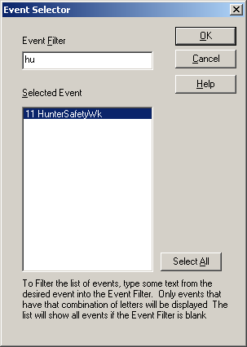

Choose how you want your list sorted. Sort your search by city if you would like to view the history of past buyers from more than one city.

To view a history of anyone who was given the opportunity to buy an event, choose: SEARCH: Show anyone who has been pitched…from…to…sort by
This search would be useful for finding out who was given the opportunity to buy a particular event last year. Or it would be useful for a Sales Manager to find out how many customers the team reached total on a particular event.
Double-click Show anyone who has been pitched…from…to…sort by
Choose a date range by clicking on the appropriate button. Click OK.
Choose the event for which you want information by using the event filter.
Choose your preferred sort. Sort by City might be the best option.

To avoid bringing up the same accounts each day during a multiple day event calling session, choose:
SEARCH: Show anyone who has not been pitched…from…to…sort by…
This search is great if you are continuing selling an event for the second or third day, or even when you come back from lunch and you don’t want to have to try and remember whom you have already called. This search will display only those records that you haven’t called recently on this pitch.
Double-click Show anyone who has not been pitched…from…to…sort by…
Choose your time frame by clicking on the appropriate button.
Click OK.
Choose the event that you are selling currently by using the event filter.
Choose your preferred sort, which may be Sort by City in many cases.

To find accounts that have not been called over a period of time, choose:
SEARCH: Show anyone not called since…sort by…
The best way to use this search is when a customer has asked only to be called once a month. Every month, on the 15th for example, you would perform this search and ask SalesReady® to find all accounts who had not been called since the 15th of last month. This method would catch most of those type of accounts, but there are reasons to call an account besides event sales, and if someone from news or the outside sales department has made a call to an account since the last time you called, the computer will not find those accounts.
Double-click Show anyone not called since…sort by…
Type the date where you would like to start
Choose your preferred sort

To catch and call accounts that have been called infrequently, choose:
SEARCH: Show anyone called less than…sort by…
Use this search to find accounts that have been skipped, or not given the opportunity to buy as often as others. Remember, someone who has never been given the opportunity COULD be a buyer. This search ensures that people who haven't been given the opportunity come up on your list.
WARNING- be sure to notice any SUMMARY NOTES or NOTES for these, they may only have been called once or twice for a REASON.
Double-click Show anyone called less than…sort by…
Type in a number of times that the account could be called less than. For example, you might want to find who has been called less than 5 times.
Choose your preferred sort

To ensure that all your Undecided calls are followed up for a yes or no, choose:
SEARCH: Show anyone undecided for last caller…from…to…sort by…
Use this search at the end of the week to clean up all your undecided calls. You don’t want to leave any money on the table when it could be counting toward your paycheck, so perform this search on Friday morning and call these accounts to follow up. Remember that you never want to leave a ? pitch as is, you must always follow up and find out whether it’s going to be a YES or a NO.

Double-click Show anyone undecided for last caller…from…to…sort by…
Choose your name from the list of callers
Choose Max Date Range as the time frame. Click OK.
Choose your preferred sort

To display those accounts that were serviced with an OTHER pitch, choose:
SEARCH: Show anyone with pitch type…pitched by caller…from…to…sort by…
To view which accounts have been faxed, invoiced, sent thank you’s, etc, this search is best. The OTHER pitch is used to log activities related to the phone call.
Double-click Show anyone with pitch type…pitched by caller…from…to…sort by…
Choose from the list the type of OTHER pitches that you want information on
Choose your name from the list of callers
Choose a date range by clicking on the appropriate button. Click OK.
Choose your preferred sort.

How to log calls

After you have narrowed your list of customers to call using the SalesReady® search functions, you are ready to start calling. On the following page is a sample SalesReady®™ database view of customers using the matching text sort.

Double-click any record, or account, to view more details about that particular customer. The Sales Entry screen displays the contact name, address, and past call information. This screen is also a launching point for logging all activities that happen throughout the course of the phone conversation. See the diagram on the following page to view an example Sales Entry Screen.
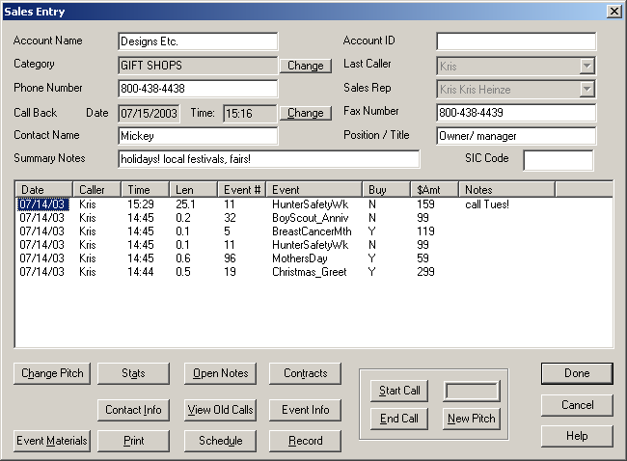

Dialing a customer with SalesReady®

There are two things you need to view before dialing:
Check the call history in the large white window, and look at the top few records to make sure that no one has called this customer recently on the same event you want to call them on.
Check the Summary Notes bar directly under the contact name. In some cases, the customer will request not to be called, and this is where you would find the DO NOT CALL REQUEST. If you see a DO NOT CALL REQUEST, refrain from calling this customer.

SalesReady® uses a computer modem to work with the phone line and allow the user to dial accounts or customers right from the screen.
Go to the bottom of the Sales Entry screen and find the button called Start Call. See the diagram below to find the Start Call button on the Sales Entry Screen.
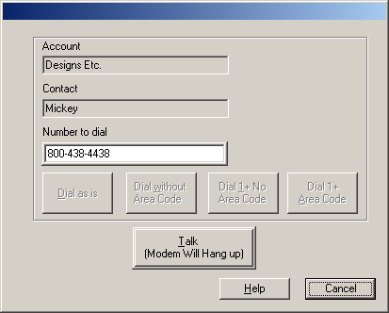
The Start Call button brings up a dialog box giving the user several options for dialing customers. The four dialing options cover both dialing in the area & out of the area.

To dial out, click the desired dialing option once, and when the phone begins to ring, click the large Talk button underneath the four dialing buttons. This will exit the Start Call screen back to the Sales Entry screen for the customer. See the diagram above to understand the dialing options and the Talk button.
Once the phone has begun ringing and you have clicked the Talk button, you are ready to start logging the conversation that takes place between you and the customer. You should be looking at the Sales Entry screen once again.

Logging calls into SalesReady®

It is important that, as a CEC, you learn how to correctly document the activities that happen during each call. You must correctly log the results of the call and the time spent on the call for reporting purposes. Not only does your Sales Manager need that information for pulling sales reports from SalesReady®, but in the case that there are any problems with your SalesReady® software, SalesReady® support technicians can use the reports to troubleshoot the problem.

The first concept to understand is the idea of a QUALIFIED CALL vs. an UNQUALIFIED CALL. A call only becomes QUALIFIED when you speak with a decision maker and that person says YES, NO OR MAYBE to a specific dollar amount. If you give the whole pitch, and then the person says they’ll tell their boss about it and call you back, it is not a qualified call. If the person you’re talking to hangs up when you say what radio station you’re from, it is not a qualified call. The only time you ever get to log a YES, NO OR MAYBE is when you have spoken with the decision maker long enough to talk money and to persuade them to give you a concrete answer.

When you are to the point that the phone is ringing and you are looking at the Sales Entry Screen for your customer, the first thing you need to do is click on the New Pitch button. When you click the New Pitch button, notice the timer box directly above the New Pitch button. When you hit the Talk button earlier, the timer started automatically. See the diagram below to find the New Pitch button.

ALWAYS open the New Pitch dialog box to start the timer and give yourself the opportunity to log a busy signal or a case where the contact person is not available, as well as the qualified calls.

- To log the result of a NON-QUALIFIED call
(when you don’t reach the decision maker i.e. busy, not in, etc):
Click the New Pitch button.
See the diagram above to find the New Pitch button.
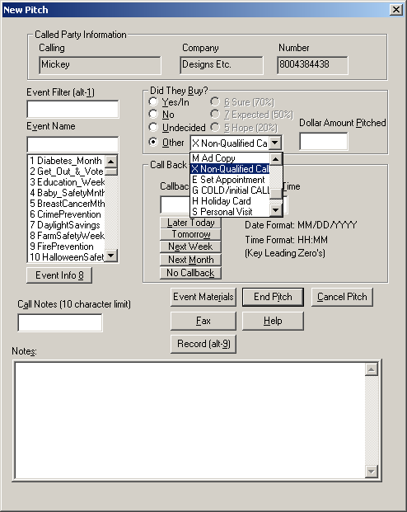
Click the OTHER pitch type drop down arrow and choose X-non-qualified call. See the diagram on the following page to find the OTHER pitch drop down menu.

Make note of the reason the call was non-qualified in the Call Notes section (i.e. busy, not in, machine, etc). See above.
There is no need to set a callback reminder on non-qualified calls. If you really want to try again when you are about the close the event, you can search for a list of those not pitched. Be jealous of your time; don’t waste your time chasing people who don’t want to be reached. Use it to find those who are willing to participate.

- To log the result of a QUALIFIED call:
There are 5 sections of the New Pitch dialog box that need to filled in on each qualified call:
The Event Name
The Buy—Yes, NO, MAYBE, OR OTHER
The Amount of the Pitch
A Callback section in the event of a MAYBE
A Notes section

Start by clicking on the New Pitch button.
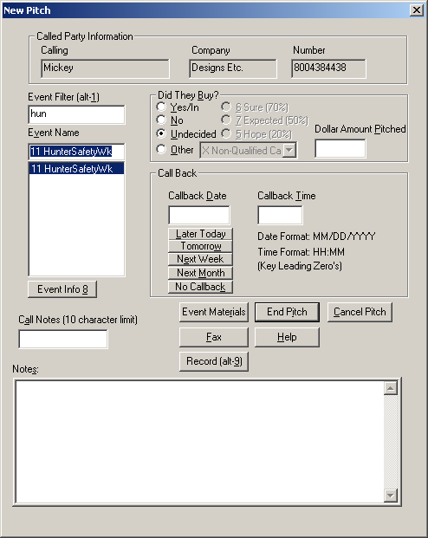
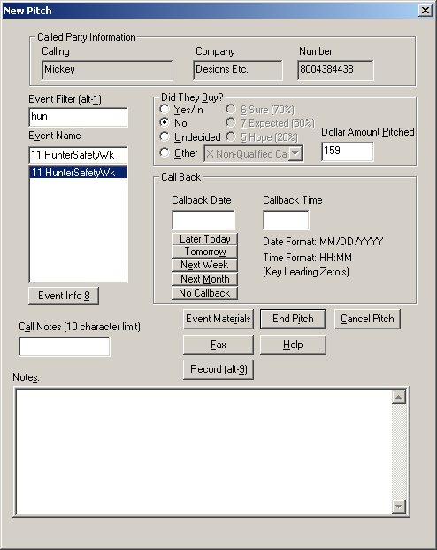
Use the Event Filter to quickly find the name of the event that you are selling. Remember to click once on the event when it appears in the window below the Event Filter.
Choose the result of the call from the list of radio buttons. YES, NO OR MAYBE. See the diagram below:
The cursor automatically jumps to the Amount section, where you log how much you pitched the customer, using whole dollar amounts, with no decimals. See above to find the amount section.
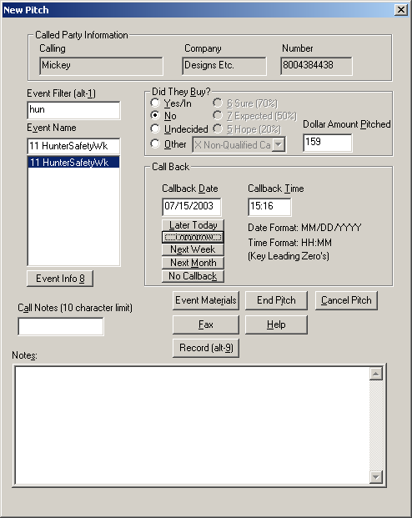
IF, the customer is undecided on buying the pitch, and you need to call them back, use the Callback section to set a reminder for yourself to close the deal. See the diagram on the following page to find the callback section.

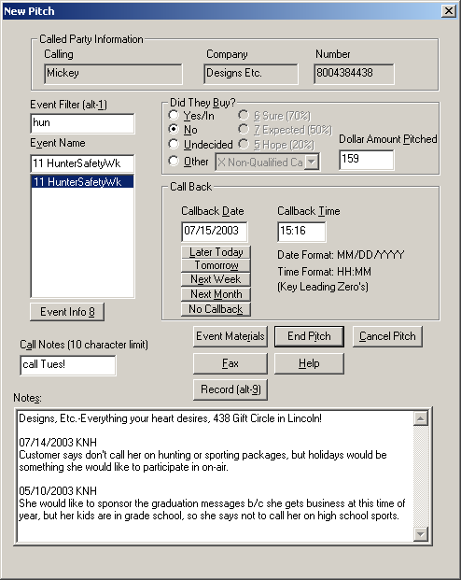
Use the Call Notes section to add more details about the event or the call. You have 10 characters to make notes and there cannot be any spaces. There is also a Notes section at the bottom of the screen to write out any more specifics about what the customers likes or dislikes or when is the best time to reach him/ her. You can also use the Notes section to store the customer tag the way the customer wants it to read. For example: Designs, Etc.—Everything your heart desires, 438 Gift Circle in Lincoln! Instead of having to ask Mickey what she wants to say on each call, you can just check the notes box, and ask Mickey if she still wants to say, See the diagram below to find the 2 types of notes sections.
Before you finish up a YES call, there are 3 things you need to identify or verify with the customer.
Verify the billing address & get a fax or email to send the invoice
Add the tag at the bottom of the ad copy the way the customer would like
Modify the invoice to reflect the package that the customer purchased (see the appendix to view the complete procedure when you make a sale).
Click the End Pitch button to finish up all types of calls. Remember to click the Done button on the Sales Entry Screen to exit the record and save all your changes. See the diagram below for the End Pitch button and the diagram on the following page for the Done button.
Click Done on the Sales Entry Screen. Double-click the next customer account and move on to the next call using the enthusiasm and momentum from the last sale to your advantage on your next few calls. See the diagram on the next page to find the Done button.

The SalesReady® Shot Clock™

Smart Dialer is a positive reinforcement tool
The only thing that stops the clock is when the user starts a call and stays on it.

It's a very effective, game-like, positive reinforcement tool.

The default shot clock time is 60 seconds, not so much because reps need a full minute in between calls, but because 60 seconds means that each penalty is exactly 1 minute and the penalties represent the minimum amount of time that was wasted.

If the rep doesn't call someone else before the clock reaches 0, the P: penalty field on the top of the screen registers a penalty. We track daily, weekly, monthly and yearly penalties. Each penalty means they took more than 60 seconds in between regular calls.

When they score a sale (Y), the clock counts down from 5 minutes, both as a reward and for time to do paperwork

Reps get three 10-minute breaks and a 30-minute lunch. The on-screen codes show how many breaks have been taken and if lunch break was taken. Once breaks and lunch are taken, the Smart Dialer won't let the reps reset the codes.

NOTE: The shot clock system can be shut off in the INI if it interferes with your system or you decide it's not what you want.

Improved efficiency with SalesReady Smart Dialer
Because reps can cheat by not ending a call in the software at the same time they physically hang up the phone, we introduced another check. Right now, when the user hits New Pitch, the length of the call is only the time elapsed from start of call to the time the End Pitch button is depressed. We added in the time that occurred FROM the time you pitched, to the time you hit DONE and move on to another record.
So if you see lots of 10 and 15-minute non-qualified phone calls, it means the rep left the SalesReady account open well after they stopped speaking with the client.

To speed entry/logging non-qualified calls, we have changed the way the software reacts upon hitting the DONE button. If the DONE button is hit and no pitch has been made, we will automatically bring up the pitch screen displaying the last event pitched. If this call is the same as the last call, all the user has to do is hit DONE one more time and move on to the next call.
In this fashion, we will now start capturing the time (even when they haven't reached a decision maker), so this shows up on the call detail report. Again, if a rep thinks they can cheat by making a 45-minute bogus call, sooner or later these “breaks” will become noticeable on the call detail report.

Smart Dialer on-screen codes:
P = Penalties. Total number of penalties.
B = Breaks Taken. Total number of breaks taken.
L = Lunch Taken. Y = Lunch has been taken, N = Lunch not taken.
SC = Shot Clock. Countdown timer in MM:SS format displays the total time for the current operation (shot clock, lunch, break). If in shot clock mode, the timer will display the time before a penalty on the current pitch wait cycle. When taking a break, it will display a countdown for the current break (duplicated in the ‘break’ dialog explained later).

Shot Clock & Penalties
When smart dialer is active, the shot clock information is displayed next to the stats in the window frame title. When the shot clock expires, a Penalty is accumulated. Whenever a penalty is acquired, it will be saved to the daily stat file.
When the SalesReady screen is first opened, the shot clock will start counting down from 5 minutes. This provides a 5-minute sign-in time to give users a little time to get ready to start the day. After the first 5 minutes, the shot clock then follows its default.

When the user enters a record, the shot clock information will be duplicated on the record entry dialog's window title. This timer may appear to be slightly behind the main timer, but they are actually the same. It isn't possible to sync them, but the Sales Entry Dialog reads the values from the main timer.

When the user initiates a call, the timer will stop until the user either hits the End Call button, or exits the record.

If the user enters a ‘Y’ type pitch, they will receive a bonus amount to their shot clock based on the BonusYPitchSeconds setting in the ini file.
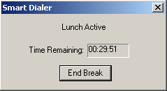
Breaks
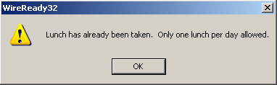
To start a lunch break, either hit CTRL+L or select SmartDialer and Start Lunch from the menu. This will launch the Lunch Active timer. Also, the lunch indicator will be changed in the daily stat file to indicate that the user has taken lunch. If the lunch timer reaches zero, a penalty will be incurred and the daily stat file will be updated.

If the user has already taken lunch today, a message box will pop to tell them they can’t have another lunch.

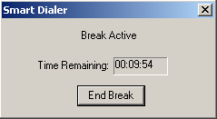
To start a regular break, either hit CTRL+B or select SmartDialer and Start Break from the menu. This will launch the Break Active timer. If the user attempts to exceed the max number of breaks, they will receive an error message. The break timer Dialog works the same as for lunch.

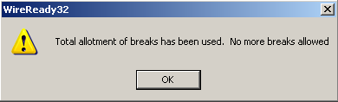

When a break or lunch timer is overrun, the clock is stopped to keep unnecessary penalties from accumulating. The shot clock will resume counting down when the user hits the ‘End Break’ button on the break or lunch timer dialog.

Advanced uses of the SalesReady software

When to schedule a callback
There are only 2 reasons to schedule a callback: When you have spoken with the decision maker and he/ she is undecided on participating in the on-air package, or when a gatekeeper has given you a specific time that you can reach the decision maker.

In the New Pitch dialog box, choose one of five choices for future callback reminder times. You may edit the time in the box, as long as you remember to log it in military time. See the diagram on the following page to understand how to edit a callback time.
- LATER TODAY—sets the callback exactly one hour into the future
- TOMORROW—sets the callback exactly 24 hours into the future
- NEXT WEEK—sets the callback exactly 7 days into the future
- NEXT MONTH—sets the callback exactly 30 days into the future
- NO CALLBACK—removes any callbacks already set for this customer

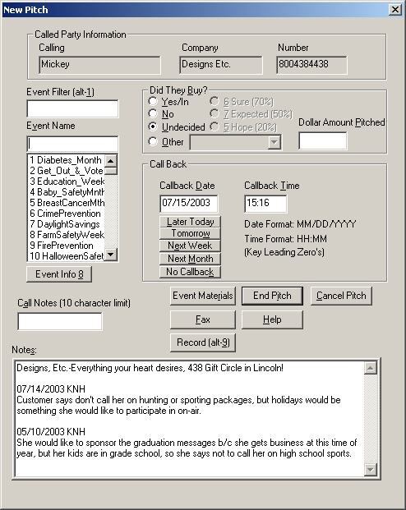
How to change a Maybe pitch to a Yes or No
It is important that you train yourself to always follow up on Undecided calls to get the customer to commit to a YES or an NO. The goal is that you have no money left on the table, and also that your records in SalesReady® reflect that you have no money left on the table. Follow the steps below to change an Undecided calls to a YES or NO call.
Double-click on the customer account to bring up the Sales Entry Screen.
Click once on the date to highlight the call that needs to be changed. See the diagram below.
Click on the Change Pitch button at the bottom of the Sales Entry Screen. See the diagram to find the Change Pitch button.

Choose either the YES radio button or the NO radio button.
Be careful here, once you choose the YES button, you can no longer change the pitch.
Click End Pitch to save your changes.

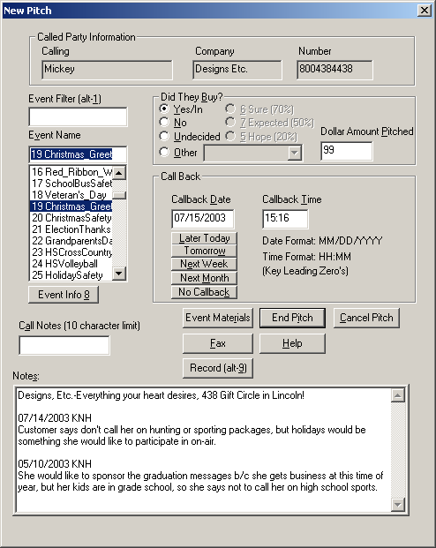

Best way to use Summary Notes
(white box underneath the contact name in Sales Entry Screen)
Use this section to “Red Flag” DO NOT CALL REQUESTS (ABBREVIATED: DNCR) and to identify a customer with particular event types (sports, health, holiday, etc). This is information that appears every time anyone opens this account.
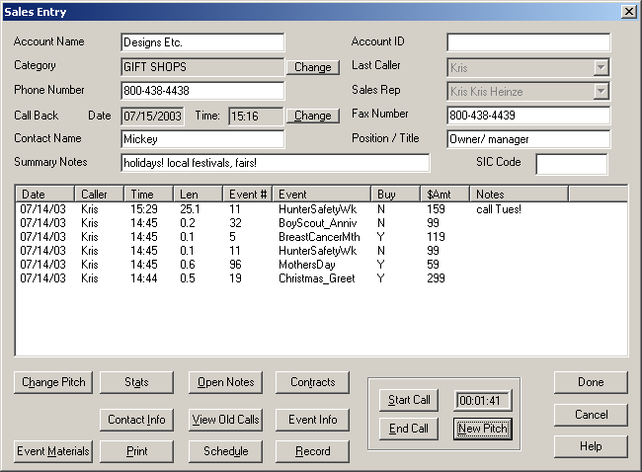

How to deal with businesses that request not to be called
Many states have do not call laws that only deal with residents/consumers, but while businesses are exempt from anti-calling laws, we ask that you respect their wishes. Calling people who are averse to buying over the phone is a waste of your time.
One way to avoid calling those who have requested not to be called is to 000 out the phone number. This leaves them in database (so you don't add them back) but prevents anyone from calling again.

However, these folks may be FAX friendly. Do not 000 out FAX numbers, as these people may be interested in receiving a fax brochure asking them to participate in an on-air campaign. (Periodically through the year, a fax campaign can be done for do not calls, that specifically says you will not be called, - please call the radio station if you want to learn more, and be offered these exciting affordable sponsorship and name recognition opportunities).

Using the Onscreen Stats
The Onscreen Stats show you how you are doing at any given time. The Onscreen stats display daily total sales, weekly total sales, monthly total sales, and yearly total sales for your workstation. There are 6 stat totals:

DTS: Daily Total Sales
WTS: Weekly Total Sales
MTS: Monthly Total Sales
MOQ: Monthly Quota
YTS: Years Total Sales
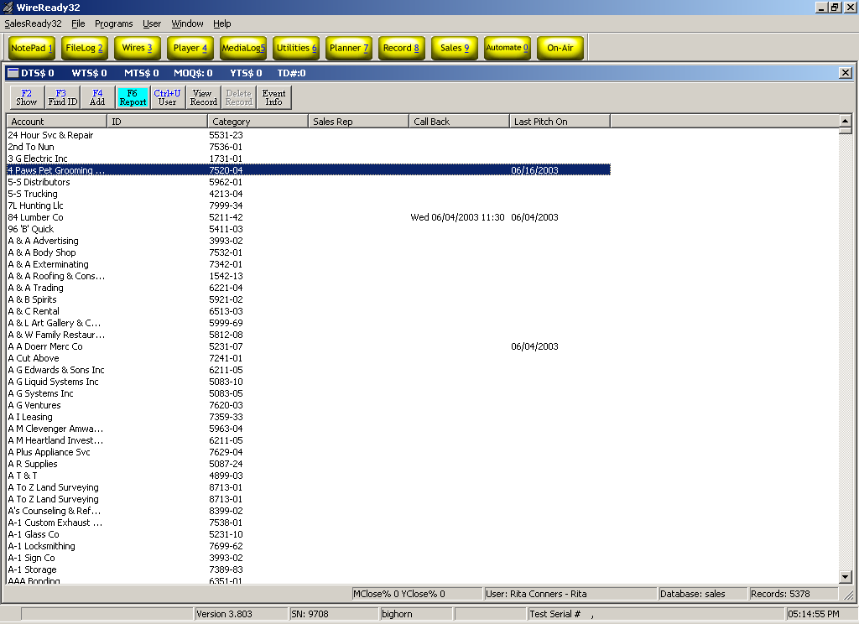
TD#: Total Dials
When using the Onscreen Stats to measure your success, you need to understand what your Sales Manager expects from you in terms of quota. You need to know how many dials you should be making each day, how many decision makers you should be talking to each day, and how many sales you should be making each day.

It is common to call as many as 200 businesses -especially in a day where most are busy, or not in, or not available to take your call. Non-qualified calls should NOT take up most of your time even though you might make 10 non-qualified calls to every 1 qualified call. If your manager hasn't seen you talking to 25-50 decision makers in a day, you will want to show your boss you made the attempt, and 200 attempts in a 7 hour day is easy.

You should expect to have no worse than a 7-10% close ratio on a new database. If you are less than 7%, ask your Sales Manager to listen to your pitch, or suggest how you can become a better seller. Also, you can hurt your close ratio by not calling the right people at the right time, and that comes back to building a relationship with your customers.

If you are using SalesReady® correctly, your close ratio will grow to between 10 and 20% in the 2nd year and approach as high as 30% in years future. When you have educated your business community and trained them to say yes to your call, and you know who to call, when to call, and what to pitch, selling will be much easier!

Procedure to open Event Materials

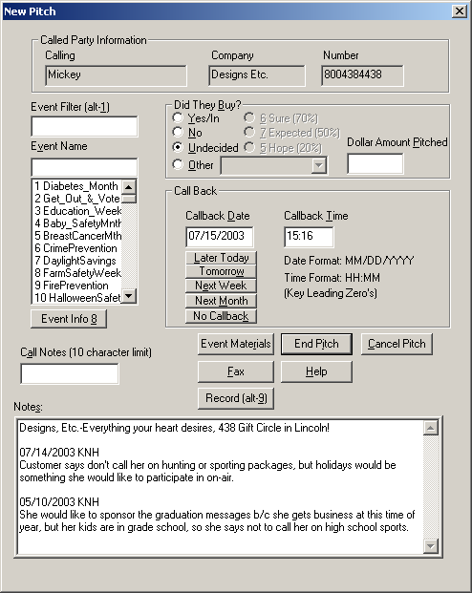
From the New Pitch window, click Event Materials.
Use the Event Filter on the left side of the screen to select the event you are pitching. See the diagram below.
Click once on the document you would like to open in the right side window.
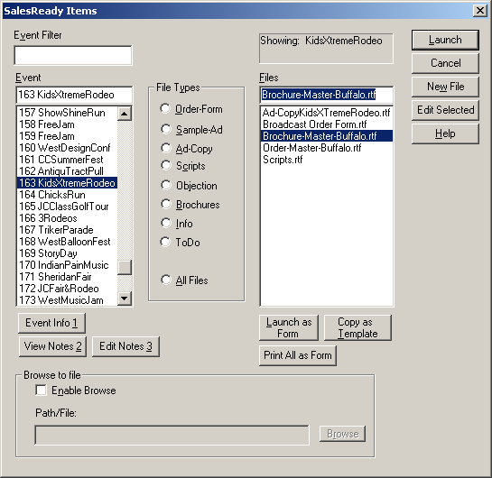
Click the Launch button in the top right-hand corner. This launches Microsoft Word and opens the selected invoice or brochure. See the diagram below.
Make your desired changes to the document.
Delete any pricing packages that the customer did NOT purchase. (Normally, there are 3 choices to choose from, and you must edit the invoice to reflect the outcome of your call).
You might also choose to type in the tag the way the customer wanted to be mentioned at the end of the message. See the diagram on the following page.

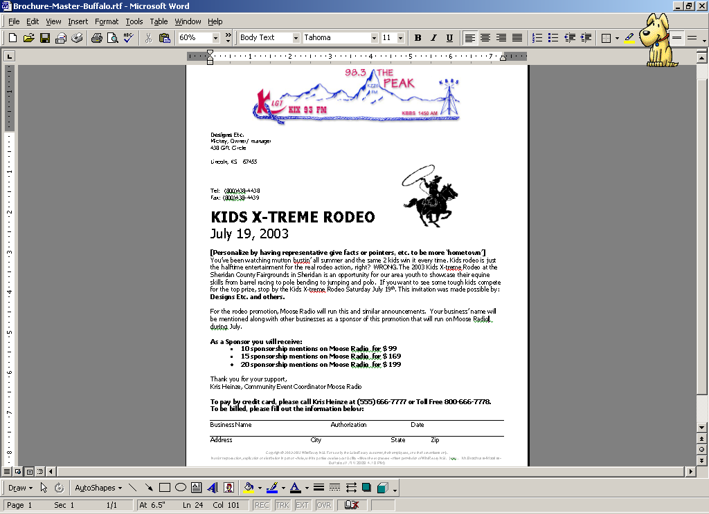

Faxing Event Materials to Customers

Procedure to fax an invoice directly to one customer

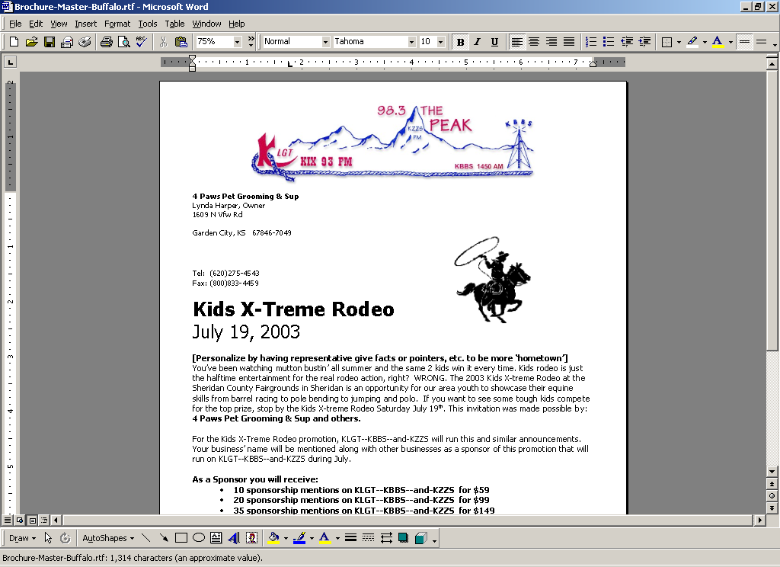
With the desired document already launched and corrected, click the “Print to Winfax” button in the Microsoft Word toolbar. See the diagram below:
Fill out the required information (i.e. contact name, phone number exactly how it needs to be dialed, subject or reason for faxing, etc.) See the diagram below.
Print to Winfax button
Add a short note thanking the customer—an example note follows. See the diagram below.
Click the Send button. See the diagram below.
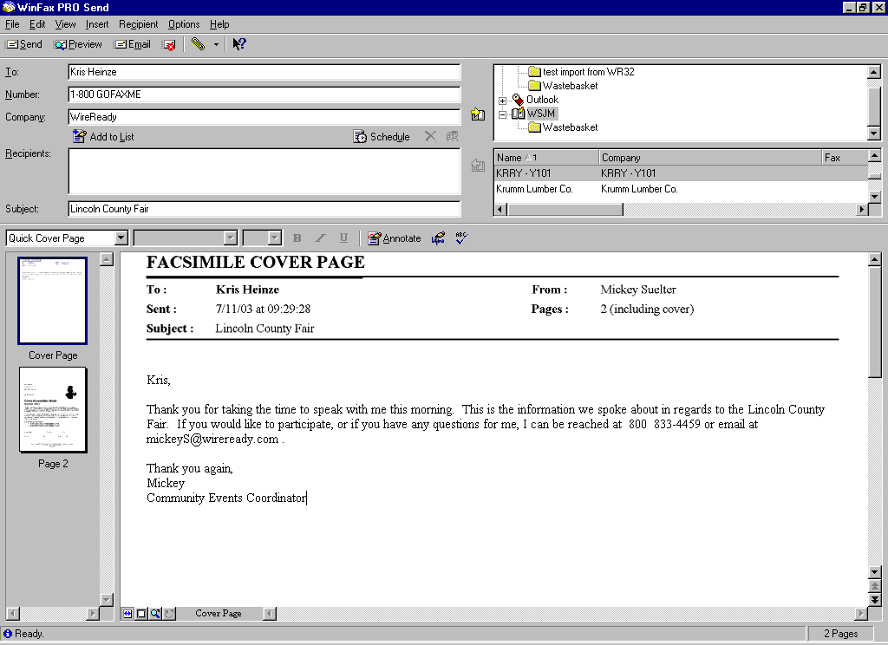
Close your Word document window to return to SalesReady®.
Step 2: Fill in the required information
(make sure phone number is typed exactly as it needs to be dialed)
Step 3: Write a thank you message.
Step 4: Click the Send button.

Procedure to fax multiple documents to one customer
With the desired document already launched and corrected, click the “print to Winfax” button in the Microsoft Word toolbar. See the diagram below:
Fill out the required information (i.e. contact name, phone number exactly how it needs to be dialed, subject or reason for faxing, etc.)
Print to Winfax button
Add a short note thanking the customer—an example note follows.
Minimize the WinFax window.
Close the Word Order-form that was just attached to the fax document.
Use WireReady32 to open the second Order-form you want to attach to the fax document.
Click the Print to Winfax button the Word toolbar. The attachment will be added to the fax document that is already open and minimized.
Continue launching the documents you will be sending to this customer for the additional events.
Maximize WinFax
Once all files are attached, click the Send button.
Close any open Word documents and return to SalesReady®.

To Email using Microsoft Word and SalesReady

- Using Event Materials, open your desired document (brochure or invoice) and make your edits.
- In Microsoft Word, go to the File menu
- Choose Send To
- When the list of choices pops out to the side, choose Mail Recipient (As Attachment)
- If you do not have this choice, please call 800-833-4459 and ask Kris to fix your email configurations
- Your document will then attach to a blank email. You’ll have to enter the email address and click the Send Button.

Procedure when you make a sale

Log a yes and a dollar amount
Verify the customers billing address/ fax number or email
Click Event Materials and launch the order-form/ invoice
Click Yes to save a copy of the form “with WireReady tags” to the correct folder.
Make corrections to the order-form
Amount sold
We can mention your business at the end of the ad—for example: “Betty, Susie Mary and Jessie at Betty’s Hair Flare congratulate the ladies volleyball team on their state championship.” Always give them an example, rather than asking “how would you like your business name tagged.”
Fax or email the invoice to the customer or print out a copy and mail it to them.
Follow in-house instructions on how to get that same invoice to Traffic and Billing.
Click the End Pitch button and click Done when finished with that customer account.
Move on to the next call, using the enthusiasm and momentum to your advantage.

Appendix A: Working on your pitching skills

Explanation of the 4-part pitch
Event sales is not telemarketing. One thing we all hate about telemarketers is that they just start talking and they don’t ever stop. The idea behind the event sales pitch is to get to your point quickly, but by also giving the customer a chance to talk and participate in the conversation. Customers will buy your event because they have an opinion or feeling (emotion) that is tied to your event. They want to do something good in the community and be known for their thoughtfulness among the community members. Always include, in your pitch, an emotional element. You cannot read a canned pitch and be successful. You should collect ideas and create your own script based on your own words so that your delivery is your own, i.e., the cadence, choice of words, and style is natural to your way of speaking. Talk to the client like he/she is one of your buddies across town—that air of informality helps persuade your emotional buy.

If you can make the pitch your own and believe in what you are selling, you will be successful. Below are the 4 elements that need to be a part of your pitch, and below that is an example of a pitch that includes those 4 elements.

Introduction
Emotional pitch
Close (ask for the money)
Answering the objections

Example sales pitch
[The idea is that instead of just being a telemarketer asking for money - you are, in essence, their PERSONAL CONSULTANT – who, for free, will make sure they know what's going on in their business area so that if there is something that interests them, we can PUT THEM ON THE AIR.]
Introduction:
Check your notes to see if this person has bought before:
IF YES, use the following pitch:
Hi, It's <!-- wr current rep long --!> from <!-- wr evnt brand --!> - YOUR community event coordinator.. I'm calling to let you know about <!-- wr event name long --!>…(tell them more).
IF NO, use the following pitch:
Hi, this is <!-- wr current rep long --!> at <!-- wr evnt brand --!>. I am one of the new community event coordinators and I'm in charge of letting local businesses know about all the events happening in <your town> every month <or your turn, i.e every two weeks).
Emotional Pitch:
I wanted to let you know about <event #1>. Give a short emotional appeal. Would you agree <event name> deserves some extra recognition or attention on-air? You can listen to a sample message right now –let me play it for you.
We are also going to be promoting event #2, event #3, and event #4 happening soon in your area too.

Close (ask for the money):
$<!-- wr evnt price low --!> will get your business name mentioned <!-- wr evnt freq low --!> times on the station, associated with <event>.
-or-
As one of the <town name> businesses who will be participating on-air promoting <event>; we can get you on the air for an investment of $<!-- wr evnt price low --!>.
If they say yes... By the way, if you were interested in getting your name on the station more, we have a double package for $<!-- wr evnt price med--!> and a triple for $<!-- wr evnt price high --!>

YES-
    - Verify the billing address
    - Add the tag at the bottom of the ad copy the way the customer would like
    - Modify the invoice to reflect the package that the customer purchased

Answering the objections:
MAYBE- ask to call back tomorrow for a decision.
Example: “Great I’ll send you some information and you can go over it. Would it better if I call you back tomorrow morning or tomorrow afternoon?”
NO- Never give up on the first no. Find a way to offer them a half package or throw out another event that they might be interested in. Thank them for their time, letting them know you’ll be in touch again to keep them informed of what is happening locally and promise to give them the same opportunity to participate in on-air coverage and promotions that we give the other businesses in town.

HINTS:

Another talking point - I think that x and y would be a great opportunity for your business to get exposure as being one of the businesses participating in this event.
Find ways to ask them questions that they have to say yes to….”Would you agree that….?”

Participating and event and SALUTE are much better words than "sponsoring"

Note: Bigger spenders will feel prouder buying a "double" or a "triple."

Make your station’s messages more emotionally appealing to your audience by getting a local authority, kid, or team to voice the message. SALUTE the team or person in the message. AND make sure you use audio playback as a selling tool while you have him/ her on the phone! Now wouldn’t you want to be one of the businesses bringing this salute on the air?

Logics about the pitch:
Think on your feet, and LISTEN to the customer. You must be able to adjust your pitch a little for each individual customer. The same pitch will not work for everyone, and that is part of building a relationship with your customer. Learn how to push their buttons and have stimulating conversation with him/ her.

Master these Three Advanced Closing Techniques
The way in which you ask for the order is extremely important. All at costs, you must avoid asking a yes or no question such as “would your business be interested in any of these packages?”
Double Question Close
Design double questions that will work well in closing your sales. The questions will ask the prospect to make one of two decisions, either of which will result in a sale. Sometimes this is called the “Either/Or” technique. “Which event package would your prefer?” “Would you prefer the $59 package or the $99 package?”
Direct Question Close
This is used on prospects who need help in making the buying decision. By using the direct question, you actually ask for the order. “Most people are choosing the $99 package—is that the package that you would prefer?” The $99 package is the best value—is this the package that you would prefer?”
Subtle Question Close
The opposite of direct questioning is the subtle question. Make a statement that implies that the prospect will buy your product or service then ask a simple question of agreement. “People will really notice if your business is associated with this type of message on the radio.” “Supporting this cause will boost your business image in the community.”

The answers to these questions will help you go right to filing out the order if they are in agreement. The prospect may be agreeable to your questions, however, and still balk at signing the order. When that happens, you simply ask, “Why not?” to get the objections out so you can handle them.

How to handle the objections
You will encounter several common objections in radio telesales. The important thing to remember is to listen to your customer and provide a real answer their questions or objections; not just regurgitate a pre-fabricated rebuttal.

No money, no budget for advertising
--This is not advertising...this is supporting (what ever the cause is) for the community. Would you like for the people in the area to know that you support (blood drive or whatever)?
--I can understand that, but these are not advertisements. What this does for you is it solidifies your business in the community whereas all the other hundreds of businesses that may or may not do advertising….this gives you a chance to keep your name out in front of public. It’s simple—if you are out of sight, you’re out of mind…and your potential customers won’t think of you or be able to remember your business name when they need your services.
--“ We are also sponsoring this and that this month. Would you prefer to participate on-air with this event or that event?”
--“It’s a shame you can’t participate this month, but can I give you call once a month to keep you informed of all the events happening in the community that you can support on the radio with us?”

We already bought advertising from the newspaper or another radio station
--“Are you familiar with our radio stations and our programming?” Our listeners are (these type of people). Wouldn’t you want these types of people visiting your business?”
--“Well I thank you for your time and I will call back next month with more opportunities to participate in causes we are supporting on-air.”

We tried radio before and didn’t have good results
“I understand that--I can appreciate that. Radio works off of frequency. The more people that hear your message or business name, the more people that are likely to visit your business. The amount of listeners doesn’t mean squat—it is frequency.”

“It’s just like school…people are just programmed to have to hear things over and over before they comprehend it and remember it.”

Can I think about it; I’m busy--do you have some information you can send me?
--We don’t want you to miss this opportunity, we only have limited air time available—I’ll need a decision in 2 days. Can I call you back for a decision on Wednesday?
--“Let me send you a brochure. I’ll give you chance to look at it and talk it over with your wife/husband. Should I call you tomorrow morning, or after lunch?”
-- Okay, that’s fine, I would be glad to call back tomorrow or in two days. Would that give you sufficient time to reach a decision / find a way to participate?
--Should I call you tomorrow morning, or after lunch?
This steers the person toward a decision quicker. Always set a reminder callback and follow up on the call!

How to handle the “no” answers—don’t take it personally
You are going to hear many no’s, especially when you are first starting, for two reasons:
You are still learning how to make your pitch your own.
You are learning about your customers for the first time.

If you want to be a successful Community Event Coordinator, you have to learn to roll with the punches and not take the no’s personally. You must smile, and let them know you’ll call them again. When you first start calling businesses, they might tell you no 7-10 times before they finally say yes. But if you keep calling, and they get used to talking to you, eventually you will find their hot buttons and learn enough about them to only call on events they would have an interest in buying. If you believe in what you are doing, you will find the yes calls, and you will be successful.

The importance of enthusiasm in your voice

Enthusiasm is essential when making and closing telephone event sales calls. A voice that conveys enthusiasm and a sense of urgency is sure to convince customers that they need to get involved. Unlike other forms of selling, telephone event sales do not take advantage of the visual. The seller’s voice alone must paint a positive picture in the mind of the buyer. With this in mind, voice, tone, and physical positioning are the three aspects of a successful telephone event sale.
Physical positioning of the seller starts with comfort. You should not be fidgeting with your chair or pen and paper when the prospective buyer picks up the phone. You want to be comfortably set before dialing, so that you can smile. The buyer can hear that smile as soon as they pick up the phone, and smiling is the first step toward generating enthusiasm and a positive feeling in the mind of the buyer.
The next way to generate enthusiasm is through your tone of voice. Using a conversational tone conveys the message that you want to make the customer a friend. A calm, low voice sounds most friendly and natural. Most people’s voices sound higher on the phone. While your voice needs to be conversational, it also needs to be a little more enthusiastic than the person whom you are speaking to. Don’t be afraid to come to natural stops in your speaking to breathe, and also to give your customer a chance to speak and contribute to the conversation.
Finally, voice is one of the most powerful ways to create positive enthusiasm in your selling. Used in this paragraph, voice means the use of words, rather than the sound of your physical voice. Add some spirit to your sales talk, and speak in such a way that the buyer feels emotionally compelled to become involved. Use specific instances when explaining the events and motivating the customer to buy. Do you convey excitement or a sense of urgency with words such as great, help, increase or now?
Each time you make a telephone event sales call, use tone and voice to convey enthusiasm, and make sure that you are comfortable and ready to SMILE when you start dialing. There is nothing more important than creating a positive energy and painting a vivid picture in the mind of the customer.

Appendix B: Working with audio clips and the phone

Procedure to play audio over the phone to potential clients
From the New Pitch screen, click Event Materials.
Use the Event Filter on the left side of the screen to choose the event. In the list of file choices on the right, double-click the file with a .wav extension or an .mp3 extension. Cool Edit 2000/ Goldwave or similar audio editing software will automatically launch the file.

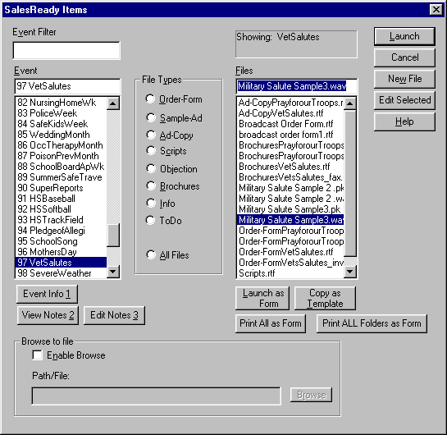

On your Virtuoso, move the slider from position #2 to position #3.
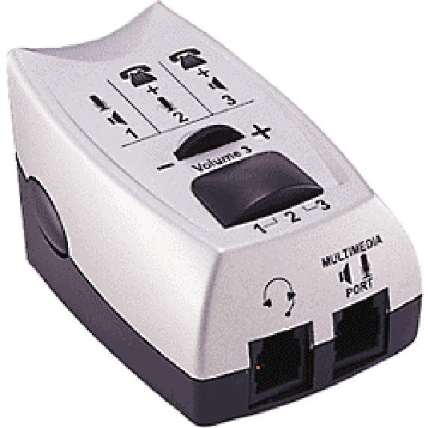
Click the Play button on the audio editor screen.

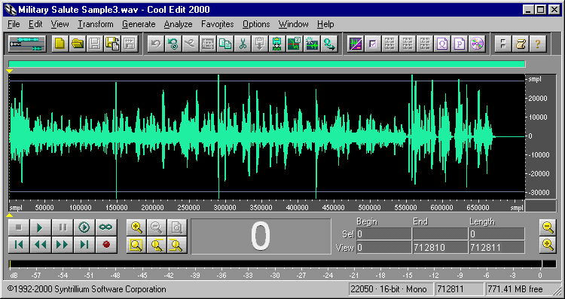
Adjust the Volume 3 wheel on your Virtuoso to make sure the client can hear the audio at a comfortable volume level.

When finished playing, move the slider on your Virtuoso back to the #2 position and click the X on the audio editor screen to close the audio software and return to the WireReady New Pitch screen.

Procedure to record audio from clients
From the New Pitch screen, click the Record (alt-9) button.
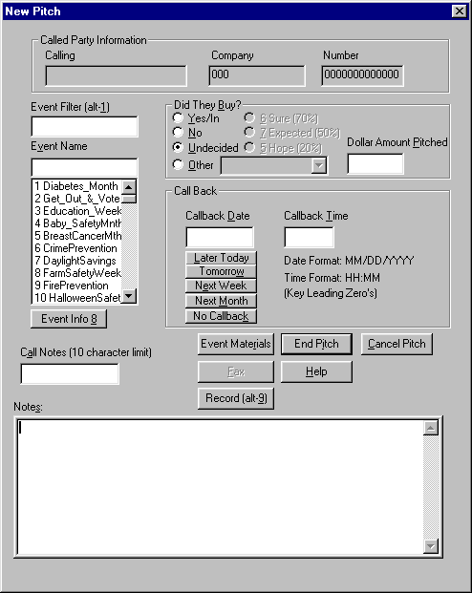

Enter a name for your new file that includes the business name of the client you are recording. See diagram below:
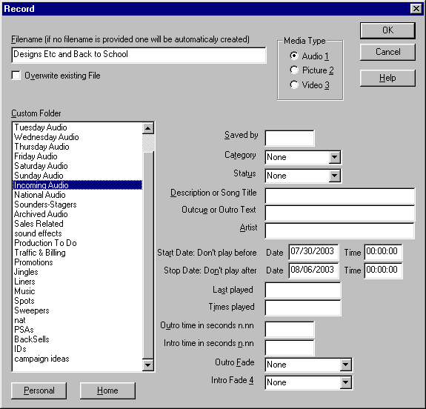
Click on the appropriate location folder for your new file.
Double-check to make sure that the radio button for Audio (1) is indeed highlighted before clicking OK.
When the audio editor opens with a blank recording file, double-check to make sure your Virtuoso is set on slider position #2.

Click the Record button on the audio editor screen. See the diagram below:

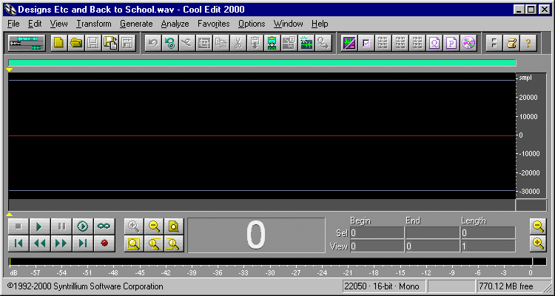
When you are finished recording, click the Stop button on the audio editor screen.
Click the X to close this window. When prompted to save your file, choose Yes. When the audio editor closes, WireReady’s New Pitch screen will be in view.

