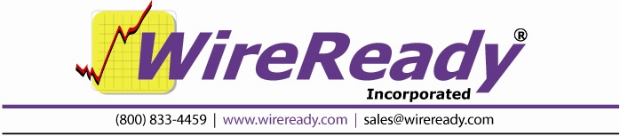

Closure-based recording
in Automate

Users Guide

WireReady NSI • PO Box 714 • Eudora, KS 66025
(800) 833-4459 • FAX (785) 542-3477
sales@wireready.com • support@wireready.com • www.wireready.com
© 2010 WireReady NSI
WireReady® is a Registered Trademark
AUTOMATE

TABLE OF CONTENTS

INTRODUCTION 5
OVERVIEW 6
AUTOMATION DECKS & AUTOMATION PROGRAMS - WHAT ARE THEY? 6
WHAT ARE AUTOMATION DECKS? 6
WHAT ARE AUTOMATION PROGRAMS? 6
AUTOMATION DECKS & AUTOMATION PROGRAMS - THEIR RELATIONSHIP 7
SCREEN OVERVIEW: AUTOMATION DECK 7
TOP STATUS LINE 8
SEQUENCE LINES 9
OPTION BUTTONS 9
WORKING WITH AUTOMATION DECKS AND PROGRAMS 10
HOW TO GET TO THE AUTOMATION DECKS 10
HOW TO MOVE BETWEEN AUTOMATION DECKS 11
HOW TO CREATE AN AUTOMATION PROGRAM 12
HOW TO SAVE AN AUTOMATION PROGRAM 12
HOW TO LOAD AN AUTOMATION PROGRAM 12
HOW TO START AN AUTOMATION PROGRAM 13
HOW TO STOP AN AUTOMATION PROGRAM 13
HOW TO CHANGE A SAVED AUTOMATION PROGRAM 13
HOW TO CLEAR AN AUTOMATION DECK 14
COMMANDS 15
WHY TO USE PASTE TO COPY BLOCKS OF COMMANDS 15
HOW TO COPY BLOCKS OF COMMANDS 16
HOW TO CROSS THE MIDNIGHT HOUR PROPERLY 17
INTRODUCTION TO COMMANDS 18
INTRODUCTION TO TIME WINDOWS 18
INTRODUCTION TO CHANNELS 19
COMMANDS SECTION 20
INTRODUCTION 20
AUTORECORD 21
HOW TO SET UP: AutoRecord 22
CHANGE PATH 23
HOW TO SET UP: Change Path 23
CHECK 24
HOW TO SET UP: Check 25
COMTALK 26
HOW TO SET UP: ComTalk 27
CONTROLDECK 28
HOW TO SET UP: ControlDeck 28
CUSTOM 29
HOW TO SET UP: Custom 30
DELAY FOR 31
HOW TO SET UP: Delay For 31
GOSUB 32
HOW TO SET UP: GoSub 33
GOTO 34
HOW TO SET UP: Goto 34
HEX TALK 35
IF 36
HOW TO SET UP: If 37
LABEL 38
HOW TO SET UP: Label 38
LATCH CHANNEL 39
HOW TO SET UP: Latch Channel 39
LOAD AND START 40
HOW TO SET UP: Load and Start 41
LOG 42
HOW TO SET UP: Log 42
TURN NETWORK ON 43
TURN NETWORK OFF 43
PULSE AND WAIT 44
HOW TO SET UP: Pulse And Wait 44
PULSE CHANNEL 45
HOW TO SET UP: Pulse Channel 46
RECORD BY NAME/CODE 47
HOW TO SET UP: Record By Name/Code 48
RETURNSUB 49
HOW TO SET UP: ReturnSub 49
SET CLOCK 50
HOW TO SET UP: Set Clock 50
SKIP 51
HOW TO SET UP: Skip 51
SPLICE 52
HOW TO SET UP: Splice 53
STOP / SHUT DOWN 54
HOW TO SET UP: Stop / Shut Down 54
SYNC 55
HOW TO SET UP: Sync 56
WAIT FOR CHANNEL 58
HOW TO SET UP: Wait for Channel 59
WAIT FOR CLOSURE 60
HOW TO SET UP: Wait for Closure 61
WAIT UNTIL 62
HOW TO SET UP: Wait Until 62
EXAMPLE OF AN AUTOMATION PROGRAM 63
SYSTEM CONFIGURATION AND OTHER OPTIONS 64
The Logs created by the Log command 64
Configuration Files 65
Assigning Sound Cards to the Automate Decks 65
HOW TO REACH WIREREADY 75

INTRODUCTION

Automate is a powerful 32-bit automation system offering great flexibility.

Automate is designed to be the "traffic cop" of your operation. Automate has access to the AudioLog *.WAV files, and also interfaces with Satellite Receivers, CD Players, Consoles, Cart Machines, Reel-Reels, and ALL other devices which can be controlled with CONTACT CLOSURES and/or RS-22 VOLTAGE LOGIC (+/- 10 volts).

Automate's flexibility, coupled with the variety of possible uses, does not make it possible to cover all potential configurations in this manual. Therefore, if there is a routine that you want Automate to perform, and you are unsure of how to create that sequence in the Automation Program, give us a call. You will be surprised at what Automate can do.

This Automate manual is intended to instruct you in the CREATION, MAINTENANCE and RUNNING of Automation Programs. This manual is designed to be read from COVER TO COVER. At times you may not be sure exactly how everything comes together. But do not be discouraged, things WILL start to come together as you read and experiment. That is not to say that the process needs to be difficult. However, the process needs to be complete.

Automation is usually run on a dedicated computer. If you are running a stand-alone system or using the computer as a workstation, the Automation Programs can be run, provided the assigned audio devices will be available during recording times.

OVERVIEW

AUTOMATION DECKS & AUTOMATION PROGRAMS - WHAT ARE THEY?

WHAT ARE AUTOMATION DECKS?

There are eight (8) Automation Decks which can be used for creating, maintaining, and running your Automation Programs.

Automation Decks ALWAYS have an Automation Program loaded. When you clear an Automation Deck, a blank Automation Program (called New Playlist) is instantly loaded into the Automation Deck.

WHAT ARE AUTOMATION PROGRAMS?

Automation Programs are sequences of AUTOMATION COMMANDS, which are arranged in an Automation Deck and saved with a unique name as an Automation Program.

Basically, an Automation Program is a list of things to do. Just like any other list, the commands (things to do) in an Automation Programs are listed, and therefore executed, in sequential order. Automation Programs are also referred to as Playlists.

Automation Programs are lists of commands which each do something. That "something" might be to wait for a channel to get a closure (the satellite network sending a tone down), switch to a different network, start recording a wav file, etc. See the section on COMMANDS for usage of each command.

AUTOMATION DECKS & AUTOMATION PROGRAMS - THEIR RELATIONSHIP

In terms of the relationship between Automation Decks and Automation Programs, think of the Automation Decks as Cart Machines, and Automation Programs as carts.

Just as cart decks are used for recording audio as well as playing the recording, Automation Decks are used for creating Automation Programs as well as running them.

Just as a cart can be played in ANY cart deck (regardless of which deck was used to record the cart), an Automation Program can be run in ANY Automation Deck, regardless of which Automation Deck was used to create the Automation Program.

Just as a cart machine can have more than 1 cart deck playing at one time, more than one Automation Deck can be running at one time. Actually ALL eight Automation Decks can have Automation Programs running at the same time.

Just as one deck can be playing a cart and another deck in the same machine can be recording a cart, Automation Decks can be active at the same time that you are creating/editing an Automation Program in a different Automation Deck.

Just as you can make a copy of a cart, and edit the copy while the original cart remains unchanged, you can make a copy of an Automation Program (by saving it to a different name), and edit the copy while the original Automation Program remains unchanged.

Just as the audio on the cart will PLAY when the cart is inserted into the cart deck and the PLAY button pressed, an Automation Program will become active when the Automation Program is inserted into an Automation Deck and the START (F3) key is pressed.

Just as one cart deck can activate another cart deck (with tones), one Automation Program can activate another Automation Program (with a command). The only difference here is that the called cart plays in a different deck than the cart which called it, while the called Automation Program runs in the same Automation Deck that the calling Automation Program was running in.

SCREEN OVERVIEW: AUTOMATION DECK

This is an Automation Deck with a blank, unsaved Automation Program loaded into it.

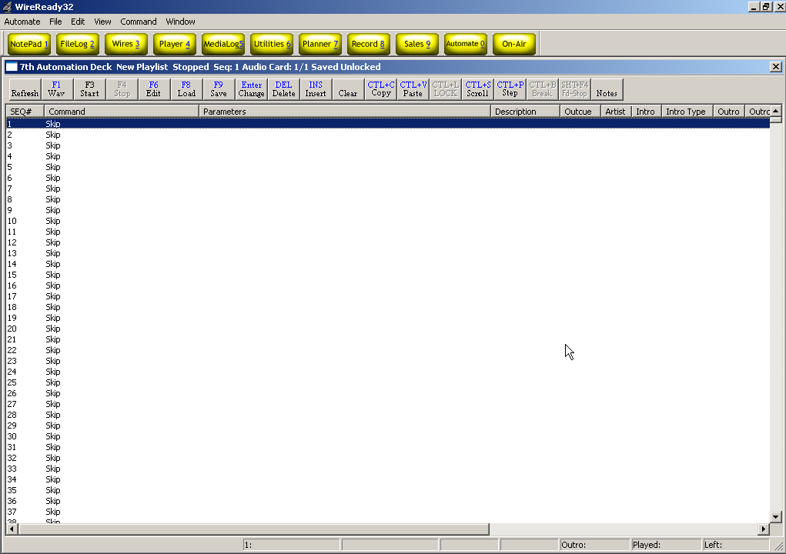

TOP STATUS LINE

The TOP STATUS LINE of the Automation Deck:
- Displays which Automation Deck you are in (1-8).
- Displays the name of the Automation Program that is currently loaded into this Automation Deck.
- Displays whether the Automation Deck is Running or Stopped.
- Displays the Sequence Number of the Automation Program where the Automation Program was last stopped. (When the Automation Program is running, this shows the sequence number of the line currently being executed).
- Displays the Audio Card being used by this Automation Deck. This is displayed as "Audio Card: 1 / 2" where the 1 is the first audio card and 2 the second audio card when the deck is configured to overlap audio during playback. If not using overlapping during playback, both characters will be the same.
- Displays whether the Automation Program has or has not been saved since modifications were last made to it.
- Displays whether the Automation Program is Locked or Unlocked.

SEQUENCE LINES

There are a total of 2400 sequences (1-2400) per Automation Program.

The SEQUENCE Line Displays:

- The NUMBER of that sequence.
- The COMMAND that is on that sequence.
- The Command's PARAMETERS (Parameters are details which are added to a command to customize it to do the specific task at hand).
- The Status of the command (waiting, playing, time remaining).

OPTION BUTTONS
The OPTION BUTTONS at the top of the Automation Deck screen show the keys that can be used to perform operations within the Automation Deck. Each of the possible operations are explained within this manual.

F1 Wav Puts a Play Wave command on the highlighted sequence #.
F3 Start Starts the currently loaded playlist on the highlighted sequence #.
F4 Stop Stops the currently running playlist.
F6 Edit Allows the user to edit the command on the highlighted sequence #.
F8 Load Loads a previously saved playlist into the Automation Deck.
F9 Save Saves the currently loaded playlist.
Enter Change Changes the command on the highlighted sequence #.
DEL Delete Deletes the highlighted sequence #.
INS Insert Inserts a Skip line above the highlighted sequence #.
Clear Clears the loaded playlist and opens a blank New Playlist.
CTL+C Copy Copies the command in the highlighted sequence #.
CTL+V Paste Pastes single or multiple commands to the current playlist.
CTL+L Lock Toggles between Locked and Unlocked state.
CTL+S Scroll Allows the user to scroll to a specific sequence # in the playlist.
CTL+P Step Allows the user to run a command on one sequence of the playlist, where the playlist will not continue to the next line when the command is completed.

WORKING WITH AUTOMATION DECKS AND PROGRAMS

HOW TO GET TO THE AUTOMATION DECKS

From the MAIN button bar in WireReady32, Strike Alt-0 or click on the Automate button.

The AUTOMATE DECK SELECTOR screen will open:

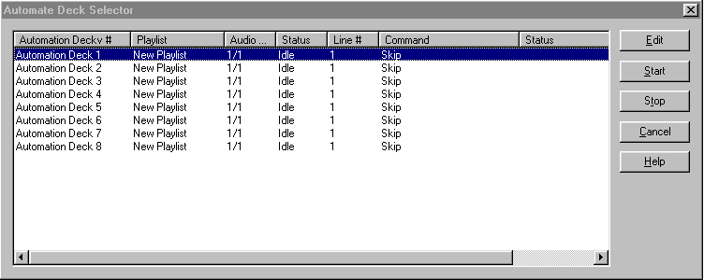
Note: The Automation Deck Selector screen shows the Status of each of the Automation Decks. If a deck shows Idle, there is no playlist running on that deck. If the Status shows Active, that deck is currently running the listed playlist.

Highlight the Automation Deck which you want to go to and press ENTER.
-OR-
Highlight the Automation Deck you want to go to and click on the Edit button.
-OR-
Double-click on the Automation Deck

HOW TO MOVE BETWEEN AUTOMATION DECKS

3 Methods

1). Using the main WireReady32 buttons
From the main button bar in WireReady32, Strike Alt-0 or click on the Automate button.

The AUTOMATE DECK SELECTOR screen will open:

Highlight the Automation Deck that you want to go to and press ENTER.
-OR-
Highlight the Automation Deck you want to go to and click on the Edit button.
-OR-
Double-click on the Automation Deck

2). Using the drop-down menu choices in the Automate screen
From the main menu in WireReady32, click on Automate or strike Alt-A on the keyboard.
The drop-down menu will appear:
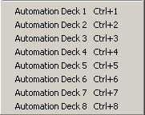
Click on the deck to move to.

3). Using the keyboard shortcuts
On the keyboard, strike the Ctrl key and the number of the deck at the same time.

HOW TO CREATE AN AUTOMATION PROGRAM
(All of the available commands are described in the Commands section.)

1) Go to an Automation Deck that is not currently active and click the Clear button to clear the deck.
2) Create the Automation Program by:
a) Pressing ENTER on a line and ADDING the necessary commands.
b) Pressing F6 over an existing command and Edit the parameters of the command.
c) Pressing the INSERT key to add a SKIP command.
d) Pressing the DELETE key to delete a command.
e) Clicking on the Copy and Paste buttons to COPY BLOCKS of commands.
3) When you are done putting all of the commands in, press F9 to SAVE the Automation Program.
Type in the NAME that you want to assign to this Automation Program. If the name is the same name as another Automation Program and you go through with the SAVE, the original Automation Program will be overwritten by the one you just created.
4) After the Automation Program is SAVED, you can click on the Clear button to CLEAR the Automation Deck.

HOW TO SAVE AN AUTOMATION PROGRAM

1) Press F9 to SAVE the Automation Program.
2) In the File Name entry box, type the name that you want to assign to this Automation Program, and press ENTER or click Save.
-OR-
If the NAME is already there, just press ENTER or click Save.
3) If a file with the same name exists, you will be prompted to replace the file. If you are sure you want to overwrite the program (if you were editing that program and are saving the changes) choose Yes to replace the file. If you are not sure if you should replace the file, choose No and give the file a different name.

HOW TO LOAD AN AUTOMATION PROGRAM

1) Press F8 while in the Automation Deck which you want to LOAD an Automation Program into.
-OR-
Click on the F8 Load button.
2) Type the NAME of the Automation Program that you want to LOAD, and press ENTER or click the Open button.
-OR-
Highlight the Automation Program that you want to LOAD and press ENTER or click on the Open button.

HOW TO START AN AUTOMATION PROGRAM

Strike the F3 key while in the Automation Deck which has the Automation Program that you want to START loaded into it.
-OR-
Click on the F3 Start button.

If the Automation Decks already have the Automation Programs you want to run loaded, you can start all decks from the Automate Deck Selector window.
-Click on the Automate button from the main button bar, or strike Alt-0 to open the Automate Deck Selector window.
-Highlight the Automation Deck that you would like to start.
-Click on the Start button or strike Alt-S.
-Continue highlighting and starting the Automation Programs.
-Click the Cancel button when done.

HOW TO STOP AN AUTOMATION PROGRAM

Press F4 while in the Automation Deck which has the Automation Program that you want to STOP loaded into it.

If you want to stop all decks from running, this can be done from the Automate Deck Selector window.
-Click on the Automate button from the main button bar, or strike Alt-0 to open the Automate Deck Selector window.
-Highlight the Automation Deck that you would like to stop.
-Click on the Stop button or strike Alt-T.
-Continue highlighting and stopping the Automation Programs.
-Click the Cancel button when done.

HOW TO CHANGE A SAVED AUTOMATION PROGRAM
To change (edit) an Automation Program:

1) Go to an Automation Deck that is not currently active and click on CLEAR to clear the Deck.
2) Press F8 to LOAD an Automation Program.
Type the NAME of the Automation Program that you want to LOAD, and press ENTER or click the Open button.
-OR-
Highlight the Automation Program that you want to LOAD and press ENTER or click on the Open button.
3) Change the Automation Program by:
a) Pressing ENTER over an existing command and OVERWRITING it with a different command.
b) Pressing F6 over an existing command and CHANGING THE PARAMETERS of the command.
c) Pressing the INSERT key to add a SKIP command.
d) Pressing the DELETE key to delete a command.
e) Clicking on the Copy and Paste buttons to COPY BLOCKS of commands.
4) When you are done putting all of the commands in, press F9 to SAVE the Automation Program.
Type in the NAME that you want to assign to this Automation Program. If the name is the same name as another Automation Program and you go through with the SAVE, the original Automation Program will be overwritten by the one you just created.
5) After the Automation Program is SAVED, you can click on the Clear button to CLEAR the Automation Deck.

HOW TO CLEAR AN AUTOMATION DECK

Click the CLEAR button to CLEAR the Automation Deck you are currently using.

The Automation Program that is in the Automation Deck will be cleared and all of the sequences will have the SKIP command on them.

Note: If the Automation Program which you are clearing has not been SAVED since changes were last made to it, the changes will be lost if you CLEAR the Automation Deck.

CLEARING an Automation Deck does NOT DELETE the Automation Program from the hard drive (Unless it was NEVER saved).

To DELETE an Automation program you must go out to DOS or the Windows desktop (and use Windows Explorer) to delete the file. The filename will be the name of the Automation Program plus the ".PLY" extension. For example, if the name of the Automation Program that you want to delete is TUESDAY, then the file you need to delete will be called TUESDAY.PLY.

The drive and directory where the files are stored is configurable. However, the Automation Program files will probably be in the W:\WIRE\USERS\PUBLIC\FILES Directory.

COMMANDS

WHY TO USE PASTE TO COPY BLOCKS OF COMMANDS

Copying blocks of commands is a VERY useful tool that will most likely save you a lot of time creating and changing Automation Programs.

Let's say that you are doing satellite automation and the commands for one hour are the same for many, or all, of the other hours. The only differences would be the time that the TIME WINDOWS are set to, the time that SET CLOCK sets the time to, and of course the PLAY commands. But when you are creating Automation Programs you need not consider which specific PLAYS will take place, but rather where in the program they will occur.

So this is what you would do:

1) Put in the commands for one full hour.
2) Use the PASTE command with the option to INCREMENT HOUR checked, and copy the hour that you created.

-OR-

Let's say you are adding a commercial break to each hour of the AUTOMATION PROGRAM. Instead of going to each hour and putting the same 4 or 5 commands in, you would use PASTE.
This is what you would do:

1) Put in the commands for the commercial breaks for one of the hours.
2) Use the PASTE command (instructions on next page) and copy the block of commands that contains the new breaks. IF THE BLOCK OF COMMANDS INCLUDES TIME WINDOWS, CHECK THE INCREMENT HOUR OPTION.
3) Repeat step #2 each time you want the block of break commands copied again.

HOW TO COPY BLOCKS OF COMMANDS

1) Highlight the sequence number that you want the block of commands to be copied to. THE HIGHLIGHT BAR CANNOT BE WITHIN THE BLOCK OF COMMANDS THAT YOU WANT TO COPY.

2) Click on the Paste button or strike Ctrl-V on the keyboard.

This window will open:
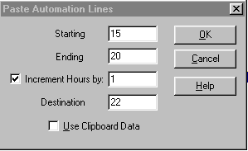

Uncheck Use Clipboard Data

3) Enter the sequence number of the first line of the block you want to copy in the Starting box
4) Enter the sequence number of the last line of the block you want to copy in the Ending box.
5) Check the Increment Hours by: box and enter in the number of hours to increment the time commands by.
6) Enter the sequence number of the line where the block is to be copied to in the Destination box.
7) Click the OK button.
When you use the Paste command with the INCREMENT HOUR option checked, ALL of the TIME WINDOWS are advanced by the number of hours entered in the box, and the THEN GOTO's for the TIME WINDOWS are changed to the correct sequence numbers.

HOW TO CROSS THE MIDNIGHT HOUR PROPERLY

As of this writing you need to cross midnight differently than all of the other hours.

If the last command executed before midnight is to PLAY your legal ID, the Automation Program will stay on the PLAY command until the audio is done and then move on to the next command. So there is a chance that the Automation Program will get to a command with a time window or a Wait Until command before midnight strikes. And what will happen when the Automation Program comes to that command?

Well, In terms of the time window, Automate will check the IF AFTER time which will be 00:xx:xx (because midnight is the 00 hour), and compare it to the current computer time. This command is gotten to before midnight, so when the times are compared, it will certainly be after 00 hour because it's the 23 hour (11 o'clock pm). And because the time is after the IF AFTER time, the THEN GOTO will be performed, and that is NOT what you want.

In terms of the WAIT UNTIL (00:xx:xx) command, the same thing will happen. When the command is reached, Automate will compare the time to WAIT UNTIL to the current computer time. This command is gotten to before midnight so when the times are compared, it will certainly be AFTER 00 hour because it's the 23 hour (11 o'clock pm). And because the time is after the WAIT UNTIL time, the Automation Program will proceed - and that is NOT what you want.

HOW TO FIX THE PROBLEM:

Use the IF command. When the IF command is used to look for a time before 1 am, it will wait until after the midnight hour is crossed before moving to the next command. An example of how the command can be used to cross midnight is below:

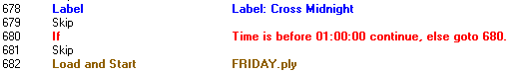

The Automation Program will look at the IF line, and compare the time to the computer's current time. If the time is before midnight, then it will be after 1 am, and the Automation Program will go to line 680. This is the same line that the IF command is on, so the Automation Program will continue to compare the time in the IF command with the computer's time. When the computer's time crosses midnight, the time will be before 1 am, and the Automation Program will continue to the next sequence. In the above example, the next line that the Automation will take action on is the Load and Start line, which will load and start the Friday playlist.

INTRODUCTION TO COMMANDS

INTRODUCTION TO TIME WINDOWS

A TIME WINDOWS is a block of time that you specify for a certain event (closure, hot key pressed, etc.) to take place. TIME WINDOWS consist of NOT BEFORE, IF AFTER, and THEN GOTO parameters.

- If the event occurs before the NOT BEFORE time, it will be ignored
- If the IF AFTER time is reached BEFORE the event occurs, the program will jump to the sequence number specified in THEN GOTO.
- If the event does, in fact, occur within the time window, the Automation Program will simply go to the next sequence number.

For example, let's say I am using the WAIT FOR CHANNEL B1-A to go HI command, which will cause the Automation Program to remain on the sequence which that command is on until the channel goes HI. And let's say that the channel will go HI when the satellite network sends down a tone to go to commercials. Now, what happens if someone at the network accidentally sends down the tone too early, or if they forget to send the tone altogether.

IF I AM NOT USING A TIME WINDOW:

If they send the tone too early, the Automation Program will cut off the audio from the network and go into commercial.

If they forget to send the tone, the Automation Program will just sit on that sequence until someone corrects the situation.

IF I AM USING A TIME WINDOW:

If they send the tone before the NOT BEFORE time, the Automation Program will ignore it because it was probably a mistake or you do not want to cover that commercial break.

If they forget to send the tone, when the IF AFTER time is reached, the Automation Program will jump to the sequence specified in THEN GOTO.

IN SUMMARY, think of a time window as a plan that you might make with a friend. "I (the tone) will be not be there until :00, so if someone rings your doorbell do not open the door because it is not me (NOT BEFORE). If I am not there by 4:00, I am not going to make it and even if I do it is too late by then (IF AFTER), so go ahead and make your other plans (THEN GOTO)".

INTRODUCTION TO CHANNELS

There are two (2) types of channels, INPUTS and OUTPUTS.
INPUTS are channels that Automate monitors to be told what to do.
OUTPUTS are channels that Automate uses to tell a device to do something.

THINK OF INPUTS AS THE COMPUTER'S EARS.
THINK OF OUTPUTS AS THE COMPUTER'S MOUTH.

Each channel has a name (B1-A, etc.) so that Automate knows which channel to listen to, or talk to.

If you did not install the hardware for this system, ask the person who did to give you a COMPLETE list of what each of the channels are used for, as well as how they are to be used (latched, pulse, etc.).

IMPORTANT NOTE: WHEN PULSING, LATCHING, OR WAITING FOR A CHANNEL, HI IS EQUIVALENT TO CLOSED (CLOSURE) AND LO IS EQUIVALENT TO OPEN.

COMMANDS SECTION

INTRODUCTION
This COMMANDS section introduces you to each of the commands that are available to you for creating Automation Programs. There are 40 commands that can be used to create an Automation Program, but many of these are not used when doing closure-based recording. Although these commands can be seen, not all of them will be available to you.

Each command is presented to you in this document with:
1) An EXAMPLE of the how the command looks when it is in an Automation Program.
2) The PURPOSE of the command.
3) An EXAMPLE OF USE of the command. These are only examples - there are a number of different possible uses for each command.
4) The PARAMETERS associated with each command. Parameters are details that are added to a command to customize it to do the specific task at hand.
5) IMPORTANT NOTES that you should know before using the command.
6) OTHER COMMANDS TO SEE which are similar in purpose, or associated with the command being presented.
7) STEP-BY-STEP INSTRUCTIONS FOR ADDING the command to an Automation Program.
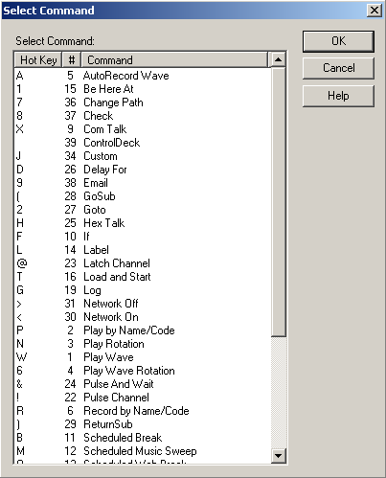

Note: All time parameters are entered in Military Format (24 hour) using 6 digits as either HHMMSS or HH:MM:SS, where HH is hours, MM is minutes, and SS is seconds.
COMMANDS

AUTORECORD
ALL ABOUT: AUTORECORD

PURPOSE: The AutoRecord command is used to automatically record an audio source and then create a *.WAV file in the AudioLog which contains your recorded audio.

EXAMPLE OF USE: If there is a program that a satellite network sends down at a certain time, and you want to play it at a different time, you would use the AutoRecord command. The AutoRecord records the audio and creates a file that can then be played at a later time.

PARAMETERS: 1) You select the file name for the WAV file that will be created. The file name which you specify can be a new file name or can be the same as a file that already exists. The existing file will be overwritten with the file created by the AutoRecord.
2) You put in the destination folder, recording length, and audio card to record on.

IMPORTANT NOTES:

ALSO SEE: RECORD BY NAME/CODE

HOW TO SET UP: AutoRecord
1) Highlight the sequence that you want the AutoRecord command to go on.
2) Press ENTER to open up the LIST OF COMMANDS.
3) Press A, or highlight A-AutoRecord Wave and press ENTER.

This window will open:
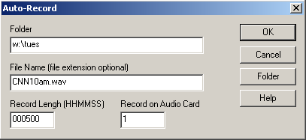
Note: All time parameters are entered in Military Format (24 hour) using 6 digits as HHMMSS, where HH is hours, MM is minutes, and SS is seconds.

4) Enter the folder path in the Folder box to assign the directory where the audio will be stored. Click on the Folder button to see a list of available AudioLog folders.
5) Enter the name of the file in the File Name box. Entering the file extension is not necessary. Automate will record the audio as a WAV file and assign WAV as the extension.
6) Enter the length of the recording in the Record Length box as a 6-digit number (HHMMSS).
7) Enter the audio card to use in the Record in Audio Card box.
8) Click the OK button to save the parameters and add the command.

CHANGE PATH
ALL ABOUT: CHANGE PATH

PURPOSE: The Change Path command is used to allow the commands Splice and Record By Name/Code to use a path other than the default play path.

EXAMPLE OF USE: If trying to put 2 audio files together using the Splice command, if they are not located in the default path, the path to find the files can be specified by the Change Path command.

PARAMETERS: This command must be the located immediately before the non-pathed command, and is only valid for a single command

HOW TO SET UP: Change Path
1) Highlight the sequence that you want the Change Path command to go on.
2) Press ENTER to open up the LIST OF COMMANDS.
3) Press 7, highlight 7-Change Path and press ENTER, or double-click on 7-Change Path.
This selector box will open:
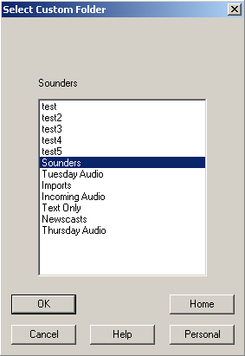

4) Highlight the Custom Folder path you would like to change to, then click OK.

CHECK
ALL ABOUT: CHECK

PURPOSE: The Check command is used to check the existence or state of a file.

EXAMPLE OF USE: This command would be used to alert users if a file has not been recorded or if the file is not the correct size. The command then sends the playlist to a specified line, where other commands can be activated to alert other users/management, or to perform some other action.

PARAMETERS: You choose the dates, times, file size and if a specified file exists. You choose what sequence line to go to if it passes or fails.

IMPORTANT NOTES: This command is intended to grow in scope over time to include checking for more than if a file exists.
SEE ALSO: EMAIL

HOW TO SET UP: Check
1) Highlight the sequence that you want the Check command to go on.
2) Press ENTER to open up the LIST OF COMMANDS.
3) Press 8, highlight 8-Check and press ENTER, or double-click on 8-Check.

This selector box will open:
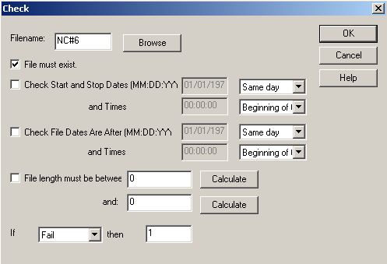

4) Enter the name of the wave file in the Filename field, or click the Browse button to browse to the file.
5) Click the File must exist checkbox if you want to have the Check command be used to see if the file exists.
6) Click the Check Start and Stop Dates box if you are going to have the command check for a specified start and stop date/time. The date and time fields will be made active if this box is checked.
7) Click the Check File Dates Are After box if you are going to have the command check that the file was created after a specified date. The date and time fields will be made active if this box is checked.
8)Check the File length must be between box if you are going to use the command to check the size of the file. Click to Calculate to have the program estimate the file size based on the format of the audio file.
9) Use the drop-down choices to choose what sequence line to go to if the above information either Passes or Fails.
10) Click the OK button to save the parameters and add the command.

COMTALK
ALL ABOUT: COMTALK

PURPOSE: The ComTalk command is used to send characters out a serial port (com port) to communicate with various devices using serial commands. This command is used mostly for communicating with audio switchers, but can also be used to communicate with the Broadcast Tools Watchdog, SCC4, SCC8, modems, and other devices.

EXAMPLE OF USE: If you wanted to tell the SCC4/SCC8 to select a channel on your satellite receiver, you would use the ComTalk command.

PARAMETERS: You type in the string of characters to send out the serial port.
You select the serial port that the device is connected to.
You select baud rate, parity, data bits, stop bits, and the inter-character delay that the device uses.

IMPORTANT NOTES: ComTalk is a ONE-WAY command. That means that we send characters out of the serial port, but will ignore ALL incoming characters returned from the device. Therefore devices that require data flow in both directions probably will not work well with this command. See the instruction manual for your specific hardware for details on the string to be used in the ComTalk command.

HOW TO SET UP: ComTalk
1) Highlight the sequence that you want the ComTalk command to go on.
2) Press ENTER to open up the LIST OF COMMANDS.
3) Press X, or highlight X-Com Talk and press ENTER.

This window will open:
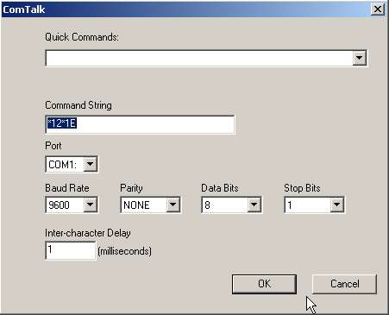

4) Enter the string of characters* that will be sent out of the specified serial port in the Command String box. * - If the string of commands that you need to send includes a CR (Carriage Return - ASCII 13), you need to use "{0x0d}" to reproduce the carriage return.
5) Enter the serial (COM) port that the device you will be communicating with is connected to in the Port box.
6) Use the drop-down menu to select the Baud Rate that the device you are communicating with uses.
7) Use the drop-down menu to select the Parity that the device you are communicating with uses.
8) Use the drop-down menu to select the Data Bits that the device you are communicating with uses.
9) Use the drop-down menu to select the Stop Bits that the device you are communicating with uses.
10) Enter the inter-character delay that the device you are communicating with uses in the Inter-character Delay box. Unless your device requires a pause between characters, leave the intercharacter delay set to 1.
11) Click the OK button to save the parameters and add the command.

CONTROLDECK
ALL ABOUT: CONTROLDECK

PURPOSE: The ControlDeck command is used to control another Automate deck.

EXAMPLE OF USE: This command could be used to control a deck during a remote event or ball game.

PARAMETERS: You set the Automate deck to control, if the other deck will be stopped or started, and the sequence line to start the other deck on.

IMPORTANT NOTES:

HOW TO SET UP: ControlDeck
1) Highlight the sequence that you want the ControlDeck command to go on.
2) Press ENTER to open up the LIST OF COMMANDS.
3) Highlight ControlDeck and press ENTER, or double-click on ControlDeck.

This window will open:

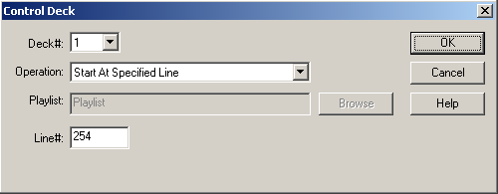

4) Use the drop-down list to choose which Automate deck to control.
5) Use the drop-down list to choose what action will be taken on the other deck.
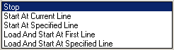
6) If one of the Load and Start statements is selected, the Playlist field will become active. If one of the statements to start at a Specified Line is selected, the Line# field will be active.
7) Enter the Playlist name or sequence line to start on.
8) Click the OK button to save the parameters and add the command.

CUSTOM
ALL ABOUT: CUSTOM

PURPOSE: The Custom command is used to save the parameters for frequently used commands in the Automation Program. By setting up a custom command, you can create a command that is easier to understand for the general user.

EXAMPLE OF USE: When switching between the computer's audio card and a network feed, it is easier to use a custom command to retain the correct Com Talk commands being sent to the switcher.

PARAMETERS: You set all of the parameters for the specific commands you want to create.

IMPORTANT NOTE: The Custom command is not a command that creates a specific result in the Automation Program. The Custom command has to be set up to use one of the existing commands, and will save the parameters for that command as one of the available custom commands.

HOW TO SET UP: Custom
1) Highlight the sequence that you want the Custom command to go on.
2) Press ENTER to open up the LIST OF COMMANDS.
3) Press J, highlight J-Custom and press ENTER, or double-click on J-Custom.

This selector box will open:
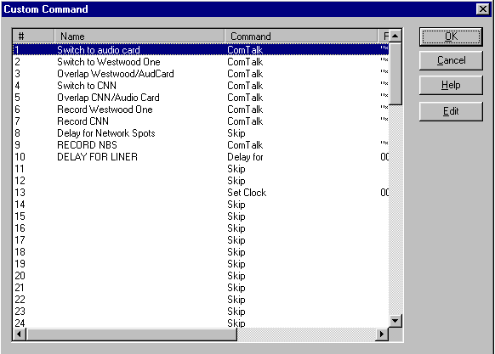

4) If there are already custom commands created, choose one of the commands and click the OK button to save the parameters and add the command.

To create a new Custom command:
1) Highlight an unused line to add the new custom command on.
2) Click the Edit button.
3) Enter a name for the custom command. This is the name that will appear in the Automation Program. Click the OK button
4) Highlight a command from the list and click the OK button.
5) Enter the parameters for the command you are creating. If you are unsure how to enter the parameters, refer to that commands information in the Commands section of this manual.
6) When you are done creating the custom command, it will be added to the list of custom commands.
7) Continue adding new commands as needed. When done adding new commands, click the OK button.

DELAY FOR
ALL ABOUT: DELAY FOR

PURPOSE: The Delay For command is used to hold the program at a specific sequence number for a specified period of time.

EXAMPLE OF USE: When you use the Auto-record command, you might want to make sure that no other commands attempt to use the same audio card. The Delay For command can be used for this. Set up a Delay For command that is as long as, or a little longer than, the autorecording.

PARAMETERS: You set the time period to delay for.

ALSO SEE: WAIT UNTIL

HOW TO SET UP: Delay For
1) Highlight the sequence that you want the Delay For command to go on.
2) Press ENTER to open up the LIST OF COMMANDS.
3) Press D, or highlight D-Delay For and press ENTER.

This window will open:
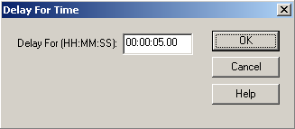

4) Enter the number of seconds that you want the Automation Program to delay for in the Enter number of seconds to Delay for box. Automate will convert that number to minutes and hours, if over 60 seconds.
5) Click the OK button to save the parameters and add the command.

GOSUB
ALL ABOUT: GOSUB

PURPOSE: The GoSub command is used to cause the program to jump to a sequence number. The sequence number that it jumps to is a series of commands that are called more than once over the duration of the program. The purpose of the command is to save time when creating/modifying the program, and to have fewer lines in the program. The GoSub command is always used in conjunction with the ReturnSub command.

EXAMPLE OF USE: If you have a series of commands that are executed at the top of every hour, it is easier to put that set of commands into the program only once and then go to them whenever you want to execute them. Let's say the set of commands that are executed at the top of every hour contains 6 commands, that would be 144 commands if the series of commands were put in each hour (over a 24 hour period). Rather than putting those six commands at the top of every hour throughout the program, you would just list them once at the end of the program, and use the GoSub command to execute the whole set. Then, because ReturnSub is included in the set of commands, when it hits the ReturnSub command, the program jumps back to the sequence immediately following the GoSub command which caused the program to jump in the first place.

PARAMETERS: You choose the sequence number to go to.

IMPORTANT NOTES: GoSub is an advanced command, and should be used with caution.
The series of commands that the GoSub command jumps to MUST be at the end of the automation program. That is, after the Load and Start command, and/or after ALL time/channel-based logic which is not part of the GoSub sets of commands.

ALSO SEE: RETURN SUB; GOTO; LOAD AND START

HOW TO SET UP: GoSub
1) Highlight the sequence that you want the GoSub command to go on.
2) Press ENTER to open up the LIST OF COMMANDS.
3) Press (, or highlight (-GoSub and press ENTER.

This window will open:
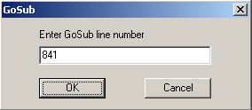

4) Enter the sequence number that you want the Automation Program to jump to when this command is executed.
5) Click the OK button to save the parameters and add the command.

GOTO
ALL ABOUT: GOTO

PURPOSE: The Goto command is used to make the program jump from the sequence the Goto command is issued on, to the sequence number specified.

EXAMPLE OF USE: If you want the program to repeat a certain set of commands, the last line of the set would be a Goto, which specifies the first sequence number of the set of commands to repeat.

PARAMETERS: You select which sequence number you want the program to go to when it executes this command.

IMPORTANT NOTES: Goto is different than GoSub because Goto will cause the program to jump to a specific sequence number, without any memory of the sequence number that caused it to jump. While GoSub will cause the program to jump to a specific sequence number, and then return to the sequence below the GoSub.

ALSO SEE: GOSUB

HOW TO SET UP: Goto

1) Highlight the sequence that you want the Goto command to go on.
2) Press ENTER to open up the LIST OF COMMANDS.
3) Press 2, or highlight 2-GOTO and press ENTER.

This window will open:

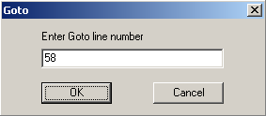

4) Type in the sequence number that you want the Automation Program to jump to when this command is executed.
5) Click the OK button to save the parameters and add the command.

HEX TALK
ALL ABOUT: HEX TALK

PURPOSE: Hex Talk is, for the most part, the ComTalk command. It was created for a specific use of ComTalk in the DOS version of automation. The Hex Talk command will work in Automate when running playlists created in the DOS ControlReady program, but ComTalk should be used if creating a new playlist.

ALSO SEE: ComTalk

IF
ALL ABOUT: IF

PURPOSE: The If command is used to check for either the current time, or whether or not a closure has been received.

EXAMPLE OF USE (If Time…): For those music sweeps scheduled towards the end of an hour, an If Time command immediately before the scheduled music sweep command can determine whether to play those songs, or to skip ahead to legal ID, and the songs scheduled for the next hour.
PARAMETERS: You choose what time to check for, and which line to go to if it is after that time (or before that time).

EXAMPLE OF USE (If Channel): When a satellite network can send any of two or more closures to trigger jingle and liners, the If Channel command (in combination with If Time) can permit one playlist to check for all of the closures. This is done by have an If Time is before line, followed by If Channel is Lo for each of the possible closures.
PARAMETERS: You choose what channel to check for, which state (HI or LO) to check for, and which line to go to if it is NOT the state you are checking for.

HOW TO SET UP: If
1) Highlight the sequence that you want the If command to go on.
2) Press ENTER to open up the LIST OF COMMANDS.
3) Press F, highlight F-If and press ENTER, or double-click on F-If.

This selector box will open:
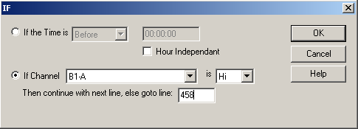
Note: All time parameters are entered in Military Format (24 hour) using 6 digits as HH:MM:SS, where HH is hours, MM is minutes, and SS is seconds.

4) a) If you are using time, use the drop-down menu to choose Before or After in the If the Time is box.
Enter the time of day the If command should use.
b) If you are using a channel, use the drop-down menu to choose the channel in the If Channel box.
Use the drop-down menu to choose if the channel should be Hi or Lo.
Enter the sequence number the Automation Program should go to in the Then continue with next line, else goto line: box.
5) Click on the OK button to save the parameters and add the command.

LABEL
ALL ABOUT: LABEL

PURPOSE: The Label command is for you to put labels and comments into the Automation Program. Automate ignores all Label commands.

EXAMPLE OF USE: At the top of every program you should have Label commands that say the name of the Automation Program, as well as the purpose of the Automation Program, and what the different input and output channels are used for. Also at the top of every hour and before each break, as well as any other place you think it is a good idea to explain what the Automation Program is doing.

PARAMETERS: You type in the text to display on the sequence that the Label command is on.

ALSO SEE: SKIP

HOW TO SET UP: Label
1) Highlight the sequence that you want the Label command to go on.
2) Press ENTER to open up the LIST OF COMMANDS.
3) Press L, or highlight L- Label and press ENTER.

This window will open:

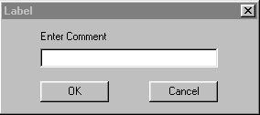

4) Type in the text that you want to be displayed, and press ENTER or click on the OK button.

LATCH CHANNEL
ALL ABOUT: LATCH CHANNEL

PURPOSE: The Latch Channel command is used when you want an AT1616 output channel to got to a certain state (HI or LO) and remain in that state until another Automation Program or another device changes the state.

EXAMPLE OF USE: If you have a device that passes audio when it has a closure, you would latch a channel HI. When you do NOT want to allow audio to be passed through the device, you would latch the channel LO.

PARAMETERS: 1) You select the state (HI or LO) that you want to latch the channel.
2) You select which output channel you want latched.

IMPORTANT NOTES: Do NOT use the Latch Channel command unless the device that is connected to the channel that you are latching needs a constant closure/voltage. For Example, do NOT use the Latch Channel command when switching channels with the Broadcast Tools 6x1(a) Stereo Switcher, as that will make it so that you cannot change channels without first unlatching the channel which was latched.

ALSO SEE: PULSE CHANNEL; TURN NETWORK ON; TURN NETWORK OFF.

HOW TO SET UP: Latch Channel
1) Highlight the sequence that you want the Latch Channel command to go on.
2) Press ENTER to open up the LIST OF COMMANDS.
3) Press @, or highlight @-Latch Channel and press ENTER.

This window will open:
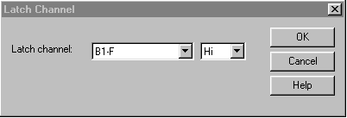

4) Use the drop-down menu to select the output channel that you want to latch.
5) Use the drop-down menu to select whether you want to latch the channel HI or LO.
6) Click the OK button to save the parameters and add the command.

LOAD AND START
ALL ABOUT: LOAD AND START

PURPOSE: The Load and Start command is used to stop the Automation Program that is running and load and start a different program, on sequence 1, in the same automation deck.

EXAMPLE OF USE: If at the end of Monday's program you want to load the program for Tuesday, you would put a Load and Start command at the end of the Monday program so that when it reaches that point the Tuesday program is loaded into the same Automation Deck and immediately started on sequence 1.

PARAMETERS: You specify which Automation Program that you want to be loaded and started.

IMPORTANT NOTES: 1) Make sure that the Automation Program that you want to Load and Start exists.
2) This command will only have an effect on the Automation Deck in which it was executed. It will NOT have any effect on the other Automation Decks that are running.

ALSO SEE: STOP / SHUT DOWN

HOW TO SET UP: Load and Start
1) Highlight the sequence that you want the Load and Start command to go on.
2) Press ENTER to open up the LIST OF COMMANDS.
3) Press T, or highlight T-Load and Start and press ENTER.

This window will open:
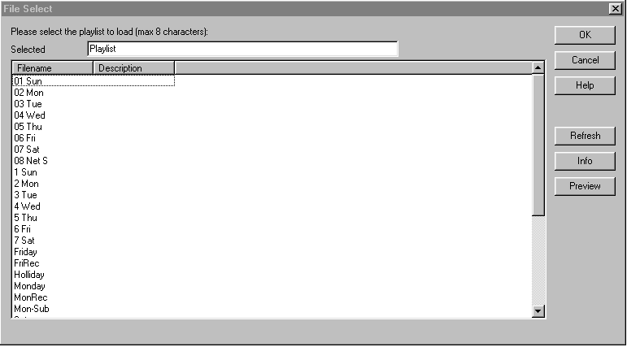

4) Highlight the Filename of the Automation program that you want to load and start when this command is executed and click the OK button.
-OR-
Double click on the Automation program that you want to load and start when this command is executed.

LOG
ALL ABOUT: LOG

PURPOSE: The Log command will cause a file to be created that will record the date and time that each line of the Automation Program was executed.

EXAMPLE OF USE: This is an information and trouble-shooting tool. It gives you the ability to go back at a later time and determine what audio files played, when the automation switched to and from satellite networks, or any other commands that have been set up.

PARAMETERS: You choose to turn the logging on or off.

IMPORTANT NOTE: Logging is off by default, so if you do not put a Log On command in a playlist, none of its commands are logged.

IMPORTANT NOTE: If you are using a liner playlist, such as shown in the examples for the If and Goto commands, do NOT turn on logging for that playlist. The log file for such a playlist would become too large.

HOW TO SET UP: Log
1) Highlight the sequence that you want the Log command to go on.
2) Press ENTER to open up the LIST OF COMMANDS.
3) Press G, highlight G-Log and press ENTER, or double-click on G-Log.

This selector box will open:
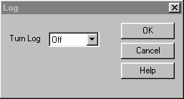
4) Use the drop-down menu to choose Off or On in the Turn Log box.
5) Click the OK button to add the command.

TURN NETWORK ON
ALL ABOUT: TURN NETWORK ON

This command is for backwards compatibility with WireReady NSI’s DOS software. This command is not to be used in Wireready32.

ALSO SEE: LATCH CHANNEL

TURN NETWORK OFF
ALL ABOUT: TURN NETWORK OFF

This command is for backwards compatibility with WireReady NSI’s DOS software. This command is not to be used in Wireready32.

ALSO SEE: LATCH CHANNEL

PULSE AND WAIT
ALL ABOUT: PULSE AND WAIT

PURPOSE: This is a combination of the Pulse command and the Wait for Channel command.

EXAMPLE OF USE: If you have a device, such as a reel-to-reel machine, that accepts a closure to start, and issues a closure when it is finished, the Pulse and Wait command would trigger that device, then wait for the device to finish.

PARAMETERS: You indicate which output of the AT1616L to send the closure from, and which input on the AT1616L to look for the device to send a closure on.

IMPORTANT NOTE:

ALSO SEE: PULSE CHANNEL; WAIT FOR CHANNEL

HOW TO SET UP: Pulse And Wait
1) Highlight the sequence that you want the Pulse And Wait command to go on.
2) Press ENTER to open up the LIST OF COMMANDS.
3) Press &, highlight &-Pulse And Wait and press ENTER, or double-click on &-Pulse And Wait.

This selector box will open:
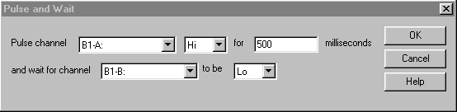
4) Use the drop-down menu to choose the channel to pulse in the Pulse channel box.
5) Use the drop-down menu to choose to pulse the channel Hi or Lo.
6) Enter the number of milliseconds to pulse the channel for in the milliseconds box.
7) Use the drop-down menu to choose the channel to wait for in the and wait for channel box.
8) Use the drop-down menu to choose to wait for the channel to go Hi or Lo in the to be box.
9) Click on the OK button to save the parameters and add the command.

PULSE CHANNEL
ALL ABOUT: PULSE CHANNEL

PURPOSE: The Pulse Channel command is used when you want an output channel to go to a certain state for a specified number of milliseconds (1/1000 second) and then go to the opposite state than the state the Pulse Channel command caused.

EXAMPLE OF USE: If you want to switch channels on the Broadcast Tools 6x1(a) switcher, you would pulse the corresponding output channel on the AT1616 HI for 500 msecs. The channel on the AT1616 will make a closure for 500 msecs which will cause the 6x1(a) to switch channels. After 500 msecs, the AT1616 output channel will return to the open (non-closure) position - but the switcher will remain on the channel that it was switched to.

PARAMETERS: 1) You select which output channel you want to pulse.
2) You select whether you want the channel to be pulsed HI or LO.
3) You set the duration that you want the channel to be pulsed for.

IMPORTANT NOTES: Do NOT use the Pulse Channel command unless the device that you are controlling only needs a brief closure/voltage.

ALSO SEE: LATCH CHANNEL

HOW TO SET UP: Pulse Channel
1) Highlight the sequence that you want the Pulse Channel command to go on.
2) Press ENTER to open up the LIST OF COMMANDS.
3) Press !, or highlight !-Pulse Channel and press ENTER.
This window will open:
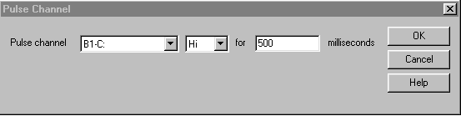

4) Use the drop-down menu to select the output channel that you want to pulse in the Pulse channel box.
5) Use the drop-down menu to select whether you want to pulse the channel HI or LO.
6) Enter the number of milliseconds that you want the channel pulsed for.
7) Click the OK button to save the parameters and add the command.

RECORD BY NAME/CODE
ALL ABOUT: RECORD BY NAME/CODE

PURPOSE: The Record By Name/Code command is used to automatically record an audio source and then create a *.WAV file in the AudioLog which contains your recorded audio.

EXAMPLE OF USE: If there were a program that a satellite network sends down at a certain time, and you want to play it at a different time, you would use the Record By Name/Code command. The Record By Name/Code records the audio and creates a file that can then be played at a later time.

PARAMETERS: 1) You select the file name for the WAV file that will be created. The file name that you specify can be a new file name or can be the same as a file that already exists. The existing file will be overwritten with the file created by the Record By Name/Code.
2) You put in the recording length. You can also set up the parameters, if desired.

IMPORTANT NOTES: The record by name command will use the first audio card that is mapped to that automation deck.

ALSO SEE: AUTORECORD

HOW TO SET UP: Record By Name/Code
1) Highlight the sequence that you want the Record By Name/Code command to go on.
2) Press ENTER to open up the LIST OF COMMANDS.
3) Press R, or highlight R-Record by Name/Code and press ENTER.

This window will open:
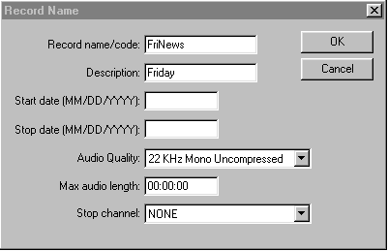
Note: All time parameters are entered in Military Format (24 hour) using 6 digits as HH:MM:SS, where HH is hours, MM is minutes, and SS is seconds.

4) Enter the name of the file in the Record name/code box. Entering the file extension is not necessary. Automate will record the audio as a WAV file and assign WAV as the extension.
5) Enter the description of the file in the Description box.
6) Enter the Start date and Stop date for the file.
7) Use the drop-down menu to choose the Audio Quality for the recording.
8) Enter the length of the recording in the Max audio length box as a 6-digit number (HH:MM:SS).
9) Use the drop-down menu to choose the Stop Channel.
10) Click the OK button to save the parameters and add the command.

RETURNSUB
ALL ABOUT: RETURNSUB

PURPOSE: The ReturnSub command is always used in conjunction with the GoSub command. ReturnSub causes the program to return to the sequence immediately following the GoSub command that caused the program to jump.

EXAMPLE OF USE: If you have issued a GoSub command, you put the ReturnSub command at the END of the series of commands that you want to be executed when the GoSub command is called.

PARAMETERS: There are no parameters associated with this command.

IMPORTANT NOTES: The ReturnSub command MUST be used in conjunction with a GoSub command.

ALSO SEE: GOSUB

HOW TO SET UP: ReturnSub
1) Highlight the sequence that you want the ReturnSub command to go on.
2) Press ENTER to open up the LIST OF COMMANDS.
3) Press ), or highlight )-ReturnSub and press ENTER.

SET CLOCK
ALL ABOUT: SET CLOCK

PURPOSE: The Set Clock command will set the computer's clock to the time of day that is specified. It is very important to keep the computer's clock accurate.

EXAMPLE OF USE: If you know that your satellite network sends down a tone at exactly 59 minutes and 55 seconds after the hour (xx:59:55), you would put in a Wait for Channel or Wait for Closure command to catch the tone, and then the very next command would be Set Clock.

PARAMETERS: You select the hour, minute, and second that you want the computer's clock set to.

IMPORTANT NOTES: You should only use Set Clock when you are sure an event (closure, etc.) will happen at an exact time.

ALSO SEE:

HOW TO SET UP: Set Clock
1) Highlight the sequence that you want the Set Clock command to go on.
2) Press ENTER to open up the LIST OF COMMANDS.
3) Press S, or highlight S-Set Clock and press ENTER.

This window will open:
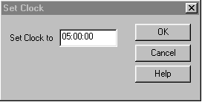
Note: All time parameters are entered in Military Format (24 hour) using 6 digits as HH:MM:SS, where HH is hours, MM is minutes, and SS is seconds.

4) Enter the time in the Set Clock to box.
5) Click the OK button to save the parameters and add the command.

SKIP
ALL ABOUT: SKIP

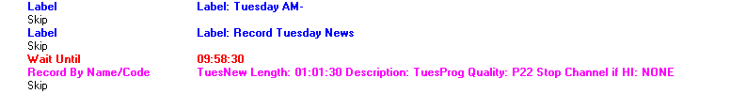

PURPOSE: The Skip command is just an optional space between commands to make the program easier to read/follow. Automate ignores all Skip commands.

EXAMPLE OF USE: Between scheduled breaks you would probably want a couple of skips to separate the breaks, as well as between different hours.

PARAMETERS: There are no parameters associated with this command

IMPORTANT NOTES: Automate ignores all Skip commands. All GOTO and GOSUB commands will be adjusted correctly as you insert Skips.

ALSO SEE: LABEL

HOW TO SET UP: Skip
1) Highlight the sequence that you want the Skip command to go on.
2) Press the Insert key on the keyboard.

-OR-

1) Highlight the sequence that you want the Skip command to go on.
2) Press ENTER to open up the LIST OF COMMANDS.
3) Press 4, or highlight Skip and press ENTER.

SPLICE
ALL ABOUT: SPLICE

PURPOSE: The Splice command is used to merge 2 audio files into 1.

EXAMPLE OF USE: If a news feed is being recorded, that when played will have an intro and commercials, several audio files could be added together. This would allow the scheduling of one audio file in the playlist, or enable the on-air personality to only play one file. This would also ensure the correct commercials are played during the newscast.

PARAMETERS: You choose the names of the 2 files to add together, and the amount of time that will be added between the files.

IMPORTANT NOTES: This command modifies the first file by adding the audio from the second file.

ALSO SEE: CHANGE PATH

HOW TO SET UP: Splice
1) Highlight the sequence that you want the Splice command to go on.
2) Press ENTER to open up the LIST OF COMMANDS.
3) Highlight Splice and press ENTER.

This window will open:
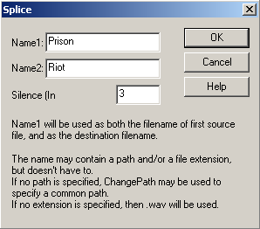

4) Enter the name of the first audio file in the Name1 field.
5) Enter the name of a second audio file in the Name2 field.
6) Enter the amount of silence to insert between the files, in milliseconds (100 would be 1/10 second, 1000 would be 1 second).
7) Click the OK button to save the parameters and add the command.

STOP / SHUT DOWN
ALL ABOUT: STOP / SHUT DOWN

PURPOSE: The Stop / Shut Down command is used to stop the Automation Program when the command is executed.

EXAMPLE OF USE: If you want the Automation Program to shut down at 7:50 pm, you would put a Wait Until 19:50:00 command followed by Stop / Shut Down.

PARAMETERS: There are no parameters associated with this command.

IMPORTANT NOTES: This command will only stop the Automation Program that contains the Stop / Shut Down command. All other Automation Programs that are running will continue to run.

ALSO SEE: WAIT UNTIL; LOAD AND START

HOW TO SET UP: Stop / Shut Down
1) Highlight the sequence that you want the Stop / Shut Down command to go on.
2) Press ENTER to open up the LIST OF COMMANDS.
3) Press 3, or highlight 3-Stop / Shut down and press ENTER.

SYNC
ALL ABOUT: SYNC

PURPOSE: The Sync command is used to have the Automation Program synchronize the audio files in a source and destination folder. Any file that exists (or is newer) in the source folder and does not exist in the destination folder will be copied to the destination folder.

EXAMPLE OF USE: This command will enable production to be done on one computer, while the new/edited audio files will be automatically copied to the Control computer for use on air.

PARAMETERS: The parameters are set upon scheduling the command in the Automation Program. The user is given the option to use existing parameters or add a new set of parameters that include the alias and source and destination folders.

IMPORTANT NOTE: Changes made to the existing parameters will affect all future uses of that alias's operation. If the Sync command has an alias of Production, and changes are made to that alias's source or destination folder, the new parameters will be reflected when that Sync command is struck in the Automation Program.

HOW TO SET UP: Sync
1) Highlight the sequence that you want the Sync command to go on.
2) Press ENTER to open up the LIST OF COMMANDS.
3) Press I, highlight I- Sync and press ENTER, or double-click on I- Sync.

This selector box will open:
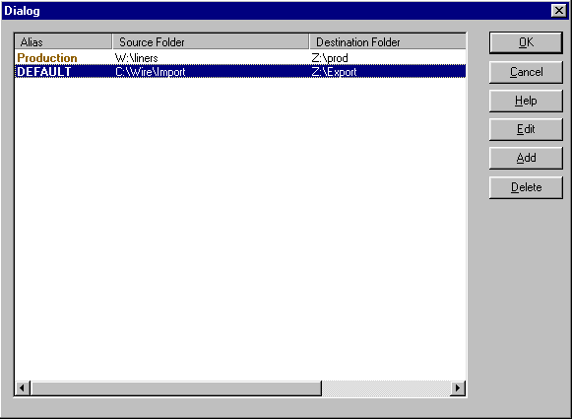

4) If there are already Sync alias parameters created, choose one and click the OK button to add the command.

To create a new Sync alias:
a) Click the Add button or strike Alt-A.
b) Enter an Alias. This is the name that will appear in the Automation Program.
c) Enter the path of the Source directory.
d) Enter the path of the Destination directory.
e) Enter the filename or file spec that is to be copied. Asterisks and questions marks are allowed.
f) Enter a Speed. This is a number from 1-100, indicating how fast the operation should take place. This is an optional parameter, and if it is not present, then it will default to 50.
g) When you are done creating the new command, click OK or strike Alt-O to save the parameters.

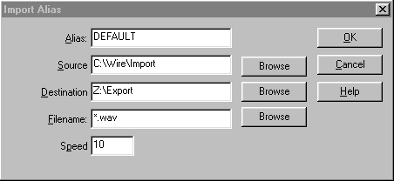

To edit an existing Sync alias:
a) Highlight the alias line to edit.
b) Click the Edit button or strike Alt-E.
c) Change the existing parameters, then click OK or strike Alt-O to save the changes.

5) Click the OK button to add the command.

WAIT FOR CHANNEL
ALL ABOUT: WAIT FOR CHANNEL

PURPOSE: The Wait for Channel command is used to hold the Automation Program on a specific sequence number until the specified input channel makes a closure (or the voltage goes HI or LO), or the time window (if used) expires.

EXAMPLE OF USE: If you were waiting for a tone from your satellite network that will in turn create a closure on one of your input channels (or cause the voltage to go HI), you would issue this command. Then the Automation Program stays at this sequence until the input channel makes a closure (or the voltage goes HI or LO), or the time window (if used) expires, and then moves on to the next sequence.

PARAMETERS: 1) You select which input channel is to be monitored.
2) You select whether we are looking for the selected channel to go HI or LO.
3) You select whether or not the command will obey a time window.
4) If you choose to obey a time window, you set the time parameters, and the sequence to go to if the time window expires.

IMPORTANT NOTES: This command is used with the AT1616L Controller. See the AT1616 document for a diagram of which terminal numbers correspond with which channels.

ALSO SEE: WAIT FOR CLOSURE; WAIT FOR HOT KEY; WAIT UNTIL.

HOW TO SET UP: Wait for Channel
1) Highlight the sequence that you want the Wait for Channel command to go on.
2) Press ENTER to open up the LIST OF COMMANDS.
3) Press C, or highlight C-Wait for Channel and press ENTER.

This window will open:
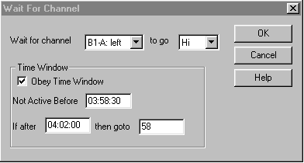
Note: All time parameters are entered in Military Format (24 hour) using 6 digits as HH:MM:SS, where HH is hours, MM is minutes, and SS is seconds.

4) Use the drop-down menu to select the input channel to monitor.
5) Use the drop-down menu to select whether the input channel which you specify will be monitored to go HI (closure) or LO (open).
6) If you have checked Obey Time Window:
- Enter the earliest time which you want this command to be executed in the Not Active Before box.
- Enter the latest time that you want this command to be executed in the If after box.
- Enter the sequence number that you want the Automation Program to jump to if the command does not occur by the If after time in the then goto box.
7) Click the OK button to save the parameters and add the command.

WAIT FOR CLOSURE
ALL ABOUT: WAIT FOR CLOSURE

PURPOSE: The Wait for Closure command is used to hold the Automation Program on a specific sequence number until the specified input channel detects a closure, or the time window (if used) expires.

EXAMPLE OF USE: If you were waiting for a tone from your satellite network that will in turn create a closure on your tone decoder that will cause the input channel to go HI, you would issue this command. The Automation Program stays at this sequence until the input channel gets the specified voltage, or the time window (if used) expires, and then moves on to the next sequence.

PARAMETERS: 1) You select which input channel is to be monitored.
2) You select whether or not the command will obey a time window.
3) If you choose to obey a time window, you set the time parameters, and the sequence to go to if the time window expires.

IMPORTANT NOTES: This command is present only for backward compatibility with Wireready’s DOS software. If setting up new commands, use the Wait for Channel command instead of Wait for Closure.

ALSO SEE: WAIT FOR CHANNEL; WAIT FOR HOT KEY; WAIT UNTIL.

HOW TO SET UP: Wait for Closure
1) Highlight the sequence that you want the Wait for Closure command to go on.
2) Press ENTER to open up the LIST OF COMMANDS.
3) Press O, or highlight O-Wait for Closure and press ENTER.

This window will open:
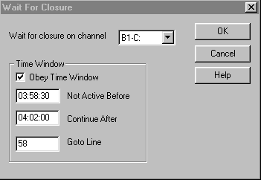
Note: All time parameters are entered in Military Format (24 hour) using 6 digits as HH:MM:SS, where HH is hours, MM is minutes, and SS is seconds.

4) Use the drop-down menu to select the input to monitor.
5) If you have checked Obey Time Window:
- Enter the earliest time which you want this command to be executed in the Not Active Before box.
- Enter the latest time that you want this command to be executed in the Continue After box.
- Enter the sequence number that you want the Automation Program to jump to (if the command does not occur by the Continue After time) in the Goto Line box.
6) Click the OK button to save the parameters and add the command.

WAIT UNTIL
ALL ABOUT: WAIT UNTIL

PURPOSE: The Wait Until command is used to hold the Automation Program on a specific sequence number until a specified time of day.

EXAMPLE OF USE: If you want to switch to ABC News at 5:00 am, you would put a Wait Until 05:00:00 command. The commands following the Wait Until would be to select ABC (PULSE, LATCH, etc.).

PARAMETERS: You set the hour, minute, and second to wait until.

IMPORTANT NOTES: When the Automation Program comes across this command, it will stay on the sequence until the time of day is at, or after, the time specified. Therefore, if you issue a Wait Until 10:00 command at 5:00 am, the Automation Program will not move for 5 hours. And if you issue a WAIT UNTIL 10:00 command at 5:00 am, the program will move to the next sequence as soon as it comes to the Wait Until command.

ALSO SEE: DELAY FOR; WAIT FOR HOT KEY; WAIT FOR CHANNEL; WAIT FOR CLOSURE.

HOW TO SET UP: Wait Until
1) Highlight the sequence that you want the Wait Until command to go on.
2) Press ENTER to open up the LIST OF COMMANDS.
3) Press U, or highlight U-Wait Until and press ENTER.

This window will open:
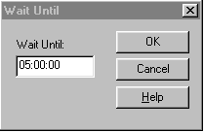
Note: All time parameters are entered in Military Format (24 hour) using 6 digits as HH:MM:SS, where HH is hours, MM is minutes, and SS is seconds.

4) Enter the HOUR, MINUTE, and SECOND that you want the program to wait until.
5) Click the OK button to save the parameters and add the command.

EXAMPLE OF AN AUTOMATION PROGRAM

This is an example of the beginning of an Automation Program for a station recording using closures.

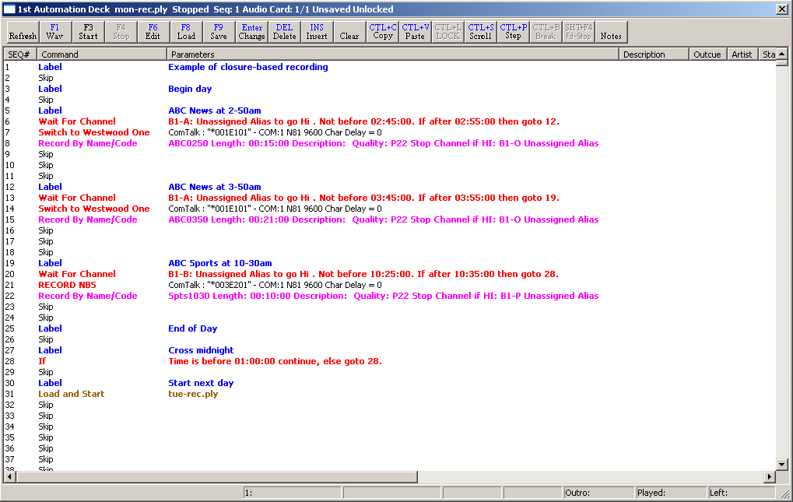

WireReady has Automation Programs that were written for a number of satellite networks. These programs can be sent to you on disks or downloaded. Call a WireReady Technical Representative for more information.

SYSTEM CONFIGURATION AND OTHER OPTIONS

The Logs created by the Log command

The log file is written in the Log folder of the user’s directory. The filename consists of the deck number, the month, the day, the year, and the playlist’s name, all separated with underscores, followed by the extension “.log”.
For example, if the root directory is “W:\Wire”, the user’s name is “Testuser”, the automation deck is 1, the date is 2-3-2002, and the playlist’s name is “Monday”, then the name of the log file is “W:\Wire\Users\Testuser\Logs\1_2_3_2002_Monday.log”.
The log file will be appended to, but neither deleted nor overwritten. It is the responsibility of the system administrator to delete unwanted logs.

The format of the log file is [sequence line number]-[time that the line was executed]-[total length of time the playlist has been running] [the command and its parameters].

Example of the log created by the Log command:
Note: if the command and its parameters will extend past the margins of the page parameters, the line is word-wrapped to the following line.
848-16:46:04- 0:00:00:00 Starting the playlist.
848-16:46:04- 0:00:00:00 LabelLabel: next hour
849-16:46:04- 0:00:00:00 LogOn
849-16:46:04- 0:00:00:00 Logging being turned on.
850-16:46:04- 0:00:00:00 LabelLabel: Command All
851-16:46:04- 0:00:00:00 Play WaveW:\Jingles\JF3D.WAV W:\Jingles\JF3D.wav o: l: 00:00:10
851-16:46:15- 0:00:00:11 Advancing to the next command.
852-16:46:15- 0:00:00:11 Play By Name/CodeCBS-1
852-16:46:15- 0:00:00:11 No valid file found to play.
853-16:46:15- 0:00:00:11 AutoRecordw:\jingles\jimrecord.wav 000100 1
854-16:46:15- 0:00:00:11 Delay for00:02:00.00
855-16:48:15- 0:00:02:11 Wait Until16:09:55
856-16:48:15- 0:00:02:11 Play WaveW:\Jingles\JF3B.WAV W:\Jingles\JF3B.wav o: l: 00:00:02
856-16:48:17- 0:00:02:13 Advancing to the next command.
857-16:48:17- 0:00:02:13 Skip
858-16:48:17- 0:00:02:13 *** BE HERE AT ***16:10:00
859-16:48:17- 0:00:02:13 Record By Name/Codebyname1 Length: 00:01:00 Description: Quality: P22 Stop Channel if HI: B1-A left
859-16:49:17- 0:00:03:13 Finished recording W:\Audio\byname1.wav
860-16:49:17- 0:00:03:13 Wait For ChannelB1-A: left to go Low. Not before 16:00:00. If after 16:15:00 then goto 862.
860-16:49:17- 0:00:03:13 Time is after 16:15:00 time. Going to line 861
862-16:49:17- 0:00:03:13 ComTalk"" - COM: 2 N81 9600 Char Delay = 1
862-16:49:17- 0:00:03:13 ComTalk outputting string .
863-16:49:17- 0:00:03:13 IfTime is before 17:00:00 continue, else goto 865.
864-16:49:17- 0:00:03:13 Delay for00:00:01.00
865-16:49:19- 0:00:03:15 GoSub1328
1328-16:49:19- 0:00:03:15 Delay for00:00:03.00
1329-16:49:22- 0:00:03:18 Play WaveW:\Jingles\JF2.WAV
1329-16:49:22- 0:00:03:18 No valid file found to play.
1330-16:49:22- 0:00:03:18 ReturnSub
866-16:49:22- 0:00:03:18 IfTime is after 17:00:00 continue, else goto 868.
869-16:49:22- 0:00:03:18 Play WaveW:\Jingles\JF3D.WAV W:\Jingles\JF3D.wav o: l: 00:00:10
869-16:49:33- 0:00:03:29 Finished playing W:\Jingles\JF3D.wav
871-16:49:33- 0:00:03:29 Play WaveW:\Jingles\JF3D.WAV W:\Jingles\JF3D.wav o: l: 00:00:10
871-16:49:43- 0:00:03:39 Advancing to the next command.
872-16:49:43- 0:00:03:39 Wait For ChannelB1-B: right to go Hi . Not before 16:30:00. If after 16:40:59 then goto 874.
872-16:49:43- 0:00:03:39 Time is after 16:40:59 time. Going to line 873
874-16:49:43- 0:00:03:39 IfChannel B1-C:Liners is Lo continue, else goto 876
875-16:49:43- 0:00:03:39 Delay for00:00:01.00
876-16:49:44- 0:00:03:40 IfChannel B1-D:Commercial is Hi continue, else goto 878
878-16:49:44- 0:00:03:40 Wait Until16:50:00
879-16:50:00- 0:00:03:56 Set Clock16:50:00
880-16:50:00- 0:00:03:56 LogOff
880-16:50:00- 0:00:03:56 Logging being turned off.

Configuration Files

Assigning Sound Cards to the Automate Decks
The sound cards are assigned to the Automate decks in the Player screen.

To assign the basic configuration options of the decks:

1) To open the Audio Player, click the Player button on the toolbar, or strike ALT-4.
2) From the Audio Player Menu bar, click Setup.
3) Click Configurations. This will open the "Configure Audio Devices" dialog box.
4) Click the Audio Boards tab to view the audio card address settings. The audio devices may not be assigned in Windows in the order that you installed them.
If you have more than one sound card in the computer, you can assign several decks to use device 1 (which you would use to record from the first source), and assign several other decks to use device 2. If you are only recording from one source, you can use the second audio card to preview or edit audio.
5) Click on the Wave Decks tab. Assign audio boards to the cart decks. This applies if there is more than one audio card installed in your computer. If only one audio card is installed, all eight decks should all be assigned to Audio Board 1.

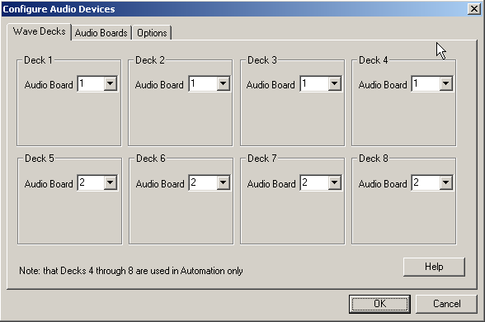
6) When finished, click OK.

[server]:\wire\system\SyncDir32.dat
This file holds the configuration of the Sync lines. When the Automation Program hit s a Sync command, this file will be read for custom folder information. All audio that is in the source directory will be copied into the destination directory.
Except when: The audio in the destination path is newer than the source path and the destination audio cannot be accessed (locked by another process, read only etc.).
Paths are acceptable both with and without trailing backslash characters.

Format of syncdir32.dat file:

<destination alias>;<destination path>;<source alias> (not used any more);<source path>;<file type>;<speed to copy> (value between 1 and 400)

Example:

Production;Z:\prod;;c:\liners;*.wav;10
DEFAULT;Z:\Export;;C:\Wire\Import;*.wav;10

[server]:\wire\users\[username]\[username].ini
This file holds configuration information for the user. The below section holds the settings affecting the Automate screen. This is a list of all possible ini keys, what they represent, their possible values, and their default values. The settings may not appear in the same order in the user’s ini files.

[Automation]:
AudioLogFilename – The filename of the log to use for a detailed log of all audio status. Possible values are any fully qualified filename. Defaults to “Off” which means no logging.
Autostart - Whether or not the automation decks should automatically start. Possible values are: “Yes” and “No”. The default is: “No”.
Automates - This is the count of automation decks that are to be opened. This is an obsolete value and can safely be ignored since all available automation decks are always opened.
B1-A through B1-P - These are the aliases of the input channels. Possible values are any character string having 20 or fewer characters. The default values are: “Input1” through “Input16”.
Column_Width_Artist - This is the column width of the Artist column in the automation screen. This ini setting is automatically written by the program whenever the column size changes. Possible values are any number. The default is: 40.
Column_Width_Command - This is the column width of the Command column in the automation screen. This ini setting is automatically written by the program whenever the column size changes. Possible values are any number. The default is: 140.
Column_Width_Description - This is the column width of the Description column in the automation screen. This ini setting is automatically written by the program whenever the column size changes. Possible values are any number. The default is: 90.
Column_Width_EndTime - This is the column width of the EndTime column in the automation screen. This ini setting is automatically written by the program whenever the column size changes. Possible values are any number. The default is: 70.
Column_Width_Intro - This is the column width of the Intro column in the automation screen. This ini setting is automatically written by the program whenever the column size changes. Possible values are any number. The default is: 35.
Column_Width_Intro_Type - This is the column width of the Intro Type column in the automation screen. This ini setting is automatically written by the program whenever the column size changes. Possible values are any number. The default is: 50.
Column_Width_Length - This is the column width of the Length column in the automation screen. This ini setting is automatically written by the program whenever the column size changes. Possible values are any number. The default is: 60.
Column_Width_Outcue - This is the column width of the Outcue column in the automation screen. This ini setting is automatically written by the program whenever the column size changes. Possible values are any number. The default is: 40.
Column_Width_Outro - This is the column width of the Outro column in the automation screen. This ini setting is automatically written by the program whenever the column size changes. Possible values are any number. The default is: 35.
Column_Width_Outro_Type - This is the column width of the Outro Type column in the automation screen. This ini setting is automatically written by the program whenever the column size changes. Possible values are any number. The default is: 50.
Column_Width_Parameters - This is the column width of the Parameters column in the automation screen. This ini setting is automatically written by the program whenever the column size changes. Possible values are any number. The default is: 120.
Column_Width_Seq - This is the column width of the Sequence number column in the automation screen. This ini setting is automatically written by the program whenever the column size changes. Possible values are any number. The default is: 50.
Column_Width_Status - This is the column width of the Status column in the automation screen. This ini setting is automatically written by the program whenever the column size changes. Possible values are any number. The default is: 400.
Column_Width_Start_Date - This is the column width of the Start Date column in the automation screen. This ini setting is automatically written by the program whenever the column size changes. Possible values are any number. The default is: 85.
Column_Width_Stop_Date - This is the column width of the Stop Date column in the automation screen. This ini setting is automatically written by the program whenever the column size changes. Possible values are any number. The default is: 85.
ComTalkPostDelayInMseconds - This is the amount of delay injected after a ComTalk command before any other ComTalk commands is issued. It is measured in milliseconds. Possible values are any number. The default is: 200.
“Deck 1 Name” through “Deck 8 Name” - This is the name of the automation deck. It is displayed in the Title bar of the deck, and in the Automation deck selection dialog box. Possible values are any valid string. The default is: “1st Automation Deck” etc.
DefaultImportMusicPath - This is the fully qualified filename of the last Music log that was imported in Automation. It is used to default the dialog box the next time it is displayed. The default is: “C:\*.log”.
DefaultImportTrafficPath - This is the fully qualified filename of the last Traffic log that was imported in Automation. It is used to default the dialog box the next time it is displayed. The default is: “C:\*.log”.
DefaultMusicLogFolder - This is the folder that is used as the default folder for audio files when importing. Possible values are: “UseDefault” (which will cause the DefaultPlayPath to be used instead), or any valid local or redirected path. The default is: “UseDefault”.
DefaultPlayPath - This is the default path that automation will use to find audio files when no path is specified. Possible values are any valid local or redirected path. The default is: "Audio\\".
DefaultTrafficLogFolder - This is the folder that is used as the default folder for audio files when importing. Possible values are: “UseDefault” (which will cause the DefaultPlayPath to be used instead), or any valid local or redirected path. The default is: “UseDefault”.
FaderFullVolume - This is the percentage of volume that is considered normal full volume. Possible values are 0-100. The default is: 90.
FaderUseIni - This is a flag indicating whether the fader should rely on the audio card’s returned volume setting, or should use the ini settings. Possible values are: “Yes” and “No”. The default is: “No”.
HideAudioPathsExtensions – This controls the display of filenames in play commands. Possible values are: “Yes” and “No”. The default is: “No”.
HideLogicParameters – This controls the display of parameters for logic type commands. Possible values are: “Yes” and “No”. The default is: “No”.
ImportMusicAirTimeOffset - This is the offset into the log line that contains the air time. Possible values are any number. The default is: 1.
ImportMusicAmPmOffset - This is the offset into the log line that contains the AM/PM indicator. Only the first letter is used and it must be “A” or “P”. Possible values are any number. A 1 indicates that the time is in 24 hour format. The default is: 1.
ImportMusicBreakTolerance - This is the amount of time that the break can be off when being filled and still be considered to be filled all the way. Possible values are any number. The default is: 1.
ImportMusicCartLength - This is the length the cart name contained in the log line. Possible values are any number. The default is: 1.
ImportMusicCartOffset - This is the offset into the log line that contains the cart name. Possible values are any number. The default is: 1.
ImportMusicFillByMode - This is the mode used when importing.Possible values are 0 and 1. “0” is fill by air time. “1” is fill by length. The default is: 0.
ImportMusicReportFilename - This is the filename of the output report that is created when the import is done. The default is: "ImportReport.txt" in the personal files folder.
ImportTrafficAirTimeOffset - This is the offset into the log line that contains the air time. Possible values are any number. The default is: 1.
ImportTrafficAmPmOffset - This is the offset into the log line that contains the AM/PM indicator. Only the first letter is used and it must be “A” or “P”. Possible values are any number. A 1 indicates that the time is in 24 hour format. The default is: 1.
ImportTrafficBreakTolerance - This is the amount of time that the break can be off when being filled and still be considered to be filled all the way. Possible values are any number. The default is: 1.
ImportTrafficCartLength - This is the length the cart name contained in the log line. Possible values are any number. The default is: 1.
ImportTrafficCartOffset - This is the offset into the log line that contains the cart name. Possible values are any number. The default is: 1.
ImportTrafficFillByMode - This is the mode used when importing.Possible values are 0 and 1. “0” is fill by air time. “1” is fill by length. The default is: 0.
ImportTrafficReportFilename - This is the filename of the output report that is created when the import is done. The default is: "ImportReport.txt" in the personal files folder.
ImportWebReportFilename - This is the filename of the Web import’s output report that is created when the import is done. The default is: "ImportWebReport.txt" in the personal files folder.
IncludeExpiredCartsInEndTimes - Determines whether or not we should include the lengths of expired cuts in EndTime calculations. Possible values are: “Yes” and “No”. The default is: “Yes”.
infocache_display_age_limit - This is the maximum time that a check of the audio file is considered to be valid for display purposes before it has to be rechecked. It is measured in minutes. Possible values are any number. The default is: 5.
infocache_play_age_limit - This is the maximum time that a check of the audio file is considered to be valid for play purposes before it has to be rechecked. It is measured in seconds. Possible values are any number. The default is: 30.
Logic Lockdown - This determines whether the information for logic commands will be able to be changed or not. Possible values are: “Yes” and “No”. The default is: “No”.
MulticolumnAudioInfo - This determines whether the information for Play commands will span across many separate columns or not. Possible values are: “Yes” and “No”. The default is: “No”.
ObeyStartAndStopDates - This controls whether or not the Start and Stop dates that are stored in the audio files are honored. Possible values are: “Yes” or “No”. The default is: “Yes”.
OutputB1-A through OutputB1-P - These are the aliases of the output channels. Possible values are any character string having 20 or fewer characters. The default values are: “Output1” through “Output16”.
PlayStateUpdateInterval - This is the time between writes of the PlayState files. The PlayState file keeps track of the information needed to restart the automation deck after a power failure. This is the time in milliseconds and any number is valid. The default is: 5000 (or 5 seconds).
QuickComTalk1 through QuickComTalk100 - These are the quick ComTalk commands. The default for each of these is: "BLANK”.
TalkOver_Volume - Obsolete. Replaced with TalkOverVolume.
TalkOverVolume - This is the percentage of volume used for TalkOver. Possible values are 0-100. The default is: 50.
UseRotationsInLogs - This is a flag indicating whether importing is allowed to import rotation files. Possible values are: “Yes” and “No”. The default is: “Yes”.

[CommonAudioLog]:
PreviewAudioDevice - The audio device to be used when previewing audio. This is the same device that is used to preview audio from anywhere in WR.

[AudioPlayer]:
Audio Boards - a list of 8 numbers separated by commas that specify which audio board each automation deck will use for the main (primary) audio board. The default is: “0,0,0,0,0,0,0,0”.
Overlapping Audio Boards - a list of 8 numbers separated by commas that specify which audio board each automation deck will use for the overlapping audio board. The default is: “0,0,0,0,0,0,0,0”.
Recording Audio Boards - a list of 8 numbers separated by commas that specify which audio board each automation deck will use for the Recording audio board. The default is: “0,0,0,0,0,0,0,0”.
Check Sample Rate - This is a flag indicating whether or not to check the sample rate of cuts, and limit the playback to only a certain sample rate. Possible values are: “Yes” and “No”. The default is: “No”.
Sample Rate Allowed - This is the only sample rate that is allowed to be played when ‘Check Sample Rate’ is set to Yes. Possible values are: any valid sample rate. If an invalid sample rate is entered, then it will be changed to the default sample rate. The default is: 22050.

[Log]:
1-8 - This determines whether or not logging is enabled for an automation deck. This is a detailed debugging type of log. It should only be turned on if directed to be done by WireReady personnel. Possible values are: “Yes” and “No”. The default is: “No”.
[Confirmation Log]:
1-8 - This determines whether or not logging is enabled for an automation deck. This is a confirmation type of log that keeps track of which cuts were played and when. Possible values are: “None” (No logging), “Old” (Old style logging), or “New” (currently not supported). The default is: “None”.

[Select Command]:
Column_Width_Hot_Key - This is the column width of the Hot Key column in the Command Selection screen. This ini setting is automatically written by the program whenever the column size changes. Possible values are any number. The default is: 50.
Column_Width_Number - This is the column width of the Number column in the Command Selection screen. This ini setting is automatically written by the program whenever the column size changes. Possible values are any number. The default is: 20.
Column_Width_Command - This is the column width of the Command column in the Command Selection screen. This ini setting is automatically written by the program whenever the column size changes. Possible values are any number. The default is: 195.
SortAscending - This determines whether the columns are sorted in ascending order or descending order. Possible values are: “Yes” and “No”. The default is: “Yes”.
SortColumn - This determines whether the columns are sorted in ascending order or descending order. Possible values are any number. The default is: 0.

[Web Publish Automation Deck 1] - [Web Publish Automation Deck 8]:
Import Source Path - This is the path used for the source files in the Web Publish command. Possible values are fully qualified paths. The default is: the default play path.
Import In Path - This is the Destination path where the files will be written. (It is called IN because it is the input path for DBCapture). Possible values are fully qualified paths. The default is: DBCapture\In under the root.
Import Alias - The alias to use when publishing files. Possible values are: any valid alias. Default is: "WebDefault".
Import Web Log Name - This is the log file that was used the last time that a Web Import was done. It is used to default the name the next time. It is written automatically by the program, and should not normally be modified. Default is: "C:\\*.log".

[FileSelect]
ColumnWidthArtist - This is the column width of the Artist column in the FileSelect screen. This ini setting is automatically written by the program whenever the column size changes. Possible values are any number. The default is: 100.
ColumnWidthAttributes - This is the column width of the Attributes column in the FileSelect screen. This ini setting is automatically written by the program whenever the column size changes. Possible values are any number. The default is: 100.
ColumnWidthCategory - This is the column width of the Category column in the FileSelect screen. This ini setting is automatically written by the program whenever the column size changes. Possible values are any number. The default is: 100.
ColumnWidthChanged - This is the column width of the Changed column in the FileSelect screen. This ini setting is automatically written by the program whenever the column size changes. Possible values are any number. The default is: 100.
ColumnWidthDescription - This is the column width of the Description column in the FileSelect screen. This ini setting is automatically written by the program whenever the column size changes. Possible values are any number. The default is: 100.
ColumnWidthFilename - This is the column width of the Filename column in the FileSelect screen. This ini setting is automatically written by the program whenever the column size changes. Possible values are any number. The default is: 100.
ColumnWidthFileSize - This is the column width of the FileSize column in the FileSelect screen. This ini setting is automatically written by the program whenever the column size changes. Possible values are any number. The default is: 100.
ColumnWidthIntrolength - This is the column width of the Introlength column in the FileSelect screen. This ini setting is automatically written by the program whenever the column size changes. Possible values are any number. The default is: 100.
ColumnWidthLastPlayed - This is the column width of the LastPlayed column in the FileSelect screen. This ini setting is automatically written by the program whenever the column size changes. Possible values are any number. The default is: 100.
ColumnWidthLength - This is the column width of the Length column in the FileSelect screen. This ini setting is automatically written by the program whenever the column size changes. Possible values are any number. The default is: 100.
ColumnWidthOutcue - This is the column width of the Outcue column in the FileSelect screen. This ini setting is automatically written by the program whenever the column size changes. Possible values are any number. The default is: 100.
ColumnWidthOutroLength - This is the column width of the OutroLength column in the FileSelect screen. This ini setting is automatically written by the program whenever the column size changes. Possible values are any number. The default is: 100.
ColumnWidthSampleRate - This is the column width of the SampleRate column in the FileSelect screen. This ini setting is automatically written by the program whenever the column size changes. Possible values are any number. The default is: 100.
ColumnWidthSavedBy - This is the column width of the SavedBy column in the FileSelect screen. This ini setting is automatically written by the program whenever the column size changes. Possible values are any number. The default is: 100.
ColumnWidthStartDate - This is the column width of the StartDate column in the FileSelect screen. This ini setting is automatically written by the program whenever the column size changes. Possible values are any number. The default is: 100.
ColumnWidthStatus - This is the column width of the Status column in the FileSelect screen. This ini setting is automatically written by the program whenever the column size changes. Possible values are any number. The default is: 100.
ColumnWidthStopDate - This is the column width of the StopDate column in the FileSelect screen. This ini setting is automatically written by the program whenever the column size changes. Possible values are any number. The default is: 100.
ColumnWidthTimesPlayed - This is the column width of the TimesPlayed column in the FileSelect screen. This ini setting is automatically written by the program whenever the column size changes. Possible values are any number. The default is: 100.
ColumnWidthArtist - This is the column width of the Artist column in the FileSelect screen. This ini setting is automatically written by the program whenever the column size changes. Possible values are any number. The default is: 100.
Directory - This is the path that is displayed when the dialog is first displayed. This ini setting is automatically written by the program. Possible values are fully qualified paths. The default is: "w:\text&Audio\".
Filename - This is the filename that is displayed when the dialog is first displayed. This ini setting is automatically written by the program. Possible values are any non-qualified filename. The default is: "*.wav".
SortAscending - This determines whether the columns are sorted in ascending order or descending order. Possible values are: “Yes” and “No”. The default is: “No”.
SortColumn - This determines whether the columns are sorted in ascending order or descending order. Possible values are any number. The default is: 0.

[Automation Throttling DO NOT MODIFY]
DisplayUpdateIntervalMS - This is the frequency that the display is updated. Do not modify this unless directed to do so by WireReady personnel. Default is: 250.
MaxBurstLines - This is the maximum number of commands that can be executed in any single clock cycle. Do not modify this unless directed to do so by WireReady personnel. Default is: 500.
MaxContLines - This is the maximum number of commands that can be executed per clock cycle continuously. Do not modify this unless directed to do so by WireReady personnel. Default is: 500.
MaxMSPerTimeSlice - This is the maximum number of milliseconds that can be used executing commands every clock cycle. Do not modify this unless directed to do so by WireReady personnel. Default is: 4.
PlayStateUpdateIntervalMS - This is how often the PlayState file will be updated. Do not modify this unless directed to do so by WireReady personnel. Default is: 5000.

HOW TO REACH WIREREADY

WireReady NSI
PO Box 714 Eudora, KS 66025
(800) 833-4459 USA & CANADA
FAX: (785) 542-3477
E-MAIL: sales@wireready.com
WEB: www.wireready.com

