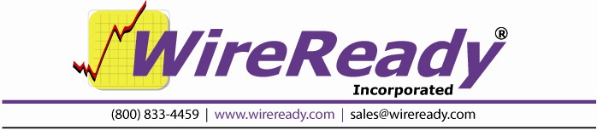

Live Assist 2 Manual

Introduction 3
Opening the Live Assist2 Screen 3
Screen Overview: Live Assist2 3
Top Status Line 4
Decks 4
Deck Controls 5
Timers 5
Buttons 6
Presets 7
Main Drop-Down Menu 8
Keyboard Shortcuts 11
Drag and Drop in Decks 12
Preset Buttons, Pages and Groups 12
Assigning Audio Files to the Preset Buttons 12
Creating a New Preset Page 12
Switching between Preset Pages 12
Assigning Names to the Preset Groups 13
Logging into Live Assist2 for Preset buttons 13
System Configuration and Other Options 14
Assigning Sound Cards to the Decks 14
Assigning Sound Cards to the Preset Buttons 14
Setting Colors for the Deck Display 15
Configuration Files 15
The User’s ini File 15
[Live Assist2] 15
[Live Assist2 Command Colors] 16
[Live Assist2 Category Colors] 18
The Preset ini File 18

Introduction
The LiveAssist2 screen is independent of the automation decks. The LiveAssist2 screen is merely a set of status indicators and controls for the automation deck. Therefore any changes in the automation deck will be visible in the controls in the LiveAssist2 window.

Opening the Live Assist2 Screen

L-Assist Button on the Main Button Bar
Click on the yellow L-Assist button to open the last playlist loaded into the Live Assist2 window. If the Live Assist2 screen has not been opened since the program was started, the playlist in Automate Deck 1 will be loaded.

L-Ast button in the deck
Click on the L-Ast button in an Automate Deck to open that playlist into the Live Assist2 screen.

Screen Overview: Live Assist2

This is a Live Assist2 screen with an Automation Program loaded into it.

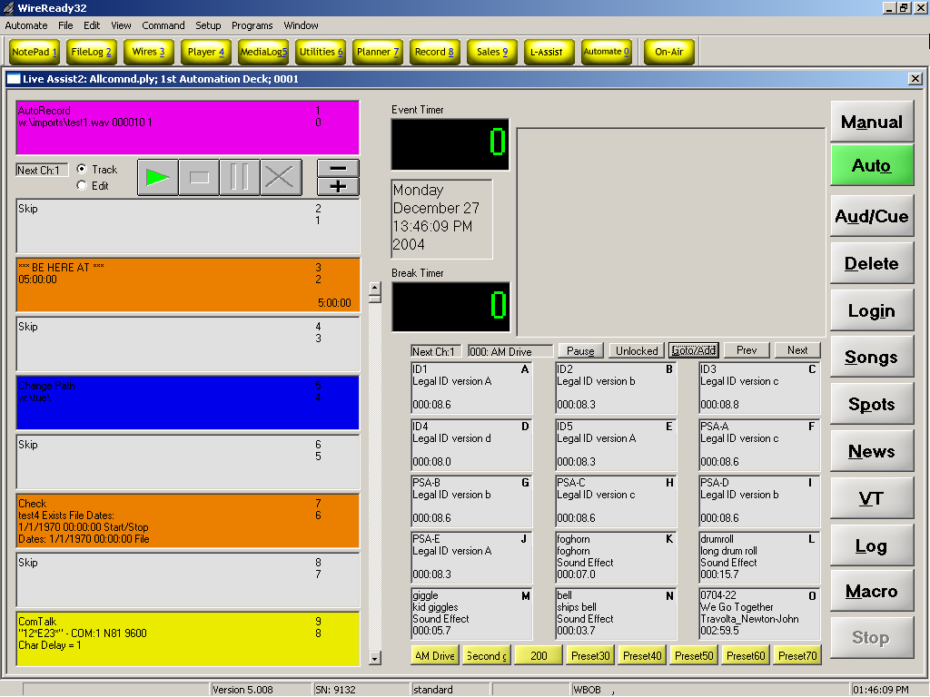
Note: The Live Assist2 screen requires the monitor to be set to 1024x768. If the yellow Preset Group buttons are not displayed on your screen, you may need to set the tray to auto-hide.

Top Status Line

The TOP STATUS LINE of the Live Assist2 screen:

- Displays the name of the Automation Program that is currently loaded into the Live Assist2 screen.
- Displays which Automation Deck the playlist is running in (1-8).
- Displays the Sequence Number of the Automation Program that is displayed in the top Live Assist2 deck. (When the Automation Program is running, this shows the sequence number of the line currently being executed).

Decks
There are 8 decks along the left side of the screen. The decks will show color for each command, depending on the configuration settings. See the section Setting Colors for the Deck Display in this manual for more information.

The Decks Display:
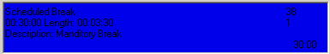
- The Command that is on that sequence. (Play commands do not display the command, just the cart name/number).
- The Intro time/Outro time of the audio file (entered from the MediaLog screen), in seconds.
- The Number of that sequence line from the Automate Deck.
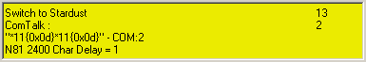
- The Command's Parameters (Parameters are details which are added to a command to customize it to do the specific task at hand).
- The Description of the audio file (entered from the MediaLog screen)
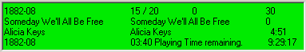
- The Position that the command is in to be activated.
- The Artist of the audio file (entered from the MediaLog screen)
- The Length of the audio file.
- The Playing Time remaining for the audio file.
- The End Time of the audio file, or the time that the file will be done playing.

Deck Controls
Between the first and second deck are the Deck Controls. This area displays the next audio device to be used, allows the user to Track or Edit the playlist, and Start, Stop, Pause the playlist, or stop the current command and move on.
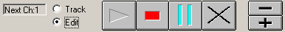
The keyboard +/- accelerators are scroll buttons that let the user move the log up or down one sequence at a time.

The Dump button (the X) will stop the running sequence in the top deck and moves to the next sequence line. This can be used to move on from WAIT UNTIL and DELAY FOR count down times when the host is running ahead. The user would click the “X” and it ends what is in the top deck and immediately goes to the next event.
When the user clicks on “Track”, this always puts the active sequence line in the top deck and displays the next 8 commands in decks 2-9 immediately under the top deck.
When the user clicks on “Edit”, this allows the user to scroll down thru the sequence lines to see what is coming later in the playlist.

Timers
The Timer section of the screen displays counters that report how much time is left in the active sequence line. The timer will display the amount of time left until a time window expires or a file is done playing or recording.
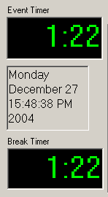
The Event Timer displays the amount of time left in the current sequence command.
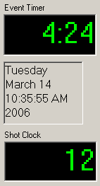
The center of timer section displays the current Day, Date and Time.

The Break Timer displays a countdown of the time left in the music or spot break if there are multiple files to play, or will display the time left in the current sequence command.

The Break Timer can be changed to display as a Shot Clock. The Shot Clock will display a count to show how much time is left in the intro of the next audio file to play. See the Configuration Files section of this manual for the configuration line.

Buttons

The Buttons on the right side of the screen are used to perform operations within the Live Assist2 screen. Each of the possible operations is explained within this manual.

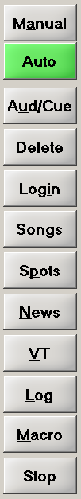
Manual When this button is activated (and turns to red), the currently playing audio will finish playing, and then the automation will stop until the Play button is activated. When the Play button is used to start an audio file while the Manual button is activated, the playlist will not continue after playing that file ends.
Auto When this button is activated (and turns to green), the playlist will continue to execute the commands in the playlist. When the Play button is used while in Auto mode, this will start the playlist on the command in the top deck.
Aud/Cue This button, when activated (and turns to yellow) will open the AudioLog Editor screen for the audio file loaded in the deck or Preset button that is clicked on. This allows the user to change information (intro/outro, description, start/stop date) or preview the audio in that file.
Delete This button, when activated (and turns to yellow) will delete the command and parameters from the highlighted sequence #, or delete the audio from the preset button, that is clicked on next. Will also remove the sequence line, moving all following commands up one line.
Login Allows a user to log in, which loads their Preset group and paths to the Songs, Spots and News buttons.
Songs Opens the File Select window with a list of audio files in a pre-selected folder.
Spots Opens the File Select window with a list of audio files in a pre-selected folder.
News Opens the File Select window with a list of audio files in a pre-selected folder.
VT Opens the Voice Track window to allow voice tracking. Not currently active. Voice tracking should be done in the Automate Decks.
Log Opens the Automate screen for the deck currently displayed in the Live Assist2 screen.
Macro Launches the Custom Command window to trigger custom commands.
Stop Stops the currently running playlist.

Presets
The Presets section of the screen:
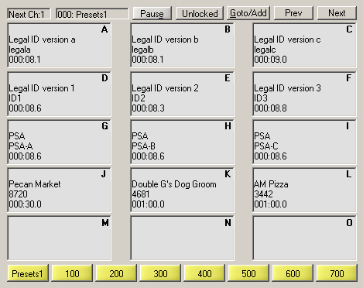
The Preset section displays the next audio device (Next Ch:) that will be used to play audio from the Preset buttons, and the number/name of the preset group currently loaded on the screen.
The Pause button, when depressed, will pause the audio currently playing from any of the lettered buttons.
The Locked/Unlocked button allows the user to toggle between allowing/denying changes to the Preset buttons.
The Goto/Add button will launch a window that will allow the user to enter a Preset Group number or Page to switch to.
The Prev button will open the Preset page that is next-lower numbered page.
The Next button will open the Preset page that is the next-higher numbered page.
The lettered buttons (A – O) store an audio file name, description, artist, and time for the file loaded into the button. Click on the button or strike the letter on the keyboard to start/stop the audio.
The yellow buttons take the user to a specific Preset Group (000, 100, 200, 300, 400, 500, 600, 700). These buttons are not configurable for the preset group they will go to, but the buttons can be renamed. See the section Assigning Names to the Preset Groups in this manual for information on how to name the yellow buttons.

Main Drop-Down Menu

The Main Menu, above the main Button bar, has 8 drop-down menus. These are the same menu choices as seen in the Automate screen, but most of the sub-menu choices are not available in this screen. Use the keyboard shortcut or click on the choice with the mouse to activate the menu choice.

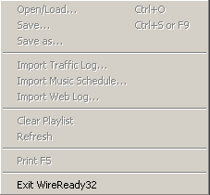
File
Exit WireReady32 Exits the program

Setup
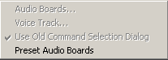
Preset Audio Boards Configures the audio devices that will be used when playing audio from the Preset buttons. See the section Assigning Sound Cards to the Preset Buttons in this manual.

Programs
The Programs menu lists the 11 screens in WireReady32. Many of these screens are not used in ControlReady for Windows. Consult the other WireReady manuals for information on using the news and sales screens.
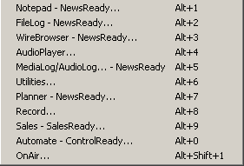
Notepad – NewsReady Alt+1 The Notepad is used to edit text and create new stories and rotations.
FileLog – NewsReady Alt+2 The FileLog is used to access text stories that have been saved from the Notepad, and to edit rotations.
WireBrowser – NewsReady Alt+3 The WireBrowser displays the wire stories that have been captured.
AudioPlayer Alt+4 The Player is used to read newscasts and play the embedded audio.
MediaLog/AudioLog – NewsReady Alt+5 The MediaLog is used to store audio files to be used in newscasts and automation.
Utilities Alt+6 The Utilities screen allows access to StormReady32, QuickRecorder, and the DOS PhoneReady and StormReady programs.
Planner – NewsReady Alt+7 The Planner is a calendar program to track appointments and assignments for newsrooms.
Record Alt+8 The Record button is used to manually record new audio files.
Sales – SalesReady Alt+9 The Sales screen is used to record and track contacts with customers/advertisers.
Automate – ControlReady Alt+0 The ControlReady for Windows decks are used to automate recording and playback of audio, and for web publishing.
OnAir Alt+Shift+1 The OnAir 10-deck screen is used for playback of audio while live.

Window
This drop-down list is used mainly for newsrooms. It allows users to clear stories from wire services that have been set to alert the WireReady32 users, and to check a list of windows that are open within the WireReady32 software. In addition to the menu choices, any open WireReady32 screens or open text files will be listed at the bottom of the menu choices in this drop-down window.
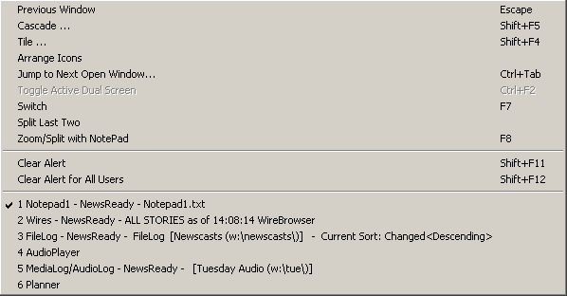
Previous Window Escape Puts the last window that was open before the Notepad as the current display.
Cascade Shift+F5 Allows the screens to be cascaded. Only active when the user is set to Windows Standard mode.
Tile Shift+F4 Allows the screens to be tiled. Only active when the user is set to Windows Standard mode.
Arrange Icons
Jump to Next Open Window Ctrl+Tab Makes the next open screen be displayed.
Toggle Active Dual Screen Ctrl+F2 Toggles between the 2 windows when the user is set to Dual Screen mode.
Switch F7 Toggles between the Notepad and the last open screen.
Split Last Two
Zoom/Split with Notepad F8 Splits the current screen (or last open screen) with the Notepad.
Clear Alert Shift+F11 Clears the red wire alert at the bottom of the screen for the logged-in user.
Clear Alert for All Users Shift +F12 Clears the red wire alert at the bottom of the screen for all users.

Keyboard Shortcuts

Preset Area
Preset buttons-letters A thru O, like the OnAir Presets, will start and stop
Pause button -- Alt+E
Goto/Add button - Alt+G
Prev button - Left Arrow key
Next button - Right Arrow key
Presets1 thru 700 buttons -- Shift+1 thru Shift+8
To open the Insert, Delete, etc menu for a button, use Ctrl+the letter (i.e. Ctrl+G for button G). Then use the up and down arrow keys on the keyboard to highlight the menu choice.

Buttons on the Right (the key strokes work, but there is not a way to choose the deck to Audition, Delete or put a Song, Spot or News file or a Macro command in)
Manual button - Alt+A
Auto - Alt+O
Aud/Cue button -- Alt+U
Delete button – Alt+D, Delete key
Login – Alt+I
Songs button - Alt+S
Spots button - Alt+P
News button - Alt+N
VT button - Alt+V
Log button - Alt+L
Macro button -- Alt+M
Stop button - F4

Deck/Log area
Play – F3
Play from End – Shift+F3
Pause button - F2
Stop button - F4
Fade to Stop – Shift+F4
Track/Edit button -- Alt+T (toggles between choices)
Move up and down the list – “+” and “–“ buttons (only active while playlist is running in Edit mode, or when the deck is stopped)
To open the Insert, Delete, etc menu for a deck, use Ctrl+the number (i.e. Ctrl+4 for the 4th deck—this number count includes the top active deck). Then use the up and down arrow keys on the keyboard to highlight the menu choice.

Drag and Drop in Decks
The audio files that are loaded into a Play command on the decks can be dragged and dropped into a different deck. If the user wants to rearrange the commercials or songs that are scheduled in a break, this can be done by left clicking and dragging the file from one deck to another. This will remove the audio file from the first deck and place it into the second deck.

Preset Buttons, Pages and Groups

Assigning Audio Files to the Preset Buttons
To assign an audio file to a Preset button, right-click on the lettered button.
A menu will pop up that allows audio to be entered or removed from the button.
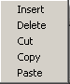
Use Insert to open the File Select window and choose a file from a directory.
Use Delete to remove the audio from the button, if you will not be moving that audio file to a different button or deck.
Use Cut to remove the audio from the button, when you will be moving the file into another button or deck.
Use Copy to make a copy of the file when you will be pasting that file into another button or deck.
Use Paste to insert an audio file (that was cut or copied from a button or deck) into a lettered button or deck.
Audio files can be dragged from one Preset button to another. Left-click and drag the file from one button to the other. This will remove the audio from the first button and drop it into the second button.
Audio files can also be dragged from the decks into the Preset buttons. Left click and drag from the deck on the left into the desired Preset button. This will copy the file and will not remove it from the deck. If a file is dropped into a Preset button that contains audio, it will be replaced with the file that was dragged over.
Audio files can not be added to or removed from a Preset button while the source or destination deck/button is active.

Creating a New Preset Page
Click the Goto/Add button.
Enter a 3-digit number to open the page with that number and then click OK.
Insert an audio file into one of the lettered buttons.
The Preset page will be saved without user intervention.

Switching between Preset Pages
To switch to one of the Groups, click on one of the yellow buttons. These will take the user to Preset page numbered 000, 100, 200, 300, 400, 500, 600, 700, or 800.

To switch to a page with a specific number (other than listed above), click the Goto/Add button and enter the 3-digit number of the page you wish to switch to, and then click OK.
Once audio is added to a page, the Prev and Next buttons can be used to navigate to that page. The Prev and Next buttons will switch to the next set page of presets that has been created. Both buttons will skip to the next configured page. For example, if
only pages 000, 300, 301, 302, 400, 800, and 801 are setup. The Prev and Next will jump to these pages in that order, and will skip any non-configured pages in between.

Assigning Names to the Preset Groups
The yellow Preset group buttons are named with the number of the group that will be opened. The names of the buttons can be changed to reflect specific jock names or programs. The number of the preset that each button launches is not configurable.
To rename a button, use the either of the following methods:
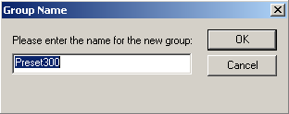
Ctrl+Shift+# Hold the Ctrl and Shift key down while striking the number of the button. The button number that you enter is not the same as what is displayed on the button (the first button from the left is #1; the one labeled as 300 is #4,he last one –700- is #8)
Ctrl+LeftMouseButton Hold the control key down while left-clicking on the button.

Logging into Live Assist2 for Preset buttons
Each user can have their own set of yellow Preset groups, along with unique paths for the Songs, Spots, and News buttons. The logins will need to be set up in advance by the administrator of the system.
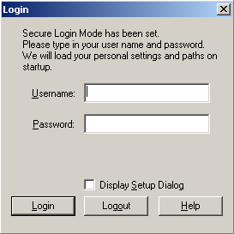
Using the Login button along the right side of the screen, a user can log in to access their 8 configured yellow main button categories.

Click on the Login button or strike Alt+I to open the Login window.
Enter a login and password in the Username and Password fields.
Click on the Login button or strike Alt+L to login.
The user’s Preset group buttons will be displayed.
The currently logged in user will be displayed above the Preset buttons.
To log out of a user, click the Login button and then click the Logout button on the window.

System Configuration and Other Options

Assigning Sound Cards to the Decks
The audio cards that will be used while playing audio from the decks are configured in the Automate screen. The 10 decks on the left are an emulated view of an automation deck.

Assigning Sound Cards to the Preset Buttons
The 10 decks on the left are an emulated view of an automation deck, and will be mapped to one card (if not overlapping) or two cards (if overlapping is enabled in the automation deck it is acting as a viewer for).
The Preset buttons can be configured to use up to 3 devices. Each of the 3 columns of Preset buttons can be assigned a different audio device.
Audio Device 1 is the device used for the first column (buttons A, D, G, J, M).
Audio Device 2 is the device used for the second column (buttons B, E, H, K, N).
Audio Device 3 is the device used for the third column (buttons C, F, I, L, O).

1) From the Automate menu bar, click Setup.
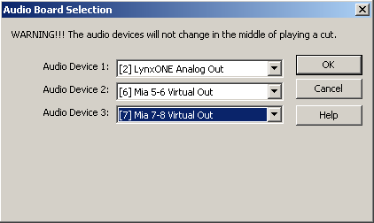
2) Click Preset Audio Boards. This will open the "Audio Board Selection" dialog box.
3) The Audio Board Selection window has entry boxes for up to 3 audio devices. Assign the audio devices using the drop-down list for each audio device.
If only one audio card is installed, all three devices should all be assigned to Audio Board 1. That device will be used for Primary Play, Overlapped Play (if using overlapping), and Recording using the drop-down lists.
4) When finished assigning devices, click OK.

Setting Colors for the Deck Display
On the 10 decks on the left side of the screen, the color of the commands and color the decks turn if they are paused or played/executed can be configured.
These colors can be configured from the *.ini file of the user that is logged into the software. See the Configuration Files section of this manual for a list of the commands and the default colors associated with them.
The user can configure any of the possible colors.
Some possible values are:
Black 255,255,255
White 0,0,0
Red 255,0,0
Green 0,255,0
Blue 0,0,255
Yellow 255,255,128
Violet 255,128,255
Orange 255,128,0
Grey 192,192,192

Configuration Files

The User’s ini File
The file [server]:\wire\users\[username]\[username].ini holds configuration information for the user. The below section holds the settings affecting the Live Assist2 screen. This is a list of all possible ini keys, what they represent, their possible values, and their default values. The settings may not appear in the same order in the user’s ini files. The easiest way to find the values is to use the Edit/Find menu choice and search for the value in the file.

[Live Assist2]
CountDownTimerBackGroundColor= | RRR,GGG,BBB | The color of the background for the count down timer. RRR = Red, GGG = Green, BBB = Blue. The values are integers from 0-255. Default is 255,255,255 (Black).
CountDownTimerTextColor= | RRR,GGG,BBB | The color of the text of the count down timer. RRR = Red, GGG = Green, BBB = Blue. The values are integers from 0-255. Default is 0,255,0 (Green)
Manual Folder= | W:\Audio | This ini setting is no longer used.
News Folder= | W:\News | Path of the folder to open when the News button is used in the LiveAssist2 screen.
PausedColor= | RRR,GGG,BBB | The color of the background for the decks where the loaded audio file has been paused. RRR = Red, GGG = Green, BBB = Blue. The values are integers from 0-255.
PlayedColor= | RRR,GGG,BBB | The color of the background for the decks where the loaded audio file has been played. RRR = Red, GGG = Green, BBB = Blue. The values are integers from 0-255.
PresetsAudioCard0= | 1 | The audio device that will be used as the first audio card for the Preset buttons. The value entered for Audio Device 1= from the Live Assist2 screen
PresetsAudioCard1= | 1 | The audio device that will be used as the second audio card for the Preset buttons. The value entered for Audio Device 2= from the Live Assist2 screen
PresetsAudioCard2= | 1 | The audio device that will be used as the third audio card for the Preset buttons. The value entered for Audio Device 3= from the Live Assist2 screen
PresetUpdateIntervalSeconds= | 10 | Number of seconds between rereading of the ini file to allow update Preset buttons for users logged into the Live Assist2 screen.
Shot Clock= | Break Timer | Break Timer=displays the amount of time left in the break.  Shot Clock=count down the Intro time of the next song.
Shot Clock Category= |  | The category of audio files that should display the Intro time when the Shot Clock is active. If left blank, any audio with non-zero intro times will display the counter in the Shot Clock.
Songs Folder= | W:\Songs | Path of the folder to open when the Songs button is used in the LiveAssist2 screen.
Spots Folder= | W:\Spots | Path of the folder to open when the Spots button is used in the LiveAssist2 screen.

[Live Assist2 Command Colors]
Colors assigned to the commands in the decks
RRR = Red, GGG = Green, BBB = Blue. The values are integers from 0-255.
Some possible values are:
Black 255,255,255
White 0,0,0
Red 255,0,0
Green 0,255,0
Blue 0,0,255
Yellow 255,255,128
Violet 255,128,255
Orange 255,128,0
Grey 192,192,192
BeHereAt= | RRR,GGG,BBB | Color of the Be Here At commands in the decks. Default is Brown.
ChangePath= | RRR,GGG,BBB | Color of the Change Path command in the decks. Default is Blue.
Check= | RRR,GGG,BBB | Color of the Check command in the decks. Default is Brown.
ComTalk= | RRR,GGG,BBB | Color of the ComTalk command in the decks. Default is Yellow.
ControlDeck= | RRR,GGG,BBB | Color of the Control Deck command in the decks. Default is Brown.
Custom= | RRR,GGG,BBB | Color of the Custom command in the decks. Default is Yellow.
DelayFor= | RRR,GGG,BBB | Color of the Delay For command in the decks. Default is Yellow.
Email= | RRR,GGG,BBB | Color of the Email command in the decks. Default is Purple.
Export= | RRR,GGG,BBB
GoSub= | RRR,GGG,BBB | Color of the GoSub command in the decks. Default is Brown.
GoTo= | RRR,GGG,BBB | Color of the Goto command in the decks. Default is Brown.
HotLoad= | RRR,GGG,BBB | Color of the Hot Load command in the decks. Default is Grey.
If= | RRR,GGG,BBB | Color of the If command in the decks. Default is Red.
IfDay= | RRR,GGG,BBB | Color of the If Day command in the decks. Default is Red.
IfMonth= | RRR,GGG,BBB | Color of the If Month command in the decks. Default is Red.
IfYear= | RRR,GGG,BBB | Color of the If Year command in the decks. Default is Red.
Import= | RRR,GGG,BBB
Label= | RRR,GGG,BBB | Color of the Label command in the decks. Default is Blue.
LatchChannel= | RRR,GGG,BBB | Color of the Latch Channel command in the decks. Default is Yellow.
Load= | RRR,GGG,BBB | Color of the Load and Start command in the decks. Default is Brown.
Log= | RRR,GGG,BBB | Color of the Log command in the decks. Default is Blue.
NetworkOff= | RRR,GGG,BBB | Color of the Network Off command in the decks. Default is Yellow.
NetworkOn= | RRR,GGG,BBB | Color of the Network On command in the decks. Default is Yellow.
PlayByName= | RRR,GGG,BBB | Color of the Play By Name/Code command in the decks. Default is Green.
PlayRotationByName= | RRR,GGG,BBB | Color of the Play Rotation command in the decks. Default is Green.
PlayRotationWave= | RRR,GGG,BBB | Color of the Play Wave Rotation command in the decks. Default is Green.
PlayWave= | RRR,GGG,BBB | Color of the Play Wave command in the decks. Default is Green.
PulseChannel= | RRR,GGG,BBB | Color of the Pulse Channel command in the decks. Default is Yellow.
PulseWait= | RRR,GGG,BBB | Color of the Pulse and Wait Channel command in the decks. Default is Yellow.
RecordByName= | RRR,GGG,BBB | Color of the Record By Name/Code command in the decks. Default is Purple.
RecordWave= | RRR,GGG,BBB | Color of the AutoRecord command in the decks. Default is Purple.
Return= | RRR,GGG,BBB | Color of the ReturnSub command in the decks. Default is Brown.
RotReset= | RRR,GGG,BBB
Run= | RRR,GGG,BBB | Color of the Run command in the decks. Default is Brown.
Scheduled Break= | RRR,GGG,BBB | Color of the Scheduled Break command in the decks. Default is Blue.
Scheduled Music= | RRR,GGG,BBB | Color of the Scheduled Music Sweep command in the decks. Default is Blue.
ScheduledWeb= | RRR,GGG,BBB | Color of the Scheduled Web Break command in the decks. Default is Blue.
SetClock= | RRR,GGG,BBB | Color of the Set Clock command in the decks. Default is Yellow.
SetEndTime= | RRR,GGG,BBB | Color of the Set EndTime command in the decks. Default is Blue.
Skip= | RRR,GGG,BBB | Color of the Skip command in the decks. Default is Grey.
Splice= | RRR,GGG,BBB | Color of the Splice command in the decks. Default is Purple.
Stop= | RRR,GGG,BBB | Color of the Stop/Shut Down command in the decks. Default is Red.
Sync= | RRR,GGG,BBB | Color of the Sync command in the decks. Default is Yellow.
WaitForChannel= | RRR,GGG,BBB | Color of the Wait For Channel command in the decks. Default is Red.
WaitForClosure= | RRR,GGG,BBB | Color of the Wait For Closure command in the decks. Default is Red.
WaitForKey= | RRR,GGG,BBB | Color of the Wait for hot key (Alt-F3) command in the decks. Default is Red.
WaitUntil= | RRR,GGG,BBB | Color of the Wait Until command in the decks. Default is Red.
Web= | RRR,GGG,BBB | Color of the Web Publish command in the decks. Default is Purple.

[Live Assist2 Category Colors]
Comedy= | RRR,GGG,BBB | Color of the Comedy category in the decks. Default is Yellow.
Commercial= | RRR,GGG,BBB | Color of the Commercial category in the decks. Default is Yellow.
Jingle= | RRR,GGG,BBB | Color of the Jingle category in the decks. Default is Yellow.
Weather= | RRR,GGG,BBB | Color of the Weather category in the decks. Default is Yellow.

The Preset ini File
The settings for the Preset buttons are stored in an ini file under the [server drive]:\wire\liveassist\[username]\ folder.

Each Preset page that is created will have a list of the buttons and the audio files currently loaded into the button. The button numbers correspond to the lettered preset button (Button0 is A, Button1 is B, etc.)
[10Deck Preset0]
PresetName=Presets1
Button0=w:\legal\ID1.wav
Button1=w:\legal\ID2.wav
Button2=w:\legal\ID3.wav
Button3=w:\legal\ID4.wav
Button4=w:\legal\ID6.wav
Button5=w:\radio\0704-15.wav
Button6=w:\radio\1882-01.wav
Button7=w:\radio\1882-02.wav
Button8=w:\radio\1882-03.wav
Button9=w:\radio\1882-04.wav
Button10=w:\radio\1882-05.wav
Button11=w:\radio\1882-06.wav
Button12=w:\radio\1882-07.wav
Button13=w:\radio\1882-08.wav
Button14=w:\radio\1882-09.wav

