

MPEGReady Setup

Open the MPEGReady Setup Program from the CD. This setup program can be run to do the initial install of the program or to modify some of the settings after installation. This setup program only allows one In/Out path to be configured. Additional paths will need to be configured manually.
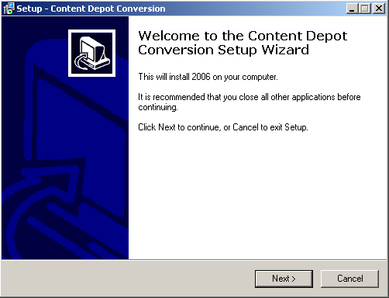
Run the cd-setup.exe.

Click Next and the following window opens:
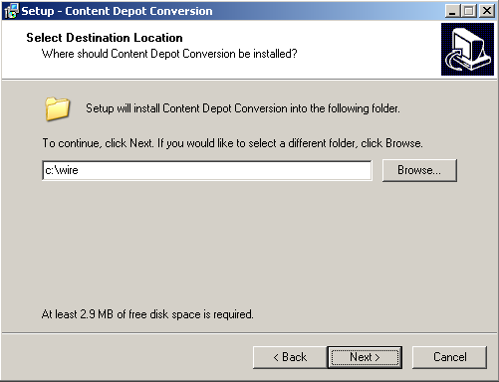

Enter the drive and path to install the files to. This will be the location that DBCapture runs from. Click Next.

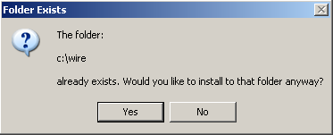
If the folder already exists, the following window will open. Click Yes to install to that folder. If you are already running a version of DBCapture from this folder for moving files or web publishing, click No to choose a different folder to install MPEGReady to.

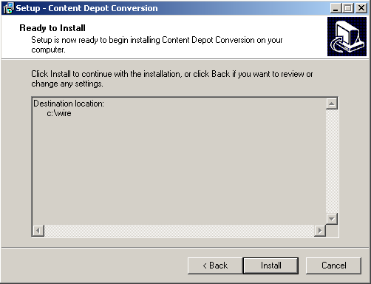
This window is to confirm the installation location of the files. Click Install to continue the install, or click Back to make changes to the location of the files.

Click Next, and the Installing window will show the progress of the file extraction.

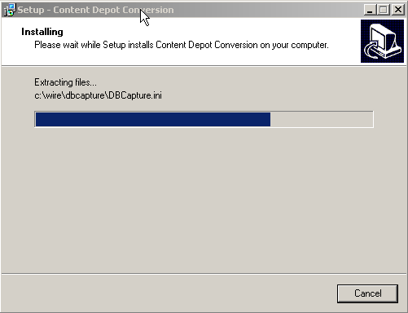

If the DBCapture.ini file already exists in the folder, it will give the following message.
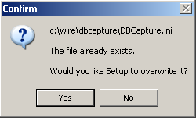
If you have been running DBCapture from this folder, choose No to not overwrite the file, and edit the DBCapture.ini file manually later. If you choose Yes, it will overwrite the existing file with the one included with the setup program.

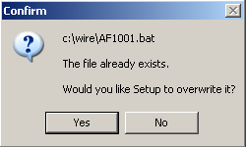
If you are updating to the new LAME files, and the audio conversion batch file exists, you will receive the following message. If you have manually edited the batch file previously, choose No to keep your existing batch file.

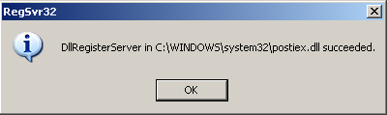
Once the files are extracted, a confirmation window will open to show that the Postiex.dll file was registered successfully. This file is needed if you will be using WRCheck to email failure alerts.

Click OK. The following window will open to let you know how to set up the source and target folders.
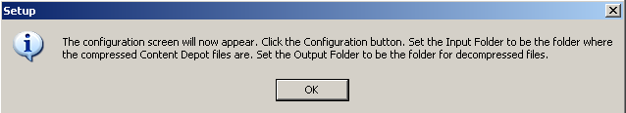

Click OK to open the Welcome to MPEGReady Setup window.

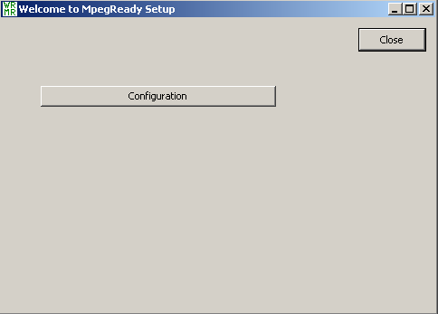
Click the Configuration button to set up the folders.

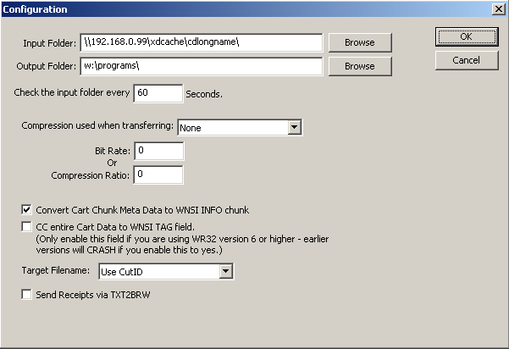
In the Configuration window, edit the Input Folder line to have the correct path for where MpegReady will search for files to process.
Edit the Output Folder line to reflect the location of the files after conversion.
The default delay between checks of the folder is set to 60 seconds. If the time between checks of the folder needs to be different, change the Check the input folder every … seconds value.
Change the value in the Compression used when transferring field to Decompressed (if converting from MP3 to WAV), MP2 (if converting from WAV to MP2) or MP3 (if converting from WAV to MP3).
Edit the Bit Rate or Compression Ratio field to specify the resulting bit rate or compression of the converted files.
The other lines can be left at the default settings.

Click OK when finished editing the Configuration window.
The Setup window lets you know to install Windows Media Player. Version 9 is used if running on a Windows 2000 machine, or Version 10 when running on a Windows XP machine.
Also shortcuts to the program are installed to the desktop and the Startup Group. Click OK.

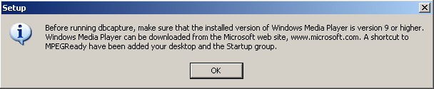

Click the Finish button to exit the Setup program.
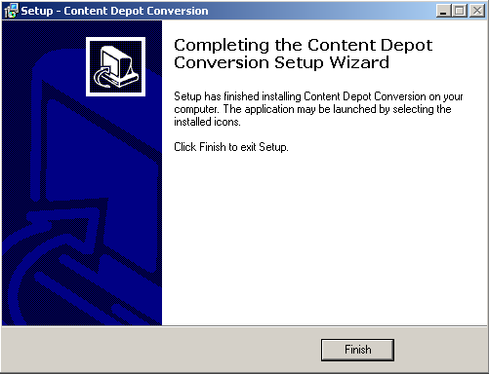

A shortcut to MPEGReady is created on the desktop. MPEGReady should run 24/7 to pick up files as they arrive in the input folder. It can run minimized if this machine is being used for something else. A shortcut to MPEGReady is also added to the startup group to have the program run upon a reboot of the computer.

If you will be processing files from multiple folders, contact WireReady NSI tech support for instructions on manually editing the Dbcapture.ini file.

