
Monitoring your software and
Resetting automatically when it fails

Use of the Kick-off device with WireReady products

Use of WRCheck to monitor software failures

TABLE OF CONTENTS
Kick-off 3
Connecting the Kick-off 3
Installing the Kick-off software 3
Configuring the Kick-off 4
Enabling Kick-off for DBCapture 4
Enabling Kick-off for WireReady32 5
Checking the logs 6
WRCheck 7
Installing and Configuring WRCheck 7
How it works 8
Enabling Heartbeat file generation for DBCapture 9
Enabling Heartbeat file generation for WinCap 9
Enabling Heartbeat file generation for PCapture 9

The need for fail-safe measure and backup routines
We understand that computers are the life of broadcast facilities. We also understand how frustrating it is when those computers fail to do their jobs. That’s why we believe in using software and devices to monitor your computers for problems and notify you and/or automatically restart when necessary to keep things running smoothly.

WireReady recommends backing up files either through redundant hot-swap drives or by saving files to a backup computer daily. Sometimes it’s not enough to simply back up files, you need software to run correctly in order to stay on the air and sound good on the air.

This is where is pays to have a few more backup plans in place. The Kick-off device protects you in case of Windows Operating System problems (the system freezes up or stops responding) and now our WireReady software can be restarted by the Kick-off as well.

In addition, we have created a small software program called WRCheck that monitors your software and notifies if that software stops responding. It can be configured to restart the software as well.

This document is a work in progress. As our software becomes more and more compatible with the Kick-off device, we will update our recommendations.
Kick-off

The Kick-off device by Sophisticated Circuits can be used to monitor a computer and automatically restart it when either the Windows OS or a WireReady program stops responding.

If an application quits responding, the Kick-off will shut down any other running programs and do a normal restart of the computer. If the Windows OS locks up, the Kick-off will remove power and restart the computer. The current WireReady applications that support the Kick-off monitoring are WireReady32 and DBCapture. Only one WireReady application per computer can be configured for Kick-off monitoring at this time.

To Install the Kick-off device:

Connecting the Kick-off
a. Shut down the computer.
b. Remove the power cord from the back of the computer.
c. Plug the power cord from the wall into the Kick-off device.
d. Connect the Kick-off's USB cable to a USB port on the back of the computer.
e. Connect the power cord of the Kick-off to the power jack on the back of the computer.

Setting up the BIOS for Power Management (different computers use different BIOS settings, so the following may not be accurate for all computers. Use the settings and menu choices that are the most similar to the ones described below)
a. Turn the computer on.
b. 5 to 30 seconds after the computer starts booting, the bottom of the screen will says something like "Press Del to enter Setup" (your machine may say to press F8). At this point, press the Delete key on the keyboard.
c. This brings up the CMOS Setup Utility menu.
d. Go into the Power Management Setup choice on the menu.
e. Arrow down to the PWR Lost Resume State, press the Enter key, and arrow to choose Turn On. Press the Enter key.
f. Press the F10 key to save.
g. The computer will now boot. To get some information to be used in configuring the Kick-off, keep track of the amount of time it takes from when you press F10 until all the icons appear on the windows desktop.

Installing the Kick-off software
a. When Windows boots, it will probably detect the Kick-off, and ask for the drivers. Click the Cancel button if this occurs.
b. After the computer has booted to the desktop, put the Kick-off CD in.
c. Go into My Computer, to the CD drive.
d. Double-click the “Kick-off! 1.0.1 Setup.exe” file.
e. Go through the installation.
f. At the end of the installation, you will need to restart the computer.
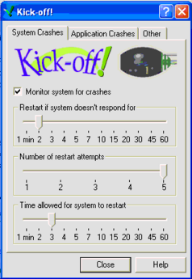

Configuring the Kick-off
a. To get into the Kick-off configuration utility, click Start, then Settings, and then Control Panel. There will be a choice of Kick-off! in the control panel. Double-click Kick-off.
b. Most of the default settings are what will be used.
c. Change the Number of restart attempts to 5.
d. Change the Time allowed for the system to restart: Add two minutes to the amount of time it took the computer to boot (after you press F10 to save in BIOS.)
e. Click Close to save these changes.

Enabling Kick-off for DBCapture
DBCapture version 5.506 or higher will communicate with the Kick-off device.
- To enable the Kick-off monitoring, the user must edit the \wire\dbcapture\dbcapture.ini file found on the drive that DBCapture.exe is running from.
- Open the file using Notepad or WordPad.
- If a version of DBCapture that supports the Kick-off has been run, the ini lines will exist. If the following lines do not exist, they must be added.
The following lines control the Kick-off settings for DBCapture:
[KickOff]
Delay-In-Seconds=0 is this amount of time after DBCapture resets the timer until it is reset again. 0 (default)=The Kick-off device will not be used.
Timeout-In-Seconds=30 is the time from when DBCapture resets the timer, until the KickOff will reboot the PC if DBCapture does not reset the timer again.
Fatal-Error-Timeout-In-Minutes=30 is the amount of time allowed to pass
without DBCapture getting an error free pass before a reboot is done (by no longer resetting the timer).
d. Suggested values, which will work for most customers are:
Delay-In-Seconds=5
Timeout-In-Seconds=30
Fatal-Error-Timeout-In-Minutes=30
If you change the above values, ALWAYS make the Delay-In-Seconds be several times shorter than Timeout-In-Seconds.
If you only want the Kick-off to reboot the computer when DBCapture stops responding, but NOT when DBCapture cannot connect to the ftp server, then set the Fatal-Error-Timeout-In-Minutes to a high value, such as 5000 (which is over 3 days).
- Close and save the changes to the dbcapture.ini file.
- Restart DBCapture.

Enabling Kick-off for WireReady32
WireReady32 version 5.013 or higher will communicate with the Kick-off device.
- Close WireReady32 on the machine that will be using the Kick-off device.
- To enable the Kick-off monitoring, the \wire\users\[username]\[username].ini file (found on the drive that WireReady32 is running from) must be edited. The username that is logging into WireReady32 on that machine can be found at the bottom of the program’s window, to the right of the serial number and version number.
- Open the ini file using Notepad or WordPad.
- If a version of WireReady32 that supports the Kick-off has been run, the ini lines will exist. The easiest way to find the lines is to use Edit (from the main menu), then Find, and search for “kickoff”. If the following lines do not exist, they must be added.
The following lines control the Kick-off settings for WireReady32:
[KickOff]
Delay-In-Seconds=0 is this amount of time after WireReady32 resets the timer until it is reset again. 0 (default)=The Kick-off device will not be used.
Timeout-In-Seconds=30 is the time from when WireReady32 resets the timer, until the KickOff will reboot the PC if WireReady32 does not reset the timer again.
If you change the above values, ALWAYS make the Delay-In-Seconds be several times shorter than Timeout-In-Seconds.
- Close and save the changes to the user’s ini file.
- Restart WireReady32.

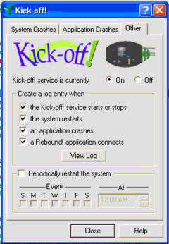
Checking the logs
a. To get into the Kick-off configuration utility, click Start, then Settings, and then Control Panel. There will be a choice of Kick-off! in the control panel. Double-click Kick-off.
b. Click the Other tab.
c. Click the View Log button.
- A new window, Event Viewer, will come up.
- Choose Application from the window on the left. Find events that list, under the Source column, “kickoffd”, and double-click it.
e. This will show in the description what occurred. A normal windows restart will result in "The service was started." A windows restart caused by Kick-off will result in "The system was restarted by Kick-off; the service is running."
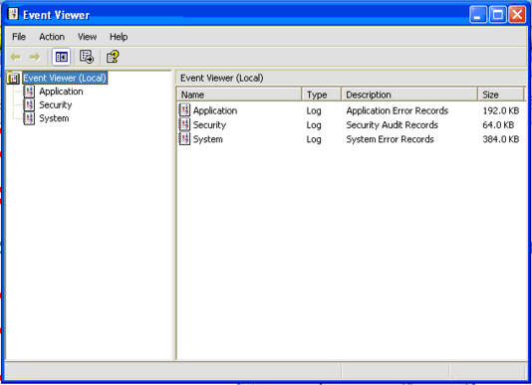

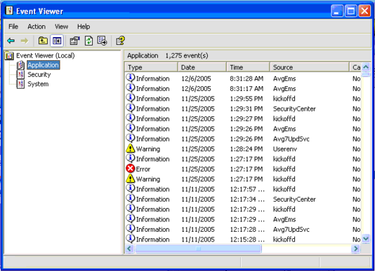

WRCheck

WRCheck will send an email to configured email addresses if a heartbeat file is more than a certain age old. Once WRCheck is trained on the heartbeat file, it can email you a warning if the program fails, and it can be configured to start a program.

Current WireReady NSI programs that generate a heartbeat file are DBCapture, PCapture, and WinCap.

Installing and Configuring WRCheck
Files needed:
WRCheck.exe

WRCheck can be run from any folder, either locally or on a network. When WRCheck runs, it will create wrcheck.ini, (the file that holds the configuration settings) if the file does not exist in the folder the program is run from.

WRCheck can be run as multiple instances, if more than one program’s heartbeat file is to be checked. Each instance of WRCheck can only monitor one heartbeat file.

Following are the wrcheck.ini settings for the WRCheck program:
[General]
Check-Path-FileName= the path and name of the heartbeat file to be checked.
Check-interval= number of seconds between checks. Default = 60 seconds
Age-Allowed= how old the file may be (in seconds) before an email is issued. Default is 180 seconds
Message-file= the text file that contains the body of the email message to be sent in the case of a failure.
To= email addresses, separated by a semi-colon that will receive the alert. It sends to single or multiple email addresses.
From= email address that is sending the file.
Subject= Subject of the alert email
Window-Title= Alternate window title (optional). Default is “WRCheck - Heartbeat Utility [Version]”
Execute-On-Failure= Program to launch if the heartbeat check fails. Must include the path and extension. Default is “_NONE_” (will not try to execute an external program).

How it works
When the program first starts, it will check the file set in the Check-Path-FileName line. The date and time that the file is first checked will be displayed in the Checking Since box. (The Window-Title line in the ini file has been changed for the screen-shot examples below).
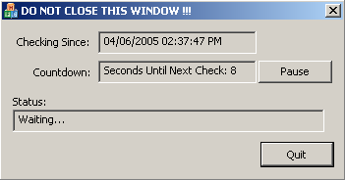
The Countdown box shows a counter with the number of seconds until the next Check.

The Status box shows "Waiting.." until the file is checked.

While running, the program may be paused via the Pause button.

When the program checks the file and finds it has not been updated in the interval set in the Check-interval= line, it will send an email to the configured address(es).

The email will be sent out using Outlook, or the program set as the default E-mail program in the Internet Properties. WRCheck will work with any MAPI-complaint email program.

If a valid path and executable program are set in the Execute-On-Failure= line, that program will be launched at the time of the failure.

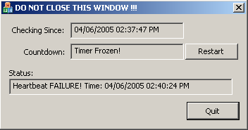
After it sends a file, the Countdown window shows "Timer Frozen!" and the Checking Since box does not update.

The Status box shows "Heartbeat FAILURE!" with the date and time that the failure was found by WRCheck.

The Pause button changes to Restart. The program stays in this paused/frozen state until it is restarted. The program may be restarted by pressing the Restart button, and it then updates the Checking Since box with the current date and time and begins checking the heartbeat file again.

Note that pressing the Pause/Restart buttons will reset the ‘checking since’ information displayed on-screen.

To close the program, click the Quit button or the X in the upper right corner.

Enabling Heartbeat file generation for DBCapture
DBCapture version 5.000 or higher will generate a heartbeat file. To enable the heartbeat file to be generated and updated, the user must edit the \wire\dbcapture\dbcapture.ini file found on the drive that DBCapture.exe is running from. The path and filename of the file that DBCapture will update is configurable.
The following lines control the heartbeat file for DBCapture:
[HeartBeat]
Enable=No Turns the feature that updates the heartbeat file on or off.
Filename=C:\Temp\DBCaptureHeartBeat.txt The path and file name of the heartbeat file that DBCapture will update.
MaxFileSizeInBytes=5000 The maximum number of bytes of data that will be written to the heartbeat file

Enabling Heartbeat file generation for WinCap
WinCap version 5.001 or higher will generate a heartbeat file. To enable the heartbeat file to be generated and updated, the user must edit the \wire\wcapture\wcapture.ini file found on the drive that WinCap.exe is running from. The path and filename of the file that WinCap will update is configurable.
The following lines control the heartbeat file for WinCap:

[HeartBeat]
Enable=No Turns the feature that updates the heartbeat file on or off.
Filename=C:\Temp\WinCapHeartBeat.txt The path and file name of the heartbeat file that WinCap will update.
MaxFileSizeInBytes=5000 The maximum number of bytes of data that will be written to the heartbeat file

Enabling Heartbeat file generation for PCapture
PCapture version 3.009 or higher will generate a heartbeat file. To enable the heartbeat file to be generated and updated, the user must edit the \wire\sts\sts.ini file found on the drive that PCapture.exe is running from. The name of the heartbeat file is not configurable with PCapture. It will always create the file “heartbeat.txt” in the \wire\sts\ folder.
The following lines control the heartbeat file for PCapture:
[sts]
HeartBeatTimer= Number of seconds between writing to the heartbeat file. 99999 Is the default value which will cause Pcapture to never write a heartbeat file.

