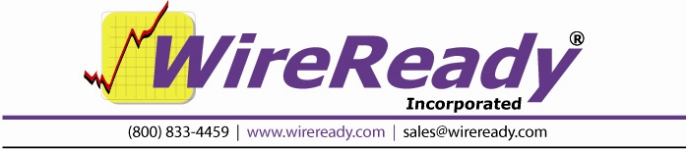
RUNDOWN MODE (WireReady32)

For news departments, which feature full-length news blocks, WireReady32 has a feature called Rundown Mode. This feature is an excellent tool for “building” complete newscasts, which typically run longer than 5 minutes. The following tutorial will show how a news department can use the Rundown Mode to create, modify and air a long-form newscast. Maintenance of the newscasts folders and stories is also included.

FEATURES OVERVIEW:

- Editors can “stack” a full hour of news and put it in the exact order it should be read on the air.

- News Directors, Editors, Producers, or Reporters can put program elements directly into the newscast, which will then be put in the proper order and read by the anchors.

- Rundown mode allows the newscast to stay in the order it is placed. For example, if an editor, producer, or anchor needs to build a 6 minute newscast starting at 3 minutes past the hour, 6 minutes worth of news stories can be placed in order (or moved into order) between the 03 Open and the 09 Close files.

- Anchors can access headline sets to write, or rewrite news stories while continuing to read other stories on the air.

- Rundown mode allows for great flexibility when adding and/or removing stories.

- Story order can be changed quickly to accommodate “breaking news,” newer stories that need to be placed higher in the rotation, or “follow” stories.

- Stories can be quickly moved up or down in the rotation by using the + (increase) or – (decrease) keys on the keyboard.

GETTING STARTED/INITIAL SETUP OF WIREREADY32

This section is for the Wireready Administrator, and includes the configuration of the WireReady32 system. This section will only be needed when setting up the news system, or to add new elements to the newscast. Users of the system (reporters, editors, anchors) can skip to the "Creating the Newscast/Putting it all Together" section.

Creating Text Folders to Store and Organize Stories

The easiest way to keep track of when stories are coming in is to give each day of the week its own FileLog folder.

To create daily text folders, use Setup32 (see Manual for the Setup32 Utility, section 1). In the Folder Name box, type the name of the day of the week. The Path will be the name of the drive, (the letter) followed by an abbreviated day of the week.

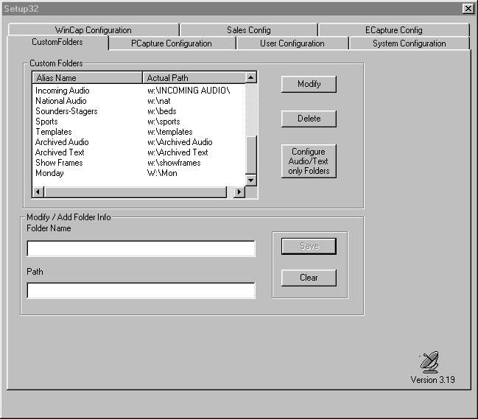

In the custom folder box above, you will see the Alias Name is Monday, and the Actual Path is W:\Mon. Repeat these same steps for the remaining days of the week.

Note: To limit the viewing of folders to the FileLog, see the Manual for the Setup32 Utility, page 2.

Creating Audio Folders to Store and Organize Actualities

Creating daily folders for the audio files will keep the system organized, easing the search for audio that corresponds to the text stories.

To create daily audio folders, use Setup32 (see Manual for the Setup32 Utility, section 1). In the Folder Name box, type the name of the day of the week, followed by "Audio". The Path will be the name of the drive, (the letter) followed by an abbreviated day of the week, with the letter A (for audio) in front of your path name. This will help you determine that you’re looking at an audio file.

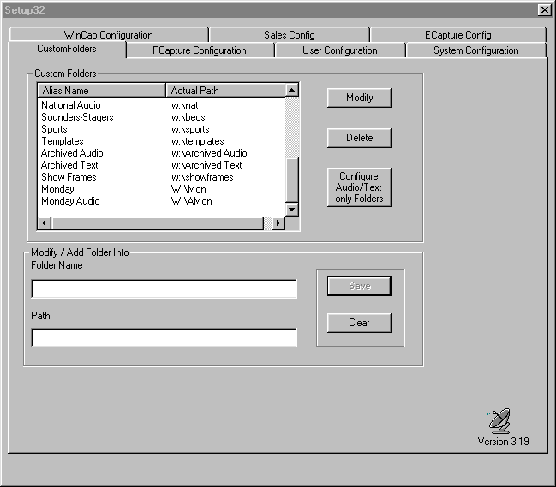

In the custom folder box above, you will see the Alias Name is Monday Audio, and the Actual Path is W:\AMon. Repeat these steps for the remaining days of the week.

Note: To limit the viewing of folders to the MediaLog, see the Manual for the Setup32 Utility, page 2.

Customizing WireReady32 by Setting up Additional Folders

You’ll find your newscasts are much easier to organize and a lot of time can be saved if you create special folders for items you use on a daily basis. Each day you can then copy them into the daily folder, instead of recreating them over-and-over again.

For instance, if you normally would copy a number of feature stories into the daily FileLog folder, you can create these individual stories in a special folder called Features.

In WireReady32, create blank text files with the name of the individual features as the slug name. Save these files into the Features folder. Each day, copy the blank files from the Features folder into the daily folder. Then open each feature file, and add the text for the day. Strike ESC to close the story. Strike "Y" when prompted to save.

Examples of other special folders are: Assignments, Phone Numbers, Sports Teases, Weather Teases, etc. The same process can be use for WAV files in the MediaLog that are used daily.

Also, elements that are used daily can be forced to stay at the top of the list of files in the folder by adding the # symbol. The more # symbols you add, the higher it stays on the list. In other words, if you place ##weather and #sports in the list, ##weather will show up on top when you click on the slug or filename column heading in the FileLog.

Note: To limit the viewing of folders to the FileLog or MediaLog, see the Manual for the Setup32 Utility, page 2.

Creating News Clock Formats for use in Newscasts

All newscasts you air will be different, but they each must follow the format of the station. These daily formats should be created just once, and placed in a folder. For this example, we’ll use “Show Frames.”

First, you need to create a FileLog folder named “Show Frames", and then create a file for each different line of the format clock.

A news clock may looks like this:

00-01 Top Story Tease
01-02 Traffic & Weather
02-09 News
09 News Close
11 Traffic
12 Weather-News
1430 Headlines
15 Sports
19 News
21 Traffic & Weather
22 Feature

To create a file in the Show Frames FileLog folder for each time frame:
- Create the folder by using Setup32.
- In WireReady32, get a new Notepad.
- Save this blank file as "00-01 Top Story Tease" into the Show Frames folder.
- Repeat the above steps for each time frame on the clock.

Once the actual frames are complete, then you can fill them in with the format, or what the anchor should be saying at that particular time. Below is an example of what the 00-01 Top Story Tease may look like:
.

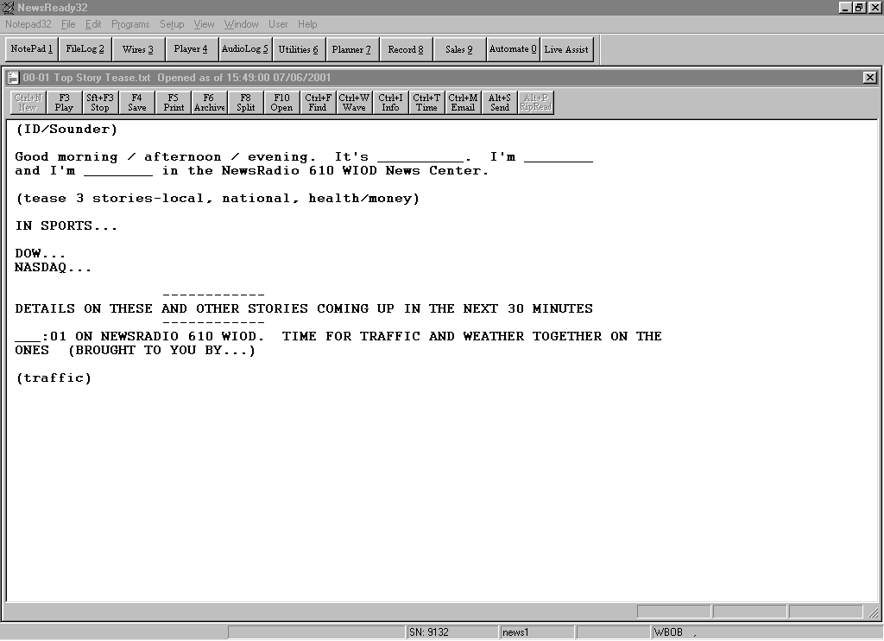

Once the format has been typed strike ESC to close the file. Strike "Y" when prompted to save. Repeat these steps to complete the format for each frame.

Putting News Clocks in Proper Order Using Rundown Mode

In order for the show frames to appear in the proper order, you must utilize the Rundown mode. In the FileLog, you’ll see a button that says ALT-U (Rundown). Make sure this button is highlighted and the + (Inc) and - (Dec) buttons are not grayed out.

Highlight a file, and move it up or down in the show using the + and/or – keys on your keyboard or by clicking on the + or - buttons on the screen.

For example, in the rundown mode, if the "09 News Close" shows up below the "19 News", you would highlight "09 News Close", then using the - key, you would move it up 5 spaces until it fell below the "02-09 News" segment. Conversely, if the "19 News" showed up above the "02-09 News", you would highlight the "19 News", then using the + key, you would move it down 5 spaces.

Continue to move the files around until they are in the desired order for the newscast.

Note: As long as the files are put in order in the rundown mode, they will appear in the proper order when the system is in the Rundown mode. If the order is all mixed up, check to see that the system is in the Rundown mode.

CREATING THE NEWSCAST/PUTTING IT ALL TOGETHER

The easiest way to build a newscast is to use the Dual Screen with the Split Screen Orientation set to Vertical. (See the Manual for the Setup32 Utility, page 5). WireReady supports “Classic Mode” which limits you to only one window (FileLog, Browser etc), where as “Dual Mode” lets you have two of any window open, which makes copying files from a daily folder to a newscast or show much easier and faster.

The editor, or the person building the newscast, would open either the WireBrowser or the daily FileLog on one side of the screen, and the FileLog folder with the show being loaded on the other side. Then you can cut and paste individual stories (from the FileLog), or create new stories from the WireBrowser (using the Notepad) and add them to the newscast. You can also have the MediaLog up on one side (for embedding audio) and the FileLog up on the other. The choice as to what you have open is based on your needs and preferences.

Using the vertical split screen is easier on the eyes, since we’re used to reading from left to right, not from top to bottom. It’s much easier to scroll or arrow or page down to the next point in the copy when using the vertical screen. You can also usually see more lines of a story when in vertical screen.

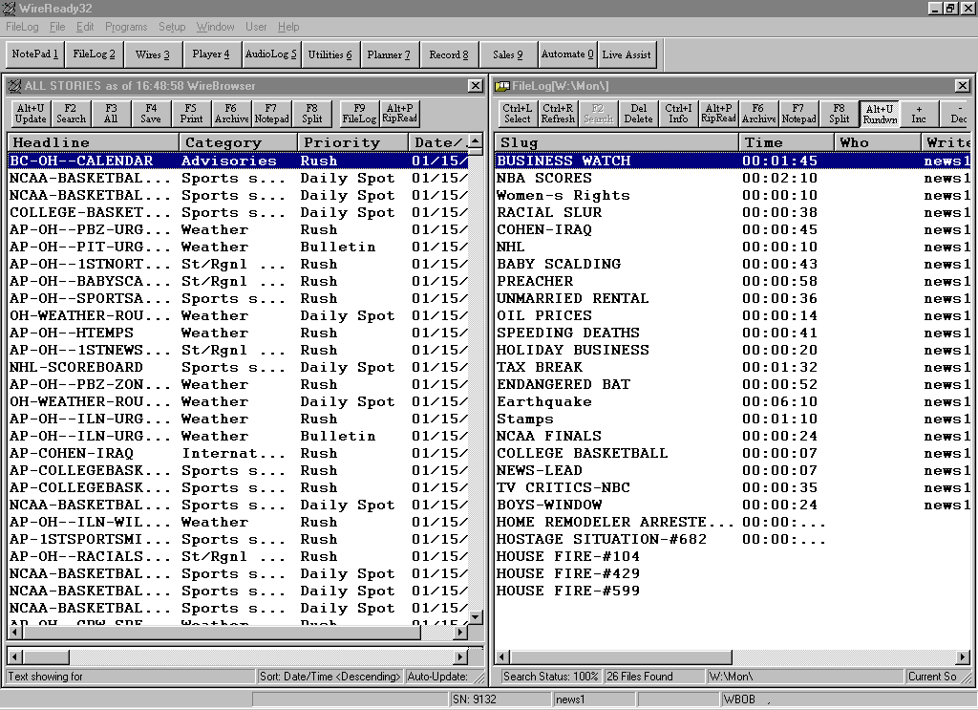

Building a Newscast

To build the 5AM Newscast, you would load the correct FileLog folder on one side of your screen. In this example, we’ve called it M-F0500. Delete the previous day's newscasts, if necessary. From the FileLog, choose the special custom folder you created the show frames in. If you named it Show Frames, you would choose CTRL-L, Show Frames, ENTER. Highlight all of the items. Copy them. Open the newscast you want to place the Show Frames in (M-F0500). Paste the items into the newscast. On the other side of the screen, load the Daily FileLog folder, i.e. Monday. The daily folders contain the stories to be read on that particular day.

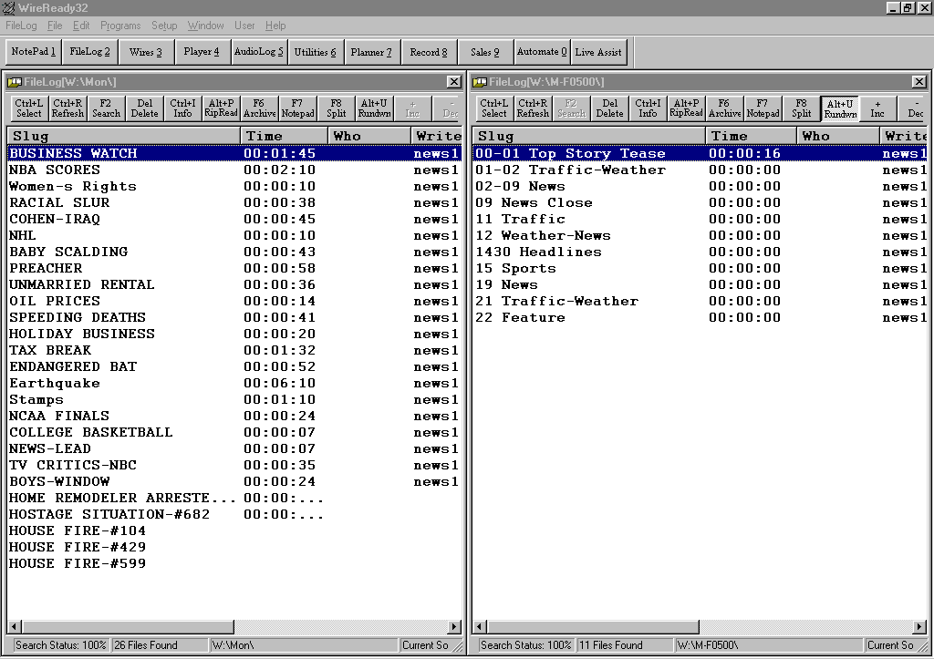

Note: Move back and forth between the two sides of the screen by either clicking with your mouse on the side you want active, or hit CTRL-F2 to toggle between windows.

Locate the stories from the Monday folder you want to add into the newscast, highlight them, choose copy, and then paste them into the M-F0500 newscast folder. Don’t worry yet about putting them in order. That can easily be done later.

If you want to copy an entire newscast or FileLog, highlight the first story, hold down the SHIFT key, and then hit END to go to the end of the list. All stories should now be highlighted.

If you want to copy a block of stories (but not all of the stories in the folder), highlight the first story, hold down the SHIFT key, and then click on the last story you want copied. All stories between the first and last story you clicked on will be highlighted.

If you want to copy selected stories, highlight the first story you want copied, hold down the CTRL key, then click the next story you want copied to highlight it. Repeat these steps until all the stories you want copied are chosen.

Repeat each step until the proper amount of stories needed is placed in the M-F0500 newscast folder.

Copying Items Used Daily Into the Newscast

Open the special custom folder that has the files used daily, i.e. Features, to be added to the M-F0500 newscast. Copy the files into the newscast folder. These files and the news clock files will form the backbone of the newscast.

Placing News Stories in the Order They Are to be Aired

Be sure your newscast folder is in the Rundown Mode. Make sure the ALT-U (Rundown) button is highlighted and the + (Inc) and - (Dec) buttons are not grayed out. All of the elements of the newscast should now appear in their proper order.

Highlight the story you want to move, and using the + and/or – keys, put it where you want it in the newscast. Repeat this step until all stories are where you want them placed. If you decide you don’t want a story, simply highlight it, then hit DELETE.

Moving Stories or Adjusting Story Location Within the Newscast

Stories can be moved around within the newscast at any time. Make sure the newscast is in the Rundown Mode, highlight the story you would like to move, then move it up or down in the newscast using the + or - key.

Inserting New Stories Into the Newscast

Often, new stories come in after the newscast has been built, but before being aired. Adding new stories to an already built newscast is very simple, following the same steps used to build the newscast. The story can then be moved into the proper location in the newscast.

Stories that will be included in the news rotation for the rest of the day will be placed in the daily folder prior to being added to the show. Reporters and producers will tell the editor the story a news story is in. The editor goes to daily folder and adds it to the newscast.

If a breaking story comes in and there is a rush to get it on the air, it would only be added to the newscast, since it would constantly be changing.

If the story does not appear in the folder it was saved or moved to, strike CTRL-R (Refresh) once you open the newscast and the story will appear at the top of your screen. Then use the + or – keys to move the story.

Note: The anchors MUST hit refresh in order for the news item to appear where the editor has placed it.

The story can be placed in the proper place within a newscast or moved once it is copied into the folder. To insert it in the proper place, highlight the story just BELOW where you want the story to be placed. When you paste the story it will appear ABOVE the story you had highlighted.

Deleting Old Stories

To delete a story from a newscast, FileLog, or MediaLog, simply highlight it, then hit DELETE. If you want to delete an entire newscast or FileLog, highlight the first story, hold down the SHIFT key, and then hit END to go to the end of the list. All stories should now be highlighted. Now hit DELETE.

If you want to delete selected stories, highlight the first story you want deleted, hold down the CTRL key, then click the next story you want deleted to highlight it. Repeat these steps until all the stories you want deleted are chosen, then hit DELETE. Strike "Y" when prompted to confirm the delete.

Loading Individual Newscasts for Air

Once the newscast is built, the FileLog folder for that newscast can be opened from any computer. The anchor can go into the broadcast booth and pull up the proper newscast on his computer easily by making sure he has the FileLog open (ALT-2), then selecting the newscast.

With the FileLog on the screen, the anchor would then hit CTRL-L. The list of custom file folders will show up. The anchor then needs to highlight the proper newscast folder by using the arrow keys or the mouse, then hit ENTER, or click on OK. The newscast will now be loaded in the FileLog.

Note: As long as the files were put in order into the newscast in the Rundown mode, they will appear in the proper order. If the order is all mixed up, check to see that the system is in the Rundown mode.

Copying a Newscast to Another Location

If the newscast is to be used more than once, you can copy it from one location to another. For instance, in this example, the M-F0500 newscast will also be the basis for the M-F0700 newscast. Instead of building the second newscast from scratch, simply copy the first newscast.

To do this, open the newscast you want to copy (FileLog, CTRL-L, M-F0500, ENTER). The entire newscast is displayed. Highlight the first story. Hold down the SHIFT key, and then hit END. All of the stories should now be highlighted. Copy the newscast (CTRL-C).

Now, open the M-F0700 show folder. CTRL-F2 (to get to the other side of the screen), then FileLog, CTRL-L, M-F0700, ENTER. If it’s blank, just paste the newscast from your clipboard (CTRL-V). If the M-F0700 is not blank, highlight all of the stories, delete them, then paste the new newscast in. The newscast will appear in the Rundown order, provided Rundown is highlighted in this FileLog. If it’s not, highlight it, and the newscast will be placed in the proper order.

Deleting Previous Day's Newscasts

Open the newscast you need (FileLog, CTRL-L, M-F0700, ENTER). All of the stories will appear. Highlight all of the stories. (Highlight the first story, hold down the SHIFT key, and hit the END key). Hit the DELETE key and answer Yes when prompted. All of the stories have now been removed.

Reloading Show Frames Into Daily Newscasts

Delete the previous day's newscasts. From the FileLog, choose the special custom folder you created the show frames in. If you named it Show Frames, you would choose CTRL-L, Show Frames, ENTER. Highlight all of the items. Copy them. Open the newscast you want to place the Show Frames in. Paste the items into the newscast.

Ready to Build Newscasts Again

The easiest way to start fresh each day is to go in and erase the previous day's newscasts before you start building today’s. If you have 10 newscasts, go through each one and delete them. Paste in your show frames. Then begin building your newscast by adding stories from the FileLog and the WireBrowser.

Copying Items Used Daily Into Daily Folders

Each day, you should copy the files from the special custom folders, i.e. Features, into the daily folders, i.e. Monday. Then just open each file, and add items. The files are then ready to be added into any newscast.

ANCHORING USING WIREREADY 32 RUNDOWN MODE

Pulling Up the Newscast

The anchor needs to make sure the FileLog is open and navigate to the proper newscast.

For example, if the anchor needs to load the M-F0500 show, he would make sure the FileLog is open, then hit CTRL-L. The list of custom file folders will show up. The anchor then needs to highlight M-F0500 by using the arrow keys or the mouse, then hit ENTER, or click on OK. The newscast will now be loaded in the FileLog.

Checking for Recent Changes Made by the Editor

Make sure your newscast is in the Rundown mode. Strike CTRL-R (or click on the Refresh button). Any additions or changes the editor has made will now appear in the newscast.
Note: No stories can be open when you do this. You must be able to see the entire rundown of stories.

Try to get into the habit of refreshing the screen regularly in case something has changed but the editor neglects to tell you. When you hit CTRL-R you will lose your place in the newscast. The cursor jumps to the last story you saved. Then you’ll have to arrow up or down to get back to the next item you need to read. (For example, if you’ve been writing your :15 headline set, but the next item you need to read is in the :02 section, the cursor will jump down to the :15 headline set after you refresh, so you’ll have to arrow back up to the proper place in the newscast.)

Writing and Reading Using the Split Screen Mode

Make sure the FileLog is in the Rundown mode (ALT-U). Put your cursor at the top of the newscast (using your mouse or arrow keys). Hit ENTER. (The first story in the newscast will open up). Read what’s in the file

To advance to the next story, hit ESC, arrow down, then hit ENTER again.

If, at any time, the anchor needs to see what’s ahead, or needs to go back in the newscast, he can hit ESC and see the show in it’s entirety.

Note: It is preferable to have a single key to advance from one story to the next, without having to hit ESCAPE, DOWN, ENTER, or hitting YES if you made a change and want it auto-saved. WireReady can provide a 3rd party program called MACRO SCHEDULER that lets you define key combinations to a single key on your regular keyboard. Price is $69 per computer, and WireReady shows you how to set it up.
For example, you could use F12 to advance to the next story, or F11 to go back up to the previous story. This would allow you to move to the previous or next story without closing the one you’re reading.

As long as you’re in the split screen mode, you can look at new stories crossing the wire, check the weather forecast, look for Dow and Nasdaq numbers, etc. Just open the wire on one side of your screen, and the newscast folder on the other.

You can easily jump from one side of the screen to the other by hitting CTRL-F2. You can also look ahead in your newscast, write headlines, save them, then move back up to the next story you’re about to read. You can do this by just having the FileLog open on both sides of the screen, or by simply using one FileLog to do both.
Moving Stories

Stories can easily be moved in a newscast. Make sure the FileLog is in the rundown mode. Looking at the full rundown of stories, highlight the one you want moved, then use the + or – key to move the story up or down.

Playing Sound From Within the Newscast

The audio will play from within the newscast if it is embedded into the text of the stories. Depending upon the setup of your news booth, the audio can be fired using the keyboard or mouse (F1, F2, F3), or from the board. If the audio will not play from within the story, check below.

It is absolutely imperative that your cursor be ABOVE the “sound block” you’re about to play or the sound will not fire. If you’re having problems playing sound, check to be sure that the cursor is above the piece of sound. If not, move the cursor, then try to play the sound again.

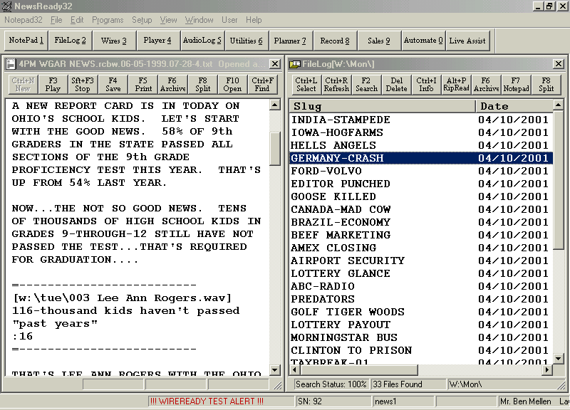
CURSOR HERE

If the sound still won’t play, check to see that you are in the proper window. With Dual Screen Mode, only one of the windows is active at a time. If the window with the story (and audio) is not in the active window (it’s not highlighted in blue), you may actually have your cursor on the other side of the screen. Were you recently looking at the wire? If so, hit CTRL-F2 to jump back over to the window with the story.

If the sound still won’t play, check to see where it was saved. Sometimes a piece of sound will be saved in an MediaLog folder that has somehow been erased. If the original MediaLog folder or the embedded audio file is gone, the sound will not play.

Another possible reason the sound won’t fire is that the slug is too long. If the name of the file wraps around the page to a second line, you’ll need to hit F8 to open the file to full screen mode and play the sound. Hit F8 again to return to the split screen mode. The name must be on one line (See below for an example).

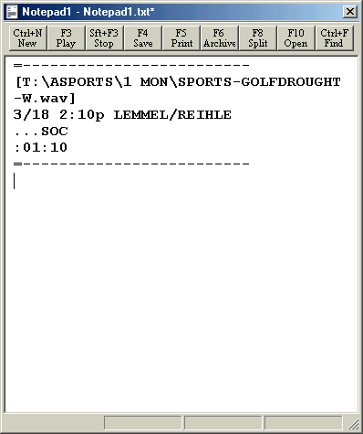
This audio will NOT play because the filename wraps to the next line.

A good rule of thumb is to keep slug names to a maximum of 15 characters, including the extension (.wav) WireReady32 will automatically add to the file name. Font size will also play a role in whether or not the name wraps around to the next line.
Advancing From One Story to the Next

When looking at the entire list of stories, arrow down to the next story to advance. Then you would hit ENTER to open. When already in a story (reading it), to advance to the next story, hit ESC, arrow down, then hit ENTER again, or (provided your WireReady32 is set up to use Macros) use the appropriate key to advance to the next story without closing the one you’re reading. For example, you could use F12 to advance to the next story. Contact WireReady NSI (800.833.4459) for information regarding supplemental macro software.

Going to Previous Stories

When looking at the entire list of stories, arrow up to go to the previous story. Then you would hit ENTER to open. When already in a story (reading it), to advance to the previous story, hit ESC, arrow up, then hit ENTER again, or (provided your Wireready is set up to use Macros) use the appropriate key to advance to the next story without closing the one you’re reading. For example, you could use F11 to go to the previous story. If, at any time, the anchor needs to see what’s ahead, or needs to go back in the newscast, he can hit ESC and see the show in it’s entirety.

NR32 RUNDOWN MODE SHORTCUTS

ALT-U Turns on/off the Rundown Mode in the FileLog.
CTRL-F2 Toggle between windows in Split-Screen mode.
CTRL-L Select. Will open the Custom Folder box in the FileLog and MediaLog to navigate between custom folders.
CTRL-R Refresh. Will refresh the screen in the FileLog and MediaLog to show all new stories added since the folder was last opened.
ALT-2 Opens the FileLog window.
ALT-3 Opens the Wire window.
ALT-5 Opens the MediaLog window.
F8 Turns on/off the split screen.
F11 Previous. Will go to the story immediately preceding the current story in the FileLog, if using macros.
F12 Next. Will go to the story immediately after the current story in the FileLog, if using macros.

