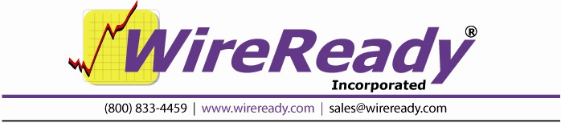

NewsReady32

Users Guide

WireReady NSI • PO Box 714 • Eudora, KS 66025
(800) 833-4459 • FAX (785) 542-3477
sales@wireready.com • support@wireready.com • www.wireready.com
© 2010 WireReady NSI
WireReady® is a Registered Trademark

Introduction 5
Modes of Operation: Standard vs. Classic vs. Dual Screen 7
Classic: The Recommended Mode For Fast-Paced Newsrooms 7
Getting Started 8
Navigating 8
Notepad 9
Notepad Toolbar 9
Notepad Drop-Down Menu 10
Editing in the Notepad 15
To Highlight/Select/Deselect Text: 15
Split Screen 17
Spell Check 17
Find and Replace 20
Saving Stories From the Notepad 20
Slug and Stamp a News Story 22
Printing From the Notepad 23
Printing in Double Space 23
Clearing the Notepad 23
Opening Saved Stories From the Notepad 24
Creating Templates 24
Embedding Audio Files into the Notepad 25
Playing an Embedded Audio File 26
Viewing the Estimated Newscast Time 27
Logging the Audio Files after a Newscast 27
Configuring the Notepad 28
Sending Text and Audio Files to Other Stations in Your Group 28
DBCapture 28
Publishing Files to a Web Site 29
FileLog 30
Filelog Toolbar 30
FileLog Drop-Down Menu 31
FILE LOG 35
Searching for Stories 36
F2 Search 36
Stored Searches 36
Creating New Stored Searches 37
FileLog - Rundown Mode 38
Copy files within the FileLog 38
Copying multiple stories 39
Deleting multiple stories 39
Moving stories from one folder to another 39
Moving text from one folder to another 39
Refreshing the FileLog 40
Locking/Unlocking a saved story 40
Archive vs. Save 40
WireBrowser 42
WireBrowser Toolbar 42
WireBrowser Drop-Down Menu 43
WIRE BROWSER 46
Sorting wire copy 47
Adjusting the column width 47
Changing the font, style, or point size 47
Viewing the toolbar and status bar 48
Searching wire copy 48
The F2 search 48
Category, Priority, Headline, and Text searches 49
Category Search 49
Priority search 49
Headline search 49
Text search 50
Creating new (Custom) searches 50
Setting Quick Searches 52
Printing wire copy 52
Printing in double space 52
Preview screen 52
Pop Viewer 53
Auto Purge 54
Copying and Pasting Wire Copy 54
Player 56
Player Buttons 57
Player Drop-Down Menu 58
AUDIO PLAYER 61
On Air Mode vs. Audition Mode 62
Setting up the Logging Capability 62
Loading the Newscast into Audio Player 63
Positioning the Divider Bar 63
Auto-Load vs. Manual Load 63
Enable/Disabling Auto-Load 64
Manually loading carts from the list 64
Loading Audio Files Directly 64
Reading your newscast on air (Single Audio Deck) 64
Resetting your Broadcast 65
MediaLog 66
MediaLog Toolbar 66
MediaLog Drop-Down Menu 67
MEDIA LOG 71
Selecting an Audio File 71
Editing the audio of an audio file 71
Setting the default audio editor 72
Editing the information attached to an audio file 72
Mass Update of audio files 73
Deleting an Audio File 74
Refreshing the audio file list 74
Sorting the MediaLog 74
Duping an audio file 74
Recording audio 75
Utilities 77
Planner 77
Planner Drop-Down Menu 79
Record 83
Sales 87
L-Assist/Live Assist 87
Automate 87
On-Air/10-Deck 87
PUTTING TOGETHER A NEWSCAST 88
Embedding audio files into the Notepad 88
Playing an embedded audio file 89
Viewing the estimated newscast time 89
Logging the audio files after a newscast 89
Creating a wrap 90
Instant Messages 90
HOW TO REACH WIREREADY 92

Introduction
Most news radio professionals are familiar with newsroom automation systems that were built around DOS or mainframe/terminal technology. Though primitive by today’s standards, these programs were popular for their inherent simplicity: one text-editing screen visible at a time, one wire service screen, one planning screen, and so on.

In their simplicity, they made use of function keys (or hotkeys) that would instantly take users to the screens in which they needed to come and go. News people could work at great speed and seemingly never look up from their keyboards.

Then came Windows, which revolutionized personal computing. Among other improvements, Windows brought greater flexibility with respect to navigating through a program and executing commands. Pull down menus made it possible to locate and choose any program option with a mouse, and almost never have to hit a key.

But, sometimes newer is not necessarily better. While pull down menus made commands and options easy to find and eliminated any need to memorize key combinations, especially for the beginner, the process was generally slower. Fortunately, Windows soon added keyboard equivalents to mouse commands. Hotkeys were added, as were the "F" (for function) keys, which make up the top row of today’s keyboards. These additions meant that users didn’t need to keep their eyes glued to the monitor.

With the superior graphical interfaces of Windows 95, 98, NT, 2000 and XP toolbar buttons gave users yet another option for navigating and executing commands. And, for saving time. Similarly, multitasking made it possible to work within several different windows at the same time.

For news radio professionals, this meant they could simultaneously work on their own stories, read wire service copy, and review someone else’s copy. They could move in and out of each with a simple click or keystroke.

NewsReady32 is a standard 32-bit Windows program that retains speedy keyboard-based navigation from DOS systems and takes advantage of modern user-friendly OS features. NewsReady32 lets you navigate, make selections, and execute commands:

- With your mouse.
- Through hotkey and function key shortcuts.
- By using the toolbar.

So if you prefer the mouse and Drag & Drop, great. If you prefer the speed and simplicity of the keyboard, NewsReady32 pays special attention to making sure you don’t have to use the mouse if you don’t want to. And, to aid memorization of all those shortcut keys, the pull down menus and toolbars on every screen will assist you.
NewsReady32 consists of twelve main screens:

- Notepad, a word processing window for editing, combining, and composing news stories and embedding audio cuts. One or more Notepads can be setup to hold your work in progress.

- FileLog, for organizing, searching, sorting, and editing stored newscasts and other news-related files. The FileLog also makes it possible to manage saved files in a variety of folders for specific days or shows, for phone books, and for other information systems. The FileLog can easily be set up for archiving news you never want to delete.

- WireBrowser, which displays and sorts your wire service stories into pre-defined searches, and also lets you perform “on the fly” searches on breaking news.

- Audio Player, which allows users to read a newscast on air and play audio cuts from an on-screen cart deck. Up to three cart decks are available, and can be loaded and played manually or automatically.

- MediaLog, which allows users to record, edit, audition, and stamp sound files into newscasts. The MediaLog also lets users organize audio in different folders.

- Utilities, which allows users to access the QuickRecorder, StormReady32 and the DOS StormReady and PhoneReady.

- Planner, a calendar-based organizer that lets the newsroom create up to six pages a day; such as an assignment page, a schedule page, and a future stories page. Users can then click on any day (past, present, or future) to add, review, or use information.

- Record, which allows users to create new media files, such as audio, video, and pictures, using the default media editor.

- Sales, to record and track contacts with current and potential advertisers.

- L-Assist, user-friendly Live Assist display of the automation program loaded into a deck. This is used during live broadcast times

- Automate, allows a user to program a list of commands to be executed automatically. An automation program can be set up to play a group of audio files consecutively or wait until a given time on the computer's clock before playing.

- On-Air, provides ten cart decks that a user can load and play at will. The carts can be played with the mouse or keyboard.

Modes of Operation: Standard vs. Classic vs. Dual Screen

Your administrator can set up NewsReady32 to run in one of several modes as follows:

Standard:
Windows programs allow users to open an unlimited number of windows, or screens, in which to work. Being able to run multiple notepads, or stories in progress, means that users don’t have to finish and save one story before starting on another. Similarly, with several WireBrowsers open at the same time, one could be auto updating on Sports while another updates on Urgents. While NewsReady32 supports this environment in its Standard mode, it also offers users the choice of Classic mode, which is more consistent with the systems to which most news radio professionals have grown accustomed over the last two decades. In Standard mode Windows can be squished and stretched, tiled or cascaded any way the user wants. This mode is ideal for advanced users who are very mouse-based in the way they use Windows.

Classic: The Recommended Mode For Fast-Paced Newsrooms
Classic mode enables NewsReady32 to operate with one screen open for each function (one Notepad, one Planner, one FileLog, one MediaLog, and one WireBrowser) for optimal speed and organization. Classic mode brings together Windows functionality and the timesaving and simplicity of traditional newsroom systems. There is no fear of getting lost or being overwhelmed by inadvertently opening too many redundant windows. More than one Notepad can be enabled in this mode for advanced users.

In Classic mode windows are automatically sized for full- and half-screen viewing. For example, hitting the F7 key will launch the Notepad, and it will appear full screen. Hitting F8 (while in Notepad) will create an equally divided screen that displays both the WireBrowser and Notepad. This "locked" feature prevents the accidental dragging of windows off the screen, as well as the incorrect sizing of windows. In Classic mode, windows can only be full or half screen. The system can be configured for either horizontal or vertical splits depending on your preference.
Whenever you hit a navigation key, i.e. ALT-3 for Wires, or click with the mouse, it automatically brings up that window in either full or split view depending on how you last used the window. You cannot accidentally open up more than one window and lose your place in the system.

With Classic mode, WireReady NSI has effectively given this 32-bit Windows program the same look and feel of our original and very popular DOS version, which remains an integral part of hundreds of radio newsrooms.

NOTE: Classic Mode supports two administrator-configurable settings. One that selects either horizontal or vertical split screens. The other which designates the number of Notepads (up to ten).

Dual Screen mode:
Dual Screen Mode has the same characteristics of Classic Mode, except that it displays two of every screen. One appears on the left (or top) window, and a second appears on the right (or bottom) window. You choose which screen to have open in each window (Notepad, FileLog, Wire, MediaLog, etc.). The CTRL-F2 key lets you bounce from one window to the other.

Getting Started

Double click the NewsReady32 icon on your Windows desktop. When prompted, enter your user name and hit ENTER.

User names will have been setup by your administrator when the program was installed. These user names are setup with the SETUP32 program that is in your WIRE\INSTALL directory. User names can be added at anytime, and are used to start the program, not the computer. These do not have to correspond to Windows or Network user names, which may provide security and even prevent a computer from booting without proper identification.

If you are running NewsReady32 in Classic or Dual Screen mode, the program will open showing the WireBrowser full screen.

Navigating
Moving through the program (or navigating) and performing tasks can be accomplished in several ways. You can use the keyboard, the mouse, the drop-down menus or the on-screen toolbar. There is no right or wrong way. NewsReady32 is designed with convenience and ease of use in mind. Whichever option you’re most comfortable with is the "right" way. Many users find that some combination (the keyboard for certain functions and the mouse for others) allows them to work most quickly and efficiently. Throughout this user manual, instructions will be provided for both keyboard and mouse options.

Notepad
The Notepad is the word processing program in NewsReady32. For ease of use and familiarity, the Notepad employs most of the same commands and key combinations as commercial software such as Microsoft Word© or Corel WordPerfect©.

To open the Notepad:
Strike F7 on the keyboard.
OR - Hold down the ALT key and hit the 1 (number) key.
OR - Click on the Notepad button on the toolbar.
OR - From the Menu bar click on Programs, then select Notepad.

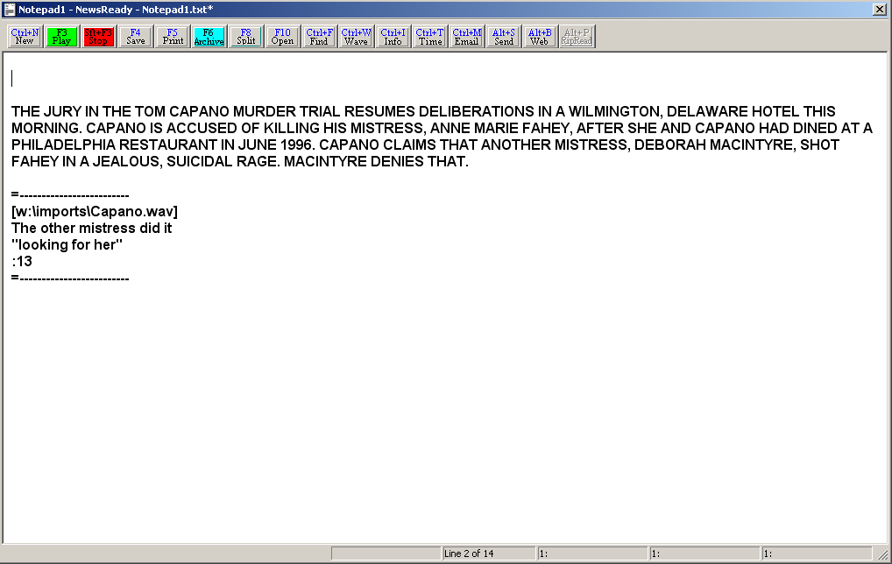

Notepad Toolbar

Ctrl+N New Clears the text in the Notepad and opens a new, blank file.
F3 Play Will play the next embedded audio file, using the audio card assigned to Deck 3 in the Player screen
Sft+F3 Stop Stops the audio that was started using the F3 key.
F4 Save Saves the file in the Notepad, and launches the Text File Header window. The Slug is used as the filename.
F5 Print Prints the text of the file, or the highlighted section of the file.
F6 Archive Saves the file in the Notepad and launches the Text File Header window. The Slug is used, along with the user name, date, and time as the filename.
F8 Split Splits the current screen (or last open screen) with the Notepad.
F10 Open Launches a dialog box to open a saved text file.
Ctrl+F Find Allows text to be searched for within the current Notepad.
Ctrl+W Wave Will embed an audio file at the current cursor position.
Ctrl+I Info Launches the Text File Header window to allow changes in the information fields for the current file.
Ctrl+T Time Displays the number of works and the length of time to read the text and play the embedded audio in the current Notepad.
Ctrl+M Email Used to send text and embedded audio to other stations when using Ecapture.
Alt+S Send Used to send text files and embedded audio to other stations when using Pcapture.
Alt+B Web Used to send text and embedded files to a web site, when using Dbcapture.
Alt+P RipRead Copies and pastes the highlighted text into a Notepad or open FileLog file.

Notepad Drop-Down Menu

The Main Menu, above the main Button bar, has 9 drop-down menus available for users to create and edit text files. Use the keyboard shortcut or click on the choice with the mouse to activate the menu choice.

Notepad32
There are no sub-menus listed under this choice.

File

New Crtl+N Clears the text in the Notepad and opens a new, blank file.
Open Ctrl+O Launches a dialog box to open a saved text file.
Speed Save Ctrl+S Saves the changes to the file using the same name and location. The file will be overwritten without being prompted.
Save F4 Saves the file in the Notepad, and launches the Text File Header window. The Slug is used as the filename.
Save as Launches a standard Windows Save window, and allows the file to be saved in a format other than as a test file.
Archive F6 Saves the file in the Notepad and launches the Text File Header window. The Slug is used, along with the user name, date, and time as the filename.
Rip+Read Alt+P Copies and pastes the highlighted text into a Notepad or open FileLog file.
Print Ctrl+P Prints the text of the file, or the highlighted section of the file.
Send Alt+S Used to send text files and embedded audio to other stations when using Pcapture.
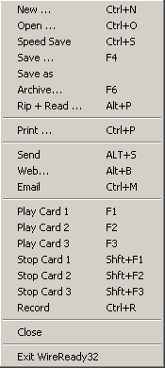
Web Alt+B Used to send text and embedded files to a web site, when using Dbcapture.
Email Ctrl+M Used to send text and embedded audio to other stations when using Ecapture.
Play Card 1 F1 Will play the next embedded audio file, using the audio card assigned to Deck 1 in the Player screen.
Play Card 2 F2 Will play the next embedded audio file, using the audio card assigned to Deck 2 in the Player screen.
Play Card 3 F3 Will play the next embedded audio file, using the audio card assigned to Deck 3 in the Player screen.
Stop Card 1 Shift+F1 Stops the audio that was started using the F1 key.
Stop Card 2 Shift+F2 Stops the audio that was started using the F2 key.
Stop Card 3 Shift+F3 Stops the audio that was started using the F3 key.
Record Ctrl+R Opens a new, blank audio file for recording. This will also embed the new audio file into the Notepad at the current cursor position.
Close Closes the current Notepad.
Exit WireReady32 Exits the user from the program.

Edit

Undo Ctrl+Z Undo the last change in the current Notepad.
Cut Ctrl+X Cuts the highlighted text out of the current Notepad.
Copy Ctrl+C Copies the highlighted text in the current Notepad and holds it on the Clipboard.
Paste Ctrl+V Pastes the Clipboard text to the cursor position in the current Notepad.
Select All Ctrl+A Highlights all the text in the current Notepad.
Spell Check Word Ctrl+K Begins the check of spelling and grammar at the cursor position.
Spell Check Entire Document Alt+K Checks the spelling and grammar of the entire document, from the beginning of the text.
Spell Options Launches a window to set the restrictions on what will be checked while doing the spell check.
Dictionary Maintenance Launches a window that allows words to be added or deleted from the global and user libraries.
Find Ctrl+F Allows text to be searched for within the current Notepad.
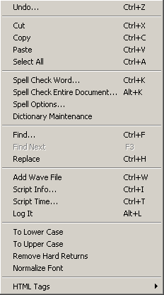
Find Next F3 Will find the next instance of the text that is being searched for in the current Notepad.
Replace Ctrl+H Allows text to be searched and replaced within the current Notepad.
Add Wave File Ctrl+W Will embed an audio file at the current cursor position.
Script Info Ctrl+I Launches the Text File Header window to allow changes in the information fields for the current file.
Script Time Ctrl+T Display the number of works and the length of time to read the text and play the embedded audio in the current Notepad.
Log It Alt+L Marks the current text file and the embedded audio files as used.
To Lower Case Changes the highlighted text to all lower case.
To Upper Case Changes the highlighted text to all upper case.
Remove Hard Returns Removes any carriage returns. Used when copying text from wire stories.
Normalize Font When pasted text has various sizes and types of fonts, this will set all highlighted text to the default font.
HTML Tags Changes the highlighted text to html format for publishing on the web.

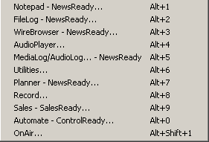
Programs
The Programs menu lists the 11 screens in NewsReady32. Consult the other WireReady manuals for information on using the automation and sales screens.

Notepad – NewsReady Alt+1 The Notepad is used to edit text and create new stories and rotations.
FileLog – NewsReady Alt+2 The FileLog is used to access text stories that have been saved from the Notepad, and to edit rotations.
WireBrowser – NewsReady Alt+3 The WireBrowser displays the wire stories that have been captured.
AudioPlayer Alt+4 The Player is used to read newscasts and play the embedded audio.
MediaLog/AudioLog – NewsReady Alt+5 The MediaLog is used to store audio files to be used in newscasts and automation.
Utilities Alt+6 The Utilities screen allows access to StormReady32, QuickRecorder, and the DOS PhoneReady and StormReady programs.
Planner – NewsReady Alt+7 The Planner is a calendar program to track appointments and assignments for newsrooms.
Record Alt+8 The Record button is used to manually record new audio files.
Sales – SalesReady Alt+9 The Sales screen is used to record and track contacts with customers/advertisers.
Automate – ControlReady Alt+0 The Automate decks are used to automate recording and playback of audio, and for web publishing.
OnAir Alt+Shift+1 The OnAir 10-deck screen is used for playback of audio while live.

Setup
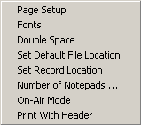
Page Setup Set up the page orientation and margins.
Fonts Set up the font size and style for the Notepad.
Double Space When checked, the printed copy of the text will be double-spaced. Does not affect the screen view.
Set Default File Location Set the default folder for saving and opening text files into the Notepad.
Set Record Location Set the default folder for accessing audio files and storing the audio when using the Record menu choice.
Number of Notepads Set the number of notepads that can be open by the user. Limited to a maximum of 10.
On-Air Mode
Print With Header When checked, will printed copy will include header information, including the filename, user name, current date and time, and NewsReady32 version number.

View
Toolbar When checked, the toolbar buttons at the top of the Notepad will be visible.

Window
In addition to the menu choices, any open NewsReady32 screens or open text files will be listed at the bottom of the menu choices in this drop-down window.
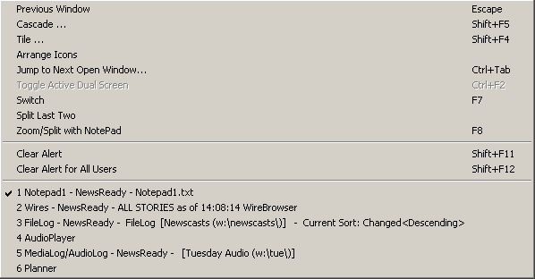
Previous Window Escape Puts the last window that was open before the Notepad as the current display.
Cascade Shift+F5 Allows the screens to be cascaded. Only active when the user is set to Windows Standard mode.
Tile Shift+F4 Allows the screens to be tiled. Only active when the user is set to Windows Standard mode.
Arrange Icons
Jump to Next Open Window Ctrl+Tab Makes the next open screen be displayed.
Toggle Active Dual Screen Ctrl+F2 Toggles between the 2 windows when the user is set to Dual Screen mode.
Switch F7 Toggles between the Notepad and the last open screen.
Split Last Two
Zoom/Split with Notepad F8 Splits the current screen (or last open screen) with the Notepad.
Clear Alert Shift+F11 Clears the red wire alert at the bottom of the screen for the logged-in user.
Clear Alert for All Users Shift +F12 Clears the red wire alert at the bottom of the screen for all users.

User
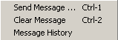
These menu choices are only available when using secure logins.
Send Message Ctrl+1 Sends a message to other users, which will appear in the header of the main window.
Clear Message Ctrl+2 Clears the message from the current user’s screen.
Message History Displays the date and text of the previously sent messages.

Help
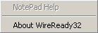
NotePad Help This menu choice is not active at this time.
About WireReady32 Displays the version number of the software and contact information for WireReady NSI.
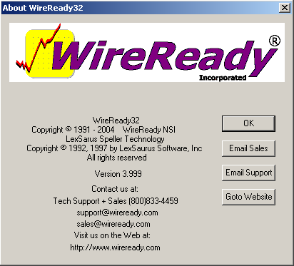

Editing in the Notepad
Since the Notepad works as a simplified word processor any text that is placed here can be edited, rewritten, moved, or deleted. The Cut and Paste options will work, as well as Drag and Drop. You may type text, change the font, print, and save while in the Notepad.

To Highlight/Select/Deselect Text:
Click the left mouse button and drag over the desired text while holding the left mouse button down.

OR
Move the cursor to the beginning of the text and then hold the Shift key down while using the arrow keys to select/deselect text. The Home, End, Page Up and Page Down keys can also be used while holding the Shift key down to select/deselect text.

Select All Highlights all the text in the current Notepad. Use Ctrl+A on the keyboard, or click on Edit and then Select All from the main drop-down menu.

Copy Places the highlighted text on the Clipboard while leaving the text in the original file. Use Copy when the text is going to be used in a different file or location within the current Notepad, but the original text is to remain. Use Ctrl+C on the keyboard, right-click within the text and choose Copy, or click on Edit and then Copy from the main drop-down menu.

Cut Removes the highlighted text from the screen and places it on the Clipboard. Use Cut when the text is going to be used in a different file or location within the current Notepad and is to be removed from its current location. Use Ctrl+X on the keyboard, right-click within the text and choose Cut, or click on Edit and then Cut from the main drop-down menu.

Delete Removes the highlighted text (or the character in front of the cursor) from the screen and does not place it on the Clipboard. When the text is not going to be used in another file or location in the same file, this is the best way to remove the text. Use the Delete key on the keyboard.

Paste Places the text on the Clipboard at the cursor position. Use Ctrl+V on the keyboard, right-click within the text and choose Paste, or click on Edit and then Paste from the main drop-down menu.

Undo Undoes the last change. If you accidentally delete, insert, or copy something and really wish you hadn’t, or if you simply change your mind about the last action you took, Undo restores the text back to the way it was before the last change was made. Use Ctrl+Z on the keyboard, right-click within the text and choose Undo, or click on Edit and then Undo from the main drop-down menu.

Drag and Drop Using the mouse, you can physically move highlighted text from one location in a file to another. To drag and drop, place the mouse anywhere within the highlighted selection and hold down the left button. Move the mouse to the desired position in the Notepad while continuing to hold the left mouse button. (There will be a small box moving alongside the mouse pointer). Release the mouse button; and the text will appear where the new cursor position is in the Notepad window. It is possible to drop the text into the middle of a sentence or word, so watch where the cursor is before releasing the mouse button.

Rip & Read Rip & Read can also be used to copy portions of a file to another open Notepad or FileLog story. By using Rip & Read, the user does not have to switch back and forth between screens to copy and paste. Highlight the text to be copied, then strike Alt+P, click on the RipRead button on the tool bar, right-click and choose Rip+Read, or click on Edit and then Rip+Read from the main drop-down menu. This will paste the highlighted text at the cursor position in the other open Notepad or open FileLog story.
NOTE: If several Notepads or FileLog stories are open, you will be asked which file is to have the text inserted. Highlight the Notepad or story to paste the text to and click the OK button or strike Enter.

Split Screen
The copy and paste features can save time by eliminating the need to retype copy, but this process, while an effective way for newcomers to become familiar with NewsReady32, may not be fast enough for real-world needs. That’s where the Split Screen comes in.
With the Split Screen, the Notepad and another window (WireBrowser or open FileLog story) can appear together on the screen. Working in these two applications simultaneously saves time. First, the extra time and keystrokes/mouse clicks that are required to move in and out of each screen is eliminated. (The same processes for copying and pasting discussed earlier can be used within Split Screen.). Second, the Split Screen lets you take advantage of Drag and Drop and Rip & Read.

When using Rip & Read with the screen split, the user can see where the cursor position is before having the text pasted into the Notepad.

Using the mouse, you can Drag and Drop highlighted text from one window to the other.

To engage the Split Screen, hit the F8 key. The last window open will be displayed in the upper window and the Notepad in the lower window. To switch between windows strike F7, or use the mouse to click on the desired window.
NOTE: F7 is typically used to access the Notepad from other screens, but can also be used to toggle between the Notepad and another screen when using Split Screen.

Spell Check
The Notepad has a basic spell check available.
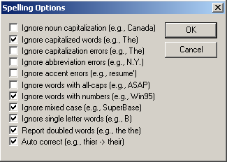
Spell Options
Each user can set the options for what is checked or ignored when doing Spell Check.
Use the mouse to select Spell Options from the Edit menu. Click on the statement to check or uncheck each option. Click the OK button or strike Enter when done to save the Spell Check options.

Dictionary Maintenance
The dictionary can be edited to include names and terms used by the staff. Both the User and Global dictionaries can be edited. The User dictionary is for the user that is currently logged into NewsReady32. All users logged into NewsReady32 use the Global dictionary.

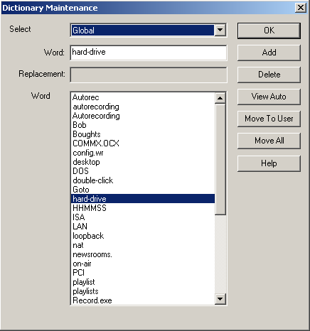
To do maintenance on the dictionary, use the mouse to select Dictionary Maintenance from the Edit menu.

To add a word to the dictionary:
Use the drop-down list in the Select window to choose User or Global.
Enter the word to be added into the Word: entry box.
Click the Add button or strike Alt+A on the keyboard to add the word to the Word list.
Click OK or strike Enter to close the Dictionary Maintenance window.

To remove a word from the dictionary:
Use the drop-down list in the Select window to choose User or Global.
Enter the word that is to be removed into the Word: entry box, or highlight it from the Word list.
Click the Delete button or strike Alt+D to remove the word from the dictionary.
Click OK or strike Enter to close the Dictionary Maintenance window.

To move words from one dictionary to another:
Use the drop-down list in the Select window to choose the dictionary to move the word from (User or Global).
Enter the word that is to be moved into the Word: entry box, or highlight it from the Word list.
Click the Move To button or strike Alt+M on the keyboard (if viewing the User dictionary, the button will be labeled Move To Global; if viewing the Global dictionary, the button will be labeled Move To User).
The word will be moved to the other dictionary.
Click OK or strike Enter to close the Dictionary Maintenance window.

To move ALL the words from one dictionary to another, click the Move All button or strike Alt+E on the keyboard.

To check the text for spelling errors:
Strike ALT+E on the keyboard or click Edit from the main menu.
Use the ARROW keys or mouse to choose either Spell Check Entire Document (to start the spell check at the top of the file) or Spell Check Word (to start the spell check at the cursor position). Then strike ENTER or click on it.
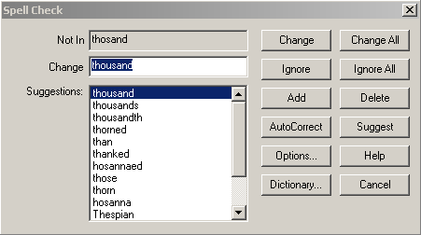
If the dictionary does not recognize a word a dialog box will appear. A list of suggested words will be displayed. Use the ARROW keys to highlight the correct spelling and then strike ENTER, double-click on the word, or highlight the word and click the Change button.
If you wish to add the word to the dictionary strike ALT+A or click the Add button. The word will be added to the User dictionary.
If you wish to delete the word to the dictionary strike ALT+D or click the Delete button. The word will be removed from the User dictionary.
If you do not wish to change the word or edit the dictionary, strike ALT+I or click the Ignore button.
If you wish to change all instances of the misspelled word in the current file, strike Alt+L or click the Change All button.
If you wish to ignore all instances of the misspelled word in the current file, strike Alt+G or click the Ignore All button.
The spell check will close automatically when it is finished, or you can strike ALT+N, click Cancel, or strike the ESC key to stop at any time.
To access the Spell Options while doing a check of spelling, strike Alt+O or click the Options button.
To access the Dictionary while doing a check of spelling, strike Alt+Y or click the Dictionary button.

Find and Replace
Individual words can easily be located in a story and be replaced automatically if necessary.

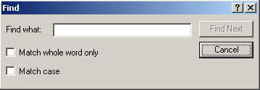
To initiate Find, use the mouse to select Find from the Edit pull down menu, or with the keyboard, strike CTRL-F. An entry box will appear, asking you to enter the word you want to find. You also have the options to Match whole word only and Match case. For example, if you wish to find only the word all. Check the box to Match whole word only or words such as allergy and ideally will also be located. The Match case option will compare the upper- and lower-case letters and only find the exact match.

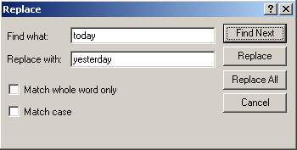
To access the Replace feature, use the mouse to select Replace from the Edit pull down menu, or with the keyboard, strike CTRL-H. In the entry box that appears, enter both the word you are seeking and the word you wish to replace it with. Within this dialog box there are several other options, such as Replace each occurrence individually or Replace All occurrences at once.

NOTE: Both the Find and the Replace features are available for a story contained in the WireBrowser, the Notepad, or the FileLog.

Saving Stories From the Notepad
Text in the Notepad is only available to the user logged into NewsReady32 until that text is saved. Stories can be saved from the Notepad so that they are accessible to other users at other workstations on the network (if set up on a LAN).

In NewsReady32, there are 2 ways to save a file from the Notepad: F4 Save and F6 Archive.
Archiving a file is similar to Saving it. Both options function almost identically when it comes to naming the file and choosing a destination folder. A critical difference is the overwrite safety feature that is built into the Archive option. If you work on a story that has the same file name as one that has already been saved to a particular custom folder, upon choosing F4 Save you will be asked if you wish to overwrite or replace the previous story. This prevents the confusion that can arise from having several files with the same name.

However, if you choose to F6 Archive, files with identical names are not overwritten. They instead retain their slug names and are differentiated by the time, date, and name of writer that are added automatically. Since multiple users may be accessing the same file at once, Archive prevents multiple users from erasing each other's stories.

To save the Notepad text:
From the main menu click on File, then select Save, strike F4 on the keyboard, or click F4 Save on the toolbar.
A Text File Header dialog box will open. Enter information about the file into the entry boxes. Many of the entry boxes can be used to store information other than the labels of the fields. The only field required to be filled in is the Slug field.
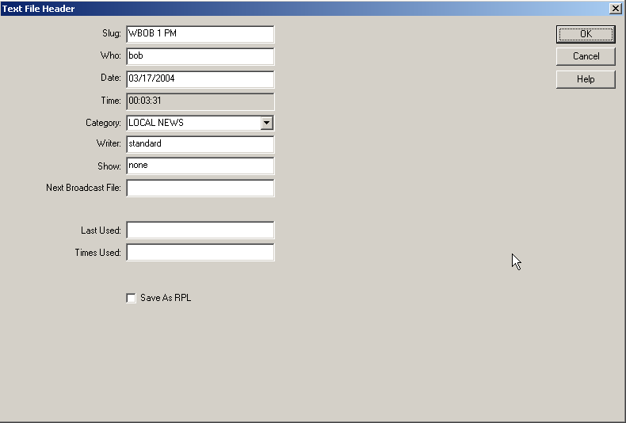

Slug this is the name of the file
Who can be used to enter the initials of the person creating or editing the file.
Date automatically filled in by the program
Time the length of time that will it will take to read the text and play the audio files embedded in the file, based on a pre-set number of words per minute. Automatically filled in by the program.
Category Contains a drop-down list of pre-configured categories.
Writer Automatically filled in with the user name logged into NewsReady32. Can be edited to enter the name or initials of the writer.
Show Used by some to record the newscast or show that the file was used in. Can be used to record any text information the user wishes.
Next Broadcast File Can be used to record any text information the user wishes.
Last Used Displays the date of the last time the file was stamped with the Log It feature.
Times Used Displays the number of times the file was stamped with the Log It feature.

Save As RPL checking this statement saves the file with the extension RPL instead of TXT. The RPL files are rotation files used with the Automation feature of NewsReady32.

After the Text File Header window is filled in, click OK or strike the Enter key to close the window.
The Custom Folder window will open. Choose the folder to store the text file in by highlighting it with the mouse or keyboard, and then clicking the OK button or striking Enter.
The file is now saved to the chosen Custom Folder.
Archiving the file follows the same process as Save. When using F4 Save, the Slug is used as the filename. When using F6 Archive, the filename is the Slug, plus the name of the user logged into NewsReady32, plus the date and time that the file was saved. The filename is hidden in the NewsReady32 program, and the stories can be identified by the Slug. This will be explained more in the FileLog section.

Slug and Stamp a News Story
There is an option that allows a user to prename the file. This option will also stamp the slug name on the first line of the story.

To perform this action:
- With the Notepad open on the screen, click Ctrl+I Info or strike CTRL-I.
- The Text File Header dialog box will appear. (Just like it does for saving).
- Enter a slug name and any other desired information, then click OK, or strike Enter.
- The slug name is stamped on the first line.

NOTE: When this file is finished and saved, the user will be prompted with the Text File Header dialog box. Since the slug has already been provided, just strike Enter to bypass.

Printing From the Notepad
From the Notepad you can print an entire story, selected pages, or just highlighted text. To print selected text from a Notepad, you’ll first need to highlight the desired text.
Strike F5 on the keyboard, click the F5 Print button, or click on Print from the File drop-down menu.
If you have highlighted text in the Notepad, only that text will be displayed behind the Print window.
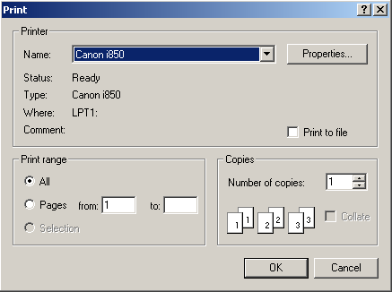
In the Print window, choose the printer from the Name drop-down box if your printer is not shown. The Print Range section of the window gives the option to print All or a range of pages. The Selection choice will be grayed out, since the Notepad only displays the highlighted text when printing. Choose the number of copies to print. Click the OK button or strike Enter on the keyboard to print the text.

Printing in Double Space
NewsReady32 provides the ability to print in double space so the hard copy is easier to read. The line spacing on the screen will not be affected, but once Print has been selected the text will re-flow to display the actual appearance. Click on Setup from the Menu bar, and then select Double Space. NOTE: A checkmark will appear beside Double Space when it is active. Another click on this choice will turn Double Space off.

Clearing the Notepad
The quickest way to clear a Notepad is to click the New button, or strike Ctrl+N. If the current Notepad has not been saved then you will be prompted to save the text to a file.

Opening Saved Stories From the Notepad
Stories that have been saved can be accessed via the FileLog, and can also be opened from within the Notepad.
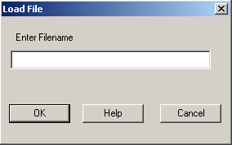
There are two modes of operation for opening files from the Notepad: Advanced and Simple. The mode is configured by the system administrator, and is a system-wide setting.

Simple Mode opens an entry window where the user enters the name of the file to open. Simple Mode will only allow files to be open from the Default Notepad directory. The Default Notepad directory is configured from the Setup menu choice, and is set for each user.

Advanced Mode opens a standard Windows Open screen, where the user can search for and choose the folder that the file is in.
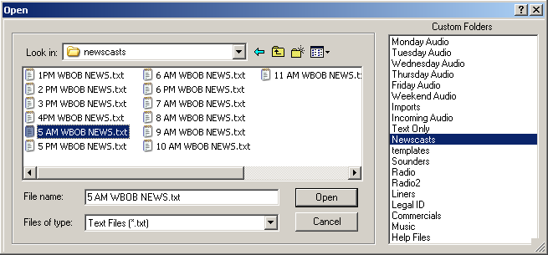

Strike F10 on the keyboard, click the F10 Open button or click on Open from the File drop-down menu to open a file into the Notepad.
Opening a saved file from the Notepad is used mostly when newscast templates have been set up for various stations or users. Once a file is opened, it can be edited, printed and saved.

Creating Templates
NewsReady32 provides for the use of templates if a newscast consistently uses the same structure. The template may be opened, the news stories inserted at the proper location, then the file archived to the FileLog. The template form can be used over-and-over-again.

Here's how to set up your own news format.
- From the Notepad, type your template file.
- Strike F4 to Save it (F6 will not work, because the template should have just the Slug as the filename).
- Type the Slug name, then click OK or strike ENTER.
- Choose the Templates folder, and click OK or strike ENTER. (The file should be saved to the Default Notepad directory if using Simple Open Mode in the Notepad).
- The template file is now saved and the text can be cleared from the Notepad.

Here's how to apply a template.
- From the Notepad, click F10 Open, strike F10, or click on Open from the File drop-down menu.
- From the Custom Folders list highlight the Templates folder.
- Double-click the file name from the list or single-click then click the Open button.
NOTE: Steps 2-3 above apply only if the Notepad Open Mode is set to Advanced. If the Open Mode is set to Simple, then you will be prompted to type the file name of the template. See your systems administrator to change the Open Mode.
- This will open the templates file.
- Type your newscast.
- Strike F4 to Save or F6 to Archive the updated file.
- Type the Slug name, then click OK or strike ENTER.
- Choose a folder other than Templates (or the Default Notepad directory).
9. Click OK or strike ENTER.

Embedding Audio Files into the Notepad
NewsReady32 allows you to embed audio files directly from your MediaLog into a story or newscast.

The Ctrl+W Wave button in the Notepad is used to embed audio files directly from the MediaLog.
Open the story or newscast in the Notepad.
Place the cursor where you want the audio to be inserted.
Click the Ctrl+W Wave button, or strike CTRL-W or click on Add Wave File from the Edit drop-down menu.

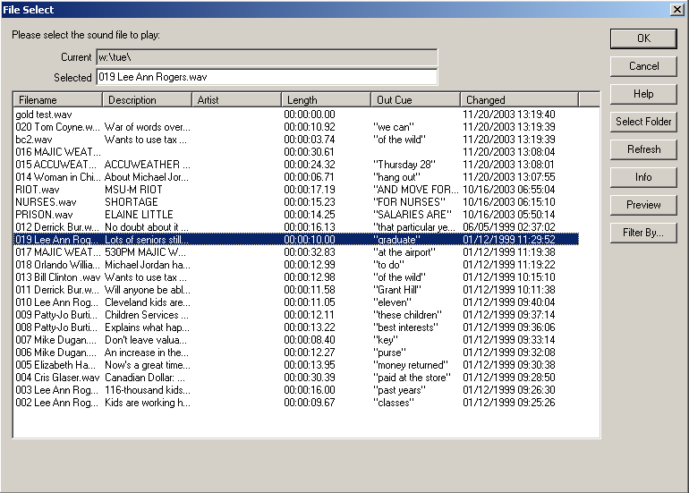

In the File Select dialog box, double-click the audio file, or single-click to highlight and click OK.
-OR-
Click on the Select Folder button to choose a file from a different folder.
Choose the folder to switch to.
Choose a WAV file from the list, and double-click on it to select it.
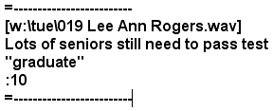
This will cause the audio file name along with its description, outcue, and length to appear in the story at the location of the cursor.

Playing an Embedded Audio File
Once an audio file has been inserted into a newscast it can be played via the keyboard. The cursor must be placed above the line where the link to the audio file is located.

To play any embedded audio file from within a newscast:
Strike F1, F2, or F3 to play the audio, or click the F3 Play button on the toolbar.
To stop the audio, hold SHIFT, and strike the same key (F1, F2, F3), or click the Sft+F3 Stop button. NOTE: The Stop button only works if the Play button or F3 was used to start the audio.
Scroll the text if necessary, and use F1, F2, or F3 to play the next cut.

NOTE: F1, F2, and F3 have the same function of playing the sound cut. If the computer has three sound cards, and the board is wired to play sound from all three, then the three function keys can be used to overlap sound.

Viewing the Estimated Newscast Time
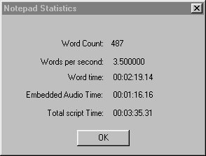
NewsReady32 can provide the approximate total script time of a newscast. The calculation is based on the average reading speed of 3.5 words per second. Embedded audio cuts will be included in the calculated time. To view the script time, click on the Ctrl+T Time button, strike CTRL-T, or choose Script Time from the Edit drop-down menu.

Word Count is the total number of words in the text file.
Words per second is configurable for each user. The default of 3.5 words per second is an average for a person reading a newscast. Contact WireReady NSI to change this value for any of the users.
Word time is the time it will take to read the entire text, in hours, minutes, and seconds.
Embedded Audio Time is the total time of the audio embedded in the text, in hours, minutes, and seconds.
Total script Time is the total time it will take to read the text and play the audio, in hours, minutes and seconds.

Logging the Audio Files after a Newscast
After airing the newscast it is often necessary to log the newscast and audio cuts that were played to prevent over-use of the same stories and cuts. NewsReady32 provides a logging system that will appear in the FileLog and MediaLog, and remove the need for hand-written logs. To log a newscast after it has been aired, click on Edit from the Menu bar, and then choose Log it. This will record the time the audio was last played, and the number of times it has been played. This will also mark the story/newscast in the FileLog with the last time used and the number of times used. Check both the FileLog and MediaLog to confirm the files were logged.

It is also possible to mark the FileLog story without logging the audio cuts. When doing a copy and paste from one folder to another, or when using Alt-P to copy text to a Notepad, the file can be logged with the date and time and the number of times used.
NOTE: These settings can be enabled or disabled for the users. See your systems administrator to configure these settings.

Configuring the Notepad
The user can customize some features in NewsReady32 while viewing the Notepad. The changes are specific to the user logged in and will not affect setting for other users. Under Setup on the Menu bar, six options may be changed, including Fonts and Double Space (discussed earlier in this document).

- Page Setup: This is where the paper size, page orientation, and margins can be adjusted.
- Font: To change the font or the size of the characters that appears in the Notepad. Choose the font, style, and size you desire, and then click OK. These selections will remain intact for the Notepad until they are changed.
- Set Default File Location: This is the first folder that is displayed when Open is chosen from the Notepad or FileLog (while in Advanced Mode). When Open is chosen while the Notepad is in Simple Mode, this is the folder that the program will look in for the entered file name.
- Set Record Location: This is the first folder that is displayed when opening WAV files from the MediaLog, and the location that a new recording will be placed in when launching a new recording from the Notepad. (Audio files are discussed later in this user manual).
- Number of Notepads: Multiple notepads are available for users. The maximum number is ten. Use the arrow keys to adjust the number of Notepads. When changing the number of Notepads, any increase in number will make those Notepads available immediately. If decreasing the number of Notepads, the change will not take place until NewsReady32 is restarted.

NOTE: See your systems administrator, if any of the options are currently unavailable.

Sending Text and Audio Files to Other Stations in Your Group
Text files, including the embedded audio files, can be sent to other stations/markets in your group that are also running NewsReady32. This requires additional software from WireReady NSI.

DBCapture
DBCapture is a stand-alone program that is used for moving text and audio files, with the ability of compressing/decompressing audio. Files can be moved between UNC folders or to/from FTP paths. DBCapture runs on the capture computer or can run from one of the workstations, and should be run at both the sending and receiving locations. DBCapture will need to be configured with the settings for paths and audio formats at both sending and receiving locations.

While the Notepad is open, click the Alt+B Web button, strike Alt+B on the keyboard, or choose Web from the File drop-down menu.
The Text File Header window with the list of Aliases will open. Choose the location to send the file to.
Click OK or strike Enter.
A second Text File Header window will open. Enter the file name into the Slug field.
Click OK or strike Enter.
The file will be sent to DBCapture, which will process and send the text and audio files to the destination Alias.
At the receiving end, DBCapture will process the incoming files and place them in the destination folder. The text file, with embedded audio, can be found in the destination folder and is ready to be used on air at the receiving station.

Publishing Files to a Web Site
NewsReady32 has the ability to publish text, audio, video and pictures directly from the Notepad to a web site using Dbcapture. The web pages and configurations for Dbcapture will have to be set up in advance. Publishing to a web page requires the purchase of the WebReady software.

While the Notepad is open, click the Alt+B Web button, strike Alt+B on the keyboard, or choose Web from the File drop-down menu.
The Text File Header window will open. Highlight the destination web page and click OK or strike Enter.
A second Text File Header window will open. The field names for this window are configurable. Enter the required information into the fields. If the Archive to filelog statement at the bottom of the screen is checked, you will be asked to choose the folder to save to after the next step.
Click OK or strike Enter. The files will be copied to an Out folder.
Dbcapture scans the Out folder, and when files are found it will publish them to the specified web pages.

FileLog
With the FileLog, you can manage saved files in a variety of custom folders, including day folders, specific-show folders, phone books, and other information systems. Custom folders can be created by your system administrator. Think of it as a modern version of the old "tray" or "clipboard" filing system.
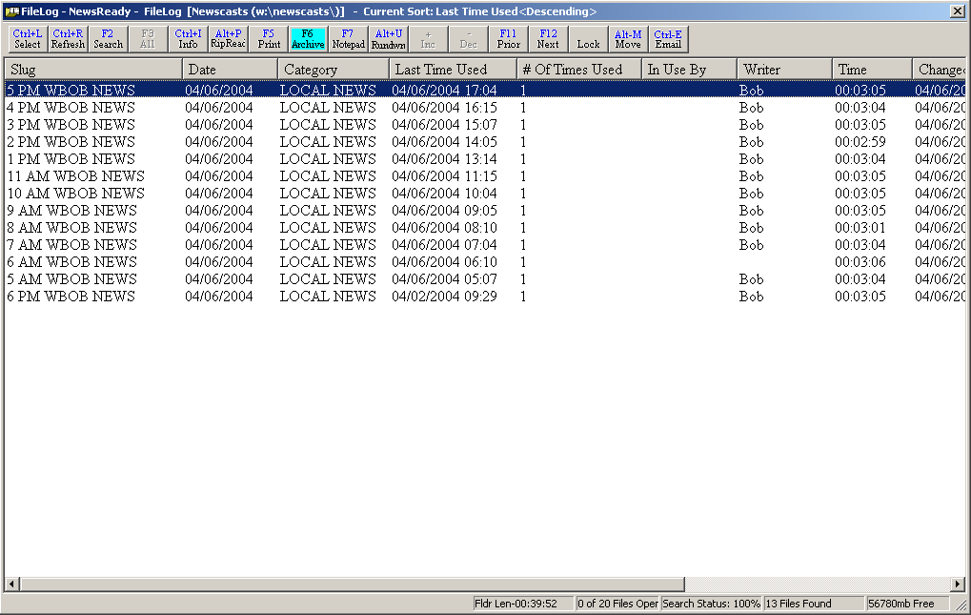

Stories are saved in chronological order, with the most recent going to the top of the list. For fast access, you can take advantage of a search feature similar to that in the WireBrowser. To rework a story from the FileLog, simply double-click the headline or use the ARROW keys to highlight a headline and hit ENTER. Split Screen, cut and paste, Rip & Read, etc. can then be used to edit the story.

To open the FileLog:
Hold down the ALT key and hit the 2 (number) key.
OR - Click on the FileLog button on the toolbar.
OR - From the Menu bar click on Programs, then select FileLog.

Filelog Toolbar

Ctrl+L Select Launches the Custom Folder window to allow the user to switch FileLog folders.
Ctrl+R Refresh Rebuilds the display and refreshes the screen. Sorts the display by the Changed date, in descending order.
F2 Search Searches the current FileLog folder for text in the slug or body of the stories, and can be restricted by a date range or category.
F3 All Displays all stories in the current folder. Only active after an F2 Search has been done.
Ctrl+I Edit Info Launches the Text File Header window and allows the user to edit the fields for the highlighted file.
Alt+P Rip+Read Copies and pastes the text of the highlighted story into a Notepad or open FileLog file.
Print Prints the text of the highlighted story.

F6 Archive Copies the highlighted story to another Custom Folder.
F7 Notepad Switches the display to the current Notepad.
Alt+U Rundown Turns on/off the Rundown Mode in the FileLog.
+ Increment Moves the highlighted story down one position in the list of files. Only active when in Rundown mode.
- Decrement Moves the highlighted story up one position in the list of files. Only active when in Rundown mode.
F11 Prior Opens the file above the highlighted file for reading or editing.

F12 Next
Ctrl+U Lock/Unlock file Toggles between read-only and normal attributes for the highlighted file. When locked, a file can be opened and edited, but not overwritten or deleted.
Alt+M Move Moves the highlighted story to a different FileLog folder.
Ctrl+E Email Used to send text and embedded audio to other stations when using Ecapture.
Del Delete Deletes the highlighted file or files.
F8 Split Splits the current screen with the Notepad.

FileLog Drop-Down Menu

The Main Menu, above the main Button bar, has 8 drop-down menus available for users to locate, manage and edit text files. Use the keyboard shortcut or click on the choice with the mouse to activate the menu choice.

FileLog
There are no sub-menus listed under this choice.

File
Select Ctrl+L Launches the Custom Folder window to allow the user to switch FileLog folders.
Refresh Ctrl+R Rebuilds the display and refreshes the screen. Sorts the display by the Changed date, in descending order.
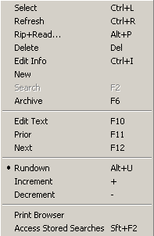
Rip+Read Alt+P Copies and pastes the text of the highlighted story into a Notepad or open FileLog file.
Delete Del Deletes the highlighted file or files.
Edit Info Ctrl+I Launches the Text File Header window and allows the user to edit the fields for the highlighted file.
New Launches the Text File Header window and allows the user to enter information about a new, blank Notepad. The blank file is opened after the Text File Header window is closed.
Search F2 Searches the current FileLog folder for text in the slug or body of the stories, and can be restricted by a date range or category.

Archive F6
Edit Text F10 Opens the highlighted file for reading or editing.
Prior F11 Opens the file above the highlighted file for reading or editing.

Next F12
Rundown Alt+U Turns on/off the Rundown Mode in the FileLog.
Increment + Moves the highlighted story down one position in the list of files. Only active when in Rundown mode.
Decrement - Moves the highlighted story up one position in the list of files. Only active when in Rundown mode.
Print Browser Prints a list of filenames in the order displayed in the FileLog folder.
Access Stored Searches Advanced searches to display text, slug or category search results.

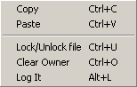
Edit
Copy Ctrl+C Copies the highlighted file in the current FileLog and holds it on the Clipboard.
Paste Ctrl+V Pastes the Clipboard file to the current FileLog folder.
Lock/Unlock file Ctrl+U Toggles between read-only and normal attributes for the highlighted file. When locked, a file can be opened and edited, but not overwritten or deleted.
Clear Owner Ctrl+O Clears the owner of the highlighted file, which appears in the In Use By field.
Log It Alt+L Marks the current text file as used. Updates the Last Used field with the current date and time, and adds 1 to the # Of Times Used field.

Programs
The Programs menu lists the 11 screens in NewsReady32. Consult the other WireReady manuals for information on using the automation and sales screens.
Notepad – NewsReady Alt+1 The Notepad is used to edit text and create new stories and rotations.
FileLog – NewsReady Alt+2 The FileLog is used to access text stories that have been saved from the Notepad, and to edit rotations.
WireBrowser – NewsReady Alt+3 The WireBrowser displays the wire stories that have been captured.
AudioPlayer Alt+4 The Player is used to read newscasts and play the embedded audio.
MediaLog/AudioLog – NewsReady Alt+5 The MediaLog is used to store audio files to be used in newscasts and automation.
Utilities Alt+6 The Utilities screen allows access to StormReady32, QuickRecorder, and the DOS PhoneReady and StormReady programs.
Planner – NewsReady Alt+7 The Planner is a calendar program to track appointments and assignments for newsrooms.
Record Alt+8 The Record button is used to manually record new audio files.
Sales – SalesReady Alt+9 The Sales screen is used to record and track contacts with customers/advertisers.
Automate – ControlReady Alt+0 The Automate decks are used to automate recording and playback of audio, and for web publishing.
OnAir Alt+Shift+1 The OnAir 10-deck screen is used for playback of audio while live.

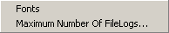
Setup
Fonts Set up the font size and style for the FileLog.
Maximum Number of FileLogs Set the maximum number of stories that can be open from the FileLog at one time by this user.

Window
In addition to the menu choices, any open NewsReady32 screens or open text files will be listed at the bottom of the menu choices in this drop-down window.
Previous Window Escape Puts the last window that was open before the Notepad as the current display.
Cascade Shift+F5 Allows the screens to be cascaded. Only active when the user is set to Windows Standard mode.
Tile Shift+F4 Allows the screens to be tiled. Only active when the user is set to Windows Standard mode.
Arrange Icons
Jump to Next Open Window Ctrl+Tab Makes the next open screen be displayed.
Toggle Active Dual Screen Ctrl+F2 Toggles between the 2 windows when the user is set to Dual Screen mode.
Switch F7 Toggles between the Notepad and the last open screen.
Split Last Two
Zoom/Split with Notepad F8 Splits the current screen (or last open screen) with the Notepad.
Clear Alert Shift+F11 Clears the red wire alert at the bottom of the screen for the logged-in user.
Clear Alert for All Users Shift +F12 Clears the red wire alert at the bottom of the screen for all users.

User
These menu choices are only available when using secure logins.
Send Message Ctrl+1 Sends a message to other users, which will appear in the header of the main window.
Clear Message Ctrl+2 Clears the message from the current user’s screen.
Message History Displays the date and text of the previously sent messages.

Help
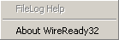
FileLog Help This menu choice is not active at this time.
About WireReady32 Displays the version number of the software and contact information for WireReady NSI.

FILE LOG

After you’ve spent time and effort on a story, the last thing you want is to lose it in a "black hole," where you waste valuable time trying to hunt it down, or it is never to be seen again.

With the FileLog, you can manage saved files in a variety of custom folders, including day folders, specific-show folders, phone books, and other information systems. Custom folders can be created by your systems administrator. Think of it as a modern version of the old "tray" or "clipboard" filing system.

Stories are saved in chronological order, with the most recent going to the top of the list. For fast access, you can take advantage of a search feature similar to that in the WireBrowser. To rework a story from the FileLog, simply double-click the headline or use the ARROW keys to highlight a headline and hit ENTER. Split Screen, cut and paste, Rip & Read, etc. can then be used to edit the story.

To switch folders at any time within the FileLog, click Select from the FileLog toolbar or hold down CTRL and hit L. To close an open file from the FileLog, simply strike ESC.

Searching for Stories
The FileLog provides two ways to search for stories with a folder. F2 Search from the toolbar, and Access Stored Searches from the File menu. Searching for saved stories in the FileLog can only be done in the currently open folder.

F2 Search
Either click on the F2 Search button on the toolbar, or strike F2 on the keyboard to activate a search.
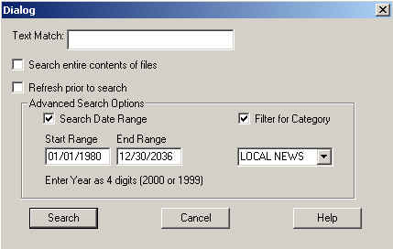
Enter the text that you would like to search for in the Text Match field. The search is not case sensitive, and will search for the characters that are entered into the field.

Check the Search entire contents of files statement to have the search include the text in each of the files in the folder. When this statement is left unchecked, the search is limited to the columns displayed in the FileLog (Filename, Slug, Category, etc).

Check the Refresh prior to search statement to have the FileLog refresh the folder before doing the search. This is helpful when using NewsReady32 on a network with multiple users saving stories from multiple workstations.

To further narrow the search, use the Advanced Search Options.
Search Date Range will allow the search to be limited to a date range. When checked, the Start Range and End Range fields become active.
Filter for Category allows the search to be limited to a specific Category.
Click the Search button when all parameters have been set to activate the search. The FileLog will only display stories meeting the search parameters.
Click on the F3 All button or Ctrl+R Refresh button to display all the stories in the FileLog folder.

Stored Searches
Newsrooms often search for the same information on a regular basis, for example stories about the Mayor of a town. NewsReady32 has the ability to store searches with set parameters to make it faster and easier to find saved stories. These searches are set up in a similar fashion to the WireBrowser searches.

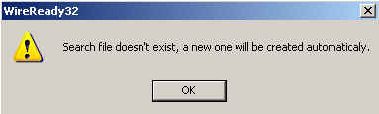
From the File menu, choose Access Stored Searches. The window displaying previously saved searches opens. If no searches have been configured for the user, a window will pop up stating that the search file does not exist and that a default set of searches will be created.

The Available Searches lists 3 default searches that cannot be edited or deleted: Category Search, Slug Search, and Text Search.
Category Search opens a window that lists all the currently configured Categories. Choose the Category of the story to search for, and click the OK button.
Slug Search opens a window where text can be entered to search for in the Slug field. Enter the text and click the OK button.
Text Search opens a window where text can be entered to search within the stories. Enter the text and click the OK button.

Creating New Stored Searches
Users can create their own custom searches.

From the FileLog select Access Stored Searches from the File pull down menu. This will display a list of the default searches, and any previously created searches.

Click the New Search button. The “Add a new Custom Search” dialog box will be displayed. Use it to define which category, slug or text matches you want to search within.

To select specific categories, first click on the Unselect All button to turn off the entire selection of categories, then single-click each category you want to be searched. To search all categories, do not click the Unselect All button.

To search for specific words in a slug, type the word in the entry box labeled 1st Slug Match. There are a total of three text boxes for slug searches if you wish to look for additional words in a slug. If you use more than one slug text box then you also need to click on the radio button labeled OR, or the radio button labeled AND. To display only stories that contain ALL the slugs you listed in the text boxes choose AND. To display stories that contain ANY of the slugs you listed choose OR.

Repeat this process for a text search by using the Text Match entry boxes. Enter the phrases or keywords you are looking for within the body of the stories. Remember to choose between OR and AND if you use more than one Text Match box.

When finished, enter a name for this search in the Search Name entry box. By default it will say Untitled Search. Click on the Save Changes button. The name will then appear at the bottom of the list of searches.

FileLog - Rundown Mode
Stories in the FileLog can be placed or prioritized in any order. To change the position of individual stories within a folder:

KEYBOARD PROCEDURE
Strike ALT-U.
Use the ARROW keys to highlight the desired story.
Strike + (plus) or - (minus) on the Number pad to move the story up or down. Note: the + and - on the keyboard may not be functional. Use the Number pad + and -.
To return to the original order, strike ALT-U again.

MOUSE PROCEDURE
Click Rundown on the toolbar.
OR - From the Menu bar click on File, then select Rundown.
Click on the story you wish to move.
Click the + Inc or - Dec buttons on the toolbar.
To return to the original order, click on the Rundown button.

Copy files within the FileLog
Files can be copied or transferred between folders in the FileLog. Entire or partial stories can be copied and pasted from one folder to another.

To copy an entire story to another folder:
1. Open the FileLog.
2. Click Select from the toolbar or hold down CTRL and hit L.
3. This will bring up the Select Custom Folder dialog box.
4. Open the custom folder containing the story you wish to copy by double-clicking it or by selecting it with the ARROW keys and hitting ENTER. (If the story is located in the Personal folder, then click the Personal button).
5. Highlight the headline by single-clicking it or by scrolling with the ARROW keys. You need not open the story.
6. Hold down the CTRL key and hit C, or select Copy from the Edit pull down menu.
7. Return to the Select Custom Folder dialog box (Click Select from the toolbar or hold down CTRL and hit L) and open the custom folder you wish to copy to.
8. Click Paste from the toolbar or hold down CTRL and hit V. The headline of the story will appear in the window.

Copying multiple stories
Several stories can be copied and pasted simultaneously by following the same procedure. But, you must first make multiple selections before choosing to copy.

Open the FileLog, then:
1. Click Select from the toolbar or hold down CTRL and hit L.
2. This will bring up the Select Custom Folder dialog box.
3. Open the custom folder containing the stories you wish to copy by double-clicking it or by selecting it with the ARROW keys and hitting ENTER.
4. Select each desired headline by single clicking it while holding down the CTRL key. Or, with the keyboard, hold down the CTRL key as you scroll with the ARROW keys, then hit the SPACEBAR to select a headline/story. There is no limit to the number of selections you can make.
5. Follow the remaining steps listed above to paste the stories to another folder.

Deleting multiple stories
Likewise, you can save time removing files/stories by deleting several at a time. Follow the same steps listed above for selecting multiple stories. Then hit the DELETE key, or select Delete from the Edit pull down menu. A warning box will appear asking you to confirm your decision.

Moving stories from one folder to another
Stories can be moved from one folder to another, rather than copied. This is very useful when archiving older stories.

1. Open the FileLog.
2. Click Select from the toolbar or hold down CTRL and hit L.
3. This will bring up the Select Custom Folder dialog box.
4. Open the custom folder containing the story you wish to copy by double-clicking it or by selecting it with the ARROW keys and hitting ENTER. (If the story is located in the Personal folder, then click the Personal button).
5. Highlight the headline by single-clicking it or by scrolling with the ARROW keys. You need not open the story. Multiple stories can be highlighted using the mouse in combination with the Shift or Ctrl keys.
6. Click Move from the toolbar or hold down the ALT key and hit M. This will bring up the Select Custom Folder dialog box.
7. Choose the custom folder you wish to move files to and click the OK button or strike the Enter key.

Moving text from one folder to another
Text can be moved or copied between folders in the FileLog. As mentioned previously, entire stories can be copied to other folders, but sometimes it is useful to be able to copy only portions of a story to another location.

To copy text between folders follow these steps:
1. Open the desired custom folder and story. Place the cursor, using your mouse or ARROW keys, at the beginning of the text you want to copy.
2. With your mouse, hold down the left button and move the cursor to the end of the desired text. Or, using the keyboard, hold down the SHIFT key and use the ARROW keys to move the cursor to the end of the desired text. You can release the mouse button or keys; the text will remain highlighted until you move the cursor.
3. Copy the selected text by holding down the CTRL key and hitting the C (letter) key. Or, using the mouse, select Copy from the Edit pull down menu at the top of the screen.
4. Open the Notepad or FileLog story where the text is to be pasted.
5. Place the cursor where the text is to be placed and strike CTRL-V.

NOTE: Hitting F8 while in FileLog will create a split screen with the FileLog and the Notepad. In this setting you can also use your mouse to drag and drop text from a FileLog story into the Notepad. See previous instructions regarding drag and drop.

Refreshing the FileLog
To view an updated list of stories at any time, click Refresh from the FileLog toolbar or hold down CTRL and hit R. If new stories were added since the FileLog was open they will not automatically be displayed until the folder is refreshed.

Locking/Unlocking a saved story
NewsReady32 provides for the ease of sharing stories between users. Anyone can access the FileLog to save or retrieve stories. While this is the intent under most circumstances, occasionally it may be necessary to lock a file so other users do not revise it. To do this locate and highlight the story in the FileLog. Do not open it. Click on the Lock button or from the Menu bar choose Edit, then Lock/Unlock file. You will be prompted with a warning message to confirm the decision. The file is now Read Only. It can be opened and edited, but not overwritten. If any users wishes to revise the story, the file must be saved with a different name. Repeat the process to unlock the file. From the FileLog highlight the file, then click Edit from the Menu bar, and choose Lock/Unlock file.

NOTE: Lock and Unlock are also available in the MediaLog.

Archive vs. Save
Archiving a file is similar to Saving it. Both options make use of the FileLog system, and function almost identically when it comes to naming the file and choosing a destination folder. A critical difference is the overwrite safety feature that is built into the Archive option. If you work on a story that has the same file name as one that has already been saved to a particular custom folder, upon choosing Save you will be asked if you wish to overwrite or replace the previous story. This prevents the confusion that can arise from having several files with the same name.

However, if you choose to Archive, files with identical names are not overwritten. They instead retain their slug names and are differentiated by the time, date, and name of writer that are added automatically. Since multiple users may be accessing the same file at once, Archive prevents multiple users from erasing each other's stories.

KEYBOARD PROCEDURE
Strike F6.
OR - Strike ALT-F, then strike R.
Enter a Slug name and any other data you choose, then strike ENTER.
Use the ARROWS keys to highlight a folder, then strike ENTER.

MOUSE PROCEDURE
Click Archive on the toolbar.
OR - From the Menu bar click on File, then select Archive.
Enter a Slug name and any other data you choose, then click OK.
Click on the correct folder, then click OK.

WireBrowser
The WireBrowser is the news activity hub of NewsReady32. This is where wire stories arrive, often a hundred or more in an hour, and are displayed in chronological order, with the most recent arrivals listed first. The WireBrowser shows each story’s headline, category, priority, and date and time. Within this application you can view, select, copy, print, sort, and save wire stories.

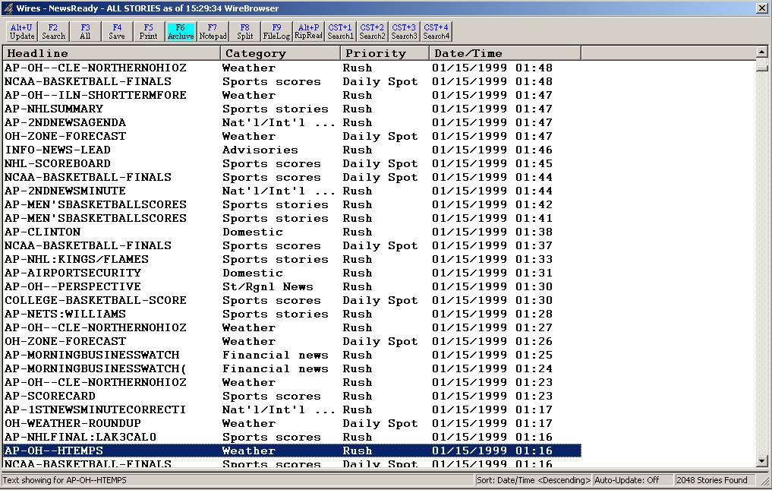

To open the WireBrowser:
Hold down the ALT key and hit the 3 (number) key.
OR - Click on the Wires button on the toolbar.
OR - From the Menu bar click on Programs, then select WireBrowser.

WireBrowser Toolbar

Alt+U Update Updates the screen and displays any new wire stories that have come in. Will update when all stories are displayed or when a search has been done.
F2 Search Search the browser to display text, category or priority search results.
F3 All Displays all stories currently help in the browser, and returns the sort order to date and time.
F4 Save Saves the highlighted story to a text file, and uses the Slug as the filename.
F5 Print Prints the text of the highlighted wire story.
F6 Archive Saves the highlighted story to a text file, and adds the user name, date and time to the Slug to create the filename.
F7 Notepad Switches the display to the current Notepad.
F8 Split Splits the screen with the Notepad.
F9 FileLog Switches the display to the current folder in the FileLog.
Alt+P RipRead Copies and pastes the text of the highlighted wire story into a Notepad or open FileLog file.
CST+1 Search1 Runs the first saved Quick Search.
CST+2 Search2 Runs the second saved Quick Search.
CST+3 Search3 Runs the third saved Quick Search.
CST+4 Search4 Runs the fourth saved Quick Search.

WireBrowser Drop-Down Menu

The Main Menu, above the main Button bar, has 8 drop-down menus available for users to create and edit text files. Use the keyboard shortcut or click on the choice with the mouse to activate the menu choice.

WireBrowser
There are no sub-menus listed under this choice.

File
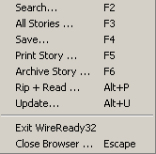
Search F2 Search the browser to display text, category or priority search results.
All Stories F3 Displays all stories currently help in the browser, and returns the sort order to date and time.
Save F4 Saves the highlighted story to a text file, and uses the Slug as the filename.
Print Story F5 Prints the text of the highlighted wire story.
Archive Story F6 Saves the highlighted story to a text file, and adds the user name, date and time to the Slug to create the filename.
Rip+Read Alt+P Copies and pastes the text of the highlighted wire story into a Notepad or open FileLog file.
Update Alt+U Updates the screen and displays any new wire stories that have come in. Will update when all stories are displayed or when a search has been done.
Exit WireReady32 Exits the user from the program.
Close Browser Escape Closes the wire browser window and displays the last open window.

Programs
The Programs menu lists the 11 screens in NewsReady32. Consult the other WireReady manuals for information on using the automation and sales screens.

Notepad – NewsReady Alt+1 The Notepad is used to edit text and create new stories and rotations.
FileLog – NewsReady Alt+2 The FileLog is used to access text stories that have been saved from the Notepad, and to edit rotations.
WireBrowser – NewsReady Alt+3 The WireBrowser displays the wire stories that have been captured.
AudioPlayer Alt+4 The Player is used to read newscasts and play the embedded audio.
MediaLog/AudioLog – NewsReady Alt+5 The MediaLog is used to store audio files to be used in newscasts and automation.
Utilities Alt+6 The Utilities screen allows access to StormReady32, QuickRecorder, and the DOS PhoneReady and StormReady programs.
Planner – NewsReady Alt+7 The Planner is a calendar program to track appointments and assignments for newsrooms.
Record Alt+8 The Record button is used to manually record new audio files.
Sales – SalesReady Alt+9 The Sales screen is used to record and track contacts with customers/advertisers.
Automate – ControlReady Alt+0 The Automate decks are used to automate recording and playback of audio, and for web publishing.
OnAir Alt+Shift+1 The OnAir 10-deck screen is used for playback of audio while live.

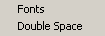
Setup
Fonts Set up the font size and style for the Wire Browser.
Double Space When checked, the printed copy of the text will be double-spaced. Does not affect the screen view. Only active in the Preview window.

View
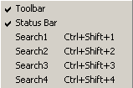
Toolbar When checked, the toolbar buttons at the top of the Wire Browser will be visible.
Status Bar When checked, the status bar, which displays the sort settings and numbers of stories found, is visible at the bottom of the browser screen.
Search1 Ctrl+Shift+1 Runs the first saved Quick Search.
Search2 Ctrl+Shift+2 Runs the second saved Quick Search.
Search3 Ctrl+Shift+3 Runs the third saved Quick Search.
Search4 Ctrl+Shift+4 Runs the fourth saved Quick Search.

Window
In addition to the menu choices, any open NewsReady32 screens or open text files will be listed at the bottom of the menu choices in this drop-down window.
Previous Window Escape Puts the last window that was open before the Notepad as the current display.
Cascade Shift+F5 Allows the screens to be cascaded. Only active when the user is set to Windows Standard mode.
Tile Shift+F4 Allows the screens to be tiled. Only active when the user is set to Windows Standard mode.
Arrange Icons
Jump to Next Open Window Ctrl+Tab Makes the next open screen be displayed.
Toggle Active Dual Screen Ctrl+F2 Toggles between the 2 windows when the user is set to Dual Screen mode.
Switch F7 Toggles between the Notepad and the last open screen.
Split Last Two
Zoom/Split with Notepad F8 Splits the current screen (or last open screen) with the Notepad.
Clear Alert Shift+F11 Clears the red wire alert at the bottom of the screen for the logged-in user.
Clear Alert for All Users Shift +F12 Clears the red wire alert at the bottom of the screen for all users.

User
These menu choices are only available when using secure logins.
Send Message Ctrl+1 Sends a message to other users, which will appear in the header of the main window.
Clear Message Ctrl+2 Clears the message from the current user’s screen.
Message History Displays the date and text of the previously sent messages.

Help
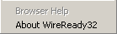
Browser Help This menu choice is not active at this time.
About WireReady32 Displays the version number of the software and contact information for WireReady NSI.

WIRE BROWSER

(Your source for building custom newscasts)

The WireBrowser is the activity hub of NewsReady32. This is where wire stories arrive, often a hundred or more in an hour, and are displayed in chronological order, with the most recent arrivals listed first. The WireBrowser shows each story’s headline, category, priority, and date and time. Within this application you can view, select, copy, print, sort, and save wire stories.

Before actually editing wire copy and inserting it into a newscast, it’s important to become familiar with the WireBrowser. The toolbar, located near the top of the screen, displays the WireBrowser’s primary functions.

Looking from left to right, the first toolbar button is Update. This feature manually updates the WireBrowser to display the most recent arrivals. The WireBrowser is programmed to update automatically, but the manual feature allows you to get updates whenever needed.

KEYBOARD PROCEDURE
Hold down ALT and hit U.

MOUSE PROCEDURE
Click Update on the toolbar.
OR - From the Menu bar click on File, then select Update.

The Search button is next on the toolbar. Information for this button follows shortly. The next button to the right is the All (for All Stories) button. The All button (formerly Show All) is similar to Update. It shows all stories in the WireBrowser; however, it does not instantly update the list. Use All anytime you wish to return to the complete list of stories. Activating Update updates the WireBrowser to show new stories based on the search specifications chosen. See the section on searching below for more information.

KEYBOARD PROCEDURE
Strike F3.

MOUSE PROCEDURE
Click All on the toolbar.
OR - From the Menu bar click on File, then select All Stories.

Sorting wire copy
NewsReady32 gives you the ability to view and arrange wire stories by headline (alphabetically), category (national news, sports, etc.), priority (rush, urgent, etc.), or date and time. To sort the wire copy, click the column heading (just below the toolbar) you wish to sort by. The wire stories will remain in this order until you change it. Click the column heading a second time to arrange the stories in reverse-alphabetical order. Remember that the All button (F3) will return the list to chronological order.

Adjusting the column width
To adjust the width of the columns in the WireBrowser simply move the mouse pointer to the vertical line that separates two columns. It is located on the gray column heading line. When the mouse pointer turns to a double-pointed horizontal arrow click and hold the left mouse button to move this separator bar to the left or right. The width of any column may be adjusted in this manner.

Changing the font, style, or point size
To change the font or the size of the characters that appear in the WireBrowser just click on Setup from the Menu bar, then select Fonts. Choose the font, style, and size you desire. These selections will remain intact until they are changed.

Viewing the toolbar and status bar
To turn On or Off the toolbar click on View on the Menu bar, then Toolbar. If a checkmark appears then the toolbar is currently visible. The same choice is available for the Status Bar. Again, a checkmark is visible when the status bar is turned on.

Searching wire copy
NewsReady32 offers powerful and easy-to-use searching capabilities that include pre-built searches that can be edited or deleted, plus the flexibility to create your own custom searches. Each user can have his or her own set of searches.

The F2 search
KEYBOARD PROCEDURE
Strike F2.

MOUSE PROCEDURE
Click Search on the toolbar.
OR - From the Menu bar click on File, then select Search.
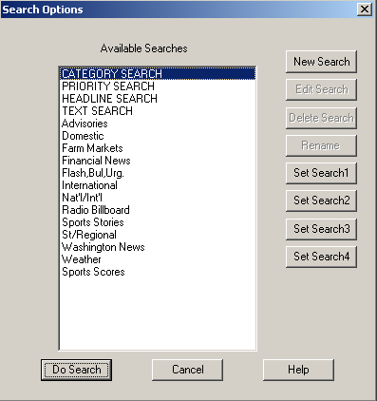
Double-click the heading of the search you wish to perform, or single-click to highlight the heading and click Do Search. The stories currently in the WireBrowser that meet that search's requirements will be displayed.

To return to a display of all stories, click the All button on the toolbar, or select All Stories from the File pull down menu, or hit F3 on the keyboard.

Category, Priority, Headline, and Text searches
These general searches are the first four on your list. They cannot be deleted.

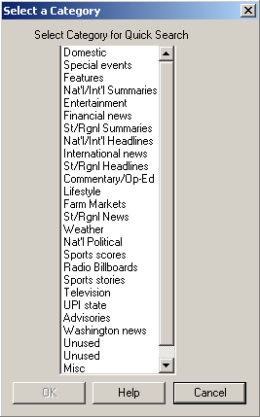
Category Search
This will display a list of all the categories (national news, sports, etc.) a story can have (as displayed on your browser).

To select this type of search double-click the word Category, or highlight it then strike ENTER. Choose the category you are looking for by double-clicking it, or by single-clicking to highlight it and clicking OK. With the keyboard, use the ARROW keys to scroll and highlight your desired category, then hit ENTER.

This will display a list of stories with the category you have chosen.

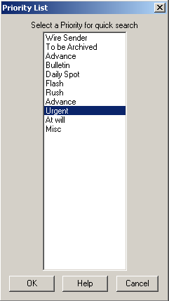

Priority search
This feature displays a list of all the priorities (rush, urgent, etc.) a story can have. Choose the priority you are looking for by double-clicking it, or by single-clicking to highlight it and clicking OK. With the keyboard, use the ARROW keys to scroll and highlight your desired priority, then hit ENTER.

This will display a list of stories with the priority you have chosen

NOTE: Categories and Priorities differ from wire service to wire service. The examples used above may not be an option, depending what wire service you have.

Headline search
This option lets you search headlines as they appear in WireBrowser. For example, to search for headlines containing the word Education, you would type Education and click OK or hit ENTER. All stories that have the word Education somewhere within the headline will be displayed
.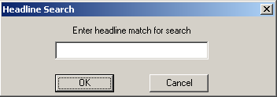

Text search
This option is similar to headline search, except that it will look for one or more words contained in the headline, category, priority and body of the story. For example, to search for stories containing the phrase Public school, you would type Public school and click OK or hit ENTER. This will display all stories that have the phrase Public school somewhere in the story.
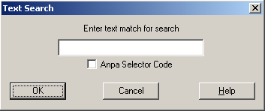
None of the F2 Searches are case-sensitive.

Creating new (Custom) searches
Users can create their own custom searches.

From the WireBrowser use your mouse to click the Search button on the toolbar, or select Search from the File pull down menu, or hit F2 on your keyboard. This will display a list of your current searches.

Click the New Search button. The “Add a new Custom Search” dialog box will be displayed. Use it to define which categories, priorities, headline or text matches you want to search within.

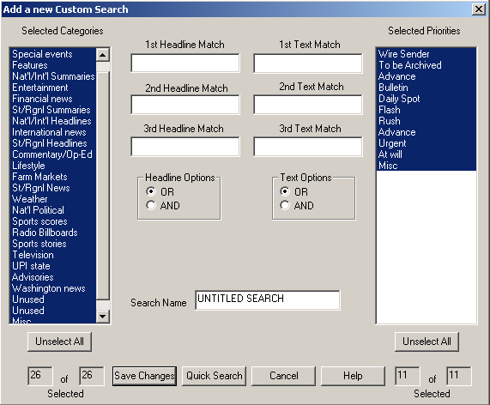

To select specific categories, first click on the Unselect All button to turn off the entire selection of categories, then single-click each category you want to be searched. To search all categories, do not click the Unselect All button. Repeat this process to select all or some of the priorities.

To search for specific words in a headline, type the word in the entry box labeled 1st Headline Match. There are a total of three text boxes for headline searches if you wish to look for additional words in a headline. If you use more than one headline text box then you also need to click on the radio button labeled OR, or the radio button labeled AND. To display only stories that contain ALL the headlines you listed in the text boxes choose AND. To display stories that contain ANY of the headlines you listed choose OR.

Repeat this process for a text search by using the Text Match entry boxes. Enter the phrases or keywords you are looking for within the body of the stories. Remember to choose between OR and AND if you use more than one Text Match box.

When finished, enter a name for this search in the Search Name entry box. By default it will say Untitled Search. Click on the Save Changes button. The name will then appear at the bottom of the list of searches when you select Search (F2) from the WireBrowser.

Setting Quick Searches
Buttons have been added to the toolbar to allow users to set their 4 most commonly used WireBrowser Custom Searches as a Quick Search. When using F2 to bring up the list of searches, the Search Options window now contains 4 additional buttons along the right side of the window (Set Search1 thru Set Search4).
To setup a Quick Search, highlight a search from the list in the Search Options window. Then click on a Set Search button to set that search as a Quick Search with that number.

Printing wire copy
Instructions for printing a newscast will be presented in greater detail later in this user guide, but it is also possible to print directly from the WireBrowser. Highlight a headline and choose from the following options:

KEYBOARD PROCEDURE
Strike F5.
OR - Hold down CTRL and hit P.

MOUSE PROCEDURE
Click Print on the toolbar.
OR - From the Menu bar click on File, then select Print.

You’ll see a print dialog box that will guide you through several printing options, including full story, individual pages or a range of pages, or print selection, which lets you print only that text you previously highlighted.

To print only a portion of a story, highlight the text before selecting Print.

Printing in double space
NewsReady32 provides the ability to print in double space so the hard copy is easier to read. This option is available when a story is open from the WireBrowser, the Notepad, or the FileLog. Simply click on Setup from the Menu bar, then select Double Space. The line spacing on the screen will not be affected, but once Print has been selected the text will re-flow to display the actual appearance. NOTE: A checkmark will appear beside Double Space when it is active. Another click on this choice will turn Double Space off.

Preview screen
This convenient feature of WireBrowser lets you divide the screen horizontally and view headlines, categories, etc. in the upper of the two windows. As you scroll up or down, individual headlines are selected or highlighted in the upper window, and the story that corresponds to each headline appears in the lower window.

Depending on its length, you may be able to view a particular story in its entirety in the lower window. But even if it runs longer, you can see it all by scrolling down, with either the keyboard’s ARROW keys or with the mouse.

To display the Preview screen (from the WireBrowser), move the mouse pointer toward the bottom of the WireBrowser window. Just below the last viewable headline, there is a gray, horizontal bar. Place the mouse pointer over this bar, and it becomes a double-pointed vertical arrow. Click and hold the left mouse button and drag the gray divider bar up or down to any position you wish. The Preview screen will be visible in the lower window. To close Preview, drag the divider bar back to the bottom of the screen
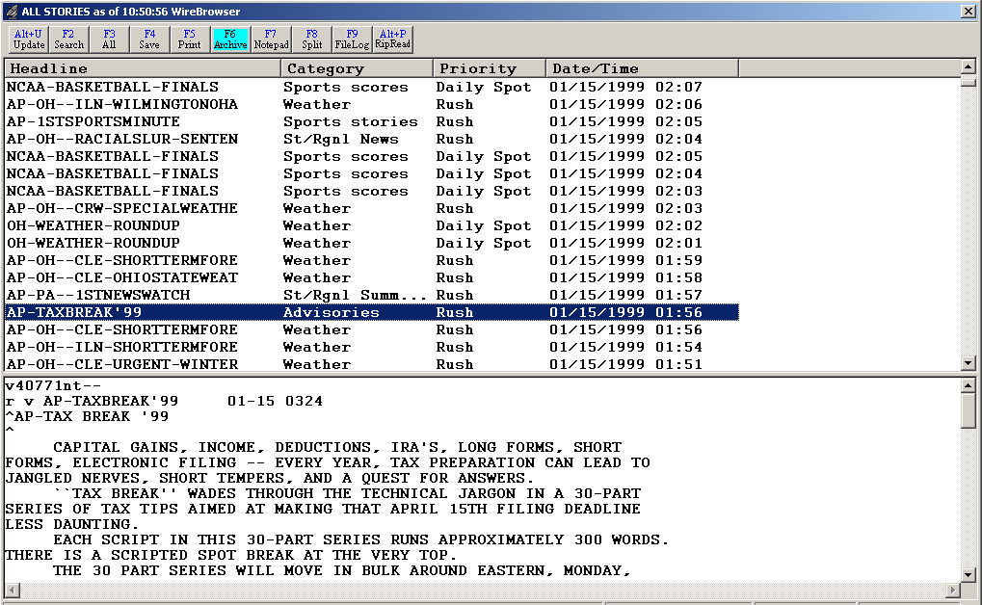
Divider Bar

Pop Viewer
A wire story can also be opened directly into an editor by double-clicking its headline or by highlighting the headline and hitting the ENTER key. When the story is opened in the Pop Viewer, you can edit, print, or copy and paste all or portions of it into the Notepad.
Within the Pop Viewer, the F11 and F12 keys will jump to the next or previous story in the list. This allows you to browse wire stories and select the ones you want as you go. Return to the WireBrowser by striking the ESC key.
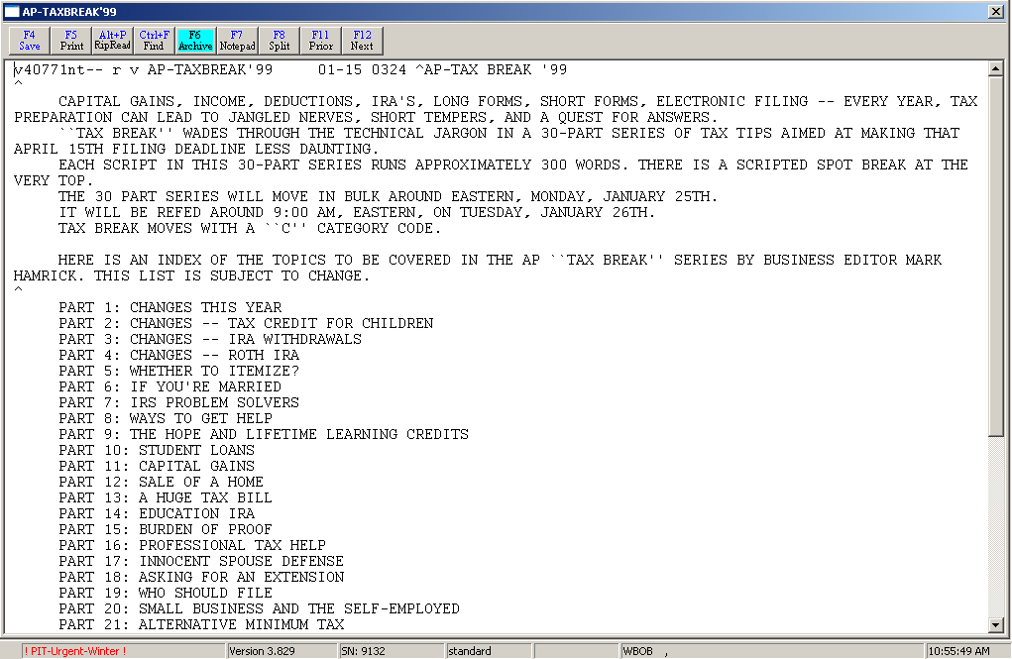

Auto Purge
It’s reasonable to ask that since wire stories are constantly being received by the WireBrowser, will the system ever become overloaded. A feature called Auto Purge, as the name suggests, automatically deletes wire stories (oldest first) when a set cache or database size is reached. Your systems administrator sets the size. For most radio stations, a 5-megabyte database will hold approximately 2000 stories or about two days’ worth of feeds.

Copying and Pasting Wire Copy
The WireBrowser, in combination with the Notepad, makes it easy to copy text from a wire story and place it into a customized newscast. Any portion of wire copy, from one word to the entire story, can be "pasted" into a newscast.

The first step is to select which story to use. If desired, use the Preview screen to view a story, or open the story in the Pop Viewer by double-clicking its headline or by highlighting the headline and hitting the ENTER key. Then highlight or select the text you wish to use:

KEYBOARD PROCEDURE
With the ARROW keys place the cursor at the beginning of the text you want to copy.
Hold down the SHIFT key and use the ARROW keys to move the cursor to the end of the desired text. (The SHIFT key in combination with PAGE UP, PAGE DOWN, HOME, or END will also highlight).

MOUSE PROCEDURE
Click with the mouse at the beginning of the text you wish to copy.
Click and hold the left button and move it to the end of the desired text, then release the button.

To copy the selected text:

KEYBOARD PROCEDURE
Hold down the CTRL key and hit the C (letter) key.

MOUSE PROCEDURE
From the Menu bar click on Edit, then select Copy.
OR - Click on the highlighted area with the right mouse button, then choose Copy with the left mouse button.

OPTIONAL PROCEDURE
You can achieve the same results by
Holding down the CTRL key and hitting the X (instead of C) key.
OR - Using the mouse, selecting Cut from the Edit pull down menu at the top of the screen.
OR - Clicking with the right mouse button, then choosing Cut with the left mouse button.

INFORMATION: You may hear the term "cut and paste" used in reference to this task. In this situation you are only copying, not cutting, text. Even if you use the CTRL-X key combination or choose Cut from the Edit pull down menu, the wire story remains intact for future use (though text momentarily appears to be missing.)

NOTE: The pull down menus can be accessed with the keyboard via the ALT key. Hold down the ALT key and hit the underscored letter of the menu you wish to open, then strike the underscored letter of the command you wish to perform.

Player
The Audio Player is a built-in cart deck that allows you to play audio files while reading your newscasts. The Audio Player can also be used to play music during live periods of an automated system.
The Audio Player includes 3 decks to play audio from, and a text window to read newscasts from. The gray divider bar can be adjusted by holding the left mouse key down while dragging the bar up or down to change the amount of text visible on the screen.

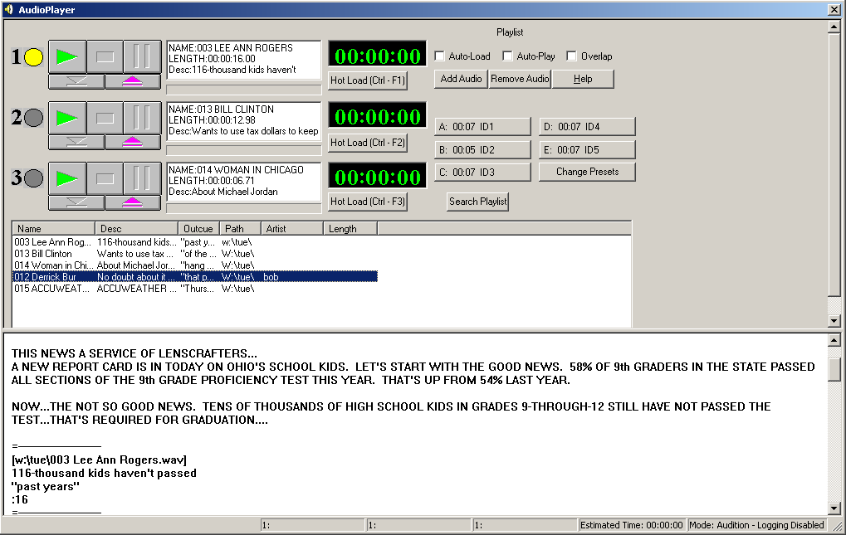

To open the Player:
Hold down the ALT key and hit the 4 (number) key.
OR - Click on the Player button on the toolbar.
OR - From the Menu bar click on Programs, then select AudioPlayer.

Player Buttons
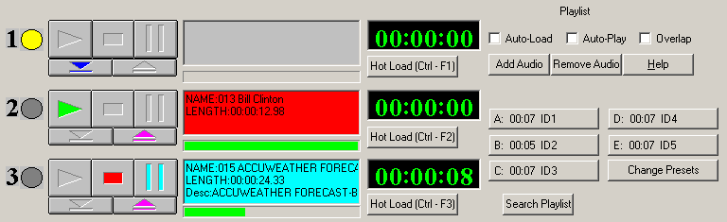

Yellow Dot Shows the Next Up deck, or the deck that will play next when using Auto Play.
Green Arrow Click this to Play the audio in the deck.
Red Square Click this to Stop the audio currently playing in the deck.
Light Blue Bars Click this to Pause the audio currently playing in the deck.
Blue Down-Arrow Click this to Load the deck with the highlighted audio file in the playlist window.
Pink Up-Arrow Click this to Eject the audio file from the deck.
Timer Displays the amount of time of the audio, either counting up or counting down.
Hot Load Button Click this to launch the File Select window to choose an audio file to load into the deck.

Auto-Load When checked, the first 3 audio files in the Playlist window will be loaded into the decks. When a file is done playing, it will be ejected and the next audio file will be loaded into the deck.
Auto-Play When checked, the audio files will play, beginning with the Next Up deck. When used in combination with Auto-Load, all the audio files in the playlist window will play.
Overlap When checked, the fade times will be used to allow the audio files to overlap. See the MediaLog section for setting up the fading parameters.
Add Audio Launches the File Select window to load an audio file into the playlist window. The audio will be added below the highlighted file in the playlist window.
Remove Audio Removes the highlighted audio file from the playlist window.
Help Launches a help file about the Player screen.
Presets A-E Displays the first five Preset buttons from the On-Air screen. These buttons can be loaded with audio that is used frequently, such as liners or Ids. Click on the button to play the audio. Click a second time to stop the audio.
Change Presets Allows the Preset Group to be changed.
Search Playlist Search the fields of the audio files in the playlist screen for the entered text.

Player Drop-Down Menu

The Main Menu, above the main Button bar, has 8 drop-down menus available for users to read newscasts onair, or play a series of audio files. Use the keyboard shortcut or click on the choice with the mouse to activate the menu choice.

AudioPlayer
Play Deck 1 (F1) Plays the audio loaded in Deck 1.
Play Deck 2 (F2) Plays the audio loaded in Deck 2.
Play Deck 3 (F3) Plays the audio loaded in Deck 3.
Stop Deck 1 (SHFT-F1) Stops the audio currently playing in Deck 1.
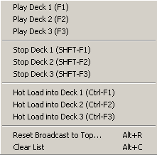
Stop Deck 2 (SHFT-F2) Stops the audio currently playing in Deck 2.
Stop Deck 3 (SHFT-F3) Stops the audio currently playing in Deck 3.

Hot Load into Deck 1 (Ctrl-F1) Launches the File Select window to load an audio file into Deck 1.
Hot Load into Deck 2 (Ctrl-F2) Launches the File Select window to load an audio file into Deck 2.
Hot Load into Deck 3 (Ctrl-F3) Launches the File Select window to load an audio file into Deck 3.
Reset Broadcast to Top Alt+R Ejects all audio from the decks and moves the cursor to the first file in the list of audio files.
Clear List Alt+C Clears all audio from the playlist window.

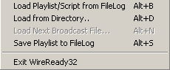
File
Load Playlist/Script from FileLog Alt+B Loads a text file into the bottom half of the screen, and loads the embedded audio files within that test file into the playlist window.
Load from Directory Alt+D Loads all the audio files from a directory into the playlist window.
Load Next Broadcast File Alt+N
Save Playlist to FileLog Alt+S Saves the audio in the playlist window as embedded files in a text file.
Exit WireReady32 Exits the user from the program.

Programs
The Programs menu lists the 11 screens in NewsReady32. Consult the other WireReady manuals for information on using the automation and sales screens.

Notepad – NewsReady Alt+1 The Notepad is used to edit text and create new stories and rotations.
FileLog – NewsReady Alt+2 The FileLog is used to access text stories that have been saved from the Notepad, and to edit rotations.
WireBrowser – NewsReady Alt+3 The WireBrowser displays the wire stories that have been captured.
AudioPlayer Alt+4 The Player is used to read newscasts and play the embedded audio.
MediaLog/AudioLog – NewsReady Alt+5 The MediaLog is used to store audio files to be used in newscasts and automation.
Utilities Alt+6 The Utilities screen allows access to StormReady32, QuickRecorder, and the DOS PhoneReady and StormReady programs.
Planner – NewsReady Alt+7 The Planner is a calendar program to track appointments and assignments for newsrooms.
Record Alt+8 The Record button is used to manually record new audio files.
Sales – SalesReady Alt+9 The Sales screen is used to record and track contacts with customers/advertisers.
Automate – ControlReady Alt+0 The Automate decks are used to automate recording and playback of audio, and for web publishing.
OnAir Alt+Shift+1 The OnAir 10-deck screen is used for playback of audio while live.

Setup
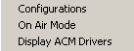
Configurations Allows the user to set the audio boards used for the 3 Player decks, the Notepad and the 8 Automate decks, and set the timer orientation.
On Air Mode When checked, a confirmation/activity log containing a record of every WAV file played from the Player is created in the following directory: [network drive]:\WIRE\USERS\[log-in name]\CONFIRM. This serves as a confirmation log for the audio that was played.
Display ACM Drivers Displays the available ACM drivers. The user cannot edit the information in this window.

View
Status Bar When checked, the status bar, which displays the audio device and counters, is visible at the bottom of the Player screen.
Window
In addition to the menu choices, any open NewsReady32 screens or open text files will be listed at the bottom of the menu choices in this drop-down window.
Previous Window Escape Puts the last window that was open before the Notepad as the current display.
Cascade Shift+F5 Allows the screens to be cascaded. Only active when the user is set to Windows Standard mode.
Tile Shift+F4 Allows the screens to be tiled. Only active when the user is set to Windows Standard mode.
Arrange Icons
Jump to Next Open Window Ctrl+Tab Makes the next open screen be displayed.
Toggle Active Dual Screen Ctrl+F2 Toggles between the 2 windows when the user is set to Dual Screen mode.
Switch F7 Toggles between the Notepad and the last open screen.
Split Last Two
Zoom/Split with Notepad F8 Splits the current screen (or last open screen) with the Notepad.
Clear Alert Shift+F11 Clears the red wire alert at the bottom of the screen for the logged-in user.
Clear Alert for All Users Shift +F12 Clears the red wire alert at the bottom of the screen for all users.

User
These menu choices are only available when using secure logins.
Send Message Ctrl+1 Sends a message to other users, which will appear in the header of the main window.
Clear Message Ctrl+2 Clears the message from the current user’s screen.
Message History Displays the date and text of the previously sent messages.

Help
Player Help This menu choice is not active at this time.
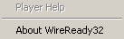
About WireReady32 Displays the version number of the software and contact information for WireReady NSI.

AUDIO PLAYER

There is another method to combine audio and text for a newscast. The Audio Player is a built-in cart deck that allows you to play audio files while reading your newscasts.

To change the basic configuration options of the cart deck:
- From the Audio Player Menu bar, click Setup.
- Click Configurations. This will open the Configure Audio Devices dialog box.
- Click on the Player Audio Boards tab. Audio boards can be assigned to each of the Player decks. This applies if there are more than one audio card installed in your computer. If only one audio card is installed, the decks should all be assigned to the same audio board.
- Click the drop-down arrows to view the audio-card address settings.
- Choose the audio board to assign to each Player Deck and the Player Buttons.
- Click the Options tab to choose how the timers work on the cart deck(s).
- When finished, click OK.
Note: The audio boards assigned to Player Decks 1-3 will also be used by the Notepad for playing embedded audio.

On Air Mode vs. Audition Mode
The Audio Player offers two modes of operation: On Air and Audition mode. The difference concerns whether the logging capability is enabled. In On Air Mode, a confirmation/activity log containing a record of every WAV file played from the Audio Player is created in the following directory: [network drive]:\WIRE\USERS\[log-in name]\CONFIRM. This serves as a confirmation log for the audio that was played.
To switch between modes click Setup on the Menu bar, then click On Air Mode. When the On Air mode is active, a checkmark will appear.

Setting up the Logging Capability
In order for the Audio Player to log audio files that have been played it is necessary that a folder called CONFIRM exists in the users directory. Once the logging is enabled you can view and print these confirmation/activity logs from the Notepad.

To create a CONFIRM directory:
- From the Notepad, click the Open button, or strike F10. This will open a window displaying various folders.
- Select the network drive letter. This is located in the "Look in" box. If it is necessary to change drives then click on the down-triangle just to the right of the "Look in" box.
- Locate and open the WIRE folder.
- Locate and open the USERS folder.
- Locate and open the folder for the current user, i.e. NEWS1.
- If the CONFIRM folder is displayed, then click Cancel. The computer is set up to log files. [Skip steps 7-10].
- If the CONFIRM folder does not appear then it must be created.
- Click the button that shows a folder with a star (toward the top of the dialog box). This will create a new folder.
- Type CONFIRM as the folder's name, and press ENTER.

To open and print a log from the Notepad follow these steps:
- Click the Notepad button or strike F7 or ALT-1.
- Click the Open button or strike F10.
- Locate and open the CONFIRM folder under the WIRE\USERS\[user name] directory.
- Click the down-arrow to the right of the Files of type box, and choose All Files (*.*).
- Double-click the log you wish to view.
- To print the log, click the Print button, or strike F5.
- The logs will be named "mm-dd-yy.log", and will display the name and time stamp of the audio file.

NOTE: In the future this confirmation/activity log will also be available for the Notepad, Live Assist, and Automate features in NewsReady32.

Loading the Newscast into Audio Player
A newscast must be loaded into the Audio Player before it can be aired. In the Audio Player screen a newscast and a broadcast file are the same thing.

To load a newscast file into the Audio Player:
- From the Audio Player Menu bar click File, then Load Playlist/Script from FileLog, or strike ALT-B.
- Locate and choose the broadcast file you wish to load. Double-click it, or single-click it then click Open.
- The actual text of the broadcast file is located at the bottom of the Audio Player window. The audio files that were inserted into the broadcast file are listed in the playlist window. The audio files are loaded in the order in which they were embedded into your newscast. They are tagged with the file name, description (if any), and outcue text (if any).

NOTE: If you already have a broadcast file loaded and you load a second one, the decks will automatically be reset and loaded with the new audio files.

Positioning the Divider Bar
Within the Audio Player window is a horizontal gray bar, which can be positioned to show as much or as little of your newscast as you wish. It appears just below the cart deck section of the screen.

To adjust the divider bar:
- Place the mouse pointer on the gray divider bar.
- The mouse will turn into a two-pointed vertical arrow.
- Click and hold down the left mouse button and move the bar up or down.
- Release the button when the bar is in the desired position.

Auto-Load vs. Manual Load
One of the features of the Audio Player is its ability to automatically load the next audio file from your newscast as you play the audio files. After an audio file as finished playing, it will be automatically ejected, and the next audio file on the list will be loaded immediately. As you scroll and read your newscast from the lower half of the Audio Player, you can play each cart in the order they are listed in the newscast.

NOTE: When the Auto-Load feature is enabled, the first deck loads the first audio file in the playlist, the second cart deck loads the second audio file from the playlist, and so on.

Enable/Disabling Auto-Load
There may be times when you prefer to manually load different audio files to preview them before playing over the air. Just below the playlist window is a check box labeled Auto-Load. When this box is checked, the Auto-Load feature is enabled. Simply click the box to activate or deactivate Auto-Load.

Manually loading carts from the list
The audio files that are listed in the Playlist can be loaded manually if that is your preference.

Here are the steps:
- Load a newscast/broadcast file.
- Click the Auto-Load check box to turn OFF Auto-load by unchecking it.
- Double-click the audio file you wish to load from the playlist. A window will appear asking you to choose which audio deck to load into. Click on the appropriate deck.
OR
3. Use the mouse or ARROW keys to highlight the audio file you wish to load. Then click the blue down-arrow in the deck you wish to load.

Loading Audio Files Directly
Individual audio files can also be loaded from a directory, as opposed to loading a broadcast file. This gives you the option of playing audio files on the air without a broadcast file present.

To load an entire directory (folder) containing audio files follow these steps:
- From the Audio Player Menu bar, click File, then Load From Directory, or strike ALT-D.
- Locate the folder that contains the audio files you wish to load.
- Highlight it, then click OK.
- All of the WAV files that are located in that folder will be loaded into the Playlist.

Loading audio files in this manner still allows you to use the auto-load feature described in the previous section.

Reading your newscast on air (Single Audio Deck)
It's time to review how to set up and read newscasts on the air. (This assumes you already have a newscast written, complete with embedded audio.)

Follow these steps:
- From the Audio Player Menu bar, Click File.
- Click Load Broadcast File, and then select the file you wish to load.
- Adjust to the horizontal divider bar if necessary.
- Confirm that the Auto-Load option is checked. This should cause the first cart of your newscast to be loaded in the first audio deck, the second cart into the second deck and the third cart in the third deck.
- To play the cart, click the green Play button. Once a cart is playing, the deck will turn green and the timer will begin to move. To stop the cart, click the red Stop button. This will also automatically eject the cart and load the next file. To pause, click the blue Pause button. While the cart is paused the deck is blue.
- Audio files can also be played by pressing the F11 key. It will play the next-up deck, which has a yellow dot to the left of it. Once an audio file has finished playing, it will automatically eject. The next audio file from your newscast will then load itself and be ready to play. You can scroll to read your newscast, then play the audio files at the appropriate times.

Resetting your Broadcast
You can reset your broadcast at any time. This ejects all audio decks and reloads with the first audio file(s). To do this click AudioPlayer on the Menu bar, and then Reset Broadcast To Top, or strike ALT-R.

MediaLog
The MediaLog lets you manage and view audio files. You can change the name of the audio file, add or edit a description, outcue/intro text, category, status, start and stop dates, and fading options for each audio file. You can also preview the audio file with a single click of a button.

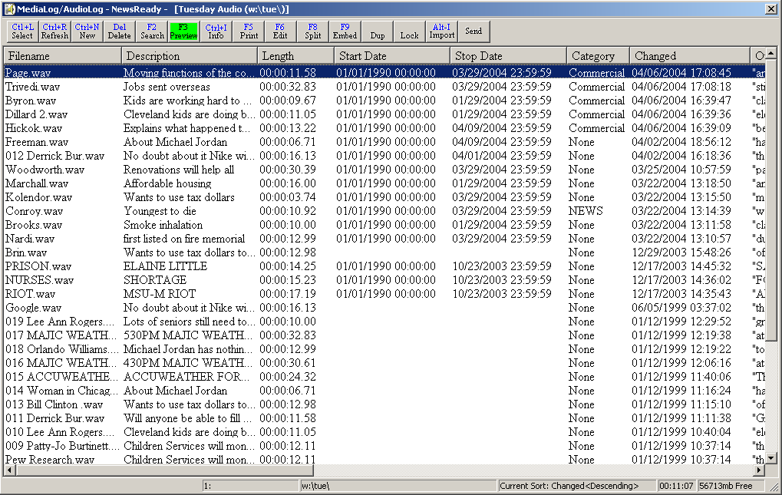

To open the MediaLog:
Hold down the ALT key and hit the 5 (number) key.
OR - Click on the MediaLog button on the toolbar.
OR - From the Menu bar click on Programs, then select MediaLog/AudioLog.

MediaLog Toolbar

Ctrl+L Select Launches the Custom Folder window to allow the user to switch MediaLog folders.
Ctrl+R Refresh Rebuilds the display and refreshes the screen. Sorts the display by the Changed date, in descending order.
Ctrl+N New Allows the user to create a new audio file for recording. The file will be stored in the currently open MediaLog folder.
Del Delete Deletes the highlighted file or files.
F2 Search Searches the current MediaLog folder for text in any of the fields, and displays only the files that meet the search parameters.
F3 Preview Plays the highlighted audio file. Click on this button while the audio is playing to stop the audio.
F4 Info Launches the AudioLog Editor window and allows the user to edit the fields for the highlighted file.
F5 Print Allows the user to print a list of audio files in the current folder. The output can be sent to the printer or to a file for sending to the music or traffic program.
F6 Edit Opens the highlighted file into the default audio editor.
F8 Split Splits the MediaLog screen with the current Notepad screen.
F9 Embed Embeds a link to the highlighted audio file into a Notepad or currently open FileLog story at the cursor position.
CTL+D Dup Allows the highlighted audio file to be copied or moved to another folder.
CTL+O Lock Toggles between read-only and normal attributes for the highlighted file. When locked, a file can be opened and edited, but not overwritten or deleted.
Alt+I Import Import/Sync files from one machine to another. Uses the source and target locations from the Sync command configured in the Automate screen.
CTL+S Send Sends the audio file to another station, when using Pcapture.

MediaLog Drop-Down Menu

The Main Menu, above the main Button bar, has 9 drop-down menus available for users to create and edit text files. Use the keyboard shortcut or click on the choice with the mouse to activate the menu choice.

AudioLog
Send Sends the audio file to another station, when using Pcapture.

File
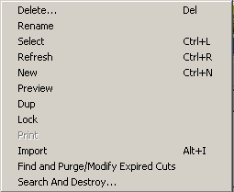
Delete Del Deletes the highlighted file or files.
Rename Allows the user to rename the highlighted file.
Select Ctrl+L Launches the Custom Folder window to allow the user to switch MediaLog folders.
Refresh Ctrl+R Rebuilds the display and refreshes the screen. Sorts the display by the Changed date, in descending order.
New Ctrl+N Allows the user to create a new audio file for recording. The file will be stored in the currently open MediaLog folder.
Preview Plays the highlighted audio file. Click on this button while the audio is playing to stop the audio.
Dup Allows the highlighted audio file to be copied or moved to another folder.
Lock Toggles between read-only and normal attributes for the highlighted file. When locked, a file can be opened and edited, but not overwritten or deleted.
Print Allows the user to print a list of audio files in the current folder. The output can be sent to the printer or to a file for sending to the music or traffic program.
Import Alt+I Import/Sync files from one machine to another. Uses the source and target locations from the Sync command configured in the Automate screen.
Find and Purge/Modify Expired Carts Finds expired carts and gives the user the option to delete, move, and modify the files.
Search And Destroy Allows the user to find and remove a file from all custom folders.

Edit
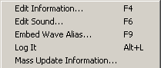
Edit Information F4 Launches the AudioLog Editor window and allows the user to edit the fields for the highlighted file.
Edit Sound F6 Opens the highlighted file into the default audio editor.
Embed Wave Alias F9 Embeds a link to the highlighted audio file into a Notepad or currently open FileLog story at the cursor position.
Log It Alt+L Marks the current text file as used. Updates the Last Played field with the current date and time, and adds 1 to the Times Played field.
Mass Update Information Allows the user to change any of the fields in the AudioLog Editor screen for multiple files.

Programs
The Programs menu lists the 11 screens in NewsReady32. Consult the other WireReady manuals for information on using the automation and sales screens.

Notepad – NewsReady Alt+1 The Notepad is used to edit text and create new stories and rotations.
FileLog – NewsReady Alt+2 The FileLog is used to access text stories that have been saved from the Notepad, and to edit rotations.
WireBrowser – NewsReady Alt+3 The WireBrowser displays the wire stories that have been captured.
AudioPlayer Alt+4 The Player is used to read newscasts and play the embedded audio.
MediaLog/AudioLog – NewsReady Alt+5 The MediaLog is used to store audio files to be used in newscasts and automation.
Utilities Alt+6 The Utilities screen allows access to StormReady32, QuickRecorder, and the DOS PhoneReady and StormReady programs.
Planner – NewsReady Alt+7 The Planner is a calendar program to track appointments and assignments for newsrooms.
Record Alt+8 The Record button is used to manually record new audio files.
Sales – SalesReady Alt+9 The Sales screen is used to record and track contacts with customers/advertisers.
Automate – ControlReady Alt+0 The Automate decks are used to automate recording and playback of audio, and for web publishing.
OnAir Alt+Shift+1 The OnAir 10-deck screen is used for playback of audio while live.

Setup
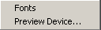
Fonts Set up the font size and style for the MediaLog.
Preview Device Sets the audio device used for previewing the audio from the MediaLog folders. The list of devices can be found from the Configurations/Setup menu choice in the Player screen.

View
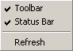
Toolbar When checked, the toolbar buttons at the top of the MediaLog will be visible.
Status Bar When checked, the status bar, which displays the preview audio device, current folder, sort settings, total time of the audio in the folder, and the amount of free space left, is visible at the bottom of the browser screen.
Refresh Rebuilds the display and refreshes the screen. Sorts the display by the Changed date, in descending order.

Window
In addition to the menu choices, any open NewsReady32 screens or open text files will be listed at the bottom of the menu choices in this drop-down window.

Previous Window Escape Puts the last window that was open before the Notepad as the current display.
Cascade Shift+F5 Allows the screens to be cascaded. Only active when the user is set to Windows Standard mode.
Tile Shift+F4 Allows the screens to be tiled. Only active when the user is set to Windows Standard mode.
Arrange Icons
Jump to Next Open Window Ctrl+Tab Makes the next open screen be displayed.
Toggle Active Dual Screen Ctrl+F2 Toggles between the 2 windows when the user is set to Dual Screen mode.
Switch F7 Toggles between the Notepad and the last open screen.
Split Last Two
Zoom/Split with Notepad F8 Splits the current screen (or last open screen) with the Notepad.
Clear Alert Shift+F11 Clears the red wire alert at the bottom of the screen for the logged-in user.
Clear Alert for All Users Shift +F12 Clears the red wire alert at the bottom of the screen for all users.

User
These menu choices are only available when using secure logins.
Send Message Ctrl+1 Sends a message to other users, which will appear in the header of the main window.
Clear Message Ctrl+2 Clears the message from the current user’s screen.
Message History Displays the date and text of the previously sent messages.

Help
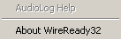
AudioLog Help This menu choice is not active at this time.
About WireReady32 Displays the version number of the software and contact information for WireReady NSI.

MEDIA LOG

The MediaLog lets you view WAV audio files in a particular directory. You can also change the name of the audio file and add or edit a description. In addition, you can add or edit other fields such as outcue/intro text, category (such as sports, news, etc.), status (such as "needs to be edited", "ready for air", etc.) and the initials of the person who created the file. You can also preview the audio file with a single click of a button.

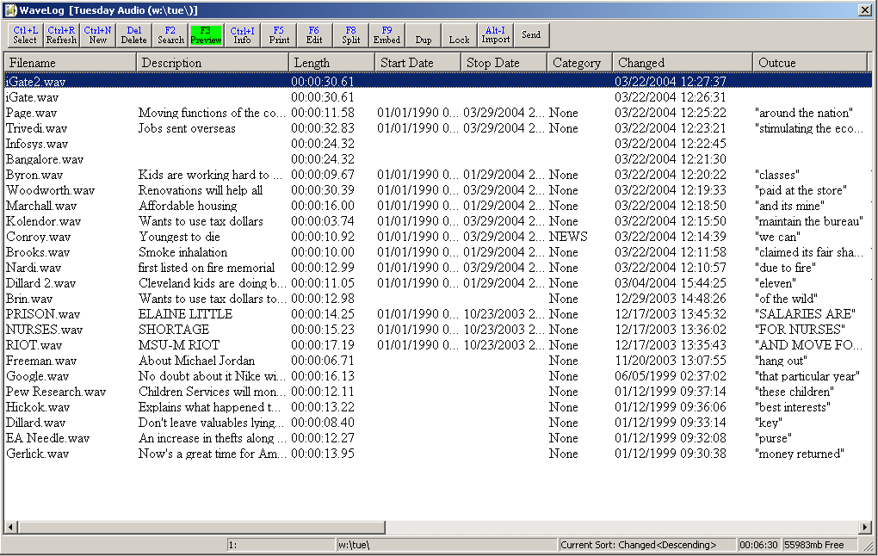

Selecting an Audio File
The structure of the MediaLog is similar to the FileLog. The same process is used to change folders and refresh the current folder.

To locate and open an audio file from the MediaLog, follow these steps:
- Click the MediaLog button at the top of the screen, or strike ALT-5.
- Click the Select button on the MediaLog toolbar, or strike CTRL-L.
- This will open a window displaying the available folders.
- Double-click the folder that contains the audio file, or single-click to highlight then click OK, or use the ARROW keys to highlight then strike ENTER.
- The audio files will be listed in the MediaLog window.

Editing the audio of an audio file
Once the list of audio files is displayed in the MediaLog window, it is possible to edit any of the audio files with a program like Cool Edit or GoldWave (or the program set as the default audio editor.).

Setting the default audio editor
It is recommended that GoldWave be set as the default audio editor. Other media players can cause significant conflict with GoldWave. This conflict may also be noticeable when using NewsReady32, and therefore may affect a news broadcast.

Follow these steps if you wish to make GoldWave your default audio player/editor (the options may be different due to Microsoft changes between Windows versions):
1. Double-click the "My Computer" icon on your desktop
2. From the Menu bar choose Tools, then Folder Options.
3. Click the File Types tab.
4. In the list of file types, find WAV Sound. Single-click on it.
5. The settings for that file type are shown in the File Type Details box. Make sure the extension is WAV.
6. Click the Edit or Change button.
7. In the Actions box, click Open.
8. Click the Edit button, then choose which program to use in opening files with this extension. You may wish to click on the Browse button to locate GoldWave. The default directory and file for GoldWave is C:\PROGRAM FILES\GOLDWAVE\GOLDWAVE.EXE.
9. Click OK when done. Then click CLOSE. Then click CLOSE again if necessary.

Once GoldWave has been set as the default audio editor, double-click the audio file name you wish to edit, or strike F6 from the MediaLog. This will automatically open GoldWave with the selected audio file. You can then switch between programs by either clicking the appropriate window or the respective buttons on the task bar, which is located at the bottom of the screen.

NOTE: Detailed instructions for GoldWave are not provided in this user manual. WireReady NSI will provide information on using GoldWave upon request.

Editing the information attached to an audio file
Once you have a listing of audio files in your MediaLog window, you can edit its information (name, description, category, status, etc.) with the click of a button.

Here's how:
- Single-click the audio file name to highlight it, or use the ARROW keys.
- Click the Info button on the toolbar, or strike F4.
- Edit the information you wish then click Save Changes when done.
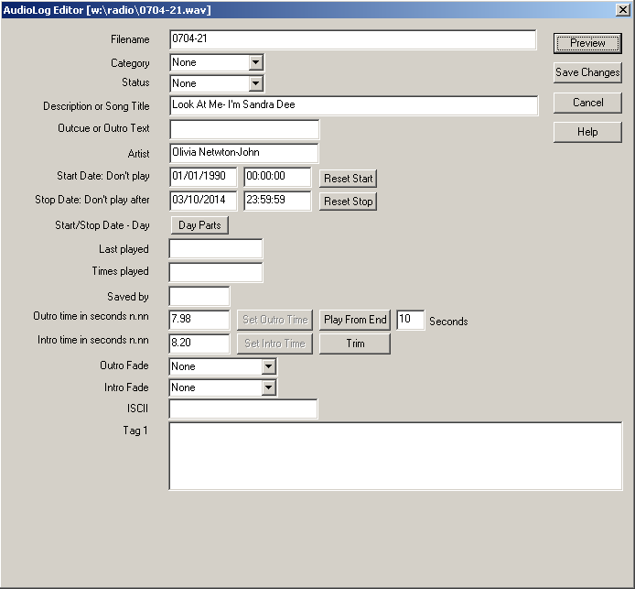
NOTE: While in the Info window you can also listen to the audio file by clicking the Preview button.

Mass Update of audio files
There may be times when a user needs to make changes to the information on multiple files. The MediaLog now supports that starting in version 4.006.
- Select one or more audio files, using the Shift or Ctrl keys while clicking with the mouse.
- Choose Edit from the main menu and then choose Mass Update Information.
- Choose the fields to update by clicking on the checkbox to the left of the field.
- Enter the information for each field and click OK. The info in the fields will be overwritten for those audio files.
Any unchecked info fields are left unaltered for the audio files. If you check a field and leave the field blank, that causes the field to be changed to blank on the applicable audio files.
If an audio file can't be updated because it's in use, a message will be given and that file will be skipped.

Deleting an Audio File
Each user can be granted permission to delete files. This applies to text files and audio files. See your systems administrator if you have been restricted from deleting files.

To permanently delete the audio file from your system follow these steps:
- Click the audio file you wish to delete, or use the ARROW keys to highlight.
- Click the Delete button on the toolbar, or choose File on the Menu bar then select Delete, or strike the DELETE key on the keyboard.

Refreshing the audio file list
If your MediaLog is open and you (or someone else) saves an audio file to the same folder then it will not instantly appear on your list. To update the list, click on the Refresh button, or strike CTRL-R.

Sorting the MediaLog
The audio files can be sorted alphabetically by any of the columns in the MediaLog. Simply click the desired gray column heading. A second click will cause the list to appear in reverse order. To return the list to its original order, click on the Refresh button, or strike CTRL-R.

Duping an audio file
Audio files can be copied or moved to another folder within the MediaLog. This is particularly helpful when audio files need to be placed in an archive folder for storage. Many stations will dump audio files weekly to save storage space on the file server; therefore, it is wise to store important audio cuts in a designated location so they don't get deleted. The Dup button in the MediaLog allows files to be copied or moved to another folder. NOTE: In the future a third option will be available. The FTP button will allow audio to be placed onto a web site. This option is currently not functional.

To copy or move an audio file:
- From the MediaLog highlight the audio file to be duped.
- Click on the Dup button.
- Choose whether to Copy to another folder or to Move to another folder.
- From the Custom Folders list highlight the folder where you wish to dup the file.
- Keep the same file name or change it.
- Click the Save button.

NOTE: "Copy to another folder" does not remove the audio file from the original folder, but "Move to another folder" does.

Recording audio
NewsReady32 provides three methods to record new audio with GoldWave. Each way will place the new audio file into the MediaLog.

METHOD 1:
- Open the MediaLog folder where the new audio file is to be stored.
- Click on the New button or strike CTRL-N.
- Enter a name for the file, then click OK or strike ENTER.
- GoldWave will open.
- Click the Record button.
- Use the board or microphone to record the audio.
- Edit the audio file using delete, normalize, etc.
- From the Menu bar click on File, then Save. or from the Toolbar click on the Save icon.
- Exit GoldWave.
- The audio file will be saved to the folder currently open in the MediaLog.
- Click the Refresh button or strike CTRL-R.

METHOD 2:
- From any screen, click on the Record button or strike ALT-8.
- Enter a name for the new audio file. (This may be left blank. The log-in name along with the time and date will become the file name).
- Choose a folder to store the file.
- Enter any information about the file (description, outro, etc)
- Click OK or strike ENTER.
- GoldWave will open.
- Click the Record button.
- Use the board or microphone to record the audio.
- Click the Close box (the X in the upper, right corner of the Window).
- When asked to save the file, choose Yes.
- From the MediaLog, click the Refresh button or strike CTRL-R.
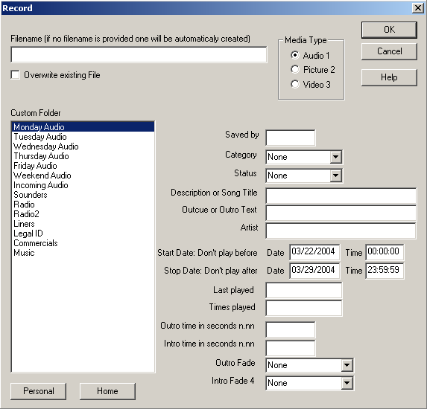
METHOD 3:
- From the Notepad, click File on the Menu bar, and then Record, or strike CTRL-R.
- Enter a name for the file, then click OK or strike ENTER.
- GoldWave will open.
- Click the Record button.
- Use the board or microphone to record the audio.
- Edit the audio file using delete, normalize, etc.
- Save the file, then exit GoldWave.
- The path name of the file will appear in the Notepad. IMPORTS is the default audio folder.
- From the MediaLog, open the IMPORTS folder.
- Click the Refresh button or strike CTRL-R if necessary.

NOTE: Method 3 not only places the audio file into the MediaLog, but it will also embed the recorded audio into the current Notepad.

Utilities

The Utilities button provides access to the DOS PhoneReady and StormReady programs, and the StormReady32 and QuickRecorder programs. If your station has purchased any of these programs then you will have access to them. Otherwise, ignore this button. All of these programs have their own user manuals and will not be described in detail here.

To open the Utilities window:
Hold down the ALT key and hit the 6 (number) key.
OR - Click on the Utilities button on the toolbar.
OR - From the Menu bar click on Programs, then select Utilities.

Planner
The Planner functions as both a system-wide and personal organizer/calendar.

The Planner allows you to:
- Store news stories for use on any given day.
- Set up personal calendars for every user.
- Schedule internal meetings.
- List upcoming events.
- Set staff assignments.

All users (when NewsReady32 is purchased and registered for group deployment) can access public information such as Future stories and Assignments, but at the same time, the Personal option lets individual users organize and plan their own activities. A user can view only the Personal Planner that is associated with his/her login and password.

To open the Planner window:
Hold down the ALT key and hit the 7 (number) key.
OR - Click on the Planner button on the toolbar.
OR - From the Menu bar click on Programs, then select Planner.

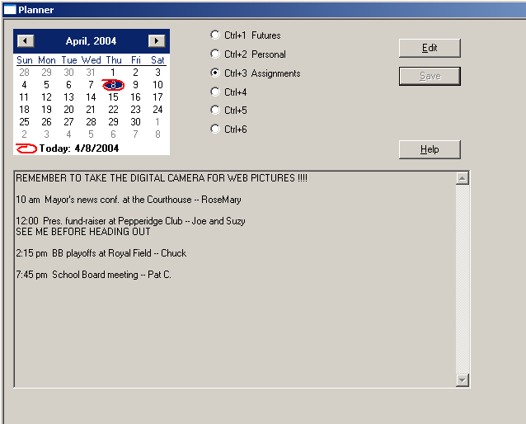

Calendar
Click on a date to view or edit the text contents assigned to that date.
Click on the arrow buttons in the calendar header to move between months.
To quickly return to today’s date, click on Today at the bottom of the calendar.

Radio Buttons
The first 3 radio buttons are pre-configured. The last 3 can be configured for the station’s use. Contact WireReady NSI for assistance in setting up the categories for the last 3 buttons.
Each radio button can have different text displayed in the text area of the screen.
Ctrl+1 Futures Future events or stories.
Ctrl+2 Personal Text in this category will only show what was entered for the logged-in user.
Ctrl+3 Assignments Staff assignments for the date.

Edit button Allows the text window to be edited. The text area will be gray until this button is clicked.
Save button Saves the text entered into the text window. Will return the text area to gray.
Help button Launches the help button to explain the Planner screen.

Text window Area where text can be added and edited.

Planner Drop-Down Menu

The Main Menu, above the main Button bar, has 7 drop-down menus available for users to edit a calendar for tracking news assignments and upcoming events. Use the keyboard shortcut or click on the choice with the mouse to activate the menu choice.

Planner
There are no sub-menus listed under this choice.

File
Exit WireReady32 Exits the user from the program.

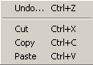
Edit
Undo Ctrl+Z Undo the last change in the current Planner screen.
Cut Ctrl+X Cuts the highlighted text out of the current Planner.
Copy Ctrl+C Copies the highlighted text in the current Planner and holds it on the Clipboard.
Paste Ctrl+V Pastes the Clipboard text to the cursor position in the current Planner.

Programs
The Programs menu lists the 11 screens in NewsReady32. Consult the other WireReady manuals for information on using the automation and sales screens.

Notepad – NewsReady Alt+1 The Notepad is used to edit text and create new stories and rotations.
FileLog – NewsReady Alt+2 The FileLog is used to access text stories that have been saved from the Notepad, and to edit rotations.
WireBrowser – NewsReady Alt+3 The WireBrowser displays the wire stories that have been captured.
AudioPlayer Alt+4 The Player is used to read newscasts and play the embedded audio.
MediaLog/AudioLog – NewsReady Alt+5 The MediaLog is used to store audio files to be used in newscasts and automation.
Utilities Alt+6 The Utilities screen allows access to StormReady32, QuickRecorder, and the DOS PhoneReady and StormReady programs.
Planner – NewsReady Alt+7 The Planner is a calendar program to track appointments and assignments for newsrooms.
Record Alt+8 The Record button is used to manually record new audio files.
Sales – SalesReady Alt+9 The Sales screen is used to record and track contacts with customers/advertisers.
Automate – ControlReady Alt+0 The Automate decks are used to automate recording and playback of audio, and for web publishing.
OnAir Alt+Shift+1 The OnAir 10-deck screen is used for playback of audio while live.

Window
In addition to the menu choices, any open NewsReady32 screens or open text files will be listed at the bottom of the menu choices in this drop-down window.
Previous Window Escape Puts the last window that was open before the Notepad as the current display.
Cascade Shift+F5 Allows the screens to be cascaded. Only active when the user is set to Windows Standard mode.
Tile Shift+F4 Allows the screens to be tiled. Only active when the user is set to Windows Standard mode.
Arrange Icons
Jump to Next Open Window Ctrl+Tab Makes the next open screen be displayed.
Toggle Active Dual Screen Ctrl+F2 Toggles between the 2 windows when the user is set to Dual Screen mode.
Switch F7 Toggles between the Notepad and the last open screen.
Split Last Two
Zoom/Split with Notepad F8 Splits the current screen (or last open screen) with the Notepad.
Clear Alert Shift+F11 Clears the red wire alert at the bottom of the screen for the logged-in user.
Clear Alert for All Users Shift +F12 Clears the red wire alert at the bottom of the screen for all users.

User
These menu choices are only available when using secure logins.
Send Message Ctrl+1 Sends a message to other users, which will appear in the header of the main window.
Clear Message Ctrl+2 Clears the message from the current user’s screen.
Message History Displays the date and text of the previously sent messages.

Help
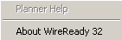
Planner Help This menu choice is not active at this time.
About WireReady32 Displays the version number of the software and contact information for WireReady NSI.

Record
The Record screen allows new audio, pictures or video files to be created using the default editor for that type of media. When Record is used, a new file is launched that has the preferred settings for the station’s media (such as 22kHz, 16-bit mono audio for *.wav format).

To open the Record window:
Hold down the ALT key and hit the 8 (number) key.
OR - Click on the Record button on the toolbar.
OR - From the Menu bar click on Programs, then select Record.

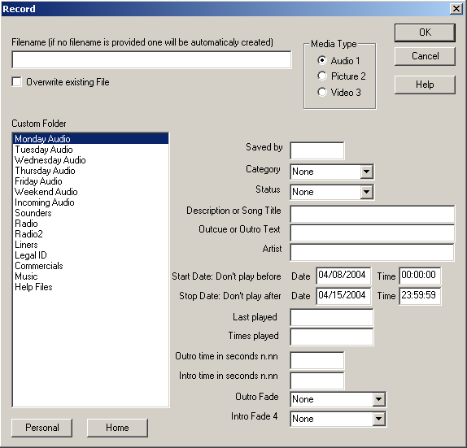

Filename: Enter the name of the file, without extension. If no filename is entered, the file will be named with the user's login name, and the date and time that the file was created.

Overwrite existing File: Click on this statement when creating a new recording that has the same filename as an existing sound file. The user will be prompted to overwrite the file when the OK button is clicked. If the filename entered is the same as an existing sound file, the user will be prompted to enter a new filename if this statement is not checked.

Custom Folder: Choose a Custom Folder from the list; use one of the following techniques:
-Click on the folder name to highlight it.
-Strike Alt-C, then
-Use the arrow keys to highlight the name.
-OR-
-Strike the first letter of the Custom Folder name. If there are multiple folders with the same first letter in the list, strike that letter until the desired folder is highlighted.

Home button: When a Custom Folder has sub-folders, you may only see a list of these sub-folders. Clicking on the Home button, or striking Alt-H, will take the user back to the main list of custom folders.

Personal button: A personal folder is available for files that are not to be shared with other users. The personal folder will only be available for the workstation user name when in workstation mode, or for the individual user name when in secure-login mode. This is not a password-protected folder

Media Type: Choose the type of media that will be recorded, Audio, Picture, or Video. The default editor for that type of media will be launched when the OK button is clicked.

Saved by: Enter the name of the user who recorded or edited the sound file.

Category: Use the drop-down arrow to view the Category list. Click on the category to assign it to the sound file. Use None if no category is to be assigned.

Status: Use the drop-down arrow to view the Status list. Click on the status to assign it to the sound file. Use None if no status is to be assigned.

Description or Song Title: Enter a description of the sound file if the file is an actuality used for news, or a song title if the file is music. The text entered in this dialog box will be included when the sound file is embedded into the NotePad, and will appear in the Parameters section of the Automate screen when scheduled in a playlist.

Outcue or Outro Text: Enter the last few words spoken if the file is a news actuality. The text entered in this dialog box will be included when the sound file is embedded into the NotePad.

Artist: Enter the name of the musical group or individual singer if the file is music.

Start Date: Don't play before: Enter the earliest date and time for the sound file to be played. The sound file will not play before this date and time when it is scheduled in an automation program if configured to Obey Start and Stop Dates.
Stop Date: Don’t play after: Enter the last date and time to play this sound file. The sound file will not play after this date and time when it is scheduled in an automation program if configured to Obey Start and Stop Dates.

Last played: This field will not be filled in, since the file is just being created.

Times Played: This field will not be filled in, since the file is just being created.

Outro time in seconds: Enter the number of seconds that the music can be set to overlap the next song or the jock speaking.

Intro time in seconds: Enter the number of seconds that the music can be set to overlap the previous song or jock speaking.

Outro Fade: Click on the drop-down arrow to view a list of outro options. Click on the desired option.
None: the sound file will be at 100% during the outro time.
Fade Down: continuous, steady decrease of the audio level from 100% to 0% for the duration of the outro time.
Talk over next cart: allows the jock to talk over the intro time of the next sound file that is scheduled to play. Keeps the level of the next sound file at 80% until the last second of the intro time.
EOM: talk-over liners can be inserted between songs. The computer will automatically play a liner over the end of the previous song at a programmable EOM, then bring the next song up so that the jock's track stops at exactly the intro time of the next up song.

Intro Fade: Click on the drop-down arrow to view a list of outro options. Click on the desired option.
None: the audio level will be at 100% during the intro time.
Fade Up: continuous, steady increase of the audio level from 0% to 100% for the duration of the intro time.
Talk over previous cart: allows the jock to talk over the outro time of the previous sound file. Keeps the level of the previous sound file at 80% until the last second of the outro time.

Sales
The SalesReady screen is used to record and track contacts with customers and potential advertisers. Consult the separate Sales manuals for information and instructions on using SalesReady.

L-Assist/Live Assist
The Live Assist screen is used for live times while automating a radio station. Consult the separate Live Assist manual for information and instructions on using L-Assist.

Automate
The Automate screen is used for automating a radio station and publishing to the web. Consult the separate Automation manual for information and instructions on using Automate.

On-Air/10-Deck
On-Air is used for live periods during automation. Consult the separate On-Air manual for the information and instructions on using On-Air.

PUTTING TOGETHER A NEWSCAST

At this point you should be familiar with the process of searching the Wire to gather information, placing selected stories into the Notepad, storing files in the FileLog, and working with WAV files in the MediaLog. The next step is to insert audio files into a newscast for airing. The next few sections explain the process.

Embedding audio files into the Notepad
NewsReady32 allows you to embed audio files directly from your MediaLog into a story or newscast. There are two methods to accomplish this. One method allows you to send an audio file from the MediaLog to a story. The other method allows you to import an audio file while viewing a newscast on the screen.

METHOD 1:
The Embed button in the MediaLog allows you to send audio to a newscast file.
- Use the Notepad or FileLog to open the story that will receive the audio file.
- Place the cursor where the audio is to be inserted.
- Open the MediaLog and locate the audio file that is to be embedded.
- Highlight the audio file.
- Click the Embed button on the toolbar, or strike F9.

This will embed the audio file name, description, outcue text, and length of audio file into the Notepad or opened FileLog story. Repeat these steps for every audio file you wish to embed.
Beginning with version 6, users can highlight and embed multiple audio from the MediaLog. Using the Ctrl or Shift key when clicking on files allows multiple files to be highlighted.

NOTE: If you have more than one Notepad or FileLog story open you will be asked to choose which to embed the audio file into.

METHOD 2
The Wave button in the FileLog and Notepad can also be used to embed audio files directly from the MediaLog.
- Open the story or newscast from the FileLog or Notepad.
- Place the cursor where you want the audio to be inserted.
- Click the Wave button, or strike CTRL-W.
- In the File Select dialog box, double-click the audio file, or single-click to highlight and click OK.

This will cause the audio file name along with its description, outcue, and length will appear in the story at the location of the cursor.

Playing an embedded audio file
Once an audio file has been inserted into a newscast it can be played via the keyboard. The cursor must be placed above the line where the link to the audio file is located.

To play any embedded audio file from within a newscast:
- Strike F1, F2, or F3 to play the audio, or click the Play button on the toolbar.
- To stop the audio, hold SHIFT, and strike the same key (F1, F2, F3), or click the Stop button. NOTE: The Stop button only works if the Play button or F3 was used to start the audio.
- Scroll the text if necessary, and use F1, F2, or F3 to play the next cut.

NOTE: F1, F2, and F3 have the same function of playing the sound cut. If the computer has three sound cards, and the board is wired to play sound from all three, then the three function keys can be used to overlap sound. The sound devices are configured using the Player screen.

Viewing the estimated newscast time
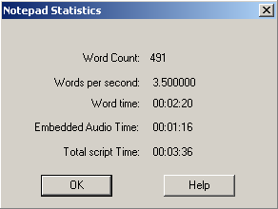
NewsReady32 can provide the approximate total script time of a newscast. The calculation is based on the average reading speed of 3.5 words per second. Embedded audio cuts will be included in the calculated time. To view the script time, click on the Time button or strike CTRL-T.

Logging the audio files after a newscast
After airing the newscast it is often necessary to log the newscast and audio cuts that were played to prevent over-use of the same stories and cuts. NewsReady32 provides a logging system that will appear in the FileLog and MediaLog, and remove the need for hand-written logs. To log a newscast after it has been aired, click on Edit from the Menu bar, and then choose Log it. This will record the time the audio was last played, and the number of times it has been played. This will also mark the story/newscast in the FileLog with the last time used and the number of times used. Check both the FileLog and MediaLog to confirm the log.

It is also possible to mark the FileLog story without logging the audio cuts. When doing a copy and paste from one folder to another, or when using Alt-P to copy text to a Notepad, the file can be logged with the date and time and the number of times used.
NOTE: These settings can be enabled or disabled for the users. See your systems administrator to configure these settings.

Creating a wrap
With most audio editors (GoldWave and Audition, for example) an entire newscast can be wrapped. With a microphone ready and the audio editor recording, a user can record a newscast with or without embedded audio cuts.

Follow these steps:
- Open the newscast from the Notepad or FileLog.
- Click the Record button or strike ALT-8.
- Enter a name for the new audio file or leave this blank.
- Select the appropriate folder, and click OK or strike ENTER.
- In the audio editor, click the Record button.
- Minimize the audio editor by clicking the Minimize button (the hyphen in the upper, right corner of the window). Do Not click on the X.
- Using a microphone read the newscast.
- Strike F1, F2, or F3 to play the audio files during the cast.
- When finished, click on the audio editor on the taskbar at the bottom of the screen to open it.
- Click the Stop button.
- Edit the audio file using delete, normalize, etc.
- Save the file, then Exit the audio editor.
- The audio file containing the wrap in now located in the MediaLog.

Instant Messages
Instant messages can only be sent between users if Secure log-ins are being used. See your system administrator to set up secure log-ins. The instant message allows any user to send a short note to another user. It is only available to the specific user it was sent to. The message will appear on the Title bar of the receiving user. The message will remain until it is cleared or another message is received.
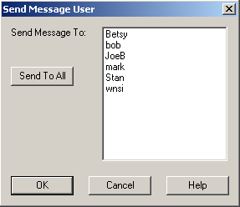
To send and receive a message:
- From the Menu bar click User, then Send Message or strike CTRL-1.
- Click on the user(s) to receive the message. A second click will unselect a user. Then click OK.
- The Send To All button allows all listed users to receive the message.

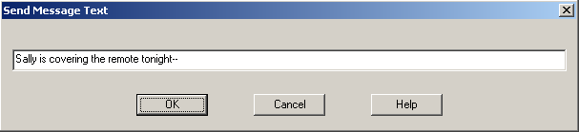
- Enter your message, then click OK or strike ENTER.
- The message will be displayed in the Title bar of all recipients.
- To clear the message from the Title bar: From the Menu bar click User, then Clear Message or strike CTRL-2.
- To display the history of all received messages: From the Menu bar click User, then Message History.

HOW TO REACH WIREREADY

WireReady NSI
PO Box 714 Eudora, KS 66025
(800) 833-4459 USA & CANADA (785) 542-2731
FAX: (785) 542-3477
E-MAIL: Sales@WireReady.com
WEB: www.WireReady.com

