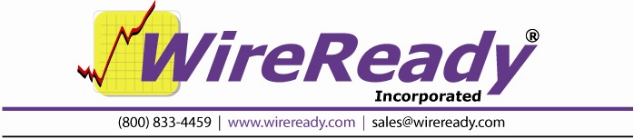

PlayOutReady
Users Manual
for use with Triple Deck Pro
Table of Contents

Overview 3
PlayOutReady ® Video playback insertion system 3
Copy Queue 5
Buffer Queue 5
Play Queue 5
MANUAL OPERATION (without Triple Deck Pro in operation) 7
F1 Play button 7
Shift-F3 Play From button 7
F5 Record button 7
F4 Stop button 7
Configure button 8
Socket Info 8
This PC’S IP: 8
Incoming IP: 8
Incoming PORT: 9
TCP Server 9
LocalFileCachePath 9
AllowDiagnosticSending and SinglePCDebugMode 9
Video Window (GENERIC MODE ONLY) 9
Top, Left, Bottom, and Right (for GENERIC mode) 9
PlayOutReady.ini 12

PlayOutReady

Overview

PlayoutReady is the video player/renderer that communicates directly with the Stradis brand mpeg2 decoder cards. Cards supporting Stradis 1.69 driver and later (SDM230, .. 260, 280, 290, 500, 230e 260e, 280e 290e 500e etc) are compatibile with PlayoutReady. Older Stradis cards will not function with this software.

Installation

Run the Playoutready Setup program. This will install Playoutready to your computer. We recommend you install to the default folder, c:\playoutready.

The Playoutready Setup program will also install Stradis driver version 1.69 on your computer.

The Playoutready package consists of two programs: Playoutready and Control WireReady. Triple Deck Pro is one of the windows within the Control WireReady, Shortcuts to these two programs are added to your start menu (Start/Programs/Wireready) by the installation.

Playoutready is the program that sends the information to the Stradis card.

Control WireReady is the program that allows you to easily play video files. Control WireReady then tells Playoutready when to play each video file.

PlayOutReady ® Video playback insertion system
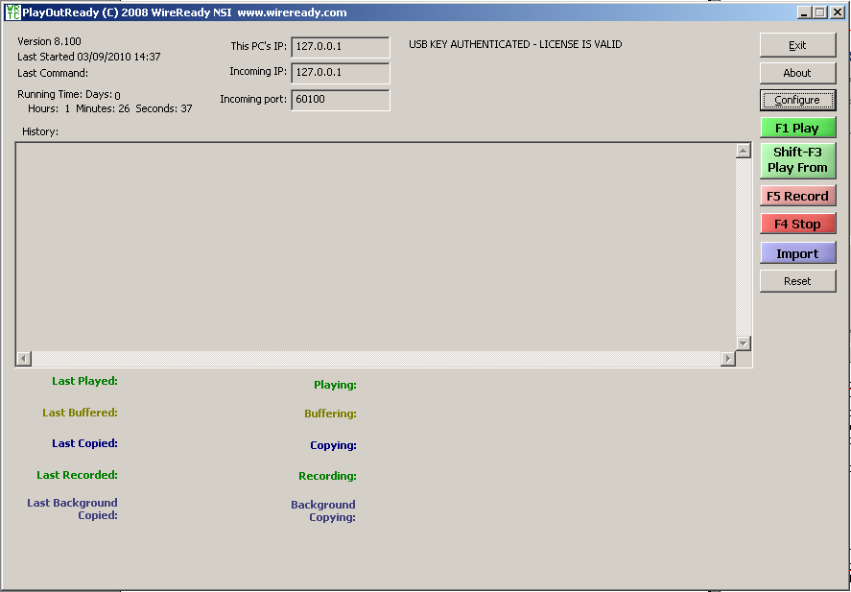

The PlayOutReady main screen displays (in the upper left corner) the version number, when the program was Last Started, the Last Command given to the program, and how long the program has been running (Running Time) since it was last started.
The IP address and port of the PlayOutReady computer and the IP address of the Master Control computer are configurable and displayed to the right of the above information. See the Configure section of this document for more information on the IP and port settings.

A History of activity is displayed in the middle section of the screen. This displays the queue level, path and filename, and whether a file played successfully or not.

In addition, below the History window, the program displays information (filename, date and time) on the current and last files processed in PlayOutReady.
PlayoutReady is a TCP/IP remote controllable video playback system that runs three independent, multi-tasked threads: Copy queue, Buffer queue and Play queue.

The PlayoutReady Master Control scheduler sends TCPIP remote commands to PlayoutReady to queue specific video files ahead of time. Queuing is the act of PlayoutReady knowing in advance as many video files as possible when back to back video files are scheduled in the Triple Deck Pro screen of Wireready32 (Master Control software) or manually loaded on this screen. Generally the former is done during normal operating procedures.

Operation Overview:

PlayoutReady tells the Stradis video card to play the mpeg file. Upon this request the card uses the file and an accompanying index file (*.STX) to frame accurately play the file. PlayoutReady can buffer the first frame of video ahead of time (when told to do so by an operator or the automation system) so that when it is time to start the file it starts very quickly, often within a frame’s time. When Playoutready is not playing a video file, the first video file loaded into the Triple Deck Pro screen is buffered. Moreover when more than one file is scheduled to play back to back, it seams the files in memory as it plays so the card does not need to stop and start on each file separately. This provides especially smooth transitions when playing commercial breaks or back to back video events of any duration.

PlayoutReady can run in a full size skin or minimal tape machine like skin. the full skin is pictures. Normally PlayoutReady is left minimized on the task bar (or system tray) and never touched by operators. For all intents it runs in the background. However it is available for monitoring, troubleshooting and in emergencies used without the master control software like a manual player with a simplified stack of video files that can be manually loaded. It can also play FROM any position in a video file if doing an emergency rejoin after programming was interrupted. (This can also be done from the Triple Deck Pro by using the pan buttons.)

PlayoutReady’s operation can be defined in terms of a COPY queue, BUFFER queue, and PLAY queue. The PLAY queue manages all files that have been submitted to play back to back including single event plays. Before a file can be played, it needs to be copied and buffered in memory. (the beginning of the video file is loaded and graphed on the card). In reality, the COPY phase is generally skipped because the video files are being played from an accessible drive/storage array that both master control and playoutready software both can see and access directly. So for all intents, we buffer and play each video file. And the first video in any back to back sequence can be buffered ahead of time, so if an operator (or trigger) needs to take the next file- we can start it instantly.

Copy Queue

The COPY QUEUE is not currently supported but was put in place to support a remotely operating version of PlayoutReady that downloads video ahead of time and keeps it in a separate cache folder on the local drive. You may see COPY QUEUE remarks in the history window, but in reality, no video is being cached in any temporary folders before or during playout. You will generally see PlayoutReady saying the file doesn’t need to be copied. That is because the file is accessible directly to PlayoutReady. That is it can see the drive(s) the video files being submitted are located on. In the future it may be possible to place a PlayoutReady software instance on a remote machine that does not have physical drive or UNC access to the files and it will be able to automatically copy (download) the files prior to playback – but this is not currently available and we are not publishing a planned release date for this feature.

Buffer Queue
For Frame Accurate starting, by default PlayOutReady buffers the NEXT up video file without exception. PlayoutReady will always buffer up the next video file to be played as soon as it begins streaming the current video file. Anytime PlayoutReady has been given a list of video files to be played back to back, it automatically buffers the next without needing further instruction from the Triple Deck Pro. Since every file is buffered in one fashion or another prior to the first frame being displayed, we monitor the time it takes us to buffer.

PlayoutReady’s monitoring screen provides information on the time it takes to buffer each file, the current file if any being buffered, and the last file it buffered with times. The history window is logged to a file if logging is enabled.

Play Queue
The play queue manages what is being played out the video card. When PlayoutReady is playing a video file- it sends real time tracking information back to Triple Deck Pro for maintaining the time left counter in the deck. The Play Queue is cleared anytime an operator using Triple Deck Pro hits STOP, or if STOP is ever hit on the PlayoutReady program itself. This allows PlayoutReady to continue playing ALL queued files even if the Wireready32 system is taken off line, crashes, or loses communication over the network. For all intents, once the files are queued, PlayoutReady is on autopilot capable of playing all the video off it’s own drive, independently unless an operator hits Stop on the Triple Deck Pro display.

PlayoutReady’s monitoring screen provides information on the time it takes to play each file, the current file if any being played, and the last file it played with times. IN addition, PlayoutReady also provides a countdown timer on any video file it is in the process of playing. The history window also shows the history and if enabled, all transactions are logged to file.

MANUAL OPERATION (without Triple Deck Pro in operation)

Because PlayoutReady and the Triple Deck Pro run in sync with each other, we recommend you do not manually control video playout from the PlayoutReady screen if Wireready32 is running. Triple Deck Pro, if left running, can override or interrupt what you do or you will not get the results you desire. IF you want to use the controls on the PlayoutReady screen, be sure exit Wireready32 first.

F1 Play button
The Play button allows a user to play a video file that is not scheduled in the Triple Deck Pro. When the Play button is used, a standard Windows Open box is launched that displays *.MPG files. Choose the audio file and click the Open button, and the video file immediately begins playing.

Shift-F3 Play From button
The Play From button allows a user to play a video file from a specific length of time from the beginning of the file. When Play From is used, a window is opened where the user can enter the path and filename of the video file to play. The Browse button can be used to navigate to the desired file. The user also enters a time from the beginning of the file to begin the video, in hours, minutes and seconds (HH:MM:SS.TTT). When the OK button is clicked, the video file begins playing at the specified time.

F5 Record button
This button is NOT SUPPORTED. We currently do not record with any encoder cards using the PlayoutReady program. However, Wireready32 software can record using our Recording software modules available with the Sky Micro Merlin based encoder/capture cards.

F4 Stop button
The Stop button is used to stop the currently playing video file.

Configure button
PlayoutReady has a very simple GUI for override emergency controls or simple live assist playback use. The CONFIGURE button can be clicked on to see the basic configuration for PlayoutReady. 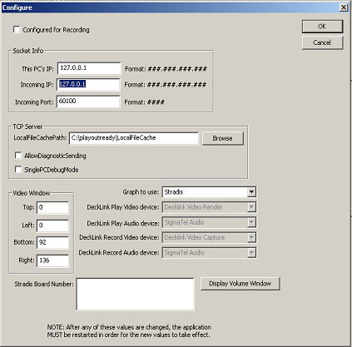
These settings can also be changed in a word processor by editing the INI file directory when PlayOutReady is not running. Note: if you make changes using the Configure button, you must exit and restart PlayoutReady for those changes to take effect.

Socket Info

This PC’S IP:
This is the IP address of the computer that is running PlayOutReady. If, as recommended, Playoutready and Wireready32/Triple Deck Pro are running on the same computer, set this to 127.0.0.1.

Incoming IP:
127.0.0.1 is the loop back port and it’s used if you are running PlayoutReady on the same computer as Triple Deck Pro. If however PlayoutReady will be running on a separate computer from Triple Deck Pro, then put the IP address of the computer that will be running Triple Deck Pro on it. The Triple Deck Pro PC is the computer sending the commands to the computer running PlayoutReady. PlayoutReady will only listen to and accept commands from the computer matching the INCOMING IP address.

Incoming PORT:
60100 is the default value. TCPIP sockets require both an IP address and a port number. This is the port number we use and it is a general-purpose port as allowed for by ICAHN, who regulates and certifies port numbers. Since we do not have an official port number for our application registered, you may use the one we specified or you may chose a different port number depending on your own IT preferences, or router abilities if you are remote controlling PlayOutReady positions outside your facility. Multiple PlayOutReady positions can use the same port number. Whatever port number you choose MUST be the same port number defined for Triple Deck Pro (see Triple Deck Pro Setup).

TCP Server

LocalFileCachePath
This is not used. (not supported at this time see above)

AllowDiagnosticSending and SinglePCDebugMode
These should be UNCHECKED for operation with Triple Deck Pro.

When the statements are checked, the following lines and buttons appear on the bottom of the PlayOutReady window.

These are used by WireReady support to diagnose a communication issue.

Video Window (GENERIC MODE ONLY)

Generic mode is not fully supported. It is designed to let someone play video using a PC video monitor (without a stradis card). It does not work on all PCs and is codec dependent.

Top, Left, Bottom, and Right (for GENERIC mode)
These are pixel coordinates that define the screen or virtual screen we play video in. For example, if you want to use PlayoutReady on a desktop’s own monitoring screen or laptop when a secondary video output card or channel is not available, you can define the video window to be any location or size on your video display. This follows the screen resolution display properties in Windows, for example 1024x768 or 800x600 (width vs height respectively). Those are the width and height coordinates of the screen.
So for example if you wanted the video image to appear in the top left hand corner of the screen (for test purposes) on a 1024x768 and you wanted it to be approximately ¼ the screen, you could set
Top=0
Left=0
Bottom=389
Right=512
If you wanted it to be the entire screen, then you’d make it:
Top=0
Left=0
Bottom=768
Right=1024

Screen resolutions and coordinates vary with the use of the video card. For example NVIDIA consumer video cards, which are also popular with Laptops, support NVIEW that can use the composite or VGA display analog output as a 2nd monitor. The LCD becomes your windows desktop (where the PlayoutReady monitor window is viewed and/or controlled) and the VGA analog output or composite output is spanned as your second monitor, using Windows built in support for dual monitors. If the 2nd monitor is a 1024x768 display then you’d use 0,0,768 and 1024 as the coordinates respective if it’s on the left, or if it’s the right monitor you’d use:
Top=0
Left=1024
Bottom=768
Right=2048

Different cards (such as DeckLink) will show up as a 2nd monitor in different ways, but once you figure out the coordinates, you are done.

Once changes are made, click the OK button and restart PlayOutReady. When PlayoutReady starts up, a black box will appear wherever you’ve defined the region for video and it will say on top whenever PlayoutReady is the program in focus on your desktop (if on a single monitor otherwise the black region will persist)

PlayOutReady Configuration File

There are other features you can enable currently by editing the INI file in a word processor. While PlayoutReady is not running, you may edit the INI file with a word processor and then restart PlayoutReady after you are finished editing and have saved/overwritten the INI file.

Logging:
Under the [log] group- you can enable or disable the log file. If enabled, PlayOutReady will log every transaction to a text file in the LOG subdirectory under where it’s run. This path is configurable and you can change the path= line to path where you want logs to be written. We recommend leaving this set to a local drive. Keep in mind you can make a local drive a sharable path on your network if you want to access this file without physically accessing the computer or you can setup a scheduled task in windows to back them up on the network. But we don’t want to be writing over your LAN to a network drive when we log activity as it can slow us down if your LAN ever has problems.

WatchDog feature with KICK OFF reboot device:
The [KICKOFF] group is used if you have purchased a KICK OFF device from WireReady. This USB connectable device is a watchdog that can power off or reboot the computer running PlayoutReady if the software should ever have a fatal error, hang or crash. The Delay-In-Seconds defines how often we will reset the count down timer on the Kick off device, and the Timeout-In-Seconds is the duration of the countdown. If the KickOff reaches 0- it reboots windows, or shuts down and powers up the computer (if your computer BIOS is set to resume after power loss). So with this in mind- it is advisable to set the delay to be HALF the count down value. And if you set the delay greater than the count down, we won’t be able to reset it before the countdown reaches 0 and that would not have a good outcome.

PlayOutReady.ini
The following groups and keys are in the typical PlayOutReady.ini file:
[Socket Info]
ThisPCsIP= | 127.0.0.1 | The IP address of the computer running PlayOutReady. Set to 127.0.0.1 when running on the same computer as Triple Deck Pro.
IncomingIP= | 127.0.0.1 | The IP address of the computer running Master Control. Set to 127.0.0.1 when running on the same computer as Triple Deck Pro.
IncomingPort= | 60100 | The incoming port number.

[PlayOutReady]
LocalFileCachePath= | c:\wire\LocalFileCache | Path to store the cached files for PlayOutReady.
BackupFilePath=
BackupPathEnable= | No
Auto Update Screen= | Yes
GraphToUse= | Stradis
AllowDiagnosticSending= | No | Yes=will still send acknowledgements to the Master Control.
SinglePCDebugMode= | No

[VideoWindow]
Top= | 0 | The top coordinate of the of the video display for PlayOutReady.
Left= | 0 | The left coordinate of the of the video display for PlayOutReady.
Bottom= | 385 | The bottom coordinate of the of the video display for PlayOutReady.
Right= | 512 | The right coordinate of the of the video display for PlayOutReady.

[Log]
Enable= | Yes | Yes=the logging is turned on  No=no logging of transactions in PlayOutReady
Path= | c:\playoutready\Logs | Path to write the log to. Recommended to be on a local drive.

[Kickoff]
Delay-In-Seconds= | 0 | The amount of time after reset of our timer until it is reset again. Default is 0
Timeout-In-Seconds= | 30 | The time from when we reset our timer, until the  Kick-off device will reboot the PC if we don't reset our timer again.  Default is 30  This value should always be bigger than the Delay-In-Seconds. A good rule of thumb is Timeout-In-Seconds=(Delay-In-Seconds x 2)+30.
Fatal-Error-Timeout-In-Minutes= | 30 | The amount of time allowed passing without us getting an error-free pass before we cause a reboot (by no longer resetting our timer). Default is 30

[Cache]
MaxCacheAgeInHours= | 26

