

TUTORIAL FOR QuickRecorder

Table of Contents

Keyboard shortcuts for QuickRecorder 3
Punch In window shortcuts 4
Overview 5
Features 5
To Start the Program 6
The QuickRecorder Main Screen 6
Basic control buttons 7
Adjusting the Cursor Position on the Slider Bar 8
Mouse 8
Rewind and Fast Forward 8
Setting the Sensitivity of the Rewind and Fast Forward buttons. 8
Go To Time 8
VU Meter 9
To Load A New Cart 10
To Record Into A Blank Cart 10
To Pause A Recording Session 10
To Stop A Recording Session 10
To Review Or Listen To The New Recording 11
To Save The Cart 11
To Record Over Audio in the Middle of a Cart (Punch In Mode) 12
To Record Over the End of Previously Recorded Audio 14
To Listen to Previously Recorded Audio 15
To Play the End of a Recorded Audio File 15
To Edit An Audio File Using The Default Audio Editor 15
The “F10 Other” Menu 16
Sending Audio Files Using Email 17
Sending Audio Files Using the Web/FTP 17
To Log in as a User 17
Creating and Managing Users and Programs 17
To Create New Users 17
To Remove Users 18
To Edit Users 18
To Copy Users 18
To Add Programs to a User 19
To Remove Programs from a User 19
To Create a New Program 20
To Remove Programs 21
To Edit Existing Programs 21
To Create a New Program by Copying an Existing Program 21
Sorting the List of Available Programs 22
Switching between the User and Program tabs 22
Technical Information 23
Configuring Quick Recorder 23
Qrecord.ini Settings File for QuickRecorder 23
Setting up the Standard Cart 26
Configuring the Email settings 26
Sending Text Commands to a Remote Device When Record or Stop is used. 26
Setting a Warning Time for Recordings 27
Assigning Prefixes to the Quickcarts 27
File Locations During Recording and Saving 28

Keyboard shortcuts for QuickRecorder

F2 or P is Pause. It pauses play and record
F3 or L is Play. It begins playing of loaded file
F4 or S is Stop. It stops play and record
F5 or R is Record. It begins audio recording at cursor position
F6 or T is Edit. It launches the default *.wav editor
F7 or J is Eject. It ejects the loaded audio file
F8 or L is Load. It opens a menu that allows a new or saved file to be loaded into an empty deck
Ctrl+A Load Cart\Audio File It opens a window to load a cart from a directory.
Ctrl+P Load Cart\Audio File (Play Only) It opens a window to load a cart from a directory. Will only allow the cart to be played. Can not record into the file.
Ctrl+E Load Cart\Audio File (Non Destructive Edit)
Ctrl+N Load By Name Allows the user to enter a file name. If the file name does not exist in the default load path, the user will be given the opportunity to create it. Will only save the file to the default save path.
Ctrl+S Load Blank Standard Cart\Audio File Loads a cart based on the Standard Cart settings with the name “unknown.wav”.
Ctrl+U Load Blank Custom Cart\Audio File Allows the user to choose the sample rate and length of cart to load.
Insert Load Blank QuickCart\Auto Named File or Program Opens a list of blank pre-named programs/templates to load.
Ctrl+Insert Load Blank Quick Cart Loads a blank cart based on the Standard Cart settings, prenamed with the date and time. If the “Load Path=” line in the “[PREFIX FILE]” group in qrecord.ini has a path and filename, a prefix will be assigned to the QuickCart.
F9 or V is Save. It opens Windows Save box (into folder preset in qrecord.ini)
F10 or O is Other. It opens a sub-menu for Standard Cart Setup and other settings
F11 or W is Rewind. It moves the cursor position back in the audio file
F12 or F is Fast Forward. It moves the cursor position ahead in the audio file
+ (plus) increases the amount of time the cursor will move with Fast Forward and Rewind. Values are (in seconds) .001, .01, .1, 1, 10, 100.
- (minus) decreases the amount of time the cursor will move with Fast Forward and Rewind. Values are (in seconds) .001, .01, .1, 1, 10, 100
Alt-M or D is Send. It sends the loaded audio file to a pre-set email address
Alt-W or T is Web/FTP. It sends the loaded audio file to a pre-set web page or ftp server.
Alt+F4 exits the QuickRecorder program.

The following can be found under the F10 Other menu, but also work from the main QuickRecorder window.
Ctrl+L is Loop Play. When checked, the audio will begin playing at the beginning of the file after reaching the end, and will continuously play in a loop until the Stop button is activated.
Ctrl+M is Analog Meters. It toggles between the Analog and Digital meter display.
Ctrl+W is Volume Control. It opens the Windows Volume Control screen.
Ctrl+Q is Multimedia Properties. It opens the Windows Sound and Audio Devices screen to allow the user to view the audio device assignments.
Ctrl+F is Setup Standard Cart. It allows the user to set up the properties and maximum time for the standard cart.
Ctrl+B is Beep Speaker at 0 VU. When checked, the computer speakers will beep when the audio level hits 0 VU.
Ctrl+I is Log In User. It allows the user to log in with an assigned user name and password to access their list of available programs.
Ctrl+O is Log Out User. It logs the user out of the list of available programs.
Ctrl+K is User and Program Manager. It allows the manager to set up new users and programs, and assign programs to the users.
Ctrl+G is Go To Time. It allows the user to enter the time to move the cursor to on the slider bar.
Alt+A is Set Default FF\Rew Sensitivity. It sets the default value for the amount of time that the cursor will move when using Rewind or Fast-Forward in the slider bar.
Alt+B is Mark Beginning Point. It sets the Begin marker for Punch In mode and opens Punch In mode window.
Alt+E is Mark Ending Point. It sets the End marker for Punch In mode and opens Punch In mode window.

Punch In window shortcuts
Shift+B is Go To Begin. It moves the cursor to the Begin marker. It is only active when in Punch In mode.
Shift+E is Go To End Marker. It moves the cursor to the End marker. It is only active when in Punch In mode.
/ (Slash from number keypad) is Play from Begin Marker. It will start the audio at the Begin marker. It is only active while in Punch In mode.
* (Asterisk from number keypad) is Play Last Second. This will play the last second of audio before the End marker. It is only active while in Punch In mode.
Alt+P is Clear. It closes the Punch In windows.

Overview

Quick Recorder is a simple recording system for WAV files. Any 3rd party editor set as the Windows default for WAV files can be used for final edits.

Features
The program allows the operator to load:
- A pre-recorded cart file for destructive editing.
- A pre-recorded cart file for play only.
- A pre-recorded cart file for non-destructive editing. This makes a copy of the file that can be edited without affecting the original recording. When the edited file is saved, it can be saved with a different file name or overwrite the original.
- A cart with a pre-determined name. This will open the named cart from a pre-set folder, if it exists. If the file does not exist, it gives the user the option to create it. (This feature is available in version 1.705 and higher)
- A blank Standard cart file. This is an audio file preset with a maximum recording length and format.
- A blank Custom cart file. This is an audio file that can be set to a different length or format than the Standard cart file.
- A blank Quickcart. This is a blank cart file using the Standard cart settings, which is automatically pre-named with the day of the month, hour, minute, and second. (Ex: 10093845.wav created on the 10th of the month at 9:38:45 am)
- A blank Program. This is a blank pre-named cart, and the user is only shown programs that have been assigned to the logged-in user.
- A blank QuickCart with a set Prefix. This is a blank cart that can be set to use the Standard cart settings, and will have a prefix before the day, hour, minute and second. This requires a list of prefixes to be configured and placed in a file. This file can also be configured to have a different length assigned for each prefix, rather than use the Standard Cart length.

To Start the Program

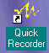
Double-click on the QuickRecorder Icon to activate recorder.

The QuickRecorder Main Screen

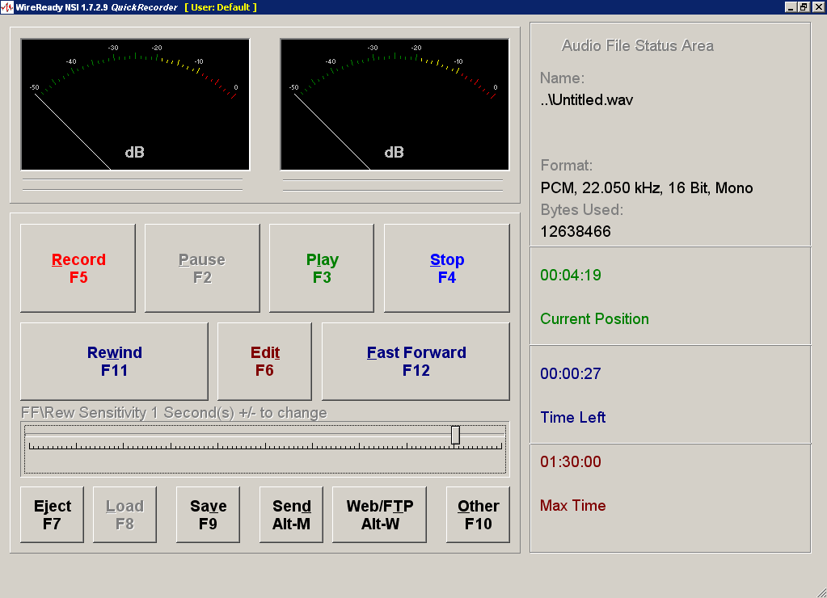

Basic control buttons

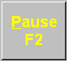 F2 Pause - pauses play and record
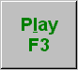 F3 Play - begins playing of loaded file
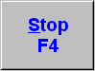 F4 Stop - stops play and record
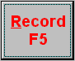 F5 Record - begins audio recording at cursor position
 F6 Edit - launches default *.wav editor
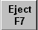 F7 Eject - ejects audio file
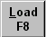 F8 Load - loads new file into empty deck
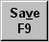 F9 Save - opens Windows Save box (into folder preset in qrecord.ini)
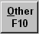 F10 Other - opens sub-menu for Standard Cart Setup and other settings
 F11 Rewind - moves cursor position back in audio file 1/20th of total audio length
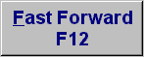 F12 Fast Forward - moves cursor position ahead in audio file 1/20th of total audio length
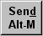 Alt-M Send - sends audio file to pre-set email address

 Alt-W Web/FTP – sends audio file to pre-set web page or ftp server.

Adjusting the Cursor Position on the Slider Bar

There are several ways to change the position of the cursor or marker on the slider bar. An audio file must be loaded into QuickRecorder for the controls to work. Play and Record will begin from the slider position.

Mouse
Click once with the left mouse button at any point on the slider bar to position the marker

Rewind and Fast Forward
Use the Rewind or Fast Forward buttons, or strike Alt+W, Alt+F, F11 or F12 on the keyboard to move the slider position.

Setting the Sensitivity of the Rewind and Fast Forward buttons.
The amount of time that the slider position will move with each time Rewind or Fast Forward is activated is adjustable. The sensitivity can be changed at any point when using QuickRecorder.
The slider can be set to move in increments ranging from 1/1000 of a second to 100 seconds. The current sensitivity setting is displayed below the Rewind and Fast Forward button. To disable the sensitivity display, edit the qrecord.ini line to read Display Sensitivity=0.
Use the “+” and “-“ buttons on the keyboard to increase or decrease the amount of time to move the slider position with each Rewind or Fast Forward keystroke.

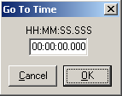
Go To Time
Choose Go To Time from the F10 Other menu, or strike Ctrl+G to open the Go To Time dialog window. Enter the time to navigate to in the entry box, and then strike Enter or click on OK.
Timers
Timers display Current Position, Time Left and Max Length. To se the timers to only display Hours, Minutes and Seconds (and not the fractions of a second), edit the qrecord.ini line to read Short Timers=1.

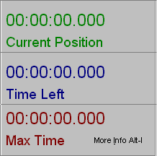

VU Meter
VU meter can display analog or digital levels.

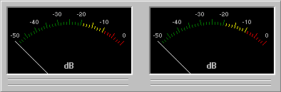

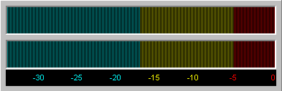

Using Quick Recorder for Recording

To Load A New Cart

Click on the F8 Load button or press F8 on the keyboard.
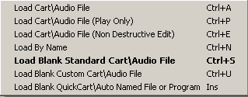
Choose to load a Blank Standard, Custom, or QuickCart, or a pre-named cart, which may be blank or have audio already recorded into it.
A Standard cart file is an audio file preset with a maximum recording length and format.
A Custom cart file is an audio file that can be set to a different length or format than the Standard cart file. If Custom is chosen, a box will open. Choose the format and enter the maximum time for the cart. Click on the Save button or press F4 on the keyboard.
A QuickCart is a blank cart file using the Standard cart settings, which is automatically pre-named with the day of the month, hour, minute, and second. (Ex: 10093845.wav created on the 10th of the month at 9:38:45 am)
Or if using carts with pre-assigned prefixes, strike Ctrl+Ins on the keyboard to bring up the list of prefixes. This will load a blank cart file with the Standard cart settings, but the day, hour, minute and second will have the prefix before it. This cart can also be assigned to have a different length than the Standard cart length.

To Record Into A Blank Cart

Press the F5 key or click on the Record button. Use the meter to determine if your levels are set correctly.

To Pause A Recording Session

Press F2 on the keyboard or click on the Pause button to pause the recording.
Press F2 Pause or F5 Record to continue recording from the paused position.

To Stop A Recording Session

Press F4 on the keyboard or click on the Stop button to end the recording.

To Review Or Listen To The New Recording

Drag the slider to the left using the mouse, or press the Home key on the keyboard to move to the beginning of the file.
Press F3 on the keyboard or click on the Play button to review the recording.
Press F4 or click on the Stop button to stop the audio from playing.
Press F2 or click on the Pause button to pause the audio. Press F2 or click on the Pause button to start the audio playing from the point it was paused.
Press F11 or click on the Rewind button to move the slider position back if you did not stop or pause the audio in the correct position.

To Save The Cart

Press F9 on the keyboard or click on the Save button to save the cart. The QuickRecorder Save Wave File box will open to save into the folder preset in the qrecord.ini file. To save to a different folder, navigate to the desired folder.
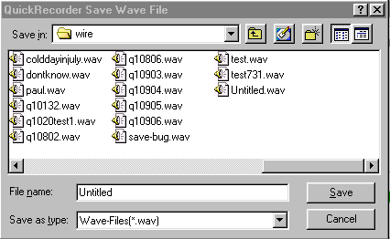
Enter a File Name for the file, then click on the Save button.
From the Quick Recorder window, press the F7 key or click Eject to empty the cart deck.

If you loaded the cart/audio file using Load By Name, the file will be saved with the name you entered, into a pre-determined folder. The above Save window will not be opened.

To Record Over Audio in the Middle of a Cart (Punch In Mode)

Double-click the Quick Recorder icon.
Click on the F8 Load button or press F8 on the keyboard.
Choose to load a cart by Name.
In the Load By Name Window, enter the name of the wave file. You can include the extension, if desired, but it is not required.
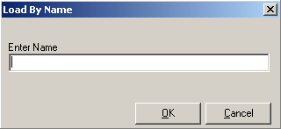
If the file does not exist, you will be given the option to create a file with that name. Click OK to create the file. Click Cancel to return to the Load By Name window and re-enter the file name if you have entered the name incorrectly.
Move the slider bar to the location of the audio to record over.
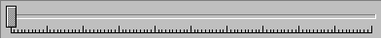
Press F3 or click Play to listen to the audio.
Press F4 (or click Stop) or press F2 (or click Pause) at the position you wish to begin recording over the audio. Strike Alt+B to set the begin marker at the cursor position. You can also strike Alt+B while playing the audio.
Move the cursor to the end of the audio to record over. Strike Alt+E to set the end marker. You can use the Fast Forward button or the arrow keys to move the cursor position, or you can strike Alt+E while the audio is playing.
When either Alt+B or Alt+E is used to set the punch-in markers, the Punch In Control window opens. This window displays the position of the Begin and End markers.
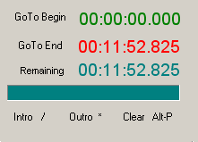
Note: Once the Begin and End markers are set, the user can move the cursor outside of the these set times using Fast Forward or Rewind.
The cursor can also be moved using the Left and Right arrow keys. The amount of time that the cursor will move with each keystroke is set to 1/1000 second. The cursor cannot be moved outside of the Punch In area using the arrow keys.
Click on the GoTo Begin button or strike Shift+B to move the cursor to the Begin marker.
Click on the GoTo End button or strike Shift+E to move the cursor to the End marker.
Click on the Close Alt-P button or strike Alt+P, to close the Punch In Control window and exit Punch In mode.
Click on the Intro / button or strike “/” on the numeric keypad to play the audio from the Begin marker. This can be activated anywhere with in the Punch In area and the cursor will be moved to the Begin marker and Play.
Click on the Outro * button or strike “*” on the numeric keypad to play the last second of audio before the End marker.
Move the cursor to the Begin marker (or another location in the Punch In area) and start recording by pressing the F5 key or clicking on the Record button.
While recording, the user can use Pause or Stop, and then continue recording from that point using Record. The Remaining line will display the time remaining in the Punch In recording session. The green progress bar will also display how much of the recording time is left.
Press F4 on the keyboard or click on the Stop button to end the recording. The recording will stop when the cursor hits the End marker, if the user does not stop it before that point.
The Punch In recording session can be reviewed by using the GoTo Begin button and then Play. The audio will only play to the End marker.
Once the audio in the middle of the file has been overwritten, the user can close the Punch In Control window, and then move the cursor to the end of the recording to continue the file.
Press F9 on the keyboard or click on the Save button to save the cart. The Saving File window will display the progress of saving the file.
From the Quick Recorder window, press the F7 key or click Eject to empty the cart deck.

To Record Over the End of Previously Recorded Audio

Double-click the Quick Recorder icon.
Click on the F8 Load button or press F8 on the keyboard.
Choose to load a cart for Non Destructive Edit.
From the QuickRecorder - Open Wave File window, highlight the desired wav file.
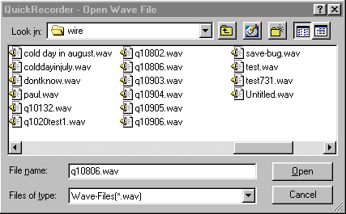
Click Open or double-click on the desired wav file to open the file.
Make sure the slider bar is at the beginning of the audio (at the left edge).
Press F3 or click Play to listen to the audio.
Press F4 (or click Stop) or press F2 (or click Pause) at the position you wish to begin recording over the audio.
Press F11 or click Rewind to move the slider position back if you did not stop or pause the audio in the correct position.
Begin recording by pressing the F5 key or clicking on the Record button.
Press F4 on the keyboard or click on the Stop button to end the recording.
Drag the slider or press the Home key to move to the beginning of the file.
Press F3 on the keyboard or click on the Play button to review the recording.
Press F9 on the keyboard or click on the Save button to save the cart. The Windows Save box will open to save into the folder preset in the qrecord.ini file. To save to a different folder, navigate to the desired folder.
Click on Save.
A box will warn you if the file name exists already. Choose Yes if you want to overwrite the file. If you do not wish to overwrite the original file, choose No, then give the file a new name and click on Save.
From the Quick Recorder window, press the F7 key or click Eject to empty the cart deck.

To Listen to Previously Recorded Audio

Double-click the Qrecord.exe icon.
Click on the F8 Load button or press F8 on the keyboard.
Choose to load a cart for Play Only or Non Destructive Edit.
From the QuickRecorder - Open Wave File window, highlight the desired wav file.
Click Open or double-click on the desired wav file to open the file.
Press F3 or click Play to listen to the audio.
Press F4 or click Stop to end listening to the audio.
To listen from the middle of the audio file, use Rewind and Fast-Forward to move the slider to the desired position, and choose Play.
When finished reviewing the audio, click on Eject or press F7 to empty the deck.

To Play the End of a Recorded Audio File

Press the End key on the keyboard.
This will move the slider position to show 5 seconds in the Time Left field.
Press F3 or click Play to listen to the audio.

OR

Press F11/F12 or click on the Rewind and Fast-Forward buttons until the Time Left field shows the length of the end of the recording you wish to listen to.
Press F3 or click Play to listen to the audio.

To Edit An Audio File Using The Default Audio Editor

Double-click the Qrecord.exe icon.
Click on the F8 Load button or press F8 on the keyboard.
Choose to Load Cart or Load Cart (Play Only).
From the QuickRecorder - Open Wave File window, highlight the desired wav file.
Click Open or double-click on the desired wav file to open the file.
Press F6 or click on the Edit button to open the default audio editor program.
Edit the audio as desired.
Save the changes to the audio file.
Exit the default editor program.
From the Quick Recorder window, press the F7 key or click Eject to empty the cart deck.

The “F10 Other” Menu

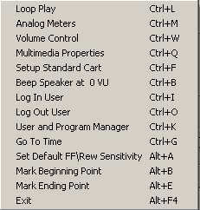
Loop Play Ctrl+L When checked, the audio will begin playing at the beginning of the file after reaching the end, and will continuously play in a loop until the Stop button is activated.
Analog Meters Ctrl+M Toggles between the Analog and Digital meter display.
Volume Control Ctrl+W Opens the Windows Volume Control screen.
Multimedia Properties Ctrl+Q Opens the Windows Sound and Audio Devices screen to allow the user to view the audio device assignments.
Setup Standard Cart Ctrl+F Allows the user to set up the properties and maximum time for the standard cart.
Beep Speaker at 0 VU Ctrl+B When checked, the computer speakers will beep when the audio level hits 0 VU.
Log In User Ctrl+I Allows the user to log in with an assigned user name and password to access their list of available programs.
Log Out User Ctrl+O Logs the user out of the list of available programs.
User and Program Manager Ctrl+K Allows the manager to set up new users and programs, and assign programs to the users.
Go To Time Ctrl+G Allows the user to enter the time to move the cursor to on the slider bar.
Set Default FF\Rew Sensitivity Alt+A Sets the default value for the amount of time that the cursor will move when using Rewind or Fast-Forward in the slider bar.
Mark Beginning Point Alt+B Sets the Begin marker for Punch In mode.
Mark Ending Point Alt+E Sets the End marker for Punch In mode.
Time Remaining Warning Sets the length of time from the end of the recording to give a visual and audio warning to the user.
Exit Alt+F4 Exits the QuickRecorder program.

Sending Audio Files Using Email

Click on the Send button or press Alt-M on the keyboard.
Choose the destination for the audio file in the Send Information window by clicking on the Destination drop-down menu.
Click the Send button or press Alt-S to send the file.

Sending Audio Files Using the Web/FTP

Click on the Web/FTP button or press Alt-W on the keyboard.
Choose the destination for the audio file in the Web/FTP window by clicking on the Destination drop-down menu.
Click the Send button or press Alt-S to send the file.

To Log in as a User
If the readers will be using pre-determined programs to record, the readers will have to log in to see their list.
Click on the F10 Other button or press F10 on the keyboard.
Choose Log In User from the menu or strike Ctrl+I on the keyboard.
Choose the User name from the drop-down list or strike the first letter of the login name (if there are multiple login names that begin with the same first letter, striking the letter multiple times will scroll thru the list of logins that begin with that letter).
Enter the password for the selected user.
Click the OK button or strike Alt+O on the keyboard to log in.

Creating and Managing Users and Programs

QuickRecorder can be set up with login names for each reader, and each login can have specific programs assigned to them. This allows the reader to see just the programs that they are currently recording.

To Create New Users
Click on the F10 Other button or press F10 on the keyboard.
Choose User and Program Manager from the menu or strike Ctrl+K on the keyboard.
Enter the Supervisor password and strike Enter or click OK.
On the Users tab, click on the Add User button, or strike Alt+A.
On the Add User window, enter the Full Name, User Name and Password for the user. You must confirm the password.
Click OK or strike Alt+O.
The user name will be added to the list in alphabetical order.
Continue adding new users.
When done adding users, click the Close button or strike Alt+C to exit the User and Program Manager screen.

To Remove Users
(The Default user cannot be removed)
Click on the F10 Other button or press F10 on the keyboard.
Choose User and Program Manager from the menu or strike Ctrl+K on the keyboard.
Enter the Supervisor password and strike Enter or click OK.
Highlight the user to remove.
Click the Remove User button or strike Alt+R.
Click Yes or strike Alt+Y when asked if you are sure you want to delete the user.
Continue removing users.
When done removing users, click the Close button or strike Alt+C to exit the User and Program Manager screen.

To Edit Users
(The Default user cannot be edited)
Click on the F10 Other button or press F10 on the keyboard.
Choose User and Program Manager from the menu or strike Ctrl+K on the keyboard.
Enter the Supervisor password and strike Enter or click OK.
Highlight the user to edit.
Click the Edit User button or strike Alt+E.
On the Edit User window, change the Full Name, User Name and Password for the user. You must confirm the password.
Click OK or strike Alt+O.
When done editing users, click the Close button or strike Alt+C to exit the User and Program Manager screen.

To Copy Users
(This will copy one user’s list of programs to a new user.)
Click on the F10 Other button or press F10 on the keyboard.
Choose User and Program Manager from the menu or strike Ctrl+K on the keyboard.
Enter the Supervisor password and strike Enter or click OK.
Highlight the user to copy.
Click the Copy User button or strike Alt+O.
On the Copy To New User window, change the Full Name, User Name and Password for the user. You must confirm the password. You can use the Clear button to clear out all of the fields.
Click OK or strike Alt+O.
When done copying users, click the Close button or strike Alt+C to exit the User and Program Manager screen.

To Add Programs to a User
(The Programs need to be created before they can be assigned to a user)
Click on the F10 Other button or press F10 on the keyboard.
Choose User and Program Manager from the menu or strike Ctrl+K on the keyboard.
Enter the Supervisor password and strike Enter or click OK.
Click the Assign\Unassign Programs button or strike Alt+S on the keyboard (It does not matter which user is highlighted from the list when this button is used).
Choose the User from the list in the bottom left corner of the Assign\Unassign Programs window.
Any programs already assigned to that user will be displayed in the Assigned Programs section of the window.
Highlight the program to assign to the user from the Available Programs section of the window.
Click the Assign button or strike Alt+A to add the program to the user’s list.
Continue adding programs, as desired.
When done assigning programs to that user, click the Save button.
Continue to choose a users from the list and assign programs, clicking the Save button when done with each user.
Click Close to exit the Assign\Unassign Programs window.

To Remove Programs from a User
(Unassigning programs from a user will not affect the other users or delete the program from the default master list of Available Programs)
Click on the F10 Other button or press F10 on the keyboard.
Choose User and Program Manager from the menu or strike Ctrl+K on the keyboard.
Enter the Supervisor password and strike Enter or click OK.
Click the Assign\Unassign Programs button or strike Alt+S on the keyboard (It does not matter which user is highlighted from the list when this button is used).
Choose the User from the list in the bottom left corner of the Assign\Unassign Programs window.
Any programs already assigned to that user will be displayed in the Assigned Programs section of the window.
Highlight the program to unassign from the user from the Assigned Programs section of the window.
Click the Unassign button or strike Alt+U to remove the program from the user’s list.
Continue removing programs, as desired.
When done removing programs from that user, click the Save button.
Continue to choose a users from the list and unassign programs, clicking the Save button when done with each user.
Click Close to exit the Assign\Unassign Programs window.

To Create a New Program
Click on the F10 Other button or press F10 on the keyboard.
Choose User and Program Manager from the menu or strike Ctrl+K on the keyboard.
Enter the Supervisor password and strike Enter or click OK.
Click on the Programs tab or strike Alt+P.
Click the Add Program button or strike Alt+A.
Enter the Name and Description of the new program.
Enter the Maximum Recording Length in the format HH:MM:SS.
If you will be using the same format (sample rate, stereo/mono) for the new program as the Standard Cart is set for, leave the Use Standard Cart format statement checked.
If this new program is to recorded in a different format (sample rate or stereo/mono). Uncheck the Use Standard Cart format statement. Use the drop-down list to select the format for the new program.
Enter the Save Path for this program.
Safety Lockout is used to prevent a program from being overwritten for a set number of hours. Often a file will be recorded and left loaded in the Quick Recorder. The next reader comes in and tries to resave the cart or save with the same name. The Safety Lockout prevents the audio from being saved for a set number of hours after it was last saved. Enter the number of hours after the program is first saved to allow a cart with the same name to overwrite it.
Click OK or strike Alt+O to add the new program to the Programs list.
Continue to add new programs.
Click Close or strike Alt+C to save the changes and close the User and Program Manager window.

To Remove Programs
Click on the F10 Other button or press F10 on the keyboard.
Choose User and Program Manager from the menu or strike Ctrl+K on the keyboard.
Enter the Supervisor password and strike Enter or click OK.
Click on the Programs tab or strike Alt+P.
Click the Remove Program button or strike Alt+R.
Click Yes or strike Alt+Y when asked if you are sure you want to delete the program.
Continue removing programs.
Click Close or strike Alt+C to save the changes and close the User and Program Manager window.

To Edit Existing Programs
Click on the F10 Other button or press F10 on the keyboard.
Choose User and Program Manager from the menu or strike Ctrl+K on the keyboard.
Enter the Supervisor password and strike Enter or click OK.
Click on the Programs tab or strike Alt+P.
Click the Edit Program button or strike Alt+E.
Edit the Name, Description, and Maximum Recording Length of the program.
If you will be using the same format (sample rate, stereo/mono) for the program as the Standard Cart is set for, check the Use Standard Cart format statement. If this program is to be recorded in a different format (sample rate or stereo/mono) than the Standard Cart, uncheck the statement. Use the drop-down list to select the format for the program.
Edit the Save Path for this program.
Edit the number of hours after the program is first saved to allow a cart with the same name to overwrite it in the Safety Lockout section.
Click OK or strike Alt+O to save the changes to the program.
Click Close or strike Alt+C to save the changes and close the User and Program Manager window.

To Create a New Program by Copying an Existing Program
(Use the Copy Program button to copy an existing program with a new name. This is used when recording a book that will be played in multiple programs. You just edit the name of the cart and all the other information stays the same)
Click on the F10 Other button or press F10 on the keyboard.
Choose User and Program Manager from the menu or strike Ctrl+K on the keyboard.
Enter the Supervisor password and strike Enter or click OK.
Click on the Programs tab or strike Alt+P.
Highlight the program to copy from the list.
Click the Copy Program button or strike Alt+O.
Edit the Name and Description of the new program.
Click OK or strike Alt+O to save the changes to the program.
Continue copying programs.
Click Close or strike Alt+C to save the changes and close the User and Program Manager window.

Sorting the List of Available Programs
(The programs can be sorted by each of the fields that are stored for the carts.)
Click on the F10 Other button or press F10 on the keyboard.
Choose User and Program Manager from the menu or strike Ctrl+K on the keyboard.
Enter the Supervisor password and strike Enter or click OK.
Click on the Programs tab or strike Alt+P.
Click the drop-down arrow at the right of the Sort button, or strike Alt+S to display the list of fields to sort by.
Choose to sort by:
Name Alt+B
Time Alt+Y
Description Alt+D
Format Alt+F
Save Location Alt+S
Lockout time Alt+L or Shift+F6
The carts will be sorted by that field, in ascending or alphabetical order.
When the User and Program Manager window is closed, it will revert to the default sort order (alphabetical by cart name).

Switching between the User and Program tabs
To switch between the User and Program tabs, click on the tab you want to be displayed.
If changes have been made and not saved on the current tab, you will be prompted to save the changes on that tab before the display will switch to the other.

Technical Information

Configuring Quick Recorder
The only file needed to run Quick Recorder is Qrecord.exe. The program can be run from any directory.

The first time Quick Recorder is run a qrecord.ini file will be created in the same directory the program is run from. The qrecord.ini file contains the settings used by the program. These standard cart settings can be set/controlled within the Quick Recorder program using the F10 menu. The paths can be edited by using any text editor.

Qrecord.ini Settings File for QuickRecorder

[Standard Cart] The settings for the Standard cart files.
FORMAT=27
LENGTH=0
Use Length For All WAV=0 1=Existing wave files display Max Time from the standard cart definition. 0=Existing wave files show the actual length of the file in Max Time.

[GUI]
Analog Meters=False When set as True/On, the program shows analog meters. When set as False/Off, the program shows digital meters.
Display Sensitivity=0 Controls whether the Rewind and Fast Forward sensitivity setting will be displayed. 0=not displayed (default). 1=sensitivity will be displayed below the Rewind and Fast Forward buttons.
Display Punch In Warning=0 Controls the display of a warning box if a user presses Record while in Punch In mode with the current position set to the beginning of the file. 1=on (default) 0=off.
Short Timers=1 0= on-screen timers will show fractions of a second (00:00:00.000) Default is 0. 1= on screen timers will only show hours, minutes and second (00:00:00). Punch In timers are not affected by this setting.
Launch After Save= When a file is saved, if a valid *.exe file with fully qualified path exists, then this will be called upon successful save of the file. Will be used to launch a window to add additional information about the audio file.
Full Screen= (default is 0) If set to 1 then the users task bar is removed and QR will occupy the full screen. In addition the user cannot resize or minimize or maximize the screen. This fully hides the desktop icons and task bar.
Password To Exit=(default is blank) If set to any other value a password is required to exit the software. In conjunction with FULL SCREEN mode this will prevent most people from accessing the operating system or network drives.
Edit Button=1 0=the F6 Edit button will be grayed out. 1=the F6 Edit button will be available to launch the loaded file into the default audio editor. Default is 1.

[FILES]
SAVE PATH=W:\Audio\ Default path where files will be saved to.
LOAD PATH=W:\wire\ Default path where files will be loaded from.
SAFETY SAVE=1 Controls the lockout password entry box if the user is trying to save a file before the lockout time has expired. 1 =On. 0 =off.
PASSWORD= This is the supervisor password that will allow the user to save a file before the lockout time has expired.
Note: Lockouts only apply to files loaded from templates.

[GPI]
ENABLE=1 0=off. Hitting Stop or Record will not send characters out of the COM port.
1=on. Hitting Stop or Record will send text characters out of the assigned COM port.
COM PORT=1 The COM port used to send characters out.
BAUD=9600 The Baud Rate used when sending characters.
PARITY=N The Parity used when sending characters.
DATA=8 The Data Bits used when sending characters.
STOP=1 The Stop Bits used when sending characters.
ON RECORD= The text string sent when the Record button is activated.
ON STOP= The text string sent when the Stop button is activated.
ON LOAD= The text string sent when the application is loaded. This string is only sent once.
ON EXIT= The text string sent when the application is exited. This string is only sent once.

[LOAD MENU] Controls the items that are active in the F8 Load menu. 1 =On. 0 =off.
ITEM1=1 Load Cart\Audio File Ctrl+A
ITEM2=1 Load Cart\Audio file (Play Only) Ctrl+P
ITEM3=1 Load Cart\Audio File (Non-Destructive Edit) Ctrl+E
ITEM4=1 Load By Name Ctrl+N
ITEM5=1 Load Blank Standard Cart\Audio File Ctrl+S
ITEM6=1 Load Blank Custom Cart\Audio File Ctrl+U
ITEM7=1 Load Blank QuickCart\Auto Named File or Program Ins

[Meter Gain]
Offset=0

[STOP]
REWIND=FALSE

[DBCAPTURE IN]
PATH=W:\WIRE\DBCAPTURE\IN Path that files will be saved to for DBCapture to process.
LAUNCH=0 Controls if the DBCapture window will be launched and displayed when the Web button is used. 0=DBCapture will not be launched. 1=DBCapture will be launched and open on the screen.

[LOAD BY NAME]
HEADSTART=1 When loading carts with the Load By Name choice, 1=place the cursor at the beginning of the file; 2=place the cursor at the end of the file.
[ARROWS]
SENSITIVITY=1000 Controls the default step movement of the slider when using Rewind or Fast Forward for slider navigation. The value is expressed in milliseconds. Valid range is 1 to 100000 (10 seconds).

[RECORDING OPTIONS]
Time Remaining Warning=True True=A warning will be given to the user when the time left in the recording reaches the setting in the Time= line. The Time Left field will blink in red for the remainder of the recording session. An audio file will play during the remainder of the recording session if one is specified in the Warning Wav= line. False=no warning will be given to the user
Time=00:01:00 The amount of time remaining in the recording when the Time Left field begins to flash and the warning audio begins to play. Format is HH:MM:SS
Warning Wav=C:\warning.wav The path and filename of the audio file to play at the warning time. Can be left blank if no audio warning is to be given.

[PREFIX FILE]
LOAD PATH=c:\mylist.txt The path and filename of the list of prefix names to be used with the Ctrl+Ins QuickCart. See the Assigning Prefixes to the QuickCarts section below for information on the list of prefixes.

SORT=1 0=the list of prefix names will not be sorted alphabetically. 1=the list of prefix names will be sorted alphabetically.

Setting up the Standard Cart
To set up the Standard Cart settings, click on the F-10 Other button. Choose Setup Standard Cart or press the S key. Use the drop-down menu to choose the desired format for the file. Edit the Max Recording Length field to set the hours, minutes, and seconds for the Standard Cart. Click on the Save button or press the F4 key to save the settings.

Configuring the Email settings
If you are using the Quick Recorder with WireReady32, or you intend to use the emailing feature, you must have Quick Recorder in a directory called WIRE, and have the EMAIL files (distributed on the CD) in a directory under WIRE called EMAIL. There are three executables that must be the WIRE directory. QRECORD.EXE, EMAIL.EXE and ECAPTURE.EXE. Email and ECapture are called automatically by the QuickRecorder when files are sent. Instructions for configuring the email system are supplied separately.

Sending Text Commands to a Remote Device When Record or Stop is used.
(This feature is available in versions 1.704 and higher)
QuickRecorder can send text commands out of a COM port to send a closure to a remote device, such as a light. The settings for this are located in the Quick Recorderecord.ini file in the folder that QuickRecorder is run from. The qrecord.ini file will include the following group and values:
[GPI]
ENABLE=1
COM PORT=1
BAUD=9600
PARITY=N
DATA=8
STOP=1
ON RECORD=
ON STOP=
ON LOAD=
ON EXIT=

Set the Enable line to equal “1” to enable the text to be sent out of the COM port.
Set the COM port to the port number that the remote device is attached to.
Set the Baud Rate, Parity, and Data and Stop Bits for the COM port. Most COM ports will use settings of 9600, N, 8, 1, as displayed above.
Enter the text string to be sent when the Record function is used in the On Record line.
Enter the text string to be sent when the Stop function is used in the On Stop line.
Enter the text string to be sent when a file is Loaded in the On Load line.
Enter the text string to be sent when QuickRecorder is exited in the On Exit line.
Save and close the qrecord.ini file. QuickRecorder will need to be restarted to enable the text strings to be sent.

Setting a Warning Time for Recordings
(This feature is available in version 1.729 and higher)
QuickRecorder can now warn users when the recording time has almost reached its end. During the warning time, the Time Left field will turn red and blink, and the audio warning file will play (if configured).
Click on the F10 Other button or press F10 on the keyboard to open the Other menu.
Choose the Time Remaining Warning choice from the menu to open the Recording Time Remaining Warning Settings window.
Click on the Enable Recording Time Remaining Warning statement to check it.
Enter the amount of time from the end of the recordings that the warning should start. This is entered as Hours, Minutes and Seconds.
If the users are to hear an audio warning, enter the drive letter, path and filename for the file to be played during the warning time into the Select Warning Sound field. Click the Browse button or press Alt+B to locate the audio file to be played. This setting is optional—the visual blinking will still occur when this field is left blank.
Click the OK button or press Alt+O on the keyboard to save the settings and close the window.

Assigning Prefixes to the QuickCarts
(This feature is available in version 1.734 and higher)
QuickRecorder can now be configured to allow program names to be used as prefixes for the Standard QuickCart. This allows users to record files using the program name, but also have the day/time feature of the QuickCart. In addition, each prefix can be assigned a cart length, which will allow each program to record for a maximum length.
In the qrecord.ini file, the line “LOAD PATH=” in the “[PREFIX FILE]” group must have a path and filename of the list of prefixes. When Ctrl+Ins is struck on the keyboard, this file will be read and the list of prefixes will be available to the user. The chosen prefix will be used in the name, along with the QuickCart auto-number. For example, if the prefix “Health” is chosen from the list, the file may be named “Health-27105804.wav” (which would be the 27th day of the month, at 10:58:04 am).
If the prefix is set with a length, then that file will use that length instead of the Standard cart’s length. If no length is set, the Standard cart length will be used as the maximum time for the cart.
The length for each prefix is configured within the file, with the prefix and the length separated by a semicolon. Below is an example of what the prefix file may look like:
Travel;010000
Health;005700
Program;002800
The Travel prefix will give the maximum length of 1 hour, the Health prefix will give the length of 57 minutes and the Program prefix will give the length of 28 minutes. The times are in the format of HHMMSS where HH is hours, MM is minutes and SS is seconds.

File Locations During Recording and Saving

Here is what happens when you use each of the Load choices:
Load Cart Ctrl+A The selected file is loaded into Quick Recorder from the directory the user chose and no temp files are created.
Load Cart (Play Only) Ctrl+P The selected file is loaded into Quick Recorder from the directory the user chose and no temp files are created.
Load Cart (Non-destructive Edit) Ctrl+E The selected file is loaded into Quick Recorder from the directory the user chose and a temp file with the same name is created in the c:\documents and settings\[username]\local settings\temp\qrecord\ folder (the [username] is the Windows login user name). Upon Save, the file is removed from the temp folder and is saved to the folder the user selects.
Load By Name Ctrl+N If the file does not already exist, the user is
prompted to create it now. The file is created in the c:\documents and settings\[username]\local settings\temp\qrecord\ folder (the [username] is the Windows login user name). When saved, the file is removed from the temp path and is saved to the Save Path from the qrecord.ini. It is never in the Load Path. If the user records more, after the first save, it is recording it to the file in the Save Path.
If the file does already exist in the Load Path, then Quick Recorder opens it and does not create a file in the temp path above. Recording into it puts the changes into the file in the Load Path. Upon saving, it is automatically saved to the Save Path, and also remains in the Load Path. If recording into it after it has been saved, it puts the changes in the file in the Save Path. If the file is still loaded in Quick Recorder after saving, but dbcapture has moved it, when you start to record, it creates a new file with that name in the Save Path.
Load a Blank Standard Cart Ctrl+S and Load a Blank Custom Cart Ctrl+U A file called Untitled is created in the c:\documents and settings\[username]\local settings\temp\qrecord\ folder (the [username] is the Windows login user name). Once it is saved, the Untitled.wav file is removed from the temp path, and the newly named file is saved to the path the user selected.
Load a Blank QuickCart/Program Ins A file is created in the c:\documents and settings\[username]\local settings\temp\qrecord\ folder (the [username] is the Windows login user name) with the name of the program or quickcart. When it is saved, it is removed from the temp path and saved in the folder the user selected.

Ctrl+Ins This keystroke combination will load a file with a prefix when the qrecord.ini line “LOAD PATH=” in the “[PREFIX FILE]” group displays a path and filename. A file is created in the c:\documents and settings\[username]\local settings\temp\qrecord\ folder (the [username] is the Windows login user name) with the name of the program or QuickCart. When it is saved, it is removed from the temp path and saved in the folder the user selected.

