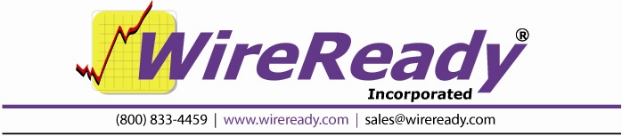

Reading the Traffic and Music Log Import Report

It is important to review the Automation Program before it is run on air to make sure that the Scheduled Breaks were filled as you intended them to be filled.

After the system scans the Traffic/Music log, it generates an Import Report, which displays on the screen. This file can be saved or printed to review at a later time also. Using this import report, you can quickly determine how well your import worked and, if necessary, manually edit and override any mistakes.

The Import Report contains the following sections:

Missing Cart Codes
This lists the file names that could not be found in the custom folders. The user should check to determine why the listed codes are not found. Either the filename is incorrect, or the cart has not been created yet or has been saved into the wrong folder, or the wrong number was scheduled in the log.
Missing Cart Codes That Were Scheduled
If the system is configured to schedule missing carts, this will list the file names that were scheduled even though they are missing. This does not specify a problem, but can be used to confirm that all the carts will be recorded before the playlist runs.
Cart Codes with invalid start/stop date range
This is a list of carts that have a start date that has not arrived yet, or a stop date that has passed. Each cart can be set with a start and stop date and time, and if the “current” date is not within that range, the cart will be listed here. The date that is used for this is the one that was specified in the importing process. The user should check all of these files in the MediaLog to reset the start and stop date if they are expected to play in the playlist.
Cart Codes with out of range Air Times
This lists the file names that are scheduled in the imported log, and there is not a Scheduled Music Sweep or Scheduled Break command with a time that matches in the playlist.
The files will not be scheduled in the playlist, since we cannot determine where they should be scheduled.
For traffic log importing, either the log has scheduled a file to play at a time that is outside of a commercial break, or the Scheduled Break command is incorrect in the playlist. If running satellite programming, check to be sure the time in the traffic log and the Schedule Break command are set to cover the time of the break. With floating breaks, even though the breaks do not run at a set time, the break must be scheduled in the playlist at a set time and the traffic log should use that same time for the break.
For music log importing, the times of the songs in the music log do not line up with the Scheduled Music Sweep commands in the playlist.
Scheduled Breaks
This lists all of the times of the Scheduled Break or Scheduled Music Sweep commands in the playlist, and if they have been filled. The Time column lists the time of the Break/Sweep command. If there is a Description assigned to that command time, it will be displayed in the second column. The Length column displays the length set in that Break/Sweep. The Secs Off column displays how many seconds different from the Length the Break/Sweep has scheduled. The > +/- column displays if the filled Break/Sweep is off more than the tolerance setting from the configuration file. The End Time column displays the time that the Break/Sweep will end, based on the time it is scheduled and the length of files that were filled in the break.
Carts That Required Us To Search Multiple Paths In Order To Find Them
This lists any carts that were not in the Default Play Path, and the program had to look in other Custom folders to find. This is for informational purposes only, and does not mean that there are any issues with the import process.
Failed To Update Cart Codes
When the configuration file is set to update any fields during the import process, this will list any file names that the program was unable to update. The files need to be checked to see if they are read-only or if the user does not have permission to modify the audio files or the folder they are contained in.

