

StormReady32TM
User's Guide

WireReady NSI • 56 Hudson Street • Northborough, MA 01532
(800) 833-4459 • (508) 393-0200 • FAX (508) 393-0255
sales@wireready.com • support@wireready.com • www.wireready.com
© 2005 WireReady NSI
WireReady® is a Registered Trademark

StormReady32 TM Users Guide

Overview 3
Edit, Add & Delete Records 3
Show, Sort, & Display Records 3
Print Records & Labels 3
Quick Updating when the phones start to ring 3
Getting Started 4
Starting the StormReady32 program 4
Getting Started: Setting Up the StormReady32 database for the first time 4
Getting Started: Customizing category and status choices 5
Filling the Database 7
Adding Records 7
Editing Records 10
Deleting Records 11
Creating Searches to Sort Your Records 11
Creating Searches 11
To Create A New Search To Show All Records 11
To Create Additional New Searches 13
What to do When the Phones Start Ringing 14
Finding (and Selecting) the Correct Record 14
Updating the Record 15
Going on the Air and Reading your List 15
Using Hot-Keys to Perform a Search 15
Reading your List 15
Printing your Lists 16
(Reading From A Print View, Saving to Disk/Web/etc.) 16
Maintenance During an Event 18
Cleaning up After the Storm 18
Resetting the Entire Database 18
Deleting Records 18
Back-up Issues 19
What Files Should I Copy? 19
Restoring Files 19

Overview

StormReady32TM is the successor to the original DOS based StormReadyTM. StormReady32TM allows you to track thousands of schools and other organizations during closings and delays resulting from weather or other emergencies. Run StormReady32TM on one computer or across several computers simultaneously on your LAN. The program is only a few keystrokes away no matter what you are doing. Finding a school and changing it’s status or even typing in special notes can be done rapidly with just a few keystrokes or click of the mouse. StormReady32 TM also works with CallTaker32 TM. CallTaker32 TM, sold separately, can automatically answer the phone lines for you (up to 48 lines) allowing school representatives to navigate audio options with a touch-tone phone.

Edit, Add & Delete Records
A record is an entry consisting of its name, town and/or county, category, status, contact information etc. Once you have stored records, you can edit and/or delete records quickly and easily. You can change an existing record by just toggling it’s status from Unknown to Closed or Delayed… etc. If you know the organizations’ ID code, you can do a fast lookup by ID code and then toggle the status and/or verifying their ID with a PIN code or other pertinent data. Deletion is protected against accidental erasures. You can add records before or during an event.
You can reset records’ storm status, individually, by search spec, or as an entire group during or after a storm.

Show, Sort, & Display Records
With only a few keystrokes you can show thousands of organizations in a list with lightning speed. You can search/show by user-defined categories and sort by any or all of the various fields such as town/county, address, organization name, ID code, etc. A custom search allows you to quickly reduce a large list to only the exact records you are looking for, in the exact sorted order you wish, displayed on the screen or paper the way you want to read them. Searches can be preset and recalled by simple names like ALL RECORDS, ALL CLOSURES, JUST SCHOOLS, JUST BUSINESSES etc.

Print Records & Labels

The database is an *.MDB access compatible database. This means that you can setup a WORD and/or ACCESS template to create labels and word documents, and mail merge as necessary.

Quick Updating when the phones start to ring
When a call comes in, with only a few keystrokes you can update an organization’s record to reflect the current status.

Getting Started

Starting the StormReady32 program
To run the program, double-click on the StormReady32 shortcut on your desktop or if you are using WireReady32, click UTILITY (version 3.236 or later) and you will see a choice for StormReady32 in the list. Once the program is running, the StormReady32 icon (storm cloud with lightning) will be visible in the toolbar tray (lower right hand corner of your screen).

To show the StormReady32 database on your screen, strike CTRL-INSERT or right-click on the StormReady32 icon and choose Show.

Technical info: The standard location for StormReady is in the WIRE folder on your computer or network server. For example W:\WIRE\STORM32.EXE (this is the target/program that is run for the system). On WireReady32 systems with multiple users, every user has it’s own copy of the STORM32.INI file (as maintained by our WIRE\INSTALL\SETUP32 program). When WireReady32 calls the program it calls W:\WIRE\STORM32.EXE s=W:\WIRE\USERS\”username”, which tells StormReady32 what INI file to use. The INI file has all the user’s settings, search parameters, and a common list of categories and statuses. W:\ is an example drive letter but may vary based on your system. If you wanted to make your own shortcut to the program, you would point to the executable and use the s= parameter to point to the folder that has the Storm32.ini file you want to use. (in a multi-user system everyone needs their own INI).

Getting Started: Setting Up the StormReady32 database for the first time
The system ships with a pre-defined MS Access compatible *.MDB database. There must be a DATA subfolder under the executable. If for example STORM32.EXE is under W:\WIRE then there must be a W:\WIRE\DATA folder. In the DATA folder there is a UDL windows link file. It tells the program where the database is located. The database may be located anywhere, but we have standardized on W:\WIRE\USERS\PUBLIC\STORM32 for the location of Storm.mdb. You can right click on the UDL file in the data subfolder if you want to change the location of the database. If this UDL file (distributed with the software) points to an incorrect location, then the program will not startup correctly and you will get a nasty error. Everyone shares the same UDL file and database.

An additional file is needed when running version 1.203 and higher of StormReady32. This is qrpdflib.dll. This file should be located in the same folder as the StormReady32 executable file.

Getting Started: Customizing category and status choices
Before adding records for various organizations we must first create a master category and status list. These categories can be anything you wish, such as Public Schools, Private Schools, Parochial Schools, Businesses, Clubs, Government., etc. The Master Status list may include Closed, Open, Delay, 1st Shift Only Report, etc. Up to 250 categories and statuses are possible. In some cases you may want the category to also apply to the time of the event. For example Afternoon classes, Evening classes, etc. This would let you reset your Public schools later in the day so you can start taking calls for the next day without resetting events that have not taken place yet. The categories and statuses are created using the SETUP32 administration program.

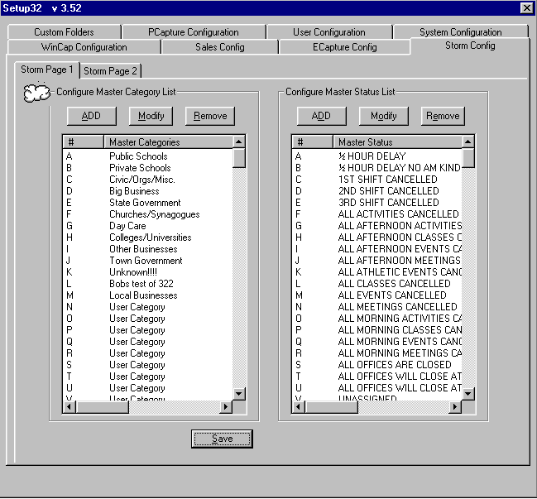

Once the Master Category and Master Status lists are created, it is recommended to post a copy of the lists at the workstations. We have distributed a common list of categories, and a common list of 150 statuses. We have labeled our categories as "A) Public Schools", "B) Private Schools", etc., because the database naturally sorts and sub-sorts alphabetically. So we have numbered the categories in the way most stations want them relative to how they sort by status or town, and then by category. You can craft your category and statuses any way you like.
In addition, statuses may be subcategorized based on category. The Setup32 program lets you create a sub-list of statuses under each category, so that public schools can have a different set of statuses to choose from than town/civil government or a business will have. This has no effect on the automatic CallTaker32 system, rather it’s something to make it easier on you if you are answering the phone and taking calls manually. Having preset statuses makes it quicker to get to the next call, if you don’t have to scroll through a list of a hundred statuses. In this fashion, you can have your top statuses pop up based on the category of the organization that calls. Moreover, StormReady32 provides HOT LETTERS for your statuses, A through Z, so the first 26 statuses for any category can be chosen with a single letter. When a record has a category for which you have not created a sublist, you will get the master list. Keep in mind the system also lets you free-hand a status, i.e. No school until Thursday, wear your hardhats and bring a lunch. Granted this takes more time than just clicking CLOSED, or hitting A.
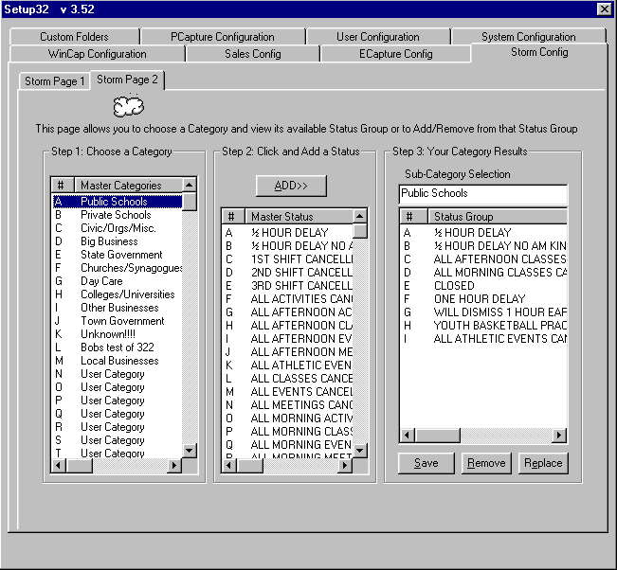

Filling the Database

Adding Records
Most stations will already have a list of organizations already waiting to be entered, complete with an ID code. If possible enter these records before an event happens. This will save you some time. However, you can add records to the database at any time, even during an event. For new installations, as a free service we will import or convert any existing database into the Storm.mdb database and/or auto-generate your ID and/or PIN codes. ID and PIN codes must be numeric. Anyone familiar with Excel or Access can cut/paste/import data into the database, and in all cases your purchase includes having us do this for you.

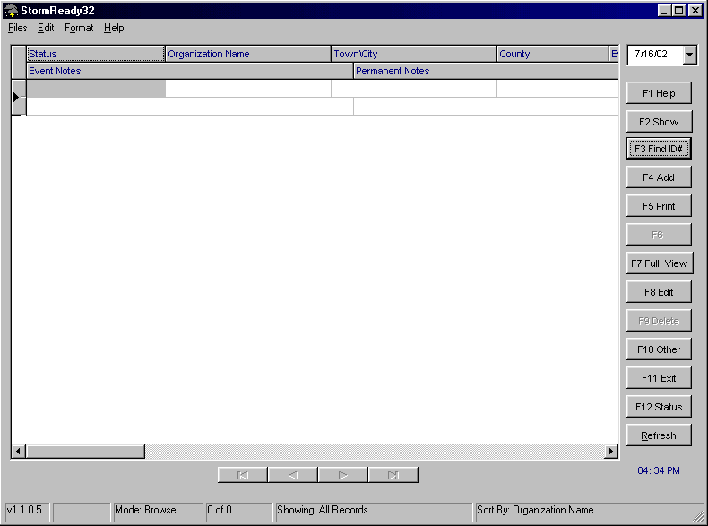

If you don’t have a database, you can always key in the records at anytime as follows:

To add records:
To add a new organization into the database, click on the F4 Add button, or strike F4 on the keyboard.
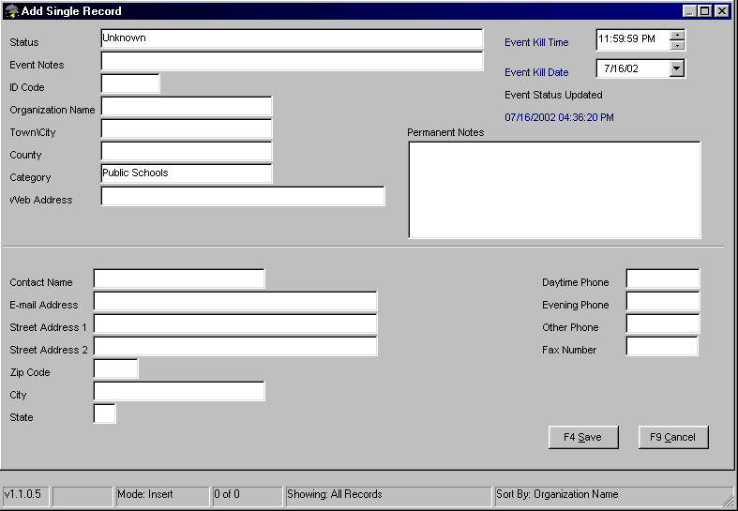
Enter the organization's information.
Note: The most important fields are generally the Organization, Town or County, and Category. These are the most common ways to sort your list when reading on the air. The minimum data you need for a record is the organization name, ID code, and PIN code (if using CallTaker32).
The ID code is required: each unique code serves as a password to authenticate the caller, and is used for locating a record when editing/updating a record.
A PIN number can be entered for each organization. Using the ID code in combination with the PIN will allow the station to provide additional security when authenticating the caller. NOTE: PIN codes are only visible/editable if you are set to DELETE/RESET records (under F10) otherwise PIN is a hidden field.
Striking the ENTER key when the cursor is in the Category field will display the list of categories created using the Setup32 administration program. Highlight the category of your choice and strike ENTER. The user can also strike letters A thru Z to instantly choose the category without having to scroll through the list.
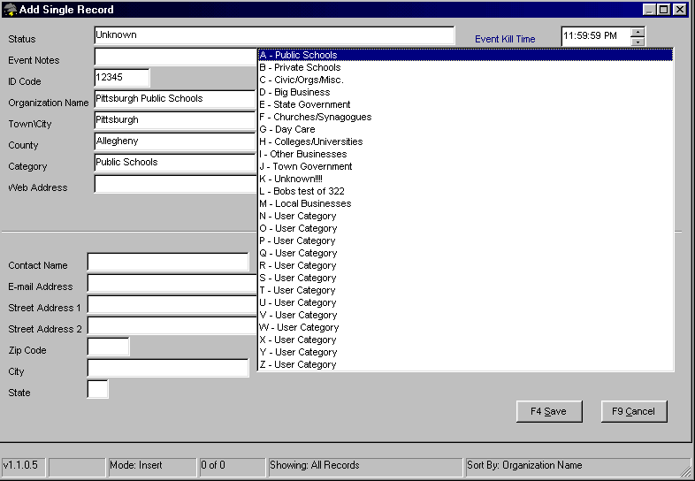
Once you have entered in all the information, press F4 to save the record.
Note: On LANs several people can add records/edit at the same time, but the database will prevent more than one person from editing the same record at the same time.

Editing Records
Editing records is simple. From the main StormReady32 screen highlight the record you wish to edit and press ENTER.

If you know the ID code of the record you wish to edit, strike F3, type in the ID code, and strike ENTER.
-OR-
Using the UP, DOWN, PAGE-UP and PAGE-DOWN keys, scroll until you have highlighted the record of the organization. Press ENTER.

Make the changes you wish to make. If after making changes you wish to go back to the original information, press F9 to Cancel the edit. Press F4 to save the record. You can edit a record at any time.
Note: On LANs several people can add records/edit at the same time, but the database will prevent more than one person from editing the same record at the same time.

Deleting Records
The ability to delete records can be toggled on and off by the user, helping to prevent accidental deletions. When you first enter StormReady32 deletions are not allowed by default.
Note: Once you have set the workstation to allow or disallow deletions, the status will not change until the program is exited or until the user changes the status.

To allow deletions:
From the main StormReady32 screen, click the F10 Other button or strike F10.
From the menu highlight Allow Deletions and Resets and press ENTER. The ability to delete is now turned on.

To disallow deletions:
From the main StormReady32 screen, click the F10 Other button or strike F10.
From the menu, highlight Disable Deletions and Resets and press ENTER. This workstation will not allow records to be deleted.

To delete a record:
From the main StormReady32 screen, highlight the record you wish to delete and click the F9 Delete button or press F9. The full record will open and prompt you to verify the deletion. If you are sure you want to delete the record, press Y for yes. If you are unsure, press N for no.
Note: Once a record is deleted, it can not be retrieved.

Creating Searches to Sort Your Records
The heart of StormReady32 is its ability to let you create custom search and sort specifications (for any way you like) to read your closings. To do this you need to know how to program searches.

Creating Searches
The first search we need to create is Search All Records. Why? So you have an easy way to find someone if they call in and don’t have a unique code.

To Create A New Search To Show All Records
Click on the F2 Show button or strike F2.
Click on Create and Modify Searches or strike ALT-0.
This will open the Create and Modify Searches window.
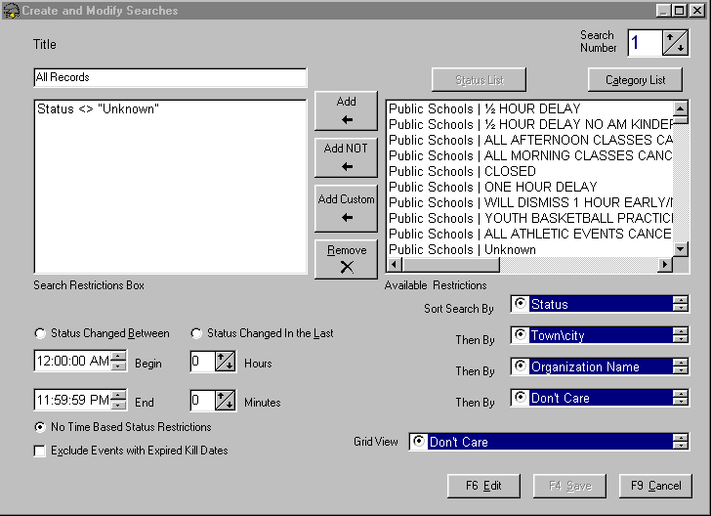
The box in the upper right hand corner tells you the number of the search displayed, which you control using the up and down buttons.
Select Search Number 1. (It is usually best to have search #1 as the All Records search, for ease of returning from any other search.)
Click on the F6 Edit button or strike F6. You can now edit the search.
Enter a name for the search (All Records) in the Title box. This is the name of the search that will appear on your custom search list.
To have this search display all of the records in your database, you will not want to have any restrictions listed in the Search Restrictions Box.
In the bottom left of the window, No Time Based Status Restrictions should be marked.
In the bottom right of the window, choose the field to sort the search by. Use the up and down arrow to the right of the Sort Search By field to change the primary sort.
Choose the field to sort the search by clicking on the circle to the left of the field name.
Follow the same procedure to narrow the sort further by choosing field names in the Then By windows.
Choose how the records will be displayed on the screen in the Grid View field. Use the up and down arrow keys to find the order of the fields on the screen.
Choose the screen display by clicking on the circle to the left of the desired grid order.
Click on the F4 Save button or strike F4 to save the search parameters.

To Create Additional New Searches
Using the box in the upper right corner of the Create and Modify Searches window, click on the up button to change the Search Number to 2.
Click on the F6 Edit button or strike F6. You can now edit the search.
Enter the name of the second search you wish to create in the Title field.
Click on the Category List button to display all of the available categories.
Choose a category for the new search.
Click on the Add button to add it to the Search Restrictions Box.
Note: Adding a category means records that match that category will be shown in that list.
Choose another category (if needed) for this search. When all desired categories have been chosen, click on the Status List button.
Note: the easiest way to show all closures and delays is to choose NOT Unknown
Choose a status for the search.
Click on the Add button to add that status to the Search Restrictions Box.
Choose another status (if needed) for this search. Continue until all desired statuses have been chosen.
Choose Status Changed Between if you want to have this search show records that have been changed within a certain time of day. Then enter the Begin and End times in the entry boxes.
Choose Status Changed In the Last if you want to have this search show records changed within the last defined time of hours and minutes. Enter the number of hours and minutes.
Choose No Time Based Restrictions if you do not want to restrict the time period that the records were changed in.
In the bottom right of the window, choose the field to sort the search by. Use the up and down arrow to the right of the Sort Search By field to change the primary sort.
Choose the field to sort the search by clicking on the circle to the left of the field name.
Follow the same procedure to narrow the sort further by choosing field names in the Then By windows.
Choose how the records will be displayed on the screen in the Grid View field. Use the up and down arrow keys to find the order of the fields on the screen.
Choose the screen display by clicking on the circle to the left of the desired grid order.
Click on the F4 Save button or strike F4 to save the search parameters.
Continue to add new searches as listed above.

NOTE: When entries are reset, the status is reset to the "z" status, which in your system may appear as a blank choice when you are programming a search. In your browser a reset status appears as "- - - - - - - - -" in the browser. It is possible to change the z status to show something like UNKNOWN, but you have to call WireReady to do this. You cannot edit the z status from within the program. Also, if you set the "z" status to UNKNOWN, this also lets someone manually change a record to unknown in the rare event that you accidentally flag someone closed and need to set them back to unknown.
Also, when setting up searches to show all your closing and delayed statuses, do not highlight the "z" status (the last one on the list of statuses) since you wouldn't want to include records for who have not called in yet.

What to do When the Phones Start Ringing

When someone calls during an event to report the status of his or her particular organization, you need to be able to find that organization’s record instantly.

Finding (and Selecting) the Correct Record
The fastest way to locate a record is by using the ID Code. Without an ID code, you must select the record manually from the browser.

Click the F3 Find ID# button or strike F3 and ask the caller for their organization’s ID code. Enter the ID code and press ENTER.
-OR-
Using the UP, DOWN, PAGE-UP and PAGE-DOWN keys, scroll until you have highlighted the record of the caller’s organization. Press ENTER

If you can’t find the record then you need to add it. (Strike F4 and add the record. See the section above labeled Adding Records). Otherwise you are ready to update the record.

You can also find a record by doing a SEARCH ALL RECORDS, hit F2, select ALL Records, you can then sort any column, and hit the letter to go to the nearest records that start with that letter for the given column your cursor is in.

You can also hit F6 FIND, this will let you type in any text match and it will find the next occurrence (from where your cursor is) of any record that has that text in it. (Be sure to have the highlight bar at the top of your list, after you hit F2 SHOW ALL RECORDS).

Updating the Record

Generally when you’re updating the record you are putting a “tag” on it, such as Closed, Delayed, or any one of your custom statuses (i.e. 2hr Delay, No kindergarten, etc.). We recommend you print out or write down all of your statuses and their respective letter codes (A,B,C,D etc.) and paste them on your monitor.

Select the record to be modified.
Press CRTL-ALT-[letter] to assign the new status.
-OR –
Hit F12 Status, and choose from one of the available statuses
-OR -
Select the record to be modified.
Click on the F8 Edit button or strike F8 to enter the record.
Strike ENTER when the cursor is in the status box.
Highlight the status of your choice and strike ENTER. The user can also strike letters A thru Z to instantly choose the status without having to scroll through the list.
When your are finished press F4 to save the record.
This latter method is required if you need to type in a free hand status for the record.

Note: If the client had a rare status which can’t be set up with a hot key, you can type in all their important information in the event notes field

Going on the Air and Reading your List

Using Hot-Keys to Perform a Search

Searches can be programmed to meet all the demands of different situations, and these searches can be most easily accessed using Hot-Keys. A hot-key is a keystroke combination that acts as a shortcut. Pressing F2 will show you a list of all searches and their respective hot-keys. Each hot-key take the form ALT-[number].

Reading your List
To enter StormReady32 and read list:
If StormReady32 is not already running, double-click on the StormReady32 shortcut on your desktop. Once the program is running, the StormReady32 icon (storm cloud with lightning) will be visible in the toolbar tray.
To show the StormReady32 database on your screen, strike CTRL-INSERT or right-click on the StormReady32 icon and choose Show.

Click on the F2 Show button or strike F2 to show a list of the pre-defined searches.
Choose a search by clicking on the Title from the list.
-OR-
Use the Hot Key (Alt-number).
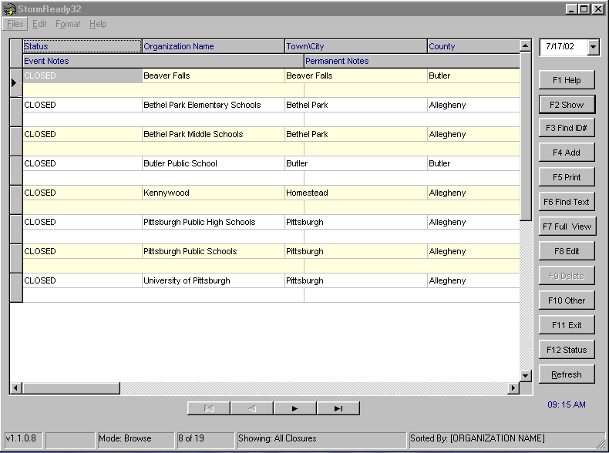
Begin reading the list from the screen. Most people will have an easier time by PRINTING the report (to the screen, paper, web site, or spreadsheet) and StormReady32 lets you do all of the above.

Printing your Lists

(Reading From A Print View, Saving to Disk/Web/etc.)
To print your list:
Perform the search.
Once the search is complete strike F5 to print the list.

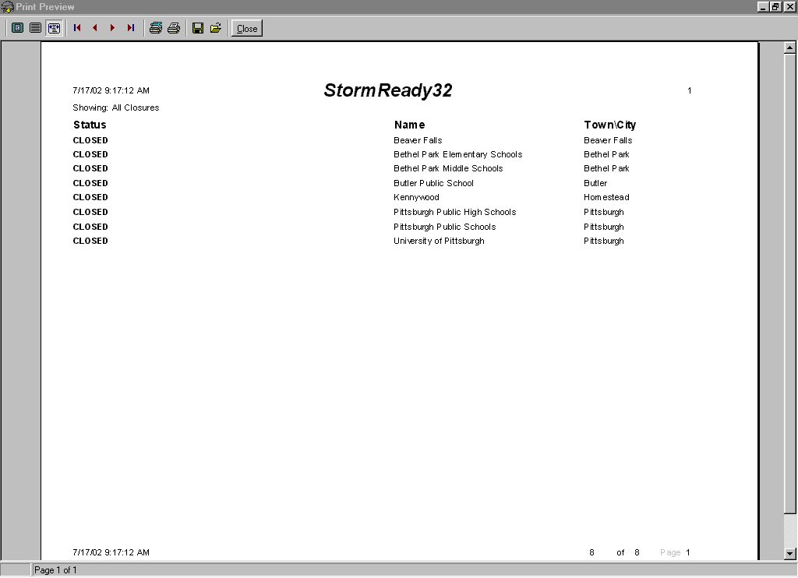
The printed form first appears on the screen. It allows you to page down through the list, and/or zoom in or out. The Print Screen is an exact representation of the way it will print, and the grid view is based on the search or the default grid view setup under F10 GRID VIEW. You have complete control of the order of columns and which columns appear.
Click on the printer icon to send the report to the printer if you prefer hard-copy.
You may generate a comma delimited output (for Excel etc), or generate an HTML formatted file, or save it to a text file for permanent storage via hard-disk CDROM or floppy.
Click on the Close button to return to the main StormReady32 screen.

Maintenance During an Event

StormReady32 offers the capability of resetting your entries, either all or just some of the entries. Resetting the entries will set the status field back to Unknown. This way the next time an event occurs, you’re ready to enter statuses.
To reset parts of your list:
You must tell your browser to display only the entries you wish to reset. The way to do this is to perform a search.

Click on the F2 Show button or strike F2 to show a list of the pre-defined searches.
Choose a search by clicking on the Title from the list.
-OR-
Use the Hot Key (Alt-number).

To reset the entries on your screen click on the F10 Other button or strike F10.
Choose Multiple Status Reset.
A window will prompt you to Reset record status?. Check the box next to Reset only visible records.
Click on the Yes button.
All visible records will be reset to Unknown.

Cleaning up After the Storm
The event has ended. Now its time to clean up and prepare the database for the next event.

Resetting the Entire Database
Once an event has passed you will want to reset all your entries:
Press F10.
Highlight multiple status reset and press ENTER.
Reset only visible records should be unchecked.
Click on the Yes button.

Deleting Records
To delete a record:
From the main StormReady32 screen, highlight the record you wish to delete and click the F9 Delete button or press F9. The full record will open and prompt you to verify the deletion. If you are sure you want to delete the record, press Y for yes. If you are unsure, press N for no.
Note: Once a record is deleted, it cannot be retrieved.

Back-up Issues

As with any program it is always important to make backup copies of your database. By making backups you can always restore your database if your database has problems. There are several ways to backup. You could backup the database files to a ZIP or JAZ drive. The ZIP and JAZ drive are just another drive letter on your system. Both the JAZ and ZIP are manufactured by Iomega Inc and can be bought at any local computer store, or through WireReady NSI. ZIP drives use 100MB disks, JAZ 1GB disks. Similarly you can burn to a writeable CD, if you have a CD-R drive available.

Or you may just want to save the database to the same drive for record keeping or a different drive on the network. Keep in mind that at the least you’ll want to do a PRINT REPORT of the entire closing list and save that printout to a CSV or similar file that can be brought up into Excel or a word-processor should someone call you in the future to find out what was read on the air.

You can also copy to another hard drive.

What Files Should I Copy?
The main program file is in the W:\WIRE folder and is called STORM32.EXE and the W:\WIRE\DATA subfolder has the STORM DATA LINK.UDL file .

Copy the entire W:\WIRE\USERS\PUBLIC\STORM32 directory In addition the master INI file is called STORM32.INI and can be found under W:\WIRE\USERS\STANDARD.

Restoring Files

Copy from the backup device (another hard drive, ZIP or JAZ) to the local drive or network, putting the files back in their original directories.

Note that restoring over existing files kills the old files so always backup your existing files before overwriting with a previous backup.

