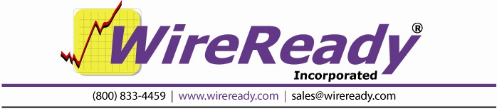

Triple Deck Pro

Users Guide

WireReady NSI P.O. Box 714 Eudora, KS 66025
(800) 833-4459 785-542-2173
sales@wireready.com support@wireready.com www.wireready.com
1997-2010 © WireReady® NSI
Triple Deck Pro

TABLE OF CONTENTS

Introduction 3
Opening the Triple Deck Screen 3
Setting the Active Deck 3
Loading Files into the List Control 3
Loading Files into the Decks 4
Playing Files 4
Screen Overview: Triple Deck Pro 5
Main Drop-Down Menu 7
System Configurations and Other Options 10
Configuring PlayOutReady 10
The User *.ini File 11
Printing a List of Media Files from the MediaLog 13
HOW TO REACH WIREREADY 14

Introduction
Triple Deck Pro provides both automated scripting decks for sophisticated playlisting and switcher control as well as triple deck graphical user interface screen (GUI). The GUI provides operator-friendly mouse, keypad and remote GPI control. Both program modules can run attended or unattended via remote GPI/RS-232/422 connection or remote keypad control. The system can import rundown/file lists and text file playlists from 3rd party systems. Once a list is loaded, the system can auto load the next item in the queue as each file is ejected, or you can drag and drop manually using the GUI. The Triple Deck screen provides up to 3 independent channels of play with Stradis Mpeg2 Decoder cards. Each deck can control a separate PlayoutReady instance, providing single-cut player and a simple means to air products over your stations.

The Triple Decks should not be configured to use the same card as an Automation deck at the same time. As when you setup the system you need to decide which card(s) will be used for playlist-based tasks and unattended operation, and which cards will be enabled for play in one or more of the triple decks. Each of the Triple Decks can only be assigned to one unique card in the system. You can't have 2 or more decks being used with one card.
If you plan to have a Triple Deck configured to the same card that you might also be using in an Automation Deck with a playlist, BE VERY CAREFUL never to try to run something in the deck while a playlist is running on the same card or vice versa or you will have unintended affects and may need to restart the program. A future version of the software will add contention protection and warn you if a card is active before you try to use it (expected in August 2010 as a free upgrade).

Our software will run from any Windows XP Pro computer, Core2Duo and faster.

Opening the Triple Deck Screen
From anywhere in the software, click on the yellow 3 Deck button or strike Alt+0 on the keyboard.

Setting the Active Deck
The deck that is highlighted with a yellow border is the active deck. To switch which deck is the active deck, use the up or down arrow keys, or click the number of the deck (1 to make Deck 1 active, 2 for Deck 2, and 3 for Deck 3).

Loading Files into the List Control
Files can be loaded into the List Control at the bottom of the Triple Deck screen either as individual files or an entire folder.
To load a group of files, open the File menu.
-Choose Load Playlist/Script from FileLog to load all of the embedded media files within a text file.
-Chose Load From Directory to load all the media files from a directory.
To load a single file, click the Add button or strike Alt+A on the keyboard. Then choose the file from the File Select window and click the OK button. If the Current Folder displayed is not the one holding the desired file(s), click the Select Folder button and choose the correct folder alias. Note: when loading a file with the Add button, the chosen file will be inserted directly below the highlighted file in the List Control window.

Loading Files into the Decks
Files can be loaded into the deck in several ways:
Method 1
Drag and drop from the List Control window into the desired deck. The file must be dropped into the large gray box between the Play and Stop buttons.
Method 2
Click the Load button (the first button on the left in the deck) to load the file highlighted in the List Control window. This will also move the highlight bar to the next file down in the List Control.
Method 3
Click on the Folder button in the deck. This will launch the File Select window. Then choose the file from the File Select window and click the OK button. If the Current Folder displayed is not the one holding the desired file(s), click the Select Folder button and choose the correct folder alias.
Note: If the Auto Load statement is checked in a deck, when the current file is ejected from the deck, the highlighted file from the List Control will automatically be loaded into that deck.

Playing Files
The decks are set up similar to a standard tape player/recorder. The Load, Play, Stop and Eject buttons work just as their labels state. The Navigation buttons along the bottom of the decks will allow the file to be moved in forward and reverse, in increments of frames, second, and minutes.
To set how much the file will be moved forward or backward, open the Deck menu, and then the Seek menu. Choose the statement that best reflects the increments that you want to use. These increments apply to both forward and reverse.
Seek Scale Tiny will move the file 1 Frame (right/left arrow or single arrow button), 1 Second (Shift plus right/left arrow or double arrow button), or 10 Seconds (Ctrl plus right/left arrow or triple arrow button)
Seek Scale Small will move the file 1 Second, 10 Seconds or 1 Minute
Seek Scale Medium will move the file 10 Seconds, 1 Minute or 10 Minutes
Seek Scale Large will move the file 1 Minute, 10 Minutes, or 1 Hour
To move the file to the beginning, strike the Home key on the keyboard or click the left-most Navigation button.
To move the file to the end, strike the End key on the keyboard or click the right-most Navigation button.

Screen Overview: Triple Deck Pro
The Triple Deck is the screen that is used with News Player Pro, the MPEG2 file-based playout designed for newscasts and talk shows.
This is a screenshot of the Triple Decks with no files loaded.
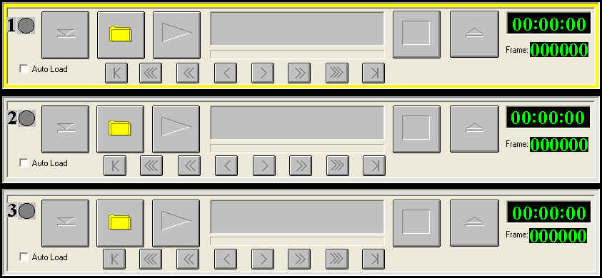

The following buttons are used in each of the 3 decks:
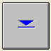 Load Will load the next file in the List Control box into the deck.
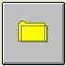 Folder Opens the FileSelect window to allow a new file to be loaded into the deck.
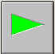 Play Starts the current file playing.
 Stop Stops the currently playing file.
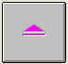 Eject Ejects the current file from the deck.
Auto Load check box When checked, the next file in the List Control box will be loaded into the deck when the current file is ejected.

Navigation
These buttons allow the user to go to the beginning of the file (|<), the end of the file (>|), or fast forward and rewind

This is a screenshot of the List Control below the decks
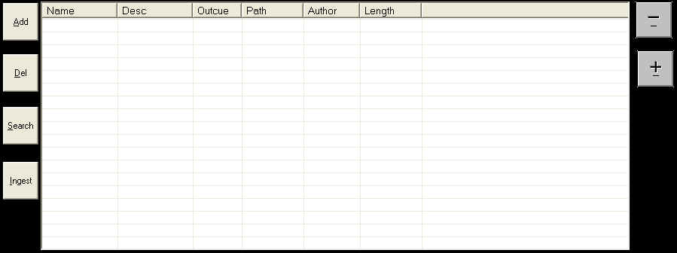

The following buttons are used in the List Control box:
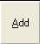 Add Opens the FileSelect window to add a new file to the List Control box
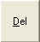 Delete Will remove the highlighted file from the List Control box.
 Search Will search within the List Control box for files matching the entered characters.
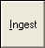 Ingest Processes mpg video files to determine the length and for quicker start of playback. NOTE: If a video file has not been ingested, its length will not show in Wireready32.
 Up/Minus Moves up the list of files and highlights the file above the current one.
 Down/Plus Moves down the list of files and highlights the file below the current one.

Timers
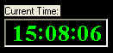 Current Time Displays the current time, as set in the computer clock.

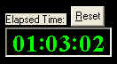 Elapsed Time Displays the number of hours, minutes and seconds that the Triple Deck screen has been open, or since the last time the timer was reset. Click the Reset button to set this timer back to 00:00:00 to start timing a new event.

Main Drop-Down Menu

The Main Menu, above the main Button bar, has 6 drop-down menus available for users to configure and control how the Triple Deck Pro screen operates. Use the keyboard shortcut or click on the item with the mouse to activate the menu choice.

Triple Deck Pro
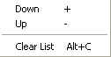
The Triple Deck Pro drop-down menu allows you to move up and down thru the List Control, and clear the list of files.

Down Moves down the list of files and highlights the file below the current one.
Up Moves up the list of files and highlights the file above the current one.
Clear List Alt+C Clears the List Control of files.

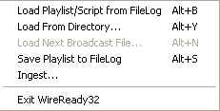
File
Load Playlist/Script from FileLog Alt+B Loads the embedded media files within a text file into the List Control window.
Load From Directory Alt+Y Loads all media files from a directory into the List Control window.

Load Next Broadcast File Alt+N (Not used at this time.)
Save Playlist to FileLog Alt+S Saves the media in the playlist window as embedded files in a text file.
Ingest Processes mpg video files to determine the length and for quicker start of playback. NOTE: If a video file has not been ingested, its length will not show in Wireready32.
Exit WireReady32 Exits the program

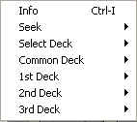
Deck
Info Ctrl+I Launches the MediaLog Editor screen to add/edit metadata for the file loaded in the active deck.

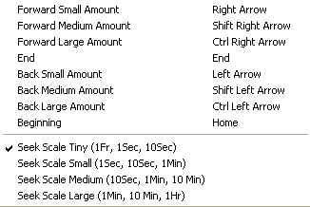
Seek Allows the user to scan through the file either by frames, seconds, or minutes, based on the Seek Scale chosen. The Seek Scale chosen also controls the Navigation buttons in each of the decks.

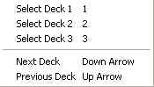
Select Deck
Select Deck 1 Makes the first deck the active deck.
Select Deck 2 Makes the second deck the active deck.
Select Deck 3 Makes the third deck the active deck.
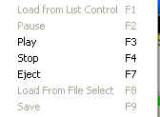
Next Deck Makes the deck above the current deck the active deck.
Previous Deck 1 Makes the deck below the current deck the active deck.

Common Deck Allows the user to control the video file in the active deck. Only the available commands are darker in the menu, based on if a file is loaded in the deck or the deck is empty.

1st 2nd and 3rd Deck Allows the user to control the video file in the specific deck. The same function keys are used in each deck, but using Shift plus the function key affects Deck 1, Ctrl+ affects Deck 2 and Alt+ affects Deck 3.

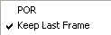
Setup

POR Launches the Triple Deck Pro Setup screen to configure the address to play media for each of the decks. (See the Configuring PlayOutReady section below)

Keep Last Frame If this box is checked, then when a video finishes playing, the last frame of the file will remain on the screen. Even if the auto-load box is checked, the video will NOT be ejected automatically. When you click the Eject button, the video will be ejected, and the next video will be autoloaded.

Programs
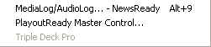
MediaLog/AudioLog – NewsReady Alt+9 The MediaLog is used to store video files to be used in automation.
PlayoutReady Master Control Launches the PlayoutReady Master Control Deck Selector window to navigate between decks.
Triple Deck Pro Opens the 3 Deck screen (grayed out since it is already open).
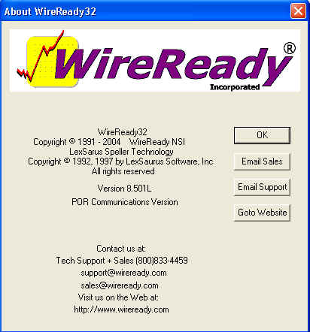
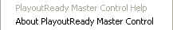
Help
PlayoutReady Master Control Help
About PlayoutReady Master Control Displays information about WireReady NSI and the version of the software.

System Configurations and Other Options

Configuring PlayOutReady

1) Click on Setup from the Main Menu, and then click on POR.
The following window opens:
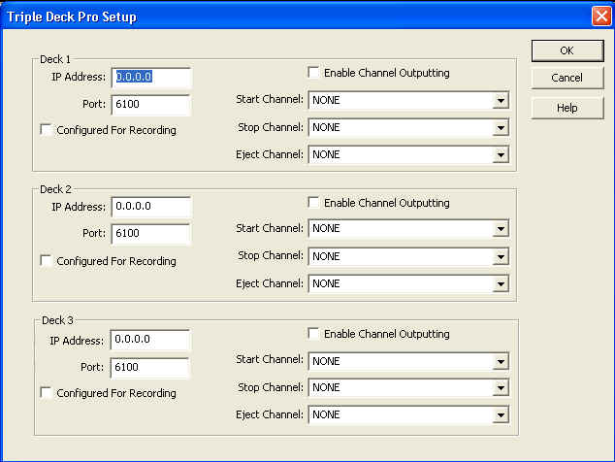
There is one section for each of the 3 decks. Any deck configured with an IP address of 0.0.0.0 will not be used to play video files. Do NOT configure more than one deck with the same IP address.

2) Enter the IP Address, which is the IP address of the computer that will be running PlayOutReady and displaying the video for that deck.
3) Enter the Port if not using the default value of 60100. If this port number is modified, be sure to use the same value in the configuration of PlayOutReady.
4) The checkbox Configured for Recording is not used at this time
5) Check the box for Enable Channel Outputting if closures will be used to play, stop or eject video files from the deck.
6) If Start, Stop and Eject Channels (closures) will be used for the deck, use the drop-down list to assign each of the channels that will be used.
7) Click the OK button to save the settings.

The User *.ini File

[server]:\wire\users\[username]\[username].ini
This file holds configuration information for the user. The below section holds the settings affecting the PlayoutReady Master Control screen. This is not a complete list of all possible ini keys, but what is needed to configure PlayOutReady Master Control.

[NewsReady32 - NewsDAD32]
AllowAudioLogBtn=Yes
AllowVideo3deckBtn=yes
Video3DeckPlayers=0

[PlayOutReady]
AutomationOnlyMode=yes
TVMode=yes
IP=127.0.0.1 The IP address of the PlayOutReady computer.
Port=60100 The port on the PlayOutReady computer.
SecondaryIP=0.0.0.0 This value is not used at this time.
SecondaryPort=60100 This value is not used at this time.
IngestDir32-Ingest-Directory-Path=W:\WIRE\System\Ingest32.dat
VideoMode=None
StradisBoardNumber=1

[Ingest]
batch-ingest-requires-new-metadata=No
single-ingest-requires-new-metadata=No
IngestFromPath=W:\spots\
IngestToPath=S:\spots_mpeg\
DatFilename=I:\WIRE\USERS\FOXMCR\SYSDAT\Ingest.dat

[Triple Deck Pro]
Column Width 0=100
Column Width 1=100
Column Width 2=50
Column Width 3=82
Column Width 4=75
Column Width 5=82
Column Width 6=334
Seek Scale=0
Keep Last Frame=No
WindowPos=0,1,-1,-1,-4,-30,0,0,1020,636
Timer Orientation=1
CurrentDir=

[Triple Deck Pro 1]
POR IP=192.168.5.3
POR Port=6100
Play-or-Record=Play
1616 Enabled=Yes
1616 Start Channel=1
1616 Stop Channel=2
Log Confirmation Enabled=No
1616 Eject Channel=3

[Triple Deck Pro 2]
POR IP=0.0.0.0
POR Port=6100
Play-or-Record=Play
1616 Enabled=No
1616 Start Channel=255
1616 Stop Channel=255
Log Confirmation Enabled=No
1616 Eject Channel=255

[Triple Deck Pro 3]
POR IP=0.0.0.0
POR Port=6100
Play-or-Record=Play
1616 Enabled=No
1616 Start Channel=255
1616 Stop Channel=255
Log Confirmation Enabled=No
1616 Eject Channel=255

Printing a List of Media Files from the MediaLog

It is now possible to print out a list of media files in the MediaLog folders. This output can be used to send a list of files to your traffic log provider.

1. Open the MediaLog folder you wish to print.

2. Click the F5 Print button or strike F5 on the keyboard.

3. The Print Options dialog box will open.
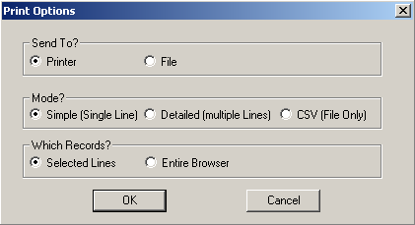

4. In the Send To? section, choose to send the information to the Printer or File.

5. In the Mode? section, choose the format of the file:
Simple (Single Line) will display the Filename, Description, Artist, Length, Saved By and Changed fields, with each media file’s information on one line.
Detailed (Multiple Lines) will display all of the fields for each media file, with each media file’s information taking 8 lines.
CSV (File Only) will display all the fields for each media file, with each field separated by a comma. This option will only send the info to a file, and will not print to the printer. If this option is chosen, File in the Send To? section will be marked.

6. In the Which Records? section, choose to print all the media files in the folder (Entire Browser), or only the ones that have been highlighted (Selected Lines).

7. Click OK.

HOW TO REACH WIREREADY

WireReady NSI
P.O. Box 714 Eudora, KS 66025
(800) 833-4459 USA & CANADA (785) 542-2173
E-MAIL: Sales@WireReady.com
WEB: www.WireReady.com

