

Using the Wires in NewsReady32

WireBrowser
The WireBrowser is the news activity hub of NewsReady32. This is where wire stories arrive, often a hundred or more in an hour, and are displayed in chronological order, with the most recent arrivals listed first. The WireBrowser shows each story’s headline, category, priority, and date and time. Within this application you can view, select, copy, print, sort, and save wire stories.

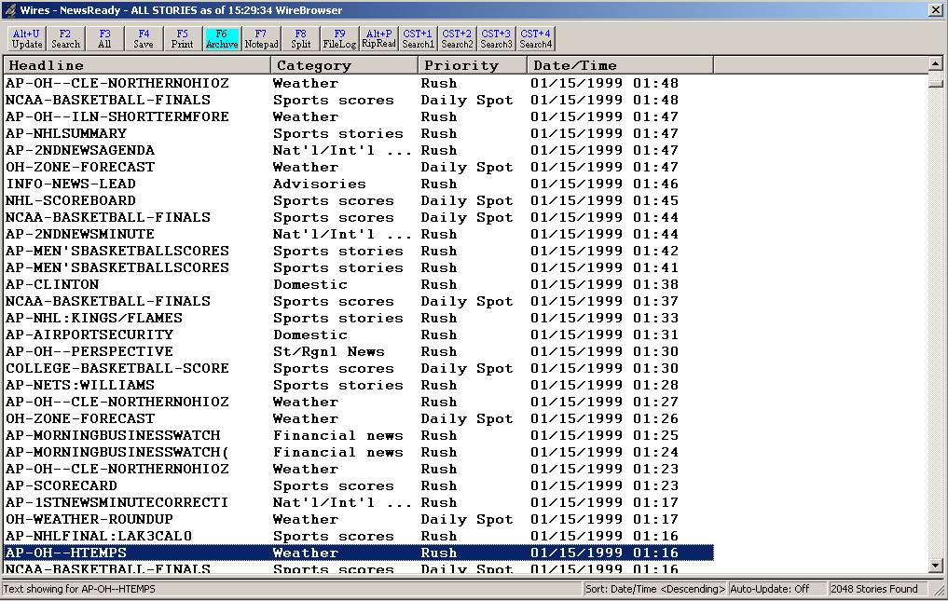

To open the WireBrowser:
Hold down the ALT key and hit the 3 (number) key.
OR - Click on the Wires button on the toolbar.
OR - From the Menu bar click on Programs, then select WireBrowser.

WireBrowser Toolbar

Alt+U Update Updates the screen and displays any new wire stories that have come in. Will update when all stories are displayed or when a search has been done.
F2 Search Search the browser to display text, category or priority search results.
F3 All Displays all stories currently help in the browser, and returns the sort order to date and time.
F4 Save Saves the highlighted story to a text file, and uses the Slug as the filename.
F5 Print Prints the text of the highlighted wire story.
F6 Archive Saves the highlighted story to a text file, and adds the user name, date and time to the Slug to create the filename.
F7 Notepad Switches the display to the current Notepad.
F8 Split Splits the screen with the Notepad.
F9 FileLog Switches the display to the current folder in the FileLog.
Alt+P RipRead Copies and pastes the text of the highlighted wire story into a Notepad or open FileLog file.
CST+1 Search1 Runs the first saved Quick Search.
CST+2 Search2 Runs the second saved Quick Search.
CST+3 Search3 Runs the third saved Quick Search.
CST+4 Search4 Runs the fourth saved Quick Search.

WIRE BROWSER

(Your source for building custom newscasts)

The WireBrowser is the activity hub of NewsReady32. This is where wire stories arrive, often a hundred or more in an hour, and are displayed in chronological order, with the most recent arrivals listed first. The WireBrowser shows each story’s headline, category, priority, and date and time. Within this application you can view, select, copy, print, sort, and save wire stories.

Before actually editing wire copy and inserting it into a newscast, it’s important to become familiar with the WireBrowser. The toolbar, located near the top of the screen, displays the WireBrowser’s primary functions.

Looking from left to right, the first toolbar button is Update. This feature manually updates the WireBrowser to display the most recent arrivals. The WireBrowser is programmed to update automatically, but the manual feature allows you to get updates whenever needed.

KEYBOARD PROCEDURE
Hold down ALT and hit U.

MOUSE PROCEDURE
Click Update on the toolbar.
OR - From the Menu bar click on File, then select Update.

The Search button is next on the toolbar. Information for this button follows shortly. The next button to the right is the All (for All Stories) button. The All button (formerly Show All) is similar to Update. It shows all stories in the WireBrowser; however, it does not instantly update the list. Use All anytime you wish to return to the complete list of stories. Activating Update updates the WireBrowser to show new stories based on the search specifications chosen. See the section on searching below for more information.

KEYBOARD PROCEDURE
Strike F3.

MOUSE PROCEDURE
Click All on the toolbar.
OR - From the Menu bar click on File, then select All Stories.

Sorting wire copy
NewsReady32 gives you the ability to view and arrange wire stories by headline (alphabetically), category (national news, sports, etc.), priority (rush, urgent, etc.), or date and time. To sort the wire copy, click the column heading (just below the toolbar) you wish to sort by. The wire stories will remain in this order until you change it. Click the column heading a second time to arrange the stories in reverse-alphabetical order. Remember that the All button (F3) will return the list to chronological order.

Adjusting the column width
To adjust the width of the columns in the WireBrowser simply move the mouse pointer to the vertical line that separates two columns. It is located on the gray column heading line. When the mouse pointer turns to a double-pointed horizontal arrow click and hold the left mouse button to move this separator bar to the left or right. The width of any column may be adjusted in this manner.

Changing the font, style, or point size
To change the font or the size of the characters that appear in the WireBrowser just click on Setup from the Menu bar, then select Fonts. Choose the font, style, and size you desire. These selections will remain intact until they are changed.

Viewing the toolbar and status bar
To turn On or Off the toolbar click on View on the Menu bar, then Toolbar. If a checkmark appears then the toolbar is currently visible. The same choice is available for the Status Bar. Again, a checkmark is visible when the status bar is turned on.

Searching wire copy
NewsReady32 offers powerful and easy-to-use searching capabilities that include pre-built searches that can be edited or deleted, plus the flexibility to create your own custom searches. Each user can have his or her own set of searches.

The F2 search
KEYBOARD PROCEDURE
Strike F2.

MOUSE PROCEDURE
Click Search on the toolbar.
OR - From the Menu bar click on File, then select Search.
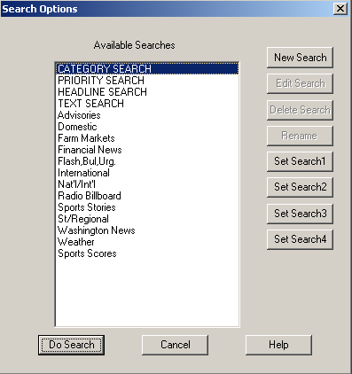
Double-click the heading of the search you wish to perform, or single-click to highlight the heading and click Do Search. The stories currently in the WireBrowser that meet that search's requirements will be displayed.

To return to a display of all stories, click the All button on the toolbar, or select All Stories from the File pull down menu, or hit F3 on the keyboard.

Category, Priority, Headline, and Text searches
These general searches are the first four on your list. They cannot be deleted.

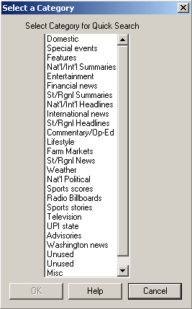
Category Search
This will display a list of all the categories (national news, sports, etc.) a story can have (as displayed on your browser).

To select this type of search double-click the word Category, or highlight it then strike ENTER. Choose the category you are looking for by double-clicking it, or by single-clicking to highlight it and clicking OK. With the keyboard, use the ARROW keys to scroll and highlight your desired category, then hit ENTER.

This will display a list of stories with the category you have chosen.

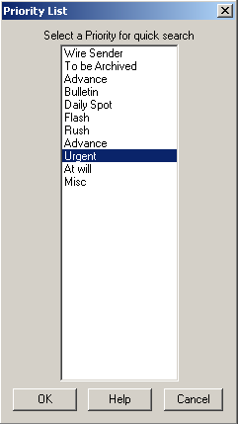

Priority search
This feature displays a list of all the priorities (rush, urgent, etc.) a story can have. Choose the priority you are looking for by double-clicking it, or by single-clicking to highlight it and clicking OK. With the keyboard, use the ARROW keys to scroll and highlight your desired priority, then hit ENTER.

This will display a list of stories with the priority you have chosen

NOTE: Categories and Priorities differ from wire service to wire service. The examples used above may not be an option, depending what wire service you have.

Headline search
This option lets you search headlines as they appear in WireBrowser. For example, to search for headlines containing the word Education, you would type Education and click OK or hit ENTER. All stories that have the word Education somewhere within the headline will be displayed
.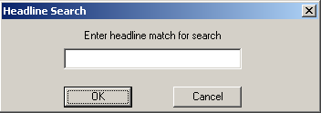

Text search
This option is similar to headline search, except that it will look for one or more words contained in the headline, category, priority and body of the story. For example, to search for stories containing the phrase Public school, you would type Public school and click OK or hit ENTER. This will display all stories that have the phrase Public school somewhere in the story.
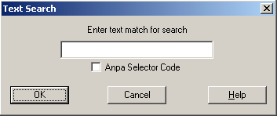
None of the F2 Searches are case-sensitive.

Creating new (Custom) searches
Users can create their own custom searches.

From the WireBrowser use your mouse to click the Search button on the toolbar, or select Search from the File pull down menu, or hit F2 on your keyboard. This will display a list of your current searches.

Click the New Search button. The “Add a new Custom Search” dialog box will be displayed. Use it to define which categories, priorities, headline or text matches you want to search within.

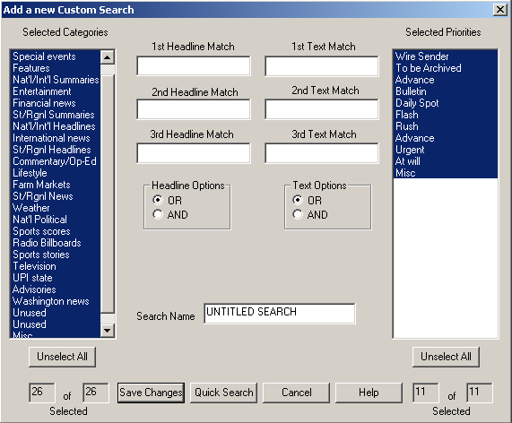

To select specific categories, first click on the Unselect All button to turn off the entire selection of categories, then single-click each category you want to be searched. To search all categories, do not click the Unselect All button. Repeat this process to select all or some of the priorities.

To search for specific words in a headline, type the word in the entry box labeled 1st Headline Match. There are a total of three text boxes for headline searches if you wish to look for additional words in a headline. If you use more than one headline text box then you also need to click on the radio button labeled OR, or the radio button labeled AND. To display only stories that contain ALL the headlines you listed in the text boxes choose AND. To display stories that contain ANY of the headlines you listed choose OR.

Repeat this process for a text search by using the Text Match entry boxes. Enter the phrases or keywords you are looking for within the body of the stories. Remember to choose between OR and AND if you use more than one Text Match box.

When finished, enter a name for this search in the Search Name entry box. By default it will say Untitled Search. Click on the Save Changes button. The name will then appear at the bottom of the list of searches when you select Search (F2) from the WireBrowser.

Setting Quick Searches
Buttons have been added to the toolbar to allow users to set their 4 most commonly used WireBrowser Custom Searches as a Quick Search. When using F2 to bring up the list of searches, the Search Options window now contains 4 additional buttons along the right side of the window (Set Search1 thru Set Search4).
To setup a Quick Search, highlight a search from the list in the Search Options window. Then click on a Set Search button to set that search as a Quick Search with that number.

Printing wire copy
Instructions for printing a newscast will be presented in greater detail later in this user guide, but it is also possible to print directly from the WireBrowser. Highlight a headline and choose from the following options:

KEYBOARD PROCEDURE
Strike F5.
OR - Hold down CTRL and hit P.

MOUSE PROCEDURE
Click Print on the toolbar.
OR - From the Menu bar click on File, then select Print.

You’ll see a print dialog box that will guide you through several printing options, including full story, individual pages or a range of pages, or print selection, which lets you print only that text you previously highlighted.

To print only a portion of a story, highlight the text before selecting Print.

Printing in double space
NewsReady32 provides the ability to print in double space so the hard copy is easier to read. This option is available when a story is open from the WireBrowser, the Notepad, or the FileLog. Simply click on Setup from the Menu bar, then select Double Space. The line spacing on the screen will not be affected, but once Print has been selected the text will re-flow to display the actual appearance. NOTE: A checkmark will appear beside Double Space when it is active. Another click on this choice will turn Double Space off.

Preview screen
This convenient feature of WireBrowser lets you divide the screen horizontally and view headlines, categories, etc. in the upper of the two windows. As you scroll up or down, individual headlines are selected or highlighted in the upper window, and the story that corresponds to each headline appears in the lower window.

Depending on its length, you may be able to view a particular story in its entirety in the lower window. But even if it runs longer, you can see it all by scrolling down, with either the keyboard’s ARROW keys or with the mouse.

To display the Preview screen (from the WireBrowser), move the mouse pointer toward the bottom of the WireBrowser window. Just below the last viewable headline, there is a gray, horizontal bar. Place the mouse pointer over this bar, and it becomes a double-pointed vertical arrow. Click and hold the left mouse button and drag the gray divider bar up or down to any position you wish. The Preview screen will be visible in the lower window. To close Preview, drag the divider bar back to the bottom of the screen
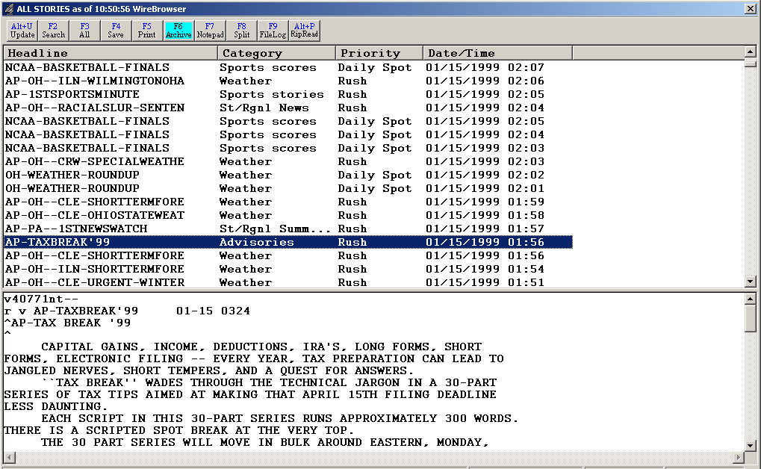
Divider Bar

Pop Viewer
A wire story can also be opened directly into an editor by double-clicking its headline or by highlighting the headline and hitting the ENTER key. When the story is opened in the Pop Viewer, you can edit, print, or copy and paste all or portions of it into the Notepad.
Within the Pop Viewer, the F11 and F12 keys will jump to the next or previous story in the list. This allows you to browse wire stories and select the ones you want as you go. Return to the WireBrowser by striking the ESC key.
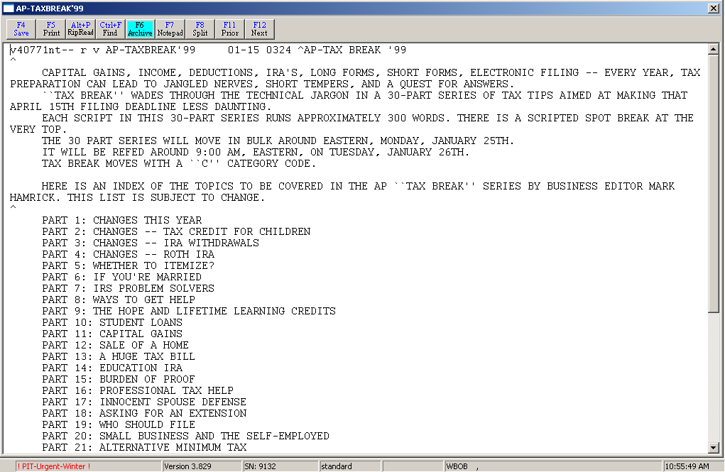

Auto Purge
It’s reasonable to ask that since wire stories are constantly being received by the WireBrowser, will the system ever become overloaded. A feature called Auto Purge, as the name suggests, automatically deletes wire stories (oldest first) when a set cache or database size is reached. Your systems administrator sets the size. For most radio stations, a 5-megabyte database will hold approximately 2000 stories or about two days’ worth of feeds.

Copying and Pasting Wire Copy
The WireBrowser, in combination with the Notepad, makes it easy to copy text from a wire story and place it into a customized newscast. Any portion of wire copy, from one word to the entire story, can be "pasted" into a newscast.

The first step is to select which story to use. If desired, use the Preview screen to view a story, or open the story in the Pop Viewer by double-clicking its headline or by highlighting the headline and hitting the ENTER key. Then highlight or select the text you wish to use:

KEYBOARD PROCEDURE
With the ARROW keys place the cursor at the beginning of the text you want to copy.
Hold down the SHIFT key and use the ARROW keys to move the cursor to the end of the desired text. (The SHIFT key in combination with PAGE UP, PAGE DOWN, HOME, or END will also highlight).

MOUSE PROCEDURE
Click with the mouse at the beginning of the text you wish to copy.
Click and hold the left button and move it to the end of the desired text, then release the button.

To copy the selected text:

KEYBOARD PROCEDURE
Hold down the CTRL key and hit the C (letter) key.

MOUSE PROCEDURE
From the Menu bar click on Edit, then select Copy.
OR - Click on the highlighted area with the right mouse button, then choose Copy with the left mouse button.

OPTIONAL PROCEDURE
You can achieve the same results by
Holding down the CTRL key and hitting the X (instead of C) key.
OR - Using the mouse, selecting Cut from the Edit pull down menu at the top of the screen.
OR - Clicking with the right mouse button, then choosing Cut with the left mouse button.

INFORMATION: You may hear the term "cut and paste" used in reference to this task. In this situation you are only copying, not cutting, text. Even if you use the CTRL-X key combination or choose Cut from the Edit pull down menu, the wire story remains intact for future use (though text momentarily appears to be missing.)

NOTE: The pull down menus can be accessed with the keyboard via the ALT key. Hold down the ALT key and hit the underscored letter of the menu you wish to open, then strike the underscored letter of the command you wish to perform.

WireBrowser Drop-Down Menu

The Main Menu, above the main Button bar, has 8 drop-down menus available for users to create and edit text files. Use the keyboard shortcut or click on the choice with the mouse to activate the menu choice.

WireBrowser
There are no sub-menus listed under this choice.

File
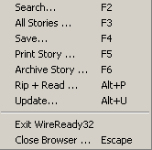
Search F2 Search the browser to display text, category or priority search results.
All Stories F3 Displays all stories currently help in the browser, and returns the sort order to date and time.
Save F4 Saves the highlighted story to a text file, and uses the Slug as the filename.
Print Story F5 Prints the text of the highlighted wire story.
Archive Story F6 Saves the highlighted story to a text file, and adds the user name, date and time to the Slug to create the filename.
Rip+Read Alt+P Copies and pastes the text of the highlighted wire story into a Notepad or open FileLog file.
Update Alt+U Updates the screen and displays any new wire stories that have come in. Will update when all stories are displayed or when a search has been done.
Exit WireReady32 Exits the user from the program.
Close Browser Escape Closes the wire browser window and displays the last open window.

Programs
The Programs menu lists the 11 screens in NewsReady32. Consult the other WireReady manuals for information on using the automation and sales screens.

Notepad – NewsReady Alt+1 The Notepad is used to edit text and create new stories and rotations.
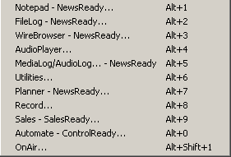
FileLog – NewsReady Alt+2 The FileLog is used to access text stories that have been saved from the Notepad, and to edit rotations.
WireBrowser – NewsReady Alt+3 The WireBrowser displays the wire stories that have been captured.
AudioPlayer Alt+4 The Player is used to read newscasts and play the embedded audio.
MediaLog/AudioLog – NewsReady Alt+5 The MediaLog is used to store audio files to be used in newscasts and automation.
Utilities Alt+6 The Utilities screen allows access to StormReady32, QuickRecorder, and the DOS PhoneReady and StormReady programs.
Planner – NewsReady Alt+7 The Planner is a calendar program to track appointments and assignments for newsrooms.
Record Alt+8 The Record button is used to manually record new audio files.
Sales – SalesReady Alt+9 The Sales screen is used to record and track contacts with customers/advertisers.
Automate – ControlReady Alt+0 The Automate decks are used to automate recording and playback of audio, and for web publishing.
OnAir Alt+Shift+1 The OnAir 10-deck screen is used for playback of audio while live.

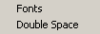
Setup
Fonts Set up the font size and style for the Wire Browser.
Double Space When checked, the printed copy of the text will be double-spaced. Does not affect the screen view. Only active in the Preview window.

View
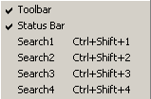
Toolbar When checked, the toolbar buttons at the top of the Wire Browser will be visible.
Status Bar When checked, the status bar, which displays the sort settings and numbers of stories found, is visible at the bottom of the browser screen.
Search1 Ctrl+Shift+1 Runs the first saved Quick Search.
Search2 Ctrl+Shift+2 Runs the second saved Quick Search.
Search3 Ctrl+Shift+3 Runs the third saved Quick Search.
Search4 Ctrl+Shift+4 Runs the fourth saved Quick Search.

Window
In addition to the menu choices, any open NewsReady32 screens or open text files will be listed at the bottom of the menu choices in this drop-down window.
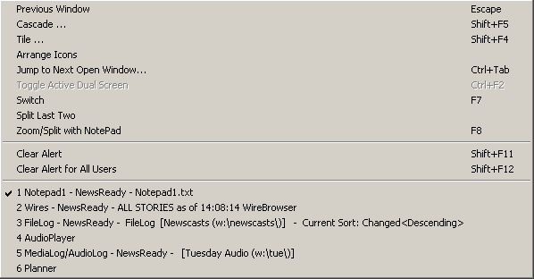
Previous Window Escape Puts the last window that was open before the Notepad as the current display.
Cascade Shift+F5 Allows the screens to be cascaded. Only active when the user is set to Windows Standard mode.
Tile Shift+F4 Allows the screens to be tiled. Only active when the user is set to Windows Standard mode.
Arrange Icons
Jump to Next Open Window Ctrl+Tab Makes the next open screen be displayed.
Toggle Active Dual Screen Ctrl+F2 Toggles between the 2 windows when the user is set to Dual Screen mode.
Switch F7 Toggles between the Notepad and the last open screen.
Split Last Two
Zoom/Split with Notepad F8 Splits the current screen (or last open screen) with the Notepad.
Clear Alert Shift+F11 Clears the red wire alert at the bottom of the screen for the logged-in user.
Clear Alert for All Users Shift +F12 Clears the red wire alert at the bottom of the screen for all users.

User
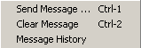
These menu choices are only available when using secure logins.
Send Message Ctrl+1 Sends a message to other users, which will appear in the header of the main window.
Clear Message Ctrl+2 Clears the message from the current user’s screen.
Message History Displays the date and text of the previously sent messages.

Help
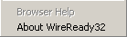
Browser Help This menu choice is not active at this time.
About WireReady32 Displays the version number of the software and contact information for WireReady NSI.
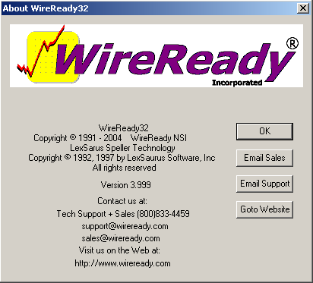

Configurations
The configuration settings for WireReady32 are stored in the user’s ini file. This file is the [server drive]:\wire\users\[username]\[username].ini file, where [username] is the workstation login name for WireReady32 (i.e. w:\wire\users\news1\news1.ini).
This file can be edited with Notepad or Wordpad, or any other text editor. Below is the section from a user’s ini file that controls the screens that the user is allowed to access. WireReady also enables the administrator to change these settings using a program called Setup32 (see the section below on using the Setup32 utilty).
When making changes to the user’s settings, the user should be logged out of the WireReady32 program.

[NewsReady32 - NewsDAD32]
Allow Audiolog Delete=  ! pre-2.601 2.01 | Yes | Yes=Enables the “Delete” button in the Medialog.  No=Hides the “Delete” button in the Medialog.
Allow F4Save=  ! pre-2.601 2.01 | 0 | 0 = No or Off  1 = Yes or On
Allow F6Archive=  ! pre-2.601 2.01 | 1 | 0 = No or Off  1 = Yes or On
Allow F9FileLog=  ! pre-2.601 2.01 | 1 | 0 = No or Off  1 = Yes or On
Allow Filelog Delete=  ! pre-2.601 2.01 | Yes | Yes=Enables the “Delete” button in the Filelog.  No=Hides the “Delete” button in the Filelog.
Allow10DeckBtn=  ! 3.266 2.14 | Yes | Yes=Enables the Yellow 10 Deck button at the top the WireReady screen.  No=Grays out the button.
AllowAudioLogBtn=  ! 3.266 2.14 | Yes | Yes=Enables the Yellow MediaLog button at the top the WireReady screen.  No=Grays out the button.
AllowAutomateBtn=  ! 3.266 2.14 | No | Yes=Enables the Yellow Automate button at the top the WireReady screen.  No=Grays out the button.
AllowLiveAssistBtn=  ! 3.266 2.14 | Yes | Has been replaced by the Allow10DeckBtn setting.
AllowLiveAssist2Btn=  ! 4.512 NA | Yes | Yes=Enables the Yellow L-Assist button at the top of the WireReady screen.  No=Grays out the button.
AllowMultipleAudioLogs=  ! pre-2.601 2.01 | 0 | Allows more than one MediaLog screen to be open at once. This setting is only available in Windows Standard mode.  0 = No or Off  1 = Yes or On
AllowMultipleBrowsers=  ! pre-2.601 2.01 | 0 | Allows more than one browser screen to be open at once. This setting is only available in Windows Standard mode.  0 = No or Off  1 = Yes or On
AllowMultipleFileLogs=  ! pre-2.601 2.01 | 0 | Allows more than one filelog screen to be open at once. This setting is only available in Windows Standard mode.  0 = No or Off  1 = Yes or On
AllowMultipleNotePads=  ! pre-2.601 2.01 | 1 | Allows more than one notepad screen to be open at once. This setting is only available in Classic or Windows Standard mode.  0 = No or Off  1 = Yes or On
AllowNotePadBtn=  ! 3.266 2.14 | Yes | Yes=Enables the Yellow Notepad button at the top the WireReady screen.  No=Grays out the button.
AllowPlannerBtn=  ! 3.266 2.14 | Yes | Yes=Enables the Yellow Planner button at the top the WireReady screen.  No=Grays out the button.
AllowPlayerBtn=  ! 3.266 2.14 | Yes | Yes=Enables the Yellow Player button at the top the WireReady screen.  No=Grays out the button.
AllowRecordBtn=  ! 3.266 2.14 | Yes | Yes=Enables the Yellow Record button at the top the WireReady screen.  No=Grays out the button.
AllowSalesBtn=  ! 3.266 2.14 | Yes | Yes=Enables the Yellow Sales button at the top the WireReady screen.  No=Grays out the button.
AllowUtilitiesBtn=  ! 3.266 2.14 | No | Yes=Enables the Yellow Utilities button at the top the WireReady screen.  No=Grays out the button.
AllowWireBrowserBtn=  ! 3.266 2.14 | Yes | Yes=Enables the Yellow Wires button at the top the WireReady screen.  No=Grays out the button.
AudioLogs=  ! pre-2.601 2.01 | 1 | Number of MediaLog screens that can be opened. This setting is only available in Windows Standard mode.
AudioPlayers=  ! pre-2.601 2.01 | 0 | Number of Player screens that can be opened. This setting is only available in Windows Standard mode.
AudioTempPath=  ! pre-2.601 2.01 | C:\Windows\Temp\NR32\AUDIO\ | Path that the audio will be temporarily copied to when a FileLog story containing embedded audio is opened. 30 character maximum
Browsers=  ! pre-2.601 2.01 | 1 | Number of browser screens that can be opened. This setting is only available in Windows Standard mode.
CUSDIR32-custom-directory-path=  ! 4.006 NA | W:\wire\system\news\cusdir32.dat | The path of the file that contains the list of custom folders for this user. Overrides the default of w:\wire\system\cusdir32.dat.
FileLogs=  ! pre-2.601 2.01 | 0 | Number of FileLog screens that can be opened. This setting is only available in Windows Standard mode.
Max FileLog Edit Windows=  ! 3.723 NA | 20 | The number of stories that can be left open from the FileLog before getting a warning. Possible values are any number in the range 2-200. Default is 20.
MaxNotePadCount=  ! pre-2.601 2.01 | 6 | Maximum number of notepads that can be opened at one time. Any number between 1 and 10.
MaxTempAudioFiles=  ! pre-2.601 2.01 | 250 | Maximum number of audio files that can be opened into the AudioTempPath. 6 character max
Mode=  ! pre-2.601 2.01 | Classic | Classic=Provides many of the standard Windows features, but restricts the user to having one screen open at a time. Most common mode.  Dual Screen= Allows the user to have 2 screens open at one time.  Standard= Activates all the standard Windows options. This mode provides the ability to tile, cascade and minimize windows. Should only be used by Advanced users.
NewsDad32=  ! pre-2.601 2.01 | No | No=the program is being used without the Enco program.  Yes=the program is being used in conjunction with the Enco NewsDad system.
Notepads=  ! pre-2.601 2.01 | 6 | Number of Notepads that are available upon start-up of WR32. Any number between 1 and 10.
Planners=  ! pre-2.601 2.01 | 0 | Number of Planner screens that can be opened. This setting is only available in Windows Standard mode.
PlayFromTempPath=  ! pre-2.601 2.01 | Yes | Yes=Allows user to enter a path in AudioTempPath edit box. Sets the user to cache audio to the local drive when opening a FileLog story with embedded audio. Default for OnAir users.  No=Edit box is grayed out. Audio will not be cached to the local drive.
QuickComTalk1=
Rundowns=  ! pre-2.601 2.01 | 0 | Number of browser screens that can be opened. This setting is only available in Windows Standard mode.
Split=  ! pre-2.601 2.01 | Horizontal | Screen Split Orientation when using Dual Screen mode.  Horizontal=When the screen is split, showing two different Wireready windows, the screen is split horizontally.  Vertical=When the screen is split, showing two different Wireready windows, the screen is split vertically.
TempAudioThreshold=  ! pre-2.601 2.01 | 250 | 5 character max. Read the maximum number of threshold audio files

Using the Setup32 Utility

To Run the Setup32 Utility
Setup32.exe resides in the Install subfolder of Wire. There are several ways to run the program from Windows, but if you are not familiar with running executable files in Windows, follow the below instructions to open Setup32.
- From the desktop double-click on the “My Computer” icon.
- Double-click the server drive containing the WireReady software.
- Double-click the Wire folder.
- Double-click the Install folder.
- Double-click the Setup32 file.

Any displayed information will be preserved when clicking between tab sections, but remember to save any changes on that particular tab before exiting the program. Clicking Save in User Configuration will not save the data on the Custom Folders tab.

USER CONFIGURATION
This section allows you to configure user or workstation log-ins. It is possible to set up different operation modes, restrict specific buttons, allow multiple notepads, and change the default directories for each user individually. If you wish to use workstation log-ins or individual log-ins to access WireReady32 then this is the section that allows you to set up those options. When making changes to an existing user, that user must be logged out of WireReady32.
The user called Standard is used when creating new users. The new user will be set with the same configuration settings as the Standard user. The STANDARD workstation login must be present. If it needs to be created use the DOS Setup utility. To run the DOS setup utility, open a DOS box, and change to the drive where WireReady32 has been installed, i.e. W:. Change to the \wire\install directory. Type SETUP and press Enter. Strike Enter to by-pass the opening screen. If necessary, type the installation path, i.e. W:\Wire\, and strike Enter. The third option on the list is User Maintenance for LAN Systems. Use the arrow keys to highlight it and press Enter. Strike Enter on Add User. For the user name type in STANDARD and strike Enter. Strike ESCape until you return to a DOS prompt. Type EXIT to return to Windows.
When using Setup32 remember to click on the Save button in the lower corner before moving to another section of the utility. Click on the User Configuration tab at the top to perform any of the following tasks:

To Create Workstation or User Names
1. Click on the User Configuration Page 1 tab.
2. Select a User Configuration Mode (Workstation or User) from the Select Configuration List box. "User" is only available for secure log-ins (see the Security Features section in this document).
3. Click on the ADD button.
4. Click on the Add New User/Workstation entry box and type the workstation or user name.
5. Click the ADD button on the Add New User/Workstation window.
6. Click OK on the User Added box.
7. Repeat this process if necessary. When done adding new user names, click on the Finished button.
8. Click on the Save button.
Note: A user name cannot exceed eight characters and cannot contain spaces.

To Delete User Names
1. Click on the User Configuration Page 1 tab.
2. Select a User Configuration Mode (Workstation or User) from the Select Configuration List box. "User" is only available for secure log-ins (see the Security Features section in this document).
3. Click on the name in the list of users.
4. Click the Delete button.
5. Click Yes when prompted if you would like to continue.
6. Click OK when prompted that the user was deleted.
7. Repeat this process if necessary.

To Reset a User Password
1. Click on the User Configuration Page 1 tab.
2. Select User in the Select Configuration List box. "User" is only available for secure log-ins (see the Security Features section in this document).
3. Click on the name in the list of users.
4. Click the Reset Password button.
5. Click OK when prompted that the password has been reset.
6. Click on the Save button.
Note: This option is only used for secure log-ins. The password is reset to blank. The next time the user logs in he/she will be asked to provide a password.

To Copy the Configuration Settings from One User to Another
1. Click on the User Configuration Page 1 tab.
2. Select a User Mode (Workstation or User) from the Select Configuration List box. "User" is only available for secure log-ins (see the Security Features section in this document).
3. Click on the name in the list of users that has the configuration you wish to copy.
4. Click the Copy to Standard button.
5. A Warning will appear explaining that the settings for the Standard workstation/user will be overwritten. Click Yes, then OK to overwrite the Standard settings.
6. Click on the name in the list of users that you wish to copy to.
7. Click the CLONE From Standard button.
8. A dialog box will be displayed that provides you with the opportunity to copy the configuration files and/or the searches. Make your choice and click the Start button.
9. Click OK when prompted that the cloning is complete.
10. Click on the Save button.

To Copy the Configuration Settings from One User to All Users
1. Click on the User Configuration Page 1 tab.
2. Select a User Mode (Workstation or User) from the Select Configuration List box. "User" is only available for secure log-ins (see the Security Features section in this document).
3. Click on the name in the list of users that has the configuration you wish to copy.
4. Click the Copy to Standard button.
5. A Warning will appear explaining that the settings for the Standard workstation/user will be overwritten. Click Yes, and then OK to overwrite the Standard settings.
6. Click the CLONE ALL Users with Standard button.
7. A dialog box will be displayed that provides you with the opportunity to copy the configuration files and/or the searches. Make your choice and click the Start button.
8. Click OK when prompted that the cloning is complete.
9. Click on the Save button.
Note: Take caution because this button will change the configuration settings and searches for ALL users to those that are currently set for the Standard user.

To Temporarily Cache Audio to the Local Hard Drive
1. Click on the User Configuration Page 1 tab.
2. Select Workstation from the Select Configuration List box.
3. Click on the name in the list of users.
4. Under the Audio Settings section click on the checkbox to Play from Temp Path.
5. Type the path name in the Temp entry box, i.e. C:\Windows\Temp\NR.
6. Type the maximum number of files for this path in the Max Files entry box. The default is 250.
7. Click on the Save button.
Note: This option is typically set for OnAir computers to prevent any pause when audio is played during a newscast.

To Set the Default Paths for Text and Audio
1. Click on the User Configuration Page 1 tab.
2. Select a User Configuration Mode (Workstation or User) from the Select Configuration List box. "User" is only available for secure log-ins (see the Security Features section in this document).
3. Click on the name in the list of users.
4. In the entry boxes, type the name of the default directory path for the NotePad and for Recording audio, i.e. W:\templates\.
5. Click on the Save button.
Note: In WireReady32 when you choose to save from the Notepad or from an audio editor, the default directory is the first path the computer will look to place the file.

To Create New Archive Categories
1. Click on the User Configuration Page 1 tab.
2. Select Workstation from the Select Configuration List box.
3. Select the workstation name.
4. Click on the Configure Categories button.
5. Enter the name in the Archive Config entry window.
6. Click on the ADD button.
7. Repeat this process if necessary. When done adding new categories, click on the SAVE button in the Configure Categories window.
8. Click on the Save button.
Note: This option is only available for Workstations. The Archive Categories are used when saving text files.

To Remove Archive Categories
1. Click on the User Configuration Page 1 tab.
2. Select Workstation from the Select Configuration List box.
3. Select the workstation name.
4. Click on the Configure Categories button.
5. Highlight the name in the list of categories.
6. Click on the REMOVE button. The category will be removed from the list.
7. Repeat this process if necessary. When done removing categories, click on the SAVE button in the Configure Categories window.
8. Click on the Save button.
Note: This option is only available for Workstations. The Archive Categories are used when saving text files.

To Reset Configuration Values for all Workstations
This function will check the $config.wr files for each user and remove duplicate archive categories and browser categories/priorities.
1. Click on the User Configuration Page 1 tab.
2. Click on the Restore Configurations ---All button.
3. Choose Yes when prompted to proceed.
4. Click OK when prompted that the restore has finished.

To Change the User Operation Mode
1. Select a User Configuration Mode (Workstation or User) from the Select Configuration List box. "User" is only available for secure log-ins (see the Security Features section in this document).
2 Click on the User Configuration Page 2 tab.
3. Click on the name in the list of users.
4. Choose the WireReady Operation Mode.
Classic is the most common mode used. It provides many of the standard Windows features, but restricts some options to prevent confusion for inexperienced users. Only one window will be visible at a time.
Dual Screen provides the flexibility of having two windows open at all times. If you split the screen in Classic Mode then one of windows is always the Notepad. This is not the case in Dual Screen Mode.
Windows Standard mode activates all the options that accompany a standard Windows program. It is for users who are knowledgeable about Windows. It provides the option to Cascade and Tile windows as well as minimize, maximize, or close windows.
5. Click on the Save button.
 WARNING: Windows Standard Mode should only be used by Advanced Users for specialized functions. Not all split screens and other issues may work with Windows Standard Mode.

Other Custom Settings for Users (Split screen and Multiple screens)
1. Select a User Configuration Mode (Workstation or User) from the Select Configuration List box. "User" is only available for secure log-ins (see the Security Features section in this document).
2. Click on the User Configuration Page 2 tab.
3. Click on the name in the list of users.
4. To change the Split Screen Orientation, click on either Horizontal or Vertical.
5. To Allow Multiple Screens, click on Notepads, FileLogs, AudioLogs, and/or Wire Browsers.
Note: Multiple FileLogs, AudioLogs, and WireBrowsers are only available in Windows Standard Mode.
6. Enter the number of Notepads you wish to allow. Ten is the maximum.
7. Click on the Save button.

To Display Stories in the Wire Browser in All Caps
1. Select Workstation from the Select Configuration List box on User Configuration Page 1.
2. Click on the User Configuration Page 2 tab.
3. Click on the name in the list of users.
4. Click on the checkbox for Browser in Caps.
5. Click on the Save button.
Note: This option is only available for Workstations.

To Lockdown Workstations or Users to the Standard Settings
This feature allows the administrator to have uniform settings for fonts, columns, and WireBrowser searches. Any or all users may be locked down to this standard configuration. The lockdown does not prevent users from making changes, but will reset back to the standard settings when they log out of WireReady32
1. Select a User Configuration Mode (Workstation or User) from the Select Configuration List box. "User" is only available for secure log-ins (see the Security Features section in this document).
2. Click on the User Configuration Page 2 tab.
3. Click on the name in the list of users.
4. Click on the checkbox for Restore WireBrowser Searches From Standard on StartUp in order to prevent users from changing the list of standard browser F2 searches.
5. Click on the checkbox for Restore Non-Hardware Settings From Standard on StartUp in order to prevent users from changing fonts and columns.
6. Click on the Save button.
Note: The Standard user (or workstation) must also have these checkboxes marked for the lockdown feature to work.

Other Custom Settings for Users (Buttons, Permissions, Defaults)
1. Click on the User Configuration Page 1 tab.
2. Select a User Configuration Mode (Workstation or User) from the Select Configuration List box. "User" is only available for secure log-ins (see the Security Features section in this document).
3. Click on the Allow Buttons tab.
4. To allow the user access to the Main Tool Bar buttons click on the appropriate checkboxes in the Main ToolBar Buttons section.
5. To allow the user access to the F4 Save or F6 Archive buttons in the Notepad and FileLog, click on the appropriate checkboxes in the Universal Buttons section.
6. To allow the user access to the NewsDad32 button, click on the NewsDad32 checkbox in the Notepad Buttons section.
Note: This button is only available for Enco DADpro32 users.
7. To allow the user permission to delete accounts in Sales, click on the Sales Delete checkbox in the Delete Permission Buttons section.
8. To allow the user permission to delete text files click on the FileLog Delete checkbox in the Delete Permission Buttons section.
9. To allow the user to delete audio files, click on the Audio/Media Log Delete checkbox in the Delete Permission Buttons section.
10. To allow the user permission for buttons in Sales, click on the appropriate checkboxes in the SalesReady Allow Buttons section.
11. Click on the Save button.

To Copy Allow Button Permissions to Other Users
1. Click on the User Configuration Page 1 tab.
2. Select a User Configuration Mode (Workstation or User) from the Select Configuration List box. "User" is only available for secure log-ins (see the Security Features section in this document).
3. Click on the Allow Buttons tab.
4. Click on the user that has the Allow buttons to copy.
5. Click on the Clone button.
6. Highlight the users to copy the Allow settings to. Ctrl-click and Shift-click work as in standard Windows programs to select items.
7. Click the Clone button in the Clone Current Allow Settings to User window.
8. Click Ok to confirm the settings were copied.
9. Click on the Save button.

